

Planning

Delegated Officer Report

Summary of application details
Application reference: | PLA-2026-000926
Application type: | Householder planning permission
Proposal: | Erection of single-storey rear and side extension.
Site address: | 19 Lindale Avenue Manchester M40 3LX
Ward(s): | Moston
Date application valid: | 21 July 2026
Applicant name: | Miss Sarah Garbett
Agent (if any): | Miss Rebecca Beech
Case officer: | Tracie Simpson
Recommendation: | Approve
Date of recommendation: | 14th September 2026

Description of site, building and/or area
The site comprises a two-storey end-terrace property located within the Moston ward of Manchester. Hardstanding is present to the front of the property, providing off street parking. A small timber shed and access ramp are situated on the front driveway with the access ramp leading to the side of the property. Access is available along the side of the property to the rear garden. The rear garden contains a patio area at its far end, together with a timber shed and a gazebo.

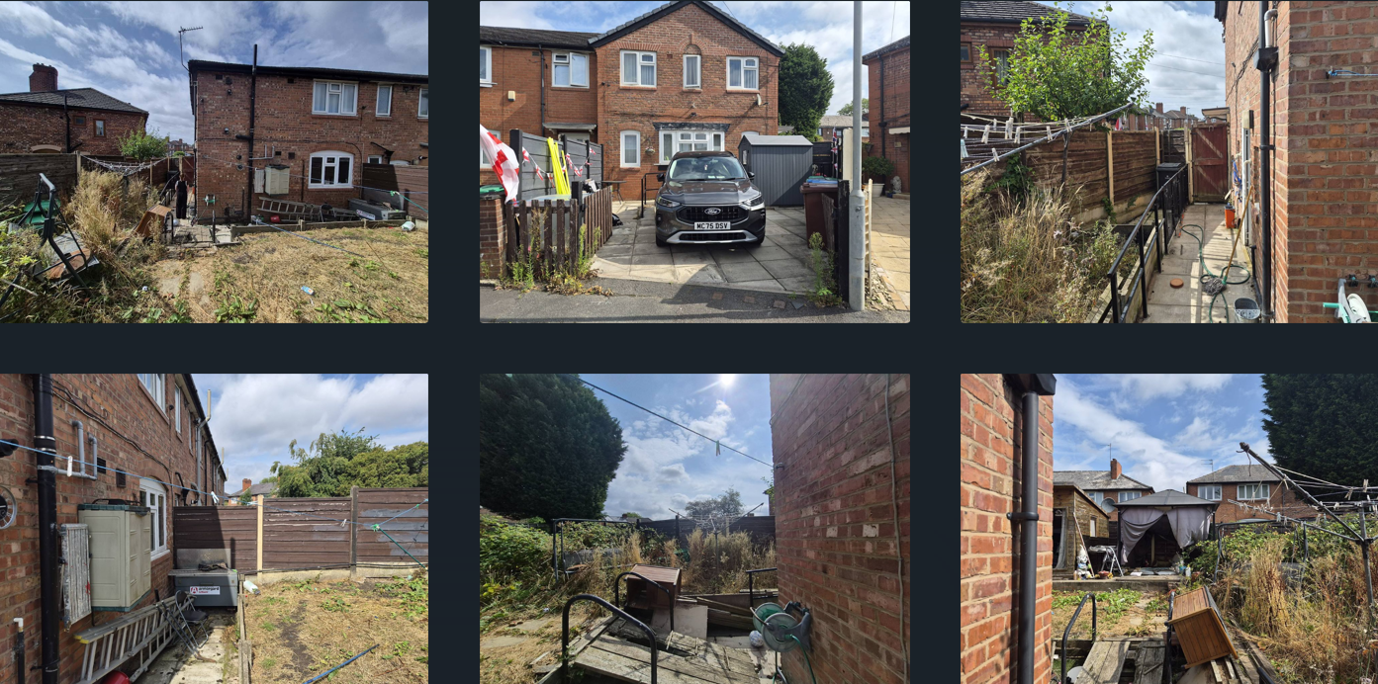

Description of development
The applicant is seeking planning permission for the erection of single storey rear and side extension.

Relevant planning history
No site history to the site

Consultation, notification and publicity responses

Consultations

N/A

Notifications and publicity

One letter of objection has been received, summary of comments as follows:

Previous objections submitted have not received a response.

Concerned that residents have not been adequately informed about the progress of the proposal.

Questions whether adapting the property is the most appropriate solution if the intended occupant is unable to use stairs.

Suggests that relocation to a ground-floor property may be a more suitable alternative.

Believes the property could be better utilised by a family able to occupy the whole house.

The proposal may not be the most effective way of meeting the occupant's needs.

Impact on neighbouring properties, particularly due to the raised garden level and its connection to adjacent gardens.

Residents should be kept informed of any future developments regarding the application.

Relevant policies
In accordance with Section 38(6) of the Planning and Compulsory Purchase Act 2004, planning applications must be determined in accordance with the statutory development plan unless material considerations indicate otherwise.

For Manchester, the development plan comprises:
- The Manchester Core Strategy (2012 to 2027);
- Saved policies of the Manchester Unitary Development Plan (UDP); and
- The Places for Everyone Joint Development Plan Document (2022 to 2039).
These documents are considered up to date and are afforded significant weight in the determination of planning applications. Relevant Supplementary Planning Documents (SPDs) and other adopted guidance may also be material considerations.
The National Planning Policy Framework sets out the government’s policies for plan-making and for making decisions on development proposals in England. It is a material consideration of critical importance in both contexts.

Where relevant, the Council is required to give special regard to the desirability of preserving listed buildings and their settings, and special attention to the desirability of preserving or enhancing the character or appearance of conservation areas, in accordance with the Planning (Listed Buildings and Conservation Areas) Act 1990.

The policies and guidance referred to below are considered the most relevant to the scale, nature and location of the proposed development.

- The Manchester Core Strategy Development Plan Document 2012-2027
  - Development Management and Planning Obligations
    - DM 1 - Development Management
  - Objective 1 - Spatial Principles
    - SP 1 - Spatial Principles (Partially replaced by PfE Policy JP-S 1)
  - Objective 6 Environment
    - EN 1 - Design Principles and Strategic Character Areas
    - EN 19 – Waste
- Guide to development in Manchester - supplementary planning document and planning guidance, April 2007
- Extant Unitary Development Plan (UDP) –
  - Citywide Development Control Policies
    - DC1 - Residential extensions
    - DC26 - Development and Noise
- Places for Everyone Plan Joint Development Plan Document 2022-2039-
  - Strategy
    - JP-Strat9: Southern Areas
  - Sustainable and Resilient Places
    - JP-S1: Sustainable Development
  - Places for People
    - JP-P1 Sustainable Places
- National Planning Policy Framework – August 2026 - National Development Management Policies (NDMPs)
  - Procedural Policies
    - Chapter 3 – Decision-making policies
      - DM1: Preparing development proposals
      - DM2: Information requirements
      - DM3: Determining development proposals
      - DM6: Use of planning conditions and obligations
      - DM7: Relationship with other regulatory regimes
      - DM9: Use of development orders
      - DM10: Removal of national permitted development rights
  - Sustainable Development
    - Chapter 4 - Achieving sustainable development
      - S3: Presumption in favour of sustainable development
      - S4: Principle of development within settlements
  - Creating high quality, sustainable places
    - Chapter 12 - Making effective use of land
      - L2: Making effective use of land
    - Chapter 14 - Achieving well-designed places
      - DP3: Key principles for well-designed places
      - DP4: The design process

Assessment
Principle
Policies SP1 and DM1 of the Manchester Core Strategy 2012 (Core Strategy) seek to ensure that new development enhances or creates character, protects and enhances the built environment; and that the design, scale and appearance of the proposed development is appropriate to its context. Policies DC1.1, DC1.2, DC1.3 and DC1.4 of The Unitary Development Plan for the City of Manchester 1995 (UDP) relate specifically to residential extensions and set out a number of criteria against which proposals for extensions will be assessed. DC1.5 - The Council will consider on their merits exemptions to the above policies in the case of applications from disabled people who may require particular adaptations to their homes. Although these latter policies are now of some age, they are consistent with the guidance in the National Planning Policy Framework (NPPF) which seeks a high standard of design in new developments which provides a good standard of amenity of all existing and future occupiers.
The principle of allowing residents to extend their homes to provide enlarged or improved accommodation is generally acceptable provided that there is no overriding, undue impact upon either the character of the property or upon the residential and visual amenity of nearby residential occupiers.
In this instance the principle of the proposal is considered acceptable, and it is not believed that there are any factors of sufficient weight in amenity terms that would warrant refusal of the application.
On balance, the proposed extension is deemed to accord with saved policy DC1 of the UDP and policies DM1 and SP1 of the Manchester Core Strategy.
Residential Amenity
The applicant is seeking planning permission for the erection of single storey rear and side extension for a disabled resident at the property. The resultant works would lead to accessible bedroom and bathroom facilities. The application has been submitted by the Manchester Equipment and Adaptations Partnership on behalf of the applicant. Objections were received from a local resident. The main concerns raised related to the potential impact of the proposal on neighbouring residents, particularly in relation to the raised garden, and whether the proposed addition was necessary and appropriate in the circumstances.
The proposed extension would be positioned along the side elevation of the property extending rearwards. It would project approximately 2.5m towards the side boundary wrapping around the dwelling with a width across the rear measuring 4.35m, whilst maintaining a substantial separation distance from the shared boundaries on either side. The projection beyond the rear measures 3.260m with a height measuring 2.5m to eaves and 3.5m to ridge height. The extension would be finished with a hipped roof design, an appearance which would be sympathetic with the host property.
The proposed openings comprise a window on the front elevation, a window on the side elevation facing No. 21 Lindale Avenue, and double doors on the side elevation facing No. 17 Lindale Avenue. Given the proposed internal layout, these openings are considered necessary to provide adequate daylight and access. To safeguard the privacy of neighbouring occupiers at No. 21 Lindale Avenue, a condition requiring the side-facing window to be fitted with obscure glazing has been attached. With regard to the double doors facing No. 17 Lindale Avenue, it is considered that the separation distance to the shared boundary, together with the existing boundary treatment, would prevent any significant overlooking or loss of privacy. Accordingly, the proposal is not considered to give rise to unacceptable residential amenity impacts.

The extension is required for the use by a disabled resident to allow additional living accommodation and therefore complies with DC1.5 of the UDP. It is felt that the proposal can be acceptably accommodated at the application property and is considered that the proposal would not interfere with the existing characteristics of the area. Should the applicant build the rear element and side element separately adhering to the limitations set out within permitted development, this could be built independently. The extension although visible from the public highway and therefore would feature within the street scene, is considered to be acceptable retaining the character of the area. Its impact upon visual amenity is considered negligible.
Overall, given the development's height, projection and relationship to adjacent properties, it is considered that the proportions of the extension to the side and rear are acceptable and can be acceptably accommodated at the application property. The footprint is not considered to create a bulky or disproportionate scale addition to the property. In terms of residential amenity, it is not considered that there will be any significant impact and the proposed development therefore the proposal complies with The National Planning Policy Framework; Core Strategy policies SP1, DM1, EN1 and Saved Policies DC1 of the Unitary Development Plan.
Siting, scale and massing
The proposal has been sited and designed to ensure that it is subservient to the original dwelling house, is not excessively large or bulky and are therefore considered to accord with the principles set out in saved UDP policies DC1 (in particular policy DC1.5).and accords with Core Strategy policies DM1 of the Core Strategy.
Design
The proposal is considered acceptable and detailed as what is normally expected of such a structure. The design of the proposal would be in keeping with the existing and surrounding properties in the area and in terms of the proposed materials it is intended to use matching materials as specified in the application form. It is believed that the proposed works would not detract from the character and appearance of the property and the design of the works would complement host dwelling.
On balance it is considered that the design and appearance of the proposed development accords with Core Strategy Policies DM1 and EN1 and in general the design is considered acceptable.
Waste management
The storage of bins are unaffected by this proposal as space at the side is retained. Therefore the proposal is in accordance with policy EN19 of the Core Strategy.
Parking
Off street car parking will still be retained as part of this proposal.

Other Legislative Requirements

Equality Act 2010
Section 149 (Public Sector Equality Duty) of the Equality Act 2010 requires due regard to the need to: Eliminate unlawful discrimination, harassment and victimisation and other conduct prohibited by the Act and; Advance equality of opportunity between persons who share a protected characteristic and persons who do not share it. The Equality Duty does not impose a legal requirement to conduct an Equality Impact Assessment. Compliance with the Equality Duty involves consciously thinking about the aims of the Equality Duty as part of the process of decision-making.

Human Rights Act 1998 considerations
This application needs to be considered against the provisions of the Human Rights Act 1998. Under Article 6, the applicants (and those third parties, including local residents, who have made representations) have a right to a fair hearing and to this end the local planning authority must give full consideration to their comments.

Protocol 1 Article 1, and Article 8 where appropriate, confer(s) a right of respect for a person’s home, other land and business assets. In taking account of all material considerations, including Council policy as set out in the Core Strategy and saved polices of the Unitary Development Plan, the Director of Planning, Building Control & Licensing has concluded that some rights conferred by these articles on the applicant(s)/objector(s)/resident(s) and other occupiers and owners of nearby land that might be affected may be interfered with but that that interference is in accordance with the law and justified by being in the public interest and on the basis of the planning merits of the development proposal. She believes that any restriction on these rights posed by the recommendation given is proportionate to the wider benefits of and that such a decision falls within the margin of discretion afforded to the Council under the Town and Country Planning Acts.

Conclusion
The proposal complies with the above policies; it received no objections, and the City Council recognises the importance of adapting homes to suit changing household needs and accommodate disabled residents. The single storey rear extension and ramped access would improve the safety and comfort of the dwelling for the resident, allowing them to remain independent in their own home, therefore development may commence in accordance with the following conditions.
For the above reasons, the proposal is unlikely to have any detrimental impact and therefore accords with saved UDP policy DC1 and policies SP1 and DM1 of the Core Strategy

Article 35 Declaration
Positive and proactive working - Officers have worked with the applicant in a positive and proactive manner based on seeking solutions to problems arising in relation to dealing with the planning application. No significant problems have arisen during the consideration of this application.

Recommendation: Approve

Conditions to be attached to decision for approval

3-year time limit
The development must be begun not later than three years beginning with the date of this permission.
Reason - Required to be imposed by Section 91 of the Town and Country Planning Act 1990 (as amended).

Specified plans
The development hereby approved shall be carried out in accordance with the following approved plans and documents received by the Local Planning Authority on 6 July 2026:
  - Proposed Plans and Elevations as drawn by Rebecca Beech
Reason: To ensure that the development is carried out in accordance with the approved details pursuant to Policies DM1 and EN1 of the Manchester Core Strategy and the National Planning Policy Framework.

Materials

The materials used in the external surfaces of the development hereby approved shall be similar in appearance to the existing building in terms of type, size, colour and texture.

Reason - In order to ensure a satisfactory appearance in the interests of visual amenity in accordance with policies SP1 and DM1 of the Core Strategy and the requirements of the National Planning Policy Framework.

EXTENSIONS – PD RIGHTS REMOVED FOR NEW OPENINGS
Notwithstanding the provisions of Schedule 2, Part 1 of the Town and Country Planning (General Permitted Development) Order 2015 (as amended) (or any order revoking and re-enacting that Order with or without modification), no additional windows, doors or other openings shall be inserted in the development hereby approved, without planning permission being granted by the Local Planning Authority.

Reason - In the interests of residential amenity, pursuant to policies DM1 and SP1 of the Manchester Core Strategy.

- OBSCURE GLAZING
The window(s) in the side elevation facing no. 21 Lindale Avenue, of the development hereby approved shall be obscure glazed to a specification of no less than level 5 of the Pilkington Glass Scale or such other alternative equivalent and shall be retained as such thereafter. Any parts of the window that can be opened must be more than 1.7 metres above the floor of the room in which the window is installed.

Reason - In order to protect the amenity of neighbouring residents and in accordance with policies SP1 and DM1 of the Core Strategy.

