

Planning

Delegated Officer Report

Summary of application details
Application reference: | PLA-2026-001217
Application type: | Householder planning permission
Proposal: | Retention of rear deck, steps and erection of privacy screening.
Site address: | 36 Woodland Road Manchester M19 2QP
Ward(s): | Levenshulme
Date application valid: | 03 August 2026
Applicant name: | Sam Oliveira
Agent (if any): | Tomislav Vuletic
Case officer: | Joshua Lee
Recommendation: | Approve
Date of recommendation: | 07/09/2026

Description of site, building and/or area
The proposal relates to a traditional two-storey red-brick semi-detached dwelling dating from the 1930-1949 period, featuring a prominent two-storey front bay window, pitched slate roof with front gable, and a small enclosed front garden behind a low brick boundary wall. To the rear the property features a dormer terrace and small rear garden.
The property is located in a mostly residential part of the Levenshulme ward of Manchester. Cringlebrook sits directly to the rear of the property with the curtilage of the property sitting within the Environment Agency’s Main River Consultation Area and some of the rearmost of the curtilage with Flood Zone 3.

Description of development
The proposal comprises the retention of a raised timber deck (700mm above ground level) to the rear garden. The deck measures approximately 6.4m wide by 3.2m deep and incorporates an outdoor kitchen. Timber privacy screens, approximately 2.8m in height (measured from ground), would be erected along the side edges of the deck.
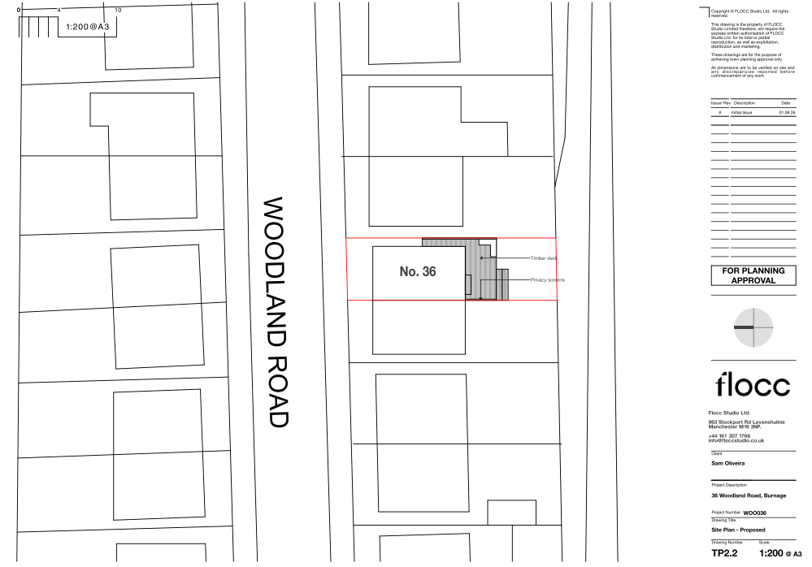
Figure 1. Proposed site plan

Relevant planning history

Enforcement Case - ENF-2026-0044
Erection of decking to rear
Status: Under Investigation, Rec'd: 2026-07-28

This application is as a result of the open enforcement investigation to regularise the development.

Consultation, notification and publicity responses

Consultations

Flood Risk Management
The LLFA has no comments to make on this application, as the proposed development is not expected to impact local flood risk assets and does not raise any concerns regarding increased surface water runoff.

Environment Agency (Planning)
The Environment Agency has reviewed the application and raises no objection in principle to the proposed development. The consultee advises that separate consent may be required under the Environmental Permitting (England and Wales) Regulations 2016 for certain works undertaken within or near a main river, flood defence or culvert. The applicant is advised to contact the Environment Agency at an early stage to determine whether an environmental permit is required, as any such permit would be separate from planning permission.

Notifications and publicity

Neighbour letters
1no objection received with concerns regarding:
- The raised deck/platform has been constructed approximately 0.8m above ground level and results in overlooking into neighbouring gardens and rear windows, causing a loss of privacy and residential amenity.
- The proposed privacy screening is not considered an acceptable solution, as it may be ineffective, visually intrusive, and would itself detract from the neighbour's outlook.
- Concerns that the elevated platform, outdoor kitchen/bar, social gatherings and alleged short-term holiday lets could lead to increased noise and disturbance.
- The applicant's drawings are said to be inadequate and misleading because they do not clearly show the height of the platform, steps and structures, making it difficult to assess the true impacts.
- A site visit is requested to properly assess overlooking, visual intrusion and relationships with neighbouring properties.
- Concerns are raised regarding the safety and stability of the proposed privacy screen due to its overall height and uncertainty about how it would be attached or constructed.
- The appearance and quality of the existing fencing and trellis are criticised, with concerns that any similar form of screening would be inadequate.
- The objector considers that the proposal fails to adequately protect neighbouring amenity and requests that the retrospective application be rejected, suggesting the application should be considered invalid

Relevant policies
In accordance with Section 38(6) of the Planning and Compulsory Purchase Act 2004, planning applications must be determined in accordance with the statutory development plan unless material considerations indicate otherwise.
For Manchester, the development plan comprises:
- The Manchester Core Strategy (2012 to 2027);
- Saved policies of the Manchester Unitary Development Plan (UDP); and
- The Places for Everyone Joint Development Plan Document (2022 to 2039).
These documents are considered up to date and are afforded significant weight in the determination of planning applications. Relevant Supplementary Planning Documents (SPDs) and other adopted guidance may also be material considerations.
The National Planning Policy Framework sets out the government’s policies for plan-making and for making decisions on development proposals in England. It is a material consideration of critical importance in both contexts.
Where relevant, the Council is required to give special regard to the desirability of preserving listed buildings and their settings, and special attention to the desirability of preserving or enhancing the character or appearance of conservation areas, in accordance with the Planning (Listed Buildings and Conservation Areas) Act 1990.
The policies and guidance referred to below are considered the most relevant to the scale, nature and location of the proposed development.
- The Manchester Core Strategy Development Plan Document 2012-2027
  - Development Management and Planning Obligations
    - DM 1 - Development Management
  - Objective 1 - Spatial Principles
    - SP 1 - Spatial Principles (Partially replaced by PfE Policy JP-S 1)
  - Objective 6 Environment
    - EN 1 - Design Principles and Strategic Character Areas
    - EN 8 – Adaptation to Climate Change (partially replaced by PfE Policies JP-S 2, JP-S 4 and JP-G 8)
    - EN 14 – Flood Risk (partially replaced by PfE Policy JP-S 4)
    - EN 19 – Waste
- Guide to development in Manchester - supplementary planning document and planning guidance, April 2007
- Extant Unitary Development Plan (UDP) –
  - Citywide Development Control Policies
    - DC1 - Residential extensions
    - DC26 - Development and Noise
- Places for Everyone Plan Joint Development Plan Document 2022-2039-
  - Strategy
    - JP-Strat9: Southern Areas
  - Sustainable and Resilient Places
    - JP-S1: Sustainable Development
    - JP-S4: Flood Risk and the Water Environment
  - Places for People
    - JP-P1 Sustainable Places
- National Planning Policy Framework – August 2026 - National Development Management Policies (NDMPs)
  - Procedural Policies
    - Chapter 3 – Decision-making policies
      - DM1: Preparing development proposals
      - DM2: Information requirements
      - DM3: Determining development proposals
      - DM6: Use of planning conditions and obligations
      - DM7: Relationship with other regulatory regimes
      - DM8: Unauthorised development and enforcement
  - Sustainable Development
    - Chapter 4 - Achieving sustainable development
      - S3: Presumption in favour of sustainable development
      - S4: Principle of development within settlements
    - Chapter 5 - Meeting the challenge of climate change
      - CC2: Mitigation of climate change
      - CC3: Adaptation to climate change
  - Creating high quality, sustainable places
    - Chapter 12 - Making effective use of land
      - L2: Making effective use of land
    - Chapter 14 - Achieving well-designed places
      - DP3: Key principles for well-designed places
      - DP4: The design process
  - Conserving and enhancing the environment
    - Chapter 18 - Managing flood risk and coastal change
      - F4: Assessing flood risk for decision-making
      - F6: Development in areas at risk of flooding from rivers or the sea
      - F7: Ensuring development is safe from flooding
      - F8: Sustainable drainage systems and watercourses

Assessment

Principle of development
The application seeks retrospective planning permission for the retention of a raised timber deck, associated steps, outdoor kitchen and privacy screening within the rear garden of a dwellinghouse at 36 Woodland Road. The works are domestic in nature and are ancillary to the established residential use of the property. The principle of alterations and additions within the curtilage of an existing dwelling is generally acceptable, subject to consideration of their design, impact on neighbouring amenity and any site-specific constraints.
The application has been submitted retrospectively following the carrying out of the development without planning permission. National Development Management Policy DM8 (Unauthorised development and enforcement) states that, where consideration is being given to retrospective planning permission, and it is concluded on the basis of evidence that the unauthorised development was intentional, that fact should be given substantial weight in considering whether planning permission should be granted. In this instance, there is no evidence before the Local Planning Authority that the breach was intentional in that sense, and the development has therefore been assessed on its planning merits having regard to the development plan and other material considerations.
It is noted that concerns have been raised regarding the possible use of the property as short-term holiday accommodation. However, no substantive evidence has been submitted to demonstrate that the property is not being occupied as a dwellinghouse. The application has therefore been assessed on the basis of the existing lawful residential use of the site. In any event, the proposal relates solely to domestic garden structures and does not seek permission for any material change of use.
Policy DM1 of the Manchester Core Strategy supports development that is appropriate to its context and does not have an unacceptable impact on neighbouring occupiers or the surrounding area. Subject to the detailed assessment below, the principle of the development is considered acceptable.

Appropriate siting, layout, scale, form, massing, materials, and detail
The development comprises a timber deck (700m high) located at the rear of the dwelling measuring approximately 6.4m in width and 3.2m in depth, together with an outdoor kitchen and timber privacy screens approximately 2.8m in height positioned along the sides of the deck.
The deck is located within the rear garden where it is largely screened from public views by the existing dwelling and surrounding boundary treatments. Owing to its domestic scale, lightweight appearance and position to the rear of the property, the structure does not appear incongruous or visually prominent within against the existing dwelling or neighbouring properties. The materials proposed are typical of residential garden structures and are appropriate to the function of the development.
The privacy screens are of a domestic form and appearance and, whilst taller than a standard boundary fence, would be viewed in the context of established garden boundary treatments.
It is also material that a fallback position exists whereby a deck of up to 300mm in height and boundary enclosures of up to 2m in height could ordinarily be erected under permitted development rights, subject to compliance with the relevant limitations and conditions. Whilst the current proposal exceeds those dimensions, the difference is not considered to result in a materially greater impact on the neighbouring amenity.
The proposal would not introduce a dominant or overbearing feature within the site and is considered compatible with the character of the host property and surrounding residential area. The development therefore accords with Policies DM1 and EN1 of the Core Strategy.
Impact on the surrounding areas in terms of the design, scale and appearance of the proposed development. Development should have regard to the character of the surrounding area.
The raised timber deck, outdoor kitchen and privacy screens are located within the rear garden and are largely screened from public view. The development is domestic in character and of a scale typical of residential garden features. Given its siting, design and materials, the proposal would not appear incongruous or harm the character and appearance of the host property or the wider area. The proposal therefore accords with Policies DM1 and EN1 of the Core Strategy.

Effects on amenity

Privacy
Raised decking can create opportunities for overlooking due to elevated viewing positions. In this case, the applicant has incorporated timber privacy screens approximately 2.8m high (2.1m from deck height) along the side edges of the deck. These screens are specifically intended to limit views towards neighbouring gardens from users of the deck. It is noted that these screens are yet to be erected, but the rear deck is in use, so it is considered reasonable and necessary to secure their installation within 30 days of the date of this decision and retention by planning condition in the interests of neighbouring residential amenity.
Having regard to the scale of the decking, the orientation of the site and the screening provided, it is considered that the development would not result in an unacceptable degree of overlooking or loss of privacy to neighbouring occupiers. While some overlooking typical of an urban residential environment may occur, the impact would not be materially greater than would ordinarily be experienced from use of a domestic garden.

Light
The development consists of a relatively lightweight open deck structure and privacy screens. Given the modest scale of the works and their position within the rear garden, the proposal would not materially reduce daylight or sunlight reaching neighbouring properties or gardens.

Noise
The deck and outdoor kitchen are intended for domestic use ancillary to the occupation of the dwellinghouse. Whilst the facilities may encourage greater use of the garden area, the level of activity generated would remain consistent with that reasonably expected from a residential property. The proposal would not give rise to unacceptable noise impacts.

Odours
The outdoor kitchen would be used on an incidental domestic basis. Any odours generated would be comparable to those arising from normal residential occupation and would not justify refusal of the application.

Accessibility: buildings and neighbourhoods fully accessible to disabled people, access to new development by sustainable transport modes.
The proposal relates to alterations within the rear garden and does not materially alter access arrangements to the dwelling. The development would have no adverse implications for accessibility.

Adequacy of internal accommodation and external amenity space.
The proposal does not reduce internal accommodation and occupies only part of the rear garden. A usable area of private outdoor amenity space would remain available. The proposal therefore maintains an adequate level of residential amenity for future occupiers.

Refuse storage and collection.
The development does not affect existing refuse storage or collection arrangements at the property. Adequate provision remains available within the site.

Vehicular access and car parking
There are no alterations proposed to vehicular access or parking arrangements. The proposal is therefore acceptable in this regard.

Green Infrastructure including open space, both public and private
While the decking occupies part of the rear garden, the property would retain a reasonable amount of private outdoor space. The proposal would not adversely affect public open space or wider green infrastructure provision.

Flood risk and drainage.
The application site adjoins Cringle Brook, with part of the rearmost section of the garden falling within Flood Zone 3. However, the brook and flood risk area are located towards the rear of the curtilage, beyond the main area of domestic activity, and the garden slopes significantly downwards away from the dwelling towards the watercourse. The raised deck is positioned closer to the dwelling on higher ground and outside the area most susceptible to flooding.
The proposal consists of a modest domestic deck structure, associated steps and privacy screening within an existing residential garden. Given its limited footprint, open construction and elevated design, the development would not materially obstruct flood flows, displace floodwater storage, or increase flood risk on or off site. The development would not introduce any sleeping accommodation, vulnerable uses or significant areas of impermeable surfacing.
Having regard to the scale, siting and nature of the proposal, it is considered that the development would not give rise to unacceptable flood risk impacts and is consistent with the objectives of Core Strategy Policy EN14, Places for Everyone Policy JP-S4 and national flood risk policies. Existing drainage arrangements would remain unchanged and the proposal is not expected to materially affect surface water runoff or the operation of the adjacent watercourse.

Other Legislative Requirements

Equality Act 2010
Section 149 (Public Sector Equality Duty) of the Equality Act 2010 requires due regard to the need to: Eliminate unlawful discrimination, harassment and victimisation and other conduct prohibited by the Act and; Advance equality of opportunity between persons who share a protected characteristic and persons who do not share it. The Equality Duty does not impose a legal requirement to conduct an Equality Impact Assessment. Compliance with the Equality Duty involves consciously thinking about the aims of the Equality Duty as part of the process of decision-making.

Human Rights Act 1998 considerations
This application needs to be considered against the provisions of the Human Rights Act 1998. Under Article 6, the applicants (and those third parties, including local residents, who have made representations) have a right to a fair hearing and to this end the local planning authority must give full consideration to their comments.
Protocol 1 Article 1, and Article 8 where appropriate, confer(s) a right of respect for a person’s home, other land and business assets. In taking account of all material considerations, including Council policy as set out in the Core Strategy and saved polices of the Unitary Development Plan, the Director of Planning, Building Control & Licensing has concluded that some rights conferred by these articles on the applicant(s)/objector(s)/resident(s) and other occupiers and owners of nearby land that might be affected may be interfered with but that that interference is in accordance with the law and justified by being in the public interest and on the basis of the planning merits of the development proposal. She believes that any restriction on these rights posed by the recommendation given is proportionate to the wider benefits of and that such a decision falls within the margin of discretion afforded to the Council under the Town and Country Planning Acts.

Planning balance & Conclusion
The proposal seeks retrospective permission for the retention of a raised rear deck, associated steps, outdoor kitchen and privacy screening within the curtilage of an existing dwelling. In reaching a decision, the identified impacts on neighbouring amenity, particularly in relation to privacy, have been carefully considered alongside the representations received. Whilst the raised nature of the deck has the potential to increase opportunities for overlooking, it is considered that the proposed privacy screens, secured by condition, would effectively mitigate these impacts to an acceptable level. The development is domestic in scale and appearance, would not harm the character of the host property or surrounding area, would not result in unacceptable noise, outlook or light impacts, and raises no substantive flood risk concerns. The proposal accords with the relevant policies of the Development Plan, including Core Strategy Policies DM1 and EN1 and Places for Everyone Policy JP-P1. Taking all material considerations into account, the benefits of allowing the retention of the development, subject to conditions, outweigh any limited harm identified. Accordingly, the application is recommended for approval.

Recommendation: Approve

Article 35 Declaration
Officers have worked with the applicant in a positive and proactive manner based on seeking solutions to problems arising in relation to dealing with the planning application. The proposal is considered to be acceptable and therefore determined within a timely manner.

Conditions to be attached to decision for approval

Specified plans
The development hereby approved shall be carried out in accordance with the following drawings and documents:
  - 2026.08.01 - WOO36 - Location Plan.pdf - Location Plan - TP2.1 - 3 Aug 2026
  - 2026.08.01 - WOO36 - Other Plans.pdf - Proposed Plans x4 3 Aug 2026
Reason - To ensure that the development is carried out in accordance with the approved plans, pursuant to policies DM 1, SP 1 and EN 1 of the Core Strategy and JP-P1 & of Places for Everyone.

Materials as approved on plan
The materials used in the external surfaces of the development hereby approved shall be those as specified on approved plan/drawing ref.
  - 2026.08.01 - WOO36 - Other Plans.pdf - Proposed Plans x4 3 Aug 2026

Reason - In order to ensure a satisfactory appearance in the interests of visual amenity in accordance with policies SP1 and DM1 of the Core Strategy and the requirements of the National Planning Policy Framework.

Privacy Screens
The timber privacy screens shown on 2026.08.01 - WOO36 - Other Plans.pdf - Proposed Plans x4 3 Aug 2026 shall be erected within 30 days of the date of this decision and retained in their approved position and maintained thereafter for the lifetime of the use of the approve deck, unless otherwise agreed in writing by the Local Planning Authority.

Reason: To safeguard the privacy and amenity of neighbouring occupiers in accordance with Policies DM1 and EN1 of the Manchester Core Strategy

Informative(s)

Environmental permit – Flood risk activities - advice to applicant
The Environmental Permitting (England and Wales) Regulations 2016 require a permit or exemption to be obtained for any of the following activities:
- erecting any temporary or permanent structure in, over or under a main river, such as a culvert, outfall, weir, dam, pipe crossing, erosion protection, scaffolding or bridge
- altering, repairing or maintaining any temporary or permanent structure in, over or under a main river, where the work could affect the flow of water in the river or affect any drainage work
- building or altering any permanent or temporary structure designed to contain or divert flood waters from a main river
- dredging, raising or removing any material from a main river, including when you are intending to improve flow in the river or use the materials removed
- diverting or impounding the flow of water or changing the level of water in a main river
- quarrying or excavation within 16 metres of any main river, flood defence (including a remote defence) or culvert
- any activity within 8 metres of the bank of a main river, or 16 metres if it is a tidal main river
- any activity within 8 metres of any flood defence structure or culvert on a main river, or 16 metres on a tidal river
- any activity within 16 metres of a sea defence structure
- activities carried out on the floodplain of a main river, more than 8 metres from the river bank, culvert or flood defence structure (or 16 metres if it is a tidal main river), if you do not have planning permission (you do not need permission to build agricultural hay stacks, straw stacks or manure clamps in these places)
For further guidance please visit Flood risk activities: environmental permits - GOV.UK or contact the EA’s National Customer Contact Centre on 03708 506 506 (Monday to Friday, 8am to 6pm) or by emailing enquiries@environment-agency.gov.uk.
The applicant should not assume that a permit will automatically be forthcoming once planning permission has been granted, and the EA advise consulting with them at the earliest opportunity.

