

Planning

Delegated Officer Report

Summary of application details
Application reference: | PLA-2026-000930
Application type: | Householder planning permission
Proposal: | Erection of single-storey extension and basement conversion with patio and raised deck to provide additional living accommodation
Site address: | 20 Hesketh Avenue Manchester M20 2QW
Ward(s): | Didsbury West
Date application valid: | 29 July 2026
Applicant name: | Robert Hopkins and Lily Shalmani
Agent (if any): | Zach Thorp
Case officer: | Joshua Lee
Recommendation: | Approve
Date of recommendation: | 21/08/2026

Description of site, building and/or area
The application site comprises a mid-terrace dwelling within a row of traditional late Edwardian two-storey red-brick terraced properties on Hesketh Avenue. The property has a pitched slate roof with a front-facing dormer and retains the established building line of the terrace. The front forecourt has been predominantly hard surfaced to provide off-street parking, enclosed by low brick boundary walls. The property features an original two storey outrigger and garden to the rear.
The property is located in a mostly residential part of the Didsbury West ward of Manchester.

Description of development
Planning permission is sought for the construction of a single-storey rear extension and the conversion of the existing basement to habitable accommodation, together with the formation of a rear patio and raised deck area.
The proposed single-storey rear extension would extend across the full width of the host dwelling and project approximately 2725mm beyond the existing rear elevation. The extension would have a sloping roof with an overall height of approximately 2700mm and would be finished in materials to match the existing dwelling, including matching brickwork and roofing materials. The rear elevation would incorporate three sets of glazed doors providing access to the external amenity space.
The basement conversion would involve the refurbishment of the existing basement to create additional residential accommodation and a utility room. The works would include tanking and insulation measures, the insertion of a new internal staircase between the ground floor and basement, and the provision of a fire escape window. Associated internal alterations are proposed at ground-floor level to facilitate access to the converted basement.
Externally, the proposals include the creation of a patio area immediately adjacent to the rear extension and a raised decked area within the rear garden, together with associated alterations to the rear elevation and the installation of a rooflight.
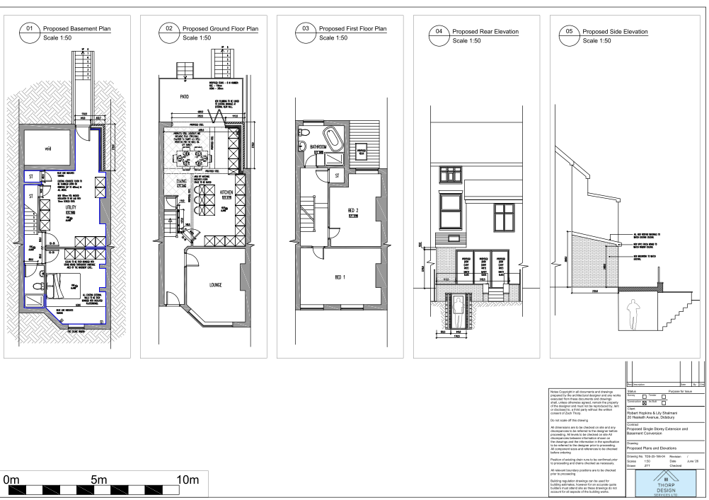
Figure 1. Proposed plans

Relevant planning history
There is no planning history at the address.

Consultation, notification and publicity responses

Notifications and publicity

Neighbour letters
One objection was received raising concerns that the proposal constitutes overdevelopment, is out of character with the area, and would result in overlooking and loss of privacy to neighbouring properties. The representation also raised concerns regarding construction management, including skip placement, builder access, and working hours. The objector further stated that they did not receive a neighbour notification letter.
Nb. The objector did not received a neighbour notification letter due to the distance between the application site and the objector's property, which falls outside the consultation area.

West Didsbury Residents Association
No response received.
Relevant planning concerns will be taken into consideration when assessing the proposed development.

Relevant policies
In accordance with Section 38(6) of the Planning and Compulsory Purchase Act 2004, decisions on planning applications must be made in line with the statutory development plan, unless material considerations indicate otherwise.

For Manchester, the development plan comprises:

- The Core Strategy (2012–2027)
- Saved policies of the Unitary Development Plan (UDP)
- The Places for Everyone Joint Development Plan Document (2022–2039)

These documents are considered up to date and carry substantial weight in decision-making. Supplementary Planning Documents (SPDs) and other local guidance may also be relevant.

National planning policy, including the National Planning Policy Framework (NPPF), is a material consideration and provides overarching guidance.

Where applicable, the Council must give special regard to preserving the character of conservation areas and the setting of listed buildings, in line with statutory duties under the Planning (Listed Buildings and Conservation Areas) Act 1990.

The policies referenced in this report are those considered most relevant to the nature, scale and location of the proposed development as follows:

- The Manchester Core Strategy Development Plan Document 2012-2027
  - Development Management and Planning Obligations
    - DM 1 - Development Management
  - Objective 1 - Spatial Principles
    - SP 1 - Spatial Principles (Partially replaced by PfE Policy JP-S 1)
  - Objective 6 Environment
    - EN 1 - Design Principles and Strategic Character Areas
    - EN 19 – Waste
- Guide to development in Manchester - supplementary planning document and planning guidance, April 2007
- Extant Unitary Development Plan (UDP) –
  - Citywide Development Control Policies
    - DC1 - Residential extensions
    - DC26 - Development and Noise
- Places for Everyone Plan Joint Development Plan Document 2022-2039-
  - Strategy
    - JP-Strat9: Southern Areas
  - Sustainable and Resilient Places
    - JP-S1: Sustainable Development
  - Places for People
    - JP-P1 Sustainable Places
- National Planning Policy Framework – August 2026 - National Development Management Policies (NDMPs)
  - Procedural Policies
    - Chapter 3 – Decision-making policies
      - DM1: Preparing development proposals
      - DM2: Information requirements
      - DM3: Determining development proposals
      - DM6: Use of planning conditions and obligations
      - DM7: Relationship with other regulatory regimes
  - Sustainable Development
    - Chapter 4 - Achieving sustainable development
      - S3: Presumption in favour of sustainable development
      - S4: Principle of development within settlements
  - Creating high quality, sustainable places
    - Chapter 14 - Achieving well-designed places
      - DP3: Key principles for well-designed places
      - DP4: The design process

Assessment

Principle of development
Many people prefer to extend their existing homes rather than move, and the planning system needs to accommodate this demand for more living space, while at the same time ensuring that the amenities of neighbours are protected, and that the overall character of the surrounding area is not harmed. The Council is not generally in favour of dealing with this issue by laying down firm rules about home extensions with each case looked at on its individual merits, having regard to a range of criteria.
In this case the principle of the development is acceptable.
As stated in Policy DM 1 of the Manchester Core Strategy, all development should have regard to the following specific issues:

Appropriate siting, layout, scale, form, massing, materials, and detail
The proposed rear extension would project approximately 2.7m from the existing rear elevation and extend across the width of the host dwelling. The extension would be single storey in scale with a maximum height of approximately 2.7m. Given its limited depth and height, the extension would appear subordinate to the host property and would not compete with the scale or proportions of the original dwelling.
The proposed materials would match the existing dwelling, including brickwork and roofing materials. The design is simple and contemporary whilst remaining sympathetic to the character and appearance of the host property.
In terms of neighbouring amenity, the proposed extension would have a limited projection of approximately 2.7m beyond the existing rear elevation and would be single storey in height with an overall height of approximately 2.7m. The extension would be positioned to the rear of the dwelling, adjoining a typical pattern of rear projections and outbuildings found along the terrace. Given its modest scale, height and siting, the proposal would not appear unduly dominant or overbearing when viewed from neighbouring properties and would not result in an unacceptable sense of enclosure. The raised deck would similarly be of limited scale and would not introduce built form of a magnitude that would materially affect the outlook of neighbouring occupiers. As such, the proposal is not considered to have an adverse impact on neighbouring residential amenity by virtue of its massing
The basement conversion would be largely internal in nature. Alterations visible externally are limited to a rooflight and changes to the rear elevation associated with the proposed extension and access to external amenity space. These works would be confined to the rear of the property and would have limited visibility from the public realm.

Impact on the surrounding areas in terms of the design, scale and appearance of the proposed development. Development should have regard to the character of the surrounding area.
The surrounding area is characterised by traditional terraced housing, many of which have been altered and extended over time. Due to the rearward location of the proposed works, the modest scale of the extension and the use of matching materials, the development would preserve the visual character of the dwelling and would not appear incongruous within the wider streetscape.

Effects on amenity

Privacy
The proposed patio area would be positioned immediately adjacent to the rear of the dwelling and would sit broadly at existing ground level. The proposed decked area would be located within the existing rear garden and would replace an existing timber deck in a similar position. Whilst the submitted plans indicate some alteration to levels, the development would not result in a significant increase in height above the surrounding garden compared with the existing situation and would therefore not create any materially greater opportunities for overlooking.
The proposed glazed doors within the rear elevation would serve ground-floor accommodation and would not result in overlooking beyond that typically associated with a dwellinghouse and its private garden. Likewise, use of the patio and deck would be consistent with the normal domestic enjoyment of the property.
Having regard to the scale of the development, the existing relationships between neighbouring rear gardens, and the fact that a decked structure already exists in this location, the proposal would not result in an unacceptable loss of privacy to neighbouring occupiers. The basement escape window and rooflight would not give rise to overlooking concerns by virtue of their design and position. Accordingly, the proposal is considered acceptable in terms of residential amenity.

Light
The proposed extension is of modest depth and single-storey scale. Given its limited projection beyond the existing rear outrigger, it would not give rise to an unacceptable loss of daylight or sunlight to neighbouring properties.
Similarly, the raised deck would not introduce built form of a scale likely to affect light levels to adjacent occupiers.

Noise
The proposed extension is not expected to generate any noise beyond what would be reasonably expected of a residential dwelling.

Construction impacts
A local resident has requested controls over construction activities. While some temporary disturbance may occur during construction, the proposal is a minor householder development. Given its limited scale and duration, a Construction Management Plan or similar restrictions would be unnecessary and onerous, and would not meet the tests for planning conditions. Any construction-related nuisance would be addressed through separate environmental protection legislation where necessary.

Accessibility: buildings and neighbourhoods fully accessible to disabled people, access to new development by sustainable transport modes.
The proposal does not change how people can get in and out of the building.

Adequacy of internal accommodation and external amenity space.
The proposal adds space inside the property with minimal effect to the outdoor area and maintains a good level of external amenity space post development.

Refuse storage and collection.
The proposal itself has little impact on waste from the site. It uses the current storage and collection methods on site and maintains external access to the rear of the property.

Vehicular access and car parking
The proposal doesn't change how vehicles access and park at the property.

Green Infrastructure including open space, both public and private
The dwelling benefits from a garden beyond the siting of the proposed development and maintains a good amount of private green space post development.

Flood risk and drainage.
The site is not located in a flood risk area and therefore does not require a flood statement or assessment.
The proposal has a negligible impact on drainage using the existing drainage on site.

Other Legislative Requirements

Equality Act 2010
Section 149 (Public Sector Equality Duty) of the Equality Act 2010 requires due regard to the need to: Eliminate unlawful discrimination, harassment and victimisation and other conduct prohibited by the Act and; Advance equality of opportunity between persons who share a protected characteristic and persons who do not share it. The Equality Duty does not impose a legal requirement to conduct an Equality Impact Assessment. Compliance with the Equality Duty involves consciously thinking about the aims of the Equality Duty as part of the process of decision-making.

Human Rights Act 1998 considerations
This application needs to be considered against the provisions of the Human Rights Act 1998. Under Article 6, the applicants (and those third parties, including local residents, who have made representations) have a right to a fair hearing and to this end the local planning authority must give full consideration to their comments.
Protocol 1 Article 1, and Article 8 where appropriate, confer(s) a right of respect for a person’s home, other land and business assets. In taking account of all material considerations, including Council policy as set out in the Core Strategy and saved polices of the Unitary Development Plan, the Director of Planning, Building Control & Licensing has concluded that some rights conferred by these articles on the applicant(s)/objector(s)/resident(s) and other occupiers and owners of nearby land that might be affected may be interfered with but that that interference is in accordance with the law and justified by being in the public interest and on the basis of the planning merits of the development proposal. She believes that any restriction on these rights posed by the recommendation given is proportionate to the wider benefits of and that such a decision falls within the margin of discretion afforded to the Council under the Town and Country Planning Acts.

Conclusion
The proposed single-storey rear extension, basement conversion, patio and raised deck are considered acceptable in principle and would provide additional living accommodation whilst remaining sympathetic to the character and appearance of the host property and the wider area. By virtue of their scale, design, siting and materials, the proposals would not appear incongruous or result in unacceptable impacts on the amenities of neighbouring occupiers through loss of light, outlook, privacy or overbearing massing. The development would retain adequate private amenity space and would not give rise to highway, drainage, heritage or environmental concerns. As such, the proposal is considered to accord with Policies DM1 and EN1 of the Manchester Core Strategy, Policy DC1 of the UDP, relevant Places for Everyone policies and the guidance contained within the NPPF and is therefore recommended for approval.

Recommendation: Approve

Article 35 Declaration
Officers have worked with the applicant in a positive and proactive manner based on seeking solutions to problems arising in relation to dealing with the planning application. The proposal is considered to be acceptable and therefore determined within a timely manner.

Conditions to be attached to decision for approval

3-year time limit
The development must be begun not later than three years beginning with the date of this permission.
Reason - Required to be imposed by Section 91 of the Town and Country Planning Act 1990 (as amended).

Specified plans
The development hereby approved shall be carried out in accordance with the following drawings and documents:
  - Location Plan (received 29 July 2026)
  - Drawing No. TDS-25-196-03 Proposed Site Plan (received 29 July 2026)
  - Drawing No. TDS-25-196-04 Proposed Plans and Elevations (received 29 July 2026)
Reason - To ensure that the development is carried out in accordance with the approved plans, pursuant to policies DM 1, SP 1 and EN 1 of the Core Strategy and JP-P1 & of Places for Everyone.

Materials to match
The materials used in the external surfaces of the development hereby approved shall be similar in appearance to the existing building in terms of type, size, colour and texture.
Reason - In order to ensure a satisfactory appearance in the interests of visual amenity in accordance with policies SP1 and DM1 of the Core Strategy and the requirements of the National Planning Policy Framework.

