

Planning

Delegated Officer Report

Summary of application details
Application reference: | 144871/FO/2026
Application type: | Full planning permission
Proposal: | Basement conversion to create one additional dwelling with installation of light wells to front and rear including car parking, bin and cycle storage.
Site address: | 1 Chatham Grove  Manchester  M20 1HS
Ward(s): | Old Moat
Date application valid: | 13 January 2026

Applicant name:
Agent (if any): | Mr Sam Golding
Case officer: | Ellie Knowles
Recommendation: | Refuse
Date of recommendation: | 4 September 2026

Description of site/building/area

1 Chatham Grove, is a three-storey semi-detached building, located within a mostly residential part of the Old Moat Ward of Manchester. The property is sited at the junction of Burton Road and Chatham Grove. The property features hardstanding to the side and front, which is currently used for refuse storage and off-street parking. The site affords an original low-height brick wall with stone coping around the front and side curtilage, abutting the pavement.

The application property has been previously subdivided into three self-contained apartments, with primary (sole) access taken from the principal elevation.

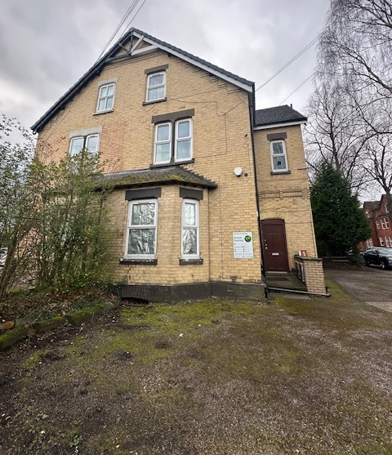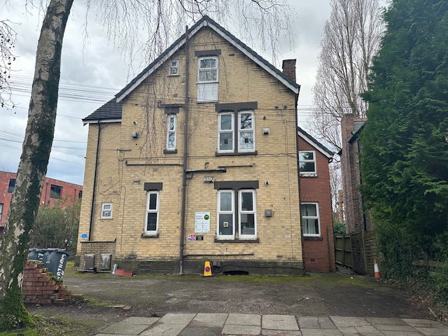
Front and northern side views of the application property.

Listed building: Not applicable

Conservation area: Not applicable

Tree Preservation Order: Not applicable

Description of development

The applicant is seeking permission for the conversion of basement to create one additional dwelling with installation of light wells to front and rear, including car parking, bin and cycle storage.

The proposed lower ground floor unit (62sqm, 2B3P) would be accessed from the rear lightwell and comprise a kitchen, living room, bathroom, 2 bedrooms and en-suite. The unit would afford 7sqm external amenity space within the front lightwell.

Access to the existing 3.no apartments to the upper floors would remain unaltered.

Vehicle parking would be relocated from the site frontage to the northern side of the application property fronting Chatham Grove.

A detached cycle store is proposed to the site frontage and formalised secure bin storage area proposed along the northern boundary of the site.
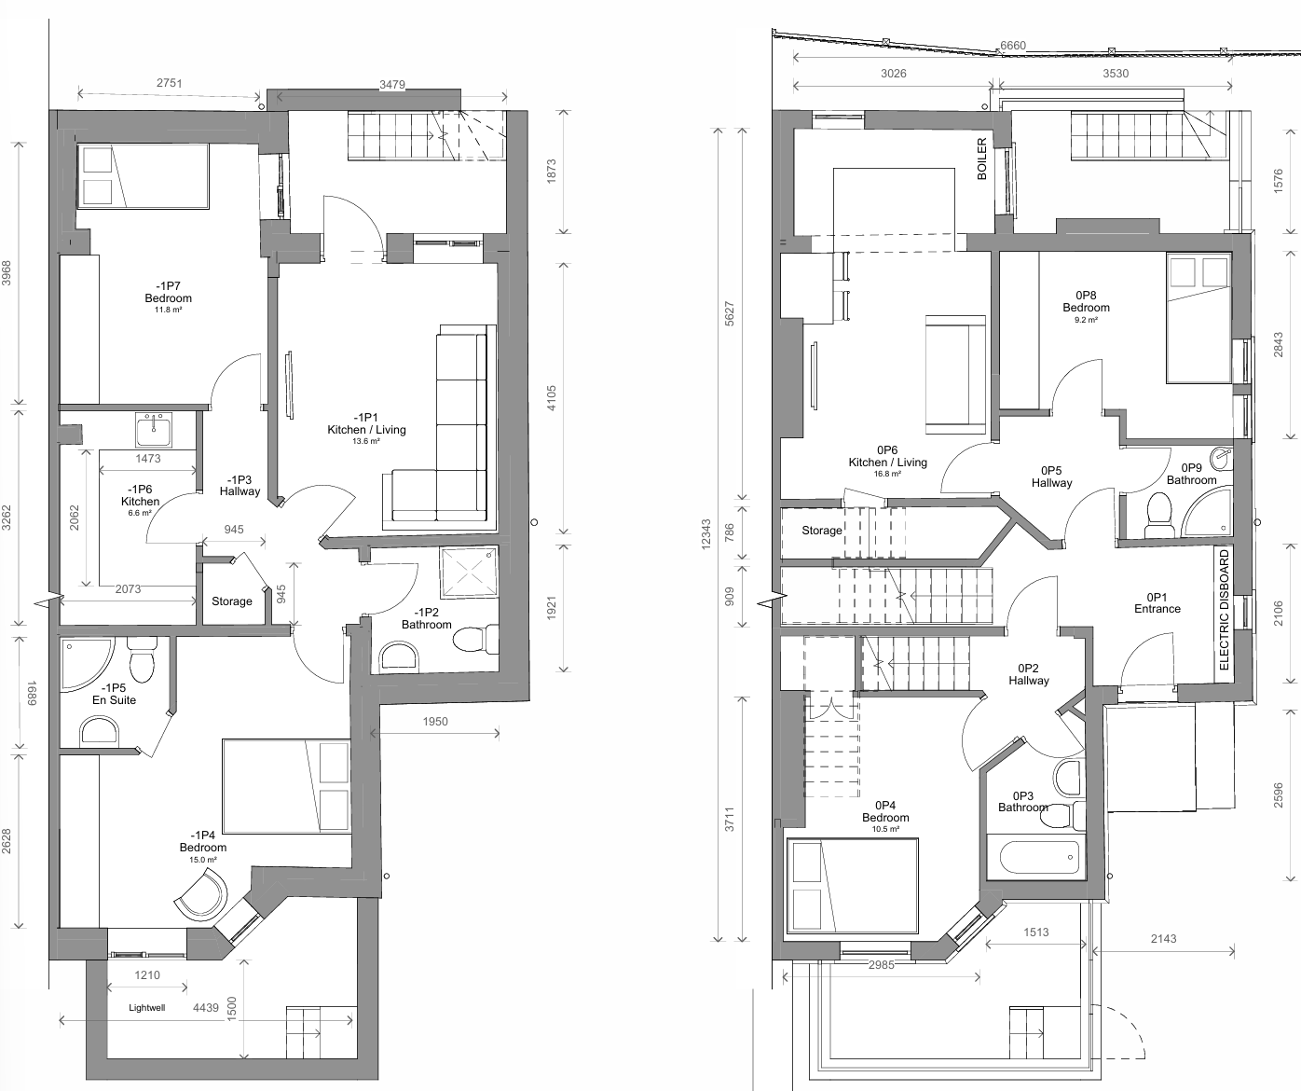
Figure 1: Proposed lower ground floor plan with front and rear lightwells and ground floor plan (unchanged)

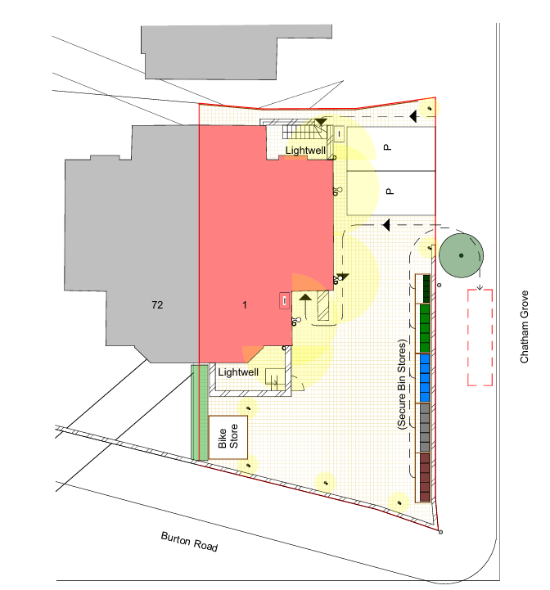
Figure 2: Proposed site plan

Consultations & Notification Responses

Local responses

One letter of representation was received from a local resident raising the following concerns:

- These renovations are not essential or necessary in any way to ensure the safe occupation of the flats.
- The work would infringe upon our right to quiet enjoyment of the units and would make the flats temporarily unhabitable.

Consultee responses

Highway Services –

CONTEXT:
The site is located adjacent to the adopted Chatham Grove to the north and Burton Road
to the east, with adoption extending to the back of the footway.

The site is situated within the Christie Parking Scheme Zone.

Chatham Grove is subject to permit holders only Mon-Fri 8am-6pm.

No Waiting At Any Time restriction is in place along Burton Road.

PROPOSAL:
It is noted that the property currently accommodates 4no. apartments.
An additional apartment is proposed at basement level.

TRIP GENERATION:
- Level of trips generated is not anticipated to be a significant increase. No highways
concerns are expected.

SITE ACCESSIBILITY:
- The site is accessed by sustainable modes.
- Regular bus services and Burton Road Metrolink Stop are located within walking
distance from the property.

PARKING AND ACCESS:
- Vehicular access to the site is from Chatham Grove.
- It is noted that there are 2no. existing car parking spaces located within the site
curtilage. However, these do not appear to be formally demarcated.
- Proposed plans indicate that a total of 2no. parking spaces is to be provided within
the site fronting Chatham Grove. This is acceptable in principle, subject to an appropriate
car parking management strategy
- All individual driveway parking spaces should be a minimum of 3.0m x 6.0m to
ensure that vehicles / pedestrians do not impact on the adopted highway.
- *Confirmation of the car parking bay dimensions is required and should be shown
on an updated plan
- Pedestrian access is via Chatham Grove.

CYCLE PARKING:
- A secure and sheltered cycle store is proposed within the site.
- Cycle store will provide 6no. cycle parking spaces - Acceptable in principle.

BOUNDARY TREATMENTS:
- It is recommended that all fencing / railings adjacent to the adopted highway are
visually permeable from a distance of 600mm upwards to ensure adequate visual
permeability for child pedestrians.
- The applicant should be advised that all gated accesses will need to provide inward
- opening gates to ensure they do not impact on the adopted footway or highway.

BASEMENT EXCAVATION:
- Should there be any basement excavations proposed adjacent to the highwaystructural drawings and calculations for the temporary and permanent support works mustbe submitted for checking (for a fee) to MCC Bridges/Structures Section. The applicant isadvised contacting highways.structures@manchester.gov.uk.

REFUSE AND SERVICING:
- Refuse bins will be stored within the site - Acceptable in principle.
- Waste collection point is from Chatham Grove.
- Refuse bins should be returned to the bin store location following collection.
- Refuse servicing should take place outside of the AM and PM peak.

Environmental Health – No objections subject to the imposition of a pre-commencement waste management strategy condition.

Greater Manchester Police – The amended plans do not adequately address the issues initially raised.

With regards the cycle store, GMP have fundamental concerns about the prominence of its location (being an obvious target for offenders as well as its visual impact on the street and impact on the outlook for residents of the adjacent apartment), as well as how secure it might be. I can’t see anywhere else on the site that suitably secure, cycle store could be accommodated, other than inside the building.

GMP consider that the site doesn’t function well enough with the current number of apartments. There are issues that, directly or indirectly, affect the security of the property, its residents and their vehicles, which include:
- permeability (at the rear);
- security qualities of the door into the property;
- adequacy of parking and the access to it off Chatham Grove;
- proper, well-managed waste storage;
- access for pedestrians; and,
- general appearance of the grounds and boundary walls.

Adding additional accommodation is likely to make a poor situation worse. GMP remain opposed to the proposals.

Relevant Planning History

At the application site –

021383 – Alterations to three flats to form four flats. Approved 12.06.1984.

History of negotiations

The officer communicated that the initial could not be supported on security, highway safety and amenity grounds. The agent submitted a revised proposal to address these issues. The revised proposal was reconsidered; however, it was deemed unacceptable in principle, even in the event of significant revisions.

Policy

Places for Everyone (2022-2039) – Places for Everyone is a long-term plan of nine Greater Manchester districts for jobs, new homes, and sustainable growth. It has been published by the GMCA on behalf of the nine districts and took effect and became part of the statutory development plan on March 21, 2024.

The PfE Plan and its policies are now a material planning consideration in the determination of planning applications. The PfE Plan and its policies must therefore be given full weight in the planning balance.

Manchester Core Strategy Development Plan Document (2012-2027) - The Core Strategy was adopted on the 11 July 2012 and replaces a large number of policies in Manchester’s Unitary Development Plan. Parts of the policies have been superseded by the Places for Everyone Plan.

The Unitary Development Plan (UDP) for the City of Manchester (1995) - The Unitary Development Plan for the City of Manchester was adopted in 1995 and has largely been replaced with the policies contained within the Core Strategy. However, there are a number of policies that are extant.

The relevant Places for Everyone policies for this application are as follows:

JP-Strat5 – Inner Areas
JP-S1 – Sustainable Development
JP-H3 – Type, Size and Design of New Housing
JP-H4 – Density of New Housing
JP-P1 – Sustainable Places

The relevant Core Strategy policies for this application are as follows:

DM 1 – Development Management
SP 1 – Spatial Principles (partially superseded by PfE)
H 1 – Overall Housing Provision (partially superseded by PfE)
H 2 – Strategic Housing Provision
H 6 – South Manchester
T 1 – Sustainable Transport (partially superseded by PfE)
T 2 – Accessible areas of opportunity and need
EN 1 – Design Principles and Strategic Character Areas
EN 19 – Waste

The relevant saved UDP policies for this application are:

DC1 – Residential Extensions
DC5 – Flat conversions
DC7 – New Housing Development
DC26 – Development and Noise

The relevant supplementary planning guidance documents for this application are:
- Waste Storage and Collection Guidance for New Developments (2017)
- Manual for Streets (2007)

A relevant material consideration is also:
- Manchester Residential Quality Guidance March 2017 (Manchester’s Emerging Space Standards)

National Planning Policy Framework

The National Planning Policy Framework (August 2026) - The National Planning Policy Framework (NPPF) sets out the Government’s planning policies for England and how these should be applied.

Planning law requires that applications for planning permission be determined in accordance with the development plan, unless material considerations indicate otherwise. The national decision-making policies in this Framework are a material consideration in making these decisions and should be read alongside the policies in the development plan.

The Local Planning Authority consider the following NPPF policies relevant to this proposal.

Policy L4 (Residential extensions) – This policy states that development proposals to extend existing dwelling houses should blend effectively with the existing building and its immediate surroundings in terms of its scale and form; and maintain acceptable living standards for current and new occupiers in terms of access to daylight, sunlight, privacy and external amenity space.

Policy DP3 (Key principles for well-designed places) – This policy states that in order for development proposals to respond to their context and create well-designed places development proposals should consider context, liveability, climate, nature, movement, built form, public space and identity.

Policy P5 (Maintaining public safety and security) – This policy states that development proposals should anticipate and address possible malicious threats and other hazards (whether natural or man-made) in relation to: (a) Their occupiers and users, by identifying potential safety risks and proportionate mitigation opportunities which can be addressed through the design of the scheme. This applies especially where particular groups may be vulnerable to crime, or to the fear of crime.

Issues

Principle of development:

The City Council will only accept new basement conversions when the new dwelling (planning unit) is deemed to have a high standard of accommodation, with minimal impact on the density of the property and residential amenity. The council generally only supports basement dwellings when access is made internally. In this case the harm of the proposal would significantly outweigh the benefit and on balance is unacceptable.

Standard of accommodation:

Light & Outlook

The development proposes 4.no floor level basement windows to the property, served by lightwells to the front and rear (see figure 1). Due to the proposed siting of openings and the modest scale of the 2.no modest lightwells, it is considered that these proposed windows would afford limited natural light provision and inadequate outlook. Notwithstanding this, the proposed kitchen (habitable room) would not be served by any opening, which raises light and ventilation concerns, to the detriment of potential occupiers. This is considered unacceptable.

Noise

The additional 2-bedroom dwelling at basement level would create additional activity including comings and goings to the address to the detriment of existing occupiers and neighbours. The location of the proposed sunken access to the rear would create a new door for access and egress, directly underneath the existing kitchen window and bedroom of the ground floor flat to the rear (see figure 1), this proposed arrangement would exacerbate the overall noise experienced by this occupier and noise emanating from the property as a whole.

Community safety and crime prevention:

Policy P5 of the National Planning Policy Framework (2026) states that development proposals should anticipate and address possible malicious threats and other hazards (whether natural or man-made) in relation to, their occupiers and users, by identifying potential safety risks and proportionate mitigation opportunities which can be addressed through the design of the scheme.

In this instance, the prevised proposal comprises a proposed primary access arrangement to the additional basement flat in the form of a rear lightwell with sunken stair access (see figures 1 & 2).

Greater Manchester Police were consulted on the revised proposal and considered the urban environment of the application site as being of a very poor quality. Stating that adding additional accommodation is likely to make a poor situation worse.

The sunken basement rear access point would be a harmful addition creating a security risk to potential occupiers by limiting natural surveillance for occupiers’ access and egress. Moreover, the proposed residents parking area is shown sited to the side of the application property directly in front of this primary access point, thus reducing permeability and natural surveillance of this area. The inclusion of CCTV and lighting in a revised proposal has not been considered to sufficiently address initial security and safety concerns raised by the LPA and GMP.

As such, it is considered that this access would lack surveillance from the public domain and provide opportunities for crime and anti-social behaviour, undermining the security of prospective residential occupiers. As such, the proposal would fail to secure a satisfactory standard of residential amenity, contrary to the objectives of creating safe, inclusive and sustainable communities in line with the provisions of policies SP1, DM1, EN1 and H6 of the Core Strategy (2012), policy DC5 Unitary Development Plan for the City of Manchester (1995) and the National Planning Policy Framework (2026).

Other Legislative Requirements

Equality Act 2010
Section 149 (Public Sector Equality Duty) of the Equality Act 2010 requires due regard to the need to: Eliminate unlawful discrimination, harassment and victimisation and other conduct prohibited by the Act and; Advance equality of opportunity between persons who share a protected characteristic and persons who do not share it. The Equality Duty does not impose a legal requirement to conduct an Equality Impact Assessment. Compliance with the Equality Duty involves consciously thinking about the aims of the Equality Duty as part of the process of decision-making.

Human Rights Act 1998 considerations
This application needs to be considered against the provisions of the Human Rights Act 1998. Under Article 6, the applicants (and those third parties, including local residents, who have made representations) have a right to a fair hearing and to this end the local planning authority must give full consideration to their comments.

Protocol 1 Article 1, and Article 8 where appropriate, confer(s) a right of respect for a person’s home, other land and business assets. In taking account of all material considerations, including Council policy as set out in the Core Strategy and saved polices of the Unitary Development Plan, the Director of Planning, Building Control & Licensing has concluded that some rights conferred by these articles on the applicant(s)/objector(s)/resident(s) and other occupiers and owners of nearby land that might be affected may be interfered with but that that interference is in accordance with the law and justified by being in the public interest and on the basis of the planning merits of the development proposal. She believes that any restriction on these rights posed by the recommendation given is proportionate to the wider benefits of and that such a decision falls within the margin of discretion afforded to the Council under the Town and Country Planning Acts.

Article 35 Declaration
Officers have communicated their concerns about this proposal to the applicant during the course of the planning application, but these concerns cannot be overcome by the submission of a revised proposal. The proposal is considered to be contrary to the development plan and therefore refused in a timely manner.

Recommendation: Refuse

Reasons for refusal

1) | The proposed development by reason of the proposed access arrangement to the basement apartment from the rear of the property, obstructed by proposed resident parking spaces, would lack surveillance from the public domain and provide opportunities for crime and anti-social behaviour, undermining the security of prospective residential occupiers. As such, the proposal would fail to secure a satisfactory standard of residential amenity, contrary to the objectives of creating safe, inclusive and sustainable communities in line with the provisions of policies SP1, DM1, EN1 and H6 of the Core Strategy (2012), policy DC5 Unitary Development Plan for the City of Manchester (1995) and the NPPF (2026).
2) | The proposed scheme fails to provide adequate levels of natural light and outlook given the limited numbers of windows serving the proposed basement flat and their position within modest lightwells, which would give rise to a poor standard of living accommodation for future occupiers and an inadequate residential accommodation contrary to counter to policies DM1, SP1, H1, H6, and EN1 of the Manchester Core Strategy; DC1 Extant UDP; JP-S1, JP-H4 and JP-P1 of the Places for Everyone Plan and the NPPF (2026).

