

Planning

Delegated Officer Report

Summary of application details
Application reference: | PLA-2026-001072
Application type: | Full planning permission
Proposal: | Erection of ancillary office building following demolition of external rear garage/shed
Site address: | 189 Mauldeth Road Manchester M19 1BA
Ward(s): | Burnage
Date application valid: | 20 July 2026
Applicant name: | Mr Hussain Nurbhai
Agent (if any): | Mr Sakib Ahmed
Case officer: | Holly Wright
Recommendation: | Approve
Date of recommendation: | 24 August 2026

Description of site, building and/or area
The application relates to a two-storey end-terraced building of redbrick and masonry with a grey tiled. The property features white uPVC-framed windows, a glazed shopfront at ground-floor level with an external roller shutter and fascia sign above, a two-storey rear outrigger, and a detached outbuilding within the rear yard space. The premises appears to be in use as an accountancy firm/office.

Sited in the Burnage ward of Manchester, this section of Mauldeth Road is mixed in terms of its character, featuring commercial, business, and service facilities as well as residential properties. The application site is also located close to Mauldeth Road railway station, Ladybarn Park, and Kingsway (A34).

The property is not listed, nor is it sited within a Conservation Area.

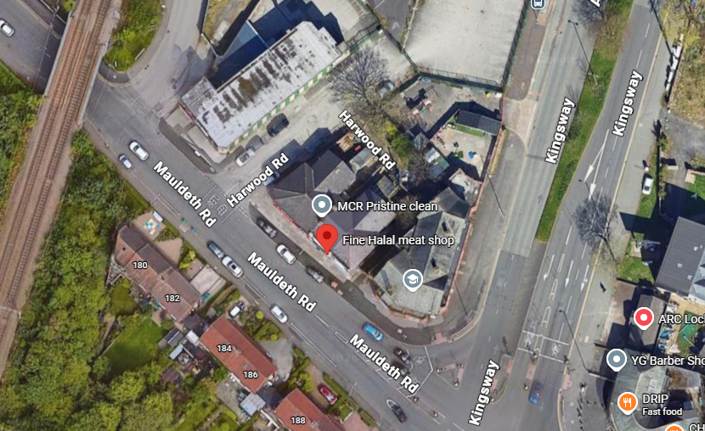



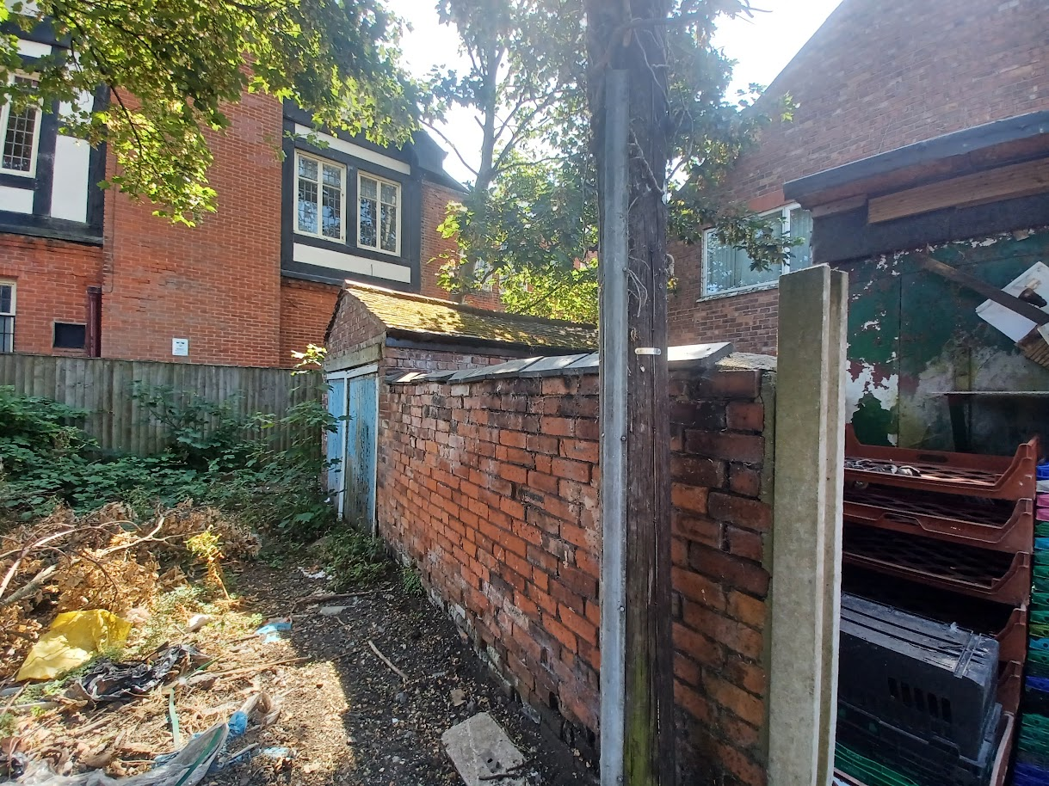

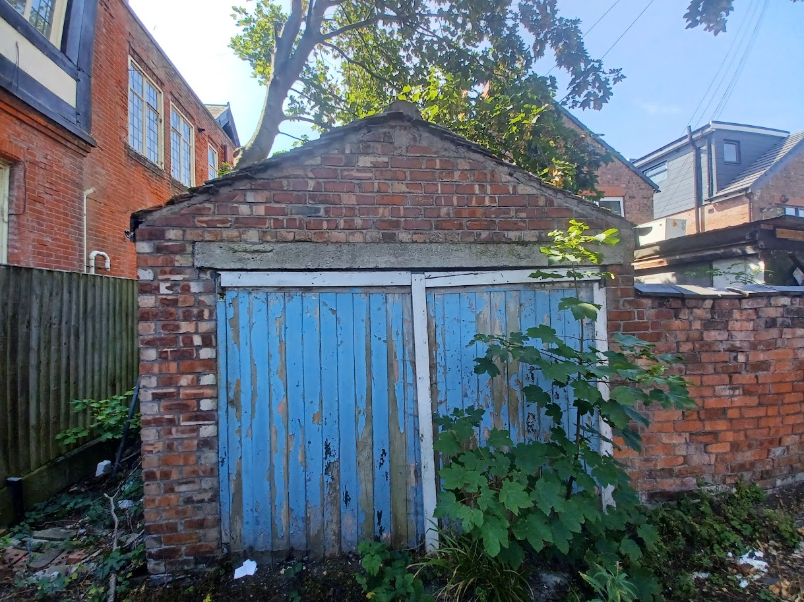
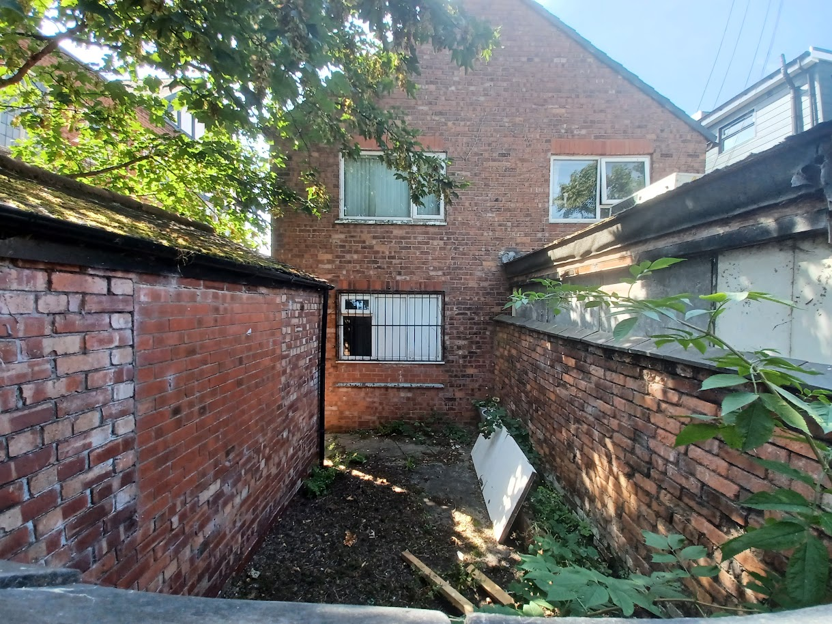

Description of development
The applicant is seeking planning permission for the erection of an ancillary office building following the demolition of an external rear garage/shed.

Relevant planning history
Planning Application – 027671 - Change of use from shop to radio controlled taxi office – Refused (1986).

Planning Application – 029172 - Change of use from shop to offices – Approved (1987).

Planning Application – 030468 - A) Illuminated fascia name sign B) Illuminated double sided projecting box sign – Approved (1988).

Consultation, notification and publicity responses

Consultations

MCC’s Highways Services made the following comments in response to the application:

- The proposed development is within the red-line boundary of the site, and as such, will not impinge upon the adopted highway.
- There is no off-road parking associated with the proposed development.
- Although the number of staff will not increase, the applicant should consider provision of secure/sheltered cycle parking provision.
- Pedestrian access will be provided internally, within the rear site area.
- It is expected that bin storage/servicing arrangements will continue as existing, although confirmation should be provided.
- Highways request that an Outline Construction Management Plan is conditioned with any approval.

Environmental Health raised no objection to the proposal, recommending conditions relating to the control of demolition and construction hours, the submission of a waste management scheme, the implementation of a watching brief, restrictions on the premises' opening hours, and the installation and operation of external plant.

Notifications and publicity

No responses received.

Relevant policies
The Manchester Core Strategy – Development Plan Document 2012-2027 (“the Core Strategy”) was adopted by the City Council on the 11th of July 2012:
- Policy DM1 – Development Management
- Policy SP1 – Spatial Principles

Places for Everyone - is a long-term plan of nine Greater Manchester districts for jobs, new homes, and sustainable growth. It has been published by the GMCA on behalf of the nine districts and took effect and became part of the statutory development plan on March 21, 2024.
- Policy JP-P1 – Sustainable Places

National Planning Policy Framework (NPPF, August 2026)
- Chapter 14 – Achieving Well-Designed Places
- Policy DP3: Key principles for well-designed places

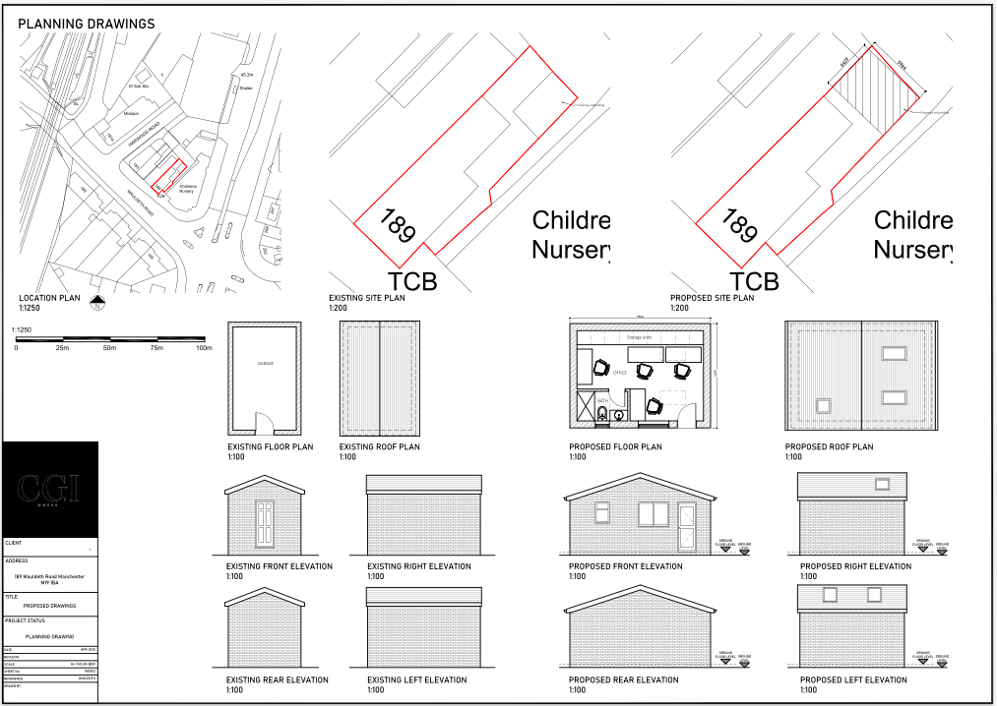
Submitted existing and proposed plans and elevations

Assessment
Principle – the principle of the proposal, to erect an ancillary office building following the demolition of an existing external rear garage/shed, is acceptable. Notwithstanding this, further consideration must be given to how the proposal affects the siting, scale, and massing of the property, its appearance, and impact upon visual and residential amenity, waste storage and parking, amongst other matters.

Siting, scale, and massing – the proposed ancillary office building would be sited within the rear yard space of No.189 Mauldeth Road, replacing the existing detached outbuilding on site. It would measure to approximately 5.964m in width, 4.429m in length, 3.4m in height with an eaves height of 2.3m. It would be sited adjacent to the plot’s northeastern, southeastern, and northwestern boundaries.

The siting, scale and massing of the proposal is considered acceptable. Whilst the proposed building would have a larger footprint than the existing outbuilding, it would be of a broadly comparable height and would occupy a similar position within the site. Further to this, its siting at the back of the property, adjacent to the existing extension evident at No.187 Mauldeth Road, would limit its visual prominence as well as potential impacts upon residential amenity, as it would not significantly alter existing conditions experienced. The proposal would also be consistent with the existing pattern of development in the surrounding area, where a number of properties along Mauldeth Road incorporate rear additions of a comparable scale. For these reasons, the proposal is not considered to result in an unduly dominant or incongruous form of development.

Appearance and visual amenity – the proposed ancillary office building would be constructed of brickwork, roof tiles, windows and doors to match the existing building, as indicated on the submitted application form. Its front elevation, facing southwest, would feature two windows and a door, whilst its side and rear elevations would be blank. Its southeast-facing roof slope would feature two rooflights, whilst its northwest-facing roof slope would feature one rooflight.

The proposal is relatively standard in terms of its design and scale for developments of this type and would be in-keeping with the existing precedent of rear additions in this locale. Sited to the rear of the property, the proposal would not be highly visible within the street scene or public realm. Moreover, its use of matching materials (i.e., brickwork, roof tiles, and windows) would ensure that the proposal does not form an overly prominent visual feature within the area. For these reasons, the proposal is not anticipated to give rise to significant harm to the character and appearance of the application property or the visual amenity of the surrounding area.

Residential amenity – given that the proposed ancillary office building would be single storey only, replacing an existing outbuilding present at the site, would be located adjacent to an existing extension at the neighbouring plot, and would feature subservient dimensions to the application property with an approximate height of 3.4m, significant issues associated with overshadowing, loss of light, loss of outlook, and the introduction of an overbearing feature are not anticipated. Additionally, as the proposed ancillary office building would not include any side-facing windows in proximity to shared boundaries, no unacceptable impacts in terms of overlooking or loss of privacy are anticipated.

In email correspondence dated 24 August 2026, the agent confirmed that the upper floors of the property are currently vacant and are not in residential use. The agent also confirmed that there are no proposals to convert these floors to residential accommodation. As a result, it is not considered that the proposal would give rise to unacceptable impacts upon occupiers of the site through noise disturbance or increased comings and goings.

Waste storage – in email correspondence dated 24 August 2026, the agent advised that the existing waste storage arrangements would remain unchanged as a result of the proposal, with refuse bins continuing to be stored within the curtilage of the site. Given that no change of use is proposed and the development relates solely to the erection of an ancillary office building, it is not considered that the proposal would generate additional waste requiring alternative storage provision. As such, the existing arrangements are considered satisfactory, and it would be unreasonable and unnecessary to impose the waste management condition recommended by Environmental Health.

Parking and impact to highway – the site does not provide off-street parking; however, it occupies a sustainable location with convenient access to the railway station and regular bus services, thereby reducing reliance on private vehicles.

Given the absence of on-site parking, the agent was asked whether there is scope to provide secure cycle parking within the site to further encourage sustainable travel. In email correspondence dated 24 August 2026, the agent advised that staff are expected to travel primarily by public transport, particularly by bus. Additionally, it should be noted that the proposal would not result in an increase in employee numbers and there is insufficient space within the site curtilage to accommodate a dedicated cycle store. It is also noted that cycle parking facilities are available in the surrounding area, including cycle loops at Mauldeth Road railway station.

As the proposal would not increase staffing levels and no intensification of the use is proposed, it is not considered that the development would result in a significant increase in vehicle movements or parking demand. Accordingly, no significant impacts upon highway safety or the operation of the surrounding highway network are anticipated.

Use – the proposal seeks permission for an ancillary office building to support and enhance the existing commercial use of the site as an accountancy business. In email correspondence dated 6 August 2026, the agent confirmed that the premises currently employs three members of staff and that staffing levels would remain unchanged as a result of the development. Consequently, the proposal is not considered to result in the over-intensification of the existing use.

Environmental Health has requested the imposition of a condition controlling operating hours. However, as no change of use is proposed and the development relates solely to ancillary accommodation associated with the existing business, such a condition is not considered necessary or reasonable and would therefore be unduly onerous. Notwithstanding this, the submitted application form confirms opening hours of 09:00 to 17:00 Monday to Friday, with the premises closed on Saturdays, Sundays and Bank Holidays. These hours are considered appropriate to the character of the area and are not expected to give rise to unacceptable amenity impacts.

External plant – no external plant is proposed as part of the application; therefore, the condition recommended by Environmental Health is not required.

Conclusion – given the above issues, it is considered that the proposal is acceptable in terms of its principle, siting, scale and massing, appearance, impact upon visual and residential amenity, waste storage and parking as it broadly complies with policies DM1, and SP1 of the Manchester Core Strategy, chapter 14 of the National Planning Policy Framework (2026), and policy JP-P1 of the Places for Everyone joint development plan document.

Other Legislative Requirements

Equality Act 2010
Section 149 (Public Sector Equality Duty) of the Equality Act 2010 requires due regard to the need to: Eliminate unlawful discrimination, harassment and victimisation and other conduct prohibited by the Act and; Advance equality of opportunity between persons who share a protected characteristic and persons who do not share it. The Equality Duty does not impose a legal requirement to conduct an Equality Impact Assessment. Compliance with the Equality Duty involves consciously thinking about the aims of the Equality Duty as part of the process of decision-making.

Human Rights Act 1998 considerations
This application needs to be considered against the provisions of the Human Rights Act 1998. Under Article 6, the applicants (and those third parties, including local residents, who have made representations) have a right to a fair hearing and to this end the local planning authority must give full consideration to their comments.

Protocol 1 Article 1, and Article 8 where appropriate, confer(s) a right of respect for a person’s home, other land and business assets. In taking account of all material considerations, including Council policy as set out in the Core Strategy and saved polices of the Unitary Development Plan, the Director of Planning, Building Control & Licensing has concluded that some rights conferred by these articles on the applicant(s)/objector(s)/resident(s) and other occupiers and owners of nearby land that might be affected may be interfered with but that that interference is in accordance with the law and justified by being in the public interest and on the basis of the planning merits of the development proposal. She believes that any restriction on these rights posed by the recommendation given is proportionate to the wider benefits of and that such a decision falls within the margin of discretion afforded to the Council under the Town and Country Planning Acts.

Recommendation: Approve

Article 35 Declaration:

Officers have worked with the applicant in a positive and proactive manner based on seeking solutions to problems arising in relation to dealing with the planning application. No significant problems have arisen during the consideration of this application, and the application has been determined in a timely manner, in accordance with the policies with the Development Plan

Condition(s) to be attached to decision for approval OR Reasons for recommendation to
Refuse

1) 3-year time limit:

The development must be begun not later than the expiration of three years beginning with the date of permission.

Reason - Required to be imposed pursuant to Section 91 of the Town and Country Act Planning Act 1990.

2) Specified plans:

The development hereby approved shall be carried out in accordance with the following approved plans and documents:

Proposed drawings shown on the document titled ‘PROPOSED DRAWINGS’, numbered ‘WD002’, received by the City Council as Local Planning Authority on 20 July 2026.

Reason - To ensure that the development is carried out in accordance with the approved plans, pursuant to policies SP1 and DM1 of the Manchester Core Strategy and the requirements of the National Planning Policy Framework.

3) Materials:

The materials used in the external surfaces of the ancillary office building hereby approved shall be similar in appearance to the existing building at No.189 Mauldeth Road in terms of type, size, colour and texture.

Reason - In order to ensure a satisfactory appearance in the interests of visual amenity in accordance with policies SP1 and DM1 of the Manchester Core Strategy and the requirements of the National Planning Policy Framework.

4) Use:

Notwithstanding the provisions of the Town and Country Planning (General Permitted Development) (England) Order 2015 (as amended) (or any order revoking and re-enacting that Order with or without modification), the ancillary office building shall be used solely for purposes ancillary and incidental to the main commercial use of the site and for no other purposes within Class E of the Schedule to the Town and Country Planning (Use Classes) Order 1987 (as amended) (or in any provision equivalent to that Class in any statutory instrument revoking and re-enacting that Order with or without modification).

Reason - To ensure that the office accommodation remains ancillary to the primary use of the site and to prevent the creation of an independent planning unit which has not been assessed as part of this application, pursuant to policies DM1 and SP1 of the Manchester Core Strategy and the requirements of the National Planning Policy Framework.

5) Watching brief:

In the event that ground contamination, groundwater contamination and/or ground gas, not previously identified, are found to be present on the site at any time after development commences, then development shall cease and/or the development shall not be occupied until, a report outlining what measures, if any, are required to remediate the land is submitted to and approved in writing by the City Council as Local Planning Authority.

The development shall then be carried out in accordance with these details, together with any previously approved Remediation Strategy.

Reason - To ensure that the presence of or the potential for any contaminated land and/or groundwater is detected and appropriate remedial action is taken in the interests of public safety, pursuant to policies DM1 and EN18 of the Manchester Core Strategy.

Informatives:

1) Construction/demolition works shall be confined to the following hours:

- Monday - Friday: 7.30am - 6pm
- Saturday: 8.30am - 2pm
- Sunday / Bank holidays: No work

Reason - To safeguard the amenities of nearby residents pursuant to policies SP1, EN19 and DM1 of the Manchester Core Strategy.

