

Planning

Delegated Officer Report

Summary of application details
Application reference: | PLA-2026-000442
Application type: | Householder planning permission
Proposal: | Elevational alterations to the rear together with the installation of an external staircase.
Site address: | 25 Mauldeth Road West Manchester M20 3EQ
Ward(s): | Old Moat
Date application valid: | 24 July 2026
Applicant name: | Dr Alice Bowen
Agent (if any): | Mrs Pauline Malaquin
Case officer: | Joshua Lee
Recommendation: | Approve
Date of recommendation: | 01/09/2026

Description of site, building and/or area
The proposal is related to a Traditional red-brick semi-detached Victorian/Edwardian dwelling with a two-storey canted bay window, front rooflights serving a loft conversion, and a gravelled front hardstanding replacing most of the original front garden. The property features an original two storey outrigger and further single storey outrigger extension.
The property is in a mostly residential part of the Old Moat ward of Manchester. The curtilage of the site intersects with Fluvial Flood Zone 2 and 3.

Description of development
Elevational alterations to the rear together with the installation of an external staircase.

Rear and side external changes
- Removal of existing openings and formation of a new frameless corner aluminium window arrangement at the rear/side corner of the existing outrigger.
- Installation of:
  - A new single glazed metal-framed door.
  - New double-glazed metal-framed doors.
  - New crittall-style double doors.
- Alterations to the rear fenestration visible on the proposed south elevation.

External works
- Removal of existing rear steps and construction of new metal steps to the garden.
- Installation of new metal handrails to the steps.
- Local rebuilding works using reclaimed existing brickwork.
- Roof repair works to match the existing materials.
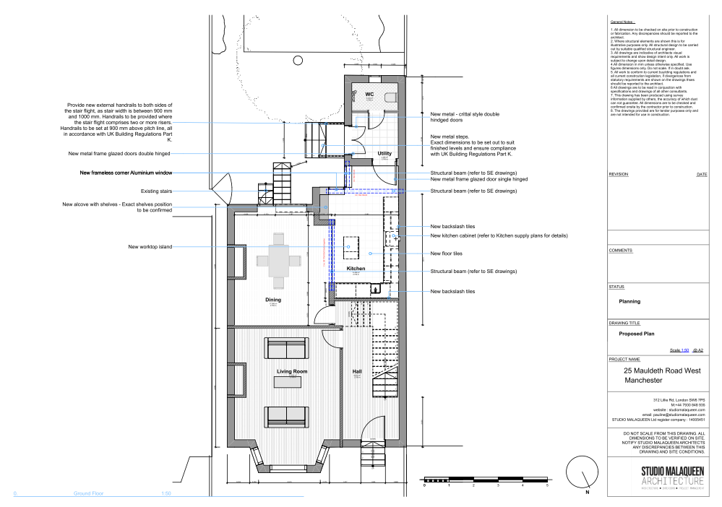
Figure 1. Proposed floor plan

Relevant planning history
No planning history at the address.

Consultation, notification and publicity responses

Consultations

Manchester City Council Flood Risk Management
- Flood Risk Management raises no objection to the proposal and advises that it can be approved without conditions.
- A public sewer crosses the site and the LPA is advised to consult United Utilities before determination.
- Informatives are recommended regarding property flood resilience measures and the potential presence of culverted watercourse infrastructure in the vicinity of the site.

Environment Agency
The EA had no comments to make in respect of the proposed development.

United Utilities
No response received.

Notifications and publicity

Neighbour letters
1no representation was made with queries about the scheme proposed.
Planning concerns will be taken into consideration when assessing the proposal. For the avoidance of doubt the full plans were available to view on the Public Register.

Relevant policies
In accordance with Section 38(6) of the Planning and Compulsory Purchase Act 2004, planning applications must be determined in accordance with the statutory development plan unless material considerations indicate otherwise.
For Manchester, the development plan comprises:
- The Manchester Core Strategy (2012 to 2027);
- Saved policies of the Manchester Unitary Development Plan (UDP); and
- The Places for Everyone Joint Development Plan Document (2022 to 2039).
These documents are considered up to date and are afforded significant weight in the determination of planning applications. Relevant Supplementary Planning Documents (SPDs) and other adopted guidance may also be material considerations.
The National Planning Policy Framework sets out the government’s policies for plan-making and for making decisions on development proposals in England. It is a material consideration of critical importance in both contexts.
Where relevant, the Council is required to give special regard to the desirability of preserving listed buildings and their settings, and special attention to the desirability of preserving or enhancing the character or appearance of conservation areas, in accordance with the Planning (Listed Buildings and Conservation Areas) Act 1990.
The policies and guidance referred to below are considered the most relevant to the scale, nature and location of the proposed development.
- The Manchester Core Strategy Development Plan Document 2012-2027
  - Development Management and Planning Obligations
    - DM 1 - Development Management
  - Objective 1 - Spatial Principles
    - SP 1 - Spatial Principles (Partially replaced by PfE Policy JP-S 1)
  - Objective 6 Environment
    - EN 1 - Design Principles and Strategic Character Areas
    - EN 8 – Adaptation to Climate Change (partially replaced by PfE Policies JP-S 2, JP-S 4 and JP-G 8)
    - EN 14 – Flood Risk (partially replaced by PfE Policy JP-S 4)
    - EN 19 – Waste
- Guide to development in Manchester - supplementary planning document and planning guidance, April 2007
- Extant Unitary Development Plan (UDP) –
  - Citywide Development Control Policies
    - DC1 - Residential extensions
    - DC26 - Development and Noise
- Places for Everyone Plan Joint Development Plan Document 2022-2039-
  - Strategy
    - JP-Strat9: Southern Areas
  - Sustainable and Resilient Places
    - JP-S1: Sustainable Development
    - JP-S4: Flood Risk and the Water Environment
  - Places for People
    - JP-P1 Sustainable Places
- National Planning Policy Framework – August 2026 - National Development Management Policies (NDMPs)
  - Procedural Policies
    - Chapter 3 – Decision-making policies
      - DM1: Preparing development proposals
      - DM2: Information requirements
      - DM3: Determining development proposals
      - DM6: Use of planning conditions and obligations
      - DM7: Relationship with other regulatory regimes
      - DM8: Unauthorised development and enforcement
  - Sustainable Development
    - Chapter 4 - Achieving sustainable development
      - S3: Presumption in favour of sustainable development
      - S4: Principle of development within settlements
    - Chapter 5 - Meeting the challenge of climate change
      - CC2: Mitigation of climate change
      - CC3: Adaptation to climate change
  - Creating high quality, sustainable places
    - Chapter 12 - Making effective use of land
      - L2: Making effective use of land
    - Chapter 14 - Achieving well-designed places
      - DP3: Key principles for well-designed places
      - DP4: The design process
  - Conserving and enhancing the environment
    - Chapter 18 - Managing flood risk and coastal change
      - F4: Assessing flood risk for decision-making
      - F6: Development in areas at risk of flooding from rivers or the sea
      - F7: Ensuring development is safe from flooding
      - F8: Sustainable drainage systems and watercourses

Assessment

Principle of development
Many people prefer to extend their existing homes rather than move, and the planning system needs to accommodate this demand for more living space, while at the same time ensuring that the amenities of neighbours are protected, and that the overall character of the surrounding area is not harmed. The Council is not generally in favour of dealing with this issue by laying down firm rules about home extensions with each case looked at on its individual merits, having regard to a range of criteria.
The application property is considered to be in lawful Class C3 use, and there is no evidence to demonstrate that it operates as a Class C4 HMO. As such, the proposal is assessed on the basis of a Class C3 dwellinghouse and the principle of the development is acceptable.
As stated in Policy DM 1 of the Manchester Core Strategy, all development should have regard to the following specific issues:

Appropriate siting, layout, scale, form, massing, materials, and detail
The proposed works are confined to the rear of the property and comprise replacement glazing, new door openings, a corner aluminium window feature and a replacement external staircase serving the rear garden. The proposal does not extend the footprint of the dwelling and does not increase the height, bulk or massing of the building.
The proposed doors and glazing would introduce a more contemporary appearance to the rear elevation. However, these alterations would be located to the rear of the property where they would have very limited visibility from the public realm. The changes would largely be experienced within the private garden environment and would not detract from the character or appearance of the host dwelling or the wider streetscene.
The external staircase is modest in scale and functional in appearance. It replaces existing rear steps and is proportionate to the host property. The submitted drawings confirm that existing brickwork will be reused where necessary and roof repairs are proposed to match existing materials, helping to ensure a satisfactory visual appearance.

Impact on the surrounding areas in terms of the design, scale and appearance of the proposed development. Development should have regard to the character of the surrounding area.
Only minimal views of the main proposed works are capable of being seen from the street. Given the position of the extension and the limited massing, together with the use of proposed materials, the character of the street would not be unduly affected.
The proposal is similar in size and scale to other buildings nearby, notably an extension approved at [x] and would not therefore disrupt the area's existing features.

Effects on amenity

Privacy
The proposal introduces new glazing and replacement doors within the rear elevation. These openings serve ground-floor accommodation and face into the applicant's private rear garden in a manner typical of residential properties. They replace existing openings within broadly the same area of the dwelling and do not introduce any materially different overlooking relationships.
The proposed external staircase would provide access between the dwelling and the rear garden only. Whilst users of the staircase may obtain some elevated views, these would be limited and transitory in nature. Importantly, the boundaries between the application site and neighbouring properties are enclosed by existing boundary treatments, which provide a significant degree of screening between gardens. As such, the staircase would not result in any unacceptable overlooking or loss of privacy to neighbouring occupiers.
Having regard to the existing boundary enclosures, the location of the proposed works and the domestic context of the site, the proposal would not give rise to a significant loss of privacy

Light

No extension or increase in built form is proposed. Consequently, the development would not result in any significant loss of daylight or sunlight to neighbouring properties through overshadowing or enclosure.

Noise

The works relate to alterations to an existing dwellinghouse and would not introduce a new use or activity likely to generate noise beyond that ordinarily associated with residential occupation.

Accessibility: buildings and neighbourhoods fully accessible to disabled people, access to new development by sustainable transport modes.
The proposal does not change how people can get in and out of the building.

Adequacy of internal accommodation and external amenity space.
The proposal adds space inside the property with minimal effect to the outdoor area and maintains a good level of external amenity space post development.

Refuse storage and collection.
The proposal itself has little impact on waste from the site. It uses the current storage and collection methods on site.

Vehicular access and car parking
The proposal doesn't change how vehicles access and park at the property.

Green Infrastructure including open space, both public and private
The dwelling benefits from a garden beyond the siting of the proposed development and maintains a good amount of private green space post development.

Flood risk and drainage.
The application was consulted on with the Council's Lead Local Flood Authority (LLFA), which raised no objection to the proposed development and advised that the proposal can be approved without the need for any planning conditions. The LLFA noted that a United Utilities public sewer is present within the site and recommended that United Utilities be consulted prior to determination. At the time of writing, no response has been received from United Utilities. Given the limited scale and nature of the proposed development, comprising external alterations and an external staircase, it is not considered that the development would give rise to significant flood risk or drainage concerns. The LLFA also recommended informatives relating to property flood resilience measures and the potential presence of culverted watercourse infrastructure in the wider vicinity of the site. Subject to these considerations, the proposal is considered acceptable in flood risk and drainage terms.

Other Legislative Requirements

Equality Act 2010
Section 149 (Public Sector Equality Duty) of the Equality Act 2010 requires due regard to the need to: Eliminate unlawful discrimination, harassment and victimisation and other conduct prohibited by the Act and; Advance equality of opportunity between persons who share a protected characteristic and persons who do not share it. The Equality Duty does not impose a legal requirement to conduct an Equality Impact Assessment. Compliance with the Equality Duty involves consciously thinking about the aims of the Equality Duty as part of the process of decision-making.

Human Rights Act 1998 considerations
This application needs to be considered against the provisions of the Human Rights Act 1998. Under Article 6, the applicants (and those third parties, including local residents, who have made representations) have a right to a fair hearing and to this end the local planning authority must give full consideration to their comments.
Protocol 1 Article 1, and Article 8 where appropriate, confer(s) a right of respect for a person’s home, other land and business assets. In taking account of all material considerations, including Council policy as set out in the Core Strategy and saved polices of the Unitary Development Plan, the Director of Planning, Building Control & Licensing has concluded that some rights conferred by these articles on the applicant(s)/objector(s)/resident(s) and other occupiers and owners of nearby land that might be affected may be interfered with but that that interference is in accordance with the law and justified by being in the public interest and on the basis of the planning merits of the development proposal. She believes that any restriction on these rights posed by the recommendation given is proportionate to the wider benefits of and that such a decision falls within the margin of discretion afforded to the Council under the Town and Country Planning Acts.

Planning balance & Conclusion
The proposed development comprises modest external alterations and the replacement of existing rear steps with a new external staircase to a dwellinghouse. The works would not result in a significant increase in the scale, massing or footprint of the property and would have limited visibility from the public realm. The proposal is considered to preserve the character and appearance of the host dwelling and surrounding area, would not result in unacceptable impacts on the residential amenity of neighbouring occupiers in terms of privacy, light or noise, and raises no significant highways, drainage or flood risk concerns. Having regard to the Development Plan as a whole, including Policies DM1, EN1 and SP1 of the Manchester Core Strategy, Policy DC1 of the UDP, relevant Places for Everyone policies and the National Planning Policy Framework, the proposal is considered acceptable. There are no material considerations that indicate a decision other than in accordance with the Development Plan and, therefore, the application is recommended for approval, subject to the conditions set out in this report.

Recommendation: Approve

Article 35 Declaration
Officers have worked with the applicant in a positive and proactive manner based on seeking solutions to problems arising in relation to dealing with the planning application. The proposal is considered to be acceptable and therefore determined within a timely manner.

Conditions to be attached to decision for approval

3-year time limit
The development must be begun not later than three years beginning with the date of this permission.
Reason - Required to be imposed by Section 91 of the Town and Country Planning Act 1990 (as amended).

Specified plans
The development hereby approved shall be carried out in accordance with the following drawings and documents:
  - Location Plan (received 22 May 2026)
  - Site/Block Plan drawing no. 1187-MRW-SMA-ZZ-M3-A-0002 (received 22 May 2026)
  - Floor Plans and Elevations drawing pack no. 1187-MRW-SMA-ZZ-M3-A-0002 GAs - Planning (7 sheets) (received 22 May 2026)
Reason - To ensure that the development is carried out in accordance with the approved plans, pursuant to policies DM 1, SP 1 and EN 1 of the Core Strategy and JP-P1 & of Places for Everyone.

Materials as approved on plan
The materials used in the external surfaces of the development hereby approved shall be those as specified on approved plan/drawings.

Reason - In order to ensure a satisfactory appearance in the interests of visual amenity in accordance with policies SP1 and DM1 of the Core Strategy and the requirements of the National Planning Policy Framework.

Informative(s)

Property Flood Resilience (PFR) measures
The applicant is advised to incorporate Property Flood Resilience (PFR) measures to a minimum of 150mm above the surface water flood level or a minimum of 600mm above the fluvial flood level.

Culvert
MCC records highlight that the underground Ley Brook is located within close proximity to the site (approximately 89 m to the North east of the site), while our records are frequently updated to ensure the highest level of accuracy, the records cannot guarantee 100% accuracy for all culverted assets. Therefore, we would request that the applicant informs the onsite contractor to remain observant and to take the appropriate safety precautions during excavation works. If any major unknown drainage assets are found beneath the site, then further investigation works should take place to identify the asset and MCC Lead Local Flood Authority (LLFA) should be contacted immediately. Any alterations to an ordinary watercourse will require consent from MCC LLFA under Land Drainage Act 1991. The developer can apply for land drainage consent (if required) via the following link: https://manchester.portal.uk.empro.verintcloudservices.com/site/myaccount/request/pr_watercourse_land

