

Planning

Delegated Officer Report

Summary of application details
Application reference: | PLA-2026-001224
Application type: | Full planning permission
Proposal: | Conversion of house (C3a) into children home (C2).
Site address: | 148 Slade Lane Manchester M19 2AQ
Ward(s): | Rusholme
Date application valid: | 13 August 2026
Applicant name: | Miss Mariam Radi
Agent (if any): | Mr Anjum Mehmood
Case officer: | Steven Mccoombe
Recommendation: | Refuse
Date of recommendation: | 11 September 2026

Description of site, building and/or area
The application site relates to a two-storey, dwellinghouse (Class C3) situated at the corner of Slade Lane and Lindsay Avenue. The existing accommodation is shown as comprising 4 bedrooms.

The bay fronted property includes front, side and rear gardens that wrap around the property and is enclosed by combination of brick wall with hedgerow above.

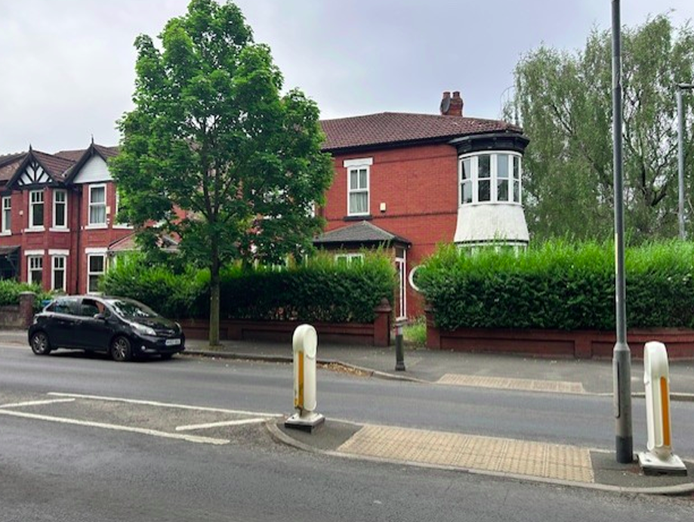
Application property

To the rear is a large single storey outbuilding, the use of which is unknown. A vehicular access enclosed by double gates serves Lindsay Avenue.

The immediate area is predominantly residential in character, largely comprising family dwellinghouses and purpose-built flat development ranging from 2-3 storeys in scale.

Description of development
Planning permission is sought for the change of use of an existing dwellinghouse (Use Class C3) to a children's home (Use Class C2). The proposal would provide accommodation for up to three children aged between 5 and 17 years, supported by trained residential childcare staff on a 24-hour basis.

The existing reception room, lounge, kitchen and dining room would be retained and used as communal living spaces. At first-floor level, three bedrooms would be provided for resident children, together with a staff office and a staff sleepover room.

It is stated that a maximum of seven people would be present during the day, comprising three resident children, three support staff and the Registered Manager. During the night, a maximum of six people would be present, comprising three resident children and three members of staff.

The Registered Manager would be on site between 9:00am and 5:00pm, Monday to Friday, while three support staff would be present at all times to provide continuous supervision.

Professional visits, including those by social workers and therapists, would be arranged by appointment and managed to minimise disruption to residents and neighbouring occupiers. Social worker visits are expected to occur approximately every six weeks.

No external alterations to the building are proposed as part of the application.

Relevant planning history
143121/FO/2025

Conversion of an existing dwellinghouse (Class C3) to a 6-bed HMO (Class C4) and alterations to the fenestration. Refused 30 July 2025. Dismissed on appeal 11 December 2025 (Ref: APP/B4215/W/25/33728240).

119564/FO/2018

Garage conversion to form self-contained dwelling with associated extensions and elevational alterations. Refused 22 May 2018.

118754/FO/2018

Conversion of detached garage to form 2no. bedsits and associated extensions and elevational alterations. Refused 5 March 2018.

037501

Construction of a garage rear of dwellinghouse. Approved 23 November 1990.

Consultation, notification and publicity responses
Local Residents/Occupiers – No representations received.

Highways Authority – The level of vehicular trips generated by the proposed change of use is not anticipated to be significant. Therefore, no highway capacity concerns are expected.

The proposal would retain the existing access arrangements and provide three on-site parking spaces, with any required highway alterations subject to the appropriate legal agreements with the Council. Clarification is sought regarding the management of staff and visitor parking, refuse storage and collection arrangements and it is recommended that a Travel Plan be implemented to promote sustainable travel and manage parking demand. Secure cycle parking should also be provided within the site and ongoing management of servicing and waste collection arrangements is recommended to ensure the development operates effectively without adverse impacts on the surrounding highway network.

Environmental Health – No objection.

Children's Commissioning – It is advised that here is currently an oversupply of children's homes across the city and as such, additional provision will only be supported where it addresses a clearly identified unmet need. The proposed three-bed Emotional and Behavioural Difficulties (EBD) home would not meet such a need, as sufficient capacity already exists within this sector. Further, the applicant has not engaged with the Council to establish local demand for the proposed provision, contrary to Ofsted guidance which expects providers to demonstrate an understanding of local need before establishing a new service. The Council must also have regard to the distribution of children's homes across Manchester and avoid undue concentrations in particular areas. In this regard, it is noted that there are already eight children's homes operating within the M19 area and the proposal would further contribute to this concentration.

Relevant policies
Local Development Framework

The Development Plan consists of:

- The Manchester Core Strategy (2012);
- Saved policies of the Unitary Development Plan for the City of Manchester (1995); and
- Places for Everyone Joint Development Plan.

The principal document within the framework is the Manchester Core Strategy which sets out the spatial vision for the City and includes strategic policies for development during the period 2012 – 2027.

'The Core Strategy Development Plan Document 2012 -2027 ("the Core Strategy") was adopted by the City Council on 11th July 2012. It is the key document in Manchester's Local Development Framework. The Core Strategy replaces significant elements of the Unitary Development Plan (UDP) as the document that sets out the long-term strategic planning policies for Manchester's future development.

A number of UDP policies have also been saved until replaced by further development plan documents to accompany the Core Strategy. Planning applications in Manchester must therefore be decided in accordance with the Core Strategy, saved UDP policies and other Local Development Documents.'

The following policy of the Unitary Development Plan is considered relevant:

Policy DC2 (Rest Homes and Nursing Homes) – relates to planning applications for rest homes, nursing homes and other uses within Class C2 of the Use Classes Order. The Council will have regard to the provision of rest homes and nursing homes where the proposed building is suitable in terms of its size and layout, and where the use can operate without causing unacceptable harm to neighbouring residents. In assessing proposals, the Council considers issues such as noise and disturbance, traffic generation, parking, servicing arrangements, access, and the impact on the character and amenity of the surrounding residential area. The policy seeks to balance the need for specialist care accommodation with the protection of established residential neighbourhoods, ensuring that care home developments are appropriately located and integrated into their surroundings.

The following policies within the Core Strategy are considered relevant:

Policy SP1 (Spatial Principles) - refers to the key spatial principles which will guide the strategic development of Manchester together with core development principles. It is stated that developments in all parts of the city should create well designed places which enhance or create character, make a positive contribution to the health, safety and well-being of residents, consider the needs of all members of the community and protect and enhance the built environment. Further, development should seek to minimise emissions, ensure the efficient use of natural resources, reuse previously developed land wherever possible, improve access to jobs, services and open space and provide good access to sustainable transport provision.

Policy DM1 (Development Management) - states that new development should have regard to more specific issues for which more detailed guidance may be given within supplementary planning documents. Issues include: the appropriate siting and appearance of development, the impact upon the surrounding area, the effects on amenity, accessibility, community safety and crime prevention, health, the adequacy of internal accommodation and amenity space and refuse storage/collection.

Policy H5 (Central Manchester) - North Manchester, over the lifetime of the Core Strategy, will accommodate around 14% of new residential development. Priority will be given to family housing and other high value, high-quality development where this can be sustained.

Policy H10 (Housing for people with additional support needs) - supports the provision of housing and accommodation for people with additional support needs, including older people, people with disabilities, those requiring care or support services, and other vulnerable groups. The policy seeks to ensure that an appropriate range of specialist housing is available across Manchester in locations that are accessible to shops, services, public transport, healthcare and community facilities. New developments should promote independence, social inclusion and good access to support networks, whilst contributing to the creation of sustainable and mixed communities.

The policy states that proposals for accommodation for people with additional support needs will be supported where: -

- There is not a high concentration of similar uses in the area already.
- Where it will contribute to the vitality and viability of the neighbourhood.
- Where there would not be a disproportionate stress on local infrastructure such as health facilities.

Places for Everyone Joint Development Plan

The Places for Everyone Plan is a strategic plan for nine of the 10 boroughs in Greater Manchester and forms part of the city's development plan.

No policies are considered directly applicable in this instance.

Other Material Considerations

The Special Needs and Supported Housing Policy (1998) and Supplementary Planning Guidance states that the City Council wishes to ensure that the City's various communities remain, or become more, sustainable in economic and social terms. In this respect, whilst generally welcoming housing developments which will provide accommodation for people with special needs in appropriate locations, the Council will seek to avoid an over-concentration of such provision in any one area.

National Planning Policy Framework (August 2026)

The central theme to the revised NPPF is to achieve sustainable development. The Government states that there are three dimensions to sustainable development: an economic role, a social role and an environmental role.

Section 3 provides guidance on the decision-making process and mirrors legislation in stating that planning permission be determined in accordance with the development plan, unless material considerations indicate otherwise.

Section 6 refers to the need to deliver a sufficient supply of homes and states that strategic policies should be informed by a local need assessment and the size, type and tenure of housing needed for different groups in the community should be assessed and reflected in planning policies.

Assessment

Principle

Section 38(6) Planning and Compulsory Purchase Act 2004 requires that decisions are to be made in accordance with the development plan, unless material considerations indicate otherwise. This is reinforced by paragraph 2 of the National Planning Policy Framework.

In this case, the principle of the proposed development is considered unacceptable and contrary to the aforementioned development plan policies and supporting guidance.

The proposed conversion of the property to supported accommodation (Use Class C2) would result in the loss of a family sized dwelling within an area where the retention of such housing is important to support the Council's housing objectives. The surrounding area is predominantly characterised by family homes, and the proposal would further reduce the stock of such accommodation whilst increasing the concentration of supported housing within the locality.

The proposal would also contribute to an overconcentration of this type of accommodation in this part of the city. The continued clustering of supported housing would undermine the balance of uses necessary to create and maintain sustainable neighbourhoods and would be detrimental to the character and function of the immediate area.

On this basis, the proposal in considered to conflict with saved policy DC2 of the Unitary Development Plan for the City of Manchester, policies H5, DM1, H10 and SP1 of the Manchester Core Strategy, The Guide to Development in Manchester (SPD) and the National Planning Policy Framework (NPPF). There are no material considerations to indicate otherwise.

The principal issues of concern are outlined further below.

Housing Balance and the loss of family accommodation

Policy H5 of the Core Strategy set out requirements for new housing development in Central Manchester, giving priority to family housing and other high value quality development. This reflects the findings of the Housing Need and Demand Assessment 2010 which identifies a need for larger family housing. Whilst this study is now some years old, the demand for larger family accommodation is still evident.

The justification text for this policy promotes the need to encourage a mixed and diverse community by retaining or attracting economically active households.

There is huge demand across the city for larger homes, demonstrated by the waiting list for social housing, highlighting that demand significantly outstrips supply.

The Manchester Move website (https://homes.manchestermove.co.uk) provides advice within its demand and options section on available properties in Manchester and is used by the City Council’s Housing and Residential Growth service as a data source, reflecting the Manchester Housing Register. The latest figures extracted from the website shows an extremely high demand for social housing in Manchester with over 20,000 live applications on the Manchester Housing Register.

The table below highlights the number of households on the Manchester Housing Register, by their band and the size of property applicants need.

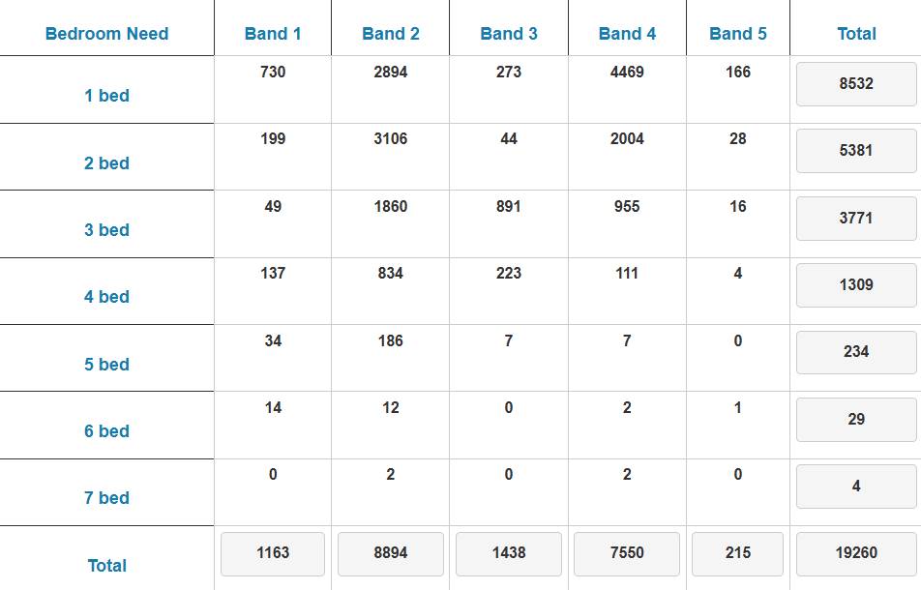
Extract taken from Manchester Move website

For example, the application property is shown as a 4-bedroom property. Figures show that for this type of property 1,309 applicants were waiting for a 4-bedroom property on 11 September 2026. The application property is therefore a dwellinghouse suitable for a family and the proposal in this case would see the loss of such.

Whilst these figures are based on the supply of social housing, there is inevitably an intrinsic relationship between the availability of family homes for sale or rent in the private sector and the demand for housing.

An important policy objective of the City Council is to improve the quality of housing stock in the city and to deliver a more sustainable housing market. This can be achieved by increasing the amount of family housing stock on offer and by providing for choice though a range of accommodation. This would allow for more balanced and cohesive neighbourhoods that provide for stronger and safer communities.

The loss of an additional family dwelling within the area would be contrary to this objective, undermining the policy aim of maintaining a balanced and sustainable residential community. It would further reduce the availability of family sized accommodation, increasing the risk of existing families being displaced from the area or discouraging new families from moving into it due to a lack of suitable housing. Whilst the loss of a single dwelling would, in isolation, have only a limited impact on the overall housing stock, it would nevertheless contribute incrementally to the existing shortfall of family housing. Further, no evidence has been provided to demonstrate that the property has been actively marketed for sale or rent and consequently no robust justification has been advanced to support the need for its proposed alternative use.

The proposed change of use therefore results in the loss of a family dwellinghouse, further eroding the balance of housing provision in the locality and conflicts with the development plan when considered as a whole with respect to delivering a sufficient supply of homes. It is not therefore believed there are any other considerations, either individually or in combination that outweigh the harm and associated development plan conflict.

The applicant argues that limited weight should be attached to concerns regarding the loss of family housing and the objection raised by Children's Commissioning. It is contended that the proposed children's home (Use Class C2) would function as a single household and retain a residential character akin to a family dwelling.

The applicant further submits that marketing requirements are specifically devised to assess the loss of housing stock to HMOs and should not be applied to children's homes, which are subject to a distinct national policy framework supporting the provision of accommodation for looked after children. Reference is also made to recent appeal decisions which, it is argued, demonstrate that children's homes can operate in a manner comparable to family housing and that objections based on the loss of family accommodation should be supported by robust evidence of housing need.

The applicant also challenges the view that there is an oversupply of children's homes in Manchester and an overconcentration within the M19 area, arguing that no published evidence to substantiate these claims. It is stated that provider engagement with Children's Commissioning is a matter for the Ofsted registration process rather than a material planning consideration and that there is no adopted planning policy setting out a methodology or threshold for assessing the overconcentration of children's homes and therefore the Council's concerns regarding geographical distribution should be afforded limited weight.

In response to this, whilst the applicant considers that the proposal would provide a valuable care facility and operate in a manner similar to a dwellinghouse, this does not overcome the concerns identified by the Council. The proposal would result in the permanent loss of a family sized dwelling within the housing stock and insufficient evidence has been provided to demonstrate that there is no reasonable prospect of the property continuing to serve its lawful residential use. The social benefits associated with the provision of children's care accommodation are acknowledged but these benefits do not outweigh the harm arising from the loss of a dwellinghouse where a continuing demand for family housing exists.

Although the proposal would continue to provide accommodation, it would no longer be available for occupation as a dwellinghouse within the general housing market. The proposal would therefore result in the loss of a Class C3 dwelling irrespective of whether residential accommodation remains on site. The suggestion that the loss of a single property is insignificant overlooks the fact that the same argument could be advanced in respect of every individual dwelling converted to an alternative use. The cumulative effect of such losses is therefore a legitimate planning consideration as whilst both uses are residential in nature and may outwardly appear similar in operation, they are distinct planning use classes serving different functions and meeting different forms of accommodation need. The proposal would therefore remove a family dwelling from the city's housing stock and replace it with specialist residential accommodation

In addition, the proposal would introduce a specialist institutional use into an established residential area. By virtue of its nature and operational characteristics, the use would not be fully comparable to a conventional dwelling and would alter the established residential function of the property. The applicant has not demonstrated that the proposal would preserve the character of the area or avoid contributing to an overconcentration of such facilities where this has been identified as a concern.

The Council is therefore of the view that the proposal conflicts with the objectives of relevant development plan policies which seek to protect the City's housing stock, maintain balanced and sustainable communities and ensure that new development is compatible with the character and function of its surroundings.

Significant weight should also be attached to a previous appeal decision (attached) relating to a similar proposal in Manchester in which the Inspector concluded that the loss of the dwelling from the stock of family housing would be harmful. Whilst that appeal related to a different proposal, the Inspector's findings regarding the property's contribution to family housing supply remain relevant.

Oversupply

Overarching policy and guidance relating to supported living provision is contained within saved policy DC2.1 of the Unitary Development Plan, policy H10 of the Manchester Core Strategy and Supplementary Planning Guidance contained within The Special Needs and Supported Housing Policy (1998).

A principal thread running these documents is the need to seek to avoid an over concentration of such provision in any one area and to ensure an evener spread of ‘special need’ accommodation within local areas and across the city as a whole.

There is a further need to ensure the protection of residential character and amenity to avoid the unnecessary loss of the bigger dwelling houses available for larger and extended families and to ensure supported needs accommodation is provided within the right areas.

In this case, the proposed development would result in an over concentration of this particular type of care within this area of the city. It is considered that further provision for the care of children would lead to the clustering and accumulation of such accommodation in the immediate area which would be harmful to the character of this immediate area and the local balance of uses, as part of creating sustainable, cohesive neighbourhoods.

The consultation response from Children's Commissioning indicates that within the Council’s administrative area there already 8 similar children’s care homes. Therefore, the need for the type of accommodation is questioned and not supported.

On the basis of the lack of support provided by Children’s Commissioning and the information on the nature and location of similar accommodation situated locally, it is considered that the introduction of the proposed use would lead to an over concentration of such uses in the immediate area, which in turn would adversely affect the character of the area, upsetting the balance of uses within a key residential neighbourhood.

Whilst it is accepted that the process of registering and operating a children's home is separate from the planning process, the planning system is nevertheless entitled to consider evidence relating to need, demand and the suitability of a proposal in the context of wider service provision. In this respect, Children's Commissioning has advised that there is an oversupply of this type of accommodation on within Manchester and that there is an existing concentration of children's homes within the M19 post code area. As the specialist body responsible for assessing accommodation requirements for children requiring care across the city, significant weight can reasonably be afforded to its professional advice.

Indeed, as can be seen from the attached appeal decision* for a similar, recent proposal in Manchester, The Inspector concluded that there was insufficient justification to depart from the Council's policy position, as evidence demonstrated that existing care provision at neighbourhood level already meets current demand. Significant weight was given to the views of the Council's Commissioning Team, who advise that the current supply of residential care accommodation exceeds need. As such, the identified need for such accommodation was not considered sufficient to override the requirements of Saved Policy DC2.1 and policy H10 of the Core Strategy.

The applicant's argument that 8 children's homes accommodate only a relatively small number of children compared with the wider housing stock also misses the central issue. The Council's concern is not solely the numerical proportion of children's homes within the city, but whether additional provision is required in light of existing capacity and whether there is a balanced distribution of such facilities across Manchester. The concentration of children's homes within a particular area remains a material consideration, particularly where specialist officers within the Council have identified concerns regarding oversupply and clustering.

The Council acknowledges that future demand for children's home provision can fluctuate and that sufficient accommodation must be available to meet emerging needs. However, the evidence provided by Children's Commissioning indicates that the type of accommodation proposed does not address an identified gap in provision and that existing capacity is currently sufficient. In the absence of evidence demonstrating a clear unmet need for additional need, only limited weight can be given to speculative arguments regarding potential future demand.

As such, the proposal has not demonstrated that the loss of a family dwellinghouse is justified by an identified need for additional children's home provision in this location. The professional advice of Children's Commissioning indicates that sufficient capacity already exists and that further provision within the M19 area is neither necessary or strategically supported at this time.



Appeal Decision
Site visit made on 17 June 2025

by N Kempton BAHons, PGDip, MA, IHBC, MRTPI
an Inspector appointed by the Secretary of State
Decision date: 31 July 2025

* Appeal Ref: APP/B4215/W/25/3363244 1520 Ashton Old Road, Manchester M11 1HN
- The appeal is made under section 78 of the Town and Country Planning Act 1990 (as amended) against a refusal to grant planning permission.
- The appeal is made by Mr Nicholas Ledger on behalf of First Steps Together Care Services against the decision of Manchester City Council.
- The application Ref is 141660/FO/2024.
- The development proposed is the change of use of 1520 Ashton Old Road to Residential Care Facility (Class C2).

Decision
1. The appeal is dismissed.

Preliminary Matters
2. The description of development is taken from the application form. The description shown on the Council’s decision notice differs from that on the application form, but the appellant has confirmed that they disagree with the description used and did not agree to the change.

Main Issue
3. The main issue relevant to this appeal the effect of the development on the mix and balance of housing provision in the locality, with particular regard to the character of the area and family sized dwellinghouses.

Reasons
- The appeal site is a mid-terrace, 2-storey property with basement and accommodation in the roofspace. To the front of the property is an open forecourt for off road parking and bin storage. To the rear is a large, enclosed garden. The immediate area is predominantly residential and comprises bed and breakfast (B&B) accommodation, including the adjacent Warren Guest House, and residential care homes. The appeal site is located on Ashton Old Road, which is the main arterial route linking Aston Under Lyne with Manchester City Centre. Also along this road is a petrol filling station, a church and some shops and services.
- The Council considers that the property is a dwellinghouse (Use Class C3). The appellant disputes that the property was formerly a family home, rather it is claimed that the property previously comprised a number of bedsits and a flat and was latterly converted in 2021/2022 to a 10-bed House in Multiple Occupation (HMO). It is not within the remit of this appeal decision to pronounce on the lawful

use of the property- that would more appropriately be the subject of a Certificate of Lawfulness of Existing Use or Development (CLEUD). The evidence before me does not show that the HMO conversion or previous subdivisions were carried out with the benefit of planning permission. It is unclear whether or not the property has actually operated, or been inhabited as a HMO, or that the use has been established as lawful. Based on the available evidence and for the purposes of determining this appeal, I find the property to be a dwellinghouse (Use Class C3) with a considerable number of bedrooms. Even so, I acknowledge that it has not operated as family accommodation for some time, but most recently has been vacant.

- Saved Policy DC2.1 of the Unitary Development Plan (1995) (UDP) states in determining planning applications for uses within Class C2 of the Use Classes Order, the Council will have regard to (f) the desirability of avoiding an overconcentration of special needs housing in any one area of the City; and (g) the desirability of broadly maintaining the existing character of a residential street or group of adjoining streets.
- Saved Policy DC2A.1 of the UDP states that planning permission will be refused when it cannot be demonstrated that development proposals will contribute to the achievement of a number of objectives for the City’s local communities, including: (ii) to ensure the protection of the residential character and amenity of family housing within established communities; and (iii) to avoid the unnecessary loss of the bigger dwellinghouses available for larger and extended families.
- Policy H10 of the Manchester Core Strategy (2012) (CS) amongst other things, states that proposals for accommodation for people with additional support needs will be supported where there is not a high concentration of similar uses in the area already. It indicates that the concentration of such uses is a factor that makes up the character of an area.
- Policy H4 of the CS confirms that 3-4 bed family accommodation is a priority in east Manchester. The Special Needs and Supported Housing Supplementary Planning Guidance (SPG)(April 1998) reinforces the approach to special needs housing and seeks to balance different kinds of residential uses.
- The area close to the appeal site has an established predominantly residential character. Within that there is some evidence of residential care homes and B&Bs alongside more conventional dwellinghouse uses, but the latter prevails.
- The proposal is for a 6-bed children’s residential care home. This would fall within the remit of Saved Policy DC2 of the UDP and CS Policy H10. In the absence of an explicit definition of what ‘high concentration’ or ‘area’ means for CS Policy H10, it is a question of judgement, based on the evidence before me. Evidence shows that two children’s homes already exist at no.s 1524 and 1484 Ashton Old Road, in close proximity to the appeal site. As such, the proposed development would constitute a high concentration in a relatively confined area of the city. This would conflict with development plan policy objectives for special needs housing provision to be evenly distributed, in the interests of fostering a mixed and balanced community. Such a cluster, or concentration, would be likely to undermine the balance of uses which contribute to the prevailing dwellinghouse character.
- Furthermore, evidence before me demonstrates that the existing provision of residential care facilities, at both street level and neighbourhood level, meets current need. The Council’s Supported Needs and Monitoring Group (SNMG) and Children’s Commissioning Team states that current provision exceeds current need. Whilst the parties disagree on the level of need for such accommodation, assessing need is a complex subject. Given their role and expertise, I give greatest weight to the SNMG regarding under occupancy. As such, need would not justify departing from the Saved Policy DC2.1 /CS Policy H10 approach in this instance.
- In addition, CS Policy H4 and other evidence points to a greater need for family sized dwellings to rebalance the housing mix of East Manchester. This is not defined, but given the explanation for H4, it relates to houses with more than 2-bedrooms. The appeal site has potential to provide accommodation for a larger family, albeit it is likely to have more than 3-4 bedrooms. So, whilst it would not lose a presently functioning family dwelling, the proposal would remove its potential to do so.
- For these reasons, I find that the development conflicts with development plan policy and guidance. The proposed change of use would be contrary to the aforementioned Saved Policy DC2 of the UDP, and CS Policies H4 and H10. The proposed development would also be contrary to CS Policy DM1 which sets out a number of specific issues to which all development should have regard, including the character of the surrounding area; and CS Policy SP1 which sets key spatial principles to guide the strategic development of the city. This policy states that there is an emphasis on the creation of neighbourhoods of choice, providing high quality and diverse housing around district centres which meet local needs.
- Furthermore, the proposal would conflict with the guidance contained within The Special Needs and Supported Housing Policy Supplementary Planning Guidance (SPG) (1998). These policies and the SPG relate to supported living provision and seek to avoid an over-concentration of such provision in any one area and to ensure a more even spread of ‘special need’ accommodation within the local area and across the city as a whole.

Other Matters
- The appellant has advanced the fallback position of the appeal property being operated as a care facility for up to 6 adults without the need for planning permission. This demonstrates a keen desire to secure a residential care facility on the site, and a greater than theoretical possibility of the appellant pursuing the fallback position. Nevertheless, if pursued, that would be on the basis that the appeal property constituted a class C3 use. As such, it would not be a use that would run counter to development plan policies that seek to manage special needs care concentrations. Moreover, it would retain its potential to function as a family dwelling in the future. Hence, the fallback position advanced would be preferable in policy terms to the appeal proposal and so does not weigh in its favour.
- In seeking to evidence the mix and availability of housing, and specifically family- sized dwellings, the appellant refers to properties on the market in the local area, the details of which have not been submitted. This amounts to anecdotal evidence, to which I attribute little weight.
- I note the appellant’s reference to the Inspector’s decision on an appeal at Shuster Road. However, that appeal relates to a change of use to Use Class C4. It is not therefore, directly comparable to the current appeal.
- The proposed development would return a vacant property to beneficial use. It would make a modest contribution to the housing supply, which is an important consideration in the context of the Government’s objective to boost significantly the supply of homes. However, given the current and former residential use of the appeal property, this is a benefit to which I attribute only limited weight.
- The appeal property is located in close proximity to local services and facilities. The proposal would provide employment opportunities, albeit small scale. These matters attract limited weight.
- The appellant states that the proposal would provide high quality living accommodation. This is noted but would not justify use of the property as a residential care facility or mitigate the harms arising from the concentration of such provision in the immediate area. I attribute minimal weight to this matter. These benefits would not be sufficient to weigh in favour of the proposal or against the identified harms.
- I have had due regard to the Public Sector Equality Duty (PSED) under Section 149 of the Equality Act 2010, which sets out the need to eliminate unlawful discrimination, advance equality of opportunity and access, and foster good relations between persons who share a protected characteristic and those who do not share it. Age is a relevant protected characteristic to which the PSED applies.
- I acknowledge that the proposed residential care facility would deliver benefits related to children, a group with the protected characteristic of age. Nevertheless, based on the totality of the evidence before me, including that of need, I have found that the harm caused would outweigh the benefits of the proposed development, which would be contrary to the development plan. As such, I am satisfied that my approach would be proportionate in these circumstances.

Conclusion
- Section 38(6) of the Planning and Compulsory Purchase Act 2004 requires that planning applications are determined in accordance with the development plan unless material considerations, which include the Framework, indicate otherwise.
- In light of the harm I have found, use of the appeal property as a residential care facility would be contrary to the development plan when read as a whole and there are no material considerations to indicate that a decision should be taken other than in accordance with that plan.
- For the reasons given above, it is proportionate and necessary to dismiss the appeal.

N Kempton
INSPECTOR

Other Legislative Requirements

Equality Act 2010
Section 149 (Public Sector Equality Duty) of the Equality Act 2010 requires due regard to the need to: Eliminate unlawful discrimination, harassment and victimisation and other conduct prohibited by the Act and; Advance equality of opportunity between persons who share a protected characteristic and persons who do not share it. The Equality Duty does not impose a legal requirement to conduct an Equality Impact Assessment. Compliance with the Equality Duty involves consciously thinking about the aims of the Equality Duty as part of the process of decision-making.

Human Rights Act 1998 considerations
This application needs to be considered against the provisions of the Human Rights Act 1998. Under Article 6, the applicants (and those third parties, including local residents, who have made representations) have a right to a fair hearing and to this end the local planning authority must give full consideration to their comments.

Protocol 1 Article 1, and Article 8 where appropriate, confer(s) a right of respect for a person’s home, other land and business assets. In taking account of all material considerations, including Council policy as set out in the Core Strategy and saved polices of the Unitary Development Plan, the Director of Planning, Building Control & Licensing has concluded that some rights conferred by these articles on the applicant(s)/objector(s)/resident(s) and other occupiers and owners of nearby land that might be affected may be interfered with but that that interference is in accordance with the law and justified by being in the public interest and on the basis of the planning merits of the development proposal. She believes that any restriction on these rights posed by the recommendation given is proportionate to the wider benefits of and that such a decision falls within the margin of discretion afforded to the Council under the Town and Country Planning Acts.

Recommendation: Refuse

Reasons for refusal

1) | The proposed change of use would result in the loss of a family sized dwellinghouse which would reduce the standard and availability of such housing in the area, undermining the provisions of policies H5, H11 and SP1 of the Manchester Core Strategy, which seek to provide an appropriate mix and balance of housing provision in the locality, in order maintain a sustainable neighbourhood and cohesive housing market.
2) | The proposed development would result in over concentration of this particular type of care within this area of the city. It is considered that further provision would lead to clustering of such accommodation in this part of the city, which would be to the detriment of the character of this immediate area and the balance of uses as part of creating sustainable neighbourhoods. As such the proposed development is contrary to saved policy DC2 of the Manchester Unitary Development Plan, policies DM1, SP1 and H10 of the Manchester Core Strategy, the provisions of the Special Needs and Supported Housing Policy (SPD) and the National Planning Policy Framework.

APP/B4215/W/18/3210218

