

Planning

Delegated Officer Report

Summary of application details
Application reference: | NOT-2026-001300
Application type: | Prior approval Part 14 Class J: Installation or alteration etc of solar equipment on non-domestic premises
Proposal: | Prior-approval for the installation of 366 photovoltaic panels on a flat roof.
Site address: | Tesco Superstore 3 Victoria Avenue East Manchester M9 6HW
Ward(s): | Charlestown
Date application valid: | 10 August 2026
Applicant name: | Mr Benjamin Thornley

Agent (if any):
Case officer: | Joshua Lee
Recommendation: | Approve
Date of recommendation: | 11/09/2026

Description of site, building and/or area
The proposal relates to a Tesco Supermarket on Victoria Avenue East.
The property sits in a mostly residential part of the Charlestown ward of Manchester adjacent to the M60 Motorway.

Description of development
Prior approval for the installation of 366 photovoltaic panels on a flat roof.
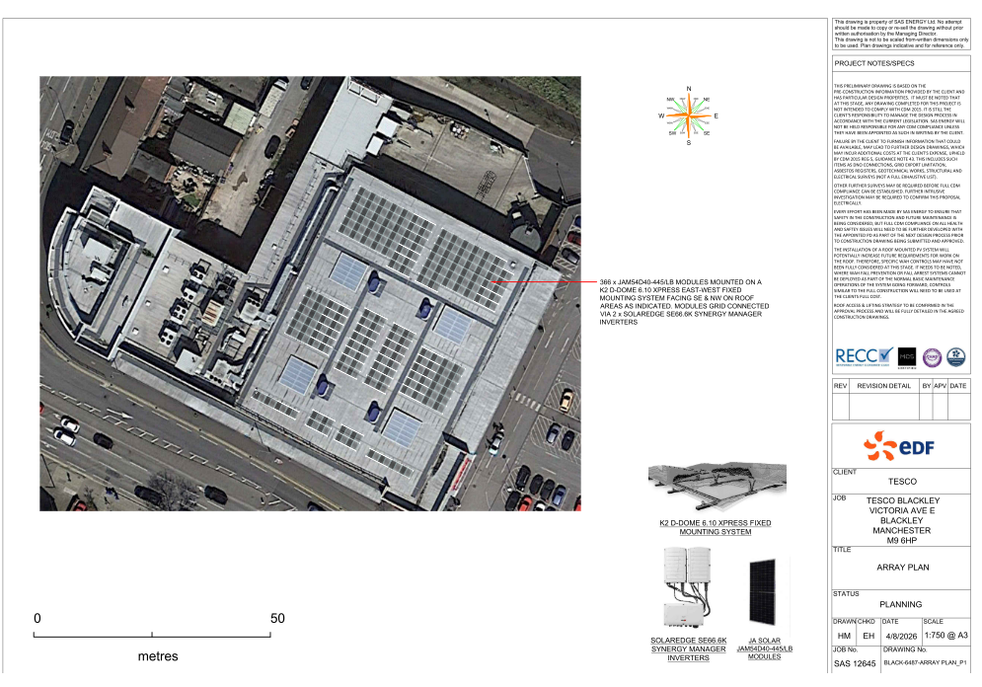
Figure 1. Proposed roof plan

Relevant planning history
The site comprises an established foodstore, library and petrol filling station development approved under planning permission 092502/FO/2010/N1 on 30 July 2010. Subsequent minor amendments to the approved development were granted under application 095223/JO/2011/N1 on 5 July 2012. The site has also been the subject of a number of advertisement consent approvals relating to signage associated with the operation of the development. No recent planning history is considered directly relevant to the assessment of the proposed photovoltaic panels.

Consultation, notification and publicity responses

Consultations

Manchester Airport Safeguarding Officer
Manchester Airport Aerodrome Safeguarding Authority has no objection to the proposed installation of photovoltaic panels. The consultee requests that the applicant is made aware of CAA crane and tall equipment notification procedures and advises that any permission should have regard to aerodrome safeguarding requirements.

National Highways
National Highways raise no objection to the proposed installation. They have reviewed the submitted information and conclude that the proposal would not adversely affect the Strategic Road Network.

Notifications and publicity

Site notice & Press advertisement
No responses received.

Relevant policies
The proposal has been submitted under Part 14, Class J of Schedule 2 to the Town and Country Planning (General Permitted Development) (England) Order 2015 (as amended), which grants planning permission for specified solar equipment on non-domestic buildings, subject to limitations, conditions and, where applicable, a prior approval process.
In determining the application, the Council is required to have regard to the National Planning Policy Framework and has also had regard to the statutory Development Plan as material considerations. However, these considerations do not expand the scope of assessment beyond the matters specified within Part 14, Class J of the GPDO.
The legislation, policies and guidance considered relevant to the assessment are:

Legislation
- The Town and Country Planning (General Permitted Development) (England) Order 2015 (as amended)
  - Schedule 2
    - Part 14 – Renewable Energy
      - Class J – Installation or alteration etc. of solar equipment on non-domestic premises
- The town and country planning (safeguarded aerodromes, technical sites and military explosives storage areas) direction 2002

National Policy
- National Planning Policy Framework (August 2026), including relevant National Development Management Policies

Local Policy
- Places for Everyone Joint Development Plan Document 2024-2039
- Manchester Core Strategy Development Plan Document 2012-2027
- Saved policies of the Manchester Unitary Development Plan

Assessment

Principle of Development
Prior approval is required for this proposal under Part 14, Class J of the GPDO because the development involves the installation of solar PV equipment on non-domestic buildings, and the legislation sets out specific matters that the Council must assess before the works can proceed.
In these cases, the Council is not considering the wider planning merits but is instead limited to assessing the design and external appearance of the equipment, including whether it may cause glare affecting neighbouring land uses, and whether the proposal complies with all limitations and conditions of Class J.
Subject to these considerations being satisfactorily addressed, the development is acceptable in principle.

Part 14, Class J

Development not permitted if –

J.1 Development is not permitted by Class J if— | Comments
- the solar PV equipment or solar thermal equipment would be installed on a pitched roof and would protrude more than 0.2 metres beyond the plane of the roof slope when measured from the perpendicular with the external surface of the roof slope; | Not applicable
- the solar PV equipment or solar thermal equipment would be installed on a flat roof, where the highest part of the solar PV equipment would be higher than 1 metre above the highest part of the roof (excluding any chimney); | The solar PV equipment is to be installed on a flat roof where the highest part of the solar PV equipment would not be higher than 1 metre above the highest part of the roof (excluding any chimney);
- the solar PV equipment or solar thermal equipment would be installed on a roof and within 1 metre of the external edge of that roof; | The solar PV equipment will not be installed within 1 metre of the external edge of that roof.
- [Omitted 2023] | Not applicable
- the solar PV equipment or solar thermal equipment would be installed on a site designated as a scheduled monument | The solar PV equipment is not being installed on a site designated as a scheduled monument
- the solar PV equipment or solar thermal equipment would be installed on a listed building or on a building within the curtilage of a listed building | the solar PV equipment is not being installed on a listed building

Conditions

J.4 Class J development is permitted subject to the following conditions | Comments
- J.4—(1) Class J development is permitted subject to the following conditions—  - the solar PV equipment or solar thermal equipment must, so far as practicable, be sited so as to minimise its effect on the external appearance of the building and the amenity of the area; and  - the solar PV equipment or solar thermal equipment is removed as soon as reasonably practicable when no longer needed. | The solar PV equipment is located on the main roof of the Tesco Superstore and has been sited, so far as practicable, to minimise its effect on the building and amenity of the area with no views from street level and negligible views from adjacent properties on Victoria Ave East.  A condition has been added to ensure removal when no longer required.
- Class J(c) development is permitted subject to the condition that before beginning the development the developer must apply to the local planning authority for a determination as to whether the prior approval of the authority will be required as to the design or external appearance of the development, in particular the impact of glare on occupiers of neighbouring land, and the following sub-paragraphs apply in relation to that application. | Application received 10/08/2026.
- The application must be accompanied by—  - written description of the proposed development.  - a plan indicating the site and showing the proposed development.  - the developer's contact address; and  - the developer's email address if the developer is content to receive communications electronically.  - together with any fee required to be paid. | Application with required documents received 10/08/2026
- The local planning authority may refuse an application where, in the opinion of the authority—  - the proposed development does not comply with, or  - the developer has provided insufficient information to enable the authority to establish whether the proposed development complies with,  any conditions, limitations or restrictions specified in Class J applicable to the development in question. | The application complies with the conditions limitations and restrictions as set out.
- Sub-paragraphs (6) and (8) do not apply where a local planning authority refuses an application under sub-paragraph (4) and for the purposes of section 78 (appeals) of the Act such a refusal is to be treated as a refusal of an application for approval. | Sub-paragraphs (6) and (8) applicable.
- The local planning authority must give notice of the proposed development—  - by site display in at least one place on or near the land to which the application relates for not less than 21 days of a notice which—  - describes the proposed development;  - provides the address of the proposed development;  - specifies the date by which representations are to be received by the local planning authority; or  - by serving a notice in that form on any adjoining owner or occupier. | A site notice was posted on 20/08/2026  Manchester Airport Safeguarding were notified of the proposed development on 14/08/2026  National Highways were notified of the proposed development on 17/08/2026
- The local planning authority may require the developer to submit such information as the authority may reasonably require in order to determine the application. | No further information required.
- The local planning authority must, when determining an application—  - take into account any representations made to them as a result of any notice given under sub-paragraph (6); and  - b)have regard to the National Planning Policy Framework issued by the Ministry of Housing, Communities and Local Government in July 2021, so far as relevant to the subject matter of the prior approval, as if the application were a planning application. | No public representations received.  Manchester Airport Aerodrome Safeguarding Authority has no objection to the proposed installation of photovoltaic panels. The consultee requests that the applicant is made aware of CAA crane and tall equipment notification procedures and advises that any permission should have regard to aerodrome safeguarding requirements.  National Highways raise no objection to the proposed installation. They have reviewed the submitted information and conclude that the proposal would not adversely affect the Strategic Road Network.  The NPPF states how “Local planning authorities should also give significant weight to the need to support energy efficiency and low carbon heating improvements to existing buildings, both domestic and non-domestic (including through installation of heat pumps and solar panels)” Para 167. The proposed development aligns with the NPPF.
- The development must not begin before the occurrence of one of the following—  - the receipt by the applicant from the local planning authority of a written notice of their determination that such prior approval is not required;  - the receipt by the applicant from the local planning authority of a written notice giving their prior approval; or  - the expiry of 56 days following the date on which the application under sub-paragraph (3) was received by the local planning authority without the authority notifying the applicant as to whether prior approval is given or refused. | The decision notice forms the written notice giving prior approval.
- The development must be carried out—  - where prior approval is required, in accordance with the details approved by the local planning authority;  - where prior approval is not required, or where sub-paragraph (9)(c) applies, in accordance with the details provided in the application referred to in sub-paragraph (3),  unless the local planning authority and the developer agree otherwise in writing | Specified plan condition attached to decision for approval.
- The local planning authority may grant prior approval unconditionally or subject to conditions reasonably related to the subject matter of the prior approval. | Relevant conditions attached to decision for approval.
- When computing the number of days in paragraph (6)(a), any day which is a public holiday must be disregarded | Not applicable

Other Legislative Requirements

Equality Act 2010
Section 149 (Public Sector Equality Duty) of the Equality Act 2010 requires due regard to the need to: Eliminate unlawful discrimination, harassment and victimisation and other conduct prohibited by the Act and; Advance equality of opportunity between persons who share a protected characteristic and persons who do not share it. The Equality Duty does not impose a legal requirement to conduct an Equality Impact Assessment. Compliance with the Equality Duty involves consciously thinking about the aims of the Equality Duty as part of the process of decision-making.

Human Rights Act 1998 considerations
This application needs to be considered against the provisions of the Human Rights Act 1998. Under Article 6, the applicants (and those third parties, including local residents, who have made representations) have a right to a fair hearing and to this end the local planning authority must give full consideration to their comments.
Protocol 1 Article 1, and Article 8 where appropriate, confer(s) a right of respect for a person’s home, other land and business assets. In taking account of all material considerations, including Council policy as set out in the Core Strategy and saved polices of the Unitary Development Plan, the Director of Planning, Building Control & Licensing has concluded that some rights conferred by these articles on the applicant(s)/objector(s)/resident(s) and other occupiers and owners of nearby land that might be affected may be interfered with but that that interference is in accordance with the law and justified by being in the public interest and on the basis of the planning merits of the development proposal. She believes that any restriction on these rights posed by the recommendation given is proportionate to the wider benefits of and that such a decision falls within the margin of discretion afforded to the Council under the Town and Country Planning Acts.

Planning balance & Conclusion
The Council's assessment is limited to the matters specified under Part 14, Class J of Schedule 2 of the Town and Country Planning (General Permitted Development) (England) Order 2015 (as amended). The proposed photovoltaic panels comply with the relevant limitations and conditions of Class J and would not result in any unacceptable impact on the external appearance of the building, visual amenity of the area, or through glare affecting neighbouring land. Consultees, including Manchester Airport Safeguarding and National Highways, raise no objection to the development. The proposal would also contribute towards renewable energy generation in accordance with national policy objectives. Accordingly, the proposal is considered acceptable and prior approval should be granted

Recommendation

Prior Approval
The proposed development raises no adverse issues in respect of external appearance, impact of glare on neighbouring properties or the general visual amenity of the area and accords with the requirements of Class J of Part 14 of Schedule 2 of the Town and Country Planning (General Permitted Development) Order 2015 as amended.

Therefore, consent is hereby granted in accordance with the following information submitted as part of planning application referenced NOT-2026-001300:

              - Application Form received 10 August 2026;
              - Location Plan Ref. BLACK-6487-LOCATION PLAN_P1 received 10 August 2026;
              - Array Plan Ref. BLACK-6487-ARRAY PLAN_P1 received 10 August 2026;
              - Tesco Superstore Blackley Supporting Planning Statement received 10 August 2026.

Reason: to ensure compliance with the Town and Country Planning (General Permitted Development) (England) Order 2015

Conditions to be attached to decision for PRIOR approval

Removal when no longer required
The solar PV equipment or solar thermal equipment will be removed as soon as reasonably practicable when no longer required.

Reason: to ensure compliance with the Town and Country Planning (General Permitted Development) (England) Order 2015.

Informative(s)

Airport – Tall equipment
The applicant’s attention is drawn to the procedures for crane and tall equipment notifications, please see: https://www.caa.co.uk/Commercial-industry/Airspace/Event-and-obstacle-notification/Crane-notification/

