

Planning

Delegated Officer Report

Summary of application details
Application reference: | PLA-2026-000892
Application type: | Full planning permission
Proposal: | Erection of a steel framed canopy and installation of electric roller shutters to facilitate external fruit and vegetable display and storage areas.
Site address: | 477 Barlow Moor Road Manchester M21 8AG
Ward(s): | Chorlton Park
Date application valid: | 20 July 2026
Applicant name: | Mr Waqas Khawaja
Agent (if any): | Mr Anees Bashir
Case officer: | Joshua Lee
Recommendation: | Refuse
Date of recommendation: | 26/08/2026

Description of site, building and/or area
The application site comprises a two-storey detached corner building occupying a prominent position at the junction of Barlow Moor Road and Malton Avenue. The building is of traditional construction with a hipped tiled roof, white-rendered upper elevations and dark painted ground floor elevations. The ground floor contains a number of shuttered openings facing both street frontages. The site is enclosed by low brick walls and metal railings and includes a hard-surfaced forecourt area used for bin storage and access. At ground floor the building was previously occupied by a retail outlet but is now vacant. At first floor the building is residential flats.
The surrounding area is predominantly urban in character, comprising a mix of commercial and residential properties and sits within the Chorlton District Centre and in the Chorlton Park ward. The site is highly visible within the street scene due to its prominent corner location with Chorlton Bus Station sitting opposite.
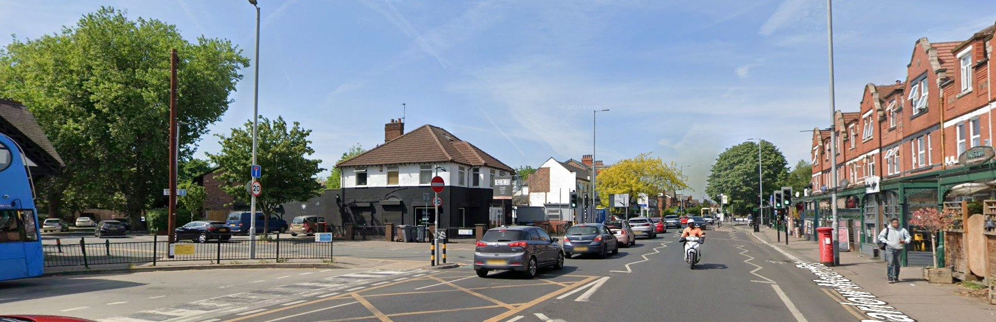
Figure 1. Site

Description of development
The proposal seeks planning permission for the erection of a steel-framed canopy to the front and side elevations of the existing retail premises, together with the installation of electric roller shutters. The canopy would wrap around the corner frontage of the building, projecting approximately 4.4m from the principal elevation and 2.8m from the side elevation, to provide covered areas for the external display and storage of fruit and vegetables associated with the existing retail use.
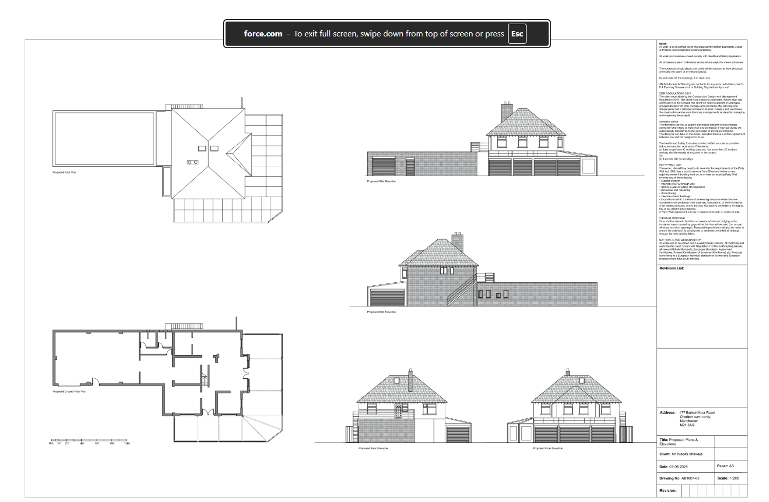
Figure 2. Proposed plans and elevations

Relevant planning history
The most relevant planning history is application 096189/FO/2011/S1, which granted permission for the change of use of the building from offices (Class B1) to a retail unit (Class A1), together with associated external alterations including a new shop entrance, canopy and shutters.
Application 114942/FO/2017 for the change of use of the retail unit to a restaurant/coffee bar (Class A3) was refused on 18 May 2017. This proposal related to a different form of development and is of limited relevance to the current application.
Earlier applications relating to the wider redevelopment of the site are not considered directly relevant to the assessment of the current proposal.

Consultation, notification and publicity responses

Consultations

Manchester City Council Highway Services
The Highway Authority has reviewed the proposal and raises no objection in principle. It notes that the development comprises the erection of a steel-framed canopy and roller shutters to facilitate external fruit and vegetable display/storage areas, with no change of use of the premises. Whilst there would be a minor increase in sales floorspace, this is not expected to result in a significant increase in customer visits, parking demand, waste generation or servicing requirements. Existing servicing arrangements via the loading bay on Malton Avenue and parking provision at the rear of the site are considered sufficient.
The Highway Authority advises that all proposed structures, including shutters, shutter boxes, steel framing and fencing, must be contained wholly within the application site and must not encroach onto or project over the adopted highway. Given the site's proximity to the junction of Barlow Moor Road and Malton Avenue, it considers that adequate visibility splays must be maintained, with a minimum visibility splay of 2.4m x 43m in each direction and remaining visually permeable above 600mm from ground level. It also advises that any gates or doors associated with the development should open inwards only. A condition is recommended requiring the retention of the visibility splay.
The Highway Authority further advises that any construction activities affecting the highway would require separate agreement with the Council's highways teams and any necessary licences or traffic management measures. Subject to recommended conditions, no highway safety concerns are raised.

Notifications and publicity

Neighbour Letters
2no objections received:
- One respondent requested further details of the proposed materials and design, including the colour and finish of the roof sheeting and shutters, whether the shutters would be solid or perforated, and details of the roof profile and construction, in order to better understand the development's visual appearance and impact.
- A second respondent requested that the Council review historical planning records relating to the existing parking area and access from Malton Avenue to establish its historic use and ensure that the proposed canopy, storage/display area and operation of the premises would not adversely affect existing parking provision or vehicular access arrangements.
Relevant planning concerns have been taken into consideration in assessment of the proposal.

Negotiations
Following an initial review of the application, the applicant was advised that the Council had significant concerns regarding the design and visual impact of the proposed steel-framed canopy and roller shutters. It was explained that, whilst retractable awnings may be acceptable in principle, the submitted proposal comprised a substantial permanent structure which was considered overly utilitarian and harmful to the character and appearance of the prominent corner site.
The applicant subsequently provided additional information regarding the operational requirements of the business and referred to other canopy structures within the locality. These representations were considered; however, it was concluded that the cited examples were not directly comparable to the application site and that the operational benefits of the proposal did not outweigh the identified design harm.
The applicant later suggested amendments involving the removal of the side canopy and roller shutters and the provision of a canopy to the front elevation only. These revisions were also considered. However, it was concluded that the Council's concerns related to the principle and design approach of a fixed canopy structure on this prominent detached corner building, rather than the specific extent of the canopy or inclusion of shutters. Consequently, it was advised that the identified concerns could not be satisfactorily addressed through amendments to the current scheme and that a fundamentally different design approach would be required. As no acceptable revisions were forthcoming, the application proceeds to determination in its submitted form.

Relevant policies
In accordance with Section 38(6) of the Planning and Compulsory Purchase Act 2004, decisions on planning applications must be made in line with the statutory development plan, unless material considerations indicate otherwise.

For Manchester, the development plan comprises:

- The Core Strategy (2012–2027)
- Saved policies of the Unitary Development Plan (UDP)
- The Places for Everyone Joint Development Plan Document (2022–2039)

These documents are considered up to date and carry substantial weight in decision-making. Supplementary Planning Documents (SPDs) and other local guidance may also be relevant.

National planning policy, including the National Planning Policy Framework (NPPF), is a material consideration and provides overarching guidance.

Where applicable, the Council must give special regard to preserving the character of conservation areas and the setting of listed buildings, in line with statutory duties under the Planning (Listed Buildings and Conservation Areas) Act 1990.

The policies referenced in this report are those considered most relevant to the nature, scale and location of the proposed development as follows:

- The Manchester Core Strategy Development Plan Document 2012-2027
  - Development Management and Planning Obligations
    - DM 1 - Development Management
  - Objective 1 - Spatial Principles
    - SP 1 - Spatial Principles (Partially replaced by PfE Policy JP-S 1)
  - Objective 2 - Economy and the City Centre
    - EC 1 - Employment and Economic Growth in Manchester
    - EC 2 – Existing Employment Space
    - EC 9 – South Manchester
  - Objective 4 – Centres
    - C 1 – Centre Hierarchy
    - C 2 – District Centres
    - C 6 - South Manchester District Centres - Chorlton, Didsbury, Fallowfield, Levenshulme and Withington
  - Objective 6 Environment
    - EN 1 - Design Principles and Strategic Character Areas
    - EN 19 – Waste
- Guide to development in Manchester - supplementary planning document and planning guidance, April 2007
- Shopfront and signage design guide
- Extant Unitary Development Plan (UDP) –
  - Citywide Development Control Policies
    - DC14 - Shop fronts and related signs
    - DC26 - Development and Noise
- Places for Everyone Plan Joint Development Plan Document 2022-2039-
  - Strategy
    - JP-Strat9: Southern Areas
  - Sustainable and Resilient Places
    - JP-S1: Sustainable Development
  - Places for Jobs
    - JP-J1: Supporting Long-Term Economic Growth
    - JP-J2: Employment Sites and Premises
  - Places for People
    - JP-P1 Sustainable Places
- National Planning Policy Framework – August 2026 - National Development Management Policies (NDMPs)
  - Procedural Policies
    - Chapter 3 – Decision-making policies
      - DM1: Preparing development proposals
      - DM2: Information requirements
      - DM3: Determining development proposals
      - DM6: Use of planning conditions and obligations
      - DM7: Relationship with other regulatory regimes
  - Sustainable Development
    - Chapter 4 - Achieving sustainable development
      - S3: Presumption in favour of sustainable development
      - S4: Principle of development within settlements
    - Chapter 5 - Meeting the challenge of climate change
      - CC2: Mitigation of climate change
      - CC3: Adaptation to climate change
  - Delivering homes and supporting growth
    - Chapter 7 - Building a strong, effective economy
      - E2: Meeting the need for business land and premises
    - Chapter 8 - Ensuring the vitality of town centres
      - TC2: Development in town centres
      - TC4: Assessing the impact of development on town centres
  - Creating high quality, sustainable places
    - Chapter 12 - Making effective use of land
      - L2: Making effective use of land
    - Chapter 14 - Achieving well-designed places
      - DP3: Key principles for well-designed places
      - DP4: The design process

Assessment

Principle of development
Whilst the site lies within Chorlton District Centre and is occupied by a retail unit, the application is not simply for the continuation of an established retail use. The proposal seeks the erection of a substantial steel-framed canopy and roller shutter enclosure to facilitate the external display and storage of goods across the site's prominent corner frontage. As such, the proposal represents a significant form of operational and physical development which requires assessment against the development plan as a whole rather than benefiting from any presumption of acceptability solely because it supports a retail use.
The Council acknowledges the economic benefits associated with supporting retail activity within District Centres. However, Policies DM1, EN1, C2 and C6 of the Manchester Core Strategy, together with Policy JP-P1 of Places for Everyone, require development within centres to positively contribute to local character, visual amenity and the quality of the public realm. Development which undermines these objectives cannot be regarded as acceptable in principle merely because it supports an existing commercial use.
The site benefits from planning permission 096189/FO/2011/S1, which granted permission for a retail use together with associated external alterations including a canopy and shutters. However, only limited weight is attached to that decision. The permission predates the adoption of the Manchester Core Strategy, the Manchester Shopfront and Signage Design Guide and the Places for Everyone Joint Development Plan Document, all of which now form key components of the policy framework against which design quality and townscape impact must be assessed. Furthermore, the earlier permission related to a materially different scheme. Whilst it is a material consideration, it does not establish that the current proposal is acceptable under the contemporary development plan framework.
For these reasons, the proposal is not considered acceptable in principle unless it can be demonstrated that it would preserve or enhance the character and appearance of the host building and surrounding area. As set out below, the proposal fails to do so.

Appropriate siting, layout, scale, form, massing, materials, and detail
The application site occupies a highly prominent and exposed position at the junction of Barlow Moor Road and Malton Avenue. Unlike many commercial premises within the District Centre which form part of continuous terraces, the building is detached and experienced as a standalone feature within the street scene. Consequently, alterations to the building are readily visible from multiple viewpoints and have a proportionately greater influence on the character and appearance of the surrounding area.
The proposed development would introduce a substantial steel-framed canopy extending approximately 4.4m from the principal elevation and 2.8m from the side elevation, wrapping around the corner of the building and creating covered areas for the display and storage of goods. Whilst the Council acknowledges the operational benefits of providing covered external space associated with the retail use, the structure would occupy a significant proportion of both public-facing elevations and would not appear as a lightweight or subordinate shopfront feature. Instead, it would be perceived as a permanent and dominant addition to the building.
The proposal would significantly alter the visual relationship between the building and the surrounding streets. Due to its scale, projection and wrap-around form, the canopy would obscure much of the building's ground floor frontage and diminish appreciation of the simple architectural form of the detached corner property. The structure would visually extend the building into the forecourt areas and introduce a utilitarian appearance more commonly associated with storage or servicing functions than with well-designed shopfront development.
Whilst canopies can contribute positively to commercial frontages, particularly where integrated into continuous shopping parades, the application site is experienced differently owing to its detached form and landmark corner position opposite Chorlton Bus Station. In this context the proposal would not read as a discreet shopfront addition but as a dominant external structure that would materially alter the character and appearance of the building.
The Council's Shopfront and Signage Design Guide seeks to ensure that shopfront alterations preserve the visual integrity of buildings and contribute positively to the public realm. The guidance advises against the use of external roller shutters and expects canopies and associated additions to be designed as subordinate elements that integrate successfully with the host building. In this instance the proposed canopy and shutters would fail to achieve these objectives and would result in a visually intrusive and unsympathetic form of development.
The proposal is therefore contrary to Policies DM1 and EN1 of the Manchester Core Strategy, Policy JP-P1 of Places for Everyone and the principles of the Council's Shopfront and Signage Design Guide.
Furthermore, the proposal fails to accord with Policy DP3 of the National Planning Policy Framework. The substantial steel-framed canopy and roller shutters would not respond positively to the character, appearance and prominent corner setting of the host building, nor would they integrate with or enhance their surroundings. Instead, they would create an overly utilitarian and visually dominant form of development that would detract from the identity and built form of this part of Chorlton District Centre. As such, the proposal conflicts with DP3(1) and the Built Form and Identity principles set out in DP3(2)(e) and (g) of the National Planning Policy Framework.

Impact on the surrounding areas in terms of the design, scale and appearance of the proposed development. Development should have regard to the character of the surrounding area.
The site occupies a gateway position within Chorlton District Centre and is prominently viewed from Barlow Moor Road, Malton Avenue, nearby pedestrian routes and Chorlton Bus Station. The building therefore makes an important contribution to local townscape character and the quality of the public realm.
The proposed canopy and shutters would introduce a visually dominant structure across both principal elevations. Owing to their permanence, scale and highly visible location, these additions would compete with and undermine the visual prominence of the host building. The proposal would create an overly commercialised and utilitarian appearance that would appear out of keeping with the detached character of the building and would detract from the wider street scene.
The proposed roller shutters would further contribute to this harm. Outside trading hours they would reduce visual activity and natural surveillance, creating a more closed and defensive appearance at a prominent location within the District Centre. This would conflict with the objectives of creating attractive, active and welcoming commercial areas.
Consequently, the proposal would fail to respond positively to local context, would undermine the visual quality of the public realm and would harm the character and appearance of the area contrary to Policies DM1, EN1, C2 and C6 of the Manchester Core Strategy, Policy JP-P1 of Places for Everyone and the design objectives of the National Planning Policy Framework

Effects on amenity

Privacy
Given the nature of the proposal and its location it is not considered that the development would result in unacceptable impact to privacy.

Light
Given the nature of the proposal and its location it is not considered that the development would result in unacceptable impact to light.

Noise
The proposal would not result in a change of use or a significant intensification of the existing retail operation. Whilst limited noise may arise from the opening and closing of the electric roller shutters and from activities associated with the display and storage of produce beneath the canopy, these activities would be characteristic of a retail premises operating within a District Centre.
The site also contains residential accommodation at first-floor level. Given the established retail use at ground floor level and the absence of any material intensification of the use, it is not considered that the proposal would result in unacceptable living conditions for occupiers of the residential accommodation above. The development is therefore not considered to give rise to unacceptable noise or disturbance impacts and accords with Policy DM1 of the Manchester Core Strategy and saved UDP Policy DC26

Road Safety and Traffic Generation
The Council's Highway Authority has reviewed the proposal and raises no objection. The development would not result in a change of use and is unlikely to generate a significant increase in customer trips, parking demand, servicing activity or vehicle movements.
Whilst the Highway Authority has advised that appropriate visibility splays should be maintained at the junction of Barlow Moor Road and Malton Avenue, it has confirmed that these matters could be addressed through amendments to the proposal or, if permission were granted, through the imposition of appropriate planning conditions. The proposal is therefore considered acceptable in highway and transportation terms.

Accessibility: buildings and neighbourhoods fully accessible to disabled people, access to new development by sustainable transport modes.
The proposal would not alter existing access arrangements to the premises. The site remains accessible by a range of sustainable transport modes, being located within Chorlton District Centre and in close proximity to bus services and other local amenities. The proposal is therefore acceptable in accessibility terms.

Adequacy of internal accommodation and external amenity space.
The proposal does not involve the creation of residential accommodation and would not adversely affect existing amenity space associated with the site. The proposal is therefore acceptable in this regard.

Refuse storage and collection.
The proposal would not materially affect refuse storage or collection arrangements at the site. The applicant has confirmed that refuse bins would be accommodated within the existing garage/bin store shown on the submitted plans. Adequate provision for the storage and collection of waste would therefore remain available within the site and no objection is raised in this regard.

Vehicular access and car parking
The proposal would not alter existing vehicular access arrangements to the site from Malton Avenue. Existing parking provision at the rear of the premises would be retained and the Highway Authority has confirmed that the development is unlikely to result in a significant increase in parking demand. No changes are proposed to the surrounding highway network and, subject to the maintenance of appropriate visibility splays, the proposal is not considered to give rise to highway safety concerns.
A neighbouring representation has requested that the Council investigate the status and historical use of the rear parking area accessed from Malton Avenue and consider whether the proposed development would affect existing parking and access arrangements. The application relates solely to the erection of a canopy and installation of roller shutters and does not propose any alterations to the existing access arrangements, parking area or servicing arrangements associated with the site. The submitted plans indicate that the existing rear parking and servicing area would remain available and the Highway Authority has raised no objection to the proposal on parking or access grounds.
Questions relating to land ownership, private parking rights, easements or other legal interests are private civil matters and are not matters that can be determined through the planning application process. In determining this application, the Council has assessed the development based on the plans submitted and is satisfied that the proposal would not, in planning terms, result in the loss of parking provision or materially alter existing vehicular access arrangements.

Green Infrastructure including open space, both public and private
The proposal would not affect existing green infrastructure or areas of public or private open space.

Flood risk and drainage.
The proposal relates to alterations to an existing building and is not located within an area at significant risk of flooding. It is not considered that the development would materially affect existing drainage arrangements and the proposal is acceptable in this regard.

Other Legislative Requirements

Equality Act 2010
Section 149 (Public Sector Equality Duty) of the Equality Act 2010 requires due regard to the need to: Eliminate unlawful discrimination, harassment and victimisation and other conduct prohibited by the Act and; Advance equality of opportunity between persons who share a protected characteristic and persons who do not share it. The Equality Duty does not impose a legal requirement to conduct an Equality Impact Assessment. Compliance with the Equality Duty involves consciously thinking about the aims of the Equality Duty as part of the process of decision-making.

Human Rights Act 1998 considerations
This application needs to be considered against the provisions of the Human Rights Act 1998. Under Article 6, the applicants (and those third parties, including local residents, who have made representations) have a right to a fair hearing and to this end the local planning authority must give full consideration to their comments.
Protocol 1 Article 1, and Article 8 where appropriate, confer(s) a right of respect for a person’s home, other land and business assets. In taking account of all material considerations, including Council policy as set out in the Core Strategy and saved polices of the Unitary Development Plan, the Director of Planning, Building Control & Licensing has concluded that some rights conferred by these articles on the applicant(s)/objector(s)/resident(s) and other occupiers and owners of nearby land that might be affected may be interfered with but that that interference is in accordance with the law and justified by being in the public interest and on the basis of the planning merits of the development proposal. She believes that any restriction on these rights posed by the recommendation given is proportionate to the wider benefits of and that such a decision falls within the margin of discretion afforded to the Council under the Town and Country Planning Acts.

Planning balance & Conclusion
The proposal would support the continued operation of a retail unit within Chorlton District Centre and would provide operational benefits through the provision of covered external display and storage space. Moderate weight is attached to these benefits, having regard to local and national objectives that support economic activity and the vitality and viability of centres.
However, the proposal is not merely a continuation of an established retail use. It involves the erection of a substantial steel-framed canopy and associated roller shutters to facilitate external display and storage areas on a prominent detached corner building. The acceptability of such development must be assessed against the development plan as a whole, including its impact on the character and appearance of the site and wider area.
Significant weight is attached to the identified design harm. The site occupies a highly prominent position within Chorlton District Centre opposite Chorlton Bus Station and is readily visible from multiple public viewpoints. The proposed canopy and roller shutters would represent a visually dominant and unsympathetic addition that would materially alter the appearance of the detached building, diminish its visual prominence and introduce an overly utilitarian form of development into the street scene. The proposal would fail to achieve the high standards of design required by the development plan and would detract from the quality, attractiveness and vitality of the public realm.
In reaching this conclusion, the Council has had regard to planning permission 096189/FO/2011/S1. However, only limited weight is attached to that decision. The permission pre-dates the adoption of the Manchester Core Strategy, the Manchester Shopfront and Signage Design Guide and the Places for Everyone Joint Development Plan Document, all of which place substantial emphasis on high-quality design, active frontages and positive contributions to local character. Furthermore, the earlier permission related to a materially different scheme. As such, it does not outweigh the conflict identified with the current development plan.
Whilst no objections are raised in relation to highway safety, residential amenity, accessibility, parking, servicing, waste management or other technical matters, the absence of harm in these respects does not outweigh the significant conflict with the design and placemaking objectives of the development plan. The proposal is therefore not considered acceptable in principle or in detail and conflicts with the development plan when read as a whole. There are no material considerations that indicate a decision should be made otherwise. Planning permission should consequently be refused.

Recommendation: Refuse

Article 35 Declaration
The application has been determined within the statutory timescale. In this instance the principle of the application proposal is contrary to the adopted development plan and are not considered to improve the economic, social or environmental conditions of the area. It is not considered, in this instance, that amendments could be made that would make them acceptable. The applicant's agent was informed of these concerns prior to the determination of the application.

Reasons for recommendation to refuse

Design & Visual Amenity harm
The proposed steel-framed canopy and associated roller shutters would, by reason of their substantial scale, projection, permanent form, wrap-around design and prominent siting on a detached corner building, fail to appear as subordinate shopfront additions and would instead constitute visually dominant and incongruous features. The development would obscure and diminish the architectural form and visual prominence of the host building, introduce an overly utilitarian appearance into the street scene and, through the introduction of external roller shutters, create a more closed and inactive frontage at this prominent location within Chorlton District Centre. As such, the proposal would fail to respond positively to local character, would not achieve a high standard of design and would harm the character, appearance, vitality and visual amenity of the surrounding area. The proposal is therefore contrary to Policies DM1, EN1, C2 and C6 of the Manchester Core Strategy, Policy JP‑P1 of Places for Everyone, the Manchester Shopfront and Signage Design Guide and Policies TC2, TC4 and DP3 of the National Planning Policy Framework.

