

Planning

Delegated Officer Report

Summary of application details
Application reference: | PLA-2026-000725
Application type: | Full planning permission
Proposal: | Installation of external front step lift following demolition of existing porch and steps with associated boundary treatment
Site address: | 10 Weardale Road Manchester M9 8WR
Ward(s): | Higher Blackley
Date application valid: | 24 July 2026
Applicant name: | Ms Lindsey Thomason
Agent (if any): | Ms Lindsey Thomason
Case officer: | Joshua Lee
Recommendation: | Approve
Date of recommendation: | 20/08/2026

Description of site, building and/or area
The proposal relates to a traditional red-brick two storey semi-detached dwellinghouse with a two-storey bay window, existing single-storey side extension, driveway parking, and front boundary wall with hedging.
The property is located in a mostly residential part of the Higher Blackley ward of Manchester.

Description of development
Installation of external front step lift following demolition of existing porch and steps with associated boundary treatment.

- Installation of an external vertical platform lift within the front/side curtilage of the dwelling to provide step-free access between the driveway and the entrance level of the property.
- Formation of a new raised paved landing area adjacent to the dwelling entrance.
- Construction of associated steps providing an alternative means of access alongside the lift.
- Erection of brick retaining walls with concrete coping stones to accommodate changes in ground levels.
- Installation of metal handrails serving the proposed access arrangements.
- Associated hard landscaping and engineering works required to integrate the lift and access infrastructure into the existing sloping driveway.
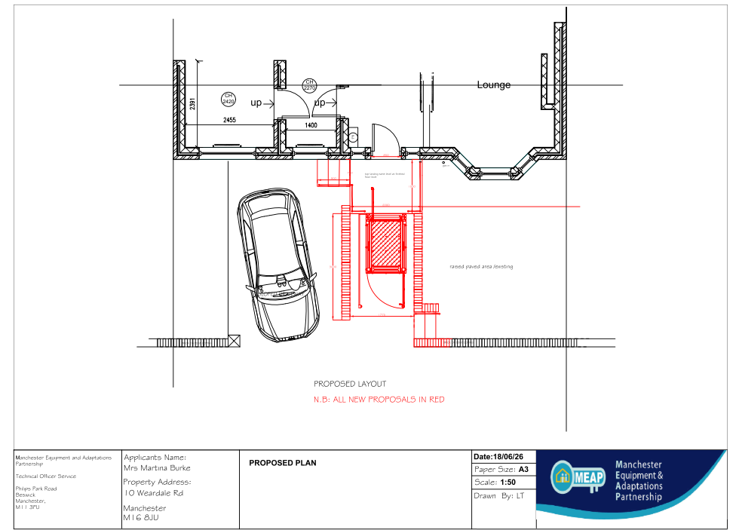
Figure 1. Proposed layout plan

Relevant planning history
No planning history at the address.

Consultation, notification and publicity responses

Consultations

Manchester City Council Highway Services
The Highway Authority raises no objection to the proposal. The development is contained wholly within the site and would not require alterations to the public highway. Subject to appropriate visibility being maintained for boundary treatments and any gates opening inwards, the Highway Authority is satisfied that the proposal would not adversely affect highway safety or the operation of the highway network. No planning conditions are requested.

Notifications and publicity

Neighbour letters
No representations received.

Relevant policies
In accordance with Section 38(6) of the Planning and Compulsory Purchase Act 2004, decisions on planning applications must be made in line with the statutory development plan, unless material considerations indicate otherwise.

For Manchester, the development plan comprises:

- The Core Strategy (2012–2027)
- Saved policies of the Unitary Development Plan (UDP)
- The Places for Everyone Joint Development Plan Document (2022–2039)

These documents are considered up to date and carry substantial weight in decision-making. Supplementary Planning Documents (SPDs) and other local guidance may also be relevant.

National planning policy, including the National Planning Policy Framework (NPPF), is a material consideration and provides overarching guidance.

Where applicable, the Council must give special regard to preserving the character of conservation areas and the setting of listed buildings, in line with statutory duties under the Planning (Listed Buildings and Conservation Areas) Act 1990.

The policies referenced in this report are those considered most relevant to the nature, scale and location of the proposed development as follows:

- The Manchester Core Strategy Development Plan Document 2012-2027
  - Development Management and Planning Obligations
    - DM 1 - Development Management
  - Objective 1 - Spatial Principles
    - SP 1 - Spatial Principles (Partially replaced by PfE Policy JP-S 1)
  - Objective 3 - Housing
    - H 10 - Housing for people with additional support needs
  - Objective 6 Environment
    - EN 1 - Design Principles and Strategic Character Areas
- Guide to development in Manchester - supplementary planning document and planning guidance, April 2007
- Extant Unitary Development Plan (UDP) –
  - Citywide Development Control Policies
    - DC1 - Residential extensions
    - DC26 - Development and Noise
- Places for Everyone Plan Joint Development Plan Document 2022-2039-
  - Strategy
    - JP-Strat5: Inner Areas
  - Sustainable and Resilient Places
    - JP-S1: Sustainable Development
  - Places for People
    - JP-P1 Sustainable Places
- National Planning Policy Framework – August 2026 - National Development Management Policies (NDMPs)
  - Procedural Policies
    - Chapter 3 – Decision-making policies
      - DM1: Preparing development proposals
      - DM2: Information requirements
      - DM3: Determining development proposals
      - DM6: Use of planning conditions and obligations
  - Sustainable Development
    - Chapter 4 - Achieving sustainable development
      - S3: Presumption in favour of sustainable development
      - S4: Principle of development within settlements
    - Chapter 5 - Meeting the challenge of climate change
      - CC2: Mitigation of climate change
      - CC3: Adaptation to climate change
  - Creating high quality, sustainable places
    - Chapter 12 - Making effective use of land
      - L2: Making effective use of land
    - Chapter 14 - Achieving well-designed places
      - DP3: Key principles for well-designed places
      - DP4: The design process
    - Chapter 15 - Promoting sustainable transport
      - TR4: Street design, access and parking
      - TR6: Assessing transport impacts

Assessment

Principle of development
The application seeks planning permission for the installation of an external platform lift and associated access works to provide step-free access to an existing dwellinghouse. The proposal is intended to improve accessibility for the occupier and does not involve a change of use of the property.
Policy DM1 of the Manchester Core Strategy supports development which is appropriately designed and contributes positively to the quality of life of residents. Core Strategy Policy H10 also recognises the importance of enabling people with additional support needs to live independently within existing residential communities. The proposal would significantly improve accessibility to the property and would support the creation of an inclusive and accessible living environment.
The principle of the development is therefore considered acceptable, subject to consideration of its detailed design and impacts on residential amenity, visual appearance and highway safety.

Appropriate siting, layout, scale, form, massing, materials, and detail
The proposed works comprise a relatively modest platform lift, raised landing, associated steps, retaining walls and handrails located within the existing front/side curtilage of the dwelling. The development is functional in nature and has been designed to respond to the site's sloping topography.
The lift replaces an existing porch which has been an accepted feature on the front of the property and within the street scene.
Due to its, size, position and location in relation to neighbours, the proposal would not create and over-dominant or overbearing feature.

Impact on the surrounding areas in terms of the design, scale and appearance of the proposed development. Development should have regard to the character of the surrounding area
Whilst the lift and associated structures would be visible from the street, their scale is limited and they would remain clearly ancillary to the host dwelling. The proposed retaining walls and boundary treatments would utilise materials that are compatible with the existing property and surrounding residential context.
The proposal would not materially alter the appearance or character of the dwelling and would not appear incongruous within the street scene.

Effects on amenity

Privacy
The proposal does not include any new windows, balconies or raised external areas capable of creating overlooking. Accordingly, there would be no material impact on the privacy of neighbouring occupiers.

Light
The development consists of relatively low-level structures positioned within the front curtilage. Given their limited height and separation from neighbouring properties, the proposal would not result in any significant loss of daylight or sunlight to adjoining occupiers.

Noise
The platform lift would serve a single dwellinghouse and would generate only limited intermittent operational noise associated with normal domestic use. This would not be of a level likely to adversely affect neighbouring residential amenity

Vibration
The operation of the lift is not expected to generate vibration levels that would adversely affect neighbouring occupiers or the surrounding environment.

Road Safety and Traffic Generation
The proposal would not intensify the residential use of the site and is not expected to generate any additional traffic. The Highway Authority has reviewed the application and raises no objection. The development is therefore considered acceptable in highway safety terms.

Accessibility: buildings and neighbourhoods fully accessible to disabled people, access to new development by sustainable transport modes.
A key benefit of the proposal is the provision of step-free access between the driveway and the entrance of the dwelling. The development would significantly improve accessibility for people with mobility impairments and would assist the occupier in remaining within their home. The proposal therefore strongly supports inclusive design objectives and accords with the accessibility aims of Policies DM1 and H10 of the Core Strategy.

Design for Health
By improving safe and independent access to the dwelling, the proposal would contribute positively to the health and wellbeing of the occupier. The development therefore supports healthy and inclusive communities.

Adequacy of internal accommodation and external amenity space.
The proposal does not reduce the quality of the internal accommodation within the dwelling. Whilst a small area of the front curtilage would be utilised for the access works, the property would retain adequate outdoor amenity space.

Refuse storage and collection.
The proposal would not affect existing refuse storage or collection arrangements serving the property. Adequate provision for waste storage would remain available within the site.

Vehicular access and car parking
The proposal would not alter the existing vehicular access to the site. Sufficient off-street parking would remain available within the property curtilage and the Highway Authority has confirmed that the development would not adversely affect highway safety.

Green Infrastructure including open space, both public and private
The proposal is confined to an existing residential plot and would not affect public open space or green infrastructure assets. Whilst a small area of hardstanding would be altered, the site would continue to provide private outdoor space

Flood risk and drainage.
The proposal relates to a minor domestic development and would utilise the existing drainage arrangements serving the dwelling. Given the limited scale of the works, the proposal would not materially affect flood risk or drainage conditions either on-site or elsewhere

Other Legislative Requirements

Equality Act 2010
Section 149 (Public Sector Equality Duty) of the Equality Act 2010 requires due regard to the need to: Eliminate unlawful discrimination, harassment and victimisation and other conduct prohibited by the Act and; Advance equality of opportunity between persons who share a protected characteristic and persons who do not share it. The Equality Duty does not impose a legal requirement to conduct an Equality Impact Assessment. Compliance with the Equality Duty involves consciously thinking about the aims of the Equality Duty as part of the process of decision-making.

Human Rights Act 1998 considerations
This application needs to be considered against the provisions of the Human Rights Act 1998. Under Article 6, the applicants (and those third parties, including local residents, who have made representations) have a right to a fair hearing and to this end the local planning authority must give full consideration to their comments.
Protocol 1 Article 1, and Article 8 where appropriate, confer(s) a right of respect for a person’s home, other land and business assets. In taking account of all material considerations, including Council policy as set out in the Core Strategy and saved polices of the Unitary Development Plan, the Director of Planning, Building Control & Licensing has concluded that some rights conferred by these articles on the applicant(s)/objector(s)/resident(s) and other occupiers and owners of nearby land that might be affected may be interfered with but that that interference is in accordance with the law and justified by being in the public interest and on the basis of the planning merits of the development proposal. She believes that any restriction on these rights posed by the recommendation given is proportionate to the wider benefits of and that such a decision falls within the margin of discretion afforded to the Council under the Town and Country Planning Acts.

Conclusion
The proposed platform lift and associated access works would provide a significant accessibility benefit for the occupier whilst having no unacceptable impact on the character and appearance of the property, the street scene, neighbouring residential amenity or highway safety. The proposal accords with the relevant policies of the Development Plan and there are no material considerations which indicate that planning permission should be withheld. Accordingly, the application is recommended for approval.

Recommendation: Approve

Article 35 Declaration
Officers have worked with the applicant in a positive and proactive manner based on seeking solutions to problems arising in relation to dealing with the planning application. The proposal is considered to be acceptable and therefore determined within a timely manner.

Conditions to be attached to decision for approval

3-year time limit
The development must be begun not later than three years beginning with the date of this permission.
Reason - Required to be imposed by Section 91 of the Town and Country Planning Act 1990 (as amended).

Specified plans
The development hereby approved shall be carried out in accordance with the following drawings and documents:
  - Location Plan, received 24 July 2026
  - Pollock Steplift Plans (Ref: 65900922), received 18 June 2026
  - Proposed External Layout Plan (V1), received 18 June 2026
  - Proposed Front Elevations (V1), received 18 June 2026
  - Proposed Side Sections (V1), received 18 June 2026
Reason - To ensure that the development is carried out in accordance with the approved plans, pursuant to policies DM 1, SP 1 and EN 1 of the Core Strategy and JP-P1 & of Places for Everyone.

Materials as approved on plan
The materials used in the external surfaces of the development hereby approved shall be those as specified on approved plan/drawings

Reason - In order to ensure a satisfactory appearance in the interests of visual amenity in accordance with policies SP1 and DM1 of the Core Strategy and the requirements of the National Planning Policy Framework.

