

Planning

Delegated Officer Report

Summary of application details
Application reference: | PLA-2026-000957
Application type: | Full planning permission
Proposal: | Elevation changes to existing warehouse unit.
Site address: | Unit 5 Clayton Court 5 Welcomb Street Manchester M11 2NB
Ward(s): | Clayton & Openshaw
Date application valid: | 24 July 2026
Applicant name: | Mannings Group
Agent (if any): | Firstplan Ltd
Case officer: | Joshua Lee
Recommendation: | Approve
Date of recommendation: | 20/08/2026

Description of site, building and/or area
The proposal relates to a commercial unit withing Clayton Court industrial estate on Welcomb Street. The unit currently features a large roller vehicle door, pedestrian door and windows.
The proposal is within a mostly commercial and industrial part of the Clayton & Openshaw ward of Manchester and is entirely surrounded by non-residential uses.

Description of development
Elevation changes to existing warehouse unit.
Installation of flow fan within the upper window on the front elevation.
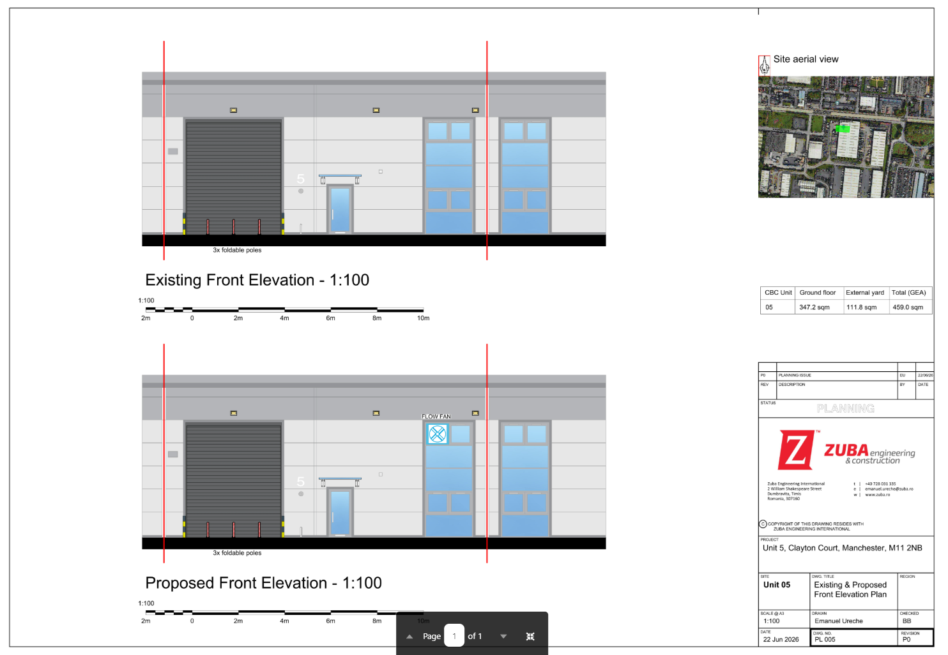
Figure 1. Existing and Proposed Elevations

Relevant planning history

Planning Application - 066914/FO/NORTH2/02
Demolition of existing industrial building and erection of 36 new industrial units in eight blocks for B1 (business), B2 (general industrial) and B8 (storage & distribution) uses and re-cladding of an existing unit with associated servicing, parking and n
Approve - 2003-07-24

Consultation, notification and publicity responses

Consultations

Manchester City Council Environmental Health
No objection is raised to the proposed development. However, as the submitted information indicates that a ventilation fan is proposed on the front elevation, Environmental Health recommends the imposition of a noise condition (NSE6) requiring any externally mounted plant to be designed and operated so that noise levels remain below background noise levels at the nearest noise-sensitive receptor, together with post-installation verification testing. Environmental Health advises that the condition may be amended or omitted if manufacturer noise data is provided and it is confirmed that there are no nearby noise-sensitive premises that could be affected by noise from the plant.

Notifications and publicity

Neighbour letters
No responses received.

Relevant policies
In accordance with Section 38(6) of the Planning and Compulsory Purchase Act 2004, decisions on planning applications must be made in line with the statutory development plan, unless material considerations indicate otherwise.

For Manchester, the development plan comprises:

- The Core Strategy (2012–2027)
- Saved policies of the Unitary Development Plan (UDP)
- The Places for Everyone Joint Development Plan Document (2022–2039)

These documents are considered up to date and carry substantial weight in decision-making. Supplementary Planning Documents (SPDs) and other local guidance may also be relevant.

National planning policy, including the National Planning Policy Framework (NPPF), is a material consideration and provides overarching guidance.

Where applicable, the Council must give special regard to preserving the character of conservation areas and the setting of listed buildings, in line with statutory duties under the Planning (Listed Buildings and Conservation Areas) Act 1990.

The policies referenced in this report are those considered most relevant to the nature, scale and location of the proposed development as follows:

- The Manchester Core Strategy Development Plan Document 2012-2027
  - Development Management and Planning Obligations
    - DM 1 - Development Management
  - Objective 1 - Spatial Principles
    - SP 1 - Spatial Principles (Partially replaced by PfE Policy JP-S 1)
  - Objective 2 - Economy and the City Centre
    - EC 1 - Employment and Economic Growth in Manchester
    - EC 5 - East Manchester
  - Objective 6 Environment
    - EN 1 - Design Principles and Strategic Character Areas
- Guide to development in Manchester - supplementary planning document and planning guidance, April 2007
- Extant Unitary Development Plan (UDP) –
  - Citywide Development Control Policies
    - DC26 - Development and Noise
- Places for Everyone Plan Joint Development Plan Document 2022-2039-
  - Strategy
    - JP-Strat5: Inner Areas
  - Sustainable and Resilient Places
    - JP-S1: Sustainable Development
  - Places for Jobs
    - JP-J1: Supporting Long-Term Economic Growth
    - JP-J2: Employment Sites and Premises
    - JP-J4: Industry and Warehousing Development
  - Places for People
    - JP-P1 Sustainable Places
- National Planning Policy Framework – August 2026 - National Development Management Policies (NDMPs)
  - Procedural Policies
    - Chapter 3 – Decision-making policies
      - DM1: Preparing development proposals
      - DM2: Information requirements
      - DM3: Determining development proposals
      - DM6: Use of planning conditions and obligations
      - DM7: Relationship with other regulatory regimes
  - Sustainable Development
    - Chapter 4 - Achieving sustainable development
      - S3: Presumption in favour of sustainable development
      - S4: Principle of development within settlements
    - Chapter 5 - Meeting the challenge of climate change
      - CC2: Mitigation of climate change
      - CC3: Adaptation to climate change
  - Delivering homes and supporting growth
    - Chapter 7 - Building a strong, effective economy
      - E2: Meeting the need for business land and premises
      - E3: Freight and logistics
  - Creating high quality, sustainable places
    - Chapter 14 - Achieving well-designed places
      - DP3: Key principles for well-designed places
      - DP4: The design process

Assessment

Principle of development
The application relates to alterations to an existing warehouse unit within Clayton Court Industrial Estate, an established employment area. The proposal does not involve a change of use of the premises and would support the continued operation of the existing commercial unit.
The site lies within an area identified for employment and industrial activity where policies EC1, EC5, JP-J1, JP-J2 and JP-J4 support the retention and enhancement of employment premises. The proposed works are limited in scale and are directly related to the functioning of the existing business.
The principle of the development is therefore acceptable and accords with the objectives of the development plan in supporting economic activity and employment uses.
As stated in Policy DM 1 of the Manchester Core Strategy, all development should have regard to the following specific issues:

Appropriate siting, layout, scale, form, massing, materials, and detail
The proposal comprises the installation of a ventilation fan within an existing upper window opening on the front elevation of the warehouse unit.
The works are minor in nature and would not result in any increase in the scale, footprint or height of the building. The fan would be accommodated within an existing opening and would not materially alter the appearance or character of the unit.

Impact on the surrounding areas in terms of the design, scale and appearance of the proposed development. Development should have regard to the character of the surrounding area.
Given the industrial character of the surrounding area and the prevalence of commercial and warehouse buildings within the estate, the proposed alteration would appear entirely appropriate in its context. The proposal would preserve the functional appearance of the building and would not cause harm to the visual amenity of the street scene.

Effects on amenity

Noise
Environmental Health has been consulted and raises no objection to the proposal. Whilst a condition has been suggested in relation to noise from the proposed ventilation fan, Environmental Health has also acknowledged the apparent absence of nearby noise-sensitive receptors and advised that the condition may be amended or omitted where it can be demonstrated that noise impacts would be negligible.
The proposed fan would be installed on an existing warehouse unit within an established industrial estate that is characterised by commercial and industrial activity. The development is limited in scale and there are no residential properties or other obvious noise-sensitive premises in the immediate vicinity of the application site.
Having regard to the nature of the proposal, its location and the surrounding land uses, it is not considered that the development would result in unacceptable noise impacts. In these circumstances, officers consider that the imposition of a condition requiring detailed acoustic information and post-installation testing would be unnecessary and disproportionate to the scale of the development.

Vibration
The proposed fan is not expected to generate significant vibration that would adversely affect surrounding occupiers.

Air Quality
The proposal does not involve any significant increase in vehicle movements or industrial processes that would adversely affect local air quality.

Odours
There is no evidence that the proposal would give rise to unacceptable odour impacts.

Accessibility: buildings and neighbourhoods fully accessible to disabled people, access to new development by sustainable transport modes.
The proposal does not change how people can get in and out of the building.

Refuse storage and collection.
The proposal would have no impact on existing refuse storage or collection arrangements.

Vehicular access and car parking
No changes are proposed to vehicular access, servicing arrangements or parking provision. Existing arrangements would remain unchanged.

Green Infrastructure including open space, both public and private
The proposal has no impact on green infrastructure.

Flood risk and drainage.
The development involves minor alterations to an existing building and would not increase the extent of impermeable surfacing or otherwise affect drainage arrangements. The proposal is therefore acceptable with regard to flood risk and drainage.

Other Legislative Requirements

Equality Act 2010
Section 149 (Public Sector Equality Duty) of the Equality Act 2010 requires due regard to the need to: Eliminate unlawful discrimination, harassment and victimisation and other conduct prohibited by the Act and; Advance equality of opportunity between persons who share a protected characteristic and persons who do not share it. The Equality Duty does not impose a legal requirement to conduct an Equality Impact Assessment. Compliance with the Equality Duty involves consciously thinking about the aims of the Equality Duty as part of the process of decision-making.

Human Rights Act 1998 considerations
This application needs to be considered against the provisions of the Human Rights Act 1998. Under Article 6, the applicants (and those third parties, including local residents, who have made representations) have a right to a fair hearing and to this end the local planning authority must give full consideration to their comments.
Protocol 1 Article 1, and Article 8 where appropriate, confer(s) a right of respect for a person’s home, other land and business assets. In taking account of all material considerations, including Council policy as set out in the Core Strategy and saved polices of the Unitary Development Plan, the Director of Planning, Building Control & Licensing has concluded that some rights conferred by these articles on the applicant(s)/objector(s)/resident(s) and other occupiers and owners of nearby land that might be affected may be interfered with but that that interference is in accordance with the law and justified by being in the public interest and on the basis of the planning merits of the development proposal. She believes that any restriction on these rights posed by the recommendation given is proportionate to the wider benefits of and that such a decision falls within the margin of discretion afforded to the Council under the Town and Country Planning Acts.

Planning balance & Conclusion
The proposal comprises a minor alteration to an existing warehouse unit within an established industrial estate through the installation of a ventilation fan within an existing window opening. The development would support the continued operation of the employment use without changing the use of the premises or materially affecting the appearance of the building, the character of the area, or the amenities of surrounding occupiers. Having regard to the scale and nature of the proposal, together with the absence of any identified adverse impacts, the development is considered to accord with the relevant policies of the Development Plan and the National Planning Policy Framework. There are no material considerations that indicate a decision other than in accordance with the Development Plan and planning permission should therefore be approved.

Recommendation: Approve

Article 35 Declaration
Officers have worked with the applicant in a positive and proactive manner based on seeking solutions to problems arising in relation to dealing with the planning application. The proposal is considered to be acceptable and therefore determined within a timely manner.

Conditions to be attached to decision for approval

3-year time limit
The development must be begun not later than three years beginning with the date of this permission.
Reason - Required to be imposed by Section 91 of the Town and Country Planning Act 1990 (as amended).

Specified plans
The development hereby approved shall be carried out in accordance with the following drawings and documents:
  - LocationPlan.pdf - Location Plan - 8 Jul 2026
  - P004-P0-Existing-Proposed Block Plan.pdf - Existing-Proposed Block Plan - PL004 - 8 Jul 2026
  - PL005-P1-Front Elevations.pdf - Existing & Proposed Front Elevation Plan - PL005 - 8 Jul 2026
Reason - To ensure that the development is carried out in accordance with the approved plans, pursuant to policies DM 1, SP 1 and EN 1 of the Core Strategy and JP-P1 & of Places for Everyone.

