

Planning

Delegated Officer Report

Summary of application details
Application reference: | PLA-2026-000949
Application type: | Householder planning permission
Proposal: | Erection of single-storey side extension to provide additional living accommodation
Site address: | 3 Roch Bank Manchester M9 8FL
Ward(s): | Higher Blackley
Date application valid: | 24 July 2026
Applicant name: | Mr Eli Jacobs
Agent (if any): | Mr Eli Radnor
Case officer: | Joshua Lee
Recommendation: | Approve
Date of recommendation: | 27/08/2026

Description of site, building and/or area
The proposal relates to a modern tow storey semidetached dwellinghouse constructed in red brick with a pitched tiled roof incorporating front dormer windows. The property features a detached garage and off-street parking.
The property is in a mostly residential part of the Higher Blackley ward of Manchester. The site is located within the EA Main River Consultation Area for the nearby River Irk.

Description of development
Erection of single-storey side extension to provide additional living accommodation
The proposed extension projects 2600mm from the existing side elevation (sitting directly adjacent to boundary with the highway) and runs 5000mm from a 3800mm set back to the principal elevation to sit in line with the existing rear elevation. The extension is finished in matching brick with a mono-pitch sliding tiled roof to match. New windows are featured to front and rear.
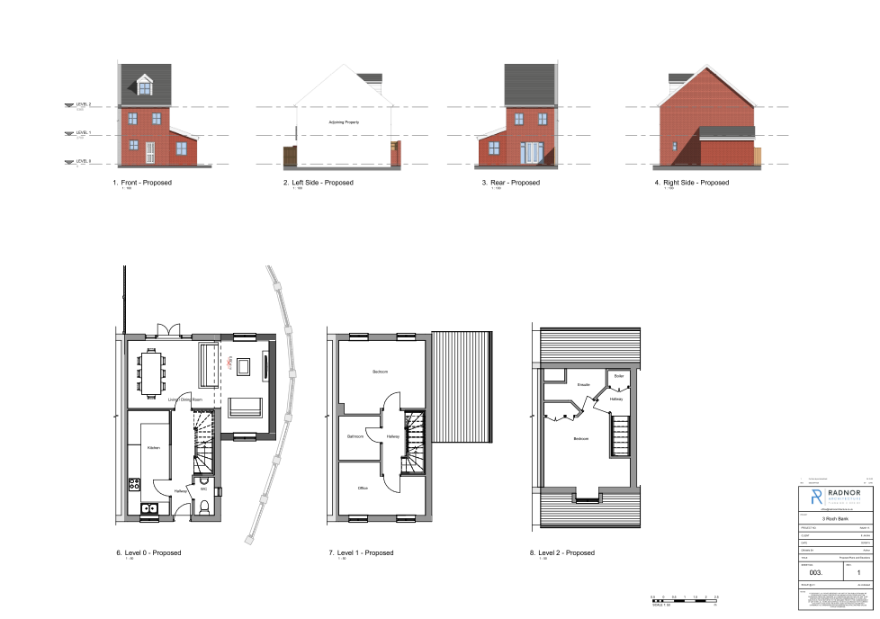
Figure 1. Proposed plans and elevations

Relevant planning history

137358/FH/2023
- Proposal: Erection of front and rear ground floor extensions to form additional accommodation.
- Application Type: Householder Planning Permission.
- Decision: Approved on 15 August 2023

066411/FO/NORTH1/02
- Proposal: Erection of 57 residential units comprising 1 and 2-bedroom apartments, 3-bedroom 2.5-storey townhouses and 4-bedroom detached houses, together with associated parking, landscaping and a riverside walkway.
- Application Type: Full Planning Permission.
- Decision: Approved on 20 March 2003.

Consultation, notification and publicity responses

Consultations

Manchester City Council Flood Risk Management
Flood Risk Management advise that a public sewer is present within the site and recommend consultation with United Utilities prior to determination. They also note the site's proximity to a main river and recommend consultation with the Environment Agency. No other flood risk concerns have been raised.

Environment Agency
The EA had no comments to make in respect of the proposed development.

United Utilities
No response received.

Notifications and publicity

Neighbour letters
No responses received

Relevant policies
In accordance with Section 38(6) of the Planning and Compulsory Purchase Act 2004, planning applications must be determined in accordance with the statutory development plan unless material considerations indicate otherwise.
For Manchester, the development plan comprises:
- The Manchester Core Strategy (2012 to 2027);
- Saved policies of the Manchester Unitary Development Plan (UDP); and
- The Places for Everyone Joint Development Plan Document (2022 to 2039).
These documents are considered up to date and are afforded significant weight in the determination of planning applications. Relevant Supplementary Planning Documents (SPDs) and other adopted guidance may also be material considerations.
The National Planning Policy Framework sets out the government’s policies for plan-making and for making decisions on development proposals in England. It is a material consideration of critical importance in both contexts.
Where relevant, the Council is required to give special regard to the desirability of preserving listed buildings and their settings, and special attention to the desirability of preserving or enhancing the character or appearance of conservation areas, in accordance with the Planning (Listed Buildings and Conservation Areas) Act 1990.
The policies and guidance referred to below are considered the most relevant to the scale, nature and location of the proposed development.

- The Manchester Core Strategy Development Plan Document 2012-2027
  - Development Management and Planning Obligations
    - DM 1 - Development Management
  - Objective 1 - Spatial Principles
    - SP 1 - Spatial Principles (Partially replaced by PfE Policy JP-S 1)
  - Objective 6 Environment
    - EN 1 - Design Principles and Strategic Character Areas
    - EN 14 – Flood Risk (partially replaced by PfE Policy JP-S 4)
    - EN 19 – Waste
- Guide to development in Manchester - supplementary planning document and planning guidance, April 2007
- Extant Unitary Development Plan (UDP) –
  - Citywide Development Control Policies
    - DC1 - Residential extensions
    - DC26 - Development and Noise
- Places for Everyone Plan Joint Development Plan Document 2022-2039-
  - Strategy
    - JP-Strat5: Inner Areas
  - Sustainable and Resilient Places
    - JP-S1: Sustainable Development
    - JP-S4: Flood Risk and the Water Environment
  - Places for People
    - JP-P1 Sustainable Places
- National Planning Policy Framework – August 2026 - National Development Management Policies (NDMPs)
  - Procedural Policies
    - Chapter 3 – Decision-making policies
      - DM1: Preparing development proposals
      - DM2: Information requirements
      - DM3: Determining development proposals
      - DM6: Use of planning conditions and obligations
      - DM7: Relationship with other regulatory regimes
  - Sustainable Development
    - Chapter 4 - Achieving sustainable development
      - S3: Presumption in favour of sustainable development
      - S4: Principle of development within settlements
    - Chapter 5 - Meeting the challenge of climate change
      - CC2: Mitigation of climate change
      - CC3: Adaptation to climate change
  - Creating high quality, sustainable places
    - Chapter 12 - Making effective use of land
      - L2: Making effective use of land
      - L3: Achieving appropriate densities
    - Chapter 14 - Achieving well-designed places
      - DP3: Key principles for well-designed places
      - DP4: The design process
  - Conserving and enhancing the environment
    - Chapter 18 - Managing flood risk and coastal change
      - F4: Assessing flood risk for decision-making
      - F6: Development in areas at risk of flooding from rivers or the sea
      - F7: Ensuring development is safe from flooding

Assessment

Principle of development
Many people prefer to extend their existing homes rather than move, and the planning system needs to accommodate this demand for more living space, while at the same time ensuring that the amenities of neighbours are protected, and that the overall character of the surrounding area is not harmed. The Council is not generally in favour of dealing with this issue by laying down firm rules about home extensions with each case looked at on its individual merits, having regard to a range of criteria.
The site benefits from an extant planning permission under application 137358/FH/2023 for front and rear ground floor extensions approved on 15 August 2023. That permission remains capable of implementation unless already lawfully commenced and therefore represents a material consideration in the determination of this application. The approved extension demonstrates that the principle of further domestic enlargement of the dwelling has previously been found acceptable.
As stated in Policy DM 1 of the Manchester Core Strategy, all development should have regard to the following specific issues:

Appropriate siting, layout, scale, form, massing, materials, and detail
The proposed extension would occupy the side of the dwelling and would remain entirely single storey in height. It would be set back from the principal elevation and incorporate a mono-pitched roof with a ridge height significantly below that of the main dwelling. The resulting form would therefore appear subordinate to the host property.
The extension would utilise matching brickwork, roof tiles and window detailing, helping to ensure that it integrates satisfactorily with the existing dwelling. Owing to its modest scale, single-storey height and subordinate design, the proposal would not appear visually dominant or incongruous within the street scene.
Due to its, size, position and location in relation to neighbours, the proposal would not create and over-dominant or overbearing feature.

Impact on the surrounding areas in terms of the design, scale and appearance of the proposed development. Development should have regard to the character of the surrounding area.
Whilst visible from public vantage points, the extension would retain the character of the host dwelling and would not materially harm the appearance or visual amenity of the surrounding area.
It is noted that the extension would be positioned directly adjacent to the highway boundary. However, given its single-storey scale, subordinate form and the presence of existing boundary treatments along the site frontage, the development would not appear unduly prominent within the street scene or result in a harmful loss of openness. The proposal would remain sympathetic to the established character of the area and would not detract from the visual qualities of the surrounding residential environment.

Effects on amenity

Privacy
The proposal includes new windows within the front and rear elevations of the extension. These openings would face areas already experienced within the normal residential relationship of neighbouring properties and would not introduce any material overlooking beyond that which currently exists.

Light
By reason of its single-storey scale and relationship to neighbouring dwellings, the proposal would not result in any significant loss of daylight or sunlight to adjacent habitable room windows or private garden areas.

Noise
The proposed extension is not expected to generate any noise beyond what would be reasonably expected of a residential dwelling.

Accessibility: buildings and neighbourhoods fully accessible to disabled people, access to new development by sustainable transport modes.
The proposal does not change how people can get in and out of the building.

Adequacy of internal accommodation and external amenity space.
The proposal adds space inside the property with minimal effect to the outdoor area and maintains a good level of external amenity space post development.

Refuse storage and collection.
The proposal itself has little impact on waste from the site. It uses the current storage and collection methods on site and maintains external access to the side of the property where bins are currently stored.

Vehicular access and car parking
The proposal doesn't change how vehicles access and park at the property.

Green Infrastructure including open space, both public and private
The dwelling benefits from a garden beyond the siting of the proposed development and maintains a good amount of private green space post development.

Flood risk and drainage.
The site is located within the Environment Agency Main River Consultation Area associated with the River Irk. The proposal relates to a modest single-storey side extension to an existing dwelling and would not introduce a more vulnerable form of development. Flood Risk Management noted the presence of a United Utilities public sewer within the site and recommended consultation with both United Utilities and the Environment Agency. The Environment Agency has confirmed that it has no comments to make on the proposal, whilst no response has been received from United Utilities. Given the limited scale of the development and its reliance on existing drainage arrangements, the proposal is not considered to give rise to unacceptable flood risk or drainage impacts.

Other Legislative Requirements

Equality Act 2010
Section 149 (Public Sector Equality Duty) of the Equality Act 2010 requires due regard to the need to: Eliminate unlawful discrimination, harassment and victimisation and other conduct prohibited by the Act and; Advance equality of opportunity between persons who share a protected characteristic and persons who do not share it. The Equality Duty does not impose a legal requirement to conduct an Equality Impact Assessment. Compliance with the Equality Duty involves consciously thinking about the aims of the Equality Duty as part of the process of decision-making.

Human Rights Act 1998 considerations
This application needs to be considered against the provisions of the Human Rights Act 1998. Under Article 6, the applicants (and those third parties, including local residents, who have made representations) have a right to a fair hearing and to this end the local planning authority must give full consideration to their comments.
Protocol 1 Article 1, and Article 8 where appropriate, confer(s) a right of respect for a person’s home, other land and business assets. In taking account of all material considerations, including Council policy as set out in the Core Strategy and saved polices of the Unitary Development Plan, the Director of Planning, Building Control & Licensing has concluded that some rights conferred by these articles on the applicant(s)/objector(s)/resident(s) and other occupiers and owners of nearby land that might be affected may be interfered with but that that interference is in accordance with the law and justified by being in the public interest and on the basis of the planning merits of the development proposal. She believes that any restriction on these rights posed by the recommendation given is proportionate to the wider benefits of and that such a decision falls within the margin of discretion afforded to the Council under the Town and Country Planning Acts.

Planning balance & Conclusion
The proposed single-storey side extension is considered acceptable in principle and would represent a sympathetic addition to the host dwelling. By virtue of its scale, design, materials and siting, the development would preserve the character and appearance of both the property and the wider street scene, whilst avoiding unacceptable impacts on the residential amenity of neighbouring occupiers. The proposal would retain adequate amenity space and parking provision, would not give rise to highway, drainage or flood risk concerns, and is not considered to result in any other material planning harm. Taking all relevant matters into account, the proposal is considered to comply with the relevant policies of the Manchester Core Strategy, saved UDP policies, Places for Everyone and the National Planning Policy Framework and is therefore recommended for approval.

Recommendation: Approve

Article 35 Declaration
Officers have worked with the applicant in a positive and proactive manner based on seeking solutions to problems arising in relation to dealing with the planning application. The proposal is considered to be acceptable and therefore determined within a timely manner.

Conditions to be attached to decision for approval

3-year time limit
The development must be begun not later than three years beginning with the date of this permission.
Reason - Required to be imposed by Section 91 of the Town and Country Planning Act 1990 (as amended).

Specified plans
The development hereby approved shall be carried out in accordance with the following drawings and documents:
  - Drawing No. RA26117-001 – Block Plan and Site Location (received 7 July 2026);
  - Drawing No. RA26117-002 – Existing Plans and Elevations (received 7 July 2026);
  - Drawing No. RA26117-003 Rev 1 – Proposed Plans and Elevations (received 7 July 2026).
Reason - To ensure that the development is carried out in accordance with the approved plans, pursuant to policies DM 1, SP 1 and EN 1 of the Core Strategy and JP-P1 & of Places for Everyone.

Materials to match
The materials used in the external surfaces of the development hereby approved shall be similar in appearance to the existing building in terms of type, size, colour and texture.
Reason - In order to ensure a satisfactory appearance in the interests of visual amenity in accordance with policies SP1 and DM1 of the Core Strategy and the requirements of the National Planning Policy Framework.

