

Planning

Delegated Officer Report

Summary of application details
Application reference: | PLA-2026-001099
Application type: | Householder planning permission
Proposal: | Erection of a single-storey rear extension, conversion of loft and garage to living accommodation, and associated elevational alterations to provide additional living accommodation
Site address: | 459 PARRS WOOD ROAD MANCHESTER M20 5NE
Ward(s): | Didsbury East
Date application valid: | 21 July 2026
Applicant name: | Sinead Murphy
Agent (if any): | Zach Thorp
Case officer: | Joshua Lee
Recommendation: | Approve
Date of recommendation: | 26/08/2026

Description of site, building and/or area
The proposal related to a two-storey detached dwellinghouse on Parrs Wood Road. The property features an existing single store outrigger and rear bay feature and a front gable finished in mock Tudor detailing.
The property is in a mostly residential part of the Didsbury East ward of Manchester. The site forms part of a street characterised by large detached interwar dwellings, many of which display Mock Tudor/ Tudor Revival architectural detailing, including decorative timber framing, prominent front-facing gables and steeply pitched roofs. The site is located in Flood Zone 2 and Network Rail land borders the rear.

Description of development
Erection of a single-storey rear extension, conversion of loft and garage to living accommodation, and associated elevational alterations to provide additional living accommodation

Single storey rear extension
The proposed single storey rear extension projects 3850mm from the existing rear elevation, demolishing the existing single storey outrigger. The proposed extension spans 6192.5mm from the existing side elevation to sit alongside the bay feature. The extension is finished in brick to match with a monopitch sloping roof finish in matching tile. The extension features large bifold glazed doors to the rear and 3no rooflights.

Loft conversion
The proposed loft conversion would include the insertion of new rooflights to both sides and the rear.

Garage conversion
The proposed garage conversion would include the removal of the existing garage door with new window and brickwork to match.

Associated elevational alteration
Other elevational alterations include the bricking up of an existing side facing door and window.
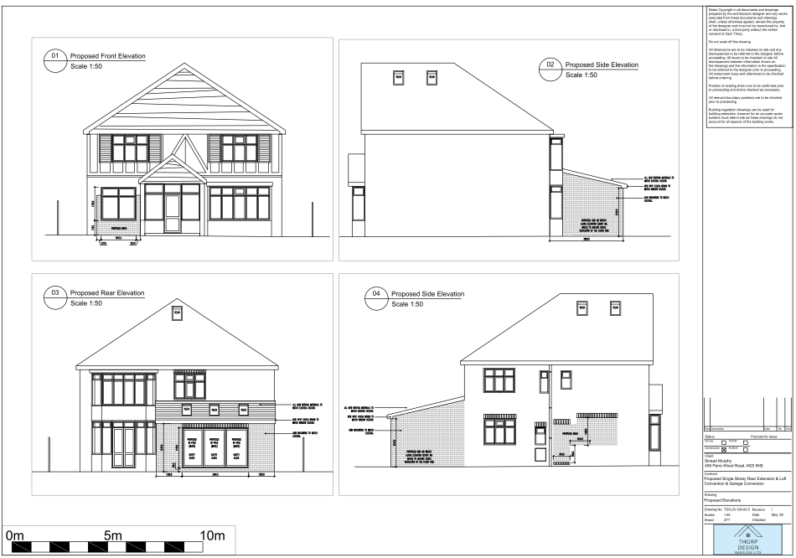
Figure 1. Proposed elevations

Relevant planning history
No relevant planning history at the address.

Consultation, notification and publicity responses

Consultations

Manchester City Council Flood Risk Management
Flood Risk Management originally requested a pre-commencement surface water drainage condition requiring details of the site's drainage arrangements, connection approvals and future maintenance. Following further discussion, the consultation response was revised and the condition withdrawn on the basis that it would be onerous for this householder development. The consultee now raises no objection to the proposal and advises that Property Flood Resilience measures should be incorporated where practicable. An informative is also recommended regarding the presence of a culvert in the vicinity of the site and the need for appropriate precautions during excavation works.

Network Rail
No objection subject to the applicant engaging with Network Rail's Asset Protection team. Advises that a BAPA will be required and that matters relating to construction methodology, excavation, drainage, scaffolding, encroachment, lighting and ongoing maintenance adjacent to the railway boundary must be agreed directly with Network Rail prior to commencement of works.

Notifications and publicity

Neighbour letters
None received.

Relevant policies
In accordance with Section 38(6) of the Planning and Compulsory Purchase Act 2004, planning applications must be determined in accordance with the statutory development plan unless material considerations indicate otherwise.
For Manchester, the development plan comprises:
- The Manchester Core Strategy (2012 to 2027);
- Saved policies of the Manchester Unitary Development Plan (UDP); and
- The Places for Everyone Joint Development Plan Document (2022 to 2039).

These documents are considered up to date and are afforded significant weight in the determination of planning applications. Relevant Supplementary Planning Documents (SPDs) and other adopted guidance may also be material considerations.
The National Planning Policy Framework sets out the government’s policies for plan-making and for making decisions on development proposals in England. It is a material consideration of critical importance in both contexts.
Where relevant, the Council is required to give special regard to the desirability of preserving listed buildings and their settings, and special attention to the desirability of preserving or enhancing the character or appearance of conservation areas, in accordance with the Planning (Listed Buildings and Conservation Areas) Act 1990.
The policies and guidance referred to below are considered the most relevant to the scale, nature and location of the proposed development.

- The Manchester Core Strategy Development Plan Document 2012-2027
  - Development Management and Planning Obligations
    - DM 1 - Development Management
  - Objective 1 - Spatial Principles
    - SP 1 - Spatial Principles (Partially replaced by PfE Policy JP-S 1)
  - Objective 6 Environment
    - EN 1 - Design Principles and Strategic Character Areas
    - EN 19 – Waste
- Guide to development in Manchester - supplementary planning document and planning guidance, April 2007
- Extant Unitary Development Plan (UDP) –
  - Citywide Development Control Policies
    - DC1 - Residential extensions
    - DC26 - Development and Noise
- Places for Everyone Plan Joint Development Plan Document 2022-2039-
  - Strategy
    - JP-Strat9: Southern Areas
  - Sustainable and Resilient Places
    - JP-S1: Sustainable Development
    - JP-S4: Flood Risk and the Water Environment
  - Places for People
    - JP-P1 Sustainable Places
- National Planning Policy Framework – August 2026 - National Development Management Policies (NDMPs)
  - Procedural Policies
    - Chapter 3 – Decision-making policies
      - DM1: Preparing development proposals
      - DM2: Information requirements
      - DM3: Determining development proposals
      - DM6: Use of planning conditions and obligations
      - DM7: Relationship with other regulatory regimes
  - Sustainable Development
    - Chapter 4 - Achieving sustainable development
      - S3: Presumption in favour of sustainable development
      - S4: Principle of development within settlements
    - Chapter 5 - Meeting the challenge of climate change
      - CC2: Mitigation of climate change
      - CC3: Adaptation to climate change
  - Creating high quality, sustainable places
    - Chapter 12 - Making effective use of land
      - L2: Making effective use of land
      - L3: Achieving appropriate densities
    - Chapter 14 - Achieving well-designed places
      - DP3: Key principles for well-designed places
      - DP4: The design process
  - Conserving and enhancing the environment
    - Chapter 18 - Managing flood risk and coastal change
      - F4: Assessing flood risk for decision-making
      - F6: Development in areas at risk of flooding from rivers or the sea
      - F7: Ensuring development is safe from flooding

Assessment

Principle of development
The proposal seeks to extend and alter an existing dwellinghouse within an established residential area. Whilst the Council acknowledges the need for additional living accommodation, development must not result in harm to the character of the area or the amenity of neighbouring occupiers.
The application site is located within a settlement where the National Planning Policy Framework states that development proposals should generally be approved unless their adverse effects would substantially outweigh the benefits. Policy DM1 of the Manchester Core Strategy similarly supports development where it responds appropriately to its context and does not result in unacceptable impacts.
Accordingly, the principle of the development is considered acceptable, subject to the detailed assessment set out below.

Appropriate siting, layout, scale, form, massing, materials, and detail
The proposed extension has been designed to reflect the character and appearance of the existing dwelling through the use of matching brickwork, roof tiles and window fenestration. The proposed materials and detailing would ensure that the development integrates well with the host property.
The extension is located to the rear of the dwelling and is wholly single storey in height. As such, it would appear clearly subservient to the original dwellinghouse in terms of its scale, form and massing. The proposed elevational alterations would similarly utilise matching materials and fenestration, ensuring a cohesive and sympathetic appearance.

Impact to No. 457
The proposed extension would not project beyond the existing side elevation and would extend only a limited distance beyond the current rear building line. Whilst the projection exceeds what could be constructed under permitted development rights by approximately 850mm, the scale of the proposal remains modest. Furthermore, neighbouring properties, including Nos. 457 and 459, have comparable extensions. It is therefore considered that the proposal would not result in an unacceptable loss of light, outlook or sense of enclosure for the occupiers of No. 457.

Impact to No. 461
Given the separation from the shared boundary with No. 461 and the limited scale of the extension, the impact on the amenity of the neighbouring occupiers would be minimal. The proposal would not give rise to unacceptable overlooking, overshadowing or loss of outlook.
Overall, by virtue of its size, position and relationship with surrounding properties, the proposed development would not appear unduly dominant, overbearing or intrusive and would have an acceptable impact on neighbouring residential amenity.

Impact on the surrounding areas in terms of the design, scale and appearance of the proposed development. Development should have regard to the character of the surrounding area.
The proposed development is considered acceptable in terms of its design, scale and appearance. The extension would be located to the rear of the property and would therefore have limited visibility from the public realm. The proposed materials, including matching brickwork, roof tiles and window fenestration, would reflect the appearance of the existing dwelling and ensure a cohesive design.
By virtue of its modest scale, single-storey height and subordinate form, the extension would remain clearly subservient to the host dwelling and would not detract from its character or appearance. Furthermore, the proposal would be viewed within a streetscene characterised by detached dwellings that have been altered and extended over time. As such, the development would integrate satisfactorily with the host property and would preserve the character and appearance of the surrounding area. The proposal is therefore considered to accord with relevant design policies of the development plan.

Effects on amenity

Privacy
The proposed development includes the installation of bi-fold doors within the new rear elevation. However, these would be located at ground floor level and would replace existing openings of a similar nature. As such, they would not introduce any materially greater opportunities for overlooking and would have an acceptable impact on neighbouring privacy.
A new window is proposed within the front elevation. Given that this window would face the public street in a similar manner to existing front-facing windows within the dwelling and wider streetscene, it would not result in any additional harmful overlooking or loss of privacy.
The proposed rooflights are positioned to serve the internal accommodation without creating opportunities for direct overlooking of neighbouring properties. Consequently, the rooflights would not give rise to any unacceptable privacy concerns.
Overall, the proposal would not result in a harmful loss of privacy for neighbouring occupiers and is therefore considered acceptable in terms of residential amenity.

Light
The proposed extension is single storey in scale and is located to the rear of the property. Given its modest height and limited projection, it would not result in a significant loss of daylight or sunlight to neighbouring properties.

Noise
The proposed extension is not expected to generate any noise beyond what would be reasonably expected of a residential dwelling.

Accessibility: buildings and neighbourhoods fully accessible to disabled people, access to new development by sustainable transport modes.
The proposal does not change how people can get in and out of the building.

Adequacy of internal accommodation and external amenity space.
The proposal adds space inside the property with minimal effect to the outdoor area and maintains a good level of external amenity space post development.

Refuse storage and collection.
The proposal itself has little impact on waste from the site. It uses the current storage and collection methods on site and maintains external access to the rear of the property.

Vehicular access and car parking
The proposal doesn't change how vehicles access and park at the property.

Green Infrastructure including open space, both public and private
The dwelling benefits from a garden beyond the siting of the proposed development and maintains a good amount of private green space post development.

Flood risk and drainage.
The application relates to a modest householder extension and associated alterations. Flood Risk Management was consulted and initially requested a condition requiring the submission of a surface water drainage strategy prior to commencement of development. Following further consideration, this requirement was withdrawn and the consultee confirmed that the proposal can be approved with no further comment.
Given the scale and nature of the proposal, and noting that the development could potentially be undertaken under permitted development rights without the need for a site-specific flood risk assessment or drainage strategy, it is not considered reasonable or necessary to require further drainage details in this instance. The development is therefore not considered to give rise to unacceptable flood risk or drainage concerns.
An informative is recommended advising the applicant to consider the incorporation of Property Flood Resilience measures and to be aware of the presence of a culvert in the vicinity of the site when undertaking excavation works.

Existing or proposed hazardous installations.

Network Rail
Network Rail advises that the site lies adjacent to the operational railway and requests that the applicant engages with its Asset Protection team before works commence. The consultee raises no objection in principle but advises that a Risk Assessment and Method Statement (RAMS), together with a Basic Asset Protection Agreement (BAPA), may be required. Advice is provided regarding drainage, earthworks, scaffolding, access, lighting and maintaining appropriate separation from the railway boundary. These matters are largely controlled through other regulatory processes and are noted for the applicant's attention.

Other Legislative Requirements

Equality Act 2010
Section 149 (Public Sector Equality Duty) of the Equality Act 2010 requires due regard to the need to: Eliminate unlawful discrimination, harassment and victimisation and other conduct prohibited by the Act and; Advance equality of opportunity between persons who share a protected characteristic and persons who do not share it. The Equality Duty does not impose a legal requirement to conduct an Equality Impact Assessment. Compliance with the Equality Duty involves consciously thinking about the aims of the Equality Duty as part of the process of decision-making.

Human Rights Act 1998 considerations
This application needs to be considered against the provisions of the Human Rights Act 1998. Under Article 6, the applicants (and those third parties, including local residents, who have made representations) have a right to a fair hearing and to this end the local planning authority must give full consideration to their comments.
Protocol 1 Article 1, and Article 8 where appropriate, confer(s) a right of respect for a person’s home, other land and business assets. In taking account of all material considerations, including Council policy as set out in the Core Strategy and saved polices of the Unitary Development Plan, the Director of Planning, Building Control & Licensing has concluded that some rights conferred by these articles on the applicant(s)/objector(s)/resident(s) and other occupiers and owners of nearby land that might be affected may be interfered with but that that interference is in accordance with the law and justified by being in the public interest and on the basis of the planning merits of the development proposal. She believes that any restriction on these rights posed by the recommendation given is proportionate to the wider benefits of and that such a decision falls within the margin of discretion afforded to the Council under the Town and Country Planning Acts.

Conclusion
The proposed single-storey rear extension, loft conversion, garage conversion and associated elevational alterations are considered to represent an acceptable form of development that would be sympathetic to the character and appearance of the host dwelling and surrounding area. The scale, design and siting of the works would not result in any unacceptable impact on the residential amenity of neighbouring occupiers in terms of outlook, privacy, daylight or noise. The proposal would retain adequate external amenity space and would not give rise to concerns relating to access, parking or refuse storage. Subject to the recommended conditions, the development is considered to comply with relevant policies of the Manchester Core Strategy, saved UDP policies, the Places for Everyone Plan and the National Planning Policy Framework. Accordingly, the application is recommended for approval.

Recommendation: Approve

Article 35 Declaration
Officers have worked with the applicant in a positive and proactive manner based on seeking solutions to problems arising in relation to dealing with the planning application. The proposal is considered to be acceptable and therefore determined within a timely manner.

Conditions to be attached to decision for approval

3-year time limit
The development must be begun not later than three years beginning with the date of this permission.
Reason - Required to be imposed by Section 91 of the Town and Country Planning Act 1990 (as amended).

Specified plans
The development hereby approved shall be carried out in accordance with the following drawings and documents:
  - Location Plan (received 21 July 2026)
  - TDS-25-196-03 Proposed Site Plan (received 21 July 2026)
  - TDS-25-196-04 Proposed Plans (received 21 July 2026)
  - TDS-25-196-04.5 Proposed Elevations (received 21 July 2026)

Reason - To ensure that the development is carried out in accordance with the approved plans, pursuant to policies DM 1, SP 1 and EN 1 of the Core Strategy and JP-P1 & of Places for Everyone.

Materials to match
The materials used in the external surfaces of the development hereby approved shall be similar in appearance to the existing building in terms of type, size, colour and texture.
Reason - In order to ensure a satisfactory appearance in the interests of visual amenity in accordance with policies SP1 and DM1 of the Core Strategy and the requirements of the National Planning Policy Framework.

Informative(s)

Network Rail
The site lies adjacent to the operational railway and Network Rail advises that no works should commence until appropriate engagement has taken place with its Asset Protection Team. The applicant may be required to enter into a Basic Asset Protection Agreement (BAPA) and submit a Risk Assessment and Method Statement (RAMS) for works undertaken close to the railway boundary. Particular attention should be given to matters including drainage, excavation, scaffolding, foundations, demolition, boundary treatments and ensuring that no part of the development encroaches onto or oversails Network Rail land or airspace. Further information can be obtained from Network Rail's Asset Protection Team. https://erjy-odcsvbcs-11211655-1568-cacctnetworkrail.builder.ocp.oraclecloud.com/ic/builder/rt/CustomerPortal/live/webApps/dcs/

Property Flood Resilience (PFR) measures
The applicant is advised to incorporate Property Flood Resilience (PFR) measures to a minimum of 150mm above the surface water flood level or a minimum of 600mm above the fluvial flood level.

Culvert
MCC records highlight that an underground culvert is located within close proximity to the site (approximately 52 m to the west of the site), while our records are frequently updated to ensure the highest level of accuracy, the records cannot guarantee 100% accuracy for all culverted assets.
Therefore, we would request that the applicant informs the onsite contractor to remain observant and to take the appropriate safety precautions during excavation works. If any major unknown drainage assets are found beneath the site, then further investigation works should take place to identify the asset and MCC Lead Local Flood Authority (LLFA) should be contacted immediately. Any alterations to an ordinary watercourse will require consent from MCC LLFA under Land Drainage Act 1991. The developer can apply for land drainage consent (if required) via the following
link: https://manchester.portal.uk.empro.verintcloudservices.com/site/myaccount/request/pr_watercourse_land

