

Planning

Delegated Officer Report

Summary of application details
Application reference: | PLA-2026-001075
Application type: | Householder planning permission
Proposal: | Installation of raised patio, excavation works to rear garden, boundary fencing and elevational alterations
Site address: | 6 Limley Grove Manchester M21 8UB
Ward(s): | Chorlton Park
Date application valid: | 20 July 2026
Applicant name: | Mr & Ms Derek & Lynne Yankson & Bradley
Agent (if any): | Ms Claire Bandy
Case officer: | Joshua Lee
Recommendation: | Approve
Date of recommendation: | 26/08/2026

Description of site, building and/or area
The proposal is related to a two storey mid-terrace dwellinghouse on Limley Grove. The property features and original two storey rear outrigger, rear garden and small front garden.
The property is located in a mostly residential part of the Chorlton Park ward of Manchester. The site intersects with Flood Zone 2 and 3 and there is some low and medium risk of surface water flooding within the curtilage.

Description of development
Installation of raised patio, excavation works to rear garden, boundary fencing and elevational alterations

Installation of raised patio
The proposed raised patio sits at 800mm above ground level to meet the internal floor level and is finished in tile with steps from the garden ground level.

Excavation works to rear garden
The excavation works would create new graduated stepped access, integrated into the raised patio, to the basement finished in tile to match the proposed raised patio.

Boundary fencing
The proposal would introduced new timber fencing which would rise to 3485mm above ground and 1800mm above the proposed patio and run 2856mm from the rear elevation of the outrigger to provide privacy screening to the proposed patio.
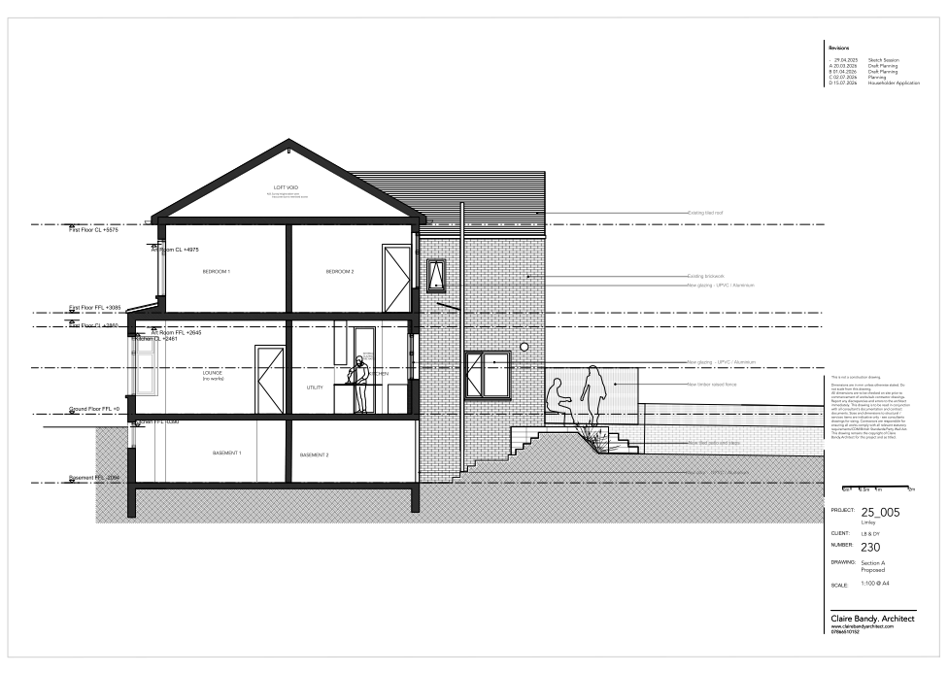
Figure 1. Section drawing from 4 Limley Grove
Elevation Alterations
The main elevational alteration is the insertion of a large rear facing window with Juliette balcony, glass balustrade and vertical timber solar shading. Additional changes include updated window fenestrations, ground floor window seat and decorative window and tile detailing.
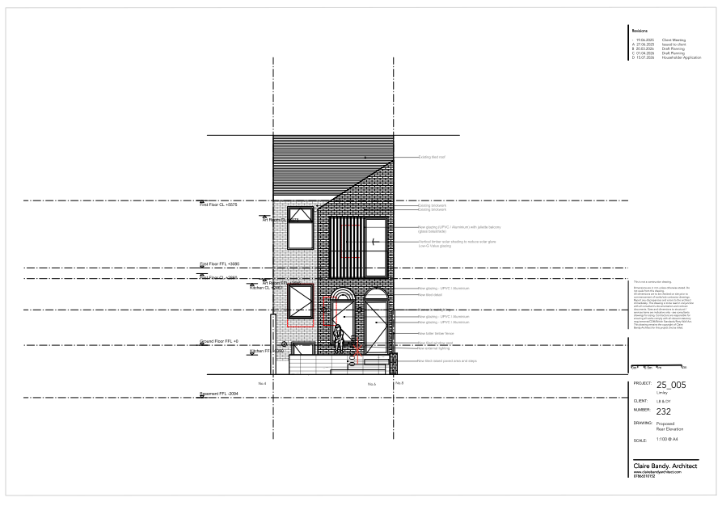
Figure 2. Proposed rear elevation

Relevant planning history

Lawful development: Proposed - PLA-2026-000034
Internal structural work, changes to window and door openings, new raised patio and associated fence.
Split - 2026-07-08
Reasons for approval
- Maintenance, improvement or other alteration works that do not materially affect the external appearance of a building are not development under Section 55(2)(a)(ii) of the Town and Country Planning Act 1990. The first-floor side window is shown on drawings 201 and 230 as new glazing of the same size and opening style as the existing window. On that basis, this element of the proposal would not constitute development and would not require planning permission.
- Alterations that affect "only the interior of the building" are not development as set out in Section 55(2)(a) of the Town and Country Planning Act 1990; as the changes to the internal walls and removal of the chimney stack relates to the interior, this element of the proposal would not constitute development and would not require planning permission.
Reasons for refusal
- The proposed first floor rear windows including the vertical timber solar shading, the ground floor rear and side windows, the ground floor and basement doors as shown on drawings 199, 200, 201, 230 Rev C, 231 Rev A and 232 does not constitute permitted development. It fails to meet the conditions of Class A within Part 1 of Schedule 2; specifically, condition A.3(a) of the Town and Country Planning (General Permitted Development) (England) Order 2015 (as amended). The proposed windows and doors are larger, differ in shape and style when compared to the existing openings.
- The proposed raised patio area as shown on drawings 199, 200,230 Rev C, 231 Rev A and 232 does not constitute permitted development. It fails to meet the requirements of sub-paragraph A.1(k)(i) of Part 1, Class A of Schedule 2 of the Town and Country Planning (General Permitted Development) (England) Order 2015 (as amended). The proposal would include a raised platform with a height greater than 0.3 metres.
- Section 55 of the Town and Country Planning Act 1990 (as amended) defines development as "the carrying out of building, engineering, mining or other operations in, on, over or under land, or the making of any material change in the use of any buildings or other land." Whilst there is a lack of a description of what constitutes an "engineering operation" in Section 55 of the Act, in practice it applies to activities altering the profile of land by excavation, embanking or tipping, or alternatively those which change the character of the surface of land. In this instance, the raised patio area and steps to the proposed basement door will require the excavation of significant amounts of material as part of the development, significant volumes of material will need to be excavated from the rear garden, before the construction of raised patio area and steps can be built. There is no class of the Town and Country Planning (General Permitted Development) (England) Order 2015 (as amended), that permits the carrying out of an engineering operation within the curtilage of a dwellinghouse and, as such, the proposed development requires planning permission.
- The proposed timber fence as shown on drawings 199, 200,230 Rev C, 231 Rev A and 232 does not constitute permitted development. It fails to meet the requirements of sub-paragraph A.1(b), of Part 2, Class A of Schedule 2 of the Town and Country Planning (General Permitted Development) (England) Order 2015 (as amended). The proposal would result in a fence with a height greater than 2 metres above ground level.

Consultation, notification and publicity responses

Consultations

Flood Risk Management
Flood Risk Management was consulted on the application and advised that the site is located within Flood Zones 2 and 3. On this basis, they requested the submission of a site-specific Flood Risk Assessment (FRA) to assess flood levels, finished floor levels and any necessary flood resilience measures prior to determination of the application.

Notifications and publicity

Neighbour letters
No responses received.

Relevant policies
In accordance with Section 38(6) of the Planning and Compulsory Purchase Act 2004, decisions on planning applications must be made in line with the statutory development plan, unless material considerations indicate otherwise.

For Manchester, the development plan comprises:

- The Core Strategy (2012–2027)
- Saved policies of the Unitary Development Plan (UDP)
- The Places for Everyone Joint Development Plan Document (2022–2039)

These documents are considered up to date and carry substantial weight in decision-making. Supplementary Planning Documents (SPDs) and other local guidance may also be relevant.

National planning policy, including the National Planning Policy Framework (NPPF), is a material consideration and provides overarching guidance.

Where applicable, the Council must give special regard to preserving the character of conservation areas and the setting of listed buildings, in line with statutory duties under the Planning (Listed Buildings and Conservation Areas) Act 1990.

The policies referenced in this report are those considered most relevant to the nature, scale and location of the proposed development as follows:

- The Manchester Core Strategy Development Plan Document 2012-2027
  - Development Management and Planning Obligations
    - DM 1 - Development Management
  - Objective 1 - Spatial Principles
    - SP 1 - Spatial Principles (Partially replaced by PfE Policy JP-S 1)
  - Objective 6 Environment
    - EN 1 - Design Principles and Strategic Character Areas
    - EN 14 – Flood Risk (partially replaced by PfE Policy JP-S 4)
- Guide to development in Manchester - supplementary planning document and planning guidance, April 2007
- Extant Unitary Development Plan (UDP) –
  - Citywide Development Control Policies
    - DC1 - Residential extensions
    - DC26 - Development and Noise
- Places for Everyone Plan Joint Development Plan Document 2022-2039-
  - Strategy
    - JP-Strat9: Southern Areas
  - Sustainable and Resilient Places
    - JP-S1: Sustainable Development
    - JP-S4: Flood Risk and the Water Environment
  - Places for People
    - JP-P1 Sustainable Places
- National Planning Policy Framework – August 2026 - National Development Management Policies (NDMPs)
  - Procedural Policies
    - Chapter 3 – Decision-making policies
      - DM1: Preparing development proposals
      - DM2: Information requirements
      - DM3: Determining development proposals
      - DM6: Use of planning conditions and obligations
      - DM7: Relationship with other regulatory regimes
      - DM10: Removal of national permitted development rights
  - Sustainable Development
    - Chapter 4 - Achieving sustainable development
      - S3: Presumption in favour of sustainable development
      - S4: Principle of development within settlements
    - Chapter 5 - Meeting the challenge of climate change
      - CC2: Mitigation of climate change
      - CC3: Adaptation to climate change
  - Creating high quality, sustainable places
    - Chapter 12 - Making effective use of land
      - L2: Making effective use of land
      - L3: Achieving appropriate densities
    - Chapter 14 - Achieving well-designed places
      - DP3: Key principles for well-designed places
      - DP4: The design process
  - Conserving and enhancing the environment
    - Chapter 18 - Managing flood risk and coastal change
      - F4: Assessing flood risk for decision-making
      - F6: Development in areas at risk of flooding from rivers or the sea
      - F7: Ensuring development is safe from flooding

Assessment

Principle of development
The proposal comprises alterations and improvements to an existing dwellinghouse, including a raised patio, excavation works, boundary fencing and elevational alterations. The site would remain in residential use, and the works are incidental to the enjoyment of the dwellinghouse. Subject to the detailed assessment of design, neighbouring amenity, flood risk and other material considerations, there is no objection in principle to the proposed development.
As stated in Policy DM 1 of the Manchester Core Strategy, all development should have regard to the following specific issues:

Appropriate siting, layout, scale, form, massing, materials, and detail
The proposal comprises a raised patio, excavation works, privacy screening and alterations to the rear elevation of the dwelling. The development is confined to the rear of the property and is proportionate to the scale and form of the existing dwellinghouse. The proposed materials, including the tiled patio finish, timber privacy screening and revised glazing, are appropriate to the host property and would result in a satisfactory appearance.
In terms of its relationship with neighbouring occupiers, the raised patio and associated screening would not result in an unacceptable level of built form within the rear garden. Whilst the privacy screen would have a maximum height of approximately 3.5m above existing ground level, it would extend only around 2.85m from the rear elevation and would be of lightweight timber construction. Given its limited extent and domestic appearance, the screen would not appear unduly dominant or overbearing when viewed from adjoining properties and would not result in an unacceptable loss of outlook.
The proposed rear elevation alterations, including the enlarged window opening and Juliette balcony, would be subordinate to the existing rear elevation and would not materially increase the built mass of the dwelling. Overall, the proposal would achieve an acceptable relationship with neighbouring properties.

Impact on the surrounding areas in terms of the design, scale and appearance of the proposed development. Development should have regard to the character of the surrounding area
The proposed raised patio, privacy screening fence and elevational alterations are confined to the rear of the property where they would have limited visibility from the public realm. The works are proportionate to the host dwelling and would appear as a functional and subordinate addition within the rear garden environment. The proposed materials, including tiling, timber screening and glazing, are considered acceptable in the context of the existing property and surrounding residential area. The development would not appear incongruous or result in material harm to the character or appearance of the dwelling or wider area.

Effects on amenity

Privacy
The raised patio would introduce an elevated outdoor area approximately 800mm above existing ground level. Whilst this has the potential to increase opportunities for overlooking, the proposal includes a timber privacy screen extending approximately 2.85m from the rear elevation at a height of 1.8m above patio level. This would effectively prevent direct overlooking between neighbouring properties in the immediate vicinity of the patio. The proposed rear-facing window and Juliette balcony do not provide additional external amenity space and are not considered to result in unacceptable overlooking beyond that typically associated with residential properties. The proposal would therefore have an acceptable impact on neighbouring privacy

Light
Given the limited scale of the raised patio and screening structure, together with their position to the rear of the property, the proposal would not result in a material loss of daylight or sunlight to neighbouring occupiers. The development would not create an overbearing feature when viewed from adjoining properties

Noise
The proposal facilitates the continued residential use of the property and would not introduce activities materially different from those normally associated with a dwellinghouse. Whilst the patio may increase use of part of the garden, any resulting noise would be typical of a residential environment and would not justify refusal of planning permission.

Accessibility: buildings and neighbourhoods fully accessible to disabled people, access to new development by sustainable transport modes.
The proposal would improve access between the dwelling, basement and rear garden through the provision of new steps and patio areas. The development would not adversely affect accessibility to the dwelling or the surrounding neighbourhood.

Adequacy of internal accommodation and external amenity space.
The proposal would provide improved access to the basement and garden areas whilst retaining a substantial rear garden. Sufficient private amenity space would remain available for the occupiers of the dwelling following completion of the works.

Refuse storage and collection.
The proposal would not affect existing refuse storage or collection arrangements at the property. Appropriate refuse storage facilities would remain available.

Vehicular access and car parking
The proposal would not alter vehicle access arrangements or parking provision associated with the dwelling. Accordingly, no highway safety or parking concerns arise.

Green Infrastructure including open space, both public and private
Whilst part of the rear garden would be altered to accommodate the raised patio and access arrangements, the property would retain a sizeable private garden. The proposal would not adversely affect the area's green infrastructure network.

Flood risk and drainage.
The site lies within Flood Zones 2 and 3 and is also identified as having areas of low to medium surface water flood risk. The proposed development comprises alterations and improvements to an existing dwellinghouse, including a raised patio, excavation works, privacy screening and elevational alterations. The proposal does not involve the creation of a new dwelling, vulnerable accommodation or a significant increase in built footprint.
Whilst Flood Risk Management requested a site-specific Flood Risk Assessment, the proposed works are domestic in scale and largely relate to alterations within the residential curtilage. The raised patio would be open in form, and the excavation works are associated with improved access to an existing basement rather than the creation of additional habitable accommodation. The development is not considered likely to materially increase flood risk on the site or elsewhere.
Having regard to the scale and nature of the proposals, together with Policies EN14 of the Core Strategy, JP-S4 of Places for Everyone and relevant national flood risk policies, the proposal is considered acceptable in flood risk and drainage terms. The development would not increase flood risk to people or property and would not prejudice the operation of existing flood flow routes.

Other Legislative Requirements

Equality Act 2010
Section 149 (Public Sector Equality Duty) of the Equality Act 2010 requires due regard to the need to: Eliminate unlawful discrimination, harassment and victimisation and other conduct prohibited by the Act and; Advance equality of opportunity between persons who share a protected characteristic and persons who do not share it. The Equality Duty does not impose a legal requirement to conduct an Equality Impact Assessment. Compliance with the Equality Duty involves consciously thinking about the aims of the Equality Duty as part of the process of decision-making.

Human Rights Act 1998 considerations
This application needs to be considered against the provisions of the Human Rights Act 1998. Under Article 6, the applicants (and those third parties, including local residents, who have made representations) have a right to a fair hearing and to this end the local planning authority must give full consideration to their comments.
Protocol 1 Article 1, and Article 8 where appropriate, confer(s) a right of respect for a person’s home, other land and business assets. In taking account of all material considerations, including Council policy as set out in the Core Strategy and saved polices of the Unitary Development Plan, the Director of Planning, Building Control & Licensing has concluded that some rights conferred by these articles on the applicant(s)/objector(s)/resident(s) and other occupiers and owners of nearby land that might be affected may be interfered with but that that interference is in accordance with the law and justified by being in the public interest and on the basis of the planning merits of the development proposal. She believes that any restriction on these rights posed by the recommendation given is proportionate to the wider benefits of and that such a decision falls within the margin of discretion afforded to the Council under the Town and Country Planning Acts.

Conclusion
The proposed raised patio, excavation works, privacy screening fence and elevational alterations are acceptable in design terms and would not result in unacceptable harm to the character of the area, neighbouring residential amenity, highway safety, biodiversity, drainage or flood risk interests. The proposal accords with Policies DM1 and EN1 of the Core Strategy, Policy DC1 of the UDP, relevant Places for Everyone policies and the relevant provisions of the NPPF. Accordingly, the application is recommended for approval subject to conditions.

Recommendation: Approve

Article 35 Declaration
Officers have worked with the applicant in a positive and proactive manner based on seeking solutions to problems arising in relation to dealing with the planning application. The proposal is considered to be acceptable and therefore determined within a timely manner.

Conditions to be attached to decision for approval

3-year time limit
The development must be begun not later than three years beginning with the date of this permission.
Reason - Required to be imposed by Section 91 of the Town and Country Planning Act 1990 (as amended).

Specified plans
The development hereby permitted shall be carried out in accordance with the following approved plans, received by the Local Planning Authority on 20 July 2026:
  - 25_005_002_PR_Site_RevB – Block Plan of the Site
  - 25_005_199_PR_B_RevC – Proposed Basement Plan
  - 25_005_200_PR_Plan_G_RevD – Proposed Ground Floor Plan
  - 25_005_201_PR_Plan_1_RevC – Proposed First Floor Plan
  - 25_005_202_PR_Plan_2_RevC – Proposed Loft Floor and Roof Plan
  - 25_005_230_PR_SecA_RevD – Section A Proposed
  - 25_005_231_PR_SecB_RevB – Section B Proposed
  - 25_005_232_PR_Ele_RevD – Proposed Rear Elevation
Reason - To ensure that the development is carried out in accordance with the approved plans, pursuant to policies DM 1, SP 1 and EN 1 of the Core Strategy and JP-P1 & of Places for Everyone.

Materials as approved on plan
The materials and finishes used in the development hereby approved shall be those specified on the approved drawings received on 20 July 2026
Reason: To ensure a satisfactory appearance of the development in the interests of visual amenity and to comply with Policies DM1 and EN1 of the Manchester Core Strategy Development Plan Document and Policy DC1 of the Unitary Development Plan.

Privacy fence
The privacy screening fence shown on drawing 25_005_232_PR_Ele_RevD and Sections A and B (drawings 25_005_230_PR_SecA_RevD and 25_005_231_PR_SecB_RevB), received on 20 July 2026, shall be erected before the raised patio is first brought into use and shall thereafter be retained and maintained for as long as the raised patio remains in use.
Reason: To safeguard the privacy and residential amenity of adjoining occupiers in accordance with Policies DM1 and EN1 of the Manchester Core Strategy Development Plan Document and Policy DC1 of the Unitary Development Plan.

Informative(s)

Property Flood Resilience (PFR) measures
The applicant is advised to incorporate Property Flood Resilience (PFR) measures to a minimum of 150mm above the surface water flood level or a minimum of 600mm above the fluvial flood level.

