

Planning

Delegated Officer Report

Summary of application details
Application reference: | PLA-2026-000096
Application type: | Full planning permission
Proposal: | Change of use of warehouse (Class B8) to form indoor sports facility consisting of six padel courts (Class E) with associated car parking.
Site address: | Unit B1 Ennis Close, Manchester, M23 9LE.
Ward(s): | Baguley
Date application valid: | 28 May 2026
Applicant name: | N/A
Agent (if any): | Mr Nathan Puckering
Case officer: | David Lawless
Recommendation: | Approve
Date of recommendation: | 01 September 2026

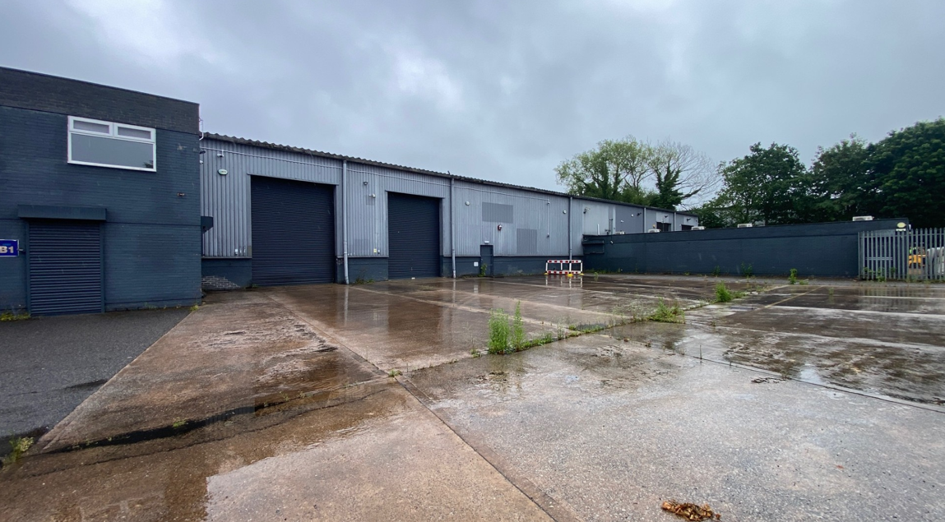

Description of site, building and/or area

This application relates to Unit B1 on Ennis Close, within the Roundthorn Industrial Estate. The property consists of a warehouse with 2 storey ancillary office extension to the front. To the front of the premises there is a car parking/service area and beyond that, off Ennis Close, there is a short layby for further parking.

To the rear of the site lies Floats Road and beyond that the Wythenshawe Hospital complex. To the front of the site, on the opposite side of Ennis Close, there are further industrial buildings. Further industrial buildings are located on either side of Unit B1.

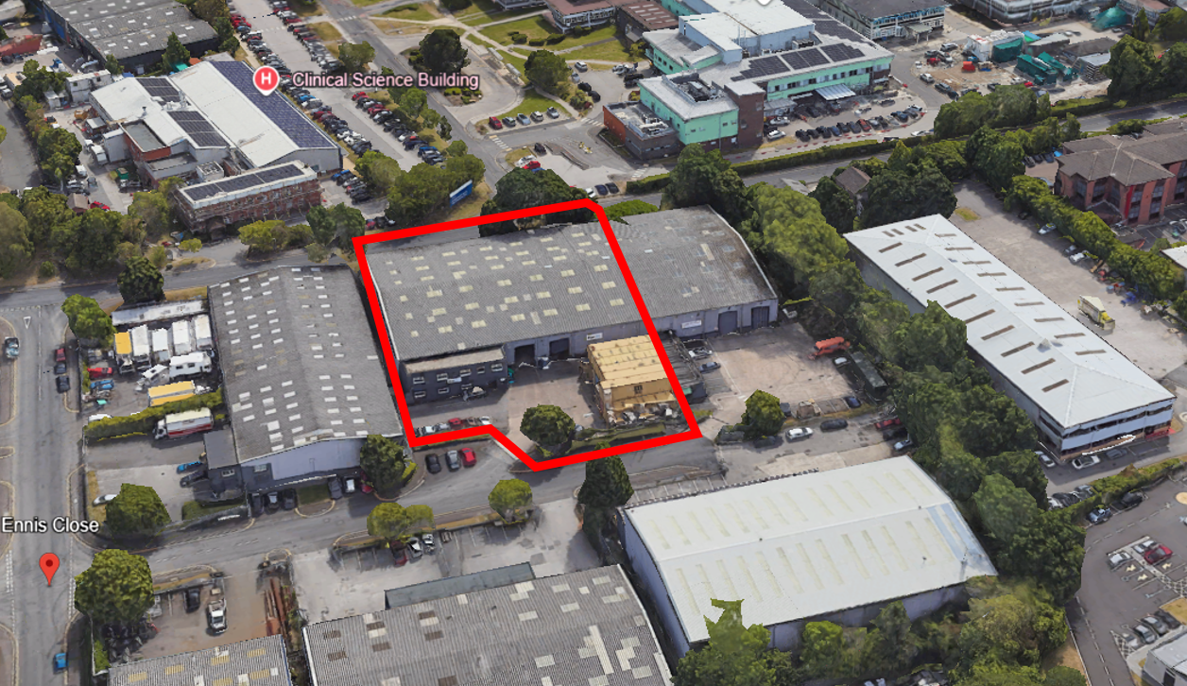

Description of development

Change of use of warehouse (Class B8) to form indoor sports facility consisting of six padel courts (Class E) with associated car parking.

The proposed layout is shown below:

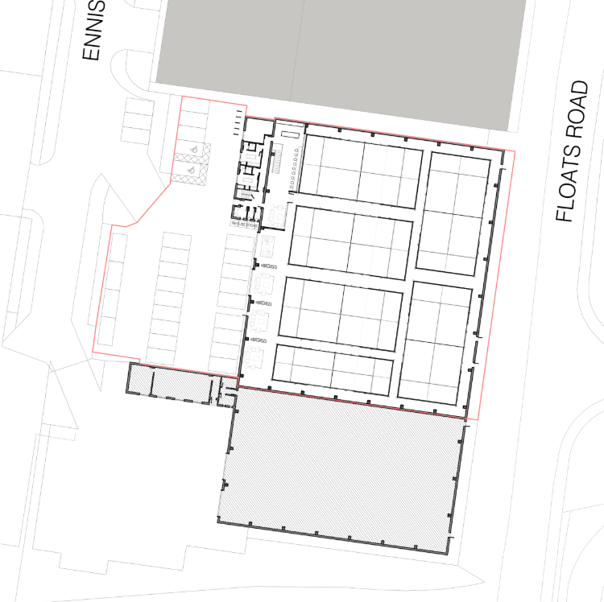

The six padel courts would be located within the main warehouse, along with a seating area and clubhouse. Changing facilities and WC’s would be located within the office accommodation situated at the front (circled red below):

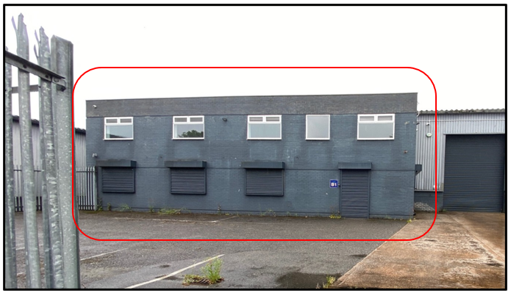
At the front of the premises the applicant is proposing to provide 27 car parking spaces, of which two would be dedicated for use by disabled staff or customers. Cycle parking is also proposed at the front of the premises.

Consultation, notification and publicity responses

Local Residents/Businesses – No comments received.

Environmental Health – No comments received.

Flood Risk Management – Raises no objections to the proposal and recommends that an informative concerning Property Flood Resilience measures be attached to any approval granted.

Highway Services – Have made the following comments:

- Proposed Site Plan (Drawing No. 012-P-SP REV B) demonstrates that 21no. car parking spaces including 2no. disabled bays is to be provided within the site – Acceptable in principle. Dimensions of standard parking bays is to be 2.5m x 4.8m, as illustrated in the Proposed Site Plan – This is welcomed by Highways.
- Dimension of the disabled parking spaces remain unclear and should include the required (minimum) 1.2m safety zone/hatching. Clarification is therefore sought, and this should be clearly illustrated on a revised site plan.
- A minimum 6.4m aisle width is to be provided within the car park – Acceptable in principle.
- Minimum 20% EV charge points (minimum 7kW) and cable ducting should be provided.
- Proposed Site Plan indicates that 12no. cycle parking spaces will be provided within the car park, situated adjacent to the disabled parking bay. All cycle parking spaces should be secure and sheltered. Cycle parking should be monitored with additional provision where demand requires.
- The refuse storage is located within the site boundary. A Waste Management Strategy should be conditioned and attached to any planning permission.

Manchester Active – Have made the following comments:

There is insufficient information submitted to assess the proposal against Manchester’s Sport Strategy objectives. The following information is required:

- Statement that clearly articulates:
  - the community benefits of the proposal that meet the needs of Manchester’s underrepresented groups given the site is located within one of the most deprived areas of Manchester.
  - Strategic need for the Padel Courts in this location
- Technical specification of the courts that show they will be designed in accordance with Sports and Play Construction Association Code of Practice for the Construction of Padel Courts.
- Community Use Agreement – all commercial Padel operators are required to enter into a Community Use Agreement with Manchester City Council, via Manchester Active as the sport and leisure arm of the Council, and the Lawn Tennis Association to ensure unmet demand for Padel from Manchester residents is accommodated.

Relevant policies

National Planning Policy Framework (August 2026) – A revised National Planning Policy Framework (NPPF) was published on 17 August 2026 following a period of public consultation and has superseded the previous version. Given the timing of its publication, the application has been assessed against both the former and revised frameworks. Having undertaken this review, it is considered that the changes introduced by the revised NPPF do not materially affect the assessment or conclusions reached in relation to the proposed development.

The revised version fundamentally restructures national planning policy with a more rules based, pro-growth approach, replacing the previous paragraph based framework and the traditional tilted balance with a new presumption in favour of sustainable development. Key reforms include stronger support for housing delivery, particularly higher-density development near major public transport hubs, greater policy support for economic growth, infrastructure and rural productivity, stronger protection for pubs and other community facilities and continued robust protection of designated landscapes. The reforms are intended to make planning decisions faster, clearer and more predictable whilst accelerating housing and economic growth.

In this instance, the relevant sections are outlined below:

Policy DM3 (Determining development proposals) – When considering development proposals, local planning authorities should:

- Work with the applicant in a positive and proactive manner, where necessary seeking solutions to problems arising from initial proposals, to enable a timely decision;
- Take a proportionate approach to the consideration of the planning matters raised by the proposals, in a way that reflects their scale, complexity and potential impact;
- Take account of planning matters raised during any pre-application engagement, including any positive responses to this engagement, as well as representations on the proposals;
- Consult statutory or internal consultees only where it is necessary to do so. Decisions on development proposals should not be delayed in order to secure advice from a statutory or internal consultee beyond their statutory deadlines unless there is insufficient information to make the decision or more detailed advice may enable an approval rather than a refusal;
- Consider whether otherwise unacceptable development proposals could be made acceptable through the use of planning conditions or planning obligations; and
- Not refuse applications for development which should clearly be approved, having regard to its accordance with the development plan, the policies in this Framework and any other material considerations.

The Places for Everyone Plan – This plan was adopted on 21 March 2024, as such the Plan and its policies are now a material planning consideration in the determination of planning applications. The Plan and its policies must therefore be given significant weight in the planning balance. The relevant policy is set out below:

Policy JP-Strat9 (Southern Areas) – This policy states that the economic competitiveness, distinctive local neighbourhood character and environmental attractiveness of the southern areas will be protected and enhanced. There will be a strong emphasis on making as much use as possible of suitable previously developed (brownfield) land and promoting the roles of the areas’ town centres and its other key assets.

Policy JP-J2 (Employment Sites and Premises) – This policy states that a diverse range of employment sites and accessible premises, both new and second-hand, will be made available across the Plan area in terms of location, scale, type and cost. This will offer opportunities for all kinds and sizes of businesses, including start-ups, firms seeking to expand, and large-scale inward investment, which will help to tackle inequalities.

It also states that existing employment areas that are important to maintaining a strong and diverse supply of sites and premises in our boroughs will be protected from redevelopment to other uses, nurtured to ensure they remain competitive and their accessibility improved where necessary. This will include local employment areas as well as key growth locations.

Policy JP-J4 (Industry and Warehousing Development) – This policy states that at least 3,513,000m² of new, accessible, industrial and warehousing floorspace will be provided in the Plan area over the period 2022-2039. To achieve this, a high level of choice and flexibility will be provided in the supply of sites for new industrial and warehousing floorspace.

It states further that the need to provide the level of industrial and warehousing land within the Plan reflects the need for Greater Manchester to compete internationally for investment and provide sufficient choice and flexibility to respond to the varied needs of different businesses. This will help Greater Manchester to maximise its ability to attract and retain businesses and hence support its long-term economic growth prospects and the availability of local jobs.

Policy JP-96 (Health) – This policy states that to help tackle health inequality, new development will be required, as far as practicable, to maximise its positive contribution to health and wellbeing, whilst avoiding any potential negative impacts of new development; and support healthy lifestyles, including through the use of active design principles, making physical activity an easy, practical and attractive choice.

Policy JP-P7 (Sport and Recreation) – This policy states that a network of high quality and accessible sports and recreation facilities will be protected and enhanced, supporting greater levels of activity for all ages.

Core Strategy Development Plan Document – The Core Strategy Development Plan Document 2012 -2027 ("the Core Strategy") was adopted by the City Council on 11th July 2012. It is the key document in Manchester's Local Development Framework. The Core Strategy replaces significant elements of the Unitary Development Plan (UDP) as the document that sets out the long-term strategic planning policies for Manchester's future development.

A number of UDP policies have been saved until replaced by further development plan documents to accompany the Core Strategy. Planning applications in Manchester must be decided in accordance with the Core Strategy, saved UDP policies and other Local Development Documents. Relevant policies in the Core Strategy are detailed below

Policy SP1, Spatial Principles – Development in all parts of the City should make a positive contribution to neighbourhoods of choice including creating well designed places that enhance or create character and protect and enhance the built and natural environment.

Policy C8,

Policy EC2, Existing Employment Space – This policy states that the Council will seek to retain and enhance existing employment space and sites. Alternative uses will only be supported on sites allocated accordingly, or if it can be demonstrated that:

- The existing use is un-viable in terms of business operations, building age and format;
- The existing use is incompatible with adjacent uses;
- The existing use is unsuitable for employment having had regard to the Manchester-Salford-Trafford SFRA; or
- On balance, proposals are able to offer greater benefits in terms of the Core Strategy's vision and spatial objectives than the existing use.

Policy EC10 (Wythenshawe) – This policy states that Wythenshawe is expected to provide 55ha of employment land within B1a offices, B1b/c research and development and light industry and B8 logistics and distribution. The majority of economic development will be focused on four areas, one of which is Roundthorn Industrial Estate. It states further that the existing employment role of Roundthorn Industrial Estate will be supported, including the existing industrial and manufacturing uses.

Policy DM1, Development Management – This policy states that all development should have regard to a number of specific issues, of which the following are of most relevance:-

- Appropriate siting, layout, scale, form, massing, materials and detail.
- Impact on the surrounding areas in terms of the design, scale and appearance of the proposed development. Development should have regard to the character of the surrounding area.
- Effects on amenity, including privacy, light, noise, vibration, air quality, odours, litter, vermin, birds, road safety and traffic generation. This could also include proposals which would be sensitive to existing environmental conditions, such as noise.
- Community safety and crime prevention.
- Design for health.
- Vehicular access and car parking.
- Effects relating to biodiversity, landscape, archaeological or built heritage.
- Green Infrastructure including open space, both public and private
- Flood risk and drainage.

Saved UDP Policies – Policy WW2, Economic Development, states that within the Roundthorn Industrial Estate the Council will permit new industrial and commercial activities, incompatible with a location in a residential area, except where serious harm to the amenity of nearby residents or adjoining businesses would result.

Policy DC26.1, Development and Noise, states that the Council intends to use the development control process to reduce the impact of noise on people living and working in, or visiting, the City. In giving effect to this intention, the Council will consider both:

- the effect of new development proposals which are likely to be generators of noise; and
- the implications of new development being exposed to existing noise sources which are effectively outside planning control.

Policy DC26.2 states that new noise-sensitive developments (including large-scale changes of use of existing land or buildings), such as housing, schools, hospitals or similar activities, will be permitted subject to their not being in locations which would expose them to high noise levels from existing uses or operations, unless the effects of the noise can realistically be reduced. In giving effect to this policy, the Council will take account both of noise exposure at the time of receiving a planning application and of any increase that may reasonably be expected in the foreseeable future.

Assessment

Principle of the Proposal – The proposal would result in the loss of existing employment floorspace and must therefore be assessed against Core Strategy Policies EC2 (Existing Employment Space) and EC10 (Wythenshawe), together with Places for Everyone Policies JP-J2 (Employment Sites and Premises) and JP-J4 (Industry and Warehousing Development). Collectively, these policies seek to safeguard existing employment land and premises whilst supporting the provision of additional employment floorspace where appropriate. Despite this policy position, Core Strategy Policy EC2 recognises that alternative uses may be acceptable where it can be demonstrated that:

- The existing use is un-viable in terms of business operations, building age and format;
- The existing use is incompatible with adjacent uses;
- On balance, proposals are able to offer greater benefits in terms of the Core Strategy's vision and spatial objectives than the existing use.

In support of the application, the applicant has advised that the site has remained vacant for approximately two years despite active marketing by Savills, Mileway and DTRE. It is further stated that no meaningful interest has been received during this period. Whilst the evidence submitted is largely anecdotal in nature, it indicates that there is currently limited market demand for the continued industrial or warehousing use of the premises. Taking this into account, and in the absence of evidence to suggest that the site is likely to be brought back into employment use in the foreseeable future, no objection is raised in principle to the redevelopment of the site for an alternative use.

Furthermore, it is recognised that the provision of padel courts would contribute to the health and wellbeing of local residents and would create employment opportunities, with the potential to support the local economy. In addition, the proposed reuse of an existing building would represent a sustainable form of development by retaining the embodied carbon within the structure and reducing the need for new construction. Finally, it is recognised that the proposed indoor sports facility aligns with the objectives of the National Planning Policy Framework (NPPF) to promote healthy and safe communities, particularly through the provision of accessible sports and recreational facilities.

In conclusion, the proposed use of the site for padel courts would secure the beneficial reuse of a previously developed site and bring a vacant building back into active use. Having regard to these benefits, together with the Council's healthy supply of office and industrial/warehousing floorspace to meet its employment needs and priorities, it is considered that the continued safeguarding of the site for traditional employment purposes is not necessary. As such, the principle of the proposed development is supported.

Notwithstanding the above conclusion, consideration must also be given to the effects of the proposal on visual amenity, residential amenity and pedestrian and highway safety. An assessment of these matters is set out below.

Community Use – Manchester Active has requested that the applicant enter into a Community Use Agreement to secure wider public access to the proposed padel facility. Whilst this would be welcomed and could provide additional community benefits, the applicant has indicated limited support for such an arrangement. Although this is regrettable, there is no policy requirement for a Community Use Agreement in this instance and its absence would not constitute a sustainable or defensible reason for refusing planning permission. On balance, the proposal remains acceptable and is therefore supported.

Residential Amenity – Padel has the potential to generate noise, primarily as a result of the ball striking the solid playing bats. However, the proposed padel courts would be located within an existing industrial building, with the nearest residential property situated approximately 230 metres from the site. Given the separation distance and the enclosed nature of the facility, it is not considered that the proposed development would give rise to unacceptable noise impacts or otherwise harm the level of residential amenity enjoyed by nearby residents.

Visual Amenity – The proposal does not raise any concerns in respect of visual amenity, as no external works are proposed. On the contrary, the continued use and improvement of the site would enhance the level of visual amenity experienced within the vicinity of the site.

Pedestrian and Highways Safety – The proposed padel facility is not considered likely to give rise to any significant adverse impact on the local highway network. The operation of the facility is based on a pre-booking system, with courts typically occupied by small groups for one-hour sessions. This results in a controlled and predictable pattern of arrivals and departures throughout the day, rather than concentrated peak period demand.

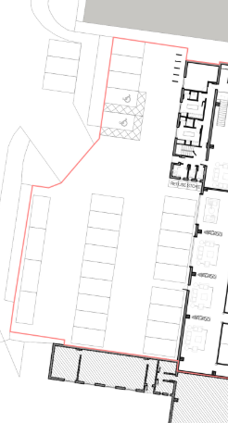
Whilst the development would provide five doubles courts and one singles court, the maximum number of players using the facility at any one time would be relatively modest and many users are expected to travel together as part of a booked playing group, thereby reducing the overall number of vehicle movements. In addition, the site benefits from an existing lawful use for warehousing (Use Class B8), which had the potential to generate a greater level of commercial and HGV traffic. The proposed leisure use would not result in HGV movements and is expected to generate a comparable, if not lower, level of traffic activity spread across the day and into weekends.

Given the above, it is considered that the proposal would not have a severe impact on pedestrian or highway safety and the operation of the surrounding road network.

Car Parking – The applicant proposes to provide 27 car parking spaces within the existing parking and service area at the front of the site. This level of provision, which includes two accessible parking spaces, is considered acceptable for the proposed use.
To support the uptake of electric vehicles and promote sustainable travel, Condition 3 requires the submission and approval of details relating to the provision of electric vehicle charging infrastructure at the site prior to its installation.

Cycle Parking – The applicant has indicated that cycle parking provision is to be provided at the front of the property. While this is welcomed, Condition 5 requires the submission of further details in order to ensure the facilities are both safe and secure.

Air Quality – It is acknowledged that the operational phase of the development has the potential to generate minor air quality impacts arising from vehicle exhaust emissions associated with traffic movements to and from the site, including those generated by staff and customers. However, having regard to the scale of the proposal, the significance of any such impacts is considered to be low.

Furthermore, the provision of electric vehicle charging points will encourage the use of low-emission vehicles and assist in minimising transport-related emissions. On this basis, it is considered that the proposal would not result in a detrimental impact on local air quality within the vicinity of the site.

Site Security – The site perimeter is secured by an existing palisade fence and gated access. In view of these existing security measures, it is not considered that the proposed development would increase opportunities for crime or anti-social behaviour, nor would it exacerbate existing levels of criminal activity within this part of the industrial estate.

Ecological Matters – The proposal does not raise any concerns in respect of ecology.

Drainage – The proposal does not involve any extensions or operational development and, therefore, raises no concerns in relation to drainage. Notwithstanding this, the informative suggested by Flood Risk Management would be attached to any approval issued.

Refuse Storage – Condition 4 would require the applicant to submit and implement a detailed refuse storage strategy.

Other Legislative Requirements

Equality Act 2010 – Section 149 (Public Sector Equality Duty) of the Equality Act 2010 requires due regard to the need to: Eliminate unlawful discrimination, harassment and victimisation and other conduct prohibited by the Act and; Advance equality of opportunity between persons who share a protected characteristic and persons who do not share it. The Equality Duty does not impose a legal requirement to conduct an Equality Impact Assessment. Compliance with the Equality Duty involves consciously thinking about the aims of the Equality Duty as part of the process of decision-making.

Human Rights Act 1998 considerations – This application needs to be considered against the provisions of the Human Rights Act 1998. Under Article 6, the applicants (and those third parties, including local residents, who have made representations) have a right to a fair hearing and to this end the local planning authority must give full consideration to their comments.

Protocol 1 Article 1, and Article 8 where appropriate, confer(s) a right of respect for a person’s home, other land and business assets. In taking account of all material considerations, including Council policy as set out in the Core Strategy and saved polices of the Unitary Development Plan, the Director of Planning, Building Control & Licensing has concluded that some rights conferred by these articles on the applicant(s)/objector(s)/resident(s) and other occupiers and owners of nearby land that might be affected may be interfered with but that that interference is in accordance with the law and justified by being in the public interest and on the basis of the planning merits of the development proposal. She believes that any restriction on these rights posed by the recommendation given is proportionate to the wider benefits of and that such a decision falls within the margin of discretion afforded to the Council under the Town and Country Planning Acts.
Conclusion

Article 35 Declaration

Officers have worked with the applicant in a positive and proactive manner based on seeking solutions to issues arising from the consideration of this application.

Recommendation: Approve

Conditions attached to this decision

1) The development must be begun not later than three years beginning with the date of this permission.
Reason - Required to be imposed by Section 91 of the Town and Country Planning Act 1990 (as amended).

2) The development hereby approved shall be carried out in accordance with the following drawings and documents:

a) Existing Location Plan, drawing no. 001-E-LP, received on 27 Apr 2026.
b) Existing Site Plan, drawing no. 002-E-SP, received on 28 May 2026.
c) Proposed Site Plan, drawing no. 012-P-SP, received on 28 May 2026.
d) Proposed Ground Floor Plan, drawing no. 013-P-GF, received on 27 Apr 2026.
e) Proposed First Floor Plan, drawing no. 014-P-FF, received on 27 Apr 2026.
f) Proposed Roof Plan, drawing no. 015-P-RP, received on 27 Apr 2026.
g) Planning, Design and Access Statement, received on 12 May 2026
h) Transport Statement, received on 28 May 2026

Reason - To ensure that the development is carried out in accordance with the approved plans. Pursuant to Policies SP1 and DM1 of the Manchester Core Strategy.

3) Prior to the commencement of the use hereby approved, details of the measures to be incorporated into the development to allow for the provision of electric vehicle charging points have been submitted to and approved by the City Council as Local Planning Authority. The approved charging points shall be provided prior to first occupation and retained thereafter.

Reason - To promote sustainable means of transport, pursuant to Policies DM1 and EN16 in the Manchester Core Strategy.

4) Prior to the first use of the development hereby approved, a detailed scheme showing the design, location and size of a facility to store refuse and waste materials shall be submitted to and approved in writing by the City Council as Local Planning Authority. The approved scheme shall be implemented in full prior to first use of the development and retained thereafter.

Reason - In the interests of residential amenity and public health, pursuant to Policies EN19 and DM1 of the Manchester Core Strategy.

5) Prior to the use of the development hereby approved, a scheme for the safe and secure storage of cycles on-site shall be submitted to and approved in writing by the City Council as Local Planning Authority. The approved cycle storage scheme shall be implemented in full within 2 months of the Local Planning Authority's written approval (or within such other timescale as may be agreed in writing by the Local Planning Authority) and shall thereafter be retained and kept available for its intended use for the lifetime of the development.

Reason - To ensure adequate, safe and convenient cycle parking is provided in the interests of sustainable transport, pursuant to Policy T1 in the Manchester Core Strategy.

Informatives

1) Flood Risk Management Informative - The applicant is advised to incorporate Property Flood Resilience (PFR) measures to a minimum of 150mm above the surface water flood level or a minimum of 600mm above the fluvial flood level.

