24.08.26 – Mock up for approval
Protection to the concrete column – 10mm high density foam pad placed behind each steel uni-strut channel/ section.

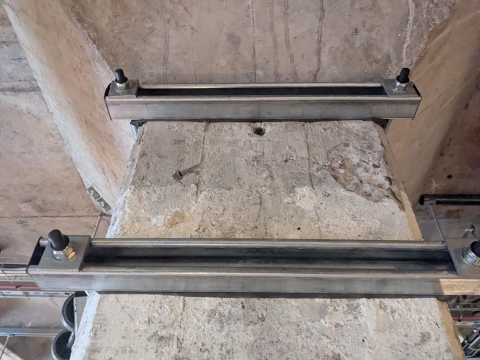 | 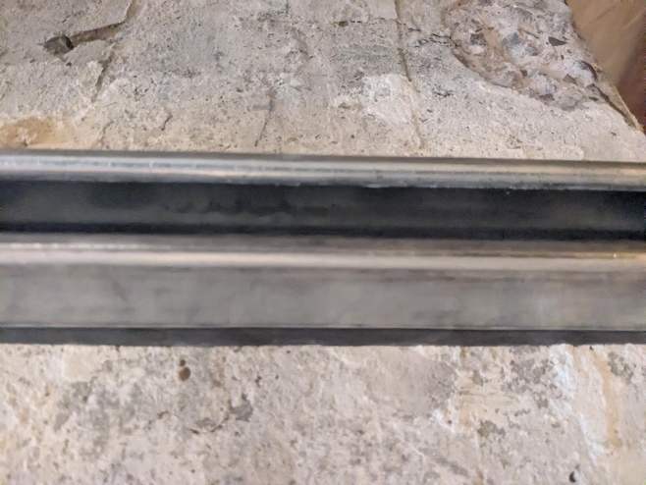
1 | 2
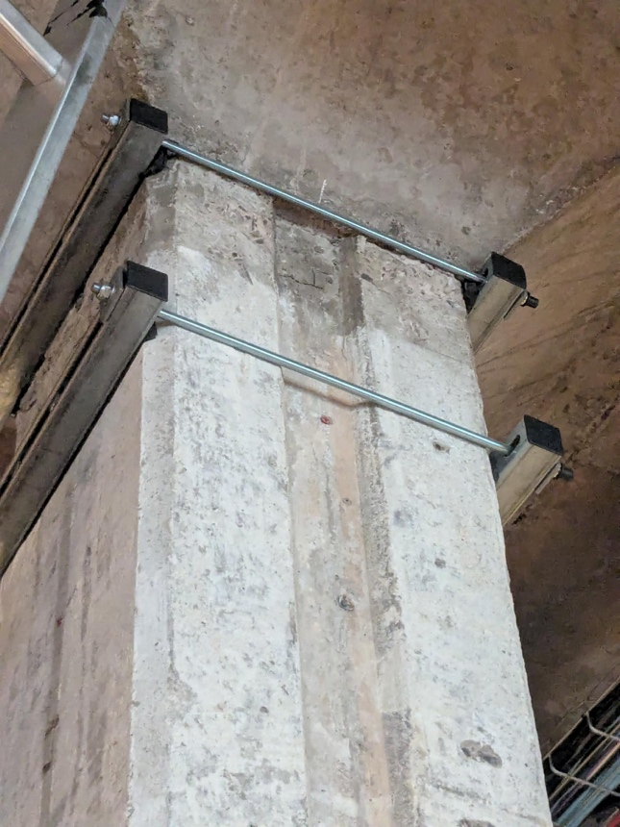 | 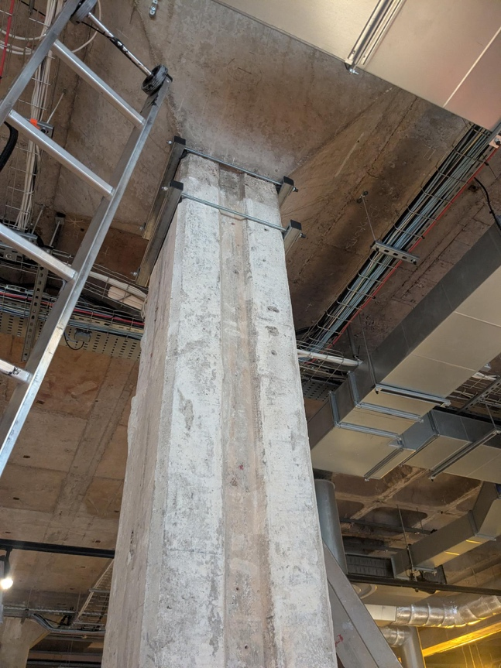
3 | 4

