

Planning

Delegated Officer Report

Summary of application details
Application reference: | PLA-2026-000988
Application type: | Householder planning permission
Proposal: | Erection of single-storey rear extension.
Site address: | 10 Belfield Road Manchester M20 6BH
Ward(s): | Didsbury East
Date application valid: | 10 July 2026
Applicant name: | Mr Aaron Cochrane
Agent (if any): | Mr Ian Pleasant
Case officer: | Tracie Simpson
Recommendation: | Approve
Date of recommendation: | 01/09/2026

Description of site, building and/or area
The application relates to a large two-storey, double fronted detached residential property situated within the Didsbury East Ward of Manchester. The dwelling is set within a generous plot with front and rear garden areas and benefits from off-street parking, a single-storey side extension, and a raised patio to the rear. Architectural features include brick-built bay projections to the principal elevation and a recessed front entrance.

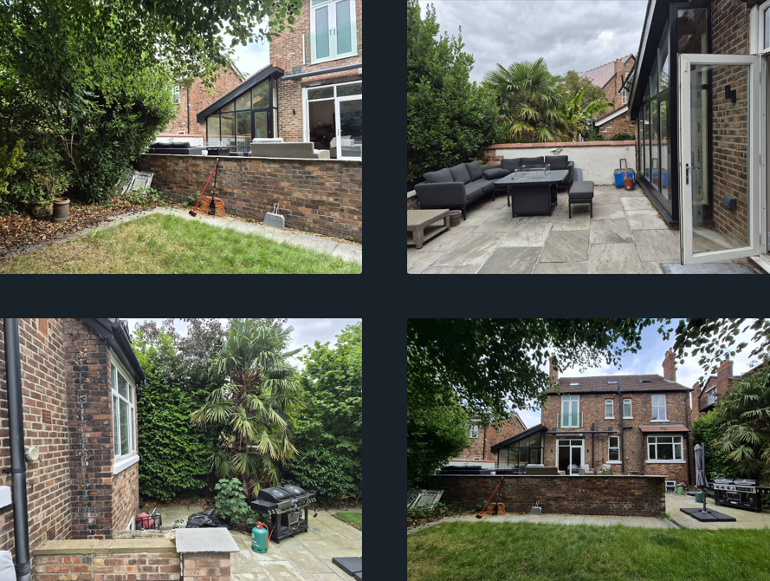

Description of development
The applicant is seeking planning permission for the erection of single-storey rear extension.

Relevant planning history
No relevant history

Consultation, notification and publicity responses

Notifications and publicity
No representations received.

Relevant policies
In accordance with Section 38(6) of the Planning and Compulsory Purchase Act 2004, planning applications must be determined in accordance with the statutory development plan unless material considerations indicate otherwise.
For Manchester, the development plan comprises:
- The Manchester Core Strategy (2012 to 2027);
- Saved policies of the Manchester Unitary Development Plan (UDP); and
- The Places for Everyone Joint Development Plan Document (2022 to 2039).
These documents are considered up to date and are afforded significant weight in the determination of planning applications. Relevant Supplementary Planning Documents (SPDs) and other adopted guidance may also be material considerations.
The National Planning Policy Framework sets out the government’s policies for plan-making and for making decisions on development proposals in England. It is a material consideration of critical importance in both contexts.
Where relevant, the Council is required to give special regard to the desirability of preserving listed buildings and their settings, and special attention to the desirability of preserving or enhancing the character or appearance of conservation areas, in accordance with the Planning (Listed Buildings and Conservation Areas) Act 1990.
The policies and guidance referred to below are considered the most relevant to the scale, nature and location of the proposed development.
- The Manchester Core Strategy Development Plan Document 2012-2027
  - Development Management and Planning Obligations
    - DM 1 - Development Management
  - Objective 1 - Spatial Principles
    - SP 1 - Spatial Principles (Partially replaced by PfE Policy JP-S 1)
  - Objective 6 Environment
    - EN 1 - Design Principles and Strategic Character Areas
    - EN 19 – Waste
- Guide to development in Manchester - supplementary planning document and planning guidance, April 2007
- Extant Unitary Development Plan (UDP) –
  - Citywide Development Control Policies
    - DC1 - Residential extensions
    - DC26 - Development and Noise
- Places for Everyone Plan Joint Development Plan Document 2022-2039-
  - Strategy
    - JP-Strat9: Southern Areas
  - Sustainable and Resilient Places
    - JP-S1: Sustainable Development
  - Places for People
    - JP-P1 Sustainable Places
- National Planning Policy Framework – August 2026 - National Development Management Policies (NDMPs)
  - Procedural Policies
    - Chapter 3 – Decision-making policies
      - DM1: Preparing development proposals
      - DM2: Information requirements
      - DM3: Determining development proposals
      - DM6: Use of planning conditions and obligations
      - DM7: Relationship with other regulatory regimes
      - DM9: Use of development orders
      - DM10: Removal of national permitted development rights
  - Sustainable Development
    - Chapter 4 - Achieving sustainable development
      - S3: Presumption in favour of sustainable development
      - S4: Principle of development within settlements
  - Creating high quality, sustainable places
    - Chapter 12 - Making effective use of land
      - L2: Making effective use of land
    - Chapter 14 - Achieving well-designed places
      - DP3: Key principles for well-designed places
      - DP4: The design process

Assessment

Principle of the Proposal

Policies SP1 and DM1 of the Manchester Core Strategy 2012 (Core Strategy) seek to ensure that new development enhances or creates character, protects and enhances the built environment; and that the design, scale and appearance of the proposed development is appropriate to its context. Policies DC1.1, DC1.2, DC1.3 and DC1.4 of The Unitary Development Plan for the City of Manchester 1995 (UDP) relate specifically to residential extensions and set out a number of criteria against which proposals for extensions will be assessed. Although these latter policies are now of some age, they are consistent with the guidance in the National Planning Policy Framework (NPPF) which seeks a high standard of design in new developments which provides a good standard of amenity of all existing and future occupiers.
The principle of allowing residents to extend their homes to provide enlarged or improved accommodation is generally acceptable provided that there is no overriding, undue impact upon either the character of the property or upon the residential and visual amenity of nearby residential occupiers.
In this instance the principle of the proposal is considered acceptable and it is not believed that there are any factors of sufficient weight in amenity terms that would warrant refusal of the application.
On balance, the proposed extension is deemed to accord with saved policy DC1 of the UDP and policies DM1 and SP1 of the Manchester Core Strategy

Residential Amenity
The applicant is seeking planning permission for the erection of a new single storey rear extension following demolition of existing single storey rear extension and bay window; this would provide additional living space to the occupiers.
Following demolition of the existing rear bay window and single storey rear projection along the shared boundary, the proposal seeks to extend the rear elevation up to the shared boundary with properties either side of the site projecting 3.3m and measuring around 8m in width, with a maximum height of approximately 3.8m. The extension would feature a mono pitch sloping roof incorporating three rooflights. Bi-folding doors are proposed leading into the rear garden, together with a rear window; no windows are proposed on the side elevations.
To safeguard the privacy of neighbouring occupiers, a condition has been attached preventing the insertion of any additional openings in the side elevations without prior consent.
The proposal complies with the City Council’s DC1 policy in terms of projection. Notwithstanding this, it is recognised that under the Larger Home Extension Scheme, a projection of up to 6.0 metres could typically be achieved, particularly given that no objections have been received.
It is considered that the height of the extension, together with its separation from the neighbouring property by a ginnel on one side, is sufficient to mitigate any potential adverse impacts along shared boundaries. Accordingly, it is concluded that the proposed development would not result in significant overshadowing or an unacceptable loss of light to neighbouring properties.
In this instance, the single storey rear extension is considered to be an acceptable addition to the property and would not provide an impact upon the occupiers of surrounding properties.
The extension would not be visible from the public highway and therefore would not be a feature within the street scene. However, the character of the area has been retained, therefore, the appearance is acceptable and its impact upon visual amenity is considered negligible.
Overall, given the development's height, projection and relationship to adjacent properties, it is considered that the proportions of the extension to the rear are acceptable and can be acceptably accommodated at the application property. The footprint is not considered to create a bulky or disproportionate scale addition to the property. In terms of residential amenity, it is not considered that there will be any significant impact and the proposed development therefore the proposal complies with The National Planning Policy Framework; Core Strategy policies SP1, DM1, EN1 and Saved Policies DC1 of the Unitary Development Plan.

Scale and Mass
The size and footprint of the proposal is not believed to provide an overbearing impact upon the residential amenities of surrounding properties. It is therefore considered that the design, scale and appearance of the proposed changes are satisfactory and are considered to accord with the principles for residential extensions set out in saved UDP policy DC1, DM1 and EN1 of the Core Strategy.

Design
The design of the proposal would be in keeping with the existing and surrounding properties in the area and in terms of the proposed materials it is intended to use matching brick and tile as specified in the application form.
The design is detailed as what is normally expected of such a structure and would not unduly impact upon residential amenity or the character of the area.
On balance it is considered that the design and appearance of the proposed development accords with Core Strategy Policies DM1 and EN1 and in general the design is considered acceptable

Bins
The storage of refuse bins are not affected by this proposal.

Car parking
Off street car parking still remains at the front of the property and therefore is unaffected by this proposal

Other Legislative Requirements

Equality Act 2010
Section 149 (Public Sector Equality Duty) of the Equality Act 2010 requires due regard to the need to: Eliminate unlawful discrimination, harassment and victimisation and other conduct prohibited by the Act and; Advance equality of opportunity between persons who share a protected characteristic and persons who do not share it. The Equality Duty does not impose a legal requirement to conduct an Equality Impact Assessment. Compliance with the Equality Duty involves consciously thinking about the aims of the Equality Duty as part of the process of decision-making.

Human Rights Act 1998 considerations
This application needs to be considered against the provisions of the Human Rights Act 1998. Under Article 6, the applicants (and those third parties, including local residents, who have made representations) have a right to a fair hearing and to this end the local planning authority must give full consideration to their comments.
Protocol 1 Article 1, and Article 8 where appropriate, confer(s) a right of respect for a person’s home, other land and business assets. In taking account of all material considerations, including Council policy as set out in the Core Strategy and saved polices of the Unitary Development Plan, the Director of Planning, Building Control & Licensing has concluded that some rights conferred by these articles on the applicant(s)/objector(s)/resident(s) and other occupiers and owners of nearby land that might be affected may be interfered with but that that interference is in accordance with the law and justified by being in the public interest and on the basis of the planning merits of the development proposal. She believes that any restriction on these rights posed by the recommendation given is proportionate to the wider benefits of and that such a decision falls within the margin of discretion afforded to the Council under the Town and Country Planning Acts.

Article 35 Declaration

Positive and proactive working - Officers have worked with the applicant in a positive and proactive manner based on seeking solutions to problems arising in relation to dealing with the planning application. The application has been determined in a timely manner and in accordance with the guidance contained within saved policy DC1 'Residential Extensions' of the Manchester Unitary Development Plan and to policy DM1 of the Core Strategy and the National Planning Policy Framework.

Conclusion
On balance, it is believed that the proposal would not interfere with the character of the area and in terms of residential amenity it is not considered that there will be any significant impact and the proposed development therefore accords with Core Strategy Policy DM1 and saved policy DC1 of the UDP.

Recommendation: Approve

Conditions to be attached to decision for approval

3-year time limit
The development must be begun not later than three years beginning with the date of this permission.
Reason - Required to be imposed by Section 91 of the Town and Country Planning Act 1990 (as amended).

Specified plans
The development hereby approved shall be carried out in accordance with the following approved plans and documents received by the Local Planning Authority on 10 July 2026:
  - 1841-LO1 Location Plan
  - 1841-101 Proposed Plans and Elevations
  - 1841-102 Proposed Plans and Elevations
Reason: To ensure that the development is carried out in accordance with the approved details pursuant to Policies DM1 and EN1 of the Manchester Core Strategy and the National Planning Policy Framework.

Materials as approved on plan
The materials used in the external surfaces of the development hereby approved shall be those as specified on approved plan/drawing ref.
  - 1841-102 Proposed Plans and Elevations recievd 10 July 2026

Reason - In order to ensure a satisfactory appearance in the interests of visual amenity in accordance with policies SP1 and DM1 of the Core Strategy and the requirements of the National Planning Policy Framework.

EXTENSIONS – PD RIGHTS REMOVED FOR NEW OPENINGS
Notwithstanding the provisions of Schedule 2, Part 1 of the Town and Country Planning (General Permitted Development) Order 2015 (as amended) (or any order revoking and re-enacting that Order with or without modification), no additional windows, doors or other openings shall be inserted in the development hereby approved, without planning permission being granted by the Local Planning Authority.

Reason - In the interests of residential amenity, pursuant to policies DM1 and SP1 of the Manchester Core Strategy.

