

Planning

Delegated Officer Report

Summary of application details
Application reference: | PLA-2026-000986
Application type: | Householder planning permission
Proposal: | Erection of a single storey rear extension, and rear dormer roof extension to rear outrigger.
Site address: | 161 ACOMB STREET MANCHESTER M14 4DY
Ward(s): | Moss Side
Date application valid: | 28 July 2026
Applicant name: | MR DAVID HALL
Agent (if any): | Mr BENJAMIN MAGUIRE
Case officer: | Joshua Lee

Recommendation:

Date of recommendation:

Description of site, building and/or area
The application property is a two-storey mid-terrace dwellinghouse of traditional red brick construction, forming part of a row of late Edwardian terraced properties. The dwelling features a ground-floor bay window, a pitched roof concealed behind a parapet, and a small enclosed front forecourt bounded by a low brick wall. To the rear the property features an original two storey outrigger and further single storey rear extension within a small rear yard.
The property is within a within a dense row of traditional late Edwardian terraced housing in a mostly residential part of the Moss Side ward of Manchester

Description of development
The proposal comprises the erection of a single-storey rear extension and a rear dormer roof extension to the existing two-storey mid-terraced dwellinghouse. The development would be accompanied by internal alterations and reconfiguration of the existing accommodation across the ground, first and second floor levels.

The single-storey rear extension would project approximately 5.1m beyond the existing rear elevation and extend across the majority of the width of the property. The extension would have an approximate eaves height of 2.4m and a maximum height of 2.9m.
A rear dormer extension is proposed within the rear roof slope. The dormer would occupy much of the rear roof plane and would provide additional accommodation within the roofspace, including a rear-facing dormer window.
The front elevation would remain largely unaltered, with the existing fenestration retained. New windows and doors are proposed within the rear elevation to serve the extension and roofspace accommodation. The submitted plans indicate that new windows and external doors would comprise uPVC double-glazed units.
The application form confirms that the external materials would be selected to match the existing dwellinghouse. Private rear amenity space would be retained following completion of the development.
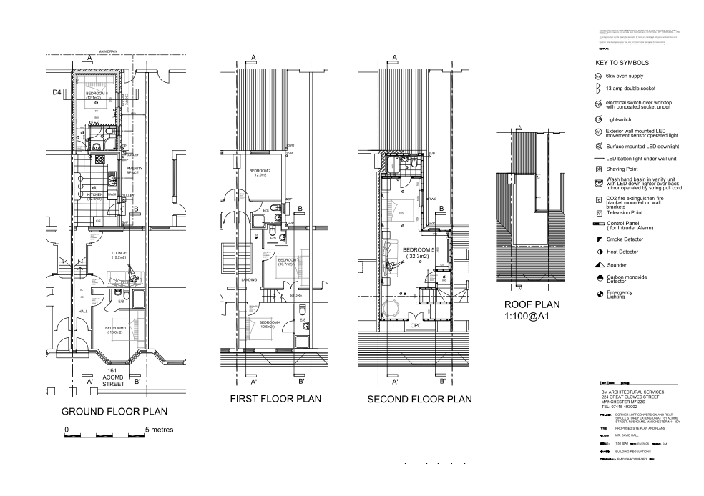
Figure 1. Proposed floor plans

Relevant planning history

Lawful development: Proposed - 145379/LP/2026
Single-storey extension and dormer roof extension both to the rear.
Refuse - 2026-04-17
- Rear Extension A.1(f)(i) - The proposed single storey rear extension as shown on the submitted drawings does not constitute permitted development. It fails to meet the requirements of Part 1, Schedule 2, A.1(f)(i) of the Town and Country Planning (General Permitted Development) (England) Order 2015 (as amended). The proposed extension would have a rearward projection of 5.1 metres and exceeds the 3 metre rearward projection permitted by A.1(f)(i).
- Refuse Dormer B.2(c) (i) and (ii) - The proposed rear dormer as shown on the submitted drawings does not constitute permitted development. It fails to meet the requirements of Part 1, Schedule 2, B.2(c)(i) and (ii) of the Town and Country Planning (General Permitted Development) (England) Order 2015 (as amended). There is no indication as to whether the proposed window would be obscurely glazed and the opening part of the window is less than 1.7 metres above the floor of the room in which it would be installed.

Consultation, notification and publicity responses

Notifications and publicity

Neighbour Letters

Negotiations
During the assessment of the application, concerns were raised regarding the proposed use of the property. Whilst the submitted plans illustrated six bedrooms, communal living space and associated bathroom facilities, the application documents did not clearly identify whether the proposal was intended to remain as a single dwellinghouse (Use Class C3) or whether a change of use to a House in Multiple Occupation (Use Class C4) was proposed.
Accordingly, the applicant/agent was contacted and asked to clarify the intended use of the property following completion of the works. Confirmation was subsequently provided that the property would remain in use as a single dwellinghouse (Use Class C3). The assessment of the application has been undertaken on that basis.

Relevant policies
In accordance with Section 38(6) of the Planning and Compulsory Purchase Act 2004, decisions on planning applications must be made in line with the statutory development plan, unless material considerations indicate otherwise.

For Manchester, the development plan comprises:

- The Core Strategy (2012–2027)
- Saved policies of the Unitary Development Plan (UDP)
- The Places for Everyone Joint Development Plan Document (2022–2039)

These documents are considered up to date and carry substantial weight in decision-making. Supplementary Planning Documents (SPDs) and other local guidance may also be relevant.

National planning policy, including the National Planning Policy Framework (NPPF), is a material consideration and provides overarching guidance.

The Government has published a consultation draft of the NPPF, intended to improve housebuilding rates through a clearer, more predictable and faster policy basis for decision and plan making. While this draft is not yet adopted, it is a material consideration.

Where applicable, the Council must give special regard to preserving the character of conservation areas and the setting of listed buildings, in line with statutory duties under the Planning (Listed Buildings and Conservation Areas) Act 1990.

The policies referenced in this report are those considered most relevant to the nature, scale and location of the proposed development as follows:

- The Manchester Core Strategy Development Plan Document 2012-2027
  - Development Management and Planning Obligations
    - DM 1 - Development Management
  - Objective 1 - Spatial Principles
    - SP 1 - Spatial Principles (Partially replaced by PfE Policy JP-S 1)
  - Objective 6 Environment
    - EN 1 - Design Principles and Strategic Character Areas
    - EN 19 – Waste
- Guide to development in Manchester - supplementary planning document and planning guidance, April 2007
- Extant Unitary Development Plan (UDP) –
  - Citywide Development Control Policies
    - DC1 - Residential extensions
    - DC26 - Development and Noise
- Places for Everyone Plan Joint Development Plan Document 2022-2039-
  - Strategy
    - JP-Strat9: Southern Areas
  - Sustainable and Resilient Places
    - JP-S1: Sustainable Development
  - Places for People
    - JP-P1 Sustainable Places
- National Planning Policy Framework (NPPF) December 2024–
  - Section 2 - Achieving sustainable development
  - Section 4 – Decision-making
  - Section 11 – Making effective use of land
  - Section 12 – Achieving well-designed places
- National Planning Policy Framework Draft for Consultation December 2025 - National decision-making policies
  - Chapter 3 – Decision-making policies
    - DM1: Preparing development proposals
    - DM2: Information requirements
    - DM3: Determining development proposals
    - DM6: Use of planning conditions and obligations
    - DM7: Relationship with other regulatory regimes
  - Chapter 4 - Achieving sustainable development
    - S3: Presumption in favour of sustainable development
    - S4: Principle of development within settlements
  - Chapter 12 - Making effective use of land
    - L4: Residential extensions
  - Chapter 14 - Achieving well-designed places
    - DP3: Key principles for well-designed places
    - DP4: The Design process

Assessment

Principle of development
Many people prefer to extend their existing homes rather than move, and the planning system needs to accommodate this demand for more living space, while at the same time ensuring that the amenities of neighbours are protected, and that the overall character of the surrounding area is not harmed. The Council is not generally in favour of dealing with this issue by laying down firm rules about home extensions with each case looked at on its individual merits, having regard to a range of criteria.
In this case the principle of the development is acceptable.
As stated in Policy DM 1 of the Manchester Core Strategy, all development should have regard to the following specific issues:

Appropriate siting, layout, scale, form, massing, materials, and detail
The proposed extension and dormer have been designed to appear subordinate to the original dwellinghouse. The single-storey rear extension would project approximately 5.1m beyond the existing rear elevation and would have an eaves height of approximately 2.4m and a maximum height of approximately 2.9m.
In terms of massing, whilst the extension would project beyond the existing rear building line, its single-storey form and relatively modest height would ensure that it does not appear unduly dominant or overbearing when viewed from neighbouring properties. The extension would be contained within the established pattern of development found to the rear of the surrounding terraced properties and would not result in a harmful sense of enclosure to adjoining occupiers.
The proposed rear dormer would be sited on the rear roof slope and would not be readily visible from the public realm. Rear dormers are a common feature within the locality and the proposal would not appear incongruous or out of keeping with the host property or surrounding area. Owing to its position within the roofscape, the dormer would not add materially to the perceived bulk of the dwelling when viewed from neighbouring properties. Significant weight is afforded to the previous Lawful Development Certificate assessment, which found no conflict with the size and volume limitations of Class B. Whilst the certificate was ultimately refused on other grounds, no concerns were identified regarding the overall size, scale or massing of the proposed dormer extension.
The application form confirms that external materials would match those of the existing dwellinghouse. Furthermore, the submitted specifications indicate that new windows and doors would comprise uPVC double-glazed units. The proposal would therefore integrate satisfactorily with the existing dwelling and preserve the character and appearance of the wider area.
Impact on the surrounding areas in terms of the design, scale and appearance of the proposed development. Development should have regard to the character of the surrounding area.
The principal works would be located to the rear of the property and would have limited visibility from the public highway. Given the siting, scale and design of the extension and dormer, together with the proposed use of matching materials, the development would not adversely affect the character or appearance of the street scene. The proposal is therefore considered to comply with Core Strategy Policies DM1 and EN1 and saved UDP Policy DC1.

Effects on amenity

Privacy
The proposal includes adding bifold doors to the new rear elevation however given these are at ground floor and replace similar windows on this elevation the impact to privacy is minimal.
The new side facing first floor windows are required to be obscure glazed to minimise overlooking concerns. The side facing window is a bathroom window so shouldn’t be onerous on the applicant. This has been conditioned.

Light
Given the proposal is entirely at ground floor level and the impact to light from the added massing is minimal.

Noise
The proposed extension is not expected to generate any noise beyond what would be reasonably expected of a residential dwelling.

Vibration
[x]

Air Quality
[X]

Odours
[X]

Litter
[X]

Vermin
[X]

Birds
[X]

Road Safety and Traffic Generation
[X]

Accessibility: buildings and neighbourhoods fully accessible to disabled people, access to new development by sustainable transport modes.
The proposal does not change how people can get in and out of the building.
The proposal introduces a new porch however doesn’t create an accessibility issue to the property.
The property is well served by local public transport.

Community safety and crime prevention.
GMP recommended…

Design for Health
[X]

Adequacy of internal accommodation and external amenity space.
The proposal adds space inside the property with minimal effect to the outdoor area and maintains a good level of external amenity space post development.

Refuse storage and collection.
The proposal itself has little impact on waste from the site. It uses the current storage and collection methods on site and maintains external access to the rear of the property.
The proposal removes external access to the rear of the property and the applicant has confirmed that waste bins are to be stored in the garage/bin store as denoted on the submitted plans.

Vehicular access and car parking
The proposal doesn't change how vehicles access and park at the property.
The proposal would remove a vehicle parking garage but maintains off street parking at the property.
The proposal would remove a vehicle parking space but maintains adequate off-street parking at the property.
The proposal includes the addition of a dropped kerb to the property which has been accepted by highways. The applicant should note that a dropped kerb application may be required (added as an informative)

Effects relating to biodiversity, landscape, archaeological or built heritage

Biodiversity
BNG – not applicable for FH

Landscape
Significant landscape changes…

Archaeological or built heritage
The proposal does not sit within a Conservation Area or near a designated heritage asset.
The proposal is within the Blackburn Park Conservation Area.

Blackburn Park is a prosperous residential area in the south of the city, and development control is aimed at maintaining this prosperity as well as the quality of the environment. This inevitably means a compromise which limits future development. However well-maintained, buildings become worn out with age and need to be replaced or refurbished.

The scale of the development minimises any harm to the conservation area and heritage assets, and the development is in keeping with existing area.

The proposal is in keeping with the architectural style of the existing property and sits comfortably within the street scene. It is of note that many properties in the area feature extensions and outbuildings.

The harm to the conservation area and local heritage assets would be less than substantial (as set out in the NPPF Section 16)

Green Infrastructure including open space, both public and private
The dwelling benefits from a garden beyond the siting of the proposed development and maintains a good amount of private green space post development.
The proposal has no impact on green infrastructure.

Flood risk and drainage.
The site is not located in a flood risk area and therefore does not require a flood statement or assessment.
The proposal is located in Flood Zone [x]. The applicant provided the required information and, Flood Risk as the LLFA, accepted that the proposal was acceptable.
The proposal is located in Flood Zone [x]. The applicant did not provide the required information. Flood Risk, as the LLFA, recommended a condition be attached for a Flood Risk Assessment to be provided.
The proposal is located in a medium/high surface water risk area…
The proposal has a negligible impact on drainage using the existing drainage on site.

Existing or proposed hazardous installations.
The proposal is within the buffer zone for the historic Parrs Wood landfill site. Environmental Health had no comments/objections to make. Environmental Health recommended that a contaminated land survey is required and has been conditioned.
TFGM were consulted on this application and had no objection to the proposed recommending an informative be attached regarding working safely near Metrolink.

Subject to scheme viability, developers will be required to demonstrate that new development incorporates sustainable construction techniques
As required.

Other Legislative Requirements

Equality Act 2010
Section 149 (Public Sector Equality Duty) of the Equality Act 2010 requires due regard to the need to: Eliminate unlawful discrimination, harassment and victimisation and other conduct prohibited by the Act and; Advance equality of opportunity between persons who share a protected characteristic and persons who do not share it. The Equality Duty does not impose a legal requirement to conduct an Equality Impact Assessment. Compliance with the Equality Duty involves consciously thinking about the aims of the Equality Duty as part of the process of decision-making.

Human Rights Act 1998 considerations
This application needs to be considered against the provisions of the Human Rights Act 1998. Under Article 6, the applicants (and those third parties, including local residents, who have made representations) have a right to a fair hearing and to this end the local planning authority must give full consideration to their comments.

Protocol 1 Article 1, and Article 8 where appropriate, confer(s) a right of respect for a person’s home, other land and business assets. In taking account of all material considerations, including Council policy as set out in the Core Strategy and saved polices of the Unitary Development Plan, the Director of Planning, Building Control & Licensing has concluded that some rights conferred by these articles on the applicant(s)/objector(s)/resident(s) and other occupiers and owners of nearby land that might be affected may be interfered with but that that interference is in accordance with the law and justified by being in the public interest and on the basis of the planning merits of the development proposal. She believes that any restriction on these rights posed by the recommendation given is proportionate to the wider benefits of and that such a decision falls within the margin of discretion afforded to the Council under the Town and Country Planning Acts.

Conclusion
{{Recommendation.arcusbuiltenv__Conclusion__c}:html(DocumentStyle)}

{{Recommendation.MCC_Work_With_Applicant_Statement__c}:hide-block-if-nothing}Article 35 Declaration
{{Recommendation.MCC_Work_With_Applicant_Statement__c}}

Recommendation: {{Recommendation.arcusbuiltenv__Recommended_Decision__c}}

Reasons for approval
[[ApprovalReasons.arcusbuiltenv__Ordering__c]:unprocessed]) | [[ApprovalReasons.arcusbuiltenv__Description__c]:html(DocumentStyle):unprocessed]

Conditions attached to this decision
[[Conditions.arcusbuiltenv__Ordering__c]:unprocessed]) | [[Conditions.arcusbuiltenv__Description__c]:html(DocumentStyle):unprocessed]

Informatives
[[Informatives.arcusbuiltenv__Ordering__c]:unprocessed]) | [[Informatives.arcusbuiltenv__Description__c]:html(DocumentStyle):unprocessed]

Reasons for refusal
[[RefusalReasons.arcusbuiltenv__Ordering__c]:unprocessed]) | [[RefusalReasons.arcusbuiltenv__Description__c]:html(DocumentStyle):unprocessed]

