

Planning

Delegated Officer Report

Summary of application details
Application reference: | PLA-2026-001009
Application type: | Consent to display an advertisement
Proposal: | Erection of double-sided internally illuminated freestanding digital advertisement totem.
Site address: | Site 3 - adjacent to No. 2 Circle Square along Symphony Park Circle Square Oxford Road Manchester M1 7ED
Ward(s): | Deansgate
Date application valid: | 13 July 2026
Applicant name: | Ocean Outdoor UK Ltd
Agent (if any): | Paul O'Neill
Case officer: | Ciara Gettinby
Recommendation: | Refuse
Date of recommendation: | 1 September 2026

Description of site, building and/or area
The proposed site is located adjacent to No.2 Circle Square, adjacent to Symphony Park, a landscaped public square which lies at the heart of a city centre neighbourhood known as Circle Square. The wider neighbourhood which is bounded by Oxford Road, Charles Street, Princess Road and the Mancunian Way was delivered through the Circle Square masterplan and The Former BBC Strategic Development Framework (BBC SRF). Circle Square now represents a successful high quality mixed use development which has been a catalyst to the now ongoing regeneration of the wider Oxford Road Corridor. The regeneration of this site previously a surface level car park, has delivered a high quality mixed-use neighbourhood comprising commercial workspace, residential accommodation, retail and leisure all centred around a brand-new city park.

A key part of delivering this high-quality neighbourhood was the setting of the building within the public realm which included a coherent placemaking strategy defined by a cohesive palette of wayfinding structures and other street furniture. This was implemented under application reference, 116450/FO/2017 approved in 2017. This included a number of slender wayfinding totems constructed from metal with a bespoke design. These are located at strategic points around the neighbourhood, encapsulating the Circle Square branding and helping to establish a strong sense of place within the wider area. The signage includes freestanding gateway totems, free standing directional totem cubes, free standing traffic directional and the wall mounted information signs (see below images demonstrating the consistent design.)

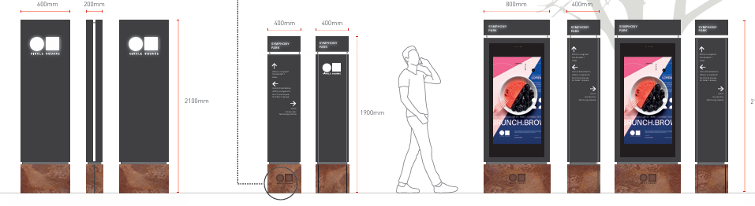
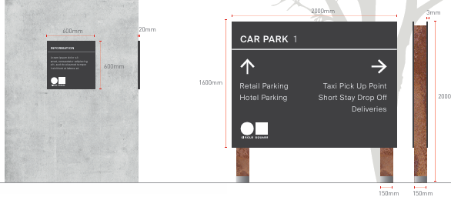
The wider area is also characterised by the neighbouring Universities, including, The University of Manchester and Manchester Metropolitan University, there is heavy footfall along Oxford Road due to the students and visitors of the University. Oxford Road is a key arterial gateway route leading into the City Centre from the Universities, it benefits from cycle lanes, and the road is restricted to buses and black cabs.

The proposed location is characterised by the tree-lined streets and greenery of Symphony Park. The carefully constructed design of the park provides a clear, scenic view of the landscaped area including its ranging elevations. This provides an attractive and peaceful area of green infrastructure for residents, workers and visitors.

There are no designated heritage assets (Scheduled Monuments, Grade I, II* and II Listed Buildings, Conservation Areas, Registered Parks and Gardens or Registered Battlefields) within the site boundary. There are a number of listed buildings in the vicinity, including Grade II listed Lass O'Gowrie pub on Charles Street and Grade II* Palace Hotel on Oxford Road. The Grade II listed Dancehall Theatre located on Oxford Road overlooks the broader Masterplan Site from the West. The Site is not within a Conservation Area but the border of the Whitworth Street Conservation Area lies to the north of on Whitworth Street. The site lies within a highly accessible City Centre location through the use of a variety of public transport including Metrolink, bus and rail.

Description of development
The proposal seeks advertisement consent for the installation of 1no. internally illuminated double sided digital advertising unit screen. This would include a black powder coated aluminium frame, and a double-sided LED screen. The unit would incorporate an Ultra HD screen on each side, ambient light sensors and laminated vandal glass. The screen would operate between 07:00 and 21:00 and would be controlled by a light sensor so that the luminance levels respond to surrounding lighting conditions.
The scheme has been submitted in relation to other advertisement consents around the Circle Square site, PLA-2026-001010, PLA-2026-001086 and PLA-2026-001009. Each proposal also consists of the erection of a double-sided illuminated freestanding digital advertisement totem.

Proposed Plans:
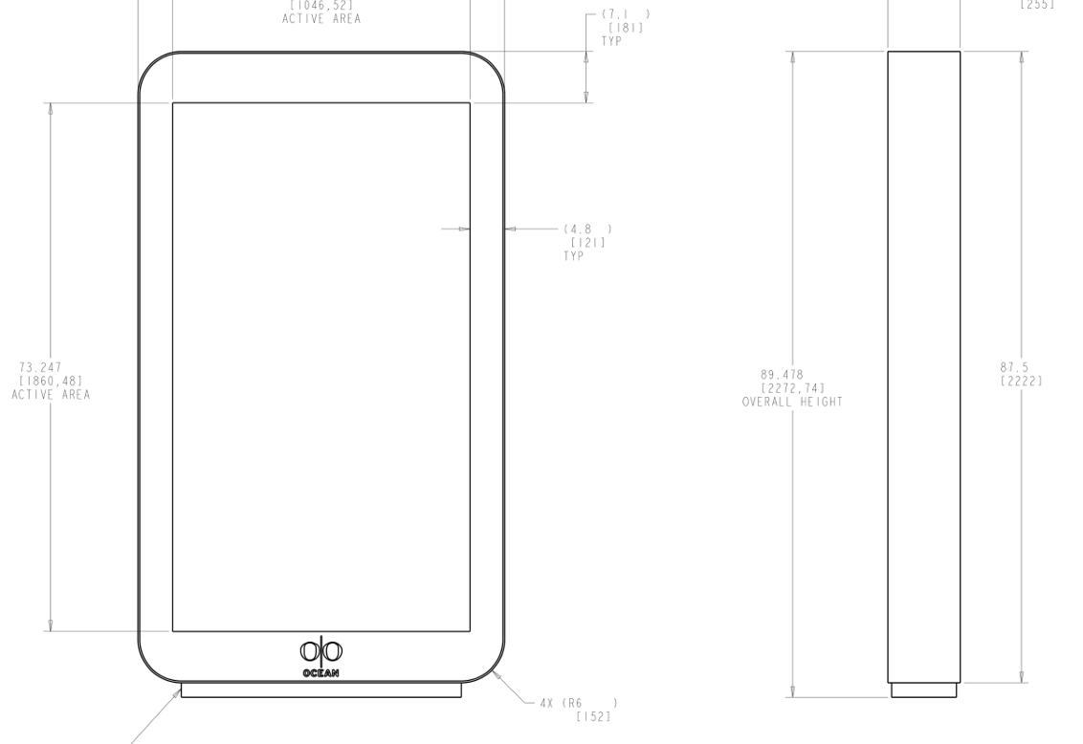
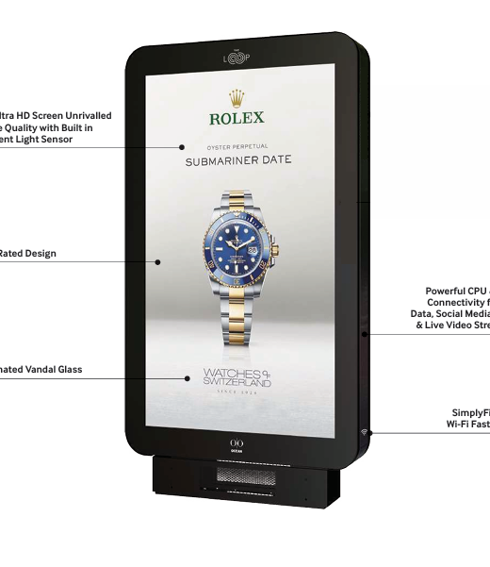
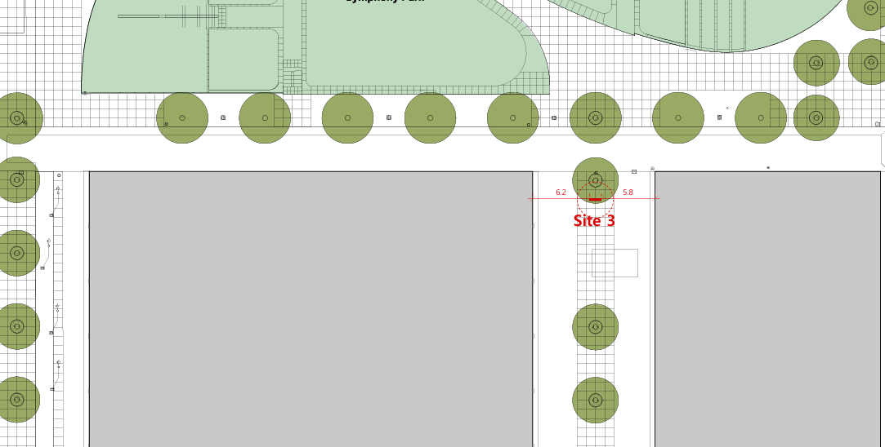

Site Photos:
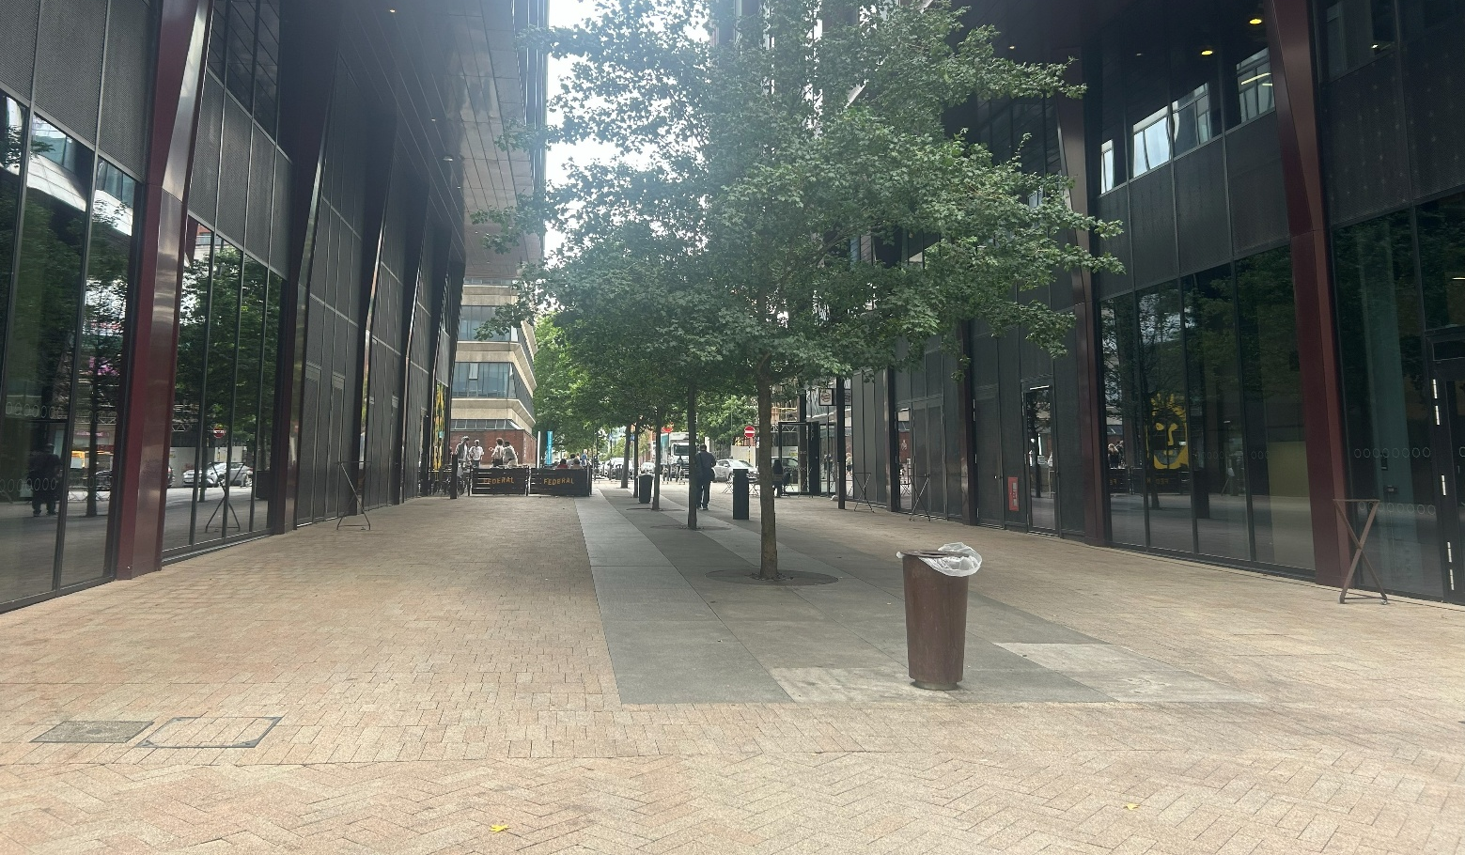

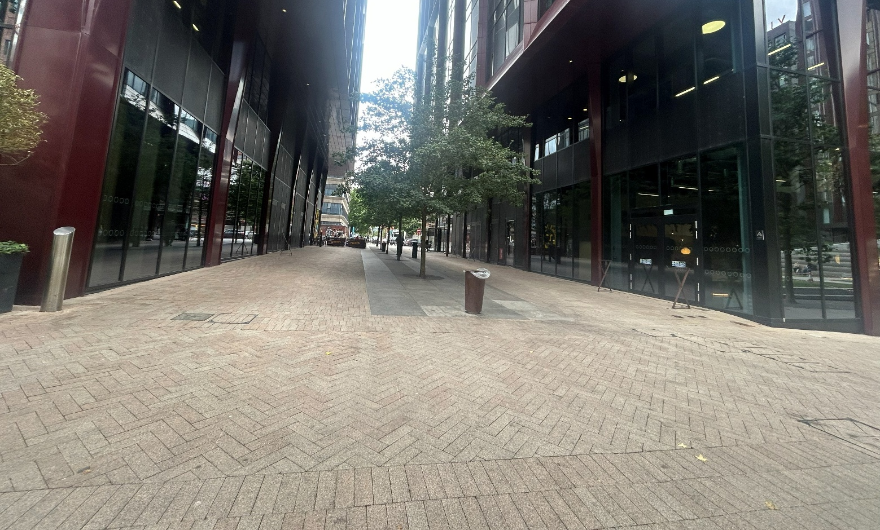

Site Photos

Consultation, notification and publicity responses

Consultations
Highway Services- No objections to the proposal but have provided necessary conditions should the application be approved.

Environmental health- Requested that if the application were to be approved, conditions should be attached to control the light of the display screens and for a maintenance management plan to be submitted.

Notifications and publicity
Neighbouring properties were notified via letter of the proposal; no representations have been received.

Relevant policies
The Town and County Planning (Control of Advertisements) Regulations 2007
The Local Planning Authority shall exercise its powers under these Regulations in the interests of amenity and public safety, taking into account-

- The provisions of the development plan, so far they are material; and
- Any other relevant factors

2.

- Factors relevant to amenity include the general characteristics of the locality, including the presence of any feature of historic, architectural, cultural or similar interest;
- Factors relevant to the public safety include-

- The safety of persons using any highway, railway, waterway, etc..
- Whether the display of an advertisement in question is likely to obscure or hinder the ready interpretation of, any traffic sign, railway signal or aid
- Whether the display of an advertisement in question is likely to hinder the operation of any device used for the purpose of security or surveillance or for measuring the speed of any vehicle

3. In taking account of factors relevant to amenity, the local planning authority may, if it thinks fit, disregard any advertisement that is being displayed.

4. Unless it appears to the Local Planning Authority to be required in the interests of amenity or public safety, an express consent for the display of advertisements shall not contain any limitation or restriction relating to the subject matter, content or design of what is to be displayed.

The following policies are considered relevant in the consideration of this application:

Places for Everyone- A long term plan of nine Greater Manchester districts for jobs, new homes and sustainable growth, it has been published by the GMCA on behalf of the nine districts (Bolton, Bury, Rochdale, Oldham, Tameside, Stockport, Manchester, Trafford, Salford, Wigan) and took into effect and become part of the statutory development plan on March 21, 2024.

-Policy JP-P1- Sustainable Places

The Manchester Core Strategy- Development Plan Document 2012- 2027 (The Core Strategy) was adopted by the City Council on the 11th of July 2012, it is a key document for the local plan which provides a framework that planning applications are assessed against.

Policy DM1- Development Management
Policy SP1- Spatial Principles

Unitary Development Plan (UDP)- The UDP has been superseded by the Core Strategy Development Plan, but certain policies are still considered relevance:

-Policy DC15- Advertisements, Hoardings and Posters

The National Planning Policy Framework (August 2026)- The Government’s new national planning policies and how they are to be implemented through local authorities.

Policy DP3- Key principles for well-designed places
Policy S3: Presumption in favour of sustainable development

Other Material Considerations:

Oxford Road Corridor Strategic Regeneration Framework Guidance (2019)
Sets out how growth will be supported by key place-making objections in terms of public realm, diversifying and uplifting the quality and range of uses around retail, food, drink, cultural sport and housing.

Former BBC Site Strategic Regeneration Framework Guidance (2013)
Sets out a guide to the future redevelopment of the former BBC site and adjoining land to ensure it becomes an economic priority and a key site for the Manchester corridor delivering high-quality regeneration on the site.

Greater Manchester’s Streets for All Design Guide (2023)
Sets out guidance on how Greater Manchester can achieve an inclusive and attractive walking and wheeling environment.

Assessment
In the case of this application, the principle of the proposal is considered unacceptable and cannot be supported as it conflicts with the development plan policies and associated guidance listed in the preceding section. It is considered that the insertion of a digital advertisement display would have an unduly harmful impact on the visual amenity of the area.

Visual Amenity
The existing signage around the site has a clear purpose to aid wayfinding and mark a key entrance route into the neighbourhood and to support that, has a bespoke design with clear visual linkages to the wider palate of materials within the public realm as a holistic part of the wayfinding strategy within the neighbourhood. The proposed totem’s design is not considered to be as detailed or reflect the character of Circle Square due to its monotonous materials and logos unrelated to the site. The proposed offers a standard commercial advertising unit that would not provide any characteristic elements that would contribute towards the quality of the visual amenity within Circle Square.

Additionally, the proposed site does not currently contain any advertisement or free-standing sign. The proposed would introduce a new advert to the location, and although the surrounding area is considered to be commercial in nature, the insertion of an LED advertisement display in this location would result in additional and unnecessary visual clutter within an area of public realm which has a well considered and high quality layout and design inclusive of bespoke wayfinding totems. The design and materials would be incongruous within that context. The proposed would not be appropriate in terms of siting, materials, scale and form and would negatively impact on the surrounding area of Circle Square in terms of its appearance and design, contrary to Policy DM1 of the Manchester Core Strategy.

Policy 15 of the UDP states that the Local Planning Authority should take into account the effects on the visual amenity and the scope for adverts to make a positive contribution to the locality, amongst other factors. The proposed advertisement would form a dominant and obtrusive feature that would intrude into an area of high amenity value, resulting in an adverse impact on the visual amenity of Circle Square. The insertion of the digital display screen would damage the views of the landscaped area and character that has been shaped by the tree-lined streets and greenery. Through refusing this application, the LPA is safeguarding the visual amenity and supporting the retention of the current high quality place-making of Circle Square.

The insertion of the double-sided LED digital display screen in this location would be contrary to Policy JP-P1 of the Places for Everyone Joint Development Document as the proposed would distract and take away from the existing landscape features of Circle Square. Policy JP-P1 states that development proposals should be consistent with ‘incorporating high quality and well managed green infrastructure and quality public realm.’ This would also undermine the Former BBC Strategy Development Framework (BBC SRF) which emphasises the importance of maintaining [the] ‘general attractiveness of the site.’ The introduction of an advertisement in this location is considered to diminish the general attractiveness of the site.

The proposal is considered to undermine the council’s current efforts to remove unnecessary street clutter from within the City Centre and would appear out of context to the street. The ‘Streets for All Design Guide’ seeks to avoid unnecessary street clutter. The free-standing sign would be visually obtrusive and constitute of a bulky, dominant item due to its height, width and large advertisement panels on both sides. Therefore, the proposal would be contrary to Policy DP3 of the NPPF as it would not integrate or enhance its surroundings nor would not respond successfully to its context.

It is noted that there was consent granted for a digital and directional totem approved within Circle Square under advertisement consent, 127455/AOH/2020, however that digital totem is in-keeping with the place making design and does not display commercial advertising, only providing information about activities and facilities within the neighbourhood. Additionally, this totem is smaller in scale (in width and screen size) and provides continuous wayfinding and directional benefits to visitors of the site while maintaining cohesive placemaking.

In consideration of the above it is considered that the proposal for the advertisement, would be visually detrimental to Circle Square and therefore contrary to the provisions of Town and Country Planning (Control of Advertisement) (England) Regulations 2007, Policies JP-P1 of the Places for Everyone Plan, Policies SP1 and DM1 of the Manchester Core Strategy (2012), saved Policies DC15.1, DC15.2 and of the Unitary Development Plan for the City of Manchester (1995) and Policy DP3 and S3 of the National Planning Policy Framework.

Public Safety
Although the proposals siting would create an increased obstacle and contributes to the impression of clutter, it is not considered that there is evidence of a public safety impact for pedestrians in order to warrant a reason for refusal on these grounds.

Other Legislative Requirements

Equality Act 2010
Section 149 (Public Sector Equality Duty) of the Equality Act 2010 requires due regard to the need to: Eliminate unlawful discrimination, harassment and victimisation and other conduct prohibited by the Act and; Advance equality of opportunity between persons who share a protected characteristic and persons who do not share it. The Equality Duty does not impose a legal requirement to conduct an Equality Impact Assessment. Compliance with the Equality Duty involves consciously thinking about the aims of the Equality Duty as part of the process of decision-making.

Human Rights Act 1998 considerations
This application needs to be considered against the provisions of the Human Rights Act 1998. Under Article 6, the applicants (and those third parties, including local residents, who have made representations) have a right to a fair hearing and to this end the local planning authority must give full consideration to their comments.

Protocol 1 Article 1, and Article 8 where appropriate, confer(s) a right of respect for a person’s home, other land and business assets. In taking account of all material considerations, including Council policy as set out in the Core Strategy and saved polices of the Unitary Development Plan, the Director of Planning, Building Control & Licensing has concluded that some rights conferred by these articles on the applicant(s)/objector(s)/resident(s) and other occupiers and owners of nearby land that might be affected may be interfered with but that that interference is in accordance with the law and justified by being in the public interest and on the basis of the planning merits of the development proposal. She believes that any restriction on these rights posed by the recommendation given is proportionate to the wider benefits of and that such a decision falls within the margin of discretion afforded to the Council under the Town and Country Planning Acts.

Conclusion
Any public safety concerns of the proposed digital advertising displays are not significant enough to refuse on public safety grounds.

However, due to a combination of its height, width, materiality, illumination and appearance, the proposed digital advert would represent a visually obtrusive feature on the pavement. Therefore, the proposed digital advert is refused on visual amenity grounds, due to the proposal being contrary to the Town and Country Planning (Control of Advertisement) (England) Regulations 2007, Policies JP-P1 of the Places for Everyone Plan, Policies SP1 and DM1 of the Manchester Core Strategy (2012), saved Policies DC15.1, DC15.2 and of the Unitary Development Plan for the City of Manchester (1995) and Policy DP3 and S3 of the National Planning Policy Framework

Recommendation: Refuse

Reasons for refusal

The proposal would result in an unduly harmful impact on visual amenity within Circle Square due to its siting, design, appearance and means of illumination and would form an obtrusive and dominant feature within street scene. It would create visual clutter which would be detrimental to the quality of the character of the immediate area, visual amenity of the local context and pedestrian experience. The proposal therefore is contrary to the provisions of Town and Country Planning (Control of Advertisement) (England) Regulations 2007, Policies JP-P1, of the Places for Everyone Plan, Policies SP1 and DM1 of the Manchester Core Strategy (2012), saved Policies DC15.1, DC15.2 of the Unitary Development Plan for the City of Manchester (1995) and Policy DP3 and S3 of the National Planning Policy Framework.

