

Planning

Delegated Officer Report

Summary of application details
Application reference: | PLA-2026-001017
Application type: | Consent to display an advertisement
Proposal: | Installation of 2no. non-illuminated high level signs.
Site address: | Sandra Burlsem Building Lower Ormond Street, Manchester M15 6BH
Ward(s): | Hulme
Date application valid: | 14 July 2026
Applicant name: | Manchester Metropolitan University
Agent (if any): | Mr Tom Young
Case officer: | Ciara Gettinby
Recommendation: | Approve
Date of recommendation: | 2 September 2026

Description of site, building and/or area
The application site relates to the Sandra Burlsem Building on Lower Ormond Street, a seven
storey building that is the base for the Manchester Law School. The building is modern in design
with wall-to-wall glazing framed in aluminium and has undergone various improvement works
over the years. The application building is located in the All Saints Campus for Manchester
Metropolitan which is also undergoing improvement projects to create a central hub for student
support services adjacent to the Sandra Burlsem Building. The site is bounded to the north by
the Mancunian Way and is connected to other Manchester Metropolitan buildings, including the
faculty of business and law. The site is bounded to the east by Oxford Road and All Saints Park
]its south-east of the applicant site.

The building is located in the vicinity of the Former Manchester Ear Hospital Listed Building, Grade II, Listed Building Roman Catholic of St Augustine of Grade II status and Listed Building Ormond Building of Grade II status.

Site Photos:


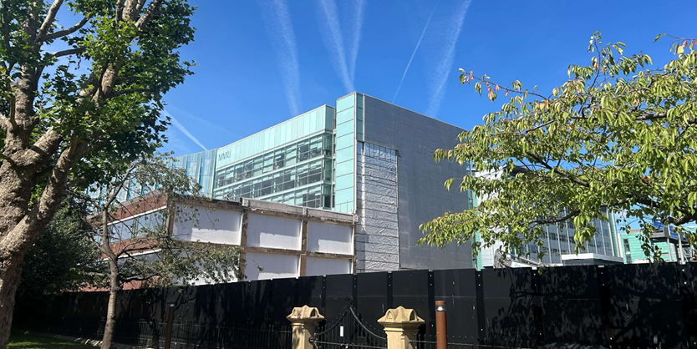

Description of development
Advertisement consent is sought for the installation of 2no. non-illuminated high-level signs. One sign would be located on the north elevation of the building and the other would be located on the south elevation of the building.

Proposed Plans:
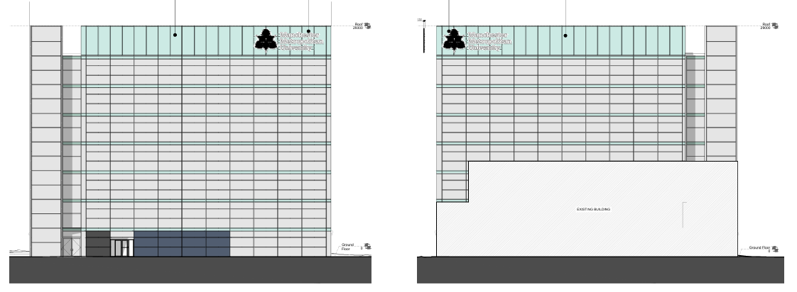

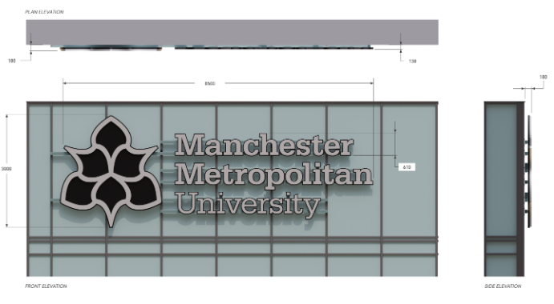

Consultation, notification and publicity responses

Consultations

Highway Services- no objections.

Notifications and publicity

Neighbours were notified of the development via letter; no representations have been received.

Relevant policies
The Town and County Planning (Control of Advertisements) Regulations 2007
The Local Planning Authority shall exercise its powers under these Regulations in the interests of amenity and public safety, taking into account-

- The provisions of the development plan, so far they are material; and
- Any other relevant factors

2.

- Factors relevant to amenity include the general characteristics of the locality, including the presence of any feature of historic, architectural, cultural or similar interest;
- Factors relevant to the public safety include-

- The safety of persons using any highway, railway, waterway, etc..
- Whether the display of an advertisement in question is likely to obscure or hinder the ready interpretation of, any traffic sign, railway signal or aid
- Whether the display of an advertisement in question is likely to hinder the operation of any device used for the purpose of security or surveillance or for measuring the speed of any vehicle

3. In taking account of factors relevant to amenity, the local planning authority may, if it thinks fit, disregard any advertisement that is being displayed.

4. Unless it appears to the Local Planning Authority to be required in the interests of amenity or public safety, an express consent for the display of advertisements shall not contain any limitation or restriction relating to the subject matter, content or design of what is to be displayed.

The following policies are considered relevant in the consideration of this application:

Places for Everyone- A long term plan of nine Greater Manchester districts for jobs, new homes and sustainable growth, it has been published by the GMCA on behalf of the nine districts (Bolton, Bury, Rochdale, Oldham, Tameside, Stockport, Manchester, Trafford, Salford, Wigan) and took into effect and become part of the statutory development plan on March 21, 2024.

Policy JP-P1: Sustainable Places

The Manchester Core Strategy- Development Plan Document 2012- 2027 (The Core Strategy) was adopted by the City Council on the 11th of July 2012, it is a key document for the local plan which provides a framework that planning applications are assessed against.

Policy DM1- Development Management
Policy SP1- Spatial Principles

Unitary Development Plan (UDP)- The UDP has been superseded by the Core Strategy Development Plan, but certain policies are still considered relevance:

-Policy 14 – Shopfronts and related signs

The National Planning Policy Framework (August 2026)- The Government’s new national planning policies and how they are to be implemented through local authorities.

Policy DP3- Key principles for well-designed places
Policy S3: Presumption in favour of sustainable development

Assessment
The advertisement regulations require that applications for shop signs be considered only in the interests of amenity and public safety. An assessment of the proposals under these criteria is outlined below.

Visual Amenity
The letters and logo would be individually mounted to a rail and would be made of aluminium. The signs would be located on the north and south elevation and would sit on the upper corner of the elevation, replacing the positioning of the existing ‘MMU’ signage. As the advertisements would be replacing existing signs, the proposed adverts are considered to be in character with the surrounding advertisement environment in terms of its size and scale. As both signs would match in appearance, design and scale, it is considered to provide a uniformed appearance across the building.

The logo and signage are considered to contribute to the distinctive sense of place of the All Saints Campus and would aid visitors in identifying the related building to the University. This proposal is part of a wider scheme in unifying material palettes and defining the university owned buildings, the proposed is considered to be in-line with this and would contribute to the overall wayfinding of the campus. Considering the above, the proposals would be consistent with Core Strategy Policies SP1 and DM1, Places for Everyone Policies JP-Strat2 and JP-P1 and Polic DC14 of the Unitary Development Plan.

Public Safety
Signage would not be illuminated and as part of this application, MCC Highway Services were consulted and no objections received. As such, there are no public safety concerns associated with this proposal, pursuant to Policy DC14 and DM1.

Other Legislative Requirements

Equality Act 2010
Section 149 (Public Sector Equality Duty) of the Equality Act 2010 requires due regard to the need to: Eliminate unlawful discrimination, harassment and victimisation and other conduct prohibited by the Act and; Advance equality of opportunity between persons who share a protected characteristic and persons who do not share it. The Equality Duty does not impose a legal requirement to conduct an Equality Impact Assessment. Compliance with the Equality Duty involves consciously thinking about the aims of the Equality Duty as part of the process of decision-making.

Human Rights Act 1998 considerations
This application needs to be considered against the provisions of the Human Rights Act 1998. Under Article 6, the applicants (and those third parties, including local residents, who have made representations) have a right to a fair hearing and to this end the local planning authority must give full consideration to their comments.

Protocol 1 Article 1, and Article 8 where appropriate, confer(s) a right of respect for a person’s home, other land and business assets. In taking account of all material considerations, including Council policy as set out in the Core Strategy and saved polices of the Unitary Development Plan, the Director of Planning, Building Control & Licensing has concluded that some rights conferred by these articles on the applicant(s)/objector(s)/resident(s) and other occupiers and owners of nearby land that might be affected may be interfered with but that that interference is in accordance with the law and justified by being in the public interest and on the basis of the planning merits of the development proposal. She believes that any restriction on these rights posed by the recommendation given is proportionate to the wider benefits of and that such a decision falls within the margin of discretion afforded to the Council under the Town and Country Planning Acts.

Conclusion

Recommendation: Approve

Conditions attached to this decision

- No advertisement is to be displayed without the permission of the owner of the site or any other person with an interest in the site entitled to grant permission.

No advertisement shall be sited or displayed so as to:
(a) endanger persons using any highway, railway, waterway, dock, harbour or aerodrome (civil or military);
(b) obscure, or hinder the ready interpretation of, any traffic sign, railway signal or aid to navigation by water or air; or
(c) hinder the operation of any device used for the purpose of security or surveillance or for measuring the speed of any vehicle.

Any advertisement displayed, and any site used for the display of advertisements, shall be maintained in a condition that does not impair the visual amenity of the site. Any structure or hoarding erected or used principally for the purpose of displaying advertisements shall be maintained in a condition that does not endanger the public. Where an advertisement is required under these Regulations to be removed, the site shall be left in a condition that does not endanger the public or impair visual amenity.

- The development hereby approved shall be carried out in accordance with the following documents:

Location Plan, drawing no. 1000 received by the LPA on 14 July 2026
Existing and Proposed elevations (North & South), drawing no. 1001, received by the LPA on the 14 July 2026
Existing and Proposed elevations (East & West), drawing no. 1002, received by the LPA on the 14 July 2026

Reason- to ensure that the development is carried out in accordance with the approved plans, pursuant to saved policy DC1 of the Unitary Development Plan for the City of Manchester and policies SP1 and DM1 of the Manchester Core Strategy.

