

Planning

Delegated Officer Report

Summary of application details
Application reference: | PLA-2026-000808
Application type: | Full planning permission
Proposal: | Erection of single storey detached dwellinghouse with associated car parking landscaping and boundary treatments.
Site address: | 46 Withenfield Road Manchester M23 9BS
Ward(s): | Brooklands
Date application valid: | 28 July 2026
Applicant name: | Mr Adrian Flanagan
Agent (if any): | Stephen Lamb
Case officer: | Steven Mccoombe
Recommendation: | Approve
Date of recommendation: | 27 August 2026

Description of site, building and/or area
The application site relates to the side garden of No.46 Withenfield Road and an existing, detached single storey residential annexe sited to the south of the main two storey dwellinghouse, previously granted planning permission in 2016.

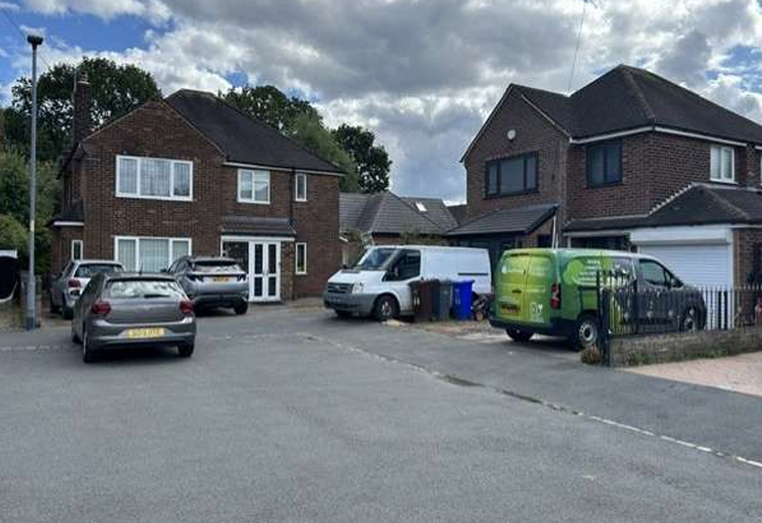
View of application site from Withenfield Road

The existing dwellinghouse is located at the end of a residential cul-de-sac within an established residential area, characterised mainly by two-storey detached and semi-detached dwellings set within relatively generous plots. The site is bounded by residential properties to the north, south and west, whilst Wythenshawe Park woodland forms the eastern boundary and can be accessed from the host property by a gate in the eastern boundary fence.

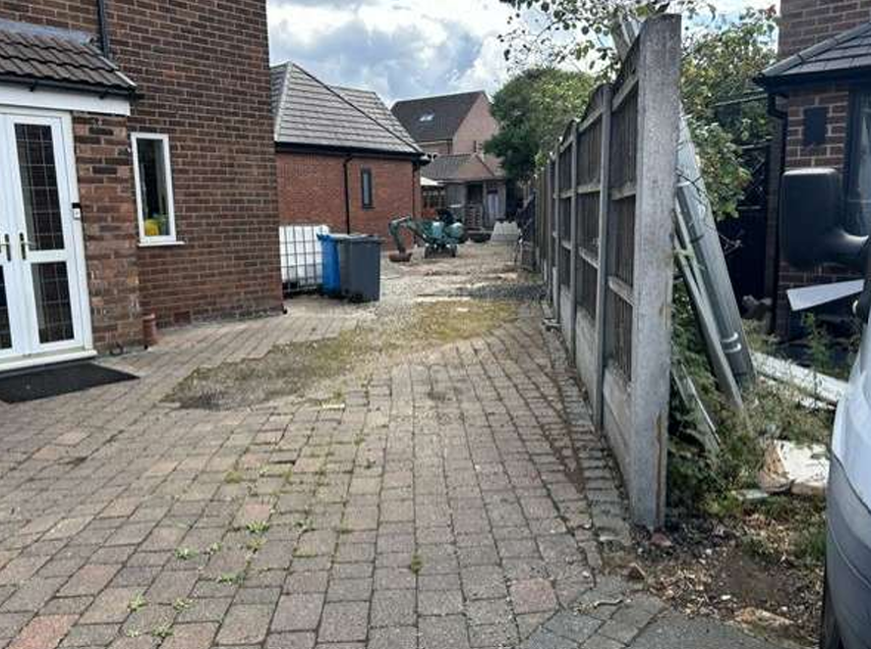
View of application site from the kerbside

Description of development
Planning permission is sought for alterations to the existing annexe and its conversion into a self-contained dwellinghouse (Class C3).

The principal amendments proposed under this application comprise the addition of a single-storey porch to the western elevation and revisions to the loft area, including the removal of windows and rooflights. Two rooflights are retained to serve the vaulted living and dining space.

The proposed floorspace comprises an open-plan kitchen, living and dining area, a separate lounge, three bedrooms, two bathrooms, a snug and a utility room.

The applicant has provided the below drawing which compares approved scheme with that of the proposed. The proposed approved building is outlined in blue and the building as constructed in black.

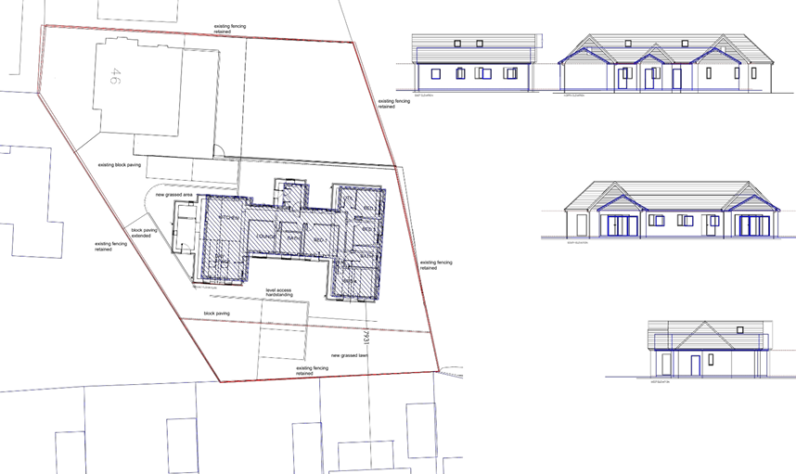
Comparison drawing between existing and proposed

The proposal incorporates dedicated off-street parking and turning facilities for the proposed dwelling, accessed from Withenfield Road via a driveway situated alongside the existing property. Off-street parking for the existing dwelling is retained within its frontage, providing space for two vehicles.

Boundary treatment comprising 1.8-metre-high timber fencing is proposed along with a pergola to the south of the proposed dwellinghouse.

Relevant planning history
110882/FO/2015/S2

Erection of a single storey outbuilding to provide ancillary residential accommodation. Approved 23 March 2016.

090513/FH/2009/S2

Erection of a single storey building in rear garden to form additional residential and leisure accommodation. Approved 15 October 2009.

072042/FH/2004/S2

Erection of a 2-storey side extension following demolition of existing garage, and conversion of loft to form additional living accommodation. Approved 3 October 2004.

Consultation, notification and publicity responses
Local Residents/Occupiers – 1 objection has been received by a neighbouring occupier.

The proposal is considered inappropriate subdivision of a plot that was intended to accommodate only a single dwelling. It is felt that the creation of two separate dwellings would result in an unacceptable intensification of residential use, leading to increased noise, activity, vehicle movements and general disturbance, to the detriment of neighbouring residents' amenity and enjoyment of their properties.

Concern is also raised regarding the loss of garden space and open character of the site.

Environmental Health – The PRA recommended a watching brief and the site was of low risk. There is a letter confirming that no unexpected contamination was found so this is acceptable, as are the waste management arrangements.

Flood Risk Management - The applicant is advised to incorporate Property Flood Resilience (PFR) measures to a minimum of 150mm above the surface water flood level or a minimum of 600mm above the fluvial flood level. The proposal can be approved with no condition required.

United Utilities – Advice is provided in relates to their assets and infrastructure and the applicant’s responsibilities.

Highways Services - No objection in principle to the proposal. It is advised that the conversion of the approved annexe to a self-contained dwelling is not expected to generate a significant increase in vehicle movements and is unlikely to result in highway capacity issues.

The site is considered to be in a sustainable location, with access to regular bus services on Moor Road and Wythenshawe Road and the Moor Road Metrolink stop within walking distance.

In respect of parking and access, the proposed provision of two tandem parking spaces is noted; however, further details are required, including a plan showing the dimensions of all new and relocated parking spaces, details of the access width, and a swept-path assessment demonstrating that vehicles can safely enter, manoeuvre within, and exit the site in a forward gear. It is also recommended the provision of access protection (H-bar) markings are provided and that boundary treatments adjacent to the access should not exceed 0.6 metres in height to maintain visibility.

Provision of a 7kW electric vehicle charging point is supported, whilst secure and covered cycle parking should be provided at a rate of one space per dwelling. The proposed refuse storage arrangements are also considered acceptable.

Relevant policies
The following policy and guidance is considered relevant to the consideration of this application:

- Policies DM1, SP1, H1, H7, T2, EN3, EN4, EN14, EN14, EN16-19 of the Core Strategy;
- Saved policy DC6, DC7.1 and DC26 of the UDP;
- Places for Everyone Joint Development Plan – policies JP-P2, JP-S1, JP-H3, JP-P1 and JP-G8.
- Guide to Development in Manchester (SPD);
- Residential Quality Guidance;
- National Planning Policy Framework (2026)

Assessment
Principle

The general principle of the building has already been established through the previous permission for the annexe. Accordingly, the key considerations in this application relate to the proposed amendments to the layout and elevations, landscaping and boundary treatments, and the building's intended use.

The site is located within an established residential area where the proposed use would be compatible with the surrounding pattern of development. The building has already been substantially completed in broad accordance with the approved plans and would not result in any materially greater impact on neighbouring residential amenity or the character and appearance of the area than that previously approved.

Further, due to generous size of the side garden area, the site is capable of accommodating a self-contained dwelling with its own curtilage, parking and turning facilities without causing harm to the surrounding area. As such, the proposal is considered acceptable in principle and compliant with the aforementioned, overarching policy and guidance.

Residential and Visual Amenity

Due to the location of the proposed building and existing boundary treatments, the development is largely screened from public domain and has a minimal presence within the wider street scene.

The building footprint is comparable to that of the previous annexe, albeit with a slight increase in roof height. The proposed external materials are in keeping with the area and would not appear strident or out of place.

Given the relationship and separation distances to neighbouring properties and the single-storey nature of the building, there would be no unduly harmful impact in terms of over shadowing or overdominance.

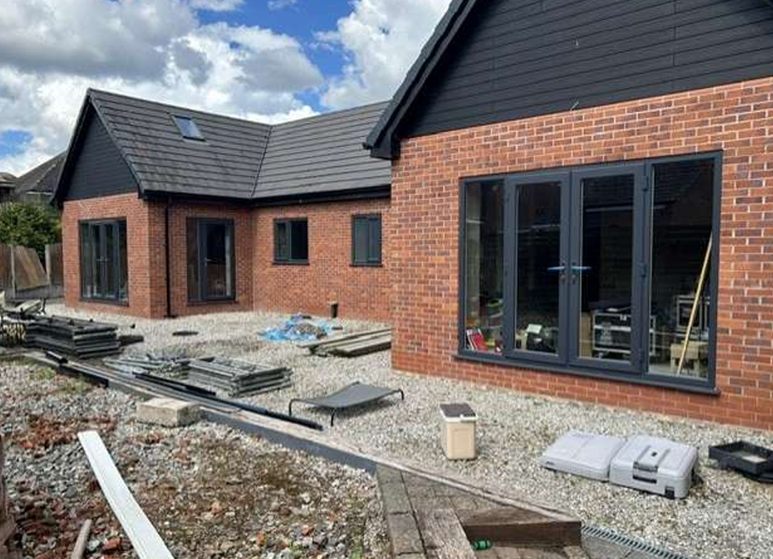
View of southern elevation facing the boundary with No.44

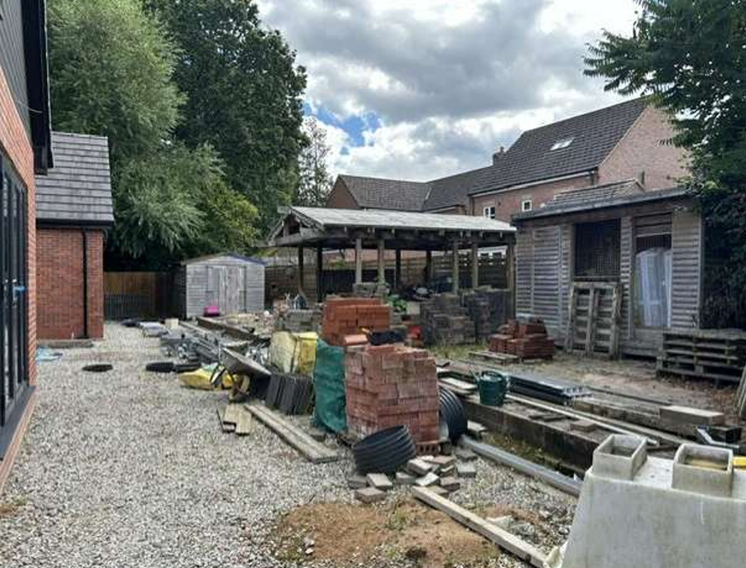
View of proposed garden area for the dwellinghouse looking
towards boundary with No.44

The shared boundary with No.44 is screened by close-boarded fencing and the side elevation of the neighbouring property contains no habitable room windows at ground floor level facing towards the application site due conservatory structure being obscurely glazed. As such, the development would not result in any material loss of privacy, outlook or residential amenity for adjoining occupiers to the south.

Whilst the proposed building would be close to the common boundary of the main dwellinghouse at No. 46 and includes a series of windows along facing the garden area, a 1.8-metre-high close-boarded fence is proposed between No. 46 and the proposed dwelling, to prevent any overlooking or perceived overlooking. A condition is also included to ensure the windows on the side elevation facing No.46 are obscurely glazing to safeguard existing and prospective occupiers from overlooking or intrusion.

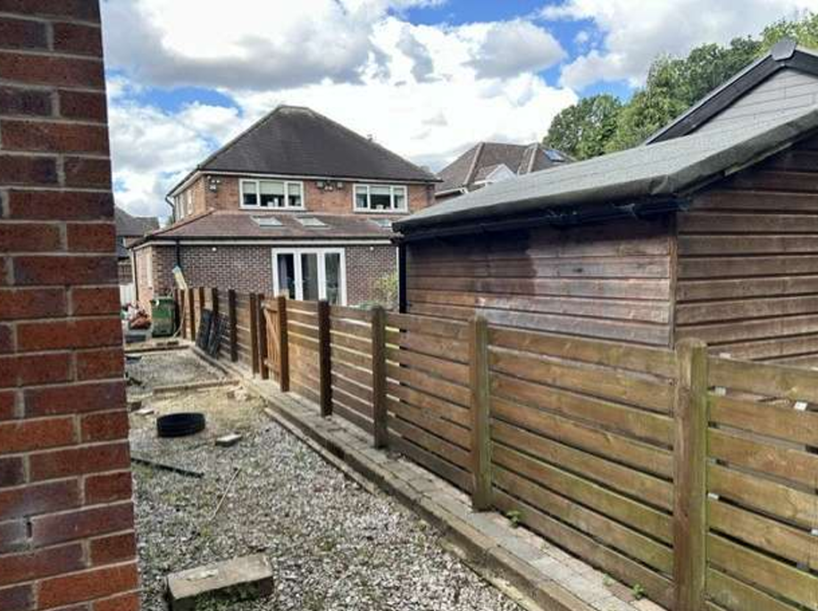

Access would be taken from the existing drive serving the site, with the anticipated activity and any associated disturbed anticipated to be modest, typical of a suburban setting and not material different to its authorised use.

On balance, the proposed residential development represents an acceptable form of infill housing that would assimilate successfully within its established residential surroundings without giving rise to any significant adverse impacts on the character of the area or the amenities of neighbouring occupiers. The development makes efficient use of a sustainable and previously developed residential curtilage, in accordance with the objectives of the National Planning Policy Framework, which seeks to optimise the use of available land and supports appropriately designed infill development within urban areas.

As further safeguards to protect neighbouring amenity and the character of the area, conditions have been included to prevent the use of the dwellinghouse hereby approved from being used as a house in multiple occupation or for serviced accommodation.

Highway Impact

The proposed change from an annexe to a self-contained family dwelling is not anticipated to result in a material increase in vehicle movements when compared with the previously approved development. The proposal would include and retain a sufficient level of off road car provision for the proposed dwellinghouse and for the existing property at No.46.

Whilst the proposal incorporates dedicated off-street parking and turning facilities to serve the new dwelling, accessed via the existing block-paved driveway at the side of the site, further details are required to demonstrate that the layout provides sufficient space for vehicles to safely manoeuvre within the site and enable them to enter and exit in a forward gear. An appropriate condition is included.

Waste Management

The proposal incorporates a separate waste storage area for the required number of receptacles, including provision for recycling. Collection is to take place form the kerbside, mirroring existing arrangements in the area. This is considered acceptable. A condition is included to ensure arrangements are in place, prior to first occupation.

Landscaping

Whilst the proposed development includes a separate private garden area comprising a lawn and hard-surfaced patio, together with an 18-metre-long timber boundary fence, further details are required regarding the precise specifications of the landscaping and boundary treatments. In addition, opportunities for further soft landscaping and planting should be secured to ensure an appropriate level of visual amenity. Appropriate conditions are included.

Other Legislative Requirements

Equality Act 2010
Section 149 (Public Sector Equality Duty) of the Equality Act 2010 requires due regard to the need to: Eliminate unlawful discrimination, harassment and victimisation and other conduct prohibited by the Act and; Advance equality of opportunity between persons who share a protected characteristic and persons who do not share it. The Equality Duty does not impose a legal requirement to conduct an Equality Impact Assessment. Compliance with the Equality Duty involves consciously thinking about the aims of the Equality Duty as part of the process of decision-making.

Human Rights Act 1998 considerations
This application needs to be considered against the provisions of the Human Rights Act 1998. Under Article 6, the applicants (and those third parties, including local residents, who have made representations) have a right to a fair hearing and to this end the local planning authority must give full consideration to their comments.

Protocol 1 Article 1, and Article 8 where appropriate, confer(s) a right of respect for a person’s home, other land and business assets. In taking account of all material considerations, including Council policy as set out in the Core Strategy and saved polices of the Unitary Development Plan, the Director of Planning, Building Control & Licensing has concluded that some rights conferred by these articles on the applicant(s)/objector(s)/resident(s) and other occupiers and owners of nearby land that might be affected may be interfered with but that that interference is in accordance with the law and justified by being in the public interest and on the basis of the planning merits of the development proposal. She believes that any restriction on these rights posed by the recommendation given is proportionate to the wider benefits of and that such a decision falls within the margin of discretion afforded to the Council under the Town and Country Planning Acts.

Article 35 Declaration
Officers have worked with the applicant / agent in a positive and proactive manner to guide the application through all stages of the planning process and resolve any issues that arose in dealing with the planning application.

Recommendation: Approve

Conditions attached to this decision
1) | The development hereby approved shall be carried out in accordance with the following drawings and documents:  Drawings referenced 26 526 PL010 (Location Plan) and 26 526 PL200 (Proposed Plans and Elevations), received by the City Council as Local Planning Authority on 25 June 2026.  ﻿ Reason - To ensure that the development is carried out in accordance with the approved plans, pursuant to policies SP1 and DM1 of the Manchester Core Strategy.
2) | Before first occupation of the dwellinghouse hereby approved, the windows on the northern side elevation facing No. 46 Withenfield Road, as shown on drawing referenced 26 526 PL200, received by the City Council as Local Planning Authority on 25 June 2026 shall be obscure glazed to a specification of no less than level 5 of the Pilkington Glass Scale or such other alternative equivalent and shall be retained as such thereafter.  ﻿Reason - To protect the amenity and living conditions of adjacent residential property from overlooking or perceived overlooking and in accordance with policies SP1 and DM1 of the Manchester Core Strategy
3) | Notwithstanding the provisions of the Town and Country Planning (General Permitted Development) Order 2015 (or any order revoking and re-enacting that Order with or without modification) the residential unit hereby approved shall not be used for any other purpose (including any other purpose in Class C3 of the Schedule to the Town and Country Planning (Use Classes) Order 1987 as amended by The Town and Country Planning (Use Classes) (Amendment) (England) Order 2020, or in any provision equivalent to that Class in any statutory instrument revoking and re-enacting that Order with or without modification) other than the purpose(s) of C3(a).  Reason - In the interests of residential amenity, to safeguard the character of the area and to maintain the sustainability of the local community through provision of accommodation that is suitable for people living as families pursuant to policies DM1 and H11 of the Core Strategy for Manchester and the guidance contained within the National Planning Policy Framework.
4) | The residential unit hereby shall be used only as a private dwelling (which description shall not include serviced properties or similar uses where sleeping accommodation (with or without other services) is provided by way of trade for money or money's worth and occupied by the same person for less than ninety consecutive nights) and for no other purpose (including any other purpose in Class C3 of the Schedule to the Town and Country Planning (Use Classes) Order 1987 (as amended), or any provision equivalent to that Class in any statutory instrument revoking and re-enacting that Order with or without modification).  Reason - In the interests of residential amenity, to safeguard the character of the area and to maintain the sustainability of the local community through provision of accommodation that is suitable for people living as families pursuant to policies DM1 and H11 of the Core Strategy for Manchester, guidance contained within the National Planning Policy Framework, and policies JP-S1, JP-P1 and JP-H3 of Places for Everyone Development Plan.
5) | Notwithstanding the provisions of the Town and Country Planning (General Permitted Development) Order 2015 or any legislation amending or replacing the same, no windows or doors shall be inserted within the exterior of the dwellinghouse, other than expressly authorised by the granting of this planning permission.  Reason - In the interests of residential amenity, since any additions to the approved dwelling may adversely impact upon the amenity of neighbouring occupiers, pursuant to Policies DM1 and SP1 of the Manchester Core Strategy.
6) | Notwithstanding the provisions of the Town and Country Planning (General Permitted Development) Order 2015 or any legislation amending or replacing the same, no building extensions or roof alterations to the dwellinghouse hereby approved are permitted without the express permission of the City Council as Local Planning Authority.  Reason - In the interests of residential amenity, since any additions to the approved dwelling may adversely impact upon visual amenity or the amenity of neighbouring occupiers, pursuant to Policies DM1 and SP1 of the Manchester Core Strategy.
7) | Notwithstanding details submitted, the dwellinghouse hereby approved shall not be occupied until there has been submitted to and approved in writing by the City Council as Local Planning Authority, a plan indicating the positions, design, materials and type of boundary treatment to be erected. The boundary treatment shall be completed prior to first occupation of the dwellinghouse and the development shall be carried out in accordance with the approved details which shall thereafter be retained.  Reason - In the interests of visual amenity, pursuant to policies SP1 and DM1 of the Manchester Core Strategy.
8) | Notwithstanding details submitted, the dwellinghouse hereby approved until a detailed hard and soft landscaping treatment scheme, has been submitted to and approved in writing by the City Council as Local Planning Authority. The approved scheme shall be implemented not later than 12 months from the date the building is first occupied. If within a period of 5 years from the date of the planting of any tree or shrub, that tree or shrub or any tree or shrub planted in replacement for it, is removed, uprooted or destroyed or dies, or becomes, in the opinion of the local planning authority, seriously damaged or defective, another tree or shrub of the same species and size as that originally planted shall be planted at the same place.  ﻿Reason - To ensure that a satisfactory landscaping scheme for the development is carried out that respects the character and visual amenities of the area, in accordance with policies SP1, EN9 and DM1 of the Manchester Core Strategy and policies JP-S1, JP-P1 and JP-H3 of the Places for Everyone Joint Development Plan.
9) | The dwellinghouse hereby approved shall not be occupied until the electric vehicle charging point shown on drawing referenced 26 526 PL200, received by the City Council as Local Planning Authority on 25 June 2026 has been installed and which shall be retained thereafter.  Reason - In the interest of air quality pursuant to policies SP1, DM1 and EN16 of the Manchester Core Strategy and policies JP-C8 and JP-S5 of the Places for Everyone Joint Development Plan.
10 | Prior to first occupation of the dwellinghouse hereby approved, full details for the provision of secure and covered cycle parking shall be submitted to and approved in writing by the City Council as Local Planning Authority. The approved details shall be installed prior to the first occupation of the development and be retained thereafter for use by people residing and visiting the property.  Reason - To ensure that there is adequate cycle parking for the development in order to comply with policies T1, T2 and DM1 of the Manchester Core strategy and policy JP-C6 of the Places for Everyone joint development plan.
11 | The dwelling hereby approved shall not be occupied until the bin storage area shown on drawing reference 26 526 PL200 (Proposed Plans and Elevations), received by the Local Planning Authority on 25 June 2026, has been provided in accordance with the approved details. The approved bin storage area shall thereafter be retained and maintained for its intended purpose and shall remain available for use for the lifetime of the development.  Reason - In the interests of public health and residential amenity, pursuant to policies DM1 and SP1 of the Manchester Core Strategy and policy JP-P1 of the Places for Everyone Joint Development Plan.
12 | Prior to first occupation of the dwellinghouse hereby approved, a scheme for the enhancement of the site for ecological purposes shall be submitted to and agreed in writing by the City Council as Local Planning Authority. Details should include bat and bird boxes. The agreed scheme shall be implemented in accordance with a timescale to be agreed and retained and maintained thereafter. Reason - Pursuant to biodiversity enhancement of the site, in accordance with policy EN15 of the Core Strategy and the National Planning Policy Framework and policy JP-G8 of the Places for Everyone Joint Development Plan.
13 | The dwellinghouse hereby approved shall not be occupied until a detailed plan showing the layout, dimensions and arrangement of the proposed vehicle parking area, together with details of the driveway width, swept path, visibility splay and access arrangements demonstrating that vehicle can access and egress the site in a forward gear, have been submitted to and approved in writing by the Local Planning Authority. The approved parking space shall be implemented in full prior to the first occupation of the development and shall thereafter be retained and kept available for such purposes at all times thereafter.  Reason- To ensure that satisfactory vehicle parking, access and manoeuvring arrangements are provided in the interests of highway safety, pursuant to policies DM1 and SP1 of the Manchester Core Strategy.

Informatives

1) | The applicant is advised to incorporate Property Flood Resilience (PFR) measures to a minimum of 150mm above the surface water flood level or a minimum of 600mm above the fluvial flood level.
2) | Highways advise that access to the driveways is protected by a H bar marking to be funded by the applicant.  3) It is the applicant's responsibility to investigate the existence of any pipelines that might cross or impact their  proposed site and also to demonstrate the exact relationship between United Utilities' assets and the  proposed development

