

Planning

Delegated Officer Report

Summary of application details
Application reference: | OTH-2026-001083
Application type: | Non-Material Amendment
Proposal: | Non Material Change to planning permission reference 143419/JO/2025 to allow increase in external floor levels of +100mm, area increase by 3%, roof plan updates following detailled design of PV and Rooflights arrangement, External Wall Louvres added and alterations to boundary treatments and hard landscaping finishes.
Site address: | Walkers Of Manchester Crabtree Lane Manchester M11 4GU
Ward(s): | Clayton & Openshaw
Date application valid: | 20 July 2026
Applicant name: | Chancerygate Manchester Ltd
Agent (if any): | Mr Dean Butler
Case officer: | Sue Wills
Recommendation: | Approve
Date of recommendation: | 24 August 2026

Description of site, building and/or area
The site is located on the section of Crabtree Lane which lies to the north of the Ashton Canal and to the south of Ashton New Road. The site covers an area of 0 .91ha, and was occupied by vacant double height and single storey industrial buildings formerly occupied by Walkers of Manchester Printers.

The area within which the site is located has industrial uses to the west and south on Crabtree Lane, and retail uses to the north and east of the site. The Strawberry Duck Public House fronts onto Crabtree Lane to the south west of the site (adjacent to the Ashton canal). To the north and north east of the site are retail uses which form a ‘local centre’ in Clayton. Further to the south of the site is the Ashton Canal, with a Grade II listed lock structure at the termination of the northern section of Crabtree Lane.

Previously approved development
Consent for the erection of 9 no. units (in 3 no. buildings) with access and servicing arrangements, car parking, landscaping and associated works (Use Classes E(g) (iii) B2 and B8) following demolition of existing buildings and structures was approved on 17th April 2024. The existing gross internal floorspace at the site was 5,314.82sq.m. As a result of the approved development this figure would be reduced by 190.71sq.m. to 5,124.1sq.m. in total. The proposed buildings were designed to reflect the proposed uses and would be formed of a combination of horizontal laid trapezoidal profiled cladding panel systems with a tata colourcoat finish. The colour scheme comprised gul grey for the inner cladding and for the outer was be a horizontally laid microrib profiled cladding panel system in merlin grey. In relation to the roof, flashings were in Merlin Grey to blend into the cladding below. The pitched roof was Goosewing Grey in colouration. Glazing was to be polyester powder coated aluminium framed glazing /curtain walling systems. The proposed buildings were double height structures with shallow pitched roofs. All the units incorporated a partial mezzanine level with ancillary floorspace. The proposed buildings were to be located in proximity to the perimeter of the site with dedicated parking and servicing areas located in front of the proposed buildings, centrally within the site. The existing access/egress points were to be stopped up, with a new vehicular access in a broadly central location on Crabtree Lane proposed. The service yards were to be surfaced with concrete, with car parking spaces being surfaced with dense bitumen tarmacadam. There existing parking provision parking spaces on site was to be increased in number to 58 (with 9 no. spaces for disabled users). The approved scheme also included the provision of 32 cycle spaces with 14 located externally under an external shelter, with 2 spaces also located inside each proposed units. A 24hour/7days a week operation was approved. The boundary treatment to the northern, eastern, southern and for the most part western perimeter of the site comprised 2.4m black weldmesh fencing. A 1.1m metal key clamp fall protection fence on the retaining wall was to be present between the boundary of the parking spaces to Unit 1 and the frontage to Crabtree Lane. A mix of column and wall mounted LED fittings was proposed within the site area. An additional substation was proposed to be located on the frontage of the site in proximity to the existing substation. This would be accessed via double gates from Crabtree Lane and would be secured from Crabtree Lane by 2.4m paladin black fencing. The substation would be enclosed in a mid-grey GRP housing.

A subsequent non material amendment application (ref: 141509/NMC/2024) sought consent to change the description of development which was related to erection of 9 no. units (in 3 no. buildings) to amend reference to the number of units within the 3 no. buildings approved. This was due to the proposed amalgamation of Units 1-4 to form one unit. The applicant sought flexibility in relation to the 3 buildings and the number of overall units within them. If the buildings had been erected no permission would be required for further subdivisions or amalgamations, only the associated elevational alterations. It is understood, however, that this approved non material amendment is no longer to be implemented, and that the development be as per the original approved in relation to the number of units proposed.
Subsequently consent was sought as part of a non material change application for amendments to the parking layout to allow for the implementation of the proposed EV car chargers. Additional space to accommodate the requisite charger columns was needed. The changes were due to the size of the pedestal bases for the proposed EV provision leading to: - the creation of a narrow-paved area between the proposed spaces to serve Units 2 and 3. - a slight widening of proposed linear hardstanding strip to the back of the row of spaces next to the loading bay to Unit 1, and -the transposition of the disabled parking space and adjacent parking space for Unit 6 with a narrow-paved area between the disabled space and row of adjacent spaces.
The original submission also referenced revisions to the cladding colours and cladding specification in relation to the elevations of all units, additional glazing added over the entrance to unit 5, and amendments to the wording of condition 20 in relation to Secure by Design. These amendments, however, were removed from consideration and it was understood would form part of a subsequent variation of condition application.

A subsequent non material amendment application ref: 145108/NMC/2026 sought consent to increase the external levels across the site by 100mm and to increase the overall GEA from the originally approved 5,535.6 sq.m. to 5,701.7 sq.m ( GIA from 5,124.1sq.m. to 5,266.7sq.m.) The increase in levels was to enable soils/earth to be retained on site with the associated reduction of the need to export material offsite. In relation to Condition 28 – the planning agent had advised that building areas have increased to align with the contractual build tolerances of minus 0% and plus 3% of the previously approved areas, and confirmed that these contractual build tolerances cannot be exceeded.

Description of development
Consent is now sought for the following changes
External Levels
- External levels increased by +100mm. (also approved under ref 145108/NMC/2026) however this referenced planning approval 138914/FO/2023. This NMA seeks to approve the same change, however referencing the implemented consent ref: 143419/JO/2025.
Building Areas
- Increase maximum floor area +3%. (also approved under ref 145108/NMC/2026) however this referenced planning approval 138914/FO/2023. This NMA seeks to approve the same change, however referencing the implemented consent ref: 143419/JO/2025.

Roof Plans
- The approved location of the Rooflights have been altered to accommodate the arrangement of PV required on the roof area and also provide enough maintenance to avoid walking on the rooflights.
- The approved plans contain an allocated area of PVs. This NMA looks to refine the location / extent of PV on the roofs, which has now been determined.

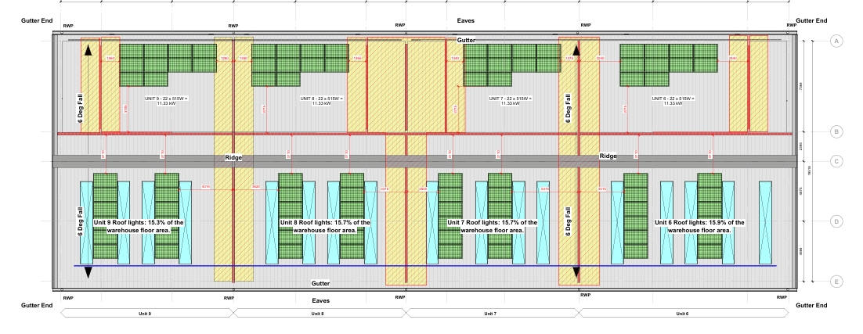
Proposed roof plan units 6-9

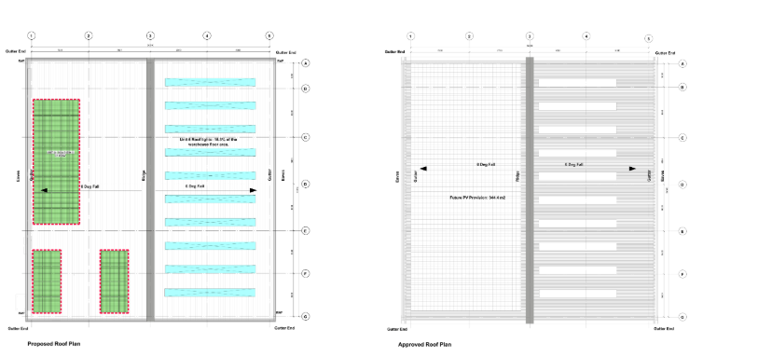
Proposed Unit 5 Previously approved

Elevations
- Approved rooflight positions have moved to match the PV arrangement above.
- Small Louvre positions are now shown on the elevations. These are located primary on the office elevations and would be coloured to match the surrounding cladding colour.

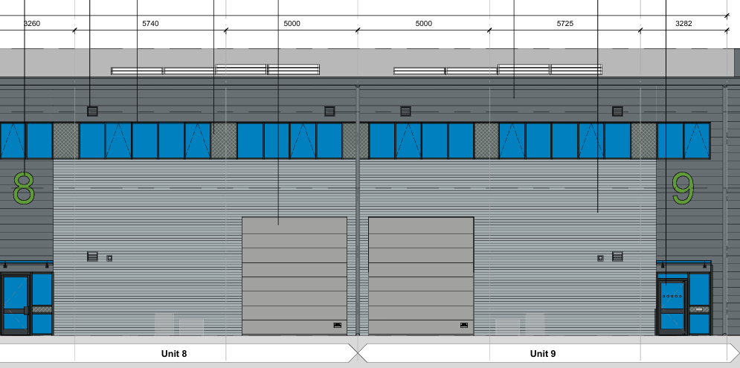
Proposed louvre locations

Boundary treatments
- Minor alignment changes to fence positions along the perimeter due to on site measurements.
- Addition of 2 personnel gates east and north of unit 4 & one gate east of unit 5, for access for cleaning / maintenance.
- Addition of 2 personnel gates to the south of the substation (south-west corner of the application boundary) to accommodate access and maintenance.

Proposed gate arrangements

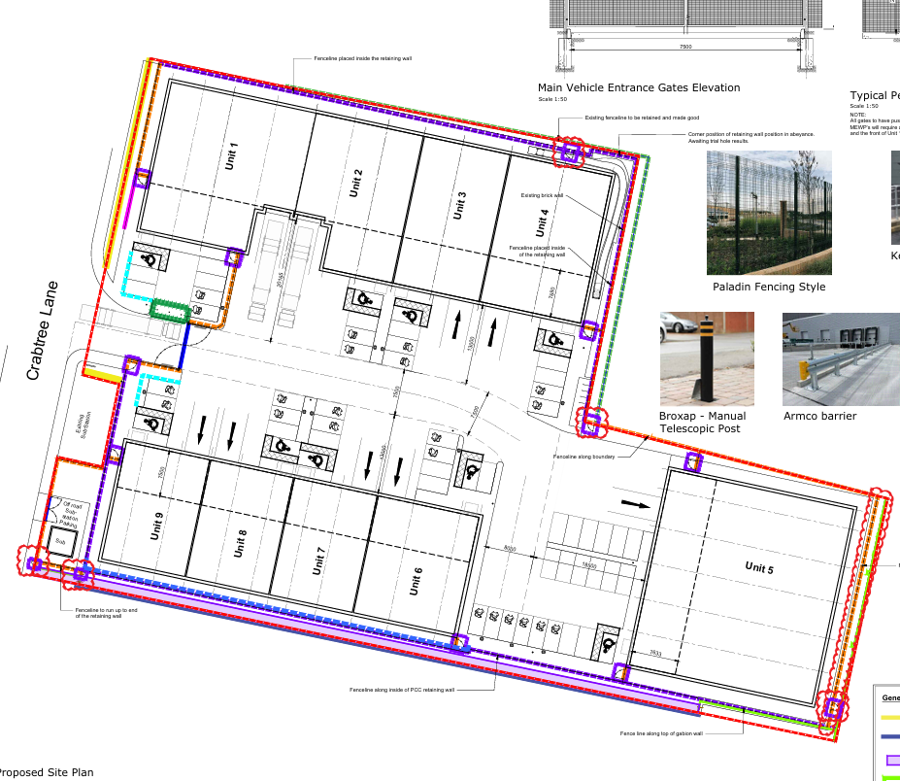

Relevant planning history
145108/NMC/2026 - Non-material change to Planning Permission 138914/FO/2023 to allow minor increase in external floor levels of +100mm, building areas increased by 3%.
Approved 3rd March 2026.

143419/JO/2025 - Variation of Condition 20 (secured by design) attached to planning permission 138914/FO/2023
Former Walkers of Manchester Printing Site, Crabtree Lane, Manchester.
Approved 29.09.2025

142848/NMC/2025 - Non-material amendment to planning permission reference 138914/FO/2023 to allow amendments to the parking layout to allow for EV car chargers Former Walkers of Manchester Printing Site, Crabtree Lane, Manchester.
Approved 28.05.2025

141509/NMC/2024 - Non-Material Amendment comprising a change to the description of application referenced 138914/FO/2023 to amend reference to the number of units within the 3 no. buildings approved.
Former Walkers of Manchester Printing Site, Crabtree Lane, Manchester.
Approved 19.11.2024

141391/JO/2024 Variation of conditions 2 (specified plans), 9a (EVCs), 10 (car parking), 11 (cycle storage), 12a (surface water drainage), 17a (waste management strategy), 19a (sustainability), 20 (Crime Impact Statement), 21a (external lighting), 22 (retaining wall), 23 (boundary treatment), 24 (landscaping), and 28 (floorspace) attached to planning permission referenced 138914/FO/2023 to allow the amalgamation of units 1 to 4 into one unit with an increase in height of 0.9m to the resultant unit, extension of mezzanine floor and additional floors within the unit (and associated increase in floorspace), together with associated elevational alterations and changes to the boundary treatment, landscaping, parking and servicing arrangements for that unit.

Former Walkers of Manchester Printing Site, Crabtree Lane.
Approved subject to conditions 17.02.2025

138914/FO/2023- Erection of 9 no. units (in 3 no. buildings) with access and servicing arrangements, car parking, landscaping and associated works (Use Classes E(g) (iii) B2 and B8) following demolition of existing buildings and structures.
Former Walkers of Manchester Printing Site, Crabtree Lane, Manchester.
Approved subject to conditions 17.04.2024

138523/DEM/2023 - Prior approval for the demolition of the existing industrial buildings. Former Walkers of Manchester Printing Site, 73 Crabtree Lane, Manchester.
No objection -12th January 2024.

076129/FO/2005/N2 - Erection of single storey side extension to industrial/storage building following demolition of existing building. Walkers Mcr Ltd, Crabtree Lane, Clayton Approved subject to conditions 15.09.2005

Consultation, notification and publicity responses

Consultations

Not applicable

Notifications and publicity
Not applicable

Relevant policies
Policy Context
These include Places for Everyone polices JP-S1, JP-S2, JP-S5, JP-S7, JP-J1, JP-J2, JP-J4 and JP-P2 ; Core Strategy policies DM1 (Development Management); EC1 (‘Employment and Economic Growth in Manchester), EC2 (Existing Employment Space), EC5 ( East Manchester), T1 (Sustainable Transport); T2 (Accessible areas of opportunity and needs); EN1 (Design principles and strategic character areas); EN3 (Heritage); EN4 (Reducing CO2 emissions by enabling low and zero carbon development); EN6 (Target framework for CO 2 reductions from low or zero carbon energy supplies); EN 8 (Adaptation to Climate Change); EN9 (Green Infrastructure); EN14 (Flood Risk); EN15 (Biodiversity and Geological Conservation); EN16 (Air Quality); EN18 (Contaminated Land); and EN19 (Waste); Saved UDP policy DC26 (noise), the National Planning Policy Framework ,NPPG, the Guide to Development in Manchester Supplementary Planning Document, and Manchester Climate Change Framework: 2020-2025 and Manchester Zero Carbon Framework (2020).

Assessment
Non material change
The proposed revisions are related to increase the external levels across the site by 100mm and to increase the overall GEA from the originally approved 5,535.6 sq.m. to 5,701.7 sq.m The increase in levels is to enable soils/earth to be retained on site with the associated reduction of the need to export material offsite.
In relation to Condition 28 - the building areas have increased to align with the contractual build tolerances of minus 0% and plus 3% of the previously approved areas. The planning agent has confirmed that these contractual build tolerances cannot be exceeded.
The approved location of the Rooflights have been altered to accommodate the arrangement of PV required on the roof area and also provide enough maintenance to avoid walking on the rooflights.
The approved plans contained an allocated area of PVs. This NMA looks to refine the location / extent of PV on the roofs, which has now been determined.

Small extract louvre positions have been incorporated into the proposed elevations. These are located primary on the office elevations and would be coloured to match the surrounding cladding colour.

Minor alignment changes to fence positions along the perimeter are proposed due to on site measurements, together with the installation of 2 personnel gates east and north of unit 4; and one gate east of unit 5, for access for cleaning / maintenance. Two further 2 personnel gates to the south of the substation (south-west corner of the application boundary) to accommodate access and maintenance.

The proposed amendments have been assessed, and it is considered that the changes are of a non-material nature and can be considered as a non-material amendment.

Other Legislative Requirements

Equality Act 2010
Section 149 (Public Sector Equality Duty) of the Equality Act 2010 requires due regard to the need to: Eliminate unlawful discrimination, harassment and victimisation and other conduct prohibited by the Act and; Advance equality of opportunity between persons who share a protected characteristic and persons who do not share it. The Equality Duty does not impose a legal requirement to conduct an Equality Impact Assessment. Compliance with the Equality Duty involves consciously thinking about the aims of the Equality Duty as part of the process of decision-making.

Human Rights Act 1998 considerations
This application needs to be considered against the provisions of the Human Rights Act 1998. Under Article 6, the applicants (and those third parties, including local residents, who have made representations) have a right to a fair hearing and to this end the local planning authority must give full consideration to their comments.

Protocol 1 Article 1, and Article 8 where appropriate, confer(s) a right of respect for a person’s home, other land and business assets. In taking account of all material considerations, including Council policy as set out in the Core Strategy and saved polices of the Unitary Development Plan, the Director of Planning, Building Control & Licensing has concluded that some rights conferred by these articles on the applicant(s)/objector(s)/resident(s) and other occupiers and owners of nearby land that might be affected may be interfered with but that that interference is in accordance with the law and justified by being in the public interest and on the basis of the planning merits of the development proposal. She believes that any restriction on these rights posed by the recommendation given is proportionate to the wider benefits of and that such a decision falls within the margin of discretion afforded to the Council under the Town and Country Planning Acts.

Conclusion

Recommendation: Approve

Paragraph One

The revisions to the approved scheme are related to :
-an increase the external levels across the site by 100mm, and to increase the overall GEA (Gross external area) from the originally approved 5,535.6 sq.m. to 5,701.7 sq.m.
- revision to the location rooflights to accommodate the arrangement of PV required on the roof area.
- defined the location / extent of PV on the roofs.
-incorporation of small extract louvre to the proposed elevations , coloured to match the surrounding cladding colour.
- minor alignment changes to fence positions along the perimeter, together with the installation of 2 personnel gates east and north of unit 4; and one gate east of unit 5, for access for cleaning / maintenance; and two further 2 personnel gates to the south of the substation (south-west corner of the application boundary) to accommodate access and maintenance.

It is considered that the proposed revisions would not have a detrimental impact in terms of the visual appearance of the commercial development, or the visual and residential amenity of the residential property and commercial properties in proximity to the site. The revisions would also not adversely affect parking and servicing arrangements for the development.

Paragraph Two

Following an assessment of the details submitted, I can confirm that the proposed amendments are considered to be of a non-material nature and acceptable to the City Council as the Local Planning Authority. The City Council is satisfied that the proposed changes will not result in any significant material alterations to the planning approval.

Condition no.2- Specified plans
2) The development hereby approved shall be carried out in accordance with the following drawings and documents:
Topographical Survey ref: 47333_T rev.0
Site Constraints Plan ref: 23168-UMC-XXXX-SI-DR-A 0501 rev.P04
Site Location Plan ref: 23168-UMC-XXXX-SI-DR-A 0502 rev.P04
Existing Site Plan Drawing No. 23168-UMC-XXXX-SI-DR-A-0503 rev. P04
Demolition Site Plan ref: 23168-UMC-XXXX-SI-DR-A 0503 rev.P03
Proposed site plan ref: 23168-UMC-XXXX-SI-DR-A 0601 rev.P05
Site Sections Plan ref: 23168-UMC-XXXX-SI-DR-A 0610 rev.P2
Proposed cycle storage Plan ref: 23168-UMC-XXXX-SI-DR-A 0702 rev.P03
Proposed substation Plan ref: 23168-UMC-XXXX-SI-DR-A 0703 rev.P03
Proposed waste strategy Plan ref: 23168-UMC-XXXX-SI-DR-A 0704 rev.P02
Unit 1 -4 Building and office plan ref:23168-UMC-01-DR-A 1001 rev.P3
Unit 1 -4 Roof plan ref: ref: 23168-UMC-01-DR-A 1002 rev.P2
Unit 1 -4 Building elevations plan ref: ref: 23168-UMC-01-DR-A 1301 rev.P1
Unit 5 Building and office plan ref: 23168-UMC-01-DR-A 1011 rev.P3
Unit 5 Roof plan ref: ref: 23168-UMC-01-DR-A 1012 rev.P2
Unit 5 Building elevations plan ref: ref: 23168-UMC-01-DR-A 1302 rev.P1
Unit 6 -9 Building and office plan ref:23168-UMC-01-DR-A 1021 rev.P3
Unit 6- 9 Roof plan ref: ref: 23168-UMC-01-DR-A 1022 rev.P2
Units 6 -9 Building elevations plan ref: ref: 23168-UMC-01-DR-A 1303 rev.P1
Design and Access Statement revision A December 2023
Air Quality Assessment ref: 572948.0001 r.1 dated December 2023
Biodiversity Enhancement Management Plan rev. 02 dated 12.12.2023
Biodiversity Net Gain Design Stage Assessment rev. 01 dated 12.12.2023
Crime Impact Statement Version B :06.12.2023 Ref: 2023/0548/CIS/01
Energy and Sustainability Statement ref: 6624-CBC-HR-RP-S-001-P03 dated November 2023 External Impact Lighting Assessment ref: 6624-CBC-OR-RP-E-001 rev.02 Dated December 2023
Framework Construction Management Plan rev.01 dated December 2023
Phase 1 Desk Based Geo-Environmental and Geotechnical Site Assessment ref: 546629.0000.0000 July 2023
Planning Statement dated 20 December 2023
Flood Risk Assessment ref: 23-026-I&L December 2023 (Notwithstanding the Proposed Drainage Strategy Layout (Drawing no. 23-026-I&L_D00_P1) contained in Appendix D) Transport Statement ref: 327475 dated December 2023
Framework Travel Plan ref: 327475 dated December 2023
Electric Vehicle Charging Specification - Sevadis Maxi Charger Pillar
Refuse Vehicle Swept path analysis plan ref: J32-7475-PS-005
Noise Impact Assessment: 572948.0001 r.1 dated December 2023
Arboricultural Impact Assessment rev.02 dated December 2023
Preliminary Ecological Assessment rev.03 dated December 2023

Received 27th December 2023

Waste Management Proforma and Site Access Junction plan ref: J32-7475-PS-002 rev.A received 4th January 2024
Biodiversity Net Gain Metric Version 2 received 1st February 2024.
Intrusive Geoenvironmental and Geotechnical Site Assessment report ref: 546629.001.0000 dated July 2023 Received 5th February 2024.

Remediation Strategy and Verification Plan. Reference 546629.0004.0000. Dated 16 February 2024.
Technical Note - Air Quality Additional Information. Reference 572948.tn1. Dated 20 February 2024.
Technical Note - Noise Additional Information. Reference 572948.tn1. Dated 20 February 2024 Received 27th February 2024

Supplementary Geo-environmental and Geotechnical Site Assessment Reference 546629.0002.0000 dated 2nd February 2024; and Asbestos in Soils Management Plan reference 546629.0003.0000 dated 2nd February 2024 received 18th March 2024

Proposed Boundary Treatments Plan ref: 23168-UMC-XXXX-SI-DR-A 0701 rev.P06 received 21st March 2024

Technical Note - Noise Additional Information. Reference 572948.t 2. 1. Dated 9th April 2024 Received 10th April 2024

Soft landscaping hand pit dug locations ( in connection with ground conditions) plan ref: 546629.0004 Fig 4 rev.P01 received 11th April 2024.

General Arrangement Plan ref:UG_2066_LAN-GA-DRW _101 rev.T2 received 15th April 2024

AS AMENDED BY:

Content of planning agent email dated 15th May 2025
Proposed site plan ref: 23168-UMC-XXXX-SI-DR-A 0601 rev.P31
Site Access Junction plan ref: J32-7475-PS-002 rev.D
16.5m HGV Swept Path Analysis plan ref: J32-7475-PS-003 rev.C
10m Rigid Vehicle Swept Path Analysis plan ref: J32-7475-PS-004 rev.C
Refuse Vehicle Swept Path Analysis plan ref: J32-7475-PS-005
Large Car Vehicle Swept Path Analysis plan ref: J32-7475-PS-007 Received 23rd May 2025 Large Car Vehicle Swept Path Analysis plan ref: J32-7475-PS-008 received 27th May 2025 AS

AS AMENDED BY:
Proposed site plan ref: 23168-UMC-XXXX-SI-DR-A-0601 rev. P38
Units 1-4 roof plan ref: 23168-UMC- 01-R1-DR-A-1003 rev.P25
Units 1-4 building elevations plan ref: 23168-UMC- 01-XX-DR-A-1301 rev.P29
Unit 5 roof plan ref: 23168-UMC- 05-R1-DR-A-1012 rev.P16
Unit 5 building elevations plan ref: 23168-UMC- 05-XX-DR-A-1302 rev.P19
Units 6-9 roof plan ref: 23168-UMC- 06-R1-DR-A-1022 rev.P16
Units 6-9 building elevations plan ref: 23168-UMC- 06-XX-DR-A-1303 rev.P17
Boundary treatment plan ref: 23168-UMC-XXXX-SI-DR-A-0701 rev.P24
Site Finishes plan ref: 23168-UMC-XXXX-SI-DR-A-0707 rev.P14
Site Sections plan ref: 23168-UMC-XXXX-SI-DR-A-0610 rev.P18
Levels & External Works plan ref: 23-026-I&L-G02 rev. C2
Received 20th July 2026

Reason - To ensure that the development is carried out in accordance with the approved plans, pursuant to policies SP1 and DM1 of the Manchester Core Strategy (2012).

9 a) Electric vehicle charging points shall be implemented in the locations shown on Proposed site plan ref: 23168-UMC-XXXX-SI-DR-A 0601 rev.P38 and specifications on Electric Vehicle Charging Specification - Sevadis Maxi Charger Pillar.

b) Prior to occupation of the development, the electric vehicle charging points shall be implemented and verified as such in writing by the City Council as local planning authority and shall remain in situ whilst the use or development is in operation.

Reason - To secure a reduction in air pollution from traffic or other sources in order to protect existing and future residents from air pollution, pursuant to policies EN16, SP1 and DM1 of the Manchester Core Strategy (2012).

10. The car parking indicated on the approved on Proposed site plan ref: 23168-UMC-XXXX-SI-DR-A 0601 rev.P38 shall be surfaced, demarcated and made available for use prior to the units, hereby approved being occupied. The car parking shall then be available at all times whilst the units are occupied.

Reason - To ensure that there is adequate car parking for the development proposed when the buildings are occupied, pursuant to policies T2, SP1 and DM1 of the Manchester Core Strategy (2012).

11. The cycle storage facilities shall be implemented in accordance with the locations as shown on the approved Proposed site plan ref: 23168-UMC-XXXX-SI-DR-A 0601 rev. P38 and Proposed cycle storage plan ref: 23168-UMC-XXXX-SI-DR-A 0702 rev. P03 (including the provision within each of the units hereby approved), prior to the proposed units being brought into use, and be retained thereafter.

Reason - To ensure that adequate provision is made for bicycle parking so that persons occupying or visiting the development have a range of options in relation to mode of transport in order to comply with Policies SP1, T1, T2, EN6 and DM1 of the Manchester Core Strategy (2012) and the guidance provided within the National Planning Policy Framework and the Guide to Development in Manchester Supplementary Planning Document and Planning Guidance.

23. The boundary treatment scheme for the development shall be implemented in accordance with Proposed Boundary Treatments Plan ref: 23168-UMC-XXXX-SI-DR-A 0701 rev.P24 received 20th July 2026. The approved scheme shall be implemented in full before the units hereby approved are first occupied and retained as such thereafter.

Reason - To ensure that the appearance of the development is acceptable to the City Council as local planning authority in the interests of the visual amenity of the area within which the site is located in order to comply with Policies SP1, EN1 and DM1 of the Manchester Core Strategy (2012), and the guidance provided within the Guide to Development in Manchester Supplementary Planning Document and Planning Guidance.

28) The permission hereby granted relates to a maximum of gross external floorspace of 5,701.7 sq.m. of commercial floorspace, including Classes E(g) (iii) B2 and B8) uses.

Reason -To ensure that the development is carried out in accordance with policies EC2 and EC5 of the Manchester Core Strategy (2012).

