

Planning

Delegated Officer Report

Summary of application details
Application reference: | PLA-2026-000710
Application type: | Consent to display an advertisement
Proposal: | Installation of 2no. externally illuminated hanging signs.
Site address: | Ground Floor Alliance House 30 Cross Street Manchester M2 7AQ
Ward(s): | Deansgate
Date application valid: | 08 July 2026
Applicant name: | Mr Miguel Perez Tallon
Agent (if any): | Mr Simon Bird
Case officer: | Ciara Gettinby
Recommendation: | Approve
Date of recommendation: | 1 September 2026

Description of site, building and/or area
The application site relates to Ground Floor, Alliance House, 30 Cross Street, which currently operates on the ground floor as a Santander bank, the upper floors are in use as offices. The building itself is a grade II listed building. The property is four storeys and features turrets and bay facades. The site is also located in the St Anne’s Square Conservation Area. Also located in the vicinity are, 25 St Ann Street (Grade II*Listed Building), 17-23 St Anns Square (Grade II Listed Building), 34-36 St Ann Street (Grade II Listed Building), and Former Lloyds Bank, 53 King Street (Grade II Listed Building).

The surrounding area is commercial in nature, with this area of the City being popular for visitors. The area is known for the retention of historical buildings and settings and benefits from the sustainable transport links such as the Metrolink and multiple bus stops along Cross Street.

Description of development
Advertisement consent is sought for the replacement of existing 2no. externally illuminated hanging signs.

Site Photos:
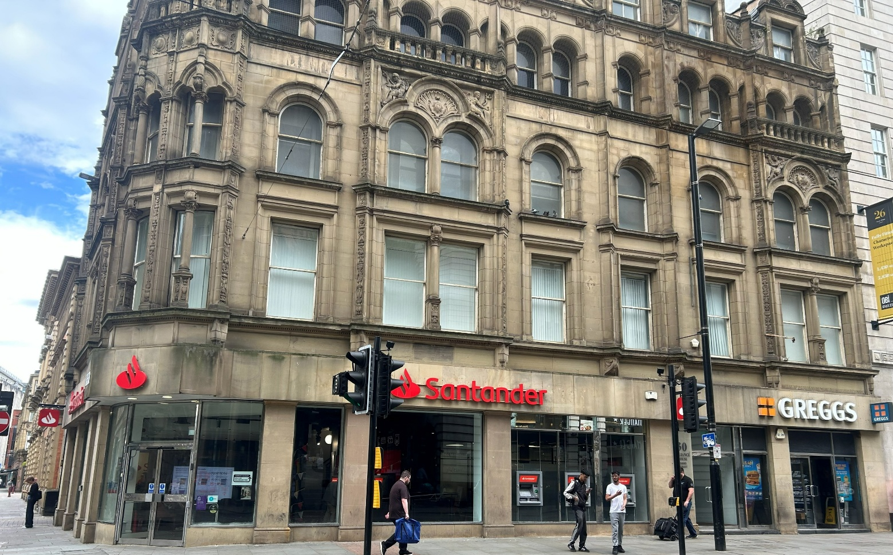

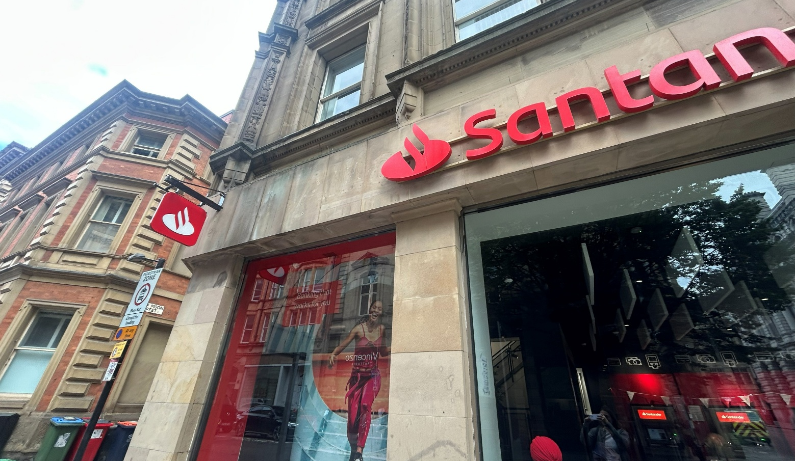

Proposed plans:

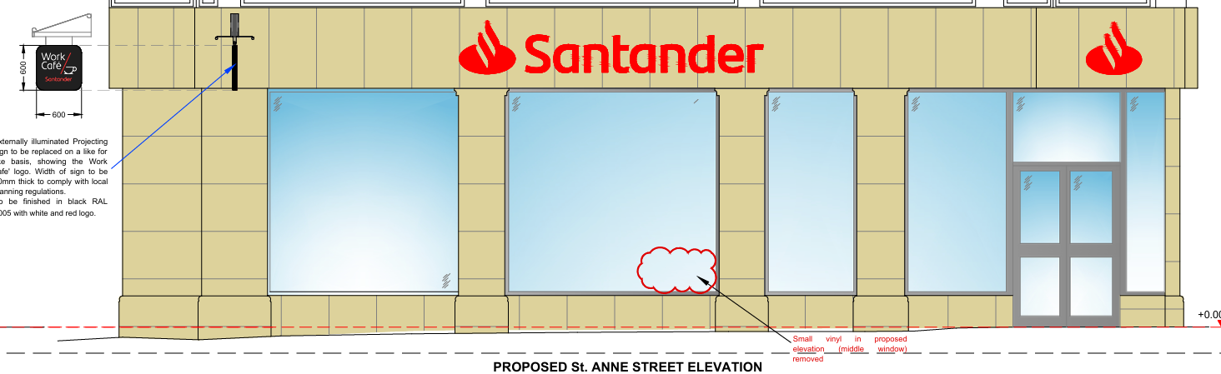

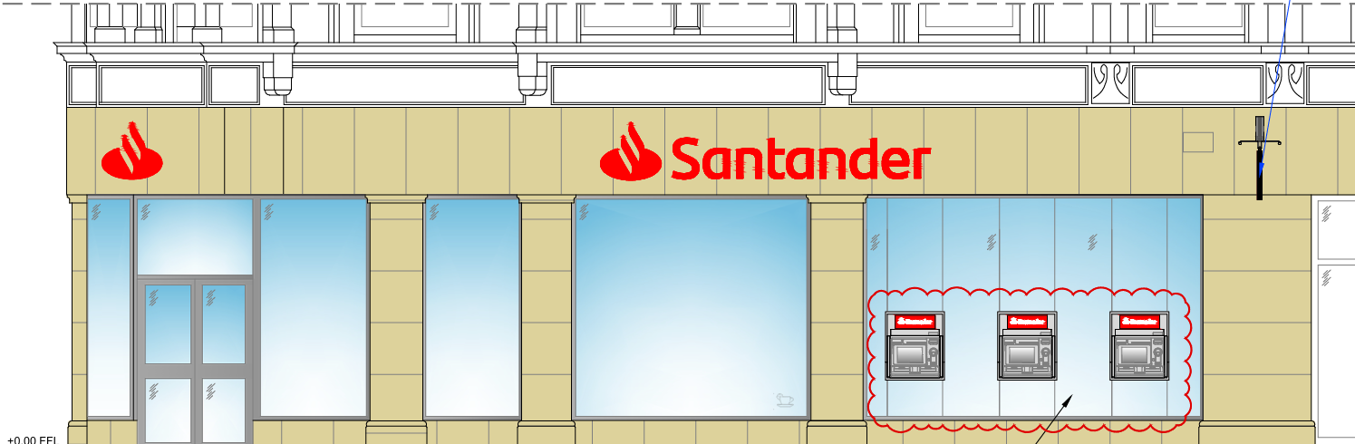

Consultation, notification and publicity responses

Consultations
Environmental health- no objections but have recommended a condition to be attached to this report and decision notice.

Highway Services- no objections.

Metrolink- no objections.

Notifications and publicity
Neighbours were notified of the development via letter; no representations have been received.

Relevant policies
The Town and County Planning (Control of Advertisements) Regulations 2007
The Local Planning Authority shall exercise its powers under these Regulations in the interests of amenity and public safety, taking into account-

- The provisions of the development plan, so far they are material; and
- Any other relevant factors

2.

- Factors relevant to amenity include the general characteristics of the locality, including the presence of any feature of historic, architectural, cultural or similar interest;
- Factors relevant to the public safety include-

- The safety of persons using any highway, railway, waterway, etc..
- Whether the display of an advertisement in question is likely to obscure or hinder the ready interpretation of, any traffic sign, railway signal or aid
- Whether the display of an advertisement in question is likely to hinder the operation of any device used for the purpose of security or surveillance or for measuring the speed of any vehicle

3. In taking account of factors relevant to amenity, the local planning authority may, if it thinks fit, disregard any advertisement that is being displayed.

4. Unless it appears to the Local Planning Authority to be required in the interests of amenity or public safety, an express consent for the display of advertisements shall not contain any limitation or restriction relating to the subject matter, content or design of what is to be displayed.

The following policies are considered relevant in the consideration of this application:

Places for Everyone- A long term plan of nine Greater Manchester districts for jobs, new homes and sustainable growth, it has been published by the GMCA on behalf of the nine districts (Bolton, Bury, Rochdale, Oldham, Tameside, Stockport, Manchester, Trafford, Salford, Wigan) and took into effect and become part of the statutory development plan on March 21, 2024.

-Policy JP-P1: Sustainable Places

The Manchester Core Strategy- Development Plan Document 2012- 2027 (The Core Strategy) was adopted by the City Council on the 11th of July 2012, it is a key document for the local plan which provides a framework that planning applications are assessed against.

Policy DM1- Development Management
Policy SP1- Spatial Principles

Unitary Development Plan (UDP)- The UDP has been superseded by the Core Strategy Development Plan, but certain policies are still considered relevance:

-Policy DC14 – Shopfronts and related signs

Other Material Considerations:

The Shopfront and Design Guide (Adopted 2024)

The National Planning Policy Framework (August 2026) The Government’s new national planning policies and how they are to be implemented through local authorities.

Policy DP3: Key principles for well-designed places
Policy DP4: The design process

Assessment
The advertisement regulations require that applications for shop signs be considered only in the interests of amenity and public safety. An assessment of the proposals under these criteria is outlined below.

Background
This application has been submitted in relation with a listed building consent and a full planning permission (PLA-2026-001033 and PLA-2026-703.) This is for an internal fit-out, installation of three ATM’s, air inlet and outlet points to the windows and a roof plant.

Visual Amenity
The proposed projecting signs would be of the same depth and dimension as the existing projecting signs to the current Santander building. Both signs would be 30mm in width and would be in line with local guidance in the Shopfront and Design Guide (2024).

The hanging sign will retain the existing hanging bracket which would ensure no further damage is imposed on the heritage asset. The LED strip of illumination would be in-keeping with the slender design of the projecting sign. As per UDP Policy DC14, the projecting sign is positioned at fascia level, respects the architectural form of buildings and shop frontages and lines with the associated fascia sign. Additionally, also in line with the shopfront and design guide, there is one projecting sign per elevation of the building.

The materials to be used are considered to be acceptable given that the signs would be made from alumium panels and acrylic logos. The proposed signs would be of the same design and colour scheme and therefore signage would have a uniform appearance across the ground floor unit. The proposed adverts are considered to be in character with the surrounding advertisement environment in terms of its size and scale. Considering the above, the proposals would be consistent with Core Strategy Policies SP1 and DM1, Places for Everyone Policies JP-Strat2 and JP-P1 and Policy DC14 of the Unitary Development Plan.

Public Safety
Signage would be installed so not to exceed illuminance level of 250cd/m2. As part of the assessment of this application, Environmental Health and MCC Highways Services were consulted, and no objections have been received. As such, there are no public safety concerns associated with this proposal, pursuant to Policy DC14 of the UDP and DM1 of the Manchester Core Strategy.

Other Legislative Requirements

Equality Act 2010
Section 149 (Public Sector Equality Duty) of the Equality Act 2010 requires due regard to the need to: Eliminate unlawful discrimination, harassment and victimisation and other conduct prohibited by the Act and; Advance equality of opportunity between persons who share a protected characteristic and persons who do not share it. The Equality Duty does not impose a legal requirement to conduct an Equality Impact Assessment. Compliance with the Equality Duty involves consciously thinking about the aims of the Equality Duty as part of the process of decision-making.

Human Rights Act 1998 considerations
This application needs to be considered against the provisions of the Human Rights Act 1998. Under Article 6, the applicants (and those third parties, including local residents, who have made representations) have a right to a fair hearing and to this end the local planning authority must give full consideration to their comments.

Protocol 1 Article 1, and Article 8 where appropriate, confer(s) a right of respect for a person’s home, other land and business assets. In taking account of all material considerations, including Council policy as set out in the Core Strategy and saved polices of the Unitary Development Plan, the Director of Planning, Building Control & Licensing has concluded that some rights conferred by these articles on the applicant(s)/objector(s)/resident(s) and other occupiers and owners of nearby land that might be affected may be interfered with but that that interference is in accordance with the law and justified by being in the public interest and on the basis of the planning merits of the development proposal. She believes that any restriction on these rights posed by the recommendation given is proportionate to the wider benefits of and that such a decision falls within the margin of discretion afforded to the Council under the Town and Country Planning Acts.

Conclusion
Given the above issues, it is considered that the advertisements are acceptable in terms of its impact upon visual amenity and public safety in accordance with Policies SP1 and DM1 of the Core Strategy, Policy DC15 of the UDP.

Recommendation: Approve

Conditions attached to this decision:

- No advertisement is to be displayed without the permission of the owner of the site or any other person with an interest in the site entitled to grant permission.

No advertisement shall be sited or displayed so as to:
(a) endanger persons using any highway, railway, waterway, dock, harbour or aerodrome (civil or military);
(b) obscure, or hinder the ready interpretation of, any traffic sign, railway signal or aid to navigation by water or air; or
(c) hinder the operation of any device used for the purpose of security or surveillance or for measuring the speed of any vehicle.

Any advertisement displayed, and any site used for the display of advertisements, shall be maintained in a condition that does not impair the visual amenity of the site. Any structure or hoarding erected or used principally for the purpose of displaying advertisements shall be maintained in a condition that does not endanger the public. Where an advertisement is required under these Regulations to be removed, the site shall be left in a condition that does not endanger the public or impair visual amenity.

- The development hereby approved shall be carried out in accordance with the following documents:

Proposed Cross Street Elevation, ref- Manchester 34CS-FR-EL-EX-PR received by the LPA on the 31 August 2026
Proposed St Ann Square Elevation, ref- Manchester 34CS-SI-EL-EX-PR received by the LPA on the 31 August 2026
Supporting information, External Signage Document, received 8 July 2026.
Location plan, ref- PP-15016368v1 received by the LPA on 17 June 2026.
Application form, received by the LPA on the 17 June 2026.

Reason- to ensure that the development is carried out in accordance with the approved plans, pursuant to saved policy DC1 of the Unitary Development Plan for the City of Manchester and policies SP1 and DM1 of the Manchester Core Strategy.

- Light

The external lighting installed shall be carried out in accordance with the submitted application form received by Manchester City Council as the Local Planning Authority on 17 June 2026, so as not to exceed 300cd/m2 to control glare and overspill onto nearby properties.

Reason- To safeguard the amenities of the occupiers of nearby properties.

