

Planning

Delegated Officer Report

Summary of application details
Application reference: | PLA-2026-000525
Application type: | Full planning permission
Proposal: | Change of Use from shop to residential ground floor flat and associated works.
Site address: | 80 Mauldeth Road West Manchester M20 1AB
Ward(s): | Old Moat
Date application valid: | 26 June 2026
Applicant name: | Mr Jason McCorkell
Agent (if any): | Mr Ken Bruce
Case officer: | Ellie Knowles
Recommendation: | Refuse
Date of recommendation: | 28 August 2026

Description of site/building/area

The application property relates to an existing ground floor commercial unit, at 80 Mauldeth Road West, in the Old Moat ward of Manchester. The property forms a middle unit of a parade of 6 units. The current use of the planning unit is a carpet and flooring shop (Class E) at ground floor and residential accommodation at first and second floors. The unit affords a glazed shopfront, signage and integrated ATM machine within the front elevation.

To the front of the site is hardstanding, which is used as off-street parking provision, with dropped kerb access taken off Mauldeth Road West.

The applicant has demonstrated ownership of no. 80 and 78 Mauldeth Road West. This adjoining end of terrace property No.78 has been significantly extended to the side and rear and converted into residential apartments with shared refuse and amenity area to the rear. Boundary treatment has been erected around this site in the form of brick walling with metal railings. Off-street parking areas are evident to the front and side of this site.

The surrounding area comprises commercial and residential properties, with the southern side of Mauldeth Road West characterised by semi-detached dwellinghouses and Old Moat Park (public greenspace). The northern side of Mauldeth Road West features mixed use properties, typically defined by commercial units at ground floor and residential uses at upper floors.

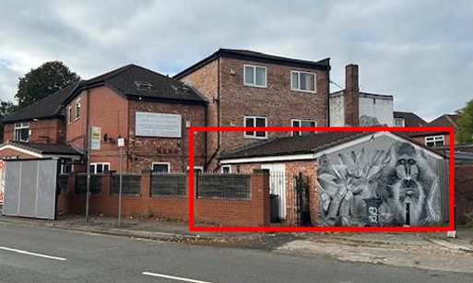
Figure 1: Rear elevation of the application property – red outline shows location of proposed commercial unit development and access alterations.

Listed building: Not applicable

Conservation area: Not applicable

Tree Preservation Order: Not applicable

Description of development

The applicant is seeking planning permission for the partial Change of Use of the rear of the ground floor commercial unit (Class E(a)) to form a two-bedroom self-contained flat (Class C3) and elevational alterations. The front of the site would retain a Class E use.

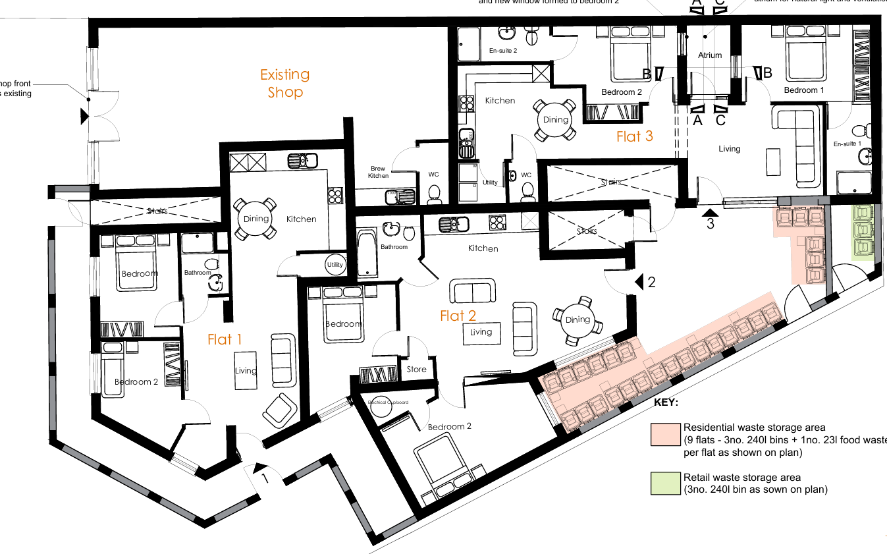

Figure 2: Proposed Ground Floor Plan; showing subdivision of the existing Class E unit

The proposal would create a 2B4P apartment, accessed from a new door within the side elevation of the existing single storey element. Additional fenestration is proposed in the form of 1.no 3-pane window to the front and installation of an internal atrium, as shown in fig.2 above.

Separate waste storage areas are proposed for commercial and residential waste streams.

Consultations & Notification Responses

Local responses
None

Consultee responses

Highway Services –

The site is located adjacent to the adopted highway of Mauldeth Road West and Yew Tree Road. A 20mph speed limit is in operation along this section of highway.
No Waiting at Any Time restriction is in place on Mauldeth Road West and Yew Tree Road, adjacent to the site.
No Loading Mon-Sat 8am-9.30am and Mon-Fri 4pm-6pm restriction is in place on Mauldeth Road West and Yew Tree Road, adjacent to the site.
There is an area of forecourt between the edge of the footway and building line, with the adoption status as maintained.

TRIP GENERATION AND JUNCTION CAPACITY:
In comparison to the former use, the level of trips generated is not anticipated to be dissimilar and as such no highway capacity concerns are expected.
SITE ACCESSIBILITY:
The site is well accessed by sustainable modes. Regular bus services are routed along Mauldeth Road West and provide connections to Withington, Didsbury Chorlton, Rusholme and Piccadilly Gardens.

PARKING AND ACCESS:
Application Form notes that no parking is proposed for the development. However, the D&A statement acknowledges that the area at the front of the property is utilised for vehicular access and parking for customers of the business.
Site observation indicates demarcated parking spaces at the front of the property.
Ideally, no parking should take place within the forecourt area.
All vehicular demands associated with the site are anticipated to contribute to the level of vehicles parked on-street.
Access to the proposed flat is to be from the existing rear courtyard at ground level with ramped access and level.

CYCLE PARKING:
In line with MCC Residential Guidelines, secure and sheltered cycle parking provision should be made, within the curtilage of the site, at a provision of one-per-unit.

BOUNDARY TREATMENTS:
It is recommended that all fencing / railings adjacent to the adopted highway are visually permeable from a distance of 600mm upwards to ensure adequate visual permeability for child pedestrians.
The applicant should be advised that all gated accesses will need to provide inward opening gates to ensure they do not impact on the adopted footway or highway.
REFUSE AND SERVICING:
Waste storage areas for residents and retail are located within the site.
Clarification is sought on current refuse collection and servicing arrangement, and whether this will change as part of the proposed change of use.

Environmental Health – No objections, subject to conditions relating to residential sound insulation and waste management.

Flood Risk Management – No objections, informative provided detailing incorporation Property Flood Resilience (PFR) measures.

Relevant Planning History

At the application site –
143914/FO/2025 – Change of use from a shop (Class E) to a one bed self-contained flat with associated elevational alterations; including retention of Class E(g)(i) office to the rear. Approved 26.01.2026. Not implemented.

122746/FO/2019 – Change of use of ground floor to 2 no. 2 bedroom apartments with associated elevational alterations. Approved 09.05.2019.

CDN/19/0979 – Discharge of Condition 6 (Noise) attached to planning permission reference 122746/FO/2019. Refused 09.12.2019.

105170/FO/2014/S1 – Erection of first and second floor extensions at rear to form enlarged self contained flats. Refused 05.08.2014.

093154/FO/2010/S1 – Erection of a single storey side extension to form office and a single storey rear extension to form store. Approved 20.07.2010.

071731/FO/2004/S1 – Erection of a 3-storey rear extension to form additional retail floor space and 2 additional self-contained flats. Approved 31.01.2005.

History of negotiations

The planning officer raised initial concerns relating to the standard of accommodation being proposed, stating the proposal could not be supported. By 21/08/2026, the agent submitted revised plans showing inclusion of an internal atrium to the additional residential apartment, although it was not considered such amendments overcome the LPAs concern. The revised scheme and additional information are assessed within this assessment.

Policy

Places for Everyone (2022-2039) – Places for Everyone is a long-term plan of nine Greater Manchester districts for jobs, new homes, and sustainable growth. It has been published by the GMCA on behalf of the nine districts and took effect and became part of the statutory development plan on March 21, 2024.

The PfE Plan and its policies are now a material planning consideration in the determination of planning applications. The PfE Plan and its policies must therefore be given full weight in the planning balance.

Manchester Core Strategy Development Plan Document (2012-2027) - The Core Strategy was adopted on the 11 July 2012 and replaces a large number of policies in Manchester’s Unitary Development Plan. Parts of the policies have been superseded by the Places for Everyone Plan.

The Unitary Development Plan (UDP) for the City of Manchester (1995) - The Unitary Development Plan for the City of Manchester was adopted in 1995 and has largely been replaced with the policies contained within the Core Strategy. However, there are a number of policies that are extant.

The relevant Places for Everyone policies for this application are as follows:

JP-S1 – Sustainable Development
JP-P1 – Sustainable Places

The relevant Core Strategy policies for this application are as follows:
DM 1 – Development Management
SP 1 – Spatial Principles (partially superseded by PfE)
EC 2 – Existing Employment Space
H 1 – Overall Housing Provision (partially superseded by PfE);
H 6 – South Manchester
EN14 – Flood Risk (partially superseded by PfE)
EN 19 – Waste

The relevant saved UDP policies for this application are:
DC5 – Flat Conversions
DC26 – Development and Noise

The relevant supplementary planning guidance documents for this application are:
- The Guide to Development in Manchester SPD
- Manchester, Salford, and Trafford Strategic Flood Risk Assessment
- GD 04: Waste Storage and Collection Guidance for New Developments (2023)

A relevant material consideration is also:
- Manchester Residential Quality Guidance March 2017 (Manchester’s Emerging Space Standards)
- Technical housing standards – nationally described space standard (27 March 2015)

National Planning Policy Framework

The Draft National Planning Policy Framework (August 2026) - The National Planning Policy Framework (NPPF) sets out the Government’s planning policies for England and how these should be applied.

Planning law requires that applications for planning permission be determined in accordance with the development plan, unless material considerations indicate otherwise. The national decision-making policies in this Framework are a material consideration in making these decisions and should be read alongside the policies in the development plan.

The Local Planning Authority consider the following NPPF policies relevant to this proposal.

HO7: Meeting the need for homes
L2: Making effective use of land
DP3: Key principles for well-designed places
P3: Living conditions and pollution
F4: Assessing flood risk for decision-making
F7: Ensuring development is safe from flooding

Issues

Principle of development:

The principle of the development, to change the use of an existing planning unit from a shop (Class E(a)) to a two bedroom – 4 person self-contained flat (C3) to the rear and retention of a class E use to the front is not considered acceptable, due to the poor standard of accommodation proposed for prospective occupiers.

Standard of accommodation:

The proposal would have an internal floor space of approx.73.6m2 for four persons, and so the LPA acknowledge the internal space provided accords with Manchester’s Emerging Space Standards.

The proposed apartment (Flat 3) would benefit from 1no.window and access door facing in the direction of Yew Tree Road, and an internal atrium – see figure 2. Amendments were made during the course of the application, to reconfigure the internal arrangement of the residential unit and incorporate an atrium.

Although such an atrium feature may offer some degree of limited light transmission and ventilation into the 2.no bedrooms and living room of the proposed unit, by the use of internal windows, it is still considered that prospective occupiers would experience adverse impacts upon their outlook, privacy, daylight and ventilation provision, as a result of the proposed development.

The proposed atrium is positioned within the eastern facing roof plane of the single storey rear element of no.80 Mauldeth Road West. Given the orientation of the application property and scale of previous extensions on site, this proposed atrium would experience significant overshadowing impacts. This existing impact is clearly shown in figures 1 & 3, which demonstrates that this proposed atrium would be significantly impacted by the existing three storey rear extension (due directly south) in the form of overshadowing and overlooking. The existing rear habitable room windows of the 3-storey extension would afford an unobstructed view into the proposed atrium and specifically bedroom 1, as annotated on plan ref: EJM2603.PFP.01.B.

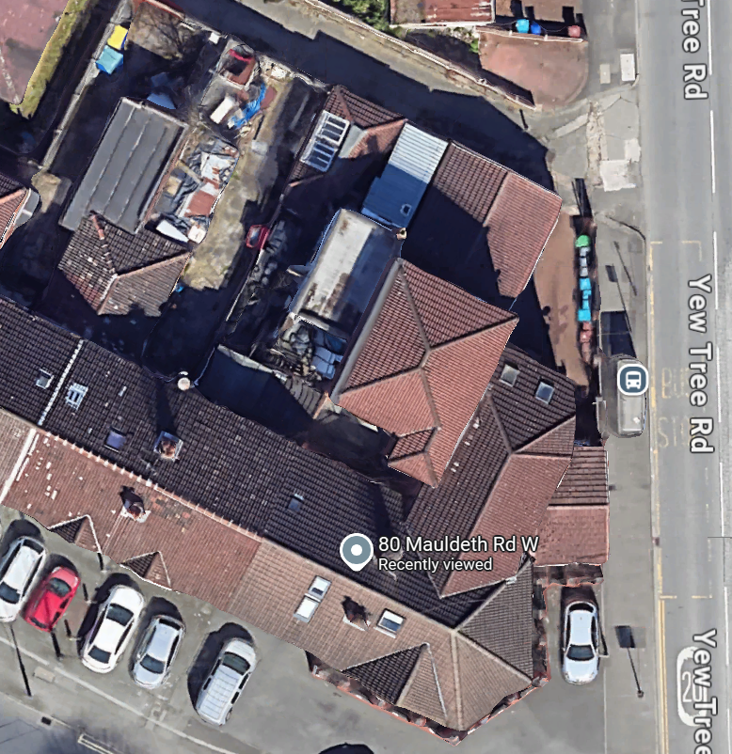
Figure 3: Aerial view of the application property, showing approximate location of the proposed atrium and existing levels of overshadowing from existing development. (Source: Google Maps)

The provision of only 1.no GF window in the western elevation of the proposed apartment is not considered to offer an adequate degree of outlook, privacy, ventilation and daylight to the proposed use, when this would be the only GF window for the proposal and would relate only to the living area. As such, the proposed kitchen and dining area (habitable room) would afford no access to natural daylight due to the proposed internal configuration.

In addition, the LPA understand the current gated courtyard directly adjacent to the proposed single GF window is utilised for bin storage of the 6 existing flats and primary access points to flat 2 and upper floor accommodation. As such, the outlook, privacy and ventilation provision of this sole window would be significantly undermined by this existing activity and any method to try mitigating these impacts (ie. closed curtains/blinds, keeping windows shut), to the detriment of future occupiers.

It is noted that the existing built form of the application property cannot incorporate any additional fenestration in the three other ground floor elevations (north, south & east), in order to address the aforementioned residential amenity concerns. This is due to the existing site constraints, comprising the location of the proposed development to the rear of the host property and it’s siting directly adjacent to the application site boundaries (no. 78 Mauldeth Road West due east and shared service access due north) – see figure 3.

As such, the proposal fails to ensure an acceptable standard of accommodation for future occupants, contrary to saved policy DC5 and DC26 of the Manchester Unitary Development Plan, policies SP1, H1, H5 and DM1 of the Manchester Core Strategy, as well as the Manchester Residential Quality Guidance, which seek to ensure that development provides a high standard of amenity for existing and future occupiers.

Environmental Matters:

The residential storage point for waste would be within the rear courtyard, adjacent to Yew Tree Road – see figure 2.

A separate gated entrance incorporating bin storage for the retained commercial use is provided to the rear. It is acknowledged that the prospective commercial tenants of the retained class E unit would be required to transfer any waste to the detached storage area, circa a distance of 45m. This estimated travel distance is contrary to the guidance contained within the GD 04 (2023), which requires ‘The horizontal distance that occupants will be required to travel to waste storage areas from should not exceed 30m, in line with the Building Regulations 2002, Part H.’

The applicant states within the submitted Waste Storage and Management Strategy (May 2026) that the ‘‘retained commercial space would be used as an office and it is anticipated to produce very little waste’. While this intended use is acknowledged, the unit falls within Use Class E, which allows a range of commercial uses to be undertaken without the need for further planning permission. Consequently, future commercial occupiers could generate significantly greater volumes and different types of waste than those associated with an office use.

As such, this proposed remote nature of commercial wate storage provision to the rear of the site, raises potential future conflict during the day-to-day use of the Class E unit.

Other Legislative Requirements

Equality Act 2010
Section 149 (Public Sector Equality Duty) of the Equality Act 2010 requires due regard to the need to: Eliminate unlawful discrimination, harassment and victimisation and other conduct prohibited by the Act and; Advance equality of opportunity between persons who share a protected characteristic and persons who do not share it. The Equality Duty does not impose a legal requirement to conduct an Equality Impact Assessment. Compliance with the Equality Duty involves consciously thinking about the aims of the Equality Duty as part of the process of decision-making.

Human Rights Act 1998 considerations
This application needs to be considered against the provisions of the Human Rights Act 1998. Under Article 6, the applicants (and those third parties, including local residents, who have made representations) have a right to a fair hearing and to this end the local planning authority must give full consideration to their comments.

Protocol 1 Article 1, and Article 8 where appropriate, confer(s) a right of respect for a person’s home, other land and business assets. In taking account of all material considerations, including Council policy as set out in the Core Strategy and saved polices of the Unitary Development Plan, the Director of Planning, Building Control & Licensing has concluded that some rights conferred by these articles on the applicant(s)/objector(s)/resident(s) and other occupiers and owners of nearby land that might be affected may be interfered with but that that interference is in accordance with the law and justified by being in the public interest and on the basis of the planning merits of the development proposal. She believes that any restriction on these rights posed by the recommendation given is proportionate to the wider benefits of and that such a decision falls within the margin of discretion afforded to the Council under the Town and Country Planning Acts.

Recommendation: Refuse

Article 35 Declaration
Officers have communicated their concerns about this proposal to the applicant during the course of the planning application, but these concerns cannot be overcome by the submission of a revised proposal. The proposal is considered to be contrary to the development plan and therefore refused in a timely manner.

Reasons for recommendation to refuse

- The proposed development (residential apartment ‘flat 3’), by reason of its design, internal configuration, location to the rear of the host property alongside its siting directly adjacent to the application site boundaries, existing extensions and waste storage areas, would create an unsatisfactory unit of living accommodation which would lack the level of amenity and provision of daylight, privacy, ventilation and outlook that the prospective residential occupiers of the proposed ‘flat 3’ could reasonably expect to enjoy. As such the proposal is contrary to the City Council’s Planning Policies SP1 and DM1 of the Manchester Core Strategy (2012), saved policy DC5 Unitary Development Plan for the City of Manchester (1995), Manchester Residential Quality Guidance and the NPPF (2026).

