

Planning

Delegated Officer Report

Summary of application details
Application reference: | PLA-2026-000685
Application type: | Householder planning permission
Proposal: | Erection of single-storey rear extension and new external cellar access to provide additional living accommodation
Site address: | 556 Wilbraham Road Manchester M21 9LB
Ward(s): | Chorlton
Date application valid: | 10 July 2026
Applicant name: | Mrs Sarah Tong
Agent (if any): | Tom Attewell
Case officer: | Joshua Lee
Recommendation: | Approve
Date of recommendation: | 28/08/2026

Description of site, building and/or area
The proposal is related to a two storey semidetached dwellinghouse on Wilbraham Road.
The property is in a mostly residential part of the Chorlton ward and within the Wilbraham Road/Edge Lane Conservation Area.

Description of development
Erection of single-storey rear extension and new external cellar access to provide additional living accommodation
The proposed single storey rear extension projects 4000mm from the rear elevation of the property to meet the rear elevation of the existing outrigger and projects 4200mm from the existing outrigger. The proposed would part demolish the existing outrigger to encapsulate the retained outrigger. The proposed extension is finished to form an orangery with brick stallrisers and white paint doors, fascias and cladding above. The proposed has a flat roof with rooflight.
A new external cellar access is proposed to the rear of the retained outrigger which replaces an existing access at the location of the proposed extension.
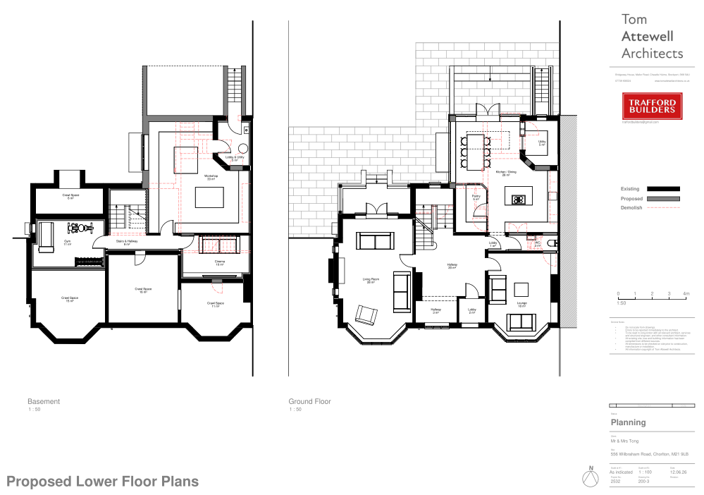
Figure 1. Proposed lower floor plans

Relevant planning history
No planning history at the address.

Consultation, notification and publicity responses

Notifications and publicity

Neighbour letters, site notice and press advertisement
No responses received.

Chorlton Civic Society
No response received.

Relevant policies
In accordance with Section 38(6) of the Planning and Compulsory Purchase Act 2004, planning applications must be determined in accordance with the statutory development plan unless material considerations indicate otherwise.
For Manchester, the development plan comprises:
- The Manchester Core Strategy (2012 to 2027);
- Saved policies of the Manchester Unitary Development Plan (UDP); and
- The Places for Everyone Joint Development Plan Document (2022 to 2039).
These documents are considered up to date and are afforded significant weight in the determination of planning applications. Relevant Supplementary Planning Documents (SPDs) and other adopted guidance may also be material considerations.
The National Planning Policy Framework sets out the government’s policies for plan-making and for making decisions on development proposals in England. It is a material consideration of critical importance in both contexts.
Where relevant, the Council is required to give special regard to the desirability of preserving listed buildings and their settings, and special attention to the desirability of preserving or enhancing the character or appearance of conservation areas, in accordance with the Planning (Listed Buildings and Conservation Areas) Act 1990.
The policies and guidance referred to below are considered the most relevant to the scale, nature and location of the proposed development.
- The Manchester Core Strategy Development Plan Document 2012-2027
  - Development Management and Planning Obligations
    - DM 1 - Development Management
  - Objective 1 - Spatial Principles
    - SP 1 - Spatial Principles (Partially replaced by PfE Policy JP-S 1)
  - Objective 6 Environment
    - EN 1 - Design Principles and Strategic Character Areas
    - EN 3 – Heritage (Deletions replaced with PfE Policy JP-P2)
    - EN 19 – Waste
- Guide to development in Manchester - supplementary planning document and planning guidance, April 2007
- Extant Unitary Development Plan (UDP) –
  - Citywide Development Control Policies
    - DC1 - Residential extensions
    - DC18 - Conservation Areas
    - DC26 - Development and Noise
- Places for Everyone Plan Joint Development Plan Document 2022-2039-
  - Strategy
    - JP-Strat9: Southern Areas
  - Sustainable and Resilient Places
    - JP-S1: Sustainable Development
  - Places for People
    - JP-P1 Sustainable Places
    - JP-P2: Heritage
- National Planning Policy Framework – August 2026 - National Development Management Policies (NDMPs)
  - Procedural Policies
    - Chapter 3 – Decision-making policies
      - DM1: Preparing development proposals
      - DM2: Information requirements
      - DM3: Determining development proposals
      - DM6: Use of planning conditions and obligations
      - DM7: Relationship with other regulatory regimes
      - DM10: Removal of national permitted development rights
  - Sustainable Development
    - Chapter 4 - Achieving sustainable development
      - S3: Presumption in favour of sustainable development
      - S4: Principle of development within settlements
  - Creating high quality, sustainable places
    - Chapter 12 - Making effective use of land
      - L2: Making effective use of land
    - Chapter 14 - Achieving well-designed places
      - DP3: Key principles for well-designed places
      - DP4: The design process
  - Conserving and enhancing the environment
    - Chapter 20 - Conserving and enhancing the historic environment
      - HE4: Securing the conservation of heritage assets
      - HE5: Assessing effects on heritage assets
      - HE9: Conservation areas

Assessment

Principle of development
Many people prefer to extend their existing homes rather than move, and the planning system needs to accommodate this demand for more living space, while at the same time ensuring that the amenities of neighbours are protected, and that the overall character of the surrounding area is not harmed. The Council is not generally in favour of dealing with this issue by laying down firm rules about home extensions with each case looked at on its individual merits, having regard to a range of criteria.
In this case the principle of the development is acceptable.
As stated in Policy DM 1 of the Manchester Core Strategy, all development should have regard to the following specific issues:

Appropriate siting, layout, scale, form, massing, materials, and detail
The proposed extension has been designed to reflect the style and appearance of the existing dwelling through the use of matching brickwork and complementary detailing.
The extension is considered subordinate to the original dwellinghouse, as it is limited to a single storey and positioned to the rear of the property.
The impact on No. 554 is considered acceptable, given that the extension would not project beyond the existing rear outrigger shared by both properties.
The impact on No. 558 is also considered acceptable due to the separation between the extension and the shared boundary, together with the presence of the existing extension at No. 558.
The proposed cellar access replaces an existing access and is acceptable.
By reason of its scale, siting and relationship to neighbouring properties, the proposal would not result in an unduly dominant or overbearing form of development and would not cause unacceptable harm to residential amenity.
Impact on the surrounding areas in terms of the design, scale and appearance of the proposed development. Development should have regard to the character of the surrounding area.
No views of the main proposed works are capable of being seen from the street. Given the position of the extension and the limited massing, together with the use of proposed materials, the character of the street would not be unduly affected.
The proposal is similar in size and scale to other buildings nearby, notably an extension approved at No 558 and would not therefore disrupt the area's existing features.

Effects on amenity

Privacy
The proposed extension incorporates glazing within the side and rear elevations. However, as these openings would be at ground-floor level and are set an appropriate distance from neighbouring properties and shared boundaries, they would not give rise to unacceptable overlooking or loss of privacy. Any potential for intervisibility is further mitigated by the substantial hedgerow along the boundary between Nos. 556 and 558, which provides an effective natural screen and maintains privacy between the properties.
The proposed rooflight would be of a flat design. Given its position and orientation towards the sky, it would not facilitate direct overlooking of neighbouring properties and would not give rise to any privacy concerns.
Accordingly, it is considered that the proposal would not result in an unacceptable impact on the privacy or residential amenity of neighbouring occupiers.

Light
Given the proposal is entirely at ground floor level, limited massing and distance to boundaries, the impact to light from the added massing is minimal.

Noise
The proposed extension is not expected to generate any noise beyond what would be reasonably expected of a residential dwelling.

Accessibility: buildings and neighbourhoods fully accessible to disabled people, access to new development by sustainable transport modes.
The proposal does not change how people can get in and out of the building.

Adequacy of internal accommodation and external amenity space.
The proposal adds space inside the property with minimal effect to the outdoor area and maintains a good level of external amenity space post development.

Refuse storage and collection.
The proposal itself has little impact on waste from the site. It uses the current storage and collection methods on site and maintains external access to the rear of the property.

Vehicular access and car parking
The proposal doesn't change how vehicles access and park at the property.

Effects relating to biodiversity, landscape, archaeological or built heritage

Built heritage
The application site is located within the Wilbraham Road/Edge Lane Conservation Area.
The junction of Wilbraham Road, a major arterial route within Manchester, and Edge Lane has long been recognised for its architectural and townscape quality, with many buildings dating from the late nineteenth century. The character of the Conservation Area is further enhanced by substantial mature tree cover, which contributes positively to its verdant setting and historic appearance.
The proposed development is modest in scale and design and would preserve the character and appearance of the Conservation Area. The proposal reflects the architectural form and appearance of the host property and would sit comfortably within the established street scene. It is also noted that extensions and ancillary outbuildings are a common feature within the locality.
Policy HE5 of the National Planning Policy Framework (NPPF) requires local planning authorities to identify and assess the particular significance of any heritage asset that may be affected by a proposal, including impacts on its setting. Proposals may:
- Enhance or better reveal the significance of a heritage asset;
- Have no effect on the significance of a heritage asset;
- Cause less than substantial or substantial harm to its significance; or
- Result in the total loss of significance.
Having regard to the scale, siting, design and relationship of the proposal to the surrounding built environment, it is considered that the development would preserve the character and appearance of the Conservation Area.
The proposal would therefore have no effect on the significance of designated heritage assets and is considered acceptable in heritage terms. The development is consistent with the heritage objectives of the NPPF and relevant local planning policies.

Green Infrastructure including open space, both public and private
The dwelling benefits from a garden beyond the siting of the proposed development and maintains a good amount of private green space post development.

Flood risk and drainage.
The site is not located in a flood risk area and therefore does not require a flood statement or assessment.
The proposal has a negligible impact on drainage using the existing drainage on site.

Other Legislative Requirements

Equality Act 2010
Section 149 (Public Sector Equality Duty) of the Equality Act 2010 requires due regard to the need to: Eliminate unlawful discrimination, harassment and victimisation and other conduct prohibited by the Act and; Advance equality of opportunity between persons who share a protected characteristic and persons who do not share it. The Equality Duty does not impose a legal requirement to conduct an Equality Impact Assessment. Compliance with the Equality Duty involves consciously thinking about the aims of the Equality Duty as part of the process of decision-making.

Human Rights Act 1998 considerations
This application needs to be considered against the provisions of the Human Rights Act 1998. Under Article 6, the applicants (and those third parties, including local residents, who have made representations) have a right to a fair hearing and to this end the local planning authority must give full consideration to their comments.
Protocol 1 Article 1, and Article 8 where appropriate, confer(s) a right of respect for a person’s home, other land and business assets. In taking account of all material considerations, including Council policy as set out in the Core Strategy and saved polices of the Unitary Development Plan, the Director of Planning, Building Control & Licensing has concluded that some rights conferred by these articles on the applicant(s)/objector(s)/resident(s) and other occupiers and owners of nearby land that might be affected may be interfered with but that that interference is in accordance with the law and justified by being in the public interest and on the basis of the planning merits of the development proposal. She believes that any restriction on these rights posed by the recommendation given is proportionate to the wider benefits of and that such a decision falls within the margin of discretion afforded to the Council under the Town and Country Planning Acts.

Conclusion
The proposed development comprises a modest single-storey rear extension and replacement external cellar access to a dwelling within the Wilbraham Road/Edge Lane Conservation Area. The extension is appropriately sited to the rear of the property, is subordinate to the host dwelling, and would not result in unacceptable harm to the character and appearance of the property, the surrounding area, or the significance of the Conservation Area. The proposal would not give rise to unacceptable impacts on the amenities of neighbouring occupiers in terms of outlook, privacy, light or noise and would retain adequate private amenity space for future occupants. Having regard to the development plan as a whole, together with all other material considerations, the proposal is considered to accord with relevant policies of the Manchester Core Strategy, saved UDP policies, the Places for Everyone Plan and the National Planning Policy Framework. The application is therefore recommended for approval, subject to the conditions set out below

Recommendation: Approve

Article 35 Declaration
Officers have worked with the applicant in a positive and proactive manner based on seeking solutions to problems arising in relation to dealing with the planning application. The proposal is considered to be acceptable and therefore determined within a timely manner.

Conditions to be attached to decision for approval

3-year time limit
The development must be begun not later than three years beginning with the date of this permission.
Reason - Required to be imposed by Section 91 of the Town and Country Planning Act 1990 (as amended).

Specified plans
The development hereby approved shall be carried out in accordance with the following drawings and documents:
  - Location Plan drawing no. 001 Rev 3, received 15 June 2026
  - Existing Lower Floor Plans drawing no. 100 Rev 3, received 15 June 2026
  - Proposed Lower Floor Plans drawing no. 200 Rev 3, received 15 June 2026
  - Proposed Upper Floor Plans drawing no. 201 Rev 3, received 15 June 2026
  - Proposed Elevations drawing no. 211 Rev 3, received 15 June 2026
  - Proposed Elevations drawing no. 212 Rev 3, received 15 June 2026
Reason - To ensure that the development is carried out in accordance with the approved plans, pursuant to policies DM 1, SP 1 and EN 1 of the Core Strategy and JP-P1 & of Places for Everyone.

Materials as approved on plan
The materials used in the external surfaces of the development hereby approved shall be those as specified on approved plan/drawing ref.
  - Proposed Elevations drawing no. 212 Rev 3, received 15 June 2026

Reason - In order to ensure a satisfactory appearance in the interests of visual amenity in accordance with policies SP1 and DM1 of the Core Strategy and the requirements of the National Planning Policy Framework.

