

Planning

Delegated Officer Report

Summary of application details
Application reference: | PLA-2026-000946
Application type: | Consent to display an advertisement
Proposal: | Erection of double-sided internally illuminated freestanding digital advertisement totem.
Site address: | Corner of Oxford Road and Symphony Park Circle Square Oxford Road Manchester M1 7ED
Ward(s): | Deansgate
Date application valid: | 07 July 2026
Applicant name: | Ocean Outdoor UK Ltd
Agent (if any): | Paul O'Neill
Case officer: | Ciara Gettinby
Recommendation: | Refuse
Date of recommendation: | 27 August 2026

Description of site, building and/or area
The proposed site is located on Oxford Road at the pedestrianised entrance route into Symphony Park, a landscaped public square which lies at the heart of a city centre neighbourhood known as Circle Square. The wider neighbourhood which is bounded by Oxford Road, Charles Street, Princess Road and the Mancunian Way was delivered through the Circle Square masterplan and The Former BBC Strategic Development Framework (BBC SRF). Circle Square now represents a successful high quality mixed use development which has been a catalyst to the now ongoing regeneration of the wider Oxford Road Corridor. The regeneration of this site previously a surface level car park, has delivered a high quality mixed-use neighbourhood comprising commercial workspace, residential accommodation, retail and leisure all centred around a brand-new city park.

A key part of delivering this high-quality neighbourhood was the setting of the building within the public realm which included a coherent placemaking strategy defined by a cohesive palette of wayfinding structures and other street furniture. This was implemented under application reference, 116450/FO/2017 approved in 2017. This included a number of slender wayfinding totems constructed from metal with a bespoke design. These are located at strategic points around the neighbourhood, encapsulating the Circle Square branding and helping to establish a strong sense of place within the wider area. The signage includes freestanding gateway totems, free standing directional totem cubes, free standing traffic directional and the wall mounted information signs (see below images demonstrating the consistent design.)

All existing signs consist of black powder coated aluminium panels, engraved with the ‘Circle Square’ logo and VeroMetal Rust effect base. The various signage types are detailed below.

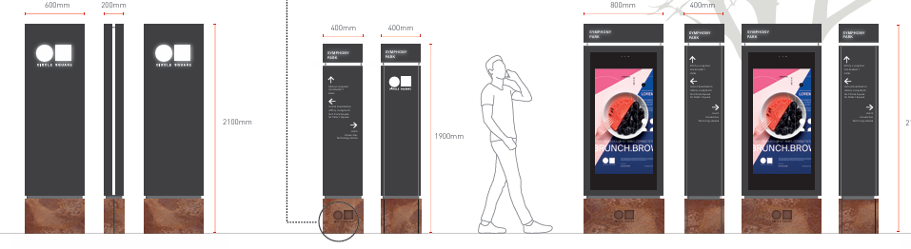

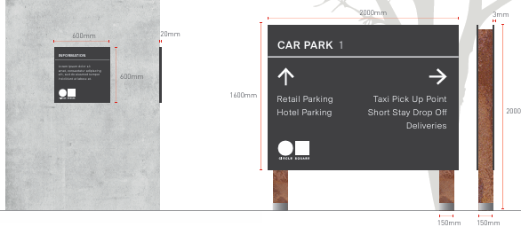
The wider area is also characterised by the neighbouring Universities, including, The University of Manchester and Manchester Metropolitan University, there is heavy footfall along Oxford Road due to the students and visitors of the University. Oxford Road is a key arterial gateway route leading into the City Centre from the Universities, it benefits from cycle lanes, and the road is restricted to buses and black cabs.

There are no designated heritage assets (Scheduled Monuments, Grade I, II* and II Listed Buildings, Conservation Areas, Registered Parks and Gardens or Registered Battlefields) within the site boundary. There are a number of listed buildings in the vicinity, including Grade II listed Lass O'Gowrie pub on Charles Street and Grade II* Palace Hotel on Oxford Road. The Grade II listed Dancehall Theatre located on Oxford Road overlooks the broader Masterplan Site from the West. The Site is not within a Conservation Area but the border of the Whitworth Street Conservation Area lies to the north of on Whitworth Street. The site lies within a highly accessible City Centre location through the use of a variety of public transport including Metrolink, bus and rail.

Currently the application site contains one of the above wayfinding totems. This aids wayfinding into the neighbourhood for visitors to and residents of the site coming off Oxford Road. The totem does not display advertisements nor have a digital screen. It measures 0.6m in width, 2.1m in height and 0.2m in depth. All sides are constructed out of black powder coated aluminium fixed to the sub-frame and fixed on a VeroMetal Iron Rust painted aluminium base and as detailed above is in keeping with the materials palette used across the public realm within Circle Square featuring the Circle Square logo engraved onto the base.

Description of development
The proposal seeks advertisement consent for the installation of 1no. internally illuminated double sided digital advertising unit screen .This would include a black powder coated aluminium frame, and a double-sided LED screen. The unit would incorporate an Ultra HD screen on each side, ambient light sensors and laminated vandal glass. The screen would operate between 07:00 and 21:00 and would be controlled by a light sensor so that the luminance levels respond to surrounding lighting conditions.

Proposed Plans:

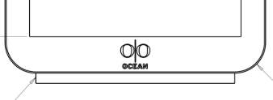

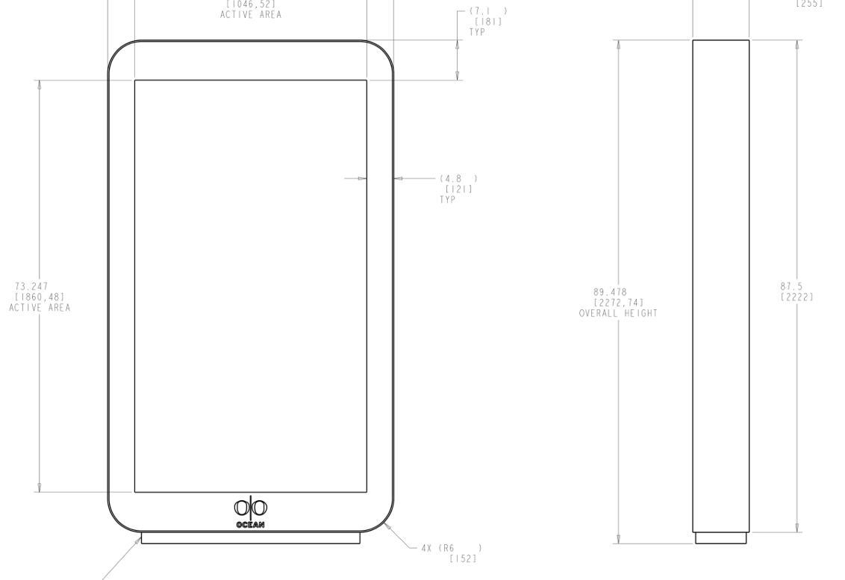
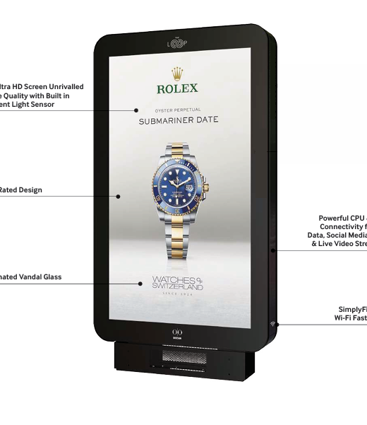

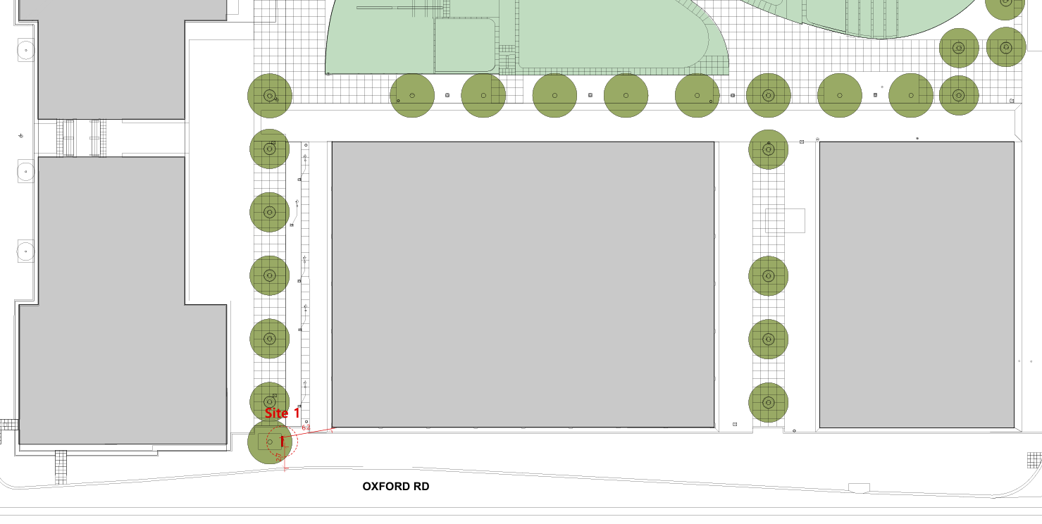

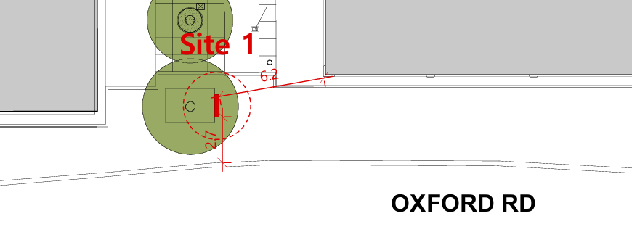

Site Photos:

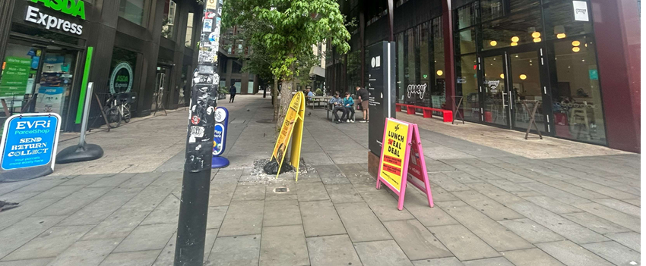

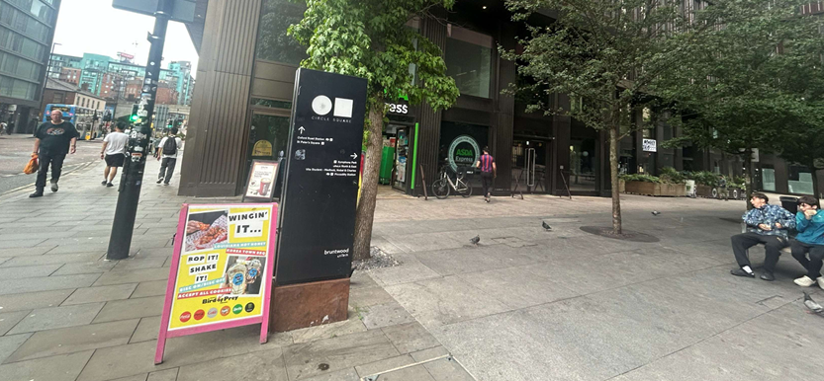

The proposed advertising totem would measure 1.2m in width, 2.2m in height and 0.35m in depth. It would have a standard design typical of the type of advertising displays found within pavements. Although the height and depth would not be significantly greater than the existing totem, the width of the totem would be doubled. The proposed totem would also introduce a 41.2 ″ (width) by 73.2 ″ (length) screen. Located on the base of the totem would be an ‘Ocean Outdoor’ logo. The applicants state that the display would show commercial advertising, estate information, and public information content.

The scheme has been submitted in relation to other advertisement consents around the Circle Square site, PLA-2026-001010, PLA-2026-001086 and PLA-2026-001009. Each proposal also consists of the erection of a double-sided illuminated freestanding digital advertisement totem.

Consultation, notification and publicity responses

Consultations
Highway Services- Requested for additional information on whether the adopted footway would be affected, however, no objections to the proposal.

Environmental health- Requested that if the application were to be approved, conditions should be attached to control the light of the display screens and for a maintenance management plan to be submitted.

Notifications and publicity

Neighbouring properties were notified via letter of the proposal, no representations have been received.

Relevant policies
The Town and County Planning (Control of Advertisements) Regulations 2007
The Local Planning Authority shall exercise its powers under these Regulations in the interests of amenity and public safety, taking into account-

- The provisions of the development plan, so far they are material; and
- Any other relevant factors

2.

- Factors relevant to amenity include the general characteristics of the locality, including the presence of any feature of historic, architectural, cultural or similar interest;
- Factors relevant to the public safety include-

- The safety of persons using any highway, railway, waterway, etc..
- Whether the display of an advertisement in question is likely to obscure or hinder the ready interpretation of, any traffic sign, railway signal or aid
- Whether the display of an advertisement in question is likely to hinder the operation of any device used for the purpose of security or surveillance or for measuring the speed of any vehicle

3. In taking account of factors relevant to amenity, the local planning authority may, if it thinks fit, disregard any advertisement that is being displayed.

4. Unless it appears to the Local Planning Authority to be required in the interests of amenity or public safety, an express consent for the display of advertisements shall not contain any limitation or restriction relating to the subject matter, content or design of what is to be displayed.

The following policies are considered relevant in the consideration of this application:

Places for Everyone- A long term plan of nine Greater Manchester districts for jobs, new homes and sustainable growth, it has been published by the GMCA on behalf of the nine districts (Bolton, Bury, Rochdale, Oldham, Tameside, Stockport, Manchester, Trafford, Salford, Wigan) and took into effect and become part of the statutory development plan on March 21, 2024.

-Policy JP-P1- Sustainable Places

The Manchester Core Strategy- Development Plan Document 2012- 2027 (The Core Strategy) was adopted by the City Council on the 11th of July 2012, it is a key document for the local plan which provides a framework that planning applications are assessed against.

Policy DM1- Development Management
Policy SP1- Spatial Principles

Unitary Development Plan (UDP)- The UDP has been superseded by the Core Strategy Development Plan, but certain policies are still considered relevance:

-Policy DC15- Advertisements, Hoardings and Posters

The National Planning Policy Framework (August 2026)- The Government’s new national planning policies and how they are to be implemented through local authorities.

Policy DP3- Key principles for well-designed places
Policy S3: Presumption in favour of sustainable development

Other Material Considerations:

Oxford Road Corridor Strategic Regeneration Framework Guidance (2019)
Sets out how growth will be supported by key place-making objections in terms of public realm, diversifying and uplifting the quality and range of uses around retail, food, drink, cultural sport and housing.

Former BBC Site Strategic Regeneration Framework Guidance (2013)
Sets out a guide to the future redevelopment of the former BBC site and adjoining land to ensure it becomes an economic priority and a key site for the Manchester corridor delivering high quality regeneration on the site.

Assessment
In the case of this application, the principle of the proposal is considered unacceptable and cannot be supported as it conflicts with the development plan policies and associated guidance listed in the preceding section. It is considered that the insertion of an advertisement and larger digital display with its standard design would have an unduly harmful impact on the visual amenity of the area.

The existing totem has a clear purpose to aid wayfinding and mark a key entrance route into the neighbourhood and to support that, has a bespoke design with clear visual linkages to the wider palate of materials within the public realm as a holistic part of the wider wayfinding strategy within the neighbourhood. The proposal would not fit in with the existing approved high quality placemaking strategy and indeed given the nature of the proposed installation and its design would undermine that quality.

Visual Amenity

The existing totem sits subtly within the backdrop of the of the surrounding buildings and public realm within Circle Square and provides minimal visual impact. The existing quality and consistency of design of the signage supports placemaking with a distinctive visual identity within the neighbourhood.

The proposed digital advert would result in a structure that would double the width of the existing totem. It would replace an existing feature that is in-keeping with architectural quality of the surrounding buildings and spaces. Policy SP1 of the Manchester Core Strategy states that development proposals should be contribute to ‘well-designed places that enhance or create character.’PfE Policy JP-P1 seeks development that respects and acknowledges character and identity of the locality in terms of design, siting, size, scale and materials used. In contrast to the slender appearance and existing high-quality bespoke design of the existing totem, the advertising totem would appear as an incongruous and alien structure both by reason of its size, colour design and illuminated nature.

Contrary to saved UDP Policy 15 the proposed digital advert would not make a positive contribution to locality, would be an incongruous structure which would intrude into an area of high amenity value and would have an adverse impact on visual amenity.

It is considered that the replacement of the existing totem with this much larger standard design illuminated advertising panel would undermine the quality of the existing placemaking of Circle Square that was envisioned and delivered through the Circle Square masterplan and The Former BBC Strategic Development Framework (BBC SRF) which emphasises the importance of ‘place-making and the general attractiveness of the site,’ the proposed development is considered to diminish the place-making and general attractiveness of the site.

The materials proposed to be used would undermine the visual cohesiveness of the neighbourhoods material palette and that of the signage within the surrounding public realm.

The proposed totem’s design is not considered to be as detailed or reflect the character of Circle Square due to it’s monotonous materials and logos unrelated to the site. The proposed offers a standard commercial advertising unit that would not provide any characteristic elements that would contribute towards the quality of the placemaking within Circle Square. The removal of the existing and introduction of the design that is of lower quality, would diminish the sense of place that Circle Square currently benefits from. The digital screen would introduce standard illuminated commercial advertising panels as a replacement of a high quality wayfinding totem and would diminish the quality of the setting within which the buildings within Circle Square sit.

Additionally, the increase in size would also result in a more prominent feature, becoming more obvious to the backdrop of its surroundings, Policy DM1 of the Manchester Core Strategy states that development proposals should be assessed on its ‘impact on surrounding areas in terms of its design, scale and appearance’ and proposals should give rise to ‘appropriate siting, layout. materials and detail.’ The increase in size would undermine the appreciation of the architectural details on the neighbouring buildings to passers-by, thereby diminishing the perceived experience of high quality within the wider site.

In terms of the NPPF the proposals would be contrary to Policy DP3 as it would not in contrast to the existing structure on the site, integrate with or enhance its surroundings nor would and likewise it would not respond successfully to context.

It is noted that there was consent granted for a digital and directional totem approved within Circle Square under advertisement consent, 127455/AOH/2020, however that digital totem is in-keeping with the place making design and does not display commercial advertising only information about activities and facilitates within the neighbourhood. Additionally, these totems are smaller in scale (in width and screen size) and have minimal visual impact. The existing digital totems provide continuous wayfinding and directional benefits to visitors of the site whilst maintaining cohesive placemaking.

The Strategic Regeneration Framework for Oxford Road establishes ‘a number of important place-making principles for the site’ including, ‘quality and design of the public realm.’ It further goes on to establish that ‘in all cases…it will be a requirement that new public and private spaces are of the highest quality’ and provide ‘an enhanced overall contribution to place making.’ The proposed totem would diminish the high standard of quality that exists in Circle Square and therefore, would not contribute positively to the place-making of the site.

In consideration of the above it is considered that the proposal for the advertisement, would be visually detrimental to the place making of Circle Square and therefore contrary to the provisions of Town and Country Planning (Control of Advertisement) (England) Regulations 2007, Policies JP-P1 of the Places for Everyone Plan, Policies SP1 and DM1 of the Manchester Core Strategy (2012), saved Policies DC15.1, DC15.2 and of the Unitary Development Plan for the City of Manchester (1995) and Policy DP3 and S3 of the National Planning Policy Framework.

Public Safety

Although the proposals siting would create an increased obstacle and contributes to the impression of clutter, it is not considered that there is evidence of a public safety impact for pedestrians in order to warrant a reason for refusal on these grounds.

Conclusion

Any public safety concerns of the proposed digital advertising displays are not significant enough to refuse on public safety grounds.

However, due to a combination of its height, width, materiality, illumination and appearance, the proposed digital advert would represent a visually obtrusive feature on the pavement. Therefore, the proposed digital advert is refused on visual amenity grounds, due to the proposal being contrary to the Town and Country Planning (Control of Advertisement) (England) Regulations 2007, Policies JP-P1 of the Places for Everyone Plan, Policies SP1 and DM1 of the Manchester Core Strategy (2012), saved Policies DC15.1, DC15.2 and of the Unitary Development Plan for the City of Manchester (1995) and Policy DP3 and S3 of the National Planning Policy Framework

Other Legislative Requirements

Equality Act 2010
Section 149 (Public Sector Equality Duty) of the Equality Act 2010 requires due regard to the need to: Eliminate unlawful discrimination, harassment and victimisation and other conduct prohibited by the Act and; Advance equality of opportunity between persons who share a protected characteristic and persons who do not share it. The Equality Duty does not impose a legal requirement to conduct an Equality Impact Assessment. Compliance with the Equality Duty involves consciously thinking about the aims of the Equality Duty as part of the process of decision-making.

Human Rights Act 1998 considerations
This application needs to be considered against the provisions of the Human Rights Act 1998. Under Article 6, the applicants (and those third parties, including local residents, who have made representations) have a right to a fair hearing and to this end the local planning authority must give full consideration to their comments.

Protocol 1 Article 1, and Article 8 where appropriate, confer(s) a right of respect for a person’s home, other land and business assets. In taking account of all material considerations, including Council policy as set out in the Core Strategy and saved polices of the Unitary Development Plan, the Director of Planning, Building Control & Licensing has concluded that some rights conferred by these articles on the applicant(s)/objector(s)/resident(s) and other occupiers and owners of nearby land that might be affected may be interfered with but that that interference is in accordance with the law and justified by being in the public interest and on the basis of the planning merits of the development proposal. She believes that any restriction on these rights posed by the recommendation given is proportionate to the wider benefits of and that such a decision falls within the margin of discretion afforded to the Council under the Town and Country Planning Acts.

Conclusion
The proposed digital advertising display, by virtue of its siting, scale, appearance and illumination, would form an overly dominant and visually obtrusive feature within the street scene. The proposed would result in the removal of an existing wayfinding sign that has a bespoke design with clear visual linkages to the wider public realm. The proposal would not fit in with the existing approved high-quality placemaking strategy. Therefore, the proposed digital advertising displays are refused on visual amenity grounds due to the proposal being contrary to the provisions of Town and Country Planning (Control of Advertisement) (England) Regulations 2007, Policies JP-P1, JP-P2 of the Places for Everyone Plan, Policies SP1 and DM1 of the Manchester Core Strategy (2012), saved Policy DC15 of the Unitary Development Plan for the City of Manchester (1995) and Policy DP3 and S3 of the National Planning Policy Framework.

Recommendation: Refuse

Reasons for refusal

The proposal would therefore result in an unduly harmful impact on the visual amenity of Circle Square due to its obtrusive and dominant feature in the street scene. The proposed digital advertising display would result in the removal of an existing wayfinding sign and would diminish the existing place-making of the public realm and is therefore contrary to the provisions of Town and Country Planning (Control of Advertisement) (England) Regulations 2007, Policies JP-P1, of the Places for Everyone Plan, Policies SP1 and DM1 of the Manchester Core Strategy (2012), saved Policies DC15.1, DC15.2 of the Unitary Development Plan for the City of Manchester (1995) and Policy DP3 and S3 of the National Planning Policy Framework.

