

Planning

Delegated Officer Report

Summary of application details
Application reference: | PLA-2026-000871
Application type: | Consent to display an advertisement
Proposal: | Installation of internally illuminated 3.5 m high totem sign.
Site address: | Walkers Of Manchester Crabtree Lane Manchester M11 4GU
Ward(s): | Clayton & Openshaw
Date application valid: | 17 July 2026
Applicant name: | Mr Joe Johnson
Agent (if any): | Mr Richard Hill
Case officer: | Sue Wills
Recommendation: | Approve
Date of recommendation: | 7th September 2026

Description of site, building and/or area
The site is located on the section of Crabtree Lane which lies to the north of the Ashton Canal and to the south of Ashton New Road. The wider site to which the signage is related covers an area of 0 .91ha and was occupied by vacant double height and single storey industrial buildings formerly occupied by Walkers of Manchester Printers. It is understood that these premises were vacated in January 2019.

The area within which the site is located has industrial uses to the west and south on Crabtree Lane, and retail uses to the north and east of the site. The Strawberry Duck Public House fronts onto Crabtree Lane to the southwest of the site (adjacent to the canal). To the north and northeast of the site are retail uses which form a ‘local centre’ in Clayton. Further to the south of the site is the Ashton Canal, with a Grade II listed lock structure at the termination of the northern section of Crabtree Lane.

Previously approved development
Permission was granted for the erection of 9 no. units (in 3 no. buildings) with access and servicing arrangements, car parking, landscaping and associated works (Use Classes E(g) (iii) B2 and B8) following demolition of existing buildings and structures. The proposed buildings were designed to reflect the proposed uses and were to be formed of a combination of horizontal laid trapezoidal profiled cladding panel systems with a tata colourcoat finish. The proposed buildings were double height with shallow pitched roofs. All units incorporated a partial mezzanine level with ancillary floorspace. The proposed buildings were located in proximity to the perimeter of the site with dedicated parking and servicing areas located in front of the proposed buildings, centrally within the site.

A 24hour/7days a week operation was sought. The boundary treatment to the northern, eastern, southern and for the most part western perimeter of the site comprised 2.4m black weldmesh fencing. A 1.1m metal key clamp fall protection fence on the retaining wall was to be incorporated between the boundary of the parking spaces to Unit 1 and the frontage to Crabtree Lane. A mix of column and wall mounted LED fittings was proposed within the site area. An additional substation was proposed to be located on the frontage of the site in proximity to the existing substation.

Description of development
Consent is sought to install a 3.5 m internally illuminated totem sign to reference the occupiers of the commercial /industrial/warehouse units which are in the process of being completed on the site. The internally illuminated totem sign would be located to the south of the access from Crabtree Lane with dimensions of 1.7 metres wide x 3.5m metres high x 0.15m in depth, and set 0.256m above ground level. The proposed signage would be set back form that back of the carriage way by circa 2.75m , and would have a 300cd/m luminance level.

Relevant planning history
PLA -2026- 000871 Installation of internally illuminated 3.5m high totem sign.
Crabtree Lane – Current

142848/NMC/2025- Non-material amendment to planning permission reference 138914/FO/2023 to allow amendments to the parking layout to allow for EV car chargers Walkers Of Manchester, Crabtree Lane. Approved 28.05.2025.

141509/NMC/2024- Non-Material Amendment comprising a change to the description of application referenced 138914/FO/2023 to amend reference to the number of units within the 3 no. buildings approved. Former Walkers Of Manchester Printing Site Crabtree Lane Approved 19.11.2024.

141391/JO/2024- Variation of conditions 2 (specified plans), 9a (EVCs), 10 (car parking), 11 (cycle storage), 12a (surface water drainage ), 17a (waste management strategy), 19a ( sustainability), 20 (crime Impact Statement), 21a ( external lighting), 22 (retaining wall), 23 (boundary treatment), 24 (landscaping), and 28 (floorspace) attached to planning permission referenced 138914/FO/2023 to allow the amalgamation of units 1 to 4 into one unit with an increase in height of 0.9m to the resultant unit, extension of mezzanine floor and additional floors within the unit (and associated increase in floorspace ), together with associated elevational alterations and changes to the boundary treatment, landscaping, parking and servicing arrangements for that unit. Former Walkers Of Manchester Printing Site, Crabtree Lane. Approved subject to conditions 17.02.2025.
138914/FO/2023- Erection of 9 no. units (in 3 no. buildings) with access and servicing arrangements, car parking, landscaping and associated works (Use Classes E(g) (iii) B2 and B8) following demolition of existing buildings and structures. Former Walkers Of Manchester Printing Site, Crabtree Lane. Approved subject to conditions 17.04.2024.

138523/DEM/2023 - Prior approval for the demolition of the existing industrial buildings. Former Walkers of Manchester Printing Site, 73 Crabtree Lane, Manchester. No objection -12th January 2024

076129/FO/2005/N2 - Erection of single storey side extension to industrial/storage building following demolition of existing building. Walkers Mcr Ltd, Crabtree Lane, Clayton Approved subject to conditions 15.09.2005

Consultation, notification and publicity responses

Consultations

Environmental Health – Have no comments.
Highway Services -The submission does not clearly indicate the proposed location of the totem. Highways request clarity regarding the proposed location.
Proposed luminance is noted as 300cd/m2 – Acceptable to highways.

Detail should be sought from the applicant in relation to any proposed construction or fit-out arrangements, where there is an impact on the highway.

The applicant is required to discuss and agree any requirements for licensing, hoarding / scaffolding, skips and utility/electricity connections with MCC's Highways Licensing Team via Email to:
highwaylicences@manchester.gov.uk.
The applicant is required to discuss and agree any requirements for temporary pedestrian and traffic management with MCC's Event and Traffic Management Team via Email to highwaynetworkmanagement@manchester.gov.uk.

Suggested condition:

(a) No individual advertisements displayed on the LED panel shall contain moving images, animation, video or full motion images or any images that resemble road signs, traffic lights or traffic signs.
(b) No individual advertisements shall be displayed for duration of less than 10 seconds.
(c) Controls shall be in place to ensure smooth uninterrupted transition of images displayed on the panel.
(d) The display panel shall be fitted with a light sensor, designed to adjust the brightness to changes in ambient light levels.
(e) A mechanism shall be in place so that if the installation breaks down, it defaults to a black screen to avoid any flashing error messages or pixilation.
(f) The maximum luminance level of the advertisements displayed on the panel shall not exceed 300 cd/m2 during non daylight hours / inclement weather

Further comments 27.08.2026
In relation to the proposed location of the totem sign, highways request a visibility splay to be provided in order to demonstrate safe and unobstructed visibility for vehicles accessing and egressing the site via Crabtree Lane.

Notifications and publicity
Local residents/local businesses - No comments received.

Relevant policies
Town and Country Planning (Control of Advertisements) Regulations 2007 - States that:

(1) The Local planning authority shall exercise its powers under these regulations in the interests of amenity and public safety, taking into account:
(a) The provisions of the development plan, so far as they are material; and
(b) Any other relevant factors.
(2) Without prejudice to the generality of paragraph (1) (b);
(a)Factors relevant to amenity include the general characteristics of the locality, including the presence of any feature of historic, architectural, cultural or similar interest;
(b) Factors relevant to public safety include'
(i) The safety of persons using any highway, railway, waterway, dock, harbour or aerodrome (civil or military);
(ii) Whether the display of the advertisement in question is likely to obscure, or hinder the ready interpretation of, any traffic sign, railway signal or aid to navigation by water or air;
(iii) Whether the display of the advertisement in question is likely to hinder the operation of any device used for the purpose of security or surveillance or for measuring the speed of any vehicle;
(3) In taking account of factors relevant to amenity, the local planning authority may, if it thinks fit, disregard any advertisement that is being displayed;
(4) Unless it appears to the local planning authority to be required in the interests of amenity or public safety, an express consent for the display of advertisements shall not contain any limitation or restriction relating to the subject matter, content or design of what is to be displayed.

National Planning Policy Framework (August 2026)
Updated in August 2026, the National Planning Policy Framework sets out the government’s policies for plan making and for making decisions on development proposals in England. The following policies from the NPPF are considered relevant to this application:
Chapter 3 – Decision-making policies
-DM1: Preparing development proposals
Chapter 14 – Achieving well designed places
- DP3: Key principles for well-designed places
- DP4: The Design Process

National Planning Policy Framework (December 2024)
This Framework came into effect on 27th March 2012 and was amended most recently in December 2024. It sets out the government's planning policies for England and how these are expected to be applied. It defines the government's requirements for the planning system `only to the extent that it is relevant, proportionate and necessary to do so'. It provides a mechanism through `which local people and their accountable councils can produce their own distinctive local and neighbourhood plans, which reflect the needs and priorities of their communities'.

The Framework re-iterates that planning law requires that applications for planning permission must be determined in accordance with the development plan unless material considerations indicate otherwise. The statutory status of the development plan remains as the starting point for decision making. However, paragraph 11 states that `at the heart of the Framework is a presumption in favour of sustainable development' and, in `decision-taking', this means that development proposals should accord with the development plan should be approved without delay unless: any adverse impacts of doing so would significantly and demonstrably outweigh the benefits, when assessed against the policies in this Framework taken as a whole or specific policies in this Framework indicate development should be restricted.

National Policy Framework has been related to the proposed development, with particular emphasis given to the following: Core planning principles - Within the overarching roles that the planning system ought to play, a set of core land-use planning principles should underpin both plan making and decision-taking with the following specific policies being particularly relevant to the proposed development:

Section 12. Achieving well-designed places - States that 'good design is a key aspect of sustainable development, creates better places in which to live and work and helps make development acceptable to communities' (paragraph 131).

With regard to advertisement signage Chapter 12 states: 'the quality and character of places can suffer when advertisements are poorly sited and designed (paragraph 141).It notes that a separate consent process within the planning system controls the display of advertisements, which should be operated in a way which is simple, efficient and effective. Advertisements should be subject to control only in the interests of amenity and public safety, taking account of cumulative impacts'.

Planning Practice Guidance
On 6 March 2014 the Department for Communities and Local Government (DCLG) launched this planning practice guidance web-based resource. The PPG seeks to both simplify and clarify planning guidance easier and simpler. It is intended to be read in conjunction with the National Planning Policy Framework (NPPF) and is relevant to key planning issues of significance to applicants and local authorities. In considering this application consideration has been given to the following aspects of the PPG:

Advertisements - This section specifically refers to, amongst other things:

i. Considerations affecting public safety;
ii Considerations affecting amenity.

Places for Everyone
The approved Places for Everyone Plan is a Joint Development Plan Document, providing a strategic plan and policies, for 9 of the 10 boroughs which make up Greater Manchester. The Plan identifies the essential aspect of the efficient and effective use of land with the preference to be given to making as much use as possible of suitable previously developed brownfield land and vacant buildings when meeting development needs.

Relevant policies of PfE in this instance are:
Policy JP-P1 Sustainable Places - Discusses the importance of development on the character and identity of a locality in terms of design, siting, size, scale and materials used.

Policy JP-C5: Streets for All - States that Streets will be designed and managed to make a significant positive contribution to the quality of place and support high levels of walking, as well as, cycling and public transport.

Manchester Core Strategy
The Core Strategy Development Plan Document 2012 -2027 ("the Core Strategy") was adopted by the City Council on 11th July 2012. It is the key document in Manchester's Local Development Framework. The Core Strategy replaces significant elements of the Unitary Development Plan (UDP) as the document that sets out the long term strategic planning policies for Manchester's future development. A number of UDP policies have been saved until replaced by further development plan documents to accompany the Core Strategy. Planning applications in Manchester must be decided in accordance with the Core Strategy, saved UDP policies and other Local Development Documents.

Policy SP1 identifies the City Council's Core Development Principles and states that development in all parts of the City should:- Make a positive contribution to neighbourhoods of choice including:
- Creating well designed places that enhance or create character
- Making a positive contribution to the health, safety and wellbeing of residents
- Considering the needs of all members of the community regardless of age, gender, disability, sexuality, religion, culture, ethnicity or income.
- Protect and enhance the built and natural environment
- Minimise emissions, ensure efficient use of natural resources and reuse previously developed land wherever possible.
- Improve access to jobs, services, education and open space by being located to reduce the need to travel and provide good access to sustainable transport provision.

Policy EN1 relates to design principles and strategic character areas and states that all development in Manchester will be expected to follow the seven principles of urban design listed below:
- Character: a place with its own identity
- Continuity and enclosure: a place where public and private places are clearly distinguished
- Quality of the public realm: a place with attractive, and successful outdoor areas
- Ease of movement: a place that is easy to get to and move through
- Legibility: a place that has a clear image and is easy to understand
- Adaptability: a place that can change easily
- Diversity: a place with variety and choice

Policy DM 1 states that all development should have regard to the following specific issues for which more detailed guidance may be given within a supplementary planning document:
- Appropriate siting, layout, scale, form, massing, materials and detail.
- Impact on the surrounding areas in terms of the design, scale and appearance of the proposed development. Development should have regard to the character of the surrounding area.
- Effects on amenity, including privacy, light, noise, vibration, air quality and road safety and traffic generation. This could also include proposals which would be sensitive to existing environmental conditions, such as noise.
- Accessibility: buildings and neighbourhoods fully accessible to disabled people, access to new development by sustainable transport modes.
- Community safety and crime prevention.
- Design for health.
- Adequacy of internal accommodation and external amenity space.
- Refuse storage and collection.
- Vehicular access and car parking.
- Effects relating to biodiversity, landscape, archaeological or built heritage.
- Green Infrastructure including open space, both public and private.
- Flood risk and drainage.
- Existing or proposed hazardous installations.

Unitary Development Plan - Saved development control policy DC14.1 sets out the considerations that the City Council will take into account in determining applications relating to shop fronts, security grilles, advertisement signs, canopies and awnings. It states that in determining applications for advertisement signs, the Council will seek to ensure that proposals are in keeping with the character of the building, adjoining buildings and the area. In the interests of amenity, signs should not normally be positioned other than at fascia level and should respect the architectural form of the building. In the interests of public safety, any sign that is detrimental to the safety of pedestrians or motorists will be refused.

Assessment
Impact of new totem sign - At 3.5 metres high, the proposed totem sign would be clearly visible in the Crabtree Lane street scene to the north of the Ashton Canal. However, the location is largely commercial, and it is considered that an internally illuminated design of the type and size proposed can be accommodated on site, without having a harmful visual impact upon the locality.

Location

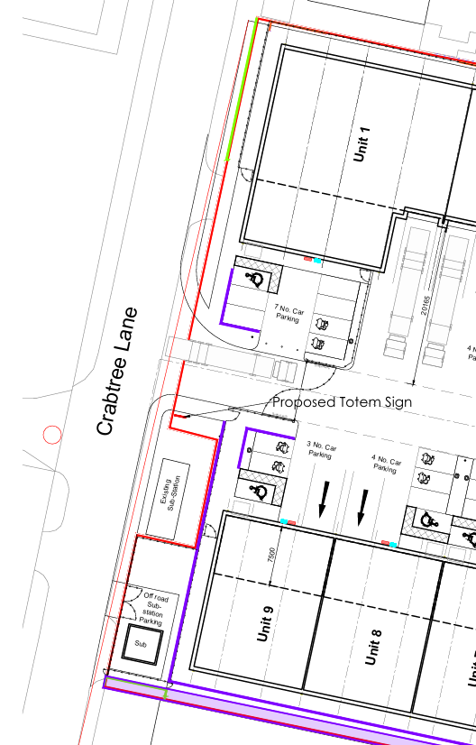

Design
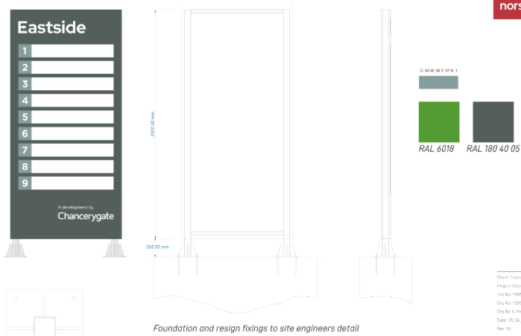

Highway safety - The sign is within the grounds of the proposed operation, and has been sited so that a sightline of 2.4m x 43m is maintained for vehicles entering and leaving the site access.
Highways Services have made comments in respect of lighting levels, it is therefore proposed to attach a condition to limit the level of luminance during non-daylight hours / inclement weather.

Other Legislative Requirements

Equality Act 2010
Section 149 (Public Sector Equality Duty) of the Equality Act 2010 requires due regard to the need to: Eliminate unlawful discrimination, harassment and victimisation and other conduct prohibited by the Act and; Advance equality of opportunity between persons who share a protected characteristic and persons who do not share it. The Equality Duty does not impose a legal requirement to conduct an Equality Impact Assessment. Compliance with the Equality Duty involves consciously thinking about the aims of the Equality Duty as part of the process of decision-making.

Human Rights Act 1998 considerations
This application needs to be considered against the provisions of the Human Rights Act 1998. Under Article 6, the applicants (and those third parties, including local residents, who have made representations) have a right to a fair hearing and to this end the local planning authority must give full consideration to their comments.

Protocol 1 Article 1, and Article 8 where appropriate, confer(s) a right of respect for a person’s home, other land and business assets. In taking account of all material considerations, including Council policy as set out in the Core Strategy and saved polices of the Unitary Development Plan, the Director of Planning, Building Control & Licensing has concluded that some rights conferred by these articles on the applicant(s)/objector(s)/resident(s) and other occupiers and owners of nearby land that might be affected may be interfered with but that that interference is in accordance with the law and justified by being in the public interest and on the basis of the planning merits of the development proposal. She believes that any restriction on these rights posed by the recommendation given is proportionate to the wider benefits of and that such a decision falls within the margin of discretion afforded to the Council under the Town and Country Planning Acts.

Conclusion

Recommendation: Approve

- No advertisement is to be displayed without the permission of the owner of the site or any
other person with an interest in the site entitled to grant permission.

No advertisement shall be sited or displayed so as to:
(a) endanger persons using any highway, railway, waterway, dock, harbour or aerodrome (civil or military);
(b) obscure, or hinder the ready interpretation of, any traffic sign, railway signal or aid to navigation by water or air; or
(c) hinder the operation of any device used for the purpose of security or surveillance or for measuring the speed of any vehicle.

Any advertisement displayed, and any site used for the display of advertisements, shall be maintained in a condition that does not impair the visual amenity of the site.

Any structure or hoarding erected or used principally for the purpose of displaying advertisements shall be maintained in a condition that does not endanger the public.

Where an advertisement is required under these Regulations to be removed, the site shall be left in a condition that does not endanger the public or impair visual amenity.

- The development hereby approved shall be carried out in accordance with
Site edged red Received 1st July 2026

Package of proposed totem plan (design and elevations and section) ref: 15857.001 rev.02 Received 2nd July 2026

Proposed Totem Sign location plan ref: 23168-UMC-XXXX-SI-DR-A-SK950 Received 17th July 2026

Visibility splay plan ref: 23168-UMC-XXXX- SI-DR-A-SK1600 received 27th August 2026

Reason - To ensure that the development is carried out in accordance with the approved plans, pursuant to policies SP1 and DM1 of the Manchester Core Strategy and saved policy DC14.1 of the Unitary Development Plan for the City of Manchester.

3) (a) To ensure the advertisement remains a static display. No individual advertisements displayed shall contain moving images, animation, video or full motion images or any images that resemble road signs, traffic lights or traffic signs.
(b) The display panels shall be fitted with a light sensor, designed to adjust the brightness to changes in ambient light levels.
(c) A mechanism shall be in place so that if the installation breaks down, it defaults to a black screen to avoid any flashing error messages or pixilation.
(d) The maximum luminance level of the advertisements displayed on the panel shall not exceed 300 cd/m2 during non-daylight hours / inclement weather.

Reason - In the interests of highway and pedestrian safety pursuant to policies T1 and DM1 of the adopted Manchester Core Strategy and saved policy DC14.1 of the Unitary Development Plan for the City of Manchester.

