

Planning

Delegated Officer Report

Summary of application details
Application reference: | PLA-2026-000884
Application type: | Householder planning permission
Proposal: | Erection of part single, part two storey side extension and part single / part two rear extension with associated landscaping
Site address: | 8 Highbury Road Manchester M16 8PT
Ward(s): | Whalley Range
Date application valid: | 02 July 2026
Applicant name: | Mr Anjum Suhail
Agent (if any): | Mr Barry Tang
Case officer: | Holly Wright
Recommendation: | Refuse
Date of recommendation: | 20 August 2026

Description of site, building and/or area
The application relates to a two-storey semi-detached dwellinghouse of redbrick with a red tile hipped roof. The property features white uPVC-framed windows, including a rounded two-storey bay to the front, a tarmacadam driveway and front garden bordered by a mid-level brick wall and piers, a single storey side extension, a two-storey rear extension, and a spacious rear garden.

Highbury Road is a residential street situated within the Whalley Range ward of Manchester, close to Wilbraham Road, William Hulme Grammar School, and Whalley Range Sports Centre. The surrounding area is predominantly residential in terms of its character, consisting of semi-detached dwellinghouses.

The property is not listed, nor is it sited within a conservation area.

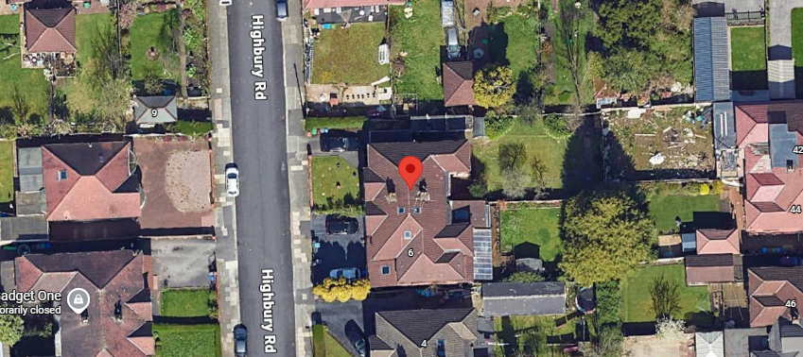

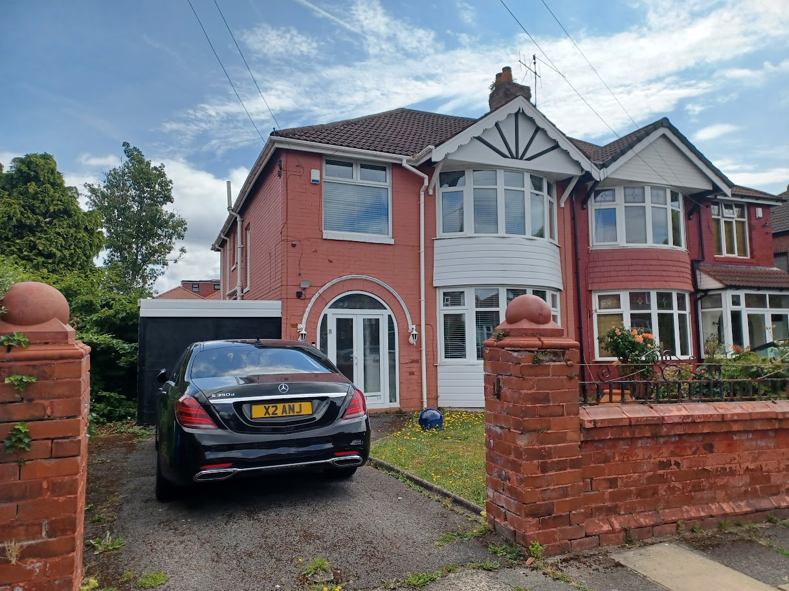
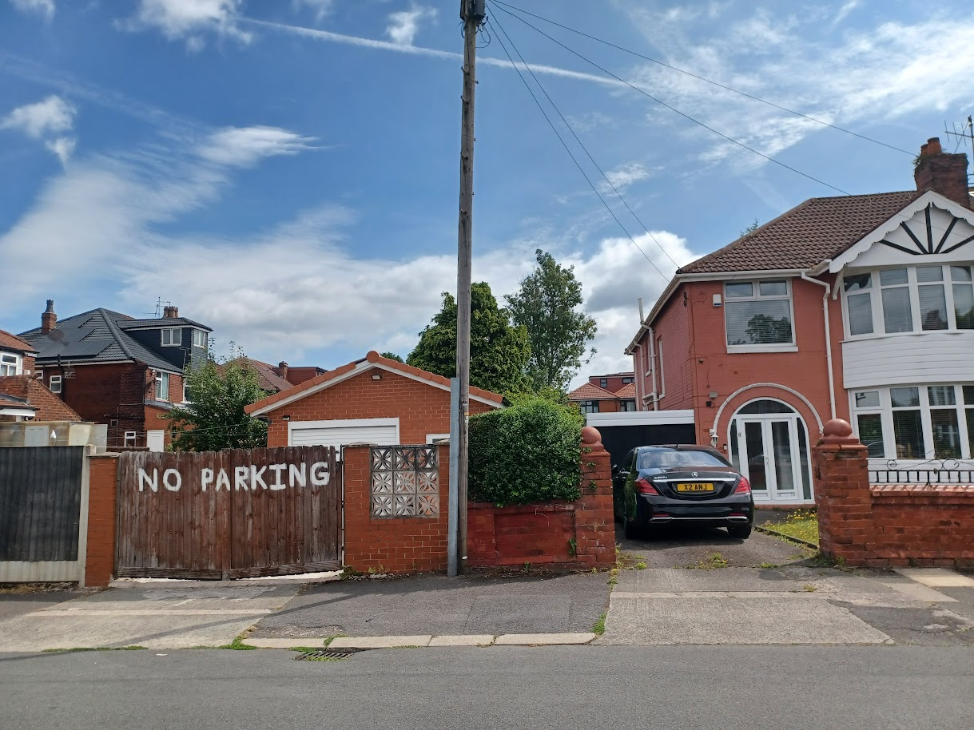

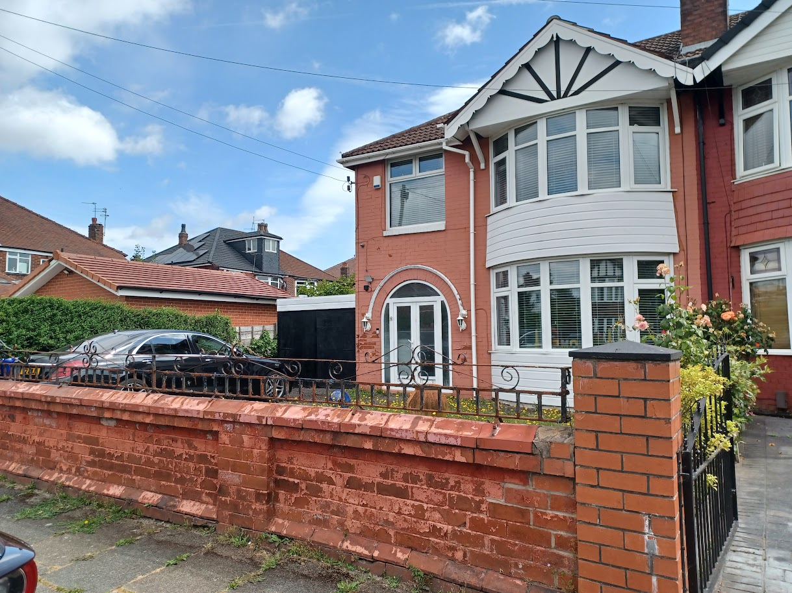
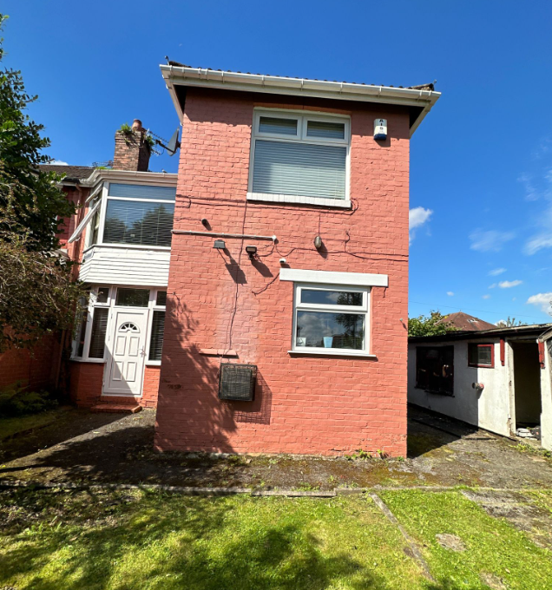
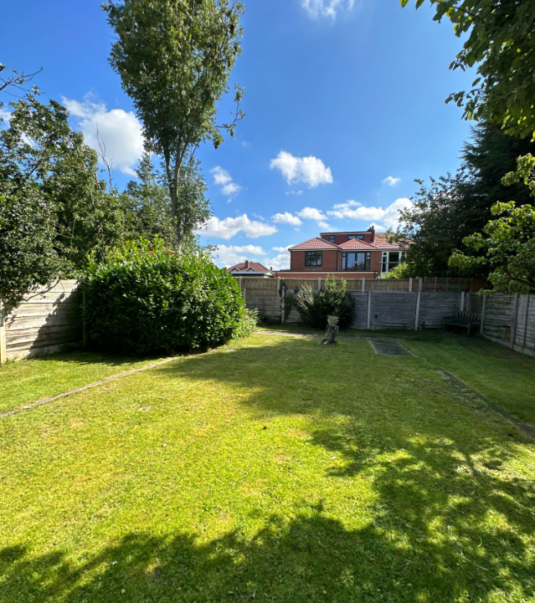

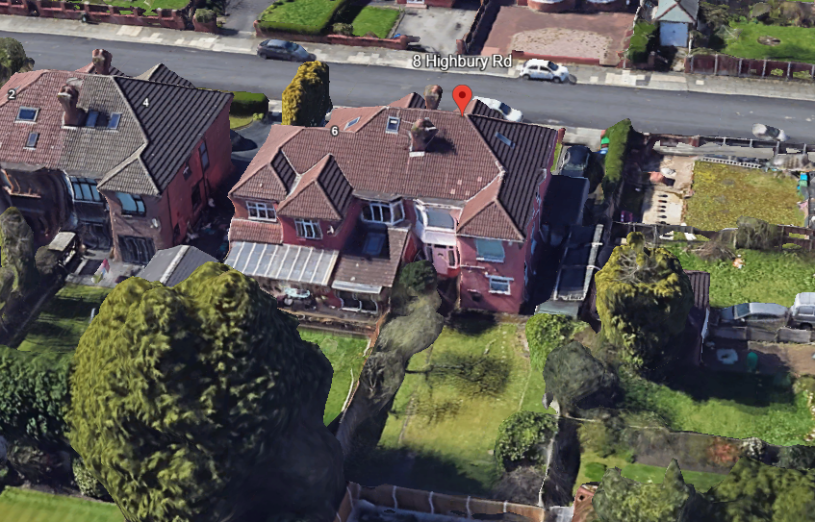

Description of development
The applicant is seeking planning permission for the erection of a part-single / part-two storey side extension and part-single / part-two rear extension with associated landscaping.

Consultation, notification and publicity responses

Consultations

Flood Risk Management – As the proposed development is located within Flood Zone 3, the applicant is required to submit a site-specific Flood Risk Assessment (FRA), including the completed FRA Proforma and supporting Environment Agency Product 4 data. This information is necessary to enable a full assessment of the site-specific flood risk, including the impacts of climate change and residual flood risk, and to demonstrate that the development will be safe for its lifetime without increasing flood risk elsewhere. The FRA should also identify any appropriate Property Flood Resilience (PFR) measures required to manage residual flood risk and enhance the resilience of the development.

Notifications and publicity

Local residents – no responses received.

Relevant policies
Unitary Development Plan (UDP) – The UDP has been superseded by the Core Strategy Development Plan, but certain policies are still considered of relevance:
- Policy DC1 – Residential Extensions

The Manchester Core Strategy – Development Plan Document 2012-2027 (“the Core Strategy”) was adopted by the City Council on the 11th of July 2012:
- Policy DM1 – Development Management
- Policy SP1 – Spatial Principles

Places for Everyone - is a long-term plan of nine Greater Manchester districts for jobs, new homes, and sustainable growth. It has been published by the GMCA on behalf of the nine districts and took effect and became part of the statutory development plan on March 21, 2024.
- Policy JP-P1 – Sustainable Places

National Planning Policy Framework (NPPF, 2026)
- Chapter 14 – Achieving Well-Designed Places
- Policy DP3: Key principles for well-designed places

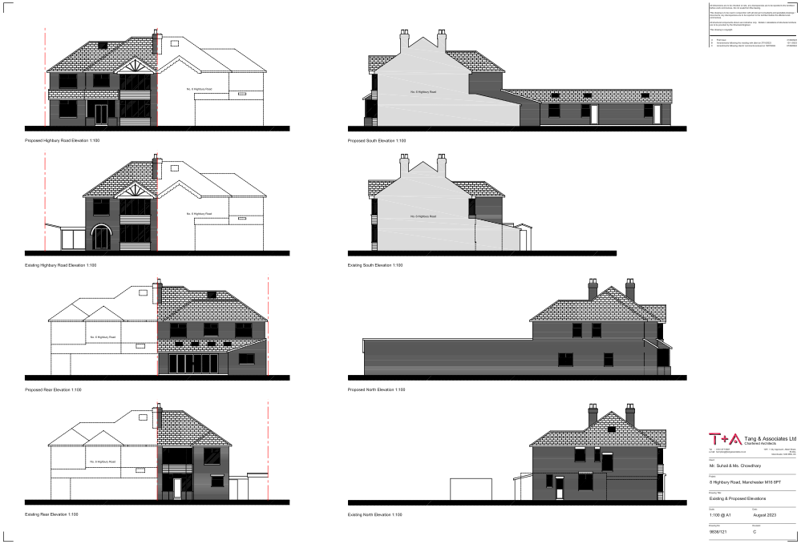
Submitted existing and proposed elevations

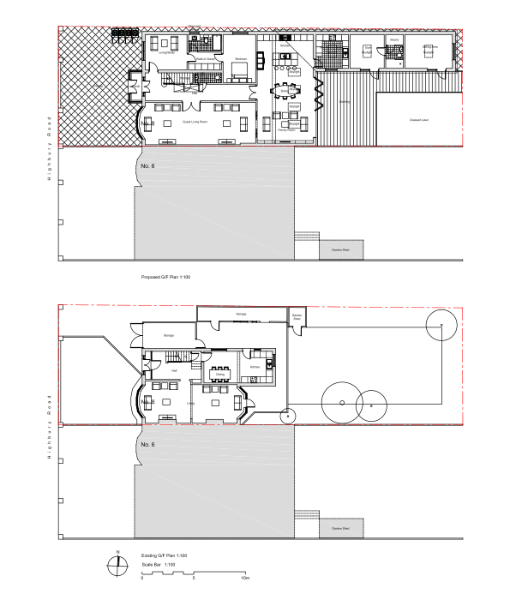
Submitted existing and proposed ground-floor plans
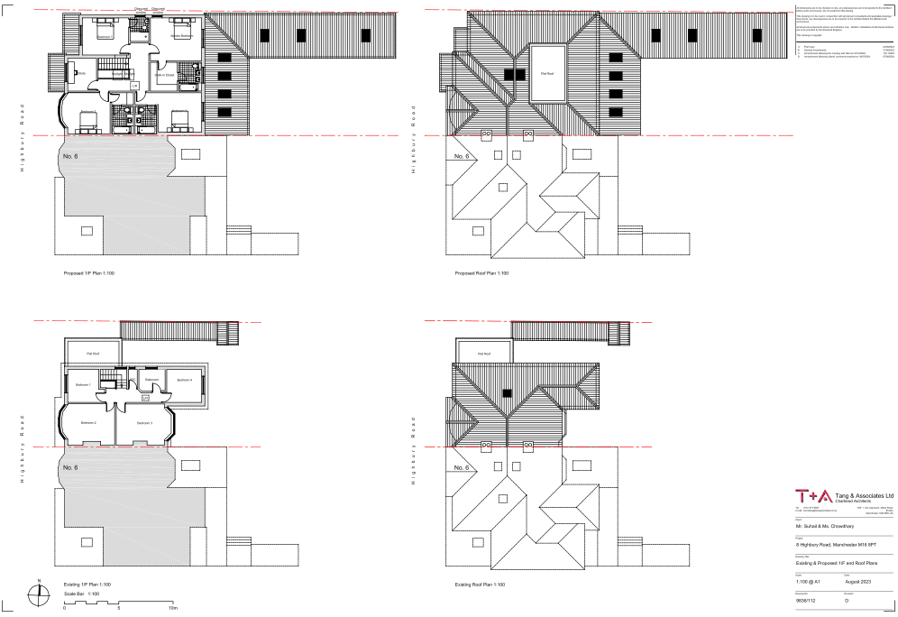
Submitted existing and proposed first-floor and roof plans

Assessment
Principle – Section 38(6) of the Planning and Compulsory Purchase Act 2004 and paragraph 3 of chapter 1 (introduction) of the National Planning Policy Framework (2026) require that
decisions must be made in accordance with the development plan, unless material
considerations indicate otherwise.

In the case of this application, the principle of the proposal is considered unacceptable and
cannot be supported as it conflicts with the development plan policies and associated guidance
listed in the preceding section.

It is considered that the proposal would, by virtue of its excessive scale, bulk and massing, together with its siting in close proximity to the plot's shared boundaries, result in a dominant and disproportionate form of development that would fail to appear as a visually subordinate and subservient addition to the host dwellinghouse. For these reasons, the proposal would constitute an overdevelopment of the application site, causing harm to the character and appearance of both the application property and the surrounding area. This harm would be further exacerbated by the inclusion of a crown roof and flat-roofed elements at first-floor level, which would appear incongruous and unsympathetic within an area characterised by traditional hipped and pitched roof forms. Additionally, the excessive scale and massing of the extension would give rise to unacceptable impacts upon the residential amenity of neighbouring occupiers, owing to its overbearing presence and adverse effects on outlook, together with increased opportunities for overlooking and loss of privacy.

Accordingly, the proposal fails to achieve the high standard of design required by local and national planning policy, would not contribute positively to local character, and would fail to safeguard the living conditions of neighbouring occupiers. On this basis, the proposal is considered to conflict with saved policy DC1 of the Unitary Development Plan, policies DM1 and SP1 of the Manchester Core Strategy, policy JP-P1 of the Places for Everyone Joint Development Plan Document, and chapter 14 of the National Planning Policy Framework (2026).

Siting, scale, and massing – the proposed part-single / part-two storey extension would be located to the side and rear of the dwellinghouse and would replace the existing single storey additions currently on the site.

At ground-floor level, the extension would project approximately 3.6m from the side elevation of the host dwellinghouse. It would extend for approximately 30m along the northern shared boundary and project up to 7.3m beyond the rear elevation adjacent to the southern shared boundary. The extension would have an overall width of approximately 11.2m, reducing to 3.9m at its rearmost point. It would be finished with a pitched roof measuring approximately 3.8m in height, with eaves at approximately 2.3m. The ground-floor element would be positioned adjacent to the northern, eastern and southern shared boundaries of the site.

At first-floor level, the extension would similarly project approximately 3.6m from the side elevation of the dwellinghouse. It would extend for approximately 11.5m alongside the northern shared boundary and project approximately 3.3m beyond the rear elevation adjacent to the southern shared boundary. The first-floor element would have an overall width of approximately 11m. The side section would incorporate a hipped roof with a maximum height of approximately 8.7m, set around 0.8m below the existing ridge height of the host dwellinghouse. To the rear, the extension would comprise a part-hipped / part-flat roof design with a maximum height of approximately 7.2m, set approximately 3.5m below the existing ridge. The flat-roofed section adjacent to No.6 would measure approximately 5.6m in height. The first-floor element would be positioned adjacent to the northern and southern shared boundaries.

The overall siting, scale and massing of the proposal is considered unacceptable. The extension would be of excessive scale, bulk and mass, by virtue of its substantial width, depth and length at both ground and first-floor level, together with its siting immediately adjacent to the site's shared boundaries, and its rearward projection which would exceed the limit stipulated within saved policy DC1(a) of the Unitary Development Plan for the City of Manchester (of 3.65m). For these reasons, the proposed extension would fail to appear as a subordinate or visually subservient addition to the host dwellinghouse, notwithstanding the inclusion of a first-floor setback and reduced ridge heights. On this basis, it is considered that the proposal would appear as a dominant and disproportionate addition to the property, resulting in an overdevelopment of the application site as a whole.

Further to this, the considerable massing of the proposed extension, particularly given its siting in close proximity to neighbouring boundaries, would give rise to significant detrimental impacts upon the residential amenity of surrounding occupiers. In particular, the proposal would introduce an unduly dominant and overbearing feature which, by reason of its scale, bulk and extent along the shared boundaries, would result in an unacceptable sense of enclosure for neighbouring residents. This harm would be exacerbated by the cumulative impact of the extensive ground and first-floor elements. Additional impacts relating to overlooking and loss of privacy are considered separately within the residential amenity section of this report.

The proposal therefore conflicts with saved policy DC1 of the Unitary Development Plan,
policies DM1 and SP1 of the Manchester Core Strategy, policy JP-P1 of the Places for
Everyone Joint Development Plan Document, and chapter 14 of the National Planning Policy Framework (2026)

Appearance and visual amenity – the details included on the submitted application form indicate that the proposed extension would be constructed using materials to match the existing dwellinghouse, including facing brickwork, roof tiles and white uPVC-framed windows. At ground-floor level, the extension would incorporate one window within the front elevation, two windows within the northern side elevation, a set of bi-folding doors and one window within the rear elevation, together with three windows and two doors within the southern side elevation. The rear-facing roof slope would contain four rooflights, whilst the south-facing roof slope would contain three rooflights. At first-floor level, the extension would feature one window within the front elevation, two windows within the northern side elevation and three windows within the rear elevation. The front and rear roof slopes would each contain a rooflight. The proposed extension would also incorporate a crown roof design comprising part-hipped and part-flat roof sections at first-floor level, together with a flat-roofed element adjacent to No. 6 Highbury Road, as shown on the submitted drawings.

Whilst the use of materials to match the existing dwellinghouse is considered acceptable and would assist in integrating the proposal with the application property, the proposal's overall appearance and impact upon the visual amenity of the area is considered unacceptable. By virtue of its excessive scale, bulk and massing, together with its extensive footprint across much of the site, the extension would fail to appear as a visually subservient addition to the original dwellinghouse. Instead, it would represent a dominant and disproportionate form of development which would overwhelm the original dwellinghouse, resulting in the overdevelopment of the site and causing harm to the character and appearance of both the application property and the surrounding area.

Further to this, the proposed roof design is considered unsympathetic to the established character of the dwellinghouse and the wider street scene. In particular, the incorporation of crown roof and flat-roofed elements at first-floor level would appear incongruous when viewed alongside the predominantly hipped and pitched roof forms of the host dwellinghouse and neighbouring properties. These features would introduce a visually discordant form of development that would detract from the cohesive appearance of the area and conflict with saved policy DC1(b) of the Unitary Development Plan for the City of Manchester, which states that two-storey flat-roofed extensions will not normally be supported. As such, the proposal is considered unacceptable in appearance and would result in undue harm to the visual amenity of the surrounding area.

The proposal therefore conflicts with saved policy DC1 of the Unitary Development Plan,
policies DM1 and SP1 of the Manchester Core Strategy, policy JP-P1 of the Places for
Everyone Joint Development Plan Document, and chapter 14 of the National Planning Policy Framework (2026).

Residential amenity – as discussed above, the excessive scale, bulk and massing of the proposed extension, together with its siting immediately adjacent to the plot's shared boundaries, would result in an unduly dominant form of development that would appear overbearing when viewed from neighbouring properties. In particular, the proposal would have a significant detrimental impact upon the amenities of occupiers at No.7, No.9 and No.11 Gildridge Road to the north, and No.6 Highbury Road to the south, owing to the substantial extent of built form introduced along and in close proximity to the shared boundaries. The resulting sense of enclosure and visual dominance would be unacceptable and harmful to the living conditions of these neighbouring occupiers.

Further to this, by virtue of its considerable scale and bulk in proximity to the shared boundary, the proposed extension would also adversely affect the outlook available from No.6 Highbury Road, particularly from the first-floor rear bay window and other rear-facing habitable room windows, where views would become dominated by the proposed built form.

In addition, the proposed windows at both ground and first-floor level would give rise to unacceptable overlooking and loss of privacy. The windows proposed within the northern side elevation, together with rear-facing windows located in close proximity to the eastern boundary, would afford direct views towards neighbouring properties and private garden areas. As a result, the occupiers of No.11 Gildridge Road and No.42 Springbridge Road would experience an increased perception of overlooking and a loss of privacy to the detriment of their residential amenity.
Accordingly, the proposal is considered to result in unacceptable harm to the living conditions of neighbouring occupiers through its overbearing presence, adverse impact upon outlook, and increased opportunities for overlooking and loss of privacy.

The proposal therefore conflicts with saved policy DC1 of the Unitary Development Plan,
policies DM1 and SP1 of the Manchester Core Strategy, policy JP-P1 of the Places for
Everyone Joint Development Plan Document, and chapter 14 of the National Planning Policy Framework (2026).

Waste storage and management – the submitted site plan shows a bin storage area to the front of the property. However, no details have been provided regarding its size, design or materials. As a result, it is not possible to assess its appearance or impact upon the character of the property and surrounding area. Further details are therefore required.

Parking – the proposal includes paving over the entire front garden and removing part of the front boundary wall to create a larger driveway and new vehicle access. However, no details have been provided regarding the proposed surfacing material, including whether it would be porous or permeable, nor have any details of on-site drainage been submitted.

As a result, it is not possible to assess whether the proposal would adequately manage surface water runoff or its potential impact on the site and surrounding area. Further details of the proposed surfacing and drainage arrangements are therefore required

Trees – the submitted site plan indicates that four trees within the rear garden would be removed to facilitate the proposed extensions and associated landscaping works. No Arboricultural Impact Assessment (AIA) or Arboricultural Method Statement (AMS) has been submitted. However, the trees are not subject to a Tree Preservation Order and the site does not lie within a Conservation Area. As such, their removal does not require planning permission.

Use – The submitted drawings indicate that, following the proposed extensions, the dwellinghouse would provide a substantial amount of accommodation. At ground-floor level, the property would comprise a guest living room, living/study room, bedroom with an en-suite and walk-in closet, hall, kitchen, dining and family room, separate wet kitchen and boiler room, gym with an en-suite and sauna, and a sitting area. At first-floor level, the property would contain a study and four bedrooms, each benefitting from an en-suite bathroom, with one bedroom also incorporating a walk-in closet

Whilst the application does not seek planning permission for a change of use and the property would therefore remain in use as a single dwellinghouse, the extent of the accommodation proposed reflects the substantial scale of the extensions. The resulting dwelling would be excessive in relation to the size of the plot and would reinforce concerns that the proposal constitutes an overdevelopment of the site. For these reasons, the proposal is considered to result in an overly large and disproportionate addition to the original dwellinghouse that would fail to respect the character and appearance of the site and surrounding area.

Single storey front extension – the submitted drawings also depict a single storey front extension which has not been included within the description of development on the application form. The extension would project approximately 1.3m forward of the principal elevation, measure approximately 3.2m in width, and have a pitched roof with an overall height of approximately 3.7m and an eaves height of approximately 2.8m. A separation distance of approximately 4.1m would be retained to the northern boundary and approximately 3.9m to the southern boundary.

As the front extension has not been included within the description of development, no information has been provided regarding its proposed materials or external finishes. The submitted drawings indicate that the extension would incorporate a set of inward-opening doors on the front elevation, together with glazing above and to both side elevations.

Given its size and design, the extension would exceed the limitations for a porch that can be erected under permitted development rights and would therefore require planning permission. As such, the extension forms part of the proposed development and has not been correctly applied for under the current application. In the event of a future planning application, the application form and description of development should be amended to include the front extension, together with full details of its proposed materials, design and external appearance.

Decking – the submitted site plan shows a decking area proposed to the rear of the dwellinghouse. However, insufficient information has been provided to determine whether the decking would be raised above ground level. Whilst the submitted elevation drawings suggest that it may be less than 300mm in height, this has not been clearly specified.

The decking has not been included within the description of development on the application form. Whilst decking may not ordinarily require planning permission, in this instance the proposed decking appears to directly adjoin the proposed extensions and would therefore form part of the wider proposal. Further to this, it is unclear whether the cumulative extent of the proposed extensions, decking and other development within the curtilage would result in more than 50% of the curtilage (excluding the original dwellinghouse) being covered. As such, planning permission may be required for the decking.

In the event of a future planning application, the application form and description of development should be amended to include the decking area, together with full details of its height, extent, proposed materials, design and appearance.

Flood Risk – Comments from the Council’s Flood Risk Management Team identify the site being within Flood Zone 3 requiring the provision of a proportionate flood risk assessment.

Conclusion – overall, it is considered that the proposal would, by virtue of its excessive scale, bulk and massing, together with its siting in close proximity to the plot's shared boundaries, result in a dominant and disproportionate form of development that would fail to appear as a visually subordinate and subservient addition to the host dwellinghouse. For these reasons, the proposal would constitute an overdevelopment of the application site, causing harm to the character and appearance of both the application property and the surrounding area. This harm would be further exacerbated by the inclusion of a crown roof and flat-roofed elements at first-floor level, which would appear incongruous and unsympathetic within an area characterised by traditional hipped and pitched roof forms. Additionally, the excessive scale and massing of the extension would give rise to unacceptable impacts upon the residential amenity of neighbouring occupiers, owing to its overbearing presence and adverse effects on outlook, together with increased opportunities for overlooking and loss of privacy.

Accordingly, the proposal fails to achieve the high standard of design required by local and national planning policy, would not contribute positively to local character, and would fail to safeguard the living conditions of neighbouring occupiers. On this basis, the proposal is considered to conflict with saved policy DC1 of the Unitary Development Plan, policies DM1 and SP1 of the Manchester Core Strategy, policy JP-P1 of the Places for Everyone Joint Development Plan Document, and chapter 14 of the National Planning Policy Framework (2026).

The agent of the application notified of the LPA’s intent to refuse the proposal.

Other Legislative Requirements

Equality Act 2010
Section 149 (Public Sector Equality Duty) of the Equality Act 2010 requires due regard to the need to: Eliminate unlawful discrimination, harassment and victimisation and other conduct prohibited by the Act and; Advance equality of opportunity between persons who share a protected characteristic and persons who do not share it. The Equality Duty does not impose a legal requirement to conduct an Equality Impact Assessment. Compliance with the Equality Duty involves consciously thinking about the aims of the Equality Duty as part of the process of decision-making.

Human Rights Act 1998 considerations
This application needs to be considered against the provisions of the Human Rights Act 1998. Under Article 6, the applicants (and those third parties, including local residents, who have made representations) have a right to a fair hearing and to this end the local planning authority must give full consideration to their comments.

Protocol 1 Article 1, and Article 8 where appropriate, confer(s) a right of respect for a person’s home, other land and business assets. In taking account of all material considerations, including Council policy as set out in the Core Strategy and saved polices of the Unitary Development Plan, the Director of Planning, Building Control & Licensing has concluded that some rights conferred by these articles on the applicant(s)/objector(s)/resident(s) and other occupiers and owners of nearby land that might be affected may be interfered with but that that interference is in accordance with the law and justified by being in the public interest and on the basis of the planning merits of the development proposal. She believes that any restriction on these rights posed by the recommendation given is proportionate to the wider benefits of and that such a decision falls within the margin of discretion afforded to the Council under the Town and Country Planning Acts.

Recommendation: Refuse

Article 35 Statement:

The proposal would not improve the social and environmental conditions of the area, nor does it
comply with the development plan and therefore does not comprise sustainable development.
There are no conditions which could reasonably have been imposed, which would have made
the development acceptable, and it is therefore not possible to approve the application.

Condition(s) to be attached to decision for approval OR Reasons for recommendation to refuse

1) The proposed extension, by reason of its excessive scale, bulk, massing and footprint, together with its siting immediately adjacent to the plot's shared boundaries, would constitute an overdevelopment of the application site. The proposal would result in a dominant and disproportionate form of development that would fail to appear as an appropriate addition to the dwellinghouse. The proposal is therefore contrary to saved policy DC1 of the Unitary Development Plan, policies DM1 and SP1 of the Manchester Core Strategy, policy JP-P1 of the Places for Everyone Joint Development Plan Document, and the National Planning Policy Framework (2026).

2) The proposed extension, by virtue of its excessive scale, bulk and massing, would fail to appear as a visually subordinate and subservient addition to the host dwellinghouse, resulting in undue harm to the character and appearance of the application property and the visual amenity of the surrounding area. The inclusion of a crown roof and flat-roofed elements at first-floor level would also introduce an incongruous and unsympathetic form of development that would juxtapose with the established character of the original dwellinghouse and surrounding residential properties, where traditional hipped and pitched roof forms predominate. The proposal is therefore contrary to saved policy DC1 of the Unitary Development Plan, policies DM1 and SP1 of the Manchester Core Strategy, policy JP-P1 of the Places for Everyone Joint Development Plan Document, and the National Planning Policy Framework (2026).

3) The proposed extension, by virtue of its excessive scale, bulk and massing, together with its siting in close proximity to the plot’s shared boundaries, would result in an unduly dominant and overbearing form of development that would generate a harmful sense of enclosure for occupiers of neighbouring residential properties and have a detrimental impact upon their outlook. In addition, the proposed windows positioned in proximity to the plot's shared boundaries would result in unacceptable overlooking and loss of privacy to neighbouring occupiers. As such, the proposal would have an unacceptable impact upon the residential amenity of neighbouring residents and is contrary to saved policy DC1 of the Unitary Development Plan, policies DM1 and SP1 of the Manchester Core Strategy, policy JP-P1 of the Places for Everyone Joint Development Plan Document, and the National Planning Policy Framework (2026).

