

Planning

Delegated Officer Report

Summary of application details
Application reference: | PLA-2026-000932
Application type: | Consent to display an advertisement
Proposal: | Installation of 2no. digital advert displays for a temporary period of five years.
Site address: | Deansgate-Castlefield Tram Stop Manchester M3 4LG
Ward(s): | Deansgate
Date application valid: | 06 July 2026
Applicant name: | Mr Jonathan Smith
Agent (if any): | Mr Ben Kelly
Case officer: | Ciara Gettinby
Recommendation: | Approve
Date of recommendation: | 24 August 2026

Description of site, building and/or area
This application relates to Deansgate Tram Stop, a major transport hub for the City of Manchester. Deansgate train station and the Metrolink tram stop is directly linked by a walkway and also compromises of passenger waiting facilities, access staircases, lifts and associated operational infrastructure. Deansgate-Castlefield Tram stop is considered one of the busiest due to being the station in which drivers exchange. The surrounding area is characterised by a mix of commercial, leisure and residential uses. The nearby area features the historic railway infrastructure along modern high-rise development.

Description of development
Advertisement consent is sought for the installation of 2no. digital advert displays for a temporary period of five years. Both digital advertisements would replace existing advertisements. The displays would be one-sided and measure a height of 2.4m and a width of 0.3m. The digital displays would provide travel information as well as advertisements. The digital displays would be made from black powder coated pressed steel and a black tinted glass media screen.

This application is part of a wider scheme to implement these digital advertisements in replacement of existing posters across tram platforms in the City Centre and has been submitted alongside,PLA-2026-000931, (Exchange Square) PLA-2026-000929, (St Peter’s Square) PLA-2026-000961(Piccadilly Gardens) and PLA-2026-000960 (Market Street).

Consultation, notification and publicity responses

Consultations
Metrolink- no objections.

Highway Services- recommended conditions and informative to be attached to the decision notice and this report.

Environmental Health- recommended conditions to be attached to the decision notice and this report.

Notifications and publicity
A site notice was displayed for public interest adjacent to the site, no representations have been received.

Proposed Plans:
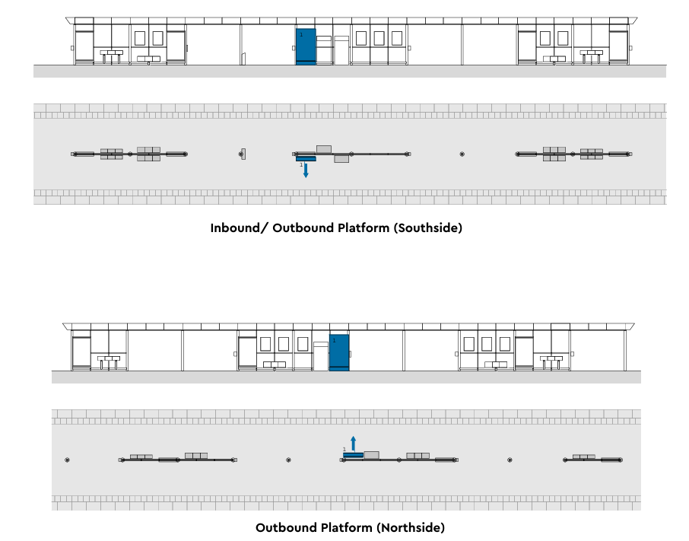
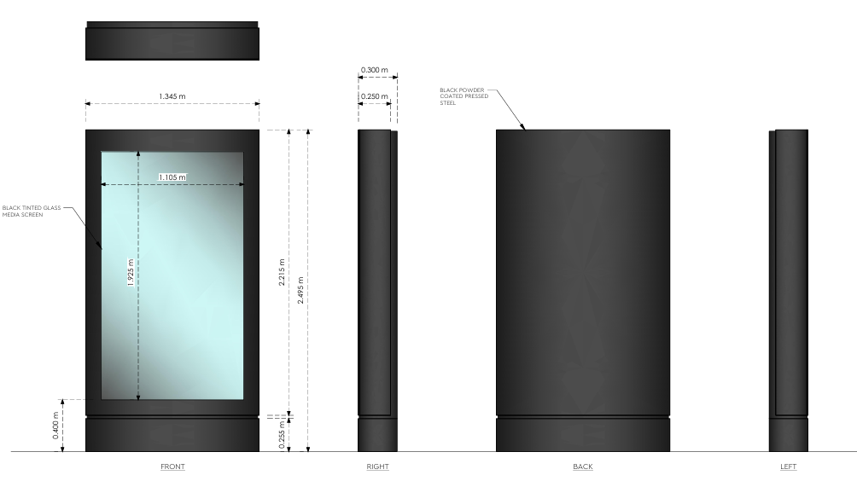

Site Photos:

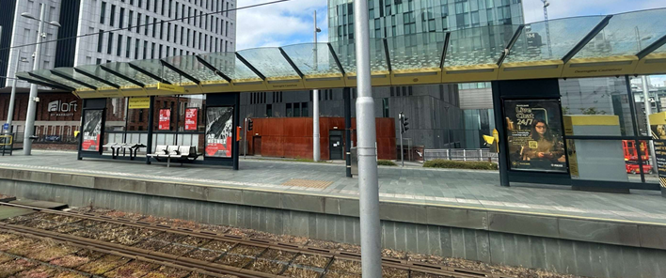

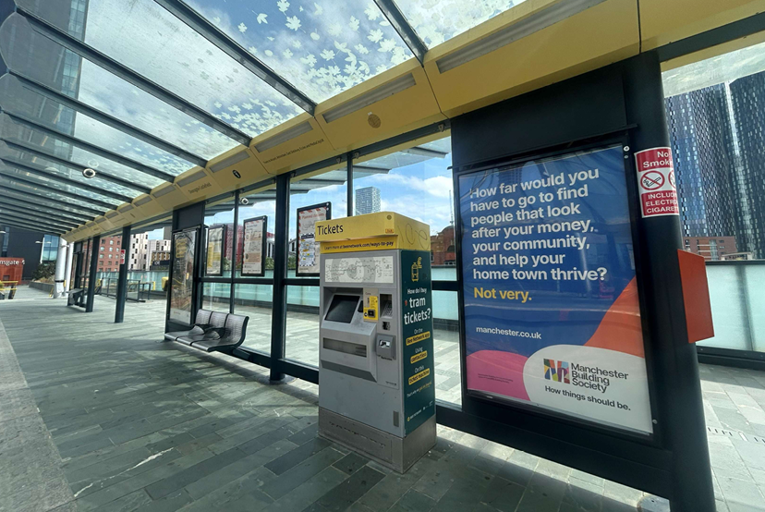
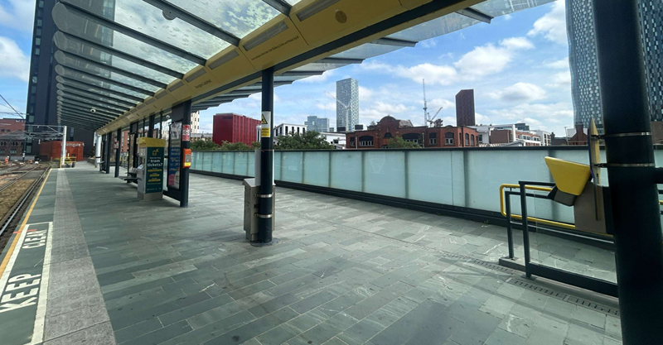

Relevant policies
The Town and County Planning (Control of Advertisements) Regulations 2007
The Local Planning Authority shall exercise its powers under these Regulations in the interests of amenity and public safety, taking into account-

- The provisions of the development plan, so far they are material; and
- Any other relevant factors

2.

- Factors relevant to amenity include the general characteristics of the locality, including the presence of any feature of historic, architectural, cultural or similar interest;
- Factors relevant to the public safety include-

- The safety of persons using any highway, railway, waterway, etc..
- Whether the display of an advertisement in question is likely to obscure or hinder the ready interpretation of, any traffic sign, railway signal or aid
- Whether the display of an advertisement in question is likely to hinder the operation of any device used for the purpose of security or surveillance or for measuring the speed of any vehicle

3. In taking account of factors relevant to amenity, the local planning authority may, if it thinks fit, disregard any advertisement that is being displayed.

4. Unless it appears to the Local Planning Authority to be required in the interests of amenity or public safety, an express consent for the display of advertisements shall not contain any limitation or restriction relating to the subject matter, content or design of what is to be displayed.

The following policies are considered relevant in the consideration of this application:

Places for Everyone- A long term plan of nine Greater Manchester districts for jobs, new homes and sustainable growth, it has been published by the GMCA on behalf of the nine districts (Bolton, Bury, Rochdale, Oldham, Tameside, Stockport, Manchester, Trafford, Salford, Wigan) and took into effect and become part of the statutory development plan on March 21, 2024.

The Manchester Core Strategy- Development Plan Document 2012- 2027 (The Core Strategy) was adopted by the City Council on the 11th of July 2012, it is a key document for the local plan which provides a framework that planning applications are assessed against.

Policy DM1- Development Management
Policy SP1- Spatial Principles

Unitary Development Plan (UDP)- The UDP has been superseded by the Core Strategy Development Plan, but certain policies are still considered relevance:

-Policy 14 – Shopfronts and related signs

Other Material Considerations:

The National Planning Policy Framework (August 2026)- The Government’s new national planning policies and how they are to be implemented through local authorities.

Policy DP3- Key principles for well-designed places
Policy S3: Presumption in favour of sustainable development

Assessment
The principle of the digital advertisements is acceptable given that it would provide updated information to users of the Metrolink and would aid visitors in navigating the City. The principle of displaying advertisements is also accepted given that it would create a revenue for Transport for Greater Manchester. The application will be assessed in terms of its visual amenity and public safety as set out below.

Visual Amenity
Policy DP3 of the National Planning Policy Framework (August 2026) states that ‘development proposals should respond to their context, so they integrate with and enhance their surroundings.’ Considering the digital advertisement would be replacing existing signage, it is not considered that the proposal would add to any visual clutter and would consist of neutral colours. The digital signs would be placed on the tram platforms and away from the City’s public areas. The proposed would replicate the scale of the existing signage and its design would consist with the existing, creating a congruous and uniformed appearance across the platforms. Policy DM1 requires that proposed advertisements are commensurate in scale to their proposed locations, in which this proposal is considered to be. Therefore, in terms of visual amenity, the proposed digital displays are considered to be acceptable.

Public Safety
The total projection of the digital advertisement would not extend further than the existing facilitates and would not interrupt the existing pathway for pedestrians and users. The positioning of the proposed displays would not be considered a distraction to those operating the trams. Signage would be installed so not to exceed illuminance level of 300cd/m2. As part of the assessment of this application, Environmental Health and MCC Highway Services were consulted and no objections were received. As such, there are no public safety concerns associated with this proposal, pursuant to Policy DC14 and DM1.

Other Legislative Requirements

Equality Act 2010
Section 149 (Public Sector Equality Duty) of the Equality Act 2010 requires due regard to the need to: Eliminate unlawful discrimination, harassment and victimisation and other conduct prohibited by the Act and; Advance equality of opportunity between persons who share a protected characteristic and persons who do not share it. The Equality Duty does not impose a legal requirement to conduct an Equality Impact Assessment. Compliance with the Equality Duty involves consciously thinking about the aims of the Equality Duty as part of the process of decision-making.

Human Rights Act 1998 considerations
This application needs to be considered against the provisions of the Human Rights Act 1998. Under Article 6, the applicants (and those third parties, including local residents, who have made representations) have a right to a fair hearing and to this end the local planning authority must give full consideration to their comments.

Protocol 1 Article 1, and Article 8 where appropriate, confer(s) a right of respect for a person’s home, other land and business assets. In taking account of all material considerations, including Council policy as set out in the Core Strategy and saved polices of the Unitary Development Plan, the Director of Planning, Building Control & Licensing has concluded that some rights conferred by these articles on the applicant(s)/objector(s)/resident(s) and other occupiers and owners of nearby land that might be affected may be interfered with but that that interference is in accordance with the law and justified by being in the public interest and on the basis of the planning merits of the development proposal. She believes that any restriction on these rights posed by the recommendation given is proportionate to the wider benefits of and that such a decision falls within the margin of discretion afforded to the Council under the Town and Country Planning Acts.

Conclusion
Given the above issues, it is considered that the advertisements are acceptable in terms of its impact upon visual amenity and public safety in accordance with Policies SP1, DM1 of the Core Strategy, and Policy DC15 of the UDP.

Recommendation: Approve

Conditions attached to this decision

- Standard Advertisement Condition
No advertisement is to be displayed without the permission of the owner of the site or any other person with an interest in the site entitled to grant permission. No advertisement shall be sited or displayed so as to:
(a) endanger persons using any highway, railway, waterway, dock, harbour or aerodrome (civil or military);
(b) obscure, or hinder the ready interpretation of, any traffic sign, railway signal or aid to navigation by water or air; or
(c) hinder the operation of any device used for the purpose of security or surveillance or for measuring the speed of any vehicle.
Any advertisement displayed, and any site used for the display of advertisements, shall be maintained in a condition that does not impair the visual amenity of the site. Any structure or hoarding erected or used principally for the purpose of displaying advertisements shall be maintained in a condition that does not endanger the public. Where an advertisement is required under these Regulations to be removed, the site shall be left in a condition that does not endanger the public or impair visual amenity.

- Specified Plans
The development hereby approved shall be carried out in accordance with the following drawings and documents,

Location plan, ref- K/XX:PA:01
Proposed site plan, ref- K/XX:PA:03
Proposed unit location, ref- K/XX:PA:05
Advertising Technical Specification, ref- K/XX:PA:06

Received by the City Council as the Local Planning Authority on 6 July 2026

Reason - To ensure that the development is carried out in accordance with the approved plans. Pursuant to policies SP1 and DM1 of the Core Strategy and saved UDP policy DC15.1

- Temporary Permission
- The express advertisement consent hereby granted is limited to a period ending on the 31 August 2031 b) On the date of the expiry of the express consent period on 31 August 2031, the advertisement hoardings and all associated development shall be removed, any use of the land/building authorised by this consent shall be discontinued, and the land/building shall be reinstated in accordance with a scheme previously approved.

Reason - To enable the City Council to consider the acceptability of the continuance of the display of the advertisement hoardings at the site on the expiry of the period of express consent, having regard to visual amenity and changing circumstances in the locality in order to comply with policies DM1, EN1, EN3, CC9, CC10, T1 and SP1 of the Adopted Core Strategy for the City of Manchester, paragraphs 2.10, 2.20, 12.6, 3.1 and 8.8 of the Guide to Development in Manchester SPD and saved policies E3.3, DC15.1 and 15.2, DC18.1 and DC19.1 of the Unitary Development Plan for Manchester

- Signage

(a) No individual advertisement/customer information displayed on the LED panel shall contain moving images, animation, video or full motion images or any images that resemble road signs, traffic lights or traffic signs.
(b) No individual advertisement/customer information shall be displayed for duration of less than 10 seconds.
(c) Controls shall be in place to ensure smooth uninterrupted transition of images displayed on the panel.
(d) The display panel shall be fitted with a light sensor, designed to adjust the brightness to changes in ambient light levels.
(e) A mechanism shall be in place so that if the installation breaks down, it defaults to a black screen to avoid any flashing error messages or pixilation.
(f) The maximum luminance level of the advertisements/customer information displayed on the panel shall not exceed 300 cd/m2 during non daylight hours / inclement weather
Or for signs less than 10m2
(f) The maximum luminance level of the advertisements/customer information displayed on the panel should not exceed 600 cd/m2 during non-daylight/ inclement weather.

Reason - To safeguard the amenities of the occupiers of nearby properties pursuant to policies SP1 and DM1 of the Manchester Core Strategy (2012) and extant policy 15.2 of the UDP (1995) for Manchester.

- Construction Management Plan
A Construction and Maintenance Management Plan (CMMP) will need to be provided prior to start of any works and be conditioned. The CMMP should include:
Details on associated vehicle access and parking.
Details on pedestrian and traffic management measures.
Detail of electrical/utility connections and associated works.
A dilapidation survey if required.
This should include any procedures/works required to change the advertisement/customer information and to also carry out maintenance and repairs.

Reason - To safeguard the amenities of nearby residents pursuant to policies SP1, EN19 and DM1 of the Manchester Core Strategy.

- LIGHT FROM DIGITAL DISPLAY SCREENS
a) The luminance level of the digital display screen shall be controlled by a light sensor to adjust the screen brightness to reflect the ambient levels during the daytime and set to a maximum brightness of 600cd/m2 during hours of darkness to accord with the recommendations of the 'The Institute of Lighting Professional's 'Professional Lighting Guide 05/23: The Brightness of Illuminated Advertisements including Digital Displays. In the event of breakdown or malfunction the screen will automatically switch off.

b) “The advertisement shall display no special visual effects of any kind during the time that the advertisement is displayed or on transition between advertisements. The displayed image shall not include animated, flashing, scrolling, intermittent or video elements and the transition between successive images shall not include fading, swiping or other animated transition method.

c) The minimum display time for each piece of content on the digital display screens shall be 10 seconds.

d). The interval between each piece of content on the digital display screens shall take place over a period no greater than one second; the complete screen shall change with no visual effects (including swiping or other animated transition methods) between displays

e) Should a fault be detected or reported with the screen or advertisement, the screen will be programmed to automatically switch to a blank screen with black background.

Reason - To safeguard the amenities of the occupiers of nearby properties pursuant to policies SP1 and DM1 of the Manchester Core Strategy (2012) and extant policy 15.2 of the UDP (1995) for Manchester.

- Management Plan
A management plan shall be submitted to demonstrate how the units will be maintained to ensure the agreed light levels are maintained and not exceeded. The plan should include details of remote monitoring and control capability, how the operator is alerted if any fault is detected and details of what action is taken where a fault is identified or reported including response time to undertake repair. The plan should include details of proposed physical inspection and monitoring frequency.

INFORMATIVES

- The applicant is required to discuss and agree any requirements for licensing, hoarding / scaffolding, skips and electrical/utility connections with MCC's Highways Licensing Team via Email to: highwaylicences@manchester.gov.uk.

- Any requirements for temporary pedestrian and traffic management will need to be agreed with MCC’s Traffic Management Team via Email to highwaynetworkmanagement@manchester.gov.uk .

- The technical note submitted to support the application acknowledges that there are site assessments and reviews to be undertaken by Metrolink. This will involve the Metrolink Engineering Assurance Process being followed to ensure that the proposed digital signage can be safely incorporated into Metrolink infrastructure and therefore we have no objection to this Application being approved.

- In addition to the agreeing the details with Metrolink as per the Technical Note we would like the Applicant to be advised that any installation works will need to comply with the details of Working Safely Near Metrolink and that the appropriate permits will need to be obtained to facilitate the works. The details of Working Safely Near Metrolink can be found at: Working safely near Metrolink | Bee Network | Powered by TfGM

