

Planning

Delegated Officer Report

Summary of application details
Application reference: | PLA-2026-000626
Application type: | Householder planning permission
Proposal: | Installation of rear dormer.
Site address: | 52 Crumpsall Lane Manchester M8 5SG
Ward(s): | Crumpsall
Date application valid: | 10 July 2026
Applicant name: | Mr Khalid Hussain
Agent (if any): | Mr Alvin Loh
Case officer: | Holly Wright
Recommendation: | Approve
Date of recommendation: | 24 August 2026

Description of site, building and/or area
The application relates to a two-storey semi-detached dwellinghouse of redbrick and white render with a red tile dual-pitch roof. The property features white uPVC-framed windows, including projecting bay windows to the front, a brick driveway and spacious front garden bordered by a mid-level brick wall and piers, a single storey side extension, a single storey rear extension, and a spacious rear garden.

Crumpsall Lane is a street situated within the Crumpsall ward of Manchester, close to Crumpsall Metrolink tram station, Crumpsall Park, and Middleton Road (A576). The surrounding area is predominantly residential in terms of its character, consisting of terraced and semi-detached dwellinghouses, and benefits from its proximity to public outdoor amenity and green spaces.

The property is not listed, nor is it sited within a conservation area.

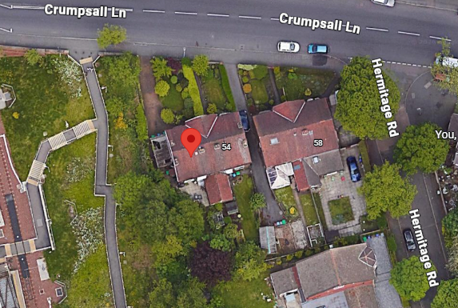
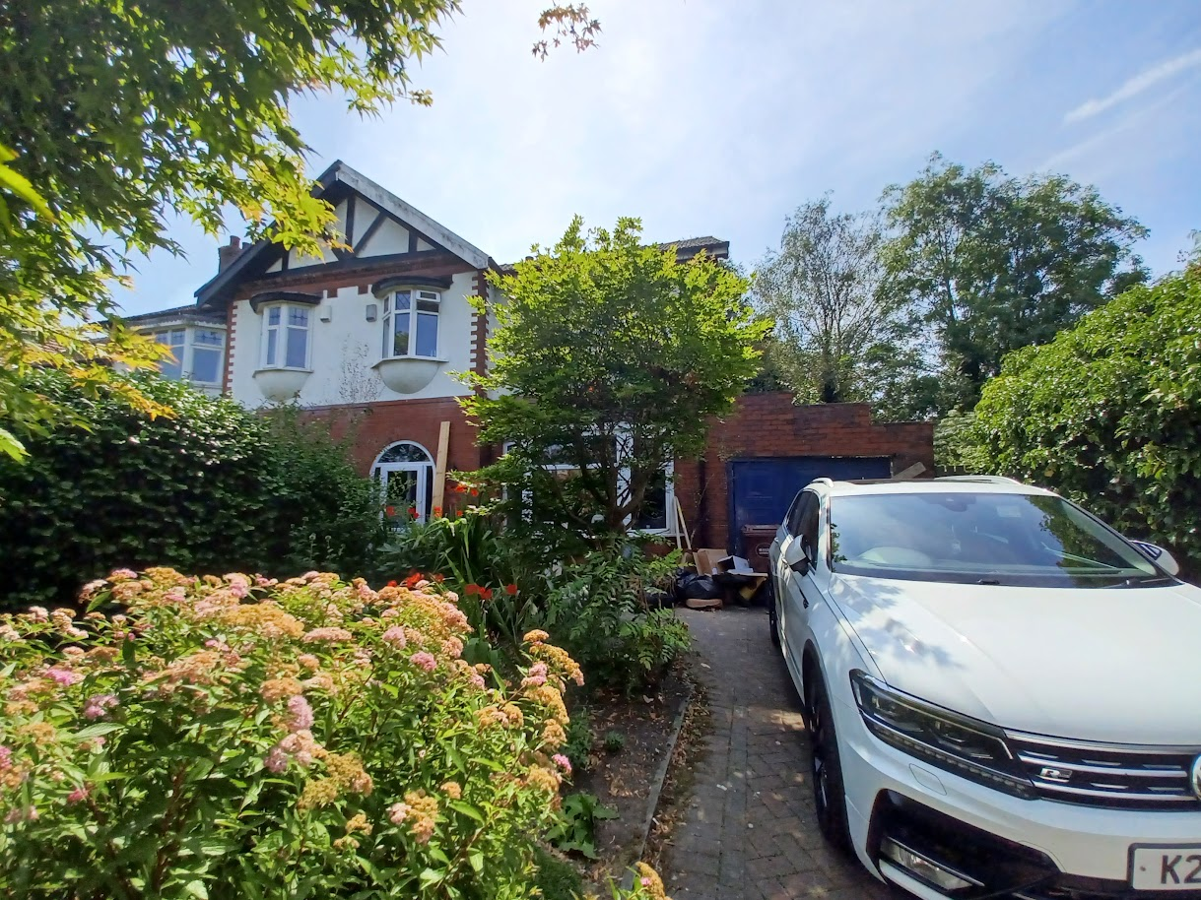
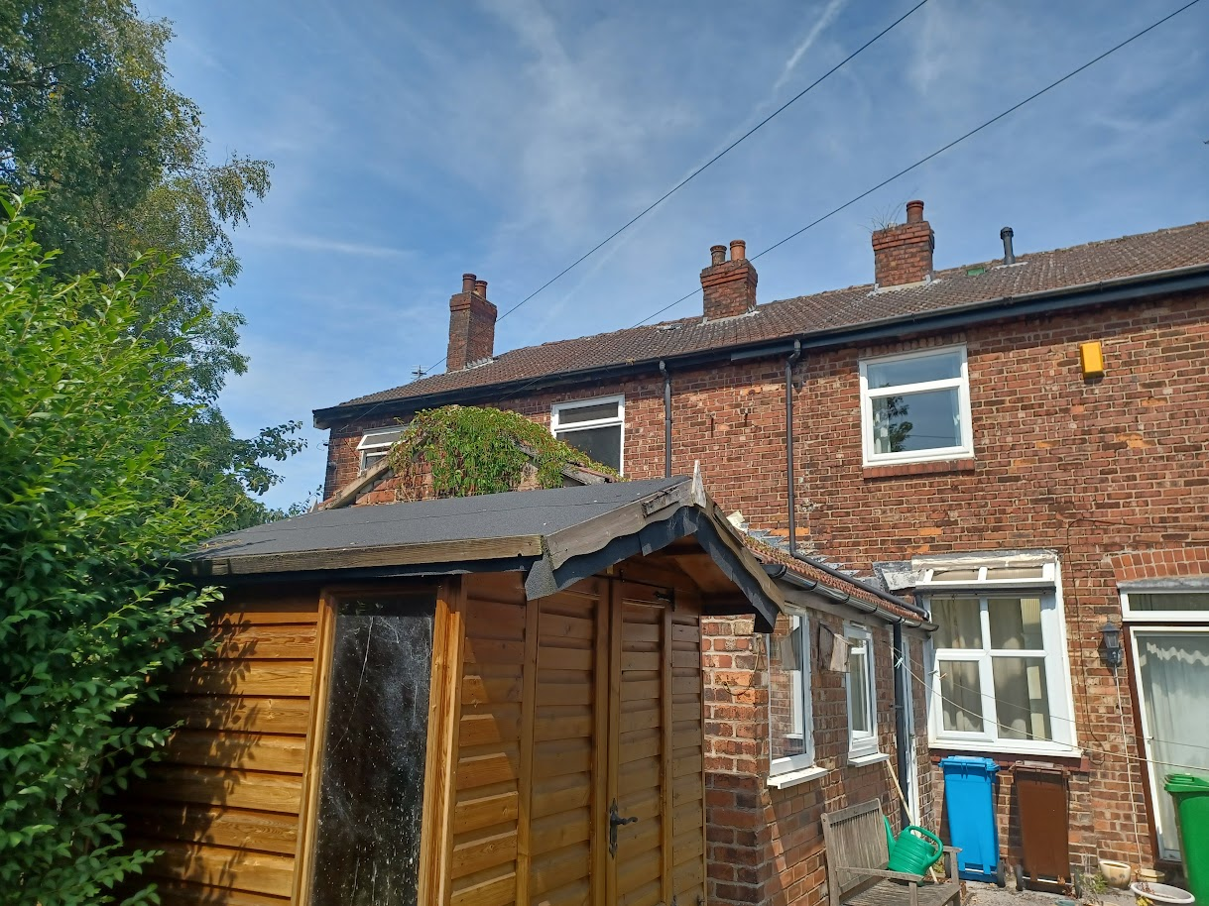
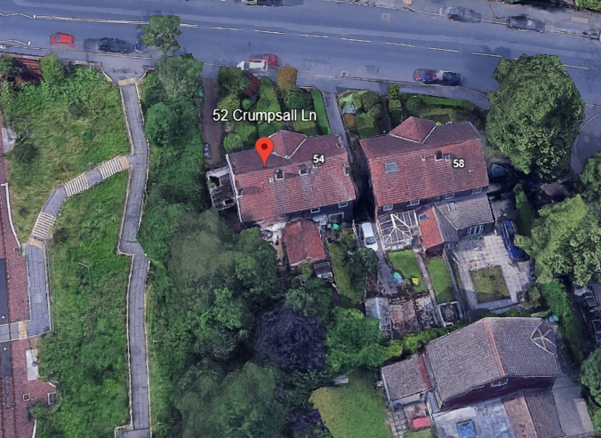

Description of development
The applicant is seeking planning permission for the installation of a rear dormer.

Consultation, notification and publicity responses

Consultations

Not applicable.

Notifications and publicity

No responses received.

Relevant policies
Unitary Development Plan (UDP) – The UDP has been superseded by the Core Strategy Development Plan, but certain policies are still considered of relevance:
- Policy DC1 – Residential Extensions

The Manchester Core Strategy – Development Plan Document 2012-2027 (“the Core Strategy”) was adopted by the City Council on the 11th of July 2012:
- Policy DM1 – Development Management
- Policy SP1 – Spatial Principles

Places for Everyone - is a long-term plan of nine Greater Manchester districts for jobs, new homes, and sustainable growth. It has been published by the GMCA on behalf of the nine districts and took effect and became part of the statutory development plan on March 21, 2024.
- Policy JP-P1 – Sustainable Places

National Planning Policy Framework (NPPF, 2026)
- Chapter 14 – Achieving Well-Designed Places
- Policy DP3: Key principles for well-designed places

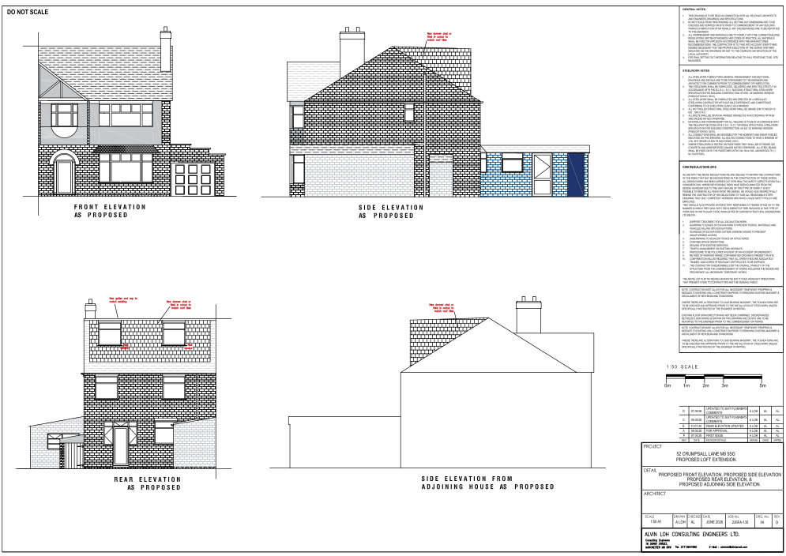
Submitted proposed elevations

Assessment
Principle – the principle of the proposal, to erect a rear dormer extension to provide additional living accommodation for a dwellinghouse, is acceptable. Notwithstanding this, consideration must be given to the proposal’s siting, scale, and massing, appearance, impact upon visual and residential amenity, waste storage, and parking, amongst other matters.

Siting, scale, and massing – the dormer would be sited on the rear-facing roof slope of the dwellinghouse, facing south. It would measure to approximately 4.1m in length, 6.3m in width, and 2.4m in height. It would be set at the same level as the existing ridge, approximately 0.5m above from the eaves, and 0.3m away from the gable end and adjoining semi.

The overall siting, scale, and massing of the proposal is considered to be acceptable as the
dormer is understood as being subservient to the host dwellinghouse in terms of its dimensions
on account of it being set at the same level as the existing ridge with adequate gaps
maintained to the existing eaves and roof edges. The proposal would therefore avoid resulting
in an ‘excessively large or bulky’ addition to the property and is not considered to cause undue
harm to the residential amenity of neighbouring occupiers in terms of introducing an overbearing
feature into the area. Sufficient private outdoor amenity space would also be retained to the
rear.

The proposal therefore accords with saved policy DC1 of the Unitary Development Plan for the
City of Manchester and policies DM1 and SP1 of the Manchester Core Strategy.

Appearance and visual amenity – in their email correspondence dated 14 August 2026, the agent of the application confirmed the dormer would feature vertical plain tiles on its elevations, coloured to match the existing roof. The flat roof would comprise a warm deck construction with a Bauder or IKO finish, and the windows would be white uPVC-framed units. Its side elevations would be blank, whilst its rear elevation would feature two windows.

The proposal is relatively standard in terms of its design and scale for developments of this type
and would be in-keeping with the existing precedent of residential extensions in this locale. Sited at the rear of the property, the proposal would not be highly visible within the street scene or public realm and, as such, should avoid forming a prominent visual feature in the area. Further to this, the dormer would feature hanging tiles coloured to match the existing roof with matching white uPVC-framed windows which would be in-keeping with the existing appearance of the property. The overall character of the property and its surrounding area should therefore not be significantly harmed by these works.

The design and appearance of the extension therefore accords with saved policy DC1 of the
Unitary Development Plan for the City of Manchester, policies DM1 and SP1 of the Manchester
Core Strategy and chapter 14 of the National Planning Policy Framework (2026).

Residential amenity – the rear dormer’s siting on the roof of the property, set at the
same level as the existing ridge, above the existing eaves and away from the roof edges,
should ensure that it does not cause issues associated with overshadowing, loss of light, or loss
of outlook, nor should it introduce an overbearing presence into the area, given that its mass
and bulk would not impact the path of light to neighbouring properties beyond that of the host
dwellinghouse itself. Further to this, the dormer’s rear-facing windows would be set back from
the eaves and, as such, should provide no further degree of overlooking than any existing
windows at first-floor level.

The proposal therefore accords with saved policy DC1 of the Unitary Development Plan for the
City of Manchester and policies DM1 and SP1 of the Manchester Core Strategy.

Waste storage – the current waste storage arrangements would be unaffected by the proposal.

Parking – the current parking arrangements would be unaffected by the proposal.

Conclusion – given the above issues, it is considered that the proposal is acceptable in terms
of its principle, siting, scale and massing, appearance, impact upon visual and residential
amenity, waste storage and parking. The proposal complies with saved policy DC1 of the
Unitary Development Plan for the City of Manchester, policies DM1 and SP1 of the Manchester
Core Strategy and chapter 14 of the National Planning Policy Framework (2026).

Other Legislative Requirements

Equality Act 2010
Section 149 (Public Sector Equality Duty) of the Equality Act 2010 requires due regard to the need to: Eliminate unlawful discrimination, harassment and victimisation and other conduct prohibited by the Act and; Advance equality of opportunity between persons who share a protected characteristic and persons who do not share it. The Equality Duty does not impose a legal requirement to conduct an Equality Impact Assessment. Compliance with the Equality Duty involves consciously thinking about the aims of the Equality Duty as part of the process of decision-making.

Human Rights Act 1998 considerations
This application needs to be considered against the provisions of the Human Rights Act 1998. Under Article 6, the applicants (and those third parties, including local residents, who have made representations) have a right to a fair hearing and to this end the local planning authority must give full consideration to their comments.

Protocol 1 Article 1, and Article 8 where appropriate, confer(s) a right of respect for a person’s home, other land and business assets. In taking account of all material considerations, including Council policy as set out in the Core Strategy and saved polices of the Unitary Development Plan, the Director of Planning, Building Control & Licensing has concluded that some rights conferred by these articles on the applicant(s)/objector(s)/resident(s) and other occupiers and owners of nearby land that might be affected may be interfered with but that that interference is in accordance with the law and justified by being in the public interest and on the basis of the planning merits of the development proposal. She believes that any restriction on these rights posed by the recommendation given is proportionate to the wider benefits of and that such a decision falls within the margin of discretion afforded to the Council under the Town and Country Planning Acts.

Recommendation: Approve

Article 35 Declaration:

Officers have worked with the applicant in a positive and proactive manner based on seeking
solutions to problems arising in relation to dealing with the planning application. Minor issues
have arisen during the consideration of this application and the officer negotiated with the agent
to reach a satisfactory resolution.

Condition(s) to be attached to decision for approval OR Reasons for recommendation to
refuse

1) 3-year time limit:

The development must be begun not later than the expiration of three years beginning with
the date of permission.

Reason - Required to be imposed pursuant to Section 91 of the Town and Country Act Planning
Act 1990.

2) Specified plans:

The development hereby approved shall be carried out in accordance with the following
documents:

- Proposed plans shown on the drawing titled ‘EXISTING GROUND FLOOR PLAN, EXISTING 1ST FLOOR PLAN, EXISTING SECTION, PROPOSED 1ST FLOOR PLAN, PROPOSED LOFT PLAN’, numbered ’01 REV C’, received by the City Council as Local Planning Authority on 7 August 2026.
- Proposed elevations shown on the drawing titled ‘PROPOSED FRONT ELEVATION, PROPOSED SIDE ELEVATION, PROPOSED REAR ELEVATION & PROPOSED ADJOINING SIDE ELEVATION’, numbered ’04 REV D’, received by the City Council as Local Planning Authority on 7 August 2026.

Reason - To ensure that the development is carried out in accordance with the approved plans,
pursuant to saved policy DC1 of the Unitary Development Plan for the City of Manchester and
policies SP1 and DM1 of the Manchester Core Strategy.

3) Materials:

Notwithstanding the details included within the documents listed under condition no.2 of this approval, the materials used in the external surfaces of the development hereby approved shall be as follows:

- Dormer elevations: hanging plain vertical tiles similar in appearance to the existing dwellinghouse in terms of type, size, colour and texture.
- Roof: Warm deck fat roof construction with Bauder or IKO finish.
- Windows: White uPVC-framed.

Reason - In order to ensure a satisfactory appearance in the interests of visual amenity in accordance with policies SP1 and DM1 of the Manchester Core Strategy and the requirements of the National Planning Policy Framework.

4) Restriction on additional openings:

Notwithstanding the provisions of Schedule 2, Part 1 of the Town and Country Planning (General Permitted Development) Order 2015 (as amended) (or any order revoking and re-enacting that Order with or without modification), no additional windows, doors or other openings shall be inserted into the elevations of the development hereby approved, without planning permission being granted by the City Council as Local Planning Authority.

Reason - In the interests of residential amenity, pursuant to policies DM1 and SP1 of the Manchester Core Strategy.

