

Planning

Delegated Officer Report

Summary of application details
Application reference: | 145497/LO/2026
Application type: | Listed building consent (Alt/Ext)
Proposal: | Listed Building Consent for refurbishment of 8no. timber windows.
Site address: | 178 Ladybarn Lane Manchester M14 6RW
Ward(s): | Withington
Date application valid: | 25 June 2026
Applicant name: | Miss Ruby Cleasby

Agent (if any):
Case officer: | Holly Wright
Recommendation: | Approve
Date of recommendation: | 24 August 2026

Description of site, building and/or area
The application site comprises a Grade II listed late 18th-century end-terrace cottage forming part of a group with Nos. 174 and 176 (List Entry No. 1291533, designated 21 July 1972).

Constructed in orange brick laid in Flemish bond beneath a low-pitched slate roof, the cottage displays characteristics typical of modest Georgian vernacular housing. The principal elevation is double-fronted with a notably high window-to-wall ratio and contains three timber sash windows at ground floor level and two at first floor level, all set beneath stone headers with stone cills. The listing description records the windows as horizontal sliding (Yorkshire) sashes and notes the presence of three further sliding sash windows to the rear. The front elevation also contains several bullseye panes, a feature repeated within the rear windows and front door glazing.

The significance of the listed building is derived primarily from the simple and well-balanced composition of the principal elevation, including its low roof profile, traditional brickwork, and historic sash window openings. Historic evidence suggests that the original arrangement may have comprised two-over-one vertically sliding sash windows at ground floor level, with Yorkshire sashes at first floor level, reflecting a common Georgian response to the restricted headroom created by low eaves. The existing glazing appears likely to be of later date, as the bullseye panes display a regular and symmetrical pattern that differs from the typically sporadic and irregular use of crown glass offcuts historically employed for repairs. Nevertheless, the overall form, scale and fenestration pattern of the building continue to make a positive contribution to its architectural and historic significance.

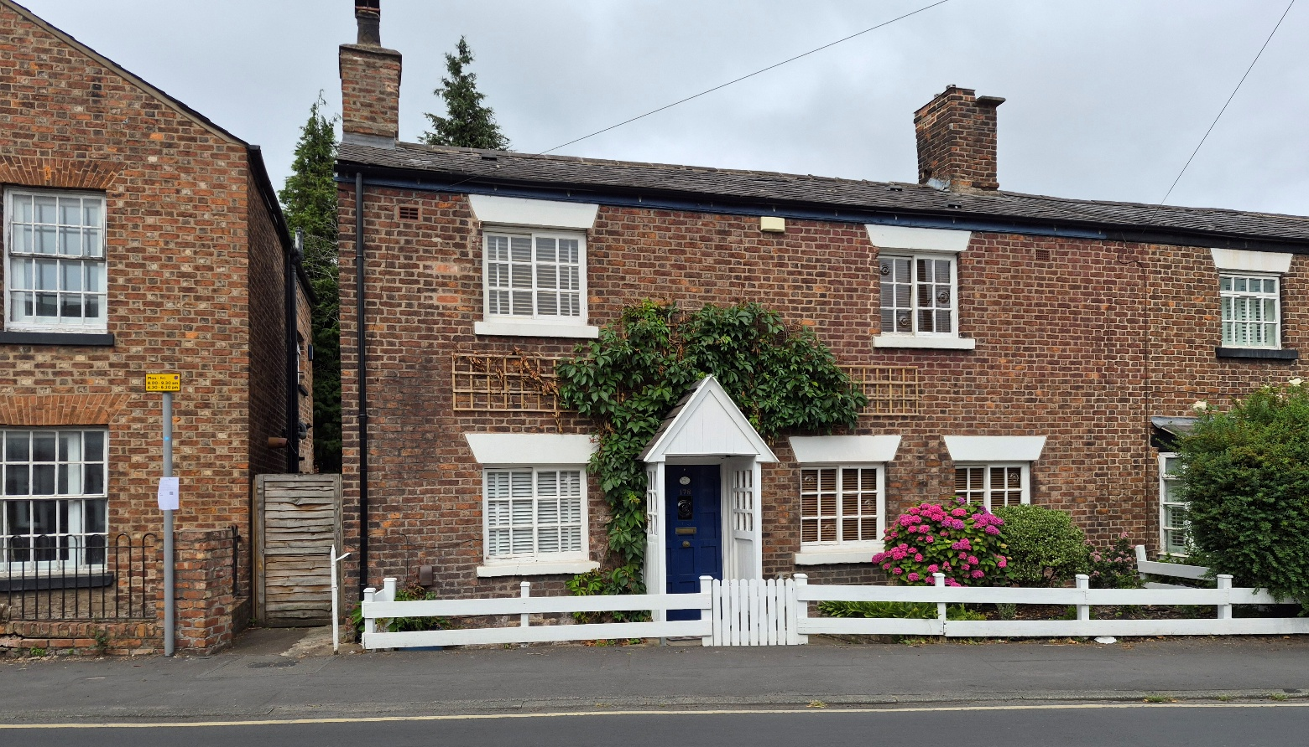

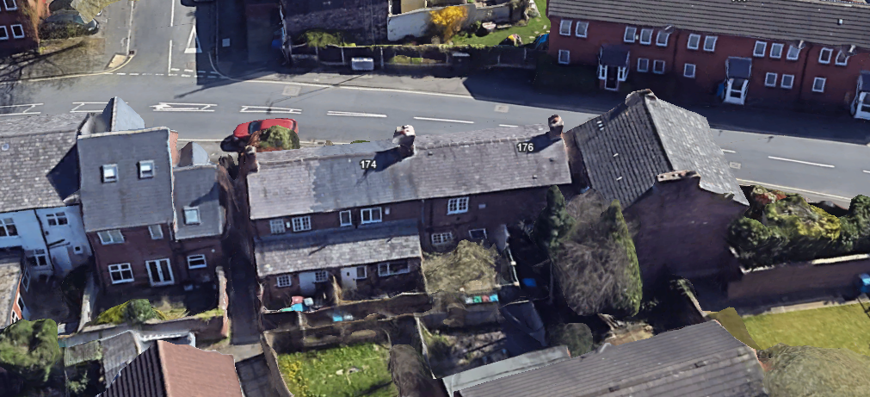
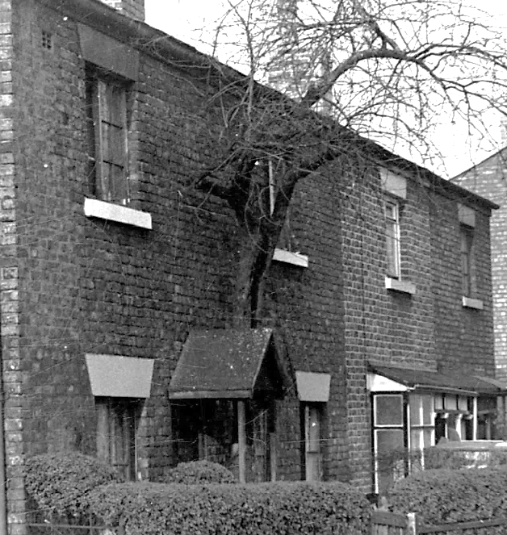

Description of development
The applicant is seeking Listed Building Consent for refurbishment of 8no. timber windows.

Consultation, notification and publicity responses

Consultations

Not applicable.

Notifications and publicity

Local residents – no responses received.

Relevant policies
The following policies are considered relevant in the consideration of this application.

Unitary Development Plan (UDP) – The UDP has been superseded by the Core Strategy
Development Plan, but certain policies are still considered of relevance:
- Policy DC19 – Listed Buildings

The Manchester Core Strategy – Development Plan Document 2012-2027 (“the Core
Strategy”) was adopted by the City Council on the 11th of July 2012:
- Policy SP1 – Spatial Principles
- Policy DM1 – Development Management
- Policy EN3 – Heritage

Places for Everyone - is a long-term plan of nine Greater Manchester districts for jobs, new
homes, and sustainable growth. It has been published by the GMCA on behalf of the nine
districts and took effect and became part of the statutory development plan on March 21, 2024.
- Policy JP-P1 – Sustainable Places
- Policy JP-P2 – Heritage

National Planning Policy Framework (NPPF, 2026)
- Chapter 14 – Achieving Well-Designed Places
- Policy DP3: Key principles for well-designed places
- Chapter 20 – Conserving and Enhancing the Historic Environment
- Policy HE4: Securing the conservation and enhancement of heritage assets
- Policy HE5: Assessing effects on heritage assets
- Policy HE6: Proposals affecting designated heritage assets

Assessment
Principle – the principle of the proposal, which includes refurbishment and repair of 8no. existing timber windows at No.178 Ladybarn Lane, to address the deterioration of the historic timber windows, including rot, failed putty, water ingress, operational defects and a cracked pane, in order to prevent further decay and preserve the original fabric of the Grade II listed building, is acceptable. Notwithstanding this, consideration must be given to the proposal’s siting, scale, and massing, appearance and impact upon visual and residential amenity, and the Grade II listed building itself.

Scope of works – the submitted window survey indicates that the proposal includes the following works to the listed building:

- Repair and refurbish the existing timber windows; no complete window replacements proposed.
- Replace rotten window sills where required.
- Remove failed putty and reinstate with new putty.
- Remove and replace old parting beads where necessary.
- Remove and replace decayed timber on a like-for-like basis.
- Remove and replace rotten glazing beads where required.
- Replace one cracked pane in Window 4 with glazing matching the existing glass.
- Sand and repaint all repaired windows to match the existing appearance.

Siting, scale, and massing – no extensions are proposed as part of the works. For these reasons, the overall siting, scale and massing of the building would be largely unaffected by the works.

Appearance and visual amenity – the proposal seeks consent for the repair and refurbishment of eight existing timber windows within the Grade II listed building. The works are limited to the replacement of decayed sills, glazing beads, parting beads and sections of rotten timber where necessary, together with the reinstatement of failed putty, repair of defective windows and the replacement of a single cracked pane with glazing that matches the existing in thickness, appearance and character. Following repair, all windows would be sanded and repainted to match the existing finish. No alterations are proposed to the design, opening style, dimensions, glazing pattern, materials or overall appearance of the windows. The works are required to address evidenced deterioration, including rot, failed putty, water ingress, defective operation and a cracked pane of glass, and will secure the long-term preservation of the windows whilst significantly improving their appearance and condition. Given that the proposals comprise sensitive, like-for-like repairs and retain the existing character and detailing of the windows, the development would preserve and enhance the visual appearance of the property.

Impact upon listed building - the proposed works represent a conservation-led approach to the repair of the building's historic timber windows. The submitted survey confirms that the intention is to retain and repair the maximum amount of historic fabric, with only those elements that are decayed beyond reasonable repair being replaced on a like-for-like basis. The proposals would not alter the architectural detailing, materials, glazing pattern, proportions or operation of the windows and would therefore preserve the building's special architectural and historic interest. Further to this, the repair of deteriorating timber, replacement of failed putty and remediation of water ingress will help prevent further loss of historic fabric and avoid the need for more extensive replacement works in the future. As such, the proposals are considered to preserve the significance of the Grade II listed building and would result in no harm to its heritage significance.

Residential amenity – as no extensions are proposed, the proposal would not alter the existing
relationship between the buildings and neighbouring properties. For these reasons, no
additional impacts in terms of overshadowing, loss of light, loss of outlook, privacy, or
overbearing effects are anticipated. The proposal is therefore considered acceptable in respect
of residential amenity.

Conclusion – given the above issues, it is considered that the proposal is acceptable in terms
of its principle, impact upon the visual and residential amenity of the area, designated assets
and their setting, amongst other issues, as it broadly complies with saved policy DC19 of the Unitary Development Plan for the City of Manchester policies DM1 , SP1 and EN3
of the Manchester Core Strategy, JP-P1 and JP-P2 of Places for Everyone, and the requirements of the National Planning Policy Framework (2026).

Other Legislative Requirements

Equality Act 2010
Section 149 (Public Sector Equality Duty) of the Equality Act 2010 requires due regard to the need to: Eliminate unlawful discrimination, harassment and victimisation and other conduct prohibited by the Act and; Advance equality of opportunity between persons who share a protected characteristic and persons who do not share it. The Equality Duty does not impose a legal requirement to conduct an Equality Impact Assessment. Compliance with the Equality Duty involves consciously thinking about the aims of the Equality Duty as part of the process of decision-making.

Human Rights Act 1998 considerations
This application needs to be considered against the provisions of the Human Rights Act 1998. Under Article 6, the applicants (and those third parties, including local residents, who have made representations) have a right to a fair hearing and to this end the local planning authority must give full consideration to their comments.

Protocol 1 Article 1, and Article 8 where appropriate, confer(s) a right of respect for a person’s home, other land and business assets. In taking account of all material considerations, including Council policy as set out in the Core Strategy and saved polices of the Unitary Development Plan, the Director of Planning, Building Control & Licensing has concluded that some rights conferred by these articles on the applicant(s)/objector(s)/resident(s) and other occupiers and owners of nearby land that might be affected may be interfered with but that that interference is in accordance with the law and justified by being in the public interest and on the basis of the planning merits of the development proposal. She believes that any restriction on these rights posed by the recommendation given is proportionate to the wider benefits of and that such a decision falls within the margin of discretion afforded to the Council under the Town and Country Planning Acts.

Recommendation: Approve

Article 35 Declaration:

Officers have worked with the applicant in a positive and proactive manner based on seeking
solutions to problems arising in relation to dealing with the planning application. Issues have
arisen during the consideration of this application and the officer negotiated with the agent to
reach a satisfactory resolution.

Condition(s) to be attached to decision for approval OR Reasons for recommendation to refuse

1) 3-year time limit:

The development must be begun not later than the expiration of three years beginning with the date of this permission.

Reason - Required to be imposed pursuant to Section 18 of the Planning (Listed Buildings and Conservation Areas) Act 1990.

2) Specified plans:

The development hereby approved shall be carried out in accordance with the following
drawings and documents:

‘178 Ladybarn Lane – Survey of 8 Windows’, received by the City Council as Local Planning Authority on 13 August 2026.

Reason - To ensure that the development is carried out in accordance with the approved plans,
pursuant to policies SP1 and DM1 of the Manchester Core Strategy.

3) Repair and refurbishment works:

The repair and refurbishment works hereby approved shall be carried out on a like-for-like basis, using materials, profiles, dimensions and detailing to match the existing windows.

Reason - To ensure there is no resulting harm to the Listed Building, pursuant to saved policy DC19 of the Unitary Development Plan, policies DM1 and EN3 of the Manchester Core Strategy, policy JP-P2 of the Places for Everyone Joint Development Plan Document, and the requirements of the National Planning Policy Framework (2026).

