

Planning

Delegated Officer Report

Summary of application details
Application reference: | PLA-2026-000885
Application type: | Full planning permission
Proposal: | Erection of a single-storey rear extension following demolition of the existing single-storey rear extension and bay window, with amendments to the previously approved roof design including the replacement of the glazed roof with a flat roof incorporating side parapets, a sedum roof and a large sky light.
Site address: | 10 Abberton Road Manchester M20 1HU
Ward(s): | Old Moat
Date application valid: | 02 July 2026
Applicant name: | Mr Llyr Roberts

Agent (if any):
Case officer: | Tracie Simpson
Recommendation: | Approve
Date of recommendation: | 19th August 2026

Description of site, building and/or area
The site comprises a two storey brick built semi-detached property in the Old Moat area of Manchester. The property has fronted bay windows and recessed porch to the front. The property benefits from a front and rear garden and hardstanding driveway with access along the side. A detached garage lies to the rear on the common boundary with no.8 Abberton Road. The property is bounded by timber fencing, hedging and soft landscaping.

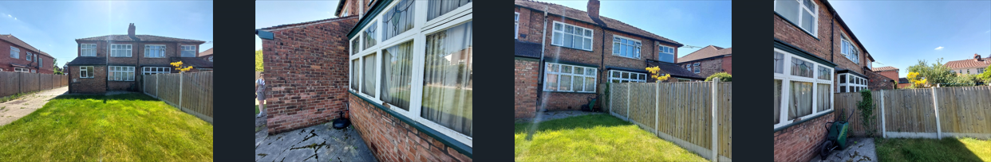

Description of development
The applicant is seeking planning permission for the erection of a single-storey rear extension following demolition of the existing single-storey rear extension and bay window, with amendments to the previously approved roof design including the replacement of the glazed roof with a flat roof incorporating side parapets, a sedum roof and a large sky light.

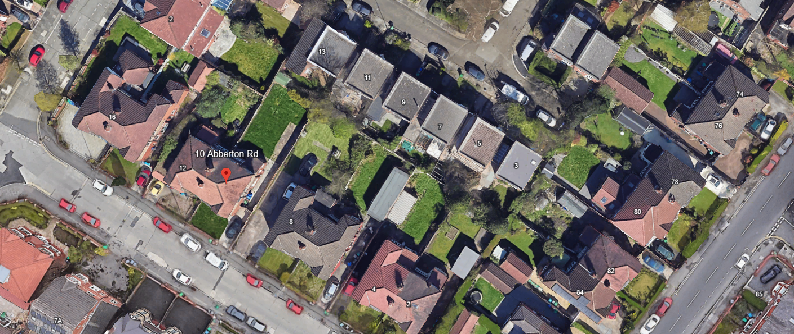

Relevant planning history
Previous applications relating to this site as follows:

Planning reference: 142571/FH/2025 – Erection of single storey extension following demolition of existing single storey rear extension and bay window. This application was approved on 21st May 2025

119760/FH/2018 - Recv: 09.05.2018 - Application Approved - 11.07.2018 10 Abberton Road, Manchester, M20 1HU, Erection of single-storey rear extension to form additional living accommodation

119531/PDE/2018 - Recv: 27.03.2018 - Application Turned Away (Legislative) - 11.04.2018 10 Abberton Road, Manchester, M20 1HU, Notification for a proposed larger home extension involving a single storey rear extension measuring 4.2 metres in length, 3.7 metres in height and 3 metres to eaves level

072637/TPO/2004/S1 - Recv: 28.07.2004 -Application Approved - 04.10.2004 10 Abberton Road, Withington NOTICE OF INTENT TO CARRY OUT WORKS TO TREES WITHIN BURTON ROAD/SANDHURST ROAD TREE PRESERVATION ORDER to lop 10 branches and any wood from 2 ash tress

057864/TPO/SOUTH1/99 - Recv: 25.10.1999 - Application Closed - 16.01.2008 10, Abberton Road,, Withington, NOTIFICATION OF INTENT TO CARRY OUT WORKS TO TREES WITHIN BURTON ROAD TREE PRESERVATION ORDER Remove dead wood and lift lower growth to 4 metres

Consultation, notification and publicity responses

Consultations

No comments received as a result of this proposal

Notifications and publicity

No representations received as a result of this proposal

Negotiations
No negotiations

Relevant policies
The following policies are considered relevant in the consideration of this application.

o Unitary Development Plan (UDP) - The UDP has been superseded by the Core Strategy Development Plan.
o Policy DC1 for Residential Extensions is still considered of relevance

The Manchester Core Strategy Development Plan Document 2012-2027 ("the Core Strategy") was adopted by the City Council on 11th July 2012.

o Policy DM 1 - Development Management
o Policy SP1 - Spatial Principles
o Policy EN1 - Design Principles
o Policy EN 19 - Waste Management
o The National Planning Policy Framework (NPPF)

Places for Everyone Plan (2022 - 2039)

We have assessed the proposal against the following policies of the Places for Everyone Plan.

JP-S1: Sustainable Development
JP-P1 Sustainable Places

This policy outlines how we aim to become one of the most liveable city regions in the world, consisting of a series of beautiful, healthy, and varied places.

We consider this proposal to accord with the principles of this policy.

Draft National Planning Policy Framework (December 2025)

The National Planning Policy Framework (NPPF) sets out the Governments' planning policies for England and how these should be applied. A draft revised NPPF was published for consultation on 16 December 2025. The consultation period runs for 12 weeks and will close on 10 March 2026.

The draft NPPF proposes significant changes to the structure and content of national policy. These include a move to Local Plan-style policy sections, a clearer distinction between planning making and decision-making policies, and the reintroduction of strategic planning through Spatial Development Strategies. Other notable changes include an expanded presumption in favour of sustainable development, policies promoting higher densities around transport hubs, and support for small and medium-scale housing schemes through a new "medium development" category. The draft also integrates Nation Development Management Policies, strengthens climate change and biodiversity policies, and introduces measures to encourage clean energy and critical minerals development.

Once adopted, the revised NPPF will replace the current framework and form a key part of national planning policy. At this stage, as the document is subject to consultation and has not yet been finalised, while still a material consideration, it can only be afforded limited weight in the determination of planning applications. In this instance, the relevant sections is outlined below:

Policy L4(Residential Extensions) - This policy states that development proposals to extend existing dwelling houses should blend effectively with the existing building and its immediate surroundings in terms of its scale and form; and maintain acceptable living standards for current and new occupiers in terms of access to daylight, sunlight, privacy and external amenity space.

Assessment
Principle of the Proposal

Policies SP1 and DM1 of the Manchester Core Strategy 2012 (Core Strategy) seek to ensure that new development enhances or creates character, protects and enhances the built environment; and that the design, scale and appearance of the proposed development is appropriate to its context. Policies DC1.1, DC1.2, DC1.3 and DC1.4 of The Unitary Development Plan for the City of Manchester 1995 (UDP) relate specifically to residential extensions and set out a number of criteria against which proposals for extensions will be assessed. Although these latter policies are now of some age, they are consistent with the guidance in the National Planning Policy Framework (NPPF) which seeks a high standard of design in new developments which provides a good standard of amenity of all existing and future occupiers.

The principle of allowing residents to extend their homes to provide enlarged or improved accommodation is generally acceptable provided that there is no overriding, undue impact upon either the character of the property or upon the residential and visual amenity of nearby residential occupiers.

In this instance the principle of the proposal is considered acceptable and it is not believed that there are any factors of sufficient weight in amenity terms that would warrant refusal of the application.

On balance, the proposed extension is deemed to accord with saved policy DC1 of the UDP and policies DM1 and SP1 of the Manchester Core Strategy

Residential Amenity

The applicant is seeking planning permission for the erection of a single-storey rear extension following demolition of the existing single-storey rear extension and bay window, with amendments to the previously approved roof design including the replacement of the glazed roof with a flat roof incorporating side parapets, a sedum roof and a large sky light.

The applicant proposes to demolish the existing outrigger and rear bay window. The proposed extension would be sited across the back wall measuring 3.937m in projection up to the shared boundary with adjoining semi detached property retaining a small gap. The roof would be flat with the inclusion of a large roof light. Sliding doors are proposed across the rear facing the garden; no windows are proposed along the side elevation facing the adjoining semi detached property, however there are two windows facing the adjacent property no.8 Abberton Road. Given the existing boundary treatment together with the distance retained to the shared boundary, it is not anticipated that there would be any significant overlooking or loss of privacy to the occupiers of the neighbouring property.

It is not considered that the proposed single-storey extension in this location would result in any undue harm to the residential amenity of the occupiers of the neighbouring properties on either side of the application site. Although the proposal exceeds the City Council's saved Policy DC1 guideline of 3.65 metres, no objections have been received from the adjoining occupiers.
Furthermore, planning permission has already been granted for a similar extension in this location, and that permission remains extant and capable of implementation. The principal difference between the previously approved scheme and the current proposal relates to the design of the roof. Given the fallback position of the extant permission, the amendment to the roof form is not considered to give rise to any additional adverse impacts upon neighbouring amenity or the character and appearance of the property.

It is felt that the proposal can be acceptably accommodated at the application property and is considered that the proposal would not interfere with the existing characteristics of the area. Overall, given the height, projection and relationship to adjacent properties, it is considered that the proportions of the extension are acceptable. The footprint is not considered to create a bulky or disproportionate scale addition to the property and therefore the development accords with Core Strategy Policy DM1 and saved policy DC1 of the UDP.

Scale and massing

The scale and massing of the proposal is considered would not cause undue harm to the current levels of amenity being enjoyed by the occupiers of surrounding properties. The extension is considered would not present an unusual feature in the immediate area due to the existence of other similar additions to a variety of house types in the immediate area. The size of the extension is considered acceptable within the surrounding environmental context and is not believed to provide an overbearing impact upon the residential amenities of surrounding properties.

It is therefore considered that the design, scale and appearance of the proposed extension is satisfactory and is considered to accord with the principles for residential extensions set out in saved UDP policy DC1, DM1 and EN1 of the Core Strategy.

Design

The design of the proposal would be in keeping with the existing and surrounding properties in the area. In terms of the proposed materials, it is intended to use matching materials as specified in the application form. The design of the extension has been tailored to fit the shape of the existing property/plot and respect the relationship with the neighbouring property at the rear and is considered acceptable. It is believed that the proposed works would not detract from the character and appearance of the property and the design of the works would complement the host dwelling detailed as what is normally expected of such a structure.

On balance it is considered that the design and appearance of the proposed development accords with Core Strategy Policies DM1 and EN1 and in general the design is considered acceptable

Waste management

The storage of bins is not affected by this proposal as adequate space along the side is retained. Therefore, the bins would accord with policy EN19 of the Core Strategy.

Parking

Current parking arrangements are unaffected by this proposal.

Other Legislative Requirements

Equality Act 2010
Section 149 (Public Sector Equality Duty) of the Equality Act 2010 requires due regard to the need to: Eliminate unlawful discrimination, harassment and victimisation and other conduct prohibited by the Act and; Advance equality of opportunity between persons who share a protected characteristic and persons who do not share it. The Equality Duty does not impose a legal requirement to conduct an Equality Impact Assessment. Compliance with the Equality Duty involves consciously thinking about the aims of the Equality Duty as part of the process of decision-making.

Human Rights Act 1998 considerations
This application needs to be considered against the provisions of the Human Rights Act 1998. Under Article 6, the applicants (and those third parties, including local residents, who have made representations) have a right to a fair hearing and to this end the local planning authority must give full consideration to their comments.

Protocol 1 Article 1, and Article 8 where appropriate, confer(s) a right of respect for a person’s home, other land and business assets. In taking account of all material considerations, including Council policy as set out in the Core Strategy and saved polices of the Unitary Development Plan, the Director of Planning, Building Control & Licensing has concluded that some rights conferred by these articles on the applicant(s)/objector(s)/resident(s) and other occupiers and owners of nearby land that might be affected may be interfered with but that that interference is in accordance with the law and justified by being in the public interest and on the basis of the planning merits of the development proposal. She believes that any restriction on these rights posed by the recommendation given is proportionate to the wider benefits of and that such a decision falls within the margin of discretion afforded to the Council under the Town and Country Planning Acts.

Conclusion
The proposal is considered to be acceptable in this location in terms of design, scale and massing, allowing the occupiers to adapt their home to meet their needs, without unduly detrimentally affecting the amenities of the occupiers of surrounding properties, and there are no material considerations of sufficient weight to indicate otherwise.

It is considered that the proposal would not give rise to any undue loss of amenity, loss of light or loss of privacy to neighbouring occupiers, therefore, the proposal is considered to accord with saved UDP policy DC1, policies SP1 and DM1 of the Core Strategy.

Recommendation: Approve

Article 35 Declaration

Positive and proactive working - Officers have worked with the applicant in a positive and proactive manner based on seeking solutions to problems arising in relation to dealing with the planning application. No significant problems have arisen during the consideration of this application.

Reasons for approval

Conditions attached to this decision

1) The development must be begun not later than the expiration of three years beginning with the date of this permission.

Reason - Required to be imposed pursuant to Section 91 of the Town and Country Planning Act 1990.

2) The development hereby approved shall be carried out in accordance with the following drawings and documents:

Received 2nd July 2026 numbered DR-W-0001 Rev A01 Proposed Floor Plan Internal Alterations

Received 2nd July 2026 Annotated Proposed Ground Floor Plan

Received 2nd July 2026 Annotated Proposed Elevations

Received 2nd July 2026 numbered DR-W-0002 Rev A01 Proposed Section A-A and B-B

Reason - To ensure that the development is carried out in accordance with the approved plans. Pursuant to policies SP1 and DM1 of the Core Strategy.

3) The materials used in the external surfaces of the development hereby approved shall be similar in appearance to the existing building in terms of type, size, colour and texture.

Reason - In order to ensure a satisfactory appearance in the interests of visual amenity in accordance with policies SP1 and DM1 of the Core Strategy and the requirements of the National Planning Policy Framework

4) Notwithstanding the provisions of Schedule 2, Part 1 of the Town and Country Planning (General Permitted Development) Order 2015 (as amended) (or any order revoking and re-enacting that Order with or without modification), no [additional] windows, doors or other openings shall be inserted in the first floor of the side elevation of the development hereby approved, without planning permission being granted by the Local Planning Authority.

Reason - In the interests of residential amenity, pursuant to policies DM1 and SP1 of the Manchester Core Strategy.

