

Planning

Delegated Officer Report

Summary of application details
Application reference: | 145451/JO/2026
Application type: | Removal/variation of conditions
Proposal: | Variation of Conditions 2 (specified plans) and 23 (tree retention) attached to planning permission 139500/FO/2024 to allow loss of tree and alteration to footprint of development
Site address: | Land On Catherine Road, Manchester M8 4HE
Ward(s): | Crumpsall
Date application valid: | 11 June 2026
Applicant name: | Ascot Limited
Agent (if any): | Sam Golding
Case officer: | Steven Mccoombe
Recommendation: | Refuse
Date of recommendation: | 21 August 2026

Description of site, building and/or area
The site consists of a vacant parcel of land to the rear of Nos. 144-146 Bury Old Road, currently overgrown with vegetation and containing a small number of trees, particularly to the northeastern corner. The adjoining properties comprise a large three-storey terrace, which is understood to be vacant. Planning permission was granted in 2025 for the conversion of the terrace into 11 apartments, including associated landscaping and parking provision.

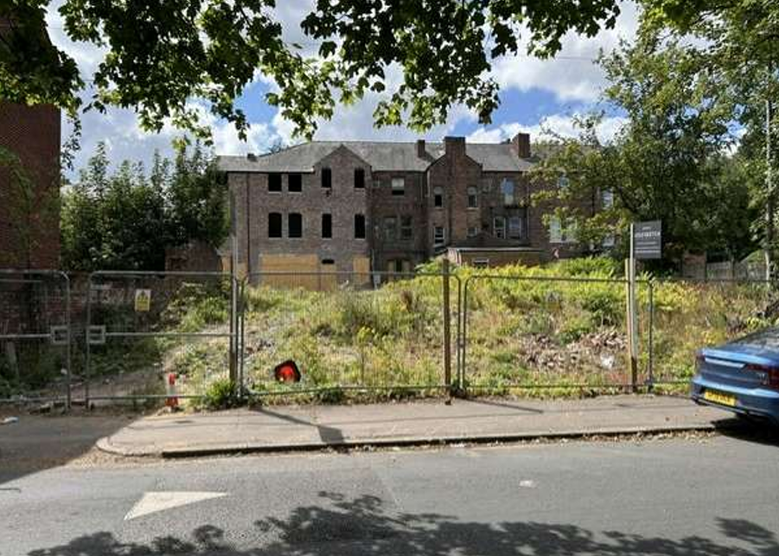
Application site in the foreground and existing building proposed for
conversion into flats in the background

The application site relates to the garden area associated with these properties which is to be sectioned off to accommodate the proposed development.

The main frontage of the site addresses Catherine Road, where there is an existing vehicular access.

The site is enclosed by a combination of brick wall, concrete panels and breeze blocks and is showing signs of deterioration.

The site is bounded by a three-storey apartment building to the east (Catherine Court) and a more recent development of three storey townhouses to the east and a surface level car park area associated with the residential building of No 148 Bury Old Road to the west. To the south, is the rear of a three-storey residential terrace at 144-146 Bury Old Road. To the north, on the opposite side of Catherine Road, the site faces twos storey residential properties, including the gable end of an end property on Fraser Road.

The surrounding area is predominantly residential in character, comprising a mix of dwellinghouses, purpose-built apartment blocks and converted properties, reflecting a variety of architectural styles and forms generally ranging between two and four storeys in height.

In terms of local amenities, Cheetham Hill District Centre is located approximately 550 metres to the south-east of the site, providing access to a range of shops, services and community facilities.

The site also lies within the Crumpsall Lane Conservation Area, which is characterised by its collection of period properties set along attractive tree-lined streets. The mature trees and established landscaping make a positive contribution to the area's historic character and appearance, forming an important element of its significance and sense of place.

Description of development

Variation of Conditions 2 (specified plans) and 23 (tree retention) attached to planning permission 139500/FO/2024 which allowed for the erection of a 3-storey block of apartments containing 6 No. self-contained flats (Class C3) with associated parking and landscaping.

The application seeks to vary the approved scheme by substituting the approved drawings listed in condition 2 (Specified Plans) with revised plans that facilitate the removal of existing trees previously agreed for retention and to reinstate the originally proposed building footprint by squaring off the front-left elevation and to amend Condition 23 (Retained Trees) to reflect the proposed removal of the tree at the front of the site, thereby removing the requirement for their retention and protection as part of the development.

In effect, these amendments would reverse previous design changes that enabled the retention of the tree and its Root Protection Area by prioritising additional built form over the retention of existing trees.

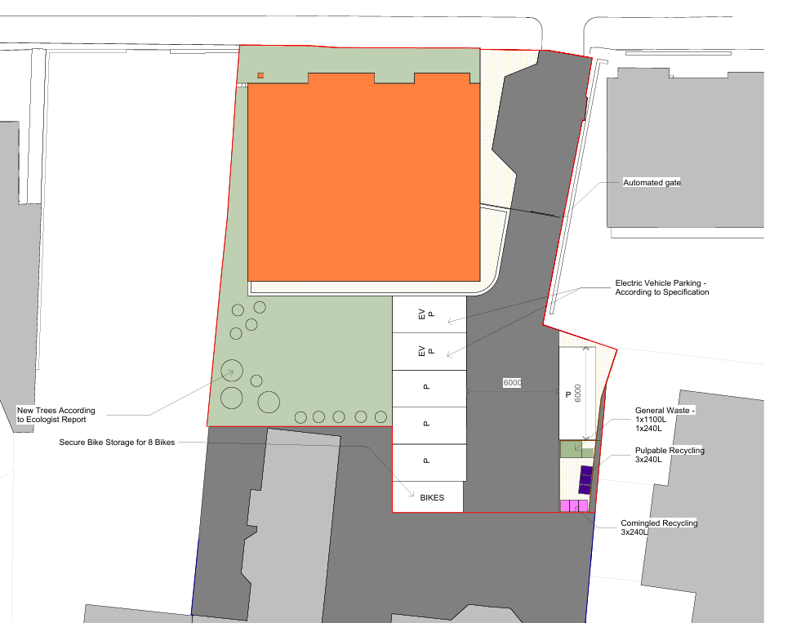
Proposed site layout

Whilst tree planting to the rear of the proposed building is proposed to mitigate the loss of other lower category trees on sites agreed for removal, no on-site mitigation is proposed for the proposed tree loss as part of this application, with the applicant intending on an update to the off-site credits required in light of statutory biodiversity net gain requirements.

The applicant states that during the detailed design and construction phase, investigations by the contractor and structural engineer confirm that the tree cannot be retained, as its root system conflicts directly with the foundations required for the approved development.

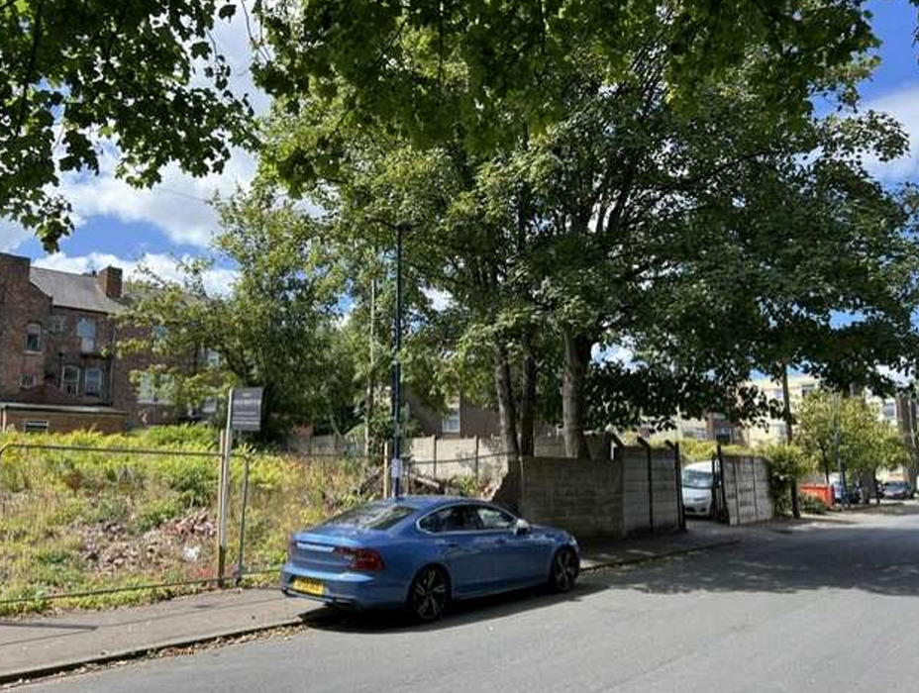
Application site and tree proposed to be removed

Relevant planning history
Erection of 3-storey block of apartments containing 6 No. self-contained flats (Class C3) with associated parking and landscaping. Approved 24 October 2024.

Consultation, notification and publicity responses
Local Residents/Occupiers – No representations received.

Environmental Health – All conditions relating to the parent permission are still relevant.

Flood Risk Management – Conditions relating to surface water drainage and associated maintenance are recommended.

Arboriculture - Object to the application as it proposes the removal of all trees on the site without providing any mitigation or replacement planting. The loss of these trees would have a significant detrimental impact on the character and appearance of the conservation area and contributes to the overall overdevelopment of the site.

Under the previous application (139500/FO/2024), proposals also included the removal of all trees on the site. In response, we noted:

"The Category B trees on the site are mature Sycamore specimens fronting Catherine Road. Whilst these trees do have visual amenity value, they have been poorly managed and appear to have been historically pollarded. It is requested that the proposed building is realigned to incorporate the trees. Alternatively, as there are no planting proposals for the site, mitigation planting is requested.

Revised plans were submitted with the previous proposal which altered the building footprint to accommodate the retained trees and their Root Protection Areas (RPAs). Those plans appeared to demonstrate that the trees could be successfully incorporated into the development layout.

Whilst it is difficult to determine precisely whether the revised layout exceeded the generally accepted 20% encroachment threshold into the RPA due to inconsistencies in scale between the drawings, the revised arrangement is considered an improvement on the current proposal.

The application now under consideration reverts to a squarer building footprint, removing the landscaped corner area that previously facilitated tree retention. This approach necessitates the loss of the existing trees and is not accompanied by any mitigation or replacement planting proposals. As such, the application represents a missed opportunity to retain valuable tree cover and preserve the character of the conservation area.

Relevant policies

Local Development Framework

The Development Plan consists of:

• The Manchester Core Strategy (2012);

• Saved policies of the Unitary Development Plan for the City of Manchester (1995);

• Places for Everyone Joint Development Plan.

The principal document within the framework is the Manchester Core Strategy which
sets out the spatial vision for the City and includes strategic policies for development
during the period 2012 – 2027.

'The Core Strategy Development Plan Document 2012 -2027 ("the Core Strategy”) was adopted by the City Council on 11th July 2012. It is the key document in Manchester’s Local Development Framework. The Core Strategy replaces significant elements of the Unitary Development Plan (UDP) as the document that sets out the long-term strategic planning policies for Manchester's future development.

A number of UDP policies have also been saved until replaced by further development plan documents to accompany the Core Strategy. Planning applications in Manchester must therefore be decided in accordance with the Core Strategy, saved UDP policies and other Local Development Documents.'

The following policies within the Core Strategy are considered relevant:

Policy SP1 (Spatial Principles) - refers to the key spatial principles which will guide the strategic development of Manchester together with core development principles. It is stated that developments in all parts of the city should create well designed places which enhance or create character, make a positive contribution to the health, safety and well-being of residents, consider the needs of all members of the community and protect and enhance the built environment. Further, development should seek to minimise emissions, ensure the efficient use of natural resources, reuse previously developed land wherever possible, improve access to jobs, services and open space and provide good access to sustainable transport provision.

Policy DM1 (Development Management) - states that new development should have regard to more specific issues for which more detailed guidance may be given within supplementary planning documents. Issues include: the appropriate siting and appearance of development, the impact upon the surrounding area, the effects on amenity, accessibility, community safety and crime prevention, health, the adequacy of internal accommodation and amenity space and refuse storage/collection.

Policy H1 (Overall Housing Provision) - establishes Manchester's strategic approach to housing growth. The policy supports the delivery of a significant increase in housing across the city to meet Manchester's needs, directing new homes primarily to sustainable and accessible locations, particularly within the Regional Centre, Inner Areas and other areas well served by public transport and local services. The policy promotes a broad choice of housing types, sizes and tenures to meet the needs of different households and communities, while supporting regeneration objectives and economic growth. It also seeks to make effective use of previously developed land, create sustainable neighbourhoods, address any existing deficiencies in physical, social and green infrastructure and ensure that housing development contributes to the creation of mixed and balanced communities.

Policy EN3 (Heritage) - seeks to ensure that Manchester's historic environment is conserved, enhanced and, where appropriate, better revealed through development. The policy requires development proposals affecting heritage assets, including listed buildings, conservation areas, scheduled monuments, archaeological remains, historic parks and other designated or non-designated assets, to protect their significance, character, setting and appearance.
Development should be informed by a thorough understanding of the asset and be of a high design quality that preserves or enhances Manchester's historic environment. The policy also recognises heritage as an important contributor to regeneration, place-making and economic growth.

Policy T2 (Accessible Areas of Opportunity and Need) - states that the Council will actively manage the pattern of development to ensure that new development: is located to ensure good access to the City's main economic drivers, including the Regional Centre, the Oxford Road Universities and Hospitals and the Airport and to ensure good national and international connections. Is easily accessible by walking, cycling and public transport; connecting residents to jobs, centres, health, leisure, open space and educational opportunities. Particular priority will be given to providing all residents access to strategic employment sites.

Within the City Centre, development should provide a level of car parking which reflects the highly accessible nature of the location, as well as the realistic requirements of the users of the development. Elsewhere, all new development should provide appropriate car parking facilities.

Policy EN1 (Design Principle and Strategic Character Areas) - relates to design principles and strategic character areas and states that all development in Manchester will be expected to follow the seven principles of urban design, as identified in national planning guidance and have regard to the strategic character area in which the development is located. Opportunities for good design to enhance the overall image of the city should be fully realised, particularly on major radial and orbital road and rail routes.

Policy EN8 (Adaptation to Climate Change) - All new development will be expected to be adaptable to climate change in terms of the design, layout, siting and function of both buildings and associated external spaces. In achieving developments which are adaptable to climate change developers should have regard to the following, although this is not an exhaustive list:

-Minimisation of flood risk by appropriate siting, drainage, and treatment of surface
areas to ensure rainwater permeability;

-Reduction in urban heat island effect through the use of Green Infrastructure such as green roofs, green walls, increased tree cover and waterways; -The need to control overheating of buildings through passive design;

-The opportunity to provide linked and diverse green space to enhance natural habitats which will assist species adaptation;

-Developers will be permitted to use green infrastructure elements such as green roofs, green walls, street trees and waterways to contribute to compliance with CO2 mitigation under Policy EN6, subject to sufficient evidence to quantify their contribution to compliance.

Policy EN9 (Green Infrastructure) - New development will be expected to maintain existing green infrastructure in terms of its quantity, quality and multiple function. Where the opportunity arises and in with current Green Infrastructure Strategies the Council will encourage developers to enhance the quality and quantity of green infrastructure, improve the performance of its functions and create and improve linkages to and between areas of green infrastructure. Where the benefits of a proposed development are considered to outweigh the loss of an existing element of green infrastructure, the developer will be required to demonstrate how this loss will be mitigated in terms of quantity, quality, function and future management.

Policy EN14 (Flood Risk) – refers to flood risk and amongst other issues stat that all new development should minimise surface water run-off, including through Sustainable Drainage Systems (SUDS) and the appropriate use of green infrastructure.

Policy EN16 (Air Quality) – states that the Council will seek to improve the air quality within Manchester, and particularly within Air Quality Management Areas, located along Manchester’s principal traffic routes. Developers will be expected to take measures to minimise and mitigate the local impact of emissions from traffic generated by the development, as well as emissions created by the use of the development itself.

Policy EN17 (Water Quality) - states that developments should minimise surface water run-off and minimise ground contamination into the watercourse construction.

Unitary Development Plan for the City of Manchester, 1995 (Saved Policies)

The below saved policies of the Unitary Development Plan are also considered relevant:

Policy DC18.1 (Conservation Areas) - requires the City Council to give particularly careful consideration to development proposals within Conservation Areas. The policy seeks to preserve and enhance the character and appearance of these areas by ensuring that new development responds appropriately to its historic surroundings. In assessing proposals, the Council considers the relationship of new buildings and structures to neighbouring buildings and spaces, the impact of alterations to existing buildings, the retention of important features such as boundary walls, gardens and trees, the effect of signs and advertisements, and any specific conservation area guidance adopted by the Council. The policy aims to ensure that development protects and, where possible, enhances the special architectural and historic qualities that justify the area's conservation designation.

Places for Everyone Greater Manchester Joint Development Plan

This plan was adopted on 21 March 2024, as such the Plan and its policies are now a material planning consideration in the determination of planning applications. The Plan and its policies must therefore be given significant weight in the planning balance. The relevant policy is set out below:

Policy JP-S1 (Sustainable Development) – This policy states that to help tackle climate change, development should aim to maximise its economic, social and environmental benefits simultaneously, minimise its adverse impacts, utilise sustainable construction techniques and actively seek opportunities to secure net gains across each of the different objectives.

Policy JP-P1 (Sustainable Places) - seeks to raise the quality of all places in a way that is sustainable in the long-term, to enhance the wellbeing for residents, as well as making Greater Manchester more attractive to potential visitors and investors.

The following key attributes that all development, wherever appropriate apply:

1. Distinctive, with a clear identity that:

A. Conserves and enhances the natural environment, landscape features,
historic environment and local history and culture;

B. Enables a clear understanding of how the place has developed; and

C. Respects and acknowledges the character and identity of the locality in terms
of design, siting, size, scale and materials used.

Policy JP-P2 (Heritage) - seeks to conserve and enhance heritage assets and their settings by ensuring development respects their significance, minimises harm, and supports the long-term protection and appreciation of Greater Manchester's historic environment.

Policy JP-G7: Trees and Woodland – This policy states that the member authorities will work to deliver the aims and objectives of the Greater Manchester Tree and Woodland Strategy, aiming to significantly increase tree cover, protect and enhance woodland, and connect people to the trees and woodland around them. This will be done through local planning and a number of associated activities, but in the case of development as follows:

• Where development would result in the loss of existing trees, requiring replacement on the basis of two new trees for each tree lost, or other measures that would also result in a net enhancement in the character and quality of the treescape and biodiversity value in the local area, with a preference for on-site provision; and

• Protecting trees and woodland during the construction phase of development.

Policy JP-G8 (A Net Enhancement of Biodiversity and Geodiversity) - This policy states that through local planning and associated activities a net enhancement of biodiversity resources will be sought. It states further than in relation to development, proposals would be expected to:

a) Follow the mitigation hierarchy of: i. Avoiding significant harm to biodiversity, particularly where it is irreplaceable, through consideration of alternative sites with less harmful impacts, then ii. Adequately mitigating any harm to biodiversity, then iii.
Adequately compensating for any remaining harm to biodiversity ;

b) Avoid fragmenting or severing connectivity between habitats;

c) Achieve a measurable net gain in biodiversity of no less than 10%;

d) Make appropriate provision for long-term management of habitats and geological
features connected to the development;

e) Where appropriate, development should: mitigate air pollution impacts on Manchester Mosses SAC; mitigate urban edge, functionally linked land and recreation disturbance impacts on the South Pennine Moors SAC/SPAs; and assess and potentially mitigate boat movement, water pollution, and light spillage and shading impacts on the Rochdale Canal SAC; and

f) Development proposals should be informed by the findings and recommendations of the appropriate biodiversity/ecological assessment(s) in the PfE evidence base and/or any updated or appropriate biodiversity/ecological assessments submitted as part of the planning application process.

Other Material Considerations

Draft National Planning Policy Framework (December 2025)

A draft revised NPPF was published for consultation on 16 December 2025 and proposes significant changes to the structure and content of national policy.

The draft NPPF represents a fundamental shift toward a more rules based, nationally led and pro‑development planning system, whilst retaining the core objective of achieving sustainable development. It restructures the framework entirely into a policy format and separates plan‑making from decision‑making policies, with national decision‑making policies expected to carry significant weight where local plans are out of date or inconsistent.
A strengthened and more explicit presumption in favour of development sits at the heart of the draft.

The reforms place strong emphasis on boosting housing delivery, including support for small sites, higher densities in sustainable locations, and continued pressure on authorities to meet housing need, alongside earlier reforms such as mandatory targets and five‑year supply expectations.

There is a marked focus on transport‑led development for sites near well‑connected public transport hubs, alongside encouragement of urban densification.

The draft also strengthens support for economic growth, infrastructure delivery, climate action and design quality; while seeking to streamline local plans so they focus only on local issues.

Overall, the direction of travel is toward a faster, more certain and delivery‑focused system, with reduced local discretion where it conflicts with national policy and a stronger emphasis on housing, sustainable locations and growth.

National Planning Policy Framework (NPPF 2026)

A revised National Planning Policy Framework (NPPF) was published on 17 August 2026 following a period of public consultation and has superseded the previous version. Given the timing of its publication, the application has been assessed against both the former and revised frameworks. Having undertaken this review, it is considered that the changes introduced by the revised NPPF do not materially affect the assessment or conclusions reached in relation to the proposed development.

The revised version fundamentally restructures national planning policy with a more rules based, pro-growth approach, replacing the previous paragraph based framework and the traditional tilted balance with a new presumption in favour of sustainable development. Key reforms include stronger support for housing delivery, particularly higher-density development near major public transport hubs, greater policy support for economic growth, infrastructure and rural productivity, stronger protection for pubs and other community facilities and continued robust protection of designated landscapes. The reforms are intended to make planning decisions faster, clearer and more predictable whilst accelerating housing and economic growth.

The Guide to Development in Manchester (SPD) (2007)

The Guide to Development in Manchester is a supplementary planning document which contains core principles to guide developers. The document offers design advice and sets out the City Council's aspirations and vision for future development and contains core principles to guide developers to produce high quality and inclusive design. The principles that development should seek to achieve, include, character and context, continuity, and enclosure, ease of movement, quality of the public realm, diversity, legibility and adaptability.

The Manchester Green and Blue Infrastructure Strategy (G&BIS)

The G&BIS sets out objectives for environmental improvements within the City in relation to key objectives for growth and development. Building on the investment to date in the city's green infrastructure and the understanding of its importance in helping to create a successful city, the vision for green and blue infrastructure in Manchester over the next 10 years is: By 2025 high quality, well maintained green and blue spaces will be an integral part of all neighbourhoods. The city's communities will be living healthy, fulfilled lives, enjoying access to parks and greenspaces and safe green routes for walking, cycling and exercise throughout the city. Businesses will be investing in areas with a high environmental quality and attractive surroundings, enjoying access to a healthy, talented workforce. New funding models will be in place, ensuring progress achieved by 2025 can be sustained and provide the platform for ongoing investment in the years to follow.

Four objectives have been established to enable the vision to be achieved:

1. Improve the quality and function of existing green and blue infrastructure, to maximise the benefits it delivers.

2. Use appropriate green and blue infrastructure as a key component of new developments to help create successful neighbourhoods and support the city's growth.

3. Improve connectivity and accessibility to green and blue infrastructure within the city and beyond.

4. Improve and promote a wider understanding and awareness of the benefits that green and blue infrastructure provides to residents, the economy and the local environment.

Assessment

Principle

Section 38(6) of the Planning and Compulsory Purchase Act 2004 requires that planning decisions are made in accordance with the development plan unless other material considerations indicate otherwise.

The National Planning Policy Framework (NPPF), at paragraphs 2 and 47, reinforces this principle. Paragraph 12 further clarifies that the presumption in favour of sustainable development does not alter the statutory status of the development plan as the starting point for decision-making. Where a proposal conflicts with an up-to-date development plan, planning permission should normally be refused.

In this instance, the proposed development is considered unacceptable in principle as it would conflict with the objectives of relevant planning policies that aim to protect and enhance accessible, high quality and sustainable green spaces, thereby promoting and strengthening environments in which people choose to live, work. In addition, the development would erode the verdant character and distinctive appearance of the conservation area, undermining the very qualities that contribute to its special architectural and historic interest. No acceptable mitigation has been submitted.

Tree Loss and the Impact to Environmental Quality and the Character and Appearance of the Conservation Area

Section 38(6) of the Planning and Compulsory Purchase Act 2004 requires that planning decisions are made in accordance with the development plan unless other material considerations indicate otherwise.

The National Planning Policy Framework (NPPF), at paragraphs 2 and 47, reinforces this principle. Paragraph 12 further clarifies that the presumption in favour of sustainable development does not alter the statutory status of the development plan as the starting point for decision-making. Where a proposal conflicts with an up-to-date development plan, planning permission should normally be refused.

In this instance, the proposed development is considered unacceptable in principle, as it would conflict with policies aimed at protecting environmental quality and safeguarding the character, appearance and significance of the conservation area.

With respect to the parent permission, a Tree Survey alongside an Arboricultural Impact Assessment originally recommended the removal of all nine trees identified within the site. However, following discussions with the applicant and the submission of a revised proposal, the proposal was amended to retain the two Category B trees (T1 and T2) located within the north-eastern corner of the site adjacent to the front boundary wall, together with one Category C tree situated to the rear, was achieved through amendments to the siting of the proposed building. It is now proposed that these trees are removed due to technical and practical constraints in delivering the proposed building.

Whilst the potential constraints regarding deliverability are understood, the Council places greater weight on tree retention in the conservation area due to the contribution that the existing trees make to the character and appearance of the Conservation Area. In the absence of an adequate mitigation, the proposal would result in an unjustified loss of green features that positively contribute to local distinctiveness, visual amenity and the Conservation Area's significance.

The applicant points to the increase of offsite credits requires as part of statutory biodiversity net gain requirements. However, this would do little to offset the harm to existing site conditions and the host conservation area.

The proposed development would result in the loss of existing trees that make a valuable contribution to the environmental quality, visual amenity and established landscape character of the site and surrounding area. These trees form a contributing part of its verdant character, providing an attractive green setting that softens the built environment and reinforces the area's distinctive sense of place.

The removal of the trees would lead to reduction in canopy cover and the erosion of the landscape that contributes positively to the character and appearance of the Conservation Area and would increase the visual prominence of the proposed development, resulting in a more urbanised appearance that would fail to preserve the setting and characteristics of the area. The proposal would also result in the loss of the wider environmental benefits provided by the trees, including biodiversity interest, carbon reduction and air quality improvements.

The harm arising from the loss of the trees is compounded by the absence of any meaningful mitigation or compensatory planting measures. Without replacement planting or landscape enhancements, the adverse effects on environmental quality and visual amenity would be permanent, and there would be no opportunity to offset or mitigate the loss of these important landscape features over time.

Accordingly, the proposal would fail to preserve or enhance the character and appearance of the Conservation Area and would result in unacceptable harm to its significance, contrary to the aforementioned, overarching development plan policy and planning guidance.

Article 35 Declaration

Officers have communicated their concerns about this proposal to the applicant during the course of the planning application, but these concerns have not been overcome. The proposal is considered to be contrary to the development plan and therefore refused in a timely manner.

Other Legislative Requirements

Equality Act 2010
Section 149 (Public Sector Equality Duty) of the Equality Act 2010 requires due regard to the need to: Eliminate unlawful discrimination, harassment and victimisation and other conduct prohibited by the Act and; Advance equality of opportunity between persons who share a protected characteristic and persons who do not share it. The Equality Duty does not impose a legal requirement to conduct an Equality Impact Assessment. Compliance with the Equality Duty involves consciously thinking about the aims of the Equality Duty as part of the process of decision-making.

Human Rights Act 1998 considerations
This application needs to be considered against the provisions of the Human Rights Act 1998. Under Article 6, the applicants (and those third parties, including local residents, who have made representations) have a right to a fair hearing and to this end the local planning authority must give full consideration to their comments.

Protocol 1 Article 1, and Article 8 where appropriate, confer(s) a right of respect for a person’s home, other land and business assets. In taking account of all material considerations, including Council policy as set out in the Core Strategy and saved polices of the Unitary Development Plan, the Director of Planning, Building Control & Licensing has concluded that some rights conferred by these articles on the applicant(s)/objector(s)/resident(s) and other occupiers and owners of nearby land that might be affected may be interfered with but that that interference is in accordance with the law and justified by being in the public interest and on the basis of the planning merits of the development proposal. She believes that any restriction on these rights posed by the recommendation given is proportionate to the wider benefits of and that such a decision falls within the margin of discretion afforded to the Council under the Town and Country Planning Acts.

Recommendation: Refuse
1) The proposed development would result in the loss of trees which make a positive contribution to the character, appearance and environmental quality of the Conservation Area. In the absence of adequate replacement planting or other mitigation measures to satisfactorily compensate for the loss of arboricultural and visual amenity, the proposal would fail to preserve or enhance the character and appearance of the Conservation Area or the environmental character of the streetscape, contrary to saved policy DC18.1 of the Unitary Development Plan for the City of Manchester, policies DM1, SP1 and EN3 of the Manchester Core Strategy, policies JP-S1, JP-P1, JP-P2 and JP-G7 of Places for Everyone Joint Development Plan and the National Planning Policy Framework (NPPF).

