

Planning

Delegated Officer Report

Summary of application details
Application reference: | PLA-2026-000857
Application type: | Removal/variation of conditions
Proposal: | Removal of Condition 4 (B8 use) attached to Planning Permission 144798/FO/2025.
Site address: | 40-42 Stocks Street Manchester M8 8QJ
Ward(s): | Cheetham
Date application valid: | 30 June 2026
Applicant name: | Dr Ghassan Kamha
Agent (if any): | Dr Kanadi Jagafa
Case officer: | Carl Glennon
Recommendation: | Refuse
Date of recommendation: | 21 August 2026

Description of site, building and/or area
The area is characterised by warehousing units and employment uses, which is reflected in the previous use of the application property, i.e., warehouse unit with ancillary offices. The application site is bounded by Stocks Street (west), Derby Street (south) and Stocks Street East (east). Stocks Street East is only partially adopted. The unadopted section (of Stock Street East) is gated at each end. The application property and external areas extend into the areas serviced via the unadopted highway. The building broadly has a rectangular configuration and with two storeys presented to Stocks Street and part of the returning elevation to Derby Street. The building primarily comprises grey brick elevations. However, its principal elevation to Stocks Street comprised a series of vertical brick columns punctuated by roller shutters to the ground floor and mix of glazing in sectional framed windows and orange cladding panels. The remaining side (southern) elevation falls to a single storey to form a parapet that screens a series of shallow pitched roofs characterised by apex ridge lines and valleys. The rear elevation incorporates a brick chimney stack that rises above the eaves line. The building is accessed and egressed via the principal elevation with roller shuttered service doors to the rear. The forecourt adjacent to the rear elevation is used for car parking without demarcated spaces. The use of the property as Class B8 warehouse has been historically established.

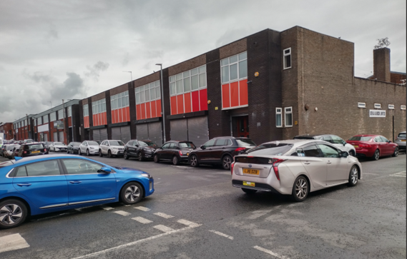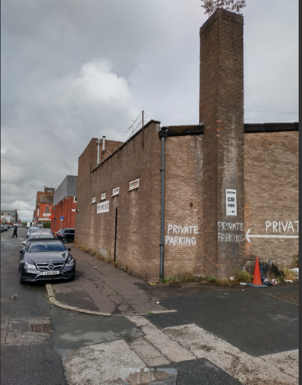
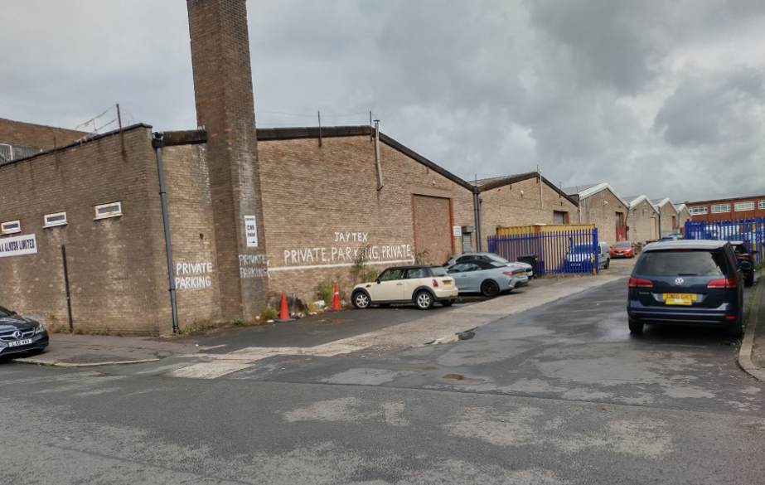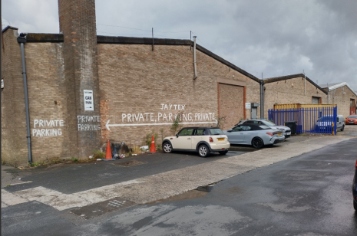
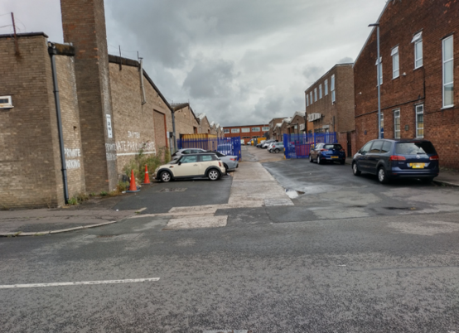

Fig.1 - Views of the application site

Description of development
The related condition 4 attached of planning permission 144798/FO/2025 allowed the following:

i. Retention of the existing configuration of the principal elevation to Stocks Street.
ii. The formation of flat roof rear extension spanning the full width of the application property. It would be constructed in matching brickworks with concrete copings to the eaves.
iii. Existing opening to the rear of the building would be enclosed apart from the retained roller shuttered serviced bay.
iv. At first floor level a series of rectangular windows would be formed.
v. The existing forecourt to Stocks Street East would be demarcated to form 14 car parking spaces (including on accessible space) and access/egress to the servicing bay.
vi. The submission indicates the provision of an EV charging unit.

Condition 4 specifically states:

The use of the development hereby authorised be ancillary to the operation of 40-42 Stocks Street as a warehouse Class B8 at all times and shall not be sub-divided or used for any other purposes with a maximum internal floorspace of 813 sq. metres.

Reason - In interests of the visual amenity of the area within which the site is located and to ensure that the development is appropriate related to the capacity of the site, pursuant to in policies SP1 and DM1 of the Core Strategy for the City of Manchester.

Relevant planning history
Planning Application PLA-2026-000857 - Removal of Condition 4 (B8 use) attached to Planning Permission 144798/FO/2025.

Consultation, notification and publicity responses

Consultations
Local residents and businesses – No comments

Highways

i. The original permission was assessed based on the use being ancillary to the existing warehouse operation. The submitted justification statement references a range of potential future uses that could be accommodated within the building, including residential, healthcare, educational, retail, leisure and other commercial uses.

ii. Highways that the omission of Condition 4 would remove the restrictions to the occupation and operation of the development. Changes to the occupation of the development may significantly affect travel characteristics, parking demands, servicing requirements and traffic generation when compared with the approved warehouse use. An analysis of these impacts has not been provided as part of the current submission. The following areas of concern have been identified:

- Trip generation and traffic impacts
- Parking demand and parking provision
- Cycle parking provision
- Servicing and delivery requirements
- Highway safety implications
- Accessibility by sustainable modes
- Impacts on the operation of the local highway network

iii. The applicant has not submitted any transport evidence demonstrating that the unrestricted use of the additional floorspace would not result in unacceptable impacts on highway safety or the operation of the surrounding highway network.

Environmental Health – No comments.

Local Lead Flood Authority – No comments.

Notifications and publicity

No site notices ore press advertisement required.

Relevant policies
National Planning Policy Framework (NPPF- August 2026)

The NPPF sets out the government’s policies for plan making and for making decisions on development proposals in England. It is a material consideration of critical importance in both contexts. This version replaces the previous NPPF published in December 2024.

Paragraph 17 States that . Achieving sustainable development means that the planning system has three overarching objectives in providing for the homes, commercial development, facilities and infrastructure which society needs. These objectives are:
a. An economic objective
b. A social objective
c. An environmental objective.

The proposal would deliver a sustainable development and would accord with the above objectives.

Chapter 3. Decision-making policies

Policy DM3: Determining development proposals – Sets out the considerations of the LPA when determining development proposals. The assessment of the development accords with these requirements.

Chapter 4. Achieving sustainable development

Policy S3: Presumption in favour of sustainable development – The development would secure active and sustainable use for the application property with potential harm mitigated through conditions.

Sustainable Development Joint Development Plan Document - Places for Everyone (2022-2039)

Policy JP-P6 (Health) – Has been related to the assessment of harm associated with the development.

Policy JP-J2: Employment Sites and Premises – States that existing employment areas that are important to the maintenance of a strong and diverse supply of sites and should be protected from redevelopment to other uses, nurtured to ensure they remain competitive and their accessibility improved where necessary. This will include local employment areas as well as key growth locations. Policy JP-J2 has been related to the impact of the proposal on the contribution of the site to local employment.

Manchester's Local Development Framework: Core Strategy

Policy SP 1 Spatial Principles

Discusses the need for development to make a positive contribution to the health, safety and wellbeing of residents. The attached condition and other operational conditions ensure that the development is appropriately related to its context (and policy SP1 is thereby accorded with).
Policy SP1 also states the importance of improving access to jobs, services, education and open space by being located to reduce the need to travel and provide good access to sustainable transport provision. These objectives are considered alongside the need to ensure that development relates to its location and context. The retention of condition 4 would ensure that the further use of the development is related satisfactorily to the surrounding context and thereby secures the objective of policy SP1, including the delivery of access to jobs.

Policy DM1 Development Management

Also requires that development should have regard to the character of the surrounding area. The introduction of new uses would need to be assessed through the planning process. However, condition 4 relates to the on-going operation of the site as a single Class B8 unit with ancillary offices. The associated assessment of the seeks to ensures that activity associated with the operation of the site including noise, waste and recycling storage and traffic is appropriately managed. The maintenance of condition 4 is necessary to secure compliance with policy DM1.

The proposed removal of condition 4, also raises the following policy considerations.

Policy EC 1 - Employment and Economic Growth in Manchester

Sets out the Council objectives for employment and economic growth requires consideration of:
i. Improving access to jobs for all via public transport, walking and cycling;
ii. Demonstrating that employment-generating development has fully considered opportunities to provide jobs for local people, through construction or use;
iii. Improving the portfolio of employment premises, by providing a range of employment sites and premises for small, medium and large businesses;
iv. Ensuring the continued social, economic and environmental regeneration of the city.

The development would provide a contribution to the local economy, supply of commercial floorspace and employment provision within an established warehousing area. The retention of condition 4 would help to ensure the continued contribution of the development to the local economy in accordance with policy EC1. It would also maintain to jobs and available of a range of employment sites in further accordance with policy EC1.

Policy EC 2 Existing Employment Space

Stated that the Council will seek to retain and enhance existing employment space and sites.
Alternative uses will only be supported on sites allocated accordingly, or if it can be demonstrated that:
i. The existing use is un-viable in terms of business operations, building age and format;
ii. The existing use is incompatible with adjacent uses;
iii. The existing use is unsuitable for employment or on balance, proposals are able to offer greater benefits in terms of the Core Strategy’s vision and spatial objectives than the existing use.

In this case, planning permission Ref: 144798/FO/2025, would secure changes to the application property that would improve the layout of the building and aid it is sustained occupation for Class B8 use. The previous application did not seek to change to the use of the property and it appears that existing Class B8 use remains viable. The details submitted with application Ref: PLA-2026-000857 have not demonstrated the use has become unviable since the previous grating of planning permission. The application property is in a location characterised by Class B8 uses. It is therefore compatible with existing uses. Alternative uses would not potentially deliver greater benefits over the existing use and its contribution to employment and the local economy. The proposal would therefore fail to accord with policy EC2.

Policy EN19 Waste

Requires the provision of arrangement for the management of waste and recycling. The proposal has not demonstrated how waste and recycling would be delivered should the building be sub-divided. Policy EN19 would not, therefore, be accorded with.

Policy T1 Sustainable Transport

Amongst other things, policy T1 seeks to reduce the negative impacts of road traffic, for example, congestion, air pollution and road accident casualties. The proposal has not demonstrated how the application property would operate should the building be sub-divided and how highways impacts may be mitigated. Policy T1 would not, therefore, be accorded with.

Unitary Development Plan saved policy

Policy CC10

This policy is relevant to the application site due to its location and seeks to ensure the continued economic vitality of this key area to the economy of the city. It states that the ‘Council will encourage the continued high level of economic activity in Strangeways and lower Cheetham Hill Road areas, recognising particularly the needs of the wholesale trades which dominate these areas’. Furthermore, ‘the Council recognises the regional role played by this locality and will pursue policies designed to improve the efficiency of existing businesses (notably wholesale cash and carry and bulk distributive trades), by environmental improvements and better parking and servicing.’ The loss of the application property for Class B8 use, in relation to its employment and economic contribution would be contrary to the objectives of policy CC10.The retention of condition 4, is consistent with delivering the objectives of policy CC10.

Strangeways and Cambridge Strategic Regeneration Framework (SRF)

The SRF has been produced in partnership between Manchester City Council (‘MCC’) and Salford City Council (‘SCC’) and will be used to guide development and investment in this key area of the city over a 20-30-year period. The SRF discusses the area which includes the application site. This area is identified for employment use. More specifically, this area is identified as a location for a mix of small and medium sized light industrial and warehouse spaces that will provide a home for future wholesaling, production, making and creation activity across a range of sectors that are not otherwise catered for in the city. The retention of condition 4 is important to the delivery of the above policy objectives.

Assessment
Impact of the removal of condition 4 – The removal of condition 4 would allow the application building to be sub-divided. The resulting occupation of the property by several different businesses would undermine the management of the future site (delivered through the conditions attached to planning permission Ref: 144798/FO/2025). This includes the impact of an overly intensively occupied building without appropriate measures to manage traffic generation, servicing and waste and recycling including traffic generation, activity and There is also concern that the removal of condition 4 would potentially severe the link between the ancillary offices and the Class B8 use. Ambiguity may therefore emerge regarding the future use of the offices, leading the introduction of activity that may not be compatible with the character of the area, i.e., Class E uses.

The application site is characterised by warehousing uses, that are characterised by noise generating activity. The submitted application references potential future use of the building. Alternative such uses would need to be assessed as part of appropriate applications. However, it is considered that a condition that specifically references Class B8, clearly signals the importance of such uses within the vicinity of the application site. Condition 4 requires acknowledgement of the nature of the area, particularly characteristics that would be harmful should noise sensitive uses be introduced.

Justification for the retention of condition 4 - The policy justification for the retention of condition 4 is set out above. There is also concern that the omission of condition 4 would undermine the operation arrangement that would be delivered through planning permission Ref: 144798/FO/2025. These arrangements would aid the sustained and managed occupation of the application property for Class B8 purposes. The previous application (Ref: 144798/FO/2025) did not seek to change or vary the use of the property, and it appears that the existing Class B8 use remains viable. The details summitted with application Ref: PLA-2026-000857 have not demonstrated the use has become unviable since the previous granting of planning permission.

Impact on employment floorspace provision - The authorised development would provide a contribution to the local economy, supply of commercial floorspace and employment provision within an established warehousing area. The retention of condition 4 would help to ensure that this contribution would continue and help to maintain to jobs across a range of employment sites in the city.

Highway issues – The application not been supported with details relating to how the application property may be sub-divided or given any clarity regarding the number units may operate within the site. The submission has not allowed an assessment of the following issues

- Trip generation and traffic impacts
- Parking demand and parking provision
- Cycle parking provision
- Servicing and delivery requirements
- Highway safety implications
- Accessibility by sustainable modes
- Impacts on the operation of the local highway network

The removal of condition 4 would thereby fail to deliver the certainty of the appropriate operation of the development provided as part of the assessment of planning application Ref: PLA-2026-000857. The retention of condition 4 is therefore appropriate.

Other Legislative Requirements

Equality Act 2010
Section 149 (Public Sector Equality Duty) of the Equality Act 2010 requires due regard to the need to: Eliminate unlawful discrimination, harassment and victimisation and other conduct prohibited by the Act and; Advance equality of opportunity between persons who share a protected characteristic and persons who do not share it. The Equality Duty does not impose a legal requirement to conduct an Equality Impact Assessment. Compliance with the Equality Duty involves consciously thinking about the aims of the Equality Duty as part of the process of decision-making.

Human Rights Act 1998 considerations
This application needs to be considered against the provisions of the Human Rights Act 1998. Under Article 6, the applicants (and those third parties, including local residents, who have made representations) have a right to a fair hearing and to this end the local planning authority must give full consideration to their comments.

Protocol 1 Article 1, and Article 8 where appropriate, confer(s) a right of respect for a person’s home, other land and business assets. In taking account of all material considerations, including Council policy as set out in the Core Strategy and saved polices of the Unitary Development Plan, the Director of Planning, Building Control & Licensing has concluded that some rights conferred by these articles on the applicant(s)/objector(s)/resident(s) and other occupiers and owners of nearby land that might be affected may be interfered with but that that interference is in accordance with the law and justified by being in the public interest and on the basis of the planning merits of the development proposal. She believes that any restriction on these rights posed by the recommendation given is proportionate to the wider benefits of and that such a decision falls within the margin of discretion afforded to the Council under the Town and Country Planning Acts.

Conclusion
The removal of condition 4 would facilitate the sub-division of the application property without demonstrable arrangements to ensure that the future occupation of the building and its external areas would be satisfactorily managed. The removal of condition 4 would undermine the sustained occupation of the application property and its on-going contribution to the local economy and the delivery of employment opportunities. The removal of condition 4 is therefore not supported.

Article 35 Declaration
In this case, officers advised the applicant via the appointed that the proposed removal of condition 4 would not accord with Council policy and therefore would not be supported. The application has been assessed and determined on the basis of the submitted details.

Recommendation: Refuse

Reasons for refusal

1) | The removal of condition 4 (relating to the operation of the authorised Class B8 use) would facilitate the sub-division of 40 – 42 Stocks Street without demonstrable arrangements to ensure that the future occupation of the building and its external areas would be satisfactorily managed. The lack of appropriate site management arrangements would potentially lead to additional traffic movement, additional servicing and activity and generation of waste and recycling that would cause undue harm to the locality, including the surrounding highway network. The removal of condition 4 would be unacceptable and contrary to policies SP1, DM1, EN19 and T1.
2) | The removal of condition 4 (relating to the operation of the authorised Class B8 use) would undermine the sustained occupation of 40 – 42 Stocks Street and its on-going contribution to the local economy and the delivery of employment opportunities. The removal of condition 4 would be unacceptable and contrary to policies SP1, DM1, EC1, EC2, Unitary Development Plan saved policy CC10, The Strangeways and Cambridge Strategic Regeneration Framework (SRF) and Sustainable Development Joint Development Plan Document - Places for Everyone policy JP-J2.

