

Planning

Delegated Officer Report

Summary of application details
Application reference: | PLA-2026-000297
Application type: | Householder planning permission
Proposal: | Erection of a single-storey rear extension.
Site address: | 13 Alford Avenue Manchester M20 1AQ
Ward(s): | Old Moat
Date application valid: | 28 July 2026
Applicant name: | Mr Muhammad Qasim
Agent (if any): | Mr M Alam
Case officer: | Joshua Lee
Recommendation: | Approve
Date of recommendation: | 21/08/2026

Description of site, building and/or area
The proposal relates to a two-storey end-terrace dwellinghouse on Alford Avenue.
The property is in a mostly residential part of the Old Moat ward of Manchester. Part of the site sits in Flood Zone 2 and at medium risk for surface water flooding.

Description of development
Erection of a single-storey rear extension.
The proposed single storey rear extension projects 4350mm from the existing rear elevation and runs across the full width of the existing property. The extension is finished in matching brick and mono-pitch sloping tiled roof to match. New glazing is features to the rear.
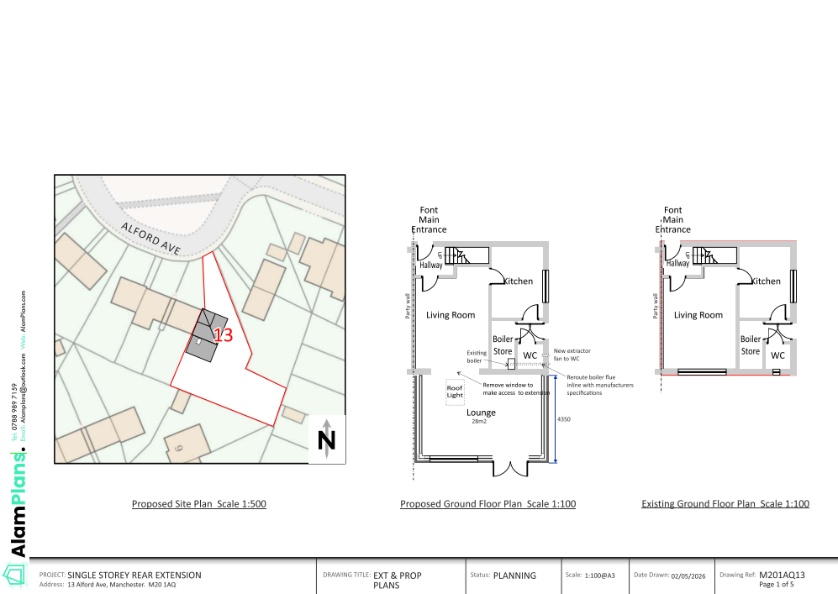
Figure 1. Floor Plan

Relevant planning history
There is no planning history at the address.

Consultation, notification and publicity responses

Consultations

Manchester City Council Flood Risk Management
Objects to the application. The site lies within Flood Zone 2, is susceptible to surface water flooding and is located within a Critical Drainage Area. Whilst the submitted information states that flood risk will not increase and references drainage and flood resilience measures, the LLFA considers that insufficient information has been provided to fully assess flood risk. A completed Flood Risk Assessment Proforma and supporting flood risk information are required to demonstrate that the development will remain safe for its lifetime, account for climate change and not increase flood risk elsewhere. Approval is therefore not recommended until this information has been submitted and assessed.

Notifications and publicity

Neighbour letters
No representations received.

Relevant policies
In accordance with Section 38(6) of the Planning and Compulsory Purchase Act 2004, decisions on planning applications must be made in line with the statutory development plan, unless material considerations indicate otherwise.

For Manchester, the development plan comprises:

- The Core Strategy (2012–2027)
- Saved policies of the Unitary Development Plan (UDP)
- The Places for Everyone Joint Development Plan Document (2022–2039)

These documents are considered up to date and carry substantial weight in decision-making. Supplementary Planning Documents (SPDs) and other local guidance may also be relevant.

National planning policy, including the National Planning Policy Framework (NPPF), is a material consideration and provides overarching guidance.

Where applicable, the Council must give special regard to preserving the character of conservation areas and the setting of listed buildings, in line with statutory duties under the Planning (Listed Buildings and Conservation Areas) Act 1990.

The policies referenced in this report are those considered most relevant to the nature, scale and location of the proposed development as follows:

- The Manchester Core Strategy Development Plan Document 2012-2027
  - Development Management and Planning Obligations
    - DM 1 - Development Management
  - Objective 1 - Spatial Principles
    - SP 1 - Spatial Principles (Partially replaced by PfE Policy JP-S 1)
  - Objective 6 Environment
    - EN 1 - Design Principles and Strategic Character Areas
    - EN 14 – Flood Risk (partially replaced by PfE Policy JP-S 4)
    - EN 19 – Waste
- Guide to development in Manchester - supplementary planning document and planning guidance, April 2007
- Extant Unitary Development Plan (UDP) –
  - Citywide Development Control Policies
    - DC1 - Residential extensions
    - DC26 - Development and Noise
- Places for Everyone Plan Joint Development Plan Document 2022-2039-
  - Strategy
    - JP-Strat9: Southern Areas
  - Sustainable and Resilient Places
    - JP-S1: Sustainable Development
    - JP-S4: Flood Risk and the Water Environment
  - Places for People
    - JP-P1 Sustainable Places
- National Planning Policy Framework – August 2026 - National Development Management Policies (NDMPs)
  - Procedural Policies
    - Chapter 3 – Decision-making policies
      - DM1: Preparing development proposals
      - DM2: Information requirements
      - DM3: Determining development proposals
      - DM6: Use of planning conditions and obligations
      - DM7: Relationship with other regulatory regimes
  - Sustainable Development
    - Chapter 4 - Achieving sustainable development
      - S3: Presumption in favour of sustainable development
      - S4: Principle of development within settlements
    - Chapter 5 - Meeting the challenge of climate change
      - CC2: Mitigation of climate change
      - CC3: Adaptation to climate change
  - Creating high quality, sustainable places
    - Chapter 12 - Making effective use of land
      - L2: Making effective use of land
    - Chapter 14 - Achieving well-designed places
      - DP3: Key principles for well-designed places
      - DP4: The design process
  - Conserving and enhancing the environment
    - Chapter 18 - Managing flood risk and coastal change
      - F4: Assessing flood risk for decision-making
      - F6: Development in areas at risk of flooding from rivers or the sea
      - F7: Ensuring development is safe from flooding
      - F8: Sustainable drainage systems and watercourses

Assessment

Principle of development
Many people prefer to extend their existing homes rather than move, and the planning system needs to accommodate this demand for more living space, while at the same time ensuring that the amenities of neighbours are protected, and that the overall character of the surrounding area is not harmed. The Council is not generally in favour of dealing with this issue by laying down firm rules about home extensions with each case looked at on its individual merits, having regard to a range of criteria.
It is also a material consideration that householders benefit from permitted development rights under Schedule 2, Part 1 of the Town and Country Planning (General Permitted Development) (England) Order 2015 (as amended). In this case, a single-storey rear extension projecting up to 6 metres from the original rear wall could potentially be carried out through the prior approval process for larger home extensions, subject to compliance with the relevant limitations and conditions. The submitted proposal projects approximately 4.35 metres from the rear elevation and therefore represents a form of development that could broadly be achieved under a fallback prior approval position.
Whilst the application must be assessed on its own planning merits, the existence of this fallback position attracts weight as a material consideration. Given the scale and nature of the proposed extension, together with the absence of unacceptable impacts identified elsewhere in this report, the principle of development is considered acceptable and consistent with Policies DM1 and DC1 of the Manchester Core Strategy and UDP respectively.
As stated in Policy DM 1 of the Manchester Core Strategy, all development should have regard to the following specific issues:

Appropriate siting, layout, scale, form, massing, materials, and detail
The proposed extension would be located to the rear of the dwelling and would project approximately 4.35m beyond the existing rear elevation. The extension would be single-storey in scale with a mono-pitched roof and would be constructed in materials matching the host dwelling. The proposal has been designed as a subordinate addition to the existing dwelling by virtue of its height, scale and rearward position.
The proposal would be constructed on the shared boundary with No. 15 Alford Avenue. Whilst the extension would be visible from this neighbouring property, it is not considered that its scale, height or massing would result in an unduly dominant or overbearing feature. The development is limited to a single storey and incorporates a mono-pitched roof which assists in reducing its visual impact on the adjoining occupiers. Given the depth and height proposed, the extension is not considered to result in unacceptable harm to outlook or residential amenity at No. 15.
Accordingly, the siting, scale, form, massing and appearance of the proposed extension are considered acceptable
Impact on the surrounding areas in terms of the design, scale and appearance of the proposed development. Development should have regard to the character of the surrounding area.
Given its location to the rear of the property, the extension would have limited visibility from the public realm and would not adversely affect the character or appearance of the street scene. The proposed materials and form would ensure that the extension appears as a sympathetic addition to the existing dwelling and local area.

Effects on amenity

Privacy
The proposal incorporates new glazed doors and windows within the rear elevation. These openings would serve the applicant's private rear garden and would not give rise to materially greater overlooking than the existing arrangement. No side-facing windows are proposed.
The proposal would therefore not result in an unacceptable loss of privacy for neighbouring occupiers.

Light
The extension would be single storey in height and, whilst visible from neighbouring gardens, would not be of such scale or massing as to cause significant overshadowing or unacceptable loss of daylight to neighbouring habitable rooms or private amenity areas.
The proposal is therefore considered to have an acceptable impact on neighbouring residential amenity.

Noise
The proposed extension is not expected to generate any noise beyond what would be reasonably expected of a residential dwelling.

Accessibility: buildings and neighbourhoods fully accessible to disabled people, access to new development by sustainable transport modes.
The proposal does not change how people can get in and out of the building.

Adequacy of internal accommodation and external amenity space.
The proposal adds space inside the property with minimal effect to the outdoor area and maintains a good level of external amenity space post development.

Refuse storage and collection.
The proposal itself has little impact on waste from the site. It uses the current storage and collection methods on site and maintains external access to the rear of the property.

Vehicular access and car parking
The proposal doesn't change how vehicles access and park at the property.

Green Infrastructure including open space, both public and private
The dwelling benefits from a garden beyond the siting of the proposed development and maintains a good amount of private green space post development.

Flood risk and drainage.
Part of the application site lies within Flood Zone 2 and is identified as having a medium risk of surface water flooding. The Council's Flood Risk Management team has advised that additional flood risk information would ordinarily be required to fully assess the proposal.
The development, however, comprises a modest single-storey rear extension to an existing dwellinghouse and would not introduce a more vulnerable use, increase occupancy levels or significantly alter the overall flood risk profile of the site. The extension would result in only a limited increase in built form and impermeable area within an established residential curtilage.
It is also a material consideration that householders benefit from permitted development rights. Subject to compliance with the relevant limitations and conditions, a larger single-storey rear extension could potentially be constructed under the prior approval process without the requirement for a site-specific Flood Risk Assessment. The current proposal is smaller in scale than that potential fallback position. Whilst each proposal must be considered on its own merits, it would be difficult to justify requiring extensive flood risk information for a development of this scale where a comparable or larger form of extension may be capable of being implemented through permitted development rights.
Having regard to the limited scale and nature of the proposal, it is not considered that the development would materially increase flood risk on the site or elsewhere, nor would it prejudice the safety of future occupants. On balance, the request for further flood risk information is considered onerous and disproportionate to the scale of development proposed. The proposal is therefore considered acceptable in flood risk and drainage terms and compliant with Policy EN14 of the Core Strategy, Policy JP-S4 of Places for Everyone and the relevant provisions of the NPPF.

Other Legislative Requirements

Equality Act 2010
Section 149 (Public Sector Equality Duty) of the Equality Act 2010 requires due regard to the need to: Eliminate unlawful discrimination, harassment and victimisation and other conduct prohibited by the Act and; Advance equality of opportunity between persons who share a protected characteristic and persons who do not share it. The Equality Duty does not impose a legal requirement to conduct an Equality Impact Assessment. Compliance with the Equality Duty involves consciously thinking about the aims of the Equality Duty as part of the process of decision-making.

Human Rights Act 1998 considerations
This application needs to be considered against the provisions of the Human Rights Act 1998. Under Article 6, the applicants (and those third parties, including local residents, who have made representations) have a right to a fair hearing and to this end the local planning authority must give full consideration to their comments.
Protocol 1 Article 1, and Article 8 where appropriate, confer(s) a right of respect for a person’s home, other land and business assets. In taking account of all material considerations, including Council policy as set out in the Core Strategy and saved polices of the Unitary Development Plan, the Director of Planning, Building Control & Licensing has concluded that some rights conferred by these articles on the applicant(s)/objector(s)/resident(s) and other occupiers and owners of nearby land that might be affected may be interfered with but that that interference is in accordance with the law and justified by being in the public interest and on the basis of the planning merits of the development proposal. She believes that any restriction on these rights posed by the recommendation given is proportionate to the wider benefits of and that such a decision falls within the margin of discretion afforded to the Council under the Town and Country Planning Acts.

Planning balance & Conclusion
The proposed single-storey rear extension would provide additional living accommodation for the occupants of the dwelling without causing unacceptable harm to the character and appearance of the property, the surrounding area, neighbouring residential amenity, flood risk interests, highway safety or other material planning considerations. The development is also capable of attracting weight from a fallback permitted development position through the larger home extension prior approval process.
The proposal is therefore considered to accord with Policies DM1, EN1 and EN14 of the Manchester Core Strategy, Policy DC1 of the UDP, Policies JP-S1 and JP-S4 of Places for Everyone and the relevant provisions of the National Planning Policy Framework. Approval is therefore recommended.

Recommendation: Approve

Article 35 Declaration
Officers have worked with the applicant in a positive and proactive manner based on seeking solutions to problems arising in relation to dealing with the planning application. The proposal is considered to be acceptable and therefore determined within a timely manner.

Conditions to be attached to decision for approval

3-year time limit
The development must be begun not later than three years beginning with the date of this permission.
Reason - Required to be imposed by Section 91 of the Town and Country Planning Act 1990 (as amended).

Specified plans
The development hereby approved shall be carried out in accordance with the following drawings and documents:
  - Location Plan received 12 May 2026;
  - Planning DRW ALFO (Combined Plans) received 12 May 2026;
  - Planning DRW West Elevation, Drawing No. M201AQ13 (Existing & Proposed West Elevation) received 28 July 2026;
  - Flood Risk Statement received 12 May 2026
  - Flood Risk Map received 12 May 2026.
Reason - To ensure that the development is carried out in accordance with the approved plans, pursuant to policies DM 1, SP 1 and EN 1 of the Core Strategy and JP-P1 & of Places for Everyone.

Materials to match
The materials used in the external surfaces of the development hereby approved shall be similar in appearance to the existing building in terms of type, size, colour and texture.
Reason - In order to ensure a satisfactory appearance in the interests of visual amenity in accordance with policies SP1 and DM1 of the Core Strategy and the requirements of the National Planning Policy Framework.

Informative(s)

Property Flood Resilience Measures
The applicant is advised to incorporate Property Flood Resilience (PFR) measures to a minimum of 150mm above the surface water flood level or a minimum of 600mm above the fluvial flood level.

