

Planning

Delegated Officer Report

Summary of application details
Application reference: | PLA-2026-001061
Application type: | Removal/variation of conditions
Proposal: | Variation of Condition 2 (specified plans) attached to Planning Permission 145495/FH/2026 to allow changes to roof form.
Site address: | 18 Kempton Road Manchester M19 2GJ
Ward(s): | Burnage
Date application valid: | 17 July 2026
Applicant name: | Mrs Rahat Shahid
Agent (if any): | Mr M Ahmed
Case officer: | Joshua Lee
Recommendation: | Approve
Date of recommendation: | 21/08/2026

Description of site, building and/or area
The proposal is related to a two-storey semidetached dwellinghouse on Kempton Road. The property features and an existing single storey rear extension alongside the original outrigger. The property features hardstanding to the front and side for off street vehicle parking and garden to the rear.
The property is in a mostly residential part of Burnage ward.

Description of development
Variation of Condition 2 (specified plans) attached to Planning Permission 145495/FH/2026 to allow changes to roof form.
The proposed change introduces a new hipped tile roof to the proposed side extension rather than the flat roof as approved.
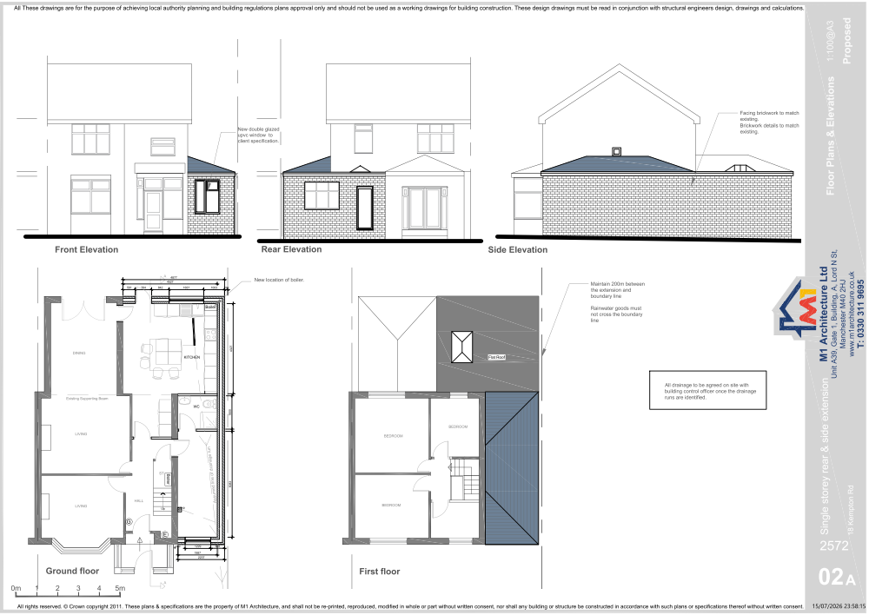
Figure 1. Proposed plans and elevations

Relevant planning history

Planning Application - 145495/FH/2026
Erection of a single-storey side and rear extension.
Approve - 2026-05-15

Planning Application - 104195/PDE/2013/N2
Prior approval Part 1 Class A.1(ea): Larger home extension - Erection of single storey rear extension projecting 5.0m to the rear, with a maximum height of 4.0m and a height at the eaves of 3.0m to form additional living accommodation
Approve - 2013-12-18

Consultation, notification and publicity responses

Notifications and publicity
No response received.

Relevant policies
In accordance with Section 38(6) of the Planning and Compulsory Purchase Act 2004, decisions on planning applications must be made in line with the statutory development plan, unless material considerations indicate otherwise.

For Manchester, the development plan comprises:

- The Core Strategy (2012–2027)
- Saved policies of the Unitary Development Plan (UDP)
- The Places for Everyone Joint Development Plan Document (2022–2039)

These documents are considered up to date and carry substantial weight in decision-making. Supplementary Planning Documents (SPDs) and other local guidance may also be relevant.

National planning policy, including the National Planning Policy Framework (NPPF), is a material consideration and provides overarching guidance.

Where applicable, the Council must give special regard to preserving the character of conservation areas and the setting of listed buildings, in line with statutory duties under the Planning (Listed Buildings and Conservation Areas) Act 1990.

The policies referenced in this report are those considered most relevant to the nature, scale and location of the proposed development as follows:

- The Manchester Core Strategy Development Plan Document 2012-2027
  - Development Management and Planning Obligations
    - DM 1 - Development Management
  - Objective 1 - Spatial Principles
    - SP 1 - Spatial Principles (Partially replaced by PfE Policy JP-S 1)
  - Objective 6 Environment
    - EN 1 - Design Principles and Strategic Character Areas
    - EN 19 – Waste
- Guide to development in Manchester - supplementary planning document and planning guidance, April 2007
- Extant Unitary Development Plan (UDP) –
  - Citywide Development Control Policies
    - DC1 - Residential extensions
    - DC26 - Development and Noise
- Places for Everyone Plan Joint Development Plan Document 2022-2039-
  - Strategy
    - JP-Strat9: Southern Areas
  - Sustainable and Resilient Places
    - JP-S1: Sustainable Development
  - Places for People
    - JP-P1 Sustainable Places
- National Planning Policy Framework – August 2026 - National Development Management Policies (NDMPs)
  - Procedural Policies
    - Chapter 3 – Decision-making policies
      - DM1: Preparing development proposals
      - DM2: Information requirements
      - DM3: Determining development proposals
      - DM6: Use of planning conditions and obligations
      - DM7: Relationship with other regulatory regimes
  - Sustainable Development
    - Chapter 4 - Achieving sustainable development
      - S3: Presumption in favour of sustainable development
      - S4: Principle of development within settlements
  - Creating high quality, sustainable places
    - Chapter 14 - Achieving well-designed places
      - DP3: Key principles for well-designed places
      - DP4: The design process

Principle of development
Planning permission was granted under reference 145495/FH/2026 for the erection of a single-storey side and rear extension at the property. The current application seeks a minor amendment through the variation of Condition 2 (approved plans) to substitute the approved flat roof to the side extension with a hipped tiled roof. The proposal does not alter the approved use of the property as a single dwellinghouse and does not increase the overall scale of development beyond that previously considered acceptable.
The site lies within an established residential area where appropriately designed alterations and extensions to dwellinghouses are acceptable in principle. The proposed amendment remains incidental to the residential use of the property and represents a modest change to the approved scheme. The revised roof form would not conflict with the spatial principles set out in Core Strategy Policy SP1, Places for Everyone Policies JP-S1 and JP-P1, or the provisions of saved UDP Policy DC1 relating to residential extensions.
Given that the principle of the extension has already been established through the extant permission and the amendment relates solely to the roof design of the approved side extension, the proposal is considered acceptable in principle. The acceptability of the revised roof form and its impacts are assessed in the sections below

Appropriate siting, layout, scale, form, massing, materials, and detail
The proposed amendment replaces the approved flat roof to the side extension with a hipped tiled roof. The revised roof form is considered sympathetic to the design and appearance of the host dwelling and would better reflect the existing roofscape of the property. The use of matching roof tiles would ensure the development remains visually integrated with the existing dwelling.
Whilst the proposal would increase the height of the approved side extension, it would remain single storey in scale and subordinate to the host dwelling. The hipped roof design reduces the visual bulk of the extension when compared to an equivalent gabled form and assists in maintaining a satisfactory relationship with neighbouring properties.
Impact on the surrounding areas in terms of the design, scale and appearance of the proposed development. Development should have regard to the character of the surrounding area.
Given its modest scale, position and design, the amended extension would not appear incongruous within the street scene and would not harm the character or appearance of the surrounding residential area

Effects on amenity

Privacy
The proposal does not include any additional windows or openings beyond those already approved. Accordingly, there would be no material increase in overlooking or loss of privacy to neighbouring occupiers.

Light
Although the hipped roof would increase the overall height of the approved side extension, the increase is limited and the extension would remain single storey in scale. The sloping roof form reduces massing close to the shared boundary and it is not considered that the proposal would lead to any significant loss of daylight or sunlight to neighbouring properties

Noise

The proposal relates solely to a change in roof design and would not generate noise beyond that normally associated with a residential dwellinghouse.

Road Safety and Traffic Generation
The proposal would not alter the use of the property, parking arrangements or access arrangements previously approved. No highway safety concerns arise as a result of the proposed amendment.

Accessibility: buildings and neighbourhoods fully accessible to disabled people, access to new development by sustainable transport modes.
The proposal relates only to the roof design of an approved extension and would not affect the accessibility of the dwelling. Existing access arrangements would remain unchanged.

Adequacy of internal accommodation and external amenity space.
The approved extension would continue to provide additional internal accommodation whilst retaining an adequate level of private external amenity space. The proposed amendment would not alter this assessment.

Refuse storage and collection.
The proposal would not affect the approved bin storage arrangements secured under planning permission 145495/FH/2026. Appropriate refuse storage would continue to be provided within the site.

Vehicular access and car parking
The proposed amendment would not alter the approved parking provision or access arrangements. Sufficient off-street parking would remain available within the site.

Green Infrastructure including open space, both public and private
The proposal would not affect public open space or green infrastructure and would maintain the existing level of private garden space within the site

Flood risk and drainage.
The proposal relates solely to a revised roof design and would not materially affect drainage arrangements. The site is not located within a flood risk area, and no drainage concerns arise.

Other Legislative Requirements

Equality Act 2010
Section 149 (Public Sector Equality Duty) of the Equality Act 2010 requires due regard to the need to: Eliminate unlawful discrimination, harassment and victimisation and other conduct prohibited by the Act and; Advance equality of opportunity between persons who share a protected characteristic and persons who do not share it. The Equality Duty does not impose a legal requirement to conduct an Equality Impact Assessment. Compliance with the Equality Duty involves consciously thinking about the aims of the Equality Duty as part of the process of decision-making.

Human Rights Act 1998 considerations
This application needs to be considered against the provisions of the Human Rights Act 1998. Under Article 6, the applicants (and those third parties, including local residents, who have made representations) have a right to a fair hearing and to this end the local planning authority must give full consideration to their comments.
Protocol 1 Article 1, and Article 8 where appropriate, confer(s) a right of respect for a person’s home, other land and business assets. In taking account of all material considerations, including Council policy as set out in the Core Strategy and saved polices of the Unitary Development Plan, the Director of Planning, Building Control & Licensing has concluded that some rights conferred by these articles on the applicant(s)/objector(s)/resident(s) and other occupiers and owners of nearby land that might be affected may be interfered with but that that interference is in accordance with the law and justified by being in the public interest and on the basis of the planning merits of the development proposal. She believes that any restriction on these rights posed by the recommendation given is proportionate to the wider benefits of and that such a decision falls within the margin of discretion afforded to the Council under the Town and Country Planning Acts.

Conclusion
The principle of the extension has already been established through planning permission 145495/FH/2026. The proposed variation seeks only to replace the approved flat roof with a hipped tiled roof. The revised design would remain subordinate to the host dwelling, would not harm the character and appearance of the area, and would not result in unacceptable impacts on neighbouring amenity. The proposal accords with the Development Plan and there are no material considerations that indicate planning permission should be withheld. Approval is therefore recommended.

Recommendation: Approve

Article 35 Declaration
Officers have worked with the applicant in a positive and proactive manner based on seeking solutions to problems arising in relation to dealing with the planning application. The proposal is considered to be acceptable and therefore determined within a timely manner.

Conditions to be attached to decision for approval

Variation - time
The development must be begun not later than the expiration of three years beginning with the date of planning permission 145495/FH/2026, that date being 15th May 2026.
Reason - Required to be imposed pursuant to Section 91 of the Town and Country Planning Act 1990.

Specified plans
The development hereby approved shall be carried out in accordance with the following drawings and documents:
  - Location Plan - 23 Mar 2026
  - 2572 – S1A Site Plan – 30 April 2026
  - 2572 - 18 Kempton Rd.pdf – Plan - Proposed Floor Plans and Elevations - Pack x3 - 17 Jul 2026
Reason - To ensure that the development is carried out in accordance with the approved plans, pursuant to policies DM 1, SP 1 and EN 1 of the Core Strategy and JP-P1 & of Places for Everyone.

Materials to match
The materials used in the external surfaces of the development hereby approved shall be similar in appearance to the existing building in terms of type, size, colour and texture.
Reason - In order to ensure a satisfactory appearance in the interests of visual amenity in accordance with policies SP1 and DM1 of the Core Strategy and the requirements of the National Planning Policy Framework.

Bin store
The secure and ventilated bin store for the storage of waste containers, including segregated and recyclable waste, as denoted in the specified plans, shall be implemented prior to the first use of the extension hereby approved and thereafter retained and maintained, in perpetuity.

Reason - In the interests of residential and visual amenity pursuant to saved policy DC1 of the Unitary Development Plan for Manchester and policies SP1 and DM1 of the Core Strategy for Manchester

