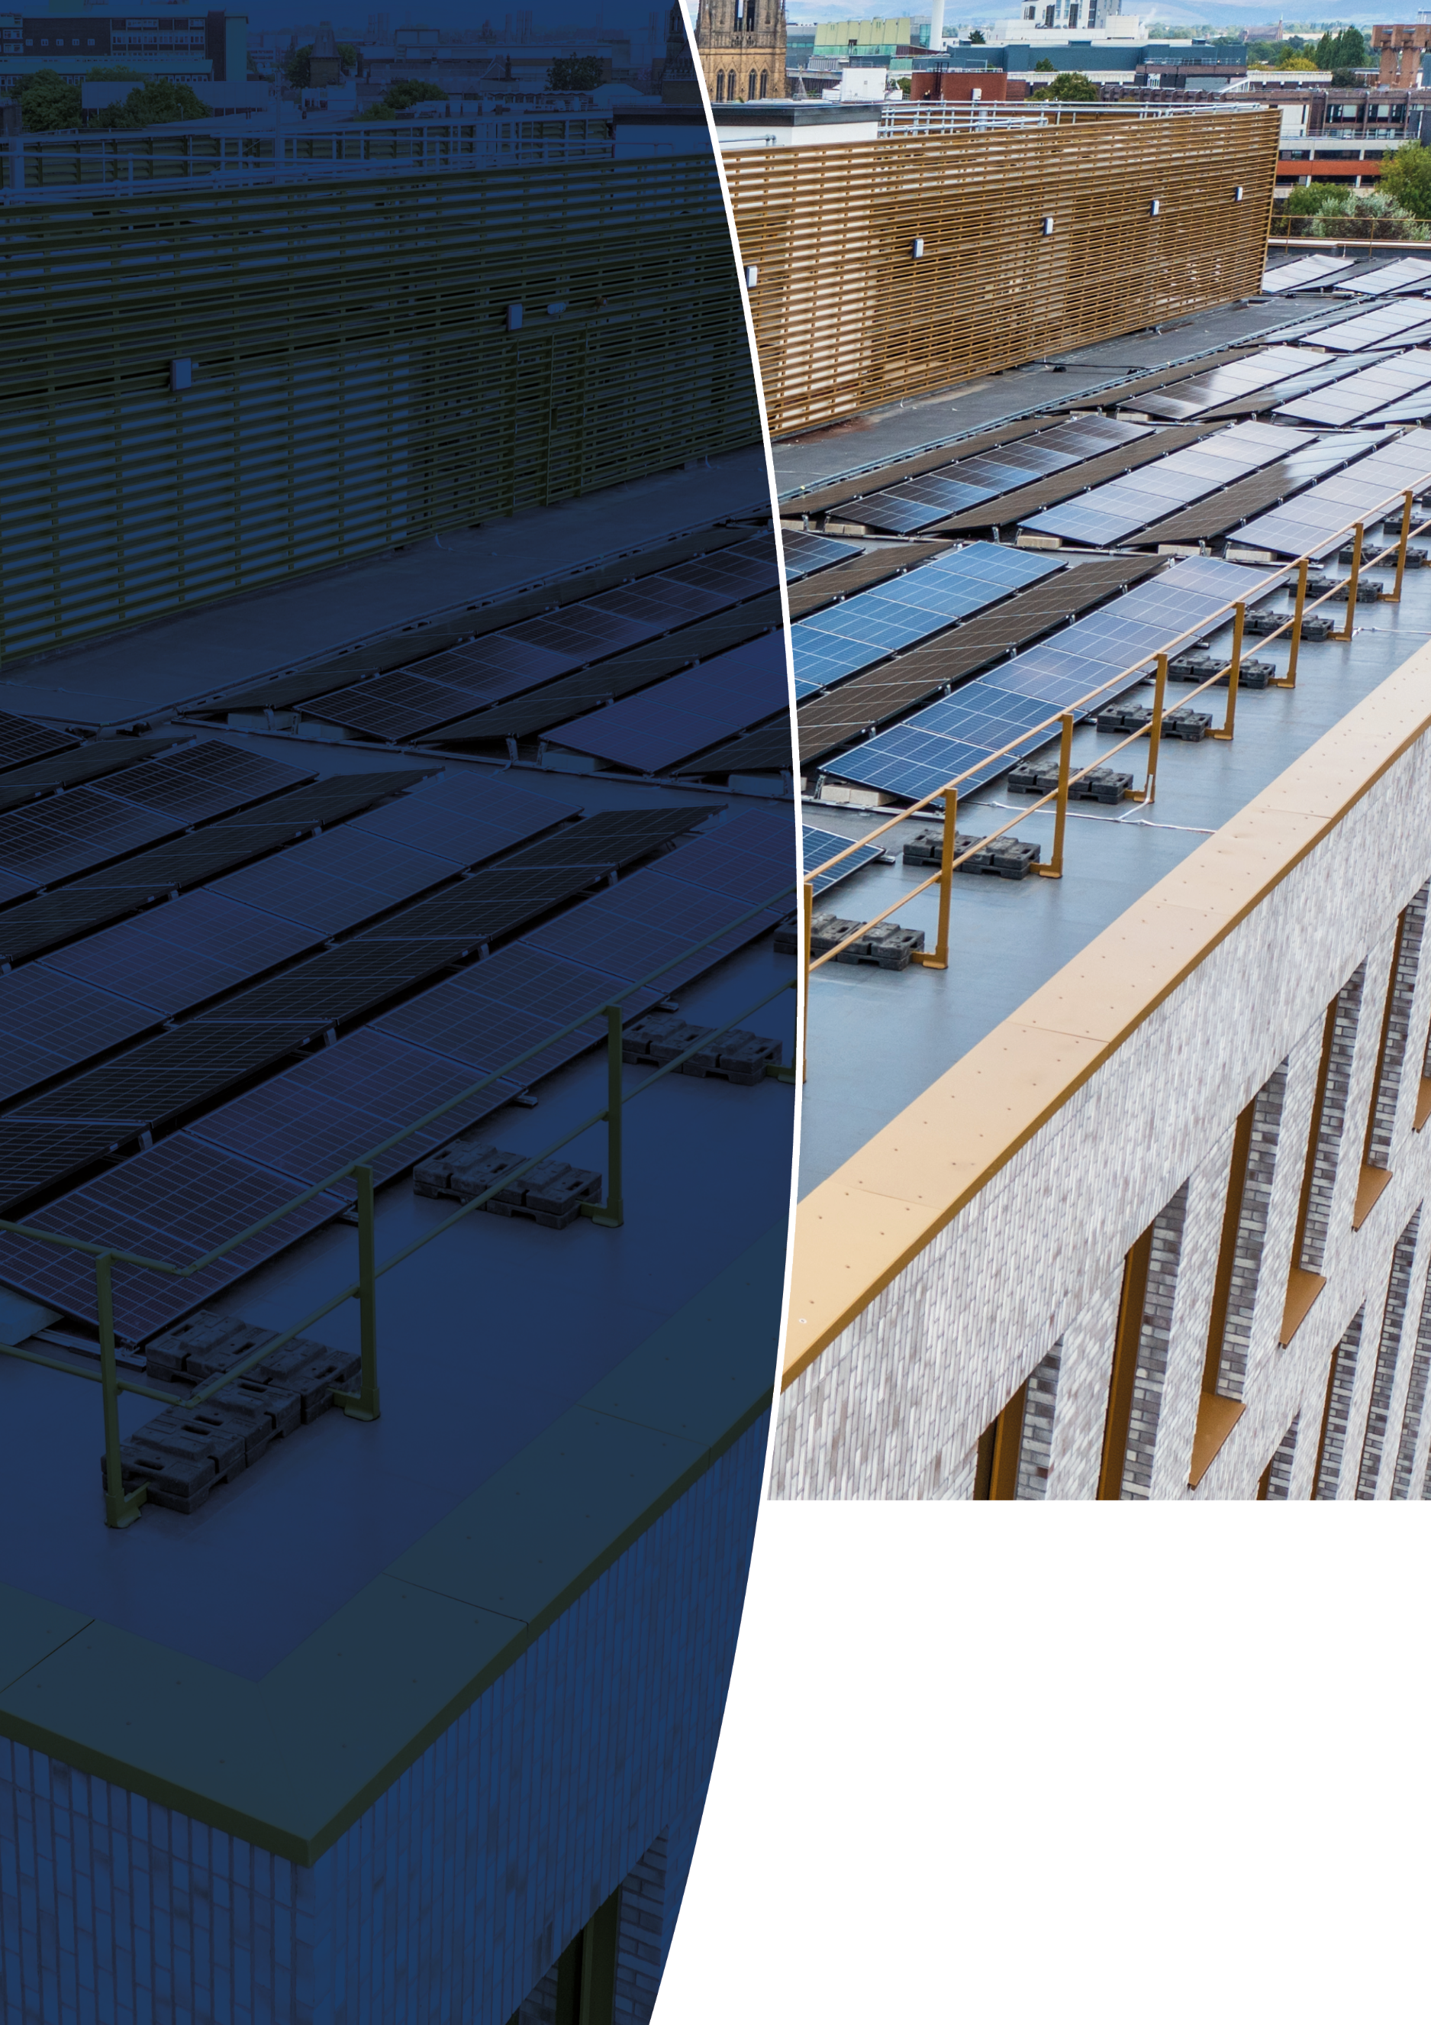
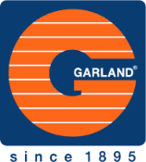
Prepared for:

For the attention of:
Fergus
Date of Issue:
14.8.26

Proposal by:
Tom Boon
tboon@garlanduk.com
07710 893 275

Customer Services Contact:
Becky Salter
info@garlanduk.com
01174 401050

MRE External Curbs
Dura-Coat
garlanduk.com
PROPOSAL
SPECIFICATION
Version 1.0

Garland UK

Your building envelope, protected by the industry experts.

For over 20 years Garland UK have built trusted relationships with thousands of customers nationwide, providing experienced, unbiased technical advice alongside manufacturing innovative building envelope systems - helping our customers to make the best decision for their asset.

Working primarily within the commercial, residential, industrial and public sectors, our technicians have advised on over 20,000 projects and installed over 5 million square metres of roofing to date. Above all, we’re proud to be 100% employee owned, achieving ESOP certification in 2008.

We offer

- New build, refurbishment and retrofit solutions
- Wide range of waterproofing systems including metal profile, modified bitumen, liquid coatings, green roof and metal facades
- Market-leading Single-Point Guarantees
- Solar energy systems
- Technical roofing expertise
- Dedicated Technical Manager throughout entire project
- Roof Asset Management Programme (RAMP)
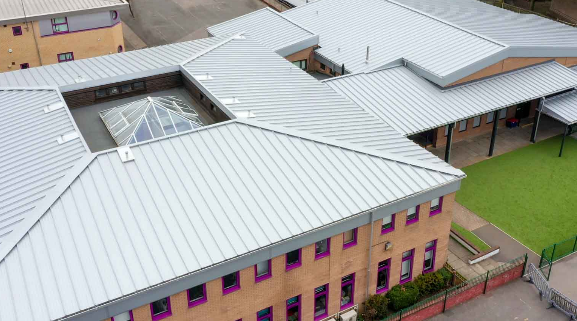
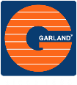

Contents
Contents 1
Revisions Record 2
1. Prelinminaries 2
2. AERIAL VIEW 6
3. SPECIFICATION 7
4. MATERIAL/SYSTEM SCHEDULE 8
5. INSTALLATION 9
6. ITEMS TO CONSIDER 17
7. APPENDICIES 20

Revisions Record

This document is subject to regular changes and as such, any significant amendments are recorded below. All amendments must be brought to the attention of all personnel within the organisation.

Version number | Revision Date | Revision | Incorporated By
1.0 |  | First Issue
1.1
1.2
1.3

Prelinminaries
generators on the Internet tend to repeat predefined chunks as necessary, making this the first true generator on the Internet. It uses a dictionary of over 200 Latin words, combined with a handful of model sentence structures, to generate Lorem Ipsum which looks reasonable. generators on the Internet tend to repeat predefined chunks as necessarycombined with a handful of model sentence structures, to generate Lorem Ipsum which looks reasonable.

generators on the Internet tend to repeat predefined chunks as necessary, making this the first true generator on the Internet. It uses a dictionary of over 200 Latin words, combined with a handful of model sentence looks on the Internet. It uses a dictionary of over 200 Latin words, combined with a handful of model sentence structures, to generate Lorem Ipsum which looks reasonable.

Introduction

This document has been compiled by The Garland Company (UK) Limited. It provides specific bespoke details to the waterproofing solution specified for the roof surveyed.

Please see the full Garland RAMP® Report for further Information.

Size approximately – Roof Sections - TBCSq. Metres

Square metre areas given are approximate only and should only be used as a guide. For accurate tendering purposes the contractor should confirm exact areas.

When the project is underway your Garland Representative will be readily available for onsite consultations when required, whilst providing inspections as described below.

On satisfactory completion of the work and Garland invoices paid in full, all Garland (UK) guarantees and relative documentation will be sent directly to the supervising officer with the guarantees also being published as a PDF File to the clients RAMP database to act as a permanent future record.

We would respectfully request that all relevant parties be in attendance on the day of final inspection to ensure that the roofing works undertaken is to the complete satisfaction of the client.

All works are to be undertaken using The Garland Company (UK) Limited specification and approved contractors.

It is a mandatory requirement that all related materials specified in this document are solely purchased through The Garland Company UK LTD and The Viking Products Group LTD. No substitutions are allowed. Failure to comply will void the Garland guarantee and a non-conformity report issued. Garland Regional Technical Managers will check conformity as part of our quality assurance process.

The Contractor is to ensure that the roofing work is left secure at the end of each working day and that equipment is left safe at the end of each work period.

Any questions regarding specification content or application should be directed to your Garland Regional Technical Manager.

The contractor shall provide all necessary containers and storage facilities for the materials required, maintain them and clear them away on completion.

Prior to the application of products supplied and manufactured by The Garland Company UK Ltd, it is strongly advised to conduct a peel bond test on a suitably prepared part of the substrate to ensure that a satisfactory adhesion can be achieved. It is also wise to repeat this process as the project progresses to ensure a sufficient bond is continued.

The contractor is to take their own core samples to satisfy themself regarding any existing roof build-up and ascertain the extent of work involved in regard to the fragility of the liners and the depth and condition of insulation and spacer systems. No claims arising from failure to do so will be considered.

All work should satisfy the requirements of current Building Regulations. It is recommended that confirmation of individual project requirements is sought from the local Building Control Office before commencement.

It is the responsibility of the roofing contractor to ensure that the building remains watertight at all times. Areas of waterproofing removed within a single day should be done so ensuring the provision of appropriate night joints/ seals.
All products must be installed in accordance with the manufacturer’s recommendations. No responsibility can be taken by the manufacturers where conditions of use are beyond our control. Garland products are available for sale in accordance with The Garland Company UK Ltd standard conditions of sale which are available on request. Whilst any information contained herein is to the best of our knowledge true and accurate, no warranty is given or implied in connection with any recommendations or suggestions made by us or our representatives, agents, or distributors, as the conditions of use and any labour involved are beyond our control. Our warranty is therefore limited to the quality of the supplied product.

Garland will not be held liable for existing roof rainwater design and drainage. When refurbishing a roof, any existing rainwater issues should be made aware to the Garland Representative.

IMPORTANT: Copyright Notice

This Specification and all documents produced by Garland in connection with the project (“Documents”) are subject to copyright laws. Garland retains the copyright in all Documents and will grant a license to the client and the roofing contractor to use the same solely for the purpose for which the Documents were prepared in connection with the project and subject expressly to Garland receiving payment in full for all its products mentioned in this Specification. For the avoidance of doubt, neither the client, its contractors nor representatives shall be entitled to copy or otherwise pass the Documents to any competitor of Garland or otherwise utilise the same to carry out the project using products which have not been supplied by Garland.

For the avoidance of doubt Garland owns all intellectual property rights (including copyright) relating to the Documents it produces, the above provision is lawful and falls within the provisions of the Copyright, Designs and Patents Act 1988. Disregard for this provision constitutes an infringement of our lawful statutory rights.
Any breach whatsoever of the legislation, including copying, communicating, lending, or issuing copies of the copyright work to others or making an adaptation of a copyright work or doing any of the acts listed above in relation to an adaptation is subject to both criminal prosecution and civil liability.
By requesting, receiving and using the information contained within this proposal you agree to be bound by the copyright terms.

Any questions regarding specification content or application should be directed to your Garland Regional Technical Manager.

CDM Notification

CDM Regulations 2015 are applicable to any construction project regardless of size and duration.

Pursuant to the Construction Design and Management Regulations 2015, you may have a duty to appoint a Principal Designer and a Principal Contractor (in writing) in connection with this project. Garland does not undertake the duties of either a Principal Designer or a Principal Contractor. We do not have the necessary skills, training or experience to perform either of these roles. We are not undertaking any such duties on your behalf.
We can supply, on request, details of some consultants who act as Principal Designers but the onus remains upon you to satisfy yourself that anyone you appoint has the relevant capabilities, resources, skills and understanding in order to undertake this role.

Unless we hear from you confirming the appointment of a Principal Designer and a Principal Contractor, with contact details for these persons, we will assume that you have decided to take on this role and perform the relevant duties yourself.

Building Safety Act Notification

Building Safety Act Regulations 2022 are applicable to any construction project regardless of size and duration.

Pursuant to the Building Safety Act Regulations 2022, you may have a duty to appoint a Principal Designer and a Principal Contractor (in writing) in connection with this project. Garland does not undertake the duties of either a Principal Designer or a Principal Contractor. We do not have the necessary skills, training or experience to perform either of these roles. We are not undertaking any such duties on your behalf.
We can supply, on request, details of some consultants who act as Principal Designers but the onus remains upon you to satisfy yourself that anyone you appoint has the relevant capabilities, resources, skills and understanding in order to undertake this role.

Unless we hear from you confirming the appointment of a Principal Designer and a Principal Contractor, with contact details for these persons, we will assume that you have decided to take on this role and perform the relevant duties yourself.
It will be the duty of the Principal Designer to check this specification to ensure compliance with current Building Regulations.
Garland will not be responsible for registering Higher-risk Buildings with the Building Safety Regulator.

Asbestos Components

An Asbestos Survey, in particular the Refurbishment & Demolition Survey in line with HSG 264 must be carried out. If licenced Asbestos is found within the building then it must be removed by a suitable licenced contractor prior to start of the works.
It shall be the responsibility of the Contractor to ensure that any work carried out on asbestos based or asbestos-cement components complies with the Asbestos (Licensing) Regulations, the Control of Asbestos at Work Regulations and all requirements of the Health and Safety Executive, including Codes of Practice and guidance A0, A9 and A12.

Detailed Health and Safety Procedures, together with method statements, must be submitted as part of the Health and Safety Plan with regard to any works to, clean, remove or dispose of Asbestos based products.

Quality Assurance Inspection

On commencement of roofing works, regular site visits will be made throughout the duration of the contract. The quality assurance report will be produced and uploaded to Garland’s online RAMP database system ready to be viewed by the client. As well as the reports being published to the database, a PDF copy will be emailed to the client after each and every site visit.

On satisfactory completion of the work, all guarantees and relevant documentation will be sent directly to the client as well as a PDF document uploaded to the Garland RAMP database for future record.
For the avoidance of doubt, Garland’s inspections will be in addition to any inspections carried out by the Contract Administrator and/or others on behalf of the Client and pursuant to the Client’s contract with the roofing contractor. Garland has no responsibility for certification of payments, completion etc. pursuant to the contract with the roofing contractor.

Compartmentation

Junction of compartment wall with roof

The roof construction must allow for proper compartmentation as required. You must refer to Approved Document Part B, Building Bulletin 100 for Schools and your local building control office for further information and guidance.

Garland employees are not qualified fire protection officers or designers; therefore a competent person must be appointed to oversee any requirement.

Quality and Codes of Practice

To ensure quality, the applicable codes of practice and standards must be followed. This specification should be delivered in line with the following standards:

BS 6229 - 2025 – Flat roofs with continuously supported flexible waterproof coverings - Code of practice

AERIAL VIEW

Summary
- A fully reinforced roofing system is to be installed throughout.
- All existing cracks are to be repaired using Dura Quick Prep prior to application of the new system.
- The existing system is currently specified in standard grey. If an alternative colour is required, the top coat is to be changed to an unpigmented finish with the appropriate dye added to achieve the required RAL colour.
- Changes to specification may be needed once access arranged

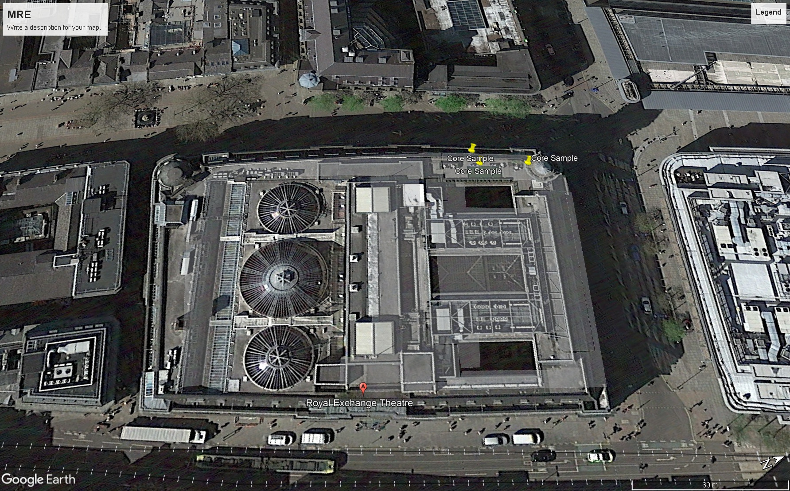

SPECIFICATION

Garland Dura-Coat Roof System

Dura-Coat is a liquid waterproofing system which provides a durable elastomeric waterproofing membrane with the option to select from a variety of coloured finishes.
Dura-Systems is a polyurethane modified, thixotropic methacrylate resin system that is suitable for creating a watertight membrane on a wide variety of substrates.

Important Notes

Prior to any works commencing on site, Garland UK will undertake adhesion tests on the roof deck. We request that sufficient time is allowed for this operation with the client providing safe access to all roof sections as required.
If access to the roof is not possible prior to the commencement of roofing works with Garland materials on site, we reserve the right to carry out these tests then with consequent/ additional time to complete roofing works pending test results.
During adhesion testing Garland UK will not be liable for costs associated with the delay of the project, including but not limited to scaffolding, contractor downtime or any other client/contractor costs. If these adhesion tests are not successful roofing works with Garland materials must not commence.
Garland reserve the right to withdraw this specification and any guarantee of Garland products if we deem the adhesion testing unsuccessful and no acceptable alternative fixing method is available.
Please contact your local Garland representative for additional information on the above item.
Note that this system build-up has no non-slip properties and should be not used on walkway areas that will be subject to rainfall or any other liquids that will make the surface slippery.

Environmental Conditions

- Do not apply roofing/waterproofing membrane during or with the threat of inclement weather.
- Application of cold fluid-applied reinforced methyl-methacrylate roofing and waterproofing membrane may proceed while air temperature is between 0°C and 35°C providing the substrate is a minimum of 5°C above the dew point.
- When ambient temperatures are at or expected to fall below 0°C or reach 30°C or higher, follow Garland recommendations for weather related application procedures.
- Ensure that substrate materials are dry and free of contaminants. Do not commence with the application unless substrate conditions are suitable. Contractor shall demonstrate that substrate conditions are suitable for the application of the materials.
- Where required by the building occupants, the contractor shall implement odour control and elimination measures prior to and during the application of the roofing/waterproofing materials.

MATERIAL/SYSTEM SCHEDULE

SUBSTRATE: Existing Asphalt

PRIMER: Dura-Systems Concrete Primer (10kg pail)

WATERPROOFING MEMBRANE: Dura-Systems Membrane (25kg pail)
Dura-Systems Membrane Thix (25kg pail)

REINFORCEMENT: Grip Polyester Soft Fabric (0.3x50m)
Grip Polyester Soft Fabric (1.0 x 50m)

TOP COAT: Dura-Systems Coloured Top Coat - Light Grey RAL 7001 (20kg pail)

CATALYST: Dura-Systems Catalyst (25kg)

CLEANER: Dura-Systems Cleaner (10kg pail)

INSTALLATION

System Build-up

Primer
Primer: | Dura-Systems Concrete Primer | ± 0.5kg/m²

Waterproof Coating (layer thickness ± 3mm)
Waterproofing membrane 1: | Dura-Systems Membrane | ± 1.2kg/m²
Reinforcement: | Grip Polyester Soft | -
Waterproofing membrane 2: | Dura-Systems Membrane | ± 1.6kg/m²

Waterproofing membrane detail: | Dura-Systems Membrane Detail | ± 2.8kg/m²

Topcoat
Coloured top coat: | Dura-Systems Coloured Top Coat | ± 0.5kg/m²

Note: The required amounts of resin are average values. The exact consumption depends on substrate conditions.

Preparation

Substrate Quality and Preparation: Prior to application of any Garland products or materials, the substrate shall be prepared as recommended by Garland and/or required for the intended application. All substrates must be clean, dry, and free of oil, grease, curing compounds, release agents, laitance, gross irregularities, loose, unsound or foreign material such as moss, algae growth, dirt, ice, snow, water or any other condition that would be detrimental to adhesion of the primer and/or resin to the substrate.

General Points Regarding Old Substrates:
- The substrates must be cleaned of any microorganisms using appropriate solutions and/or resources such as suitable fungicidal solutions.
- Existing coatings or paint must be eliminated by shot blasting or by grinding.
- Non-adherent or friable areas are to be removed.
- Substrates must not have a moisture content higher than 4%.

Initial Power Wash: All surfaces should initially be power washed in order to reveal a clean surface suitable for inspection and where necessary, repair. A minimum 2000 psi is recommended for preparation. There is no specific maximum as this may vary according to the equipment used and the surfaces being cleaned. At no time should the pressure jet be so high as to cause damage to the substrate being cleaned. Adjust pressure to clean away contamination and friable material from the surface. Note: Exercise suitable precautions when using high pressure equipment.

Surface Water & Contamination: Any surface lying water, mould growths, moss or other vegetation, loose debris, etc., should be removed from areas to be coated.

Fixed Items: Any fixed item which is not to be included in the waterproofing schedule, including wires, vents, cables, lightning conductors etc., must either be totally removed or in order to allow access, be suspended/temporarily loosened from the surfaces to be treated. Such items should not be removed without proper authority or deference to safety. The waterproofing should be allowed to sufficiently cure before replacement of these fixtures.
Vent & Plant Units: Contractors must temporarily remove or raise the plant in order to allow for the installation of the new roof system. Plant must be sat on suitable protection once the roofing works are complete in order to protect the roof system. Vents must be raised in order to allow for the installation of the new roof system and to ensure a minimum upstand height of 150mm above the finished roof level.

Conductors: Any lightning conductor cables present should not be overlaid. They must either be totally removed or in order to allow access, be suspended from the surfaces to be treated. The contractor should not remove such items without proper authority.
Drain Ware: Inspect all rainwater outlets and downpipes to ensure that they are free flowing. If any blockages or defects are discovered they should be brought to the client’s attention as soon as possible to allow remedial action to be agreed and action to be taken as soon as practical so that the application may proceed. Leave drain covers in place until preparation of the area is complete but remove prior to installation. New outlets must be installed.
Previous Repairs: Inspect any previous repair materials, patches, etc.; any that are loose or suspected to be loose should be removed. All repairs must be core tested, any repairs found with water trapped between the repair and the original waterproofing must be stripped.

Surface Repairs: The existing surfaces are to be inspected and made good prior to application of the coating system. Remove all blisters on the existing roof surface and make good ready to receive the coating system. Large cracks should be filled using TS-2136 or compatible material. If necessary, patch repairs should be carried out and allowed to cure prior to application.

Known Growth - General Surfaces: Once areas of moss, mould, algae and other fungal growths or vegetation have been removed and surfaces have also been thoroughly cleaned, apply a biocidal wash at a maximum spread rate of 10 square metres per litre (equivalent to a minimum quantity of 0.1 litres per square metre), to guard against subsequent infection. Allow to dry onto absorbent surfaces before continuing with the application. On non-absorbent surfaces, allow to react before thoroughly rinsing to remove all traces of the solution. Note: See Health & Safety data before use.

Final Cleaning: Remove all dust, debris and superfluous materials from the roof and leave in a dry and clean condition. All vegetation and associated debris is to be removed prior to application of the primer.

Roof Structure: All softwood timbers used in the roof structure should be treated and a minimum of class 2 durability.

Supporting Structure

The overall condition is to be checked and repairs carried out if needed to ensure a suitable substrate and structure throughout. Special care to be taken where the rafters have evident rot. Only once the sub-structure has been signed off by a structural engineer is the Garland system to be installed.

Deck

Inspect the deck for any damage repairing all items as deemed necessary, the deck must be checked to ensure its integrity and any damaged areas must be replaced.

Any peculiarities or details discovered, which might affect the performance of the Garland system, should be reported immediately to your Garland Regional Technical Manager in order that we may assist in overcoming the problem.

The roof deck MUST be inspected by your Garland Regional Technical Manager prior to any waterproofing application. Once the roof has been approved, the following waterproofing specification should be applied.

Primer

Deck Primer: Dura-Systems Concrete Primer (10kg)

Vacuum clean the surface to remove all dust and then apply onto the prepared surface with a roller at a consumption rate of 0.5kg/m².
Allow to cure. (approx. ± 30 minutes at 20°C).

Dura-Systems Catalyst must be added to the Dura-Systems Concrete Primer to initiate curing.

Mixing of Primer and Catalyst:
Mix Dura-Systems Concrete Primer with a spiral agitator for a minimum of 1 minute until the liquid has a uniform colour.

Add the correct amount (by weight) of Dura-Systems Catalyst depending on temperature to the resin and mix with the same agitator for 2 minutes or until the powder is completely mixed. The catalyst is completely dissolved when there are no white specs remaining.

Catalyst Values:
At 30°C add 2% by weight of catalyst
At 20°C add 3% by weight of catalyst
At 10°C add 5% by weight of catalyst
Temperatures relate to the temperature of the substrate.
Refer to the ‘Catalyst Dosages’ table within the appendices section of this Specification.

Coverage Rate: 0.5 kg/m²

Waterproofing Membrane

Waterproofing Membrane: Dura-Systems Membrane (25kg)

Apply onto the prepared surface with a roller at a rate of 1.2 kg/m². In the wet coating, bed in Grip Polyester Soft Reinforcement and apply a second layer of Dura-Systems Membrane wet on wet at a rate of 1.6 kg/m².
Grip Polyester Soft is to be laid to have 75mm side and head laps.
Allow to cure (approx. ± 40 minutes at 20°C).
Note. Wet-on-wet application is not necessary if impractical, allowing the material to cure between coats is acceptable on the basis no contamination or moisture is present when applying the second coat, a maximum of 24 hours between coats is recommended.

All upstands etc. should be detailed first and run onto the main surface by a minimum of 100mm. The system must be terminated into a chase prior to being sealed.

Dura-Systems Catalyst must be added to Dura-Systems Membrane to initiate curing.

Mixing of Waterproofing Membrane and Catalyst:
Mix Dura-Systems Membrane with a spiral agitator for a minimum of 1 minute until the liquid has a uniform colour.

Add the correct amount (by weight) of Dura-Systems Catalyst depending on temperature to the resin and mix with the same agitator for 2 minutes or until the powder is completely mixed. The catalyst is completely dissolved when there are no white specs remaining.

Catalyst Values:
At 30°C add 1% by weight of catalyst
At 25°C add 1.5% by weight of catalyst
At 20°C add 2% by weight of catalyst
At 15°C add 3% by weight of catalyst
At 10°C add 4% by weight of catalyst
At 5°C add 5% by weight of catalyst
Temperatures relate to the temperature of the substrate.
Refer to the ‘Catalyst Dosages’ table within the appendices section of this Specification.

Coverage Rate: 2.8 kg/m²

A combination of Dura-Systems Membrane and Dura-Systems Membrane Thix should be used on all vertical flashings and slopes to prevent slumping. This is usually mixed at a 30:70 ratio necessary to obtain a suitable viscosity. Other ratios are permitted depending upon the application requirements.

Coloured Topcoat

Topcoat: Dura-Systems Coloured Topcoat - Light Grey RAL 7001 (20kg)

Apply with a roller the Dura-Systems Topcoat onto the Membrane layer at a consumption rate of 0.5kg/m².
Allow to cure. (approx. ± 40 minutes at 20°C).

Dura-Systems Catalyst must be added to the Dura-Systems Topcoat to initiate curing.

Mixing of Coloured Topcoat and Catalyst:
Mix Dura-Systems Topcoat with a spiral agitator for a minimum of 1 minute until the liquid has a uniform

Add the correct amount (by weight) of Dura-Systems Catalyst depending on temperature to the resin and mix with the same agitator for 2 minutes or until the powder is completely mixed. The catalyst is completely dissolved when there are no white specs remaining.

Catalyst Values:
At 30°C add 1% by weight of catalyst
At 25°C add 1.5% by weight of catalyst
At 20°C add 2% by weight of catalyst
At 15°C add 3% by weight of catalyst
At 10°C add 4% by weight of catalyst
At 5°C add 5% by weight of catalyst
Temperatures relate to the temperature of the substrate.
Refer to the ‘Catalyst Dosages’ table within the appendices section of this Specification.

Coverage Rate: 0.5 kg/m²

Dura-Systems Topcoat must be applied within 24 hours of the Dura-Systems Membrane to achieve maximum bond strength. If contamination or moisture becomes present within this time, it should be removed using Dura-Systems Cleaner.
When coating over asphalt Dura-Systems Coloured Topcoat in Light Grey RAL 7001 must be used.

Consumption

Consumption rates of all products stated will increase if the substrate is uneven or has a rough surface finish.
Use volume to area calculations and/or wet film thickness readings where appropriate to ensure correct material coverage.

Depending on the slope of the substrate, halving of the material coverage and doubling the number of coats may be necessary to prevent material slumping especially of vertical faces.
Dura-Systems Thix should be used on all vertical flashings and steep slopes to prevent slumping. This can be mixed with the regular resin if necessary to obtain a suitable viscosity.

Inspection During Application

Conditions for application
The humidity and ambient temperature must be checked using appropriate equipment before each application (thermometer, moisture metre, contact thermometer, dew point meter or similar).
The dew point must be determined and the temperature of the substrate checked. The surface humidity of substrates must be verified using a TRAMEX CME4 type spot moisture meter.

Ambient and weather conditions must be continually monitored and checked. If conditions fall outside of recommended tolerances application must be stopped.

Examination of the substrate
The substrate finish need to be continually checked for smoothness and condition prior to coating works. Any irregularities must be corrected.
Substrates must not have a moisture content higher than 4%.

Detailing

Treatment of details should be completed first with an overlap of at least 100mm on to the main floor area.

Upstand details:

All upstand kerb details should be raised to provide a minimum 150mm upstand height from the finished roof level where possible, if this cannot be achieved and might affect the performance of the Garland waterproofing system, it should be reported immediately to your Garland Regional Technical Manager in order that we may assist in overcoming the problem. Garland cannot take responsibility for water ingress over waterproofing details insufficiently high.

Attention should be paid in particular to all details such as roof light & vent kerbs, door and window sill’s and flashing details. These may need to be raised to comply with the minimum 150mm upstand regulation.
Where level thresholds are required, a minimum 75mm upstand height is permitted when conforming to BS6229:2018. Waterproofing should be dressed under the door sill, with the sill projecting a minimum of 45mm from the upstand.

Drainage connections (grids, drains, gullies, downpipes):

The perimeter of drainage connections or penetrations is to be filled with Quick-Prep resin mortar. Once cured Quick-Prep can be waterproofed by directly receiving the Dura-Coat system.

Flashings:

Any existing flashings are to be replaced in accordance with good roofing practice.
Inspect the existing chases and ensure that they are a minimum of 25mm deep. Cut to this depth if required, install Leadax flashings, secured with fixing clips and then point using Garland TS-2136 Urethane Mastic.

Any new flashings require a chase to be cut 25mm deep that should provide a minimum 150mm upstand above the finished level of the waterproofing. Install Leadax flashings, secured with fixing clips and then point using Garland TS-2136 Urethane Mastic.

Bridging Cracks:

Cracks must be identified by the installing operatives and treated as per the below.

Cracks of 0.3mm or less
Will be bridged by the waterproofing system without additional treatment.

Cracks between 0.3mm and 0.8mm
These should be treated by cutting a V with a pneumatic drill. After the crack has been suitably chased, fill with Dura-Systems Membrane or Membrane Thix.

Cracks between 0.8mm and 2mm
These should be considered active and should be bridged using a suitable cut piece of Grip Polyester Soft reinforcement embedded between two layers of Dura-Systems Membrane or Membrane Thix.
This type of detail treatment may remain visible in the finished system.

Perimeter edges:

Where applicable raise water checks to maintain 50mm upstand from the finished roof level. Dress the specified waterproofing to the water check detail and finish with Viking Products Group LTD GRP L-Profile Edge Trim.
At flat perimeter edges to guttering, dress the specified waterproofing over a Viking Products Group LTD GRP L-Profile Edge Trim.

Pipes, tubes & vents:

Install the Viking Products Group LTD Cowled Telescopic Vent where a pipe penetrates the waterproofing system. Place the upstand pipe over the soil vent pipe centrally. Ensure the High-Performance membrane flange on the upstand pipe is fully supported and bonded by hot-air welding.

The telescopic double pipe is then positioned to fit into the soil vent pipe and simultaneously over the upstand pipe. The height of the telescopic double pipe can be altered as required and then fixed with the self-tapping screw included. Compliance for the minimum height must be in accordance with the current Building Regulations. The Cowled Telescopic Vent can be extended 700mm from flange to cowl with a 35mm lap between the telescopic double pipe and the upstand pipe. Fixing the vented cowl finishes the Cowled Telescopic Vent. The vented cowl fits over the telescopic double pipe and is fixed with the self-tapping screw included.

Where Viking Products Group LTD telescopic vent are not usable, lead sleeves must be used, if necessary these must be made up for the individual vent or pipe.

Where vent pipes and tubes can be removed or redirected so that no penetration through the waterproofing is required, this should be done so at all times.

Rainwater outlets:

Roof Outlets:

Where possible new internal outlets are to be sumped in order to aid water egression.

All existing rainwater outlets should be checked to ensure they are not blocked or leaking.

Install Viking Products Group LTD Roof Outlets in accordance with the current instructions. The roof outlet has a rubber ‘O’ ring fitted to its spigot. This ‘O’ ring provides a seal to the internal diameter of the down pipe. The outlet has a high-performance membrane flange that should be fully supported and bonded by hot-air welding. The flange should be incorporated within the existing perimeter gutter the number of outlets and their positions can be located on the attached plan.

After the waterproofing is complete install the stainless-steel outlet grate. The grate is fastened with an expanding clamp, which grips the outlet spigot internally.

The specified Dura-Coat waterproofing system is to be installed to the outlet area as per instructions in the detail specification. This to ensure the area is fully secure.

On completion, all rain water outlets should be checked to ensure that they are free flowing.

Parapet Outlets:

Existing parapet outlets should be maintained to allow water to discharge into the existing hoppers. Where possible, the outlets are to be sumped in order to aid the flow of surface water. If required, new lead chutes to be affixed – these are to be made to fit the existing outlet.

The specified Dura-Coat waterproofing system is to be installed to the outlet area as per instructions in the detail specification. This to ensure the area is fully secure.

Roof penetrations:

All roof penetrations must be waterproofed with either a Viking Products Group LTD Cable Duct or for multiple cables a Viking Products Group LTD Roof Pro PP3 Unit.

Plant, air conditioning units, etc:

Where plant, air conditioning units or ventilation systems require positioning on top of the finished roof surface a loose laid section of Viking Rubber Matting should be positioned for the system to rest on.
This will require the approval of your Garland Regional Technical Manager.

Asbestos:

It is the roofing contractor’s responsibility to check the relevant buildings asbestos register.

If there is any risk of Asbestos which could affect the installation of the new waterproofing system this must be brought to the attention of the contract administrator on tendering for the project.

ITEMS TO CONSIDER

Storage & Handling

All materials, except bulk deliveries, shall be delivered in the manufacturer's original containers. The containers shall be sealed and display the manufacturer's original label(s).

All liquid materials shall be stored in a cool, dry, shaded area during hot weather or in a dry, heated area during cold weather. Roll goods and granules shall be stored in a clean, temperature-controlled area. Any materials exposed to the elements shall be elevated above the ground and covered by a tarpaulin. Materials must not be exposed to excessive heat or direct flame.

Materials shall be handled so as to minimise damage or contamination with moisture or foreign matter. Solvent based materials are combustible. Keep containers closed when the materials are not in use.

Safety

Refer to all applicable data including, but not limited to, Material Safety Data Sheets, Technical Data Sheets, Product Labels and specific instructions for personal protection requirements.

Refer to the Hazard Elimination and Reduction Assessment for particular hazards associated with this design.

Job Conditions

Roofing materials shall not be applied during inclement weather and the installation shall not proceed in the event that precipitation is probable during application.

Notes

The contractor is to ensure water tightness of the roof at all times.
Workmanship that is incorrect and does not meet Codes of Practice will not be permitted, even if the system is watertight. The client will be told that all such faults must be remedied, before the Guarantee is issued.

Any building work which is the responsibility of the roofing contractor and has a bearing on the life of the Garland Waterproofing System must be carried out by properly trained tradesmen.

All reasonable undertakings and inclusions required to complete the works must be allowed for within the Tender price, whether or not specifically identified within the Tender Documentation or Specification. All work to conform to good practice and current British Standards and Regulations.

All the above work will be regularly monitored by your Garland Regional Technical Manager, with all progress reports to be emailed to the supervising officer the following day of the site visit.

For any further information regarding this specification please contact your Garland Regional Technical Manager.

Core samples are indicative of the roof construction only at the area where the sample was taken. The Roofing Contractor must satisfy themselves as to the existing roof construction of all roof areas prior to forwarding their Tender documentation.

If any discrepancies regarding the core samples are noted by the Roofing Contractor, they should be brought to the attention of your Garland Regional Technical Manager prior to forwarding the Tender Documentation. This will allow time for any changes in the specification to be adjusted if required.

The Garland Company (UK) Ltd does not, either itself or through its representatives, provides architectural or engineering advice or designs save in relation to its products. Garland (UK) Ltd offers no opinion on and expressly disclaims any responsibility for the integrity or structural soundness of any roof deck or structure on which its products may be applied. The Owner is advised to seek independent advice from a structural engineer as to the structural soundness and integrity of the roof deck, and its ability to properly support the contemplated roof installation. Garland accepts no responsibility or liability in relation to such matters and no Garland representative is authorised to vary this disclaimer.

Detail Drawings and Calculations

Please see the attached detail drawings relevant for the proposed specification

Garland UK Guarantee

A 20 Year Independent Single Point Garland (UK) Guarantee is available for the roof section for both material performance and labour on this contract subject to this specification being followed and applied by a Garland (UK) approved contractor.

It is a mandatory requirement that all related materials specified in this document are solely purchased through The Garland Company UK LTD and The Viking Products Group LTD. No substitutions are allowed. Failure to comply will void the Garland guarantee and a non-conformity report issued. Garland Regional Technical Managers will check conformity as part of our quality assurance process.

Guarantee Issue Procedure

On completion of the works, the Garland (UK) Ltd Regional Technical Manager will carry out a final inspection and agree any necessary remedial works prior to signing off the roofing works to ensure that the work has been completed in accordance with the specification.

It is advised this meeting should be attended by a representative of Garland (UK) Ltd, the approved contractor’s site manager and a representative for the client. Within due course of this meeting, subject to all parties being satisfied with the work, a guarantee will be issued to the client.
The guarantee will be issued to the client in hard copy and a digital copy will be attached electronically to the client’s database.

Access & Maintenance

As well as Approved Document Part K requiring edge protection to roofs with access of a minimum of once a month, Working at Height Regulations 2005 places responsibility on duty holders (employer and/or building owners) to do everything in their power to prevent a fall from occurring. This correlates with Section 4 of the Health and Safety at Work Act 1974, with emphasis on owners of a non-domestic premise having a duty towards all persons even if not a direct employee to have safe systems in place.

Depending on the required maintenance plan Viking Product Group can advise on what safety system is required.

Where there is no internal access to the roof space, a Vertical Access CAT Ladder Kit or Ladder Fixing Point must be installed in a suitable location agreed with the end client, ideally away from any public accessed space. This must be fully incorporated within the Viking Safety Maintenance system.

On the roof, any changes in the roof height above should have either a Step Kit or a Vertical Access Ladder installed to allow for safe thoroughfare onto the relevant higher/lower areas of the roof space.

Twice a year during your annual inspections, the following of our maintenance and housekeeping activities should be performed but not limited to:

- Remove unnecessary debris (leaves, branches, paper, etc.) from roof surface, drains and gutters
- Trim any branches or trees that hang over the building and that can clog drains
- Reseal all areas surrounding venting, plumbing or roof top equipment
- Make all necessary repairs to roof membrane and flashings
Please note that if this roof is fragile, it is not to be walked upon without correct and safe access equipment.

Cleaning & Maintenance

Cleaning products containing alcohol and solvent can discolour and damage MMA/PUMA systems so must not be used. Products containing ammonia and ammonium chloride must also not be used.
Therefore, for the cleaning of Dura-Coat system we would recommend CHEMSPEC DFC Heavy Duty Cleaner Degreaser.
Cleaning using CHEMSPEC DFC can be carried out using a Mop and Bucket, Auto Scrubber Dryer or Pressure Washer depending on the size of application and machine practicality.
Pressure should not exceed 725psi or a water temperature of >50ºC should not be used. To prevent surface etching occurring, high pressure spraying equipment should remain a minimum of 6 to 10 inches from the surface.

Daily cleaning: 25ml per 4 litres of water
Weekly cleaning: 50ml per 4 litres of water
Monthly cleaning: 100ml per 4litres of water

APPENDICIES

Catalyst Dosages

Dura-Systems Concrete Primer
Substrate Temperature (°C) | Catalyst Required (%) | Catalyst Required  per 10kg pail (g) | Catalyst Required  per 1kg (g)
30 | 2 | 200 | 20
20 | 3 | 300 | 30
15 | 4 | 400 | 40
10 | 5 | 500 | 50
5 | 6 | 600 | 60

Dura-Systems Membrane / Thix / Detail

Substrate Temperature (°C) | Catalyst Required (%) | Catalyst Required  per 25kg pail (g) | Catalyst Required  per 1kg (g)
30 | 1 | 250 | 10
20 | 2 | 500 | 20
15 | 3 | 750 | 30
10 | 4 | 1000 | 40
5 | 5 | 1250 | 50

Dura-Systems Topcoat
Substrate Temperature (°C) | Catalyst Required (%) | Catalyst Required  per 20kg pail (g) | Catalyst Required  per 1kg (g)
30 | 1 | 200 | 10
20 | 1.5 | 300 | 15
10 | 2 | 400 | 20
5 | 3 | 600 | 30

Order List

Code | Name | Description | Dimensions
DS-050 | Dura-Systems Concrete Primer | Primer for porous substrates | 10kg
DS-200 | Dura-Systems Membrane | Waterproofing resin | 25kg
DS-250 | Dura-Systems Membrane Thix | Thixotropic waterproofing membrane | 25kg
DS-270 | Dura-Systems Membrane Detail | Reinforced waterproofing membrane | 10kg
4877 | Grip Polyester Soft 50m | Polyester reinforcement for coatings | 1x50m
4877-300 | Grip Polyester Soft 300mm | Polyester reinforcement for coatings | 0.3x50m
DS-410 | Dura-Systems Topcoat – Light Grey | UV resistant top coat RAL 7001 | 20kg
CR-C-25 | Dura-Systems Catalyst | Catalyst to initiate curing | 25kg
CR-C-1 | Dura-Systems Catalyst | Catalyst to initiate curing | 1kg
DS-900 | Dura-Systems Cleaner | Cleaning solution for tools | 10kg

