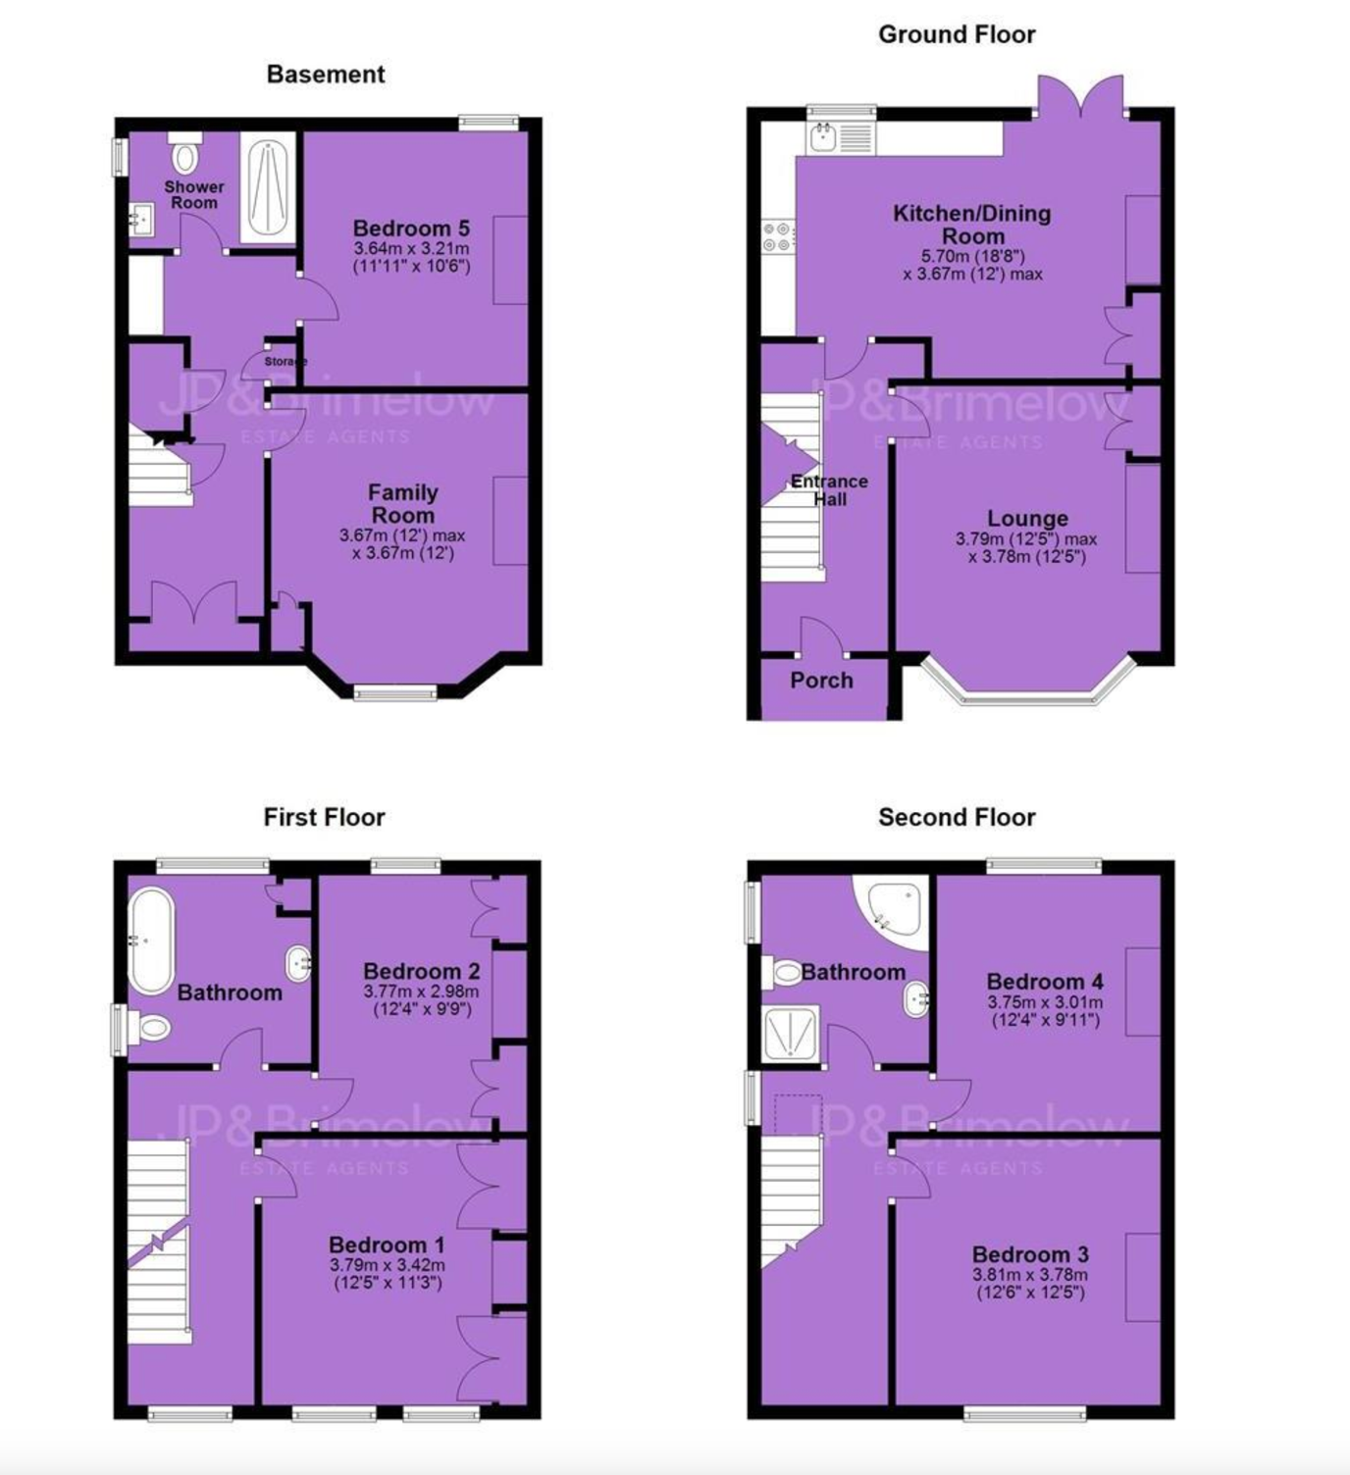
Office
3.64m x 3.21m
(11’11”x10’6”)

