

Planning

Delegated Officer Report

Summary of application details
Application reference: | PLA-2026-000890
Application type: | Removal/variation of conditions
Proposal: | Variation of Condition 2 attached to planning permission 145273/FH/2026 to allow for external rear steps to be changed to a terrace patio
Site address: | 2 Burlington Road Manchester M20 4PY
Ward(s): | Withington
Date application valid: | 02 July 2026
Applicant name: | James Kerr
Agent (if any): | Mr Chris Rodgers
Case officer: | Holly Wright
Recommendation: | Approve
Date of recommendation: | 20 August 2026

Description of site, building and/or area
The application relates to a two-storey detached dwellinghouse of redbrick with a grey slate
hipped roof. The property features timber-framed windows, including two ground-floor bays to
the front, a front garden bordered by a mid-level brick wall with a piers and mature hedging, a
gravel driveway to the side, a single storey attached garage to the side, a two-storey rear
outrigger, and a spacious rear garden.

Burlington Road is a residential street situated within the Withington ward of Manchester, close
to Wilmslow Road, Ladybarn Park, and Old Moat Park. The area is predominantly residential in
terms of its character, consisting of detached and semi-detached dwellinghouses, and benefits
from its proximity to public outdoor amenity and green spaces.

The property is not listed, nor is it sited within a Conservation Area.
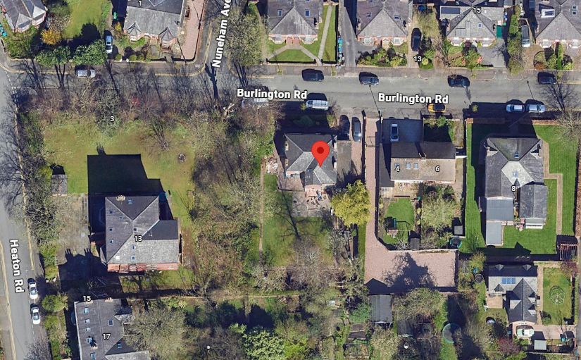
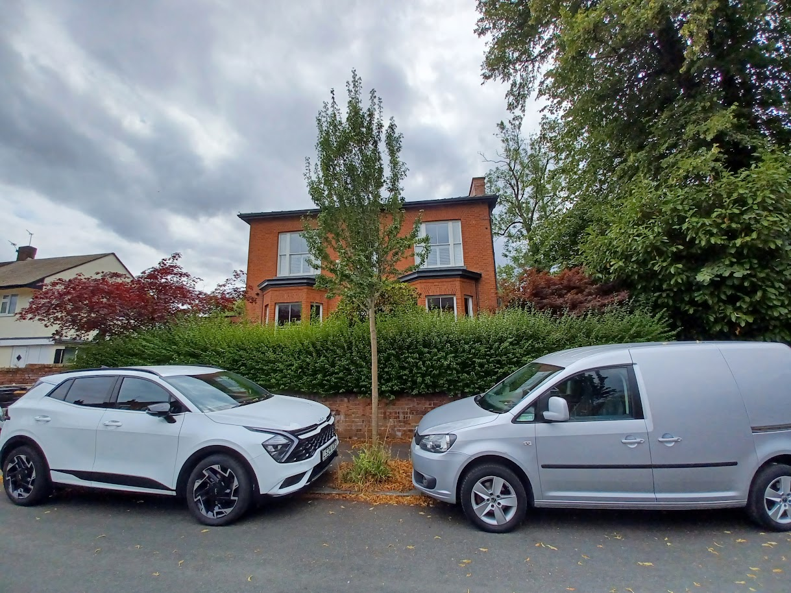
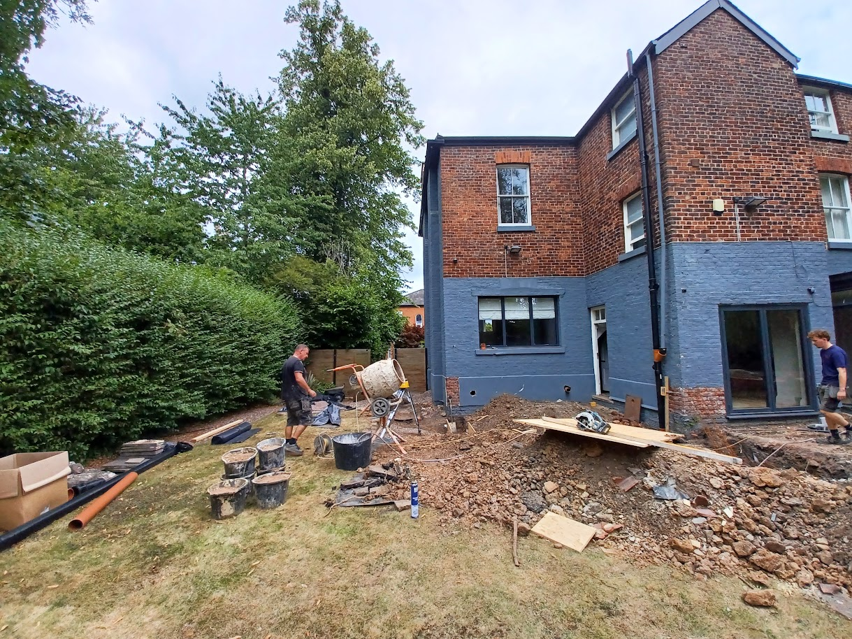

Description of development
Under planning application 145273/FH/2026, planning permission was granted for the “Erection of single-storey rear extension, new windows and doors to the rear, alterations to existing garage including new roof, parapet and windows, new lightwells formed on the front bays with railings and new basement windows” in 2026.

The applicant is now seeking to vary conditions 2 (specified plans) attached to planning permission 145273/FH/2026 to allow for external rear steps to be changed to a terrace patio.

Relevant planning history
Planning Application - 145273/FH/2026 - Erection of single- storey rear extension, new windows and doors to the rear, alterations to existing garage including new roof, parapet and windows, new lightwells formed on the front bays with railings and new basement windows – Approved (2026).

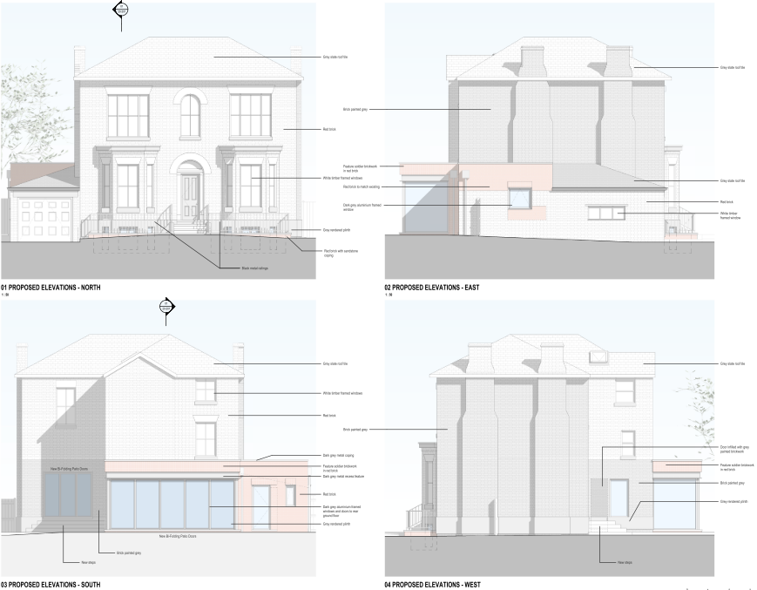
Approved elevations of 145273/FH/2026

Consultation, notification and publicity responses

Consultations

Flood Risk Management raised no objection to the proposal, however recommended that informative notes be attached to any approval relating to property flood resilience measures and providing advice regarding the presence of a culvert within the vicinity of the site.

Withington Civic Society – no response received.

Withington Village Regeneration Partnership – no response received.

Notifications and publicity

No responses received.

Relevant policies
Unitary Development Plan (UDP) – The UDP has been superseded by the Core Strategy Development Plan, but certain policies are still considered of relevance:
- Policy DC1 – Residential Extensions

The Manchester Core Strategy – Development Plan Document 2012-2027 (“the Core Strategy”) was adopted by the City Council on the 11th of July 2012:
- Policy DM1 – Development Management
- Policy SP1 – Spatial Principles

Places for Everyone - is a long-term plan of nine Greater Manchester districts for jobs, new homes, and sustainable growth. It has been published by the GMCA on behalf of the nine districts and took effect and became part of the statutory development plan on March 21, 2024.
- Policy JP-P1 – Sustainable Places

National Planning Policy Framework (NPPF, August 2026)
- Chapter 14 – Achieving Well-Designed Places
- Policy DP3: Key principles for well-designed places

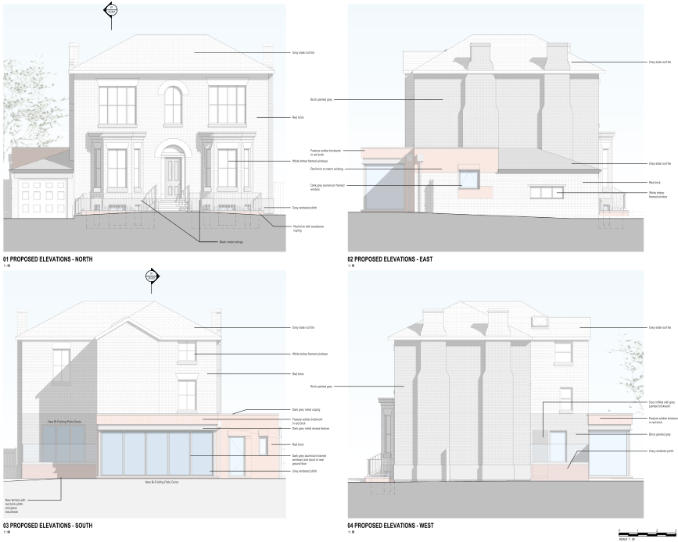
Submitted proposed elevations

Assessment
Principle – the principle of the proposal, to vary the specified plans of a previous
planning permission in order to allow for external rear steps to be changed to a terrace patio, is acceptable. Notwithstanding this, further consideration must be given to how the proposal affects the siting, scale, and massing of the property, its appearance, and impact upon visual and residential amenity, waste storage and parking, amongst other matters.

Description of proposed alterations to 145273/FH/2026 - the proposal includes the following alterations to the previous planning permission:

Replacement of the previously approved external steps to the rear of the dwellinghouse with a raised terrace patio (constructed of red brick), measuring to approximately 3m in length, 3.9m in width, and 0.8m in height, bordered by a 1m-high glass balustrade. A gap of approximately 7m would be maintained to the boundary shared with No.13 Heaton Road and a gap of approximately 20m would be maintained to the plot’s rear boundary.

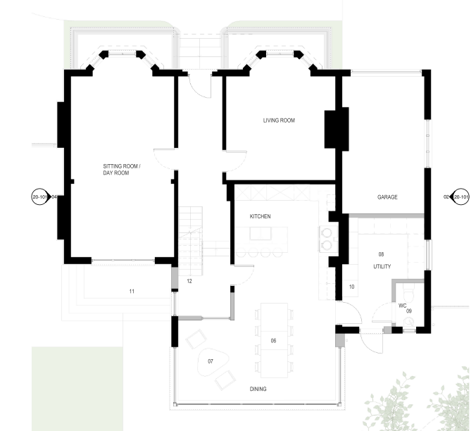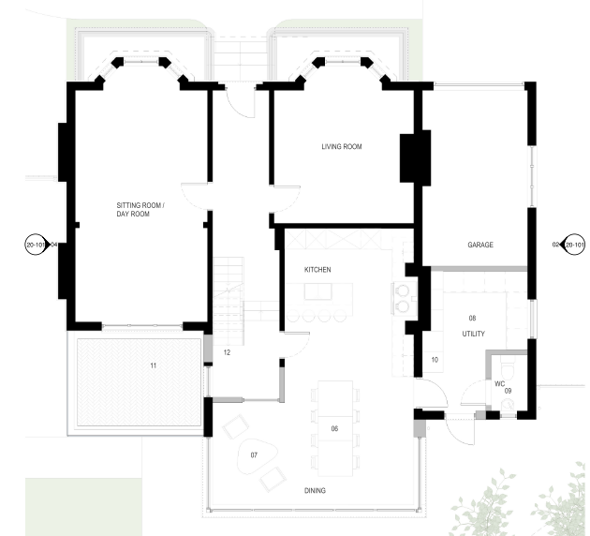
Previously approved ground-floor plan (left) and proposed ground-floor plan (right)

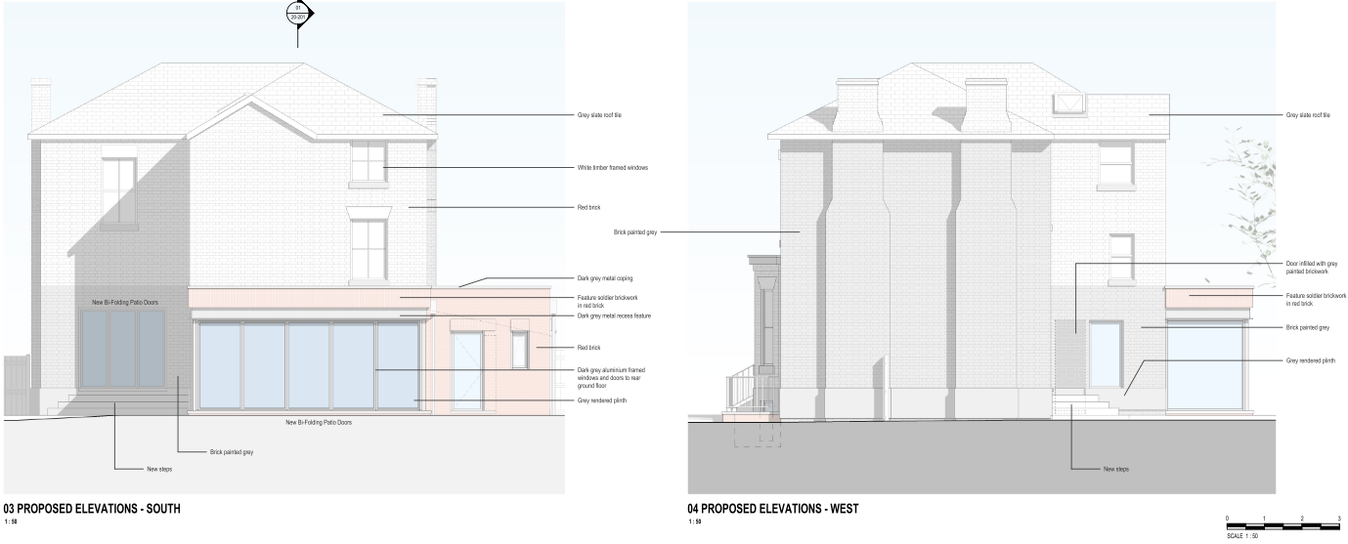
Previously approved elevations

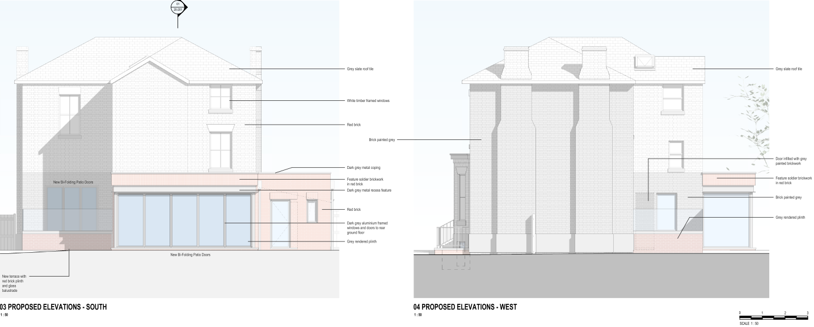
Proposed elevations

Siting, scale, and massing – the proposed amendments to the previously approved scheme are considered acceptable in terms of their siting, scale and massing. The changes would not alter the footprint, scale or overall massing of the approved rear extension, garage alterations or front lightwells. Furthermore, the proposed raised terrace patio would be modest in scale, projecting no further than the existing two-storey rear outrigger, whilst maintaining substantial gaps to the plot’s shared boundaries. The proposal is therefore not considered to cause undue harm to the visual or residential amenity of the area as it would remain visually subservient to the existing dwellinghouse and would be sited away from neighbouring residential properties.

Appearance and visual amenity – the proposed amendments to the previously approved scheme are considered acceptable in terms of their impact upon the appearance of the host dwellinghouse and the visual amenity of the surrounding area. The proposed raised terrace patio would be located to the rear of the dwellinghouse and, as such, would not be readily visible from the public realm or within the street scene. Further to this, its use of sympathetic materials, including brickwork and a glazed balustrade, would ensure that the proposal integrates appropriately with the existing property and does not appear as an unduly prominent or incongruous feature. Accordingly, the proposal is not considered to result in significant harm to the character and appearance of the application property or the visual amenity of the wider area.

Residential amenity – the proposed amendments to the previously approved scheme are considered acceptable in terms of their impact upon residential amenity. The proposed raised terrace patio would be positioned a sufficient distance from neighbouring properties, with an approximate gap of 7m from the boundary shared with No.13 Heaton Road and approximately 20m from properties to the rear. Given these distances, together with the limited scale of the proposal, it is not considered that the raised platform would give rise to unduly harmful impacts in terms of overlooking, loss of privacy, overbearing effects, or disturbance to neighbouring occupiers.

Notwithstanding the absence of any proposed privacy screening, such measures are not considered necessary in this instance. The raised terrace would maintain substantial gaps from neighbouring boundaries and dwellinghouses and there is existing mature hedging/landscaping along the western shared boundary, thereby limiting opportunities for direct overlooking and ensuring that neighbouring residents' privacy is adequately protected.

Accordingly, the proposed amendments are not considered to result in unacceptable harm to the residential amenity of surrounding properties.

Waste – the proposal would not alter the waste storage and management arrangements of
145273/FH/2026.

Parking – the proposal would not alter the parking arrangements of 145273/FH/2026.

Conclusion – given the above issues, it is considered that the proposal is acceptable in terms
of its principle, siting, scale and massing, appearance, impact upon visual and residential
amenity, waste storage and parking as it broadly complies with saved policy DC1 of the Unitary
Development Plan for the City of Manchester, policies DM1 and SP1 of the Manchester Core
Strategy and chapter 14 of the National Planning Policy Framework (2026).

Other Legislative Requirements

Equality Act 2010
Section 149 (Public Sector Equality Duty) of the Equality Act 2010 requires due regard to the need to: Eliminate unlawful discrimination, harassment and victimisation and other conduct prohibited by the Act and; Advance equality of opportunity between persons who share a protected characteristic and persons who do not share it. The Equality Duty does not impose a legal requirement to conduct an Equality Impact Assessment. Compliance with the Equality Duty involves consciously thinking about the aims of the Equality Duty as part of the process of decision-making.

Human Rights Act 1998 considerations
This application needs to be considered against the provisions of the Human Rights Act 1998. Under Article 6, the applicants (and those third parties, including local residents, who have made representations) have a right to a fair hearing and to this end the local planning authority must give full consideration to their comments.

Protocol 1 Article 1, and Article 8 where appropriate, confer(s) a right of respect for a person’s home, other land and business assets. In taking account of all material considerations, including Council policy as set out in the Core Strategy and saved polices of the Unitary Development Plan, the Director of Planning, Building Control & Licensing has concluded that some rights conferred by these articles on the applicant(s)/objector(s)/resident(s) and other occupiers and owners of nearby land that might be affected may be interfered with but that that interference is in accordance with the law and justified by being in the public interest and on the basis of the planning merits of the development proposal. She believes that any restriction on these rights posed by the recommendation given is proportionate to the wider benefits of and that such a decision falls within the margin of discretion afforded to the Council under the Town and Country Planning Acts.

Recommendation: Approve

Article 35 Declaration

Officers have worked with the applicant in a positive and proactive manner based on seeking
solutions to problems arising in relation to dealing with the planning application. No significant
problems have arisen during the consideration of this application, and the application has been
determined in a timely manner, in accordance with the policies with the Development Plan.

Condition(s) to be attached to decision for approval OR Reasons for recommendation to
refuse

1) Time limit:

The development must be begun not later than the expiration of three years beginning with the
date of planning permission 145273/FH/2026 that date being the 27 April 2026.

Reason - Required to be imposed pursuant to Section 91 of the Town and Country Planning Act
1990.

2) Specified plans:

The development hereby approved shall be carried out in accordance with the following
documents and drawings:

‘PROPOSED SITE PLAN’, numbered ’26-0003-20-001 PL02’, received by the City Council as
Local Planning Authority on the 7 August 2026.
‘PROPOSED FLOOR PLANS 1 OF 2’, numbered ’26-0003-20-002 PL03’, received by the City Council as Local Planning Authority on 2 July 2026.
‘PROPOSED FLOOR PLANS 2 OF 2’, numbered ’26-0003-20-003 PL03’, received by the City
Council as Local Planning Authority on 2 July 2026.
‘PROPOSED ELEVATIONS SHEET 01’, numbered ’26-0003-20-101 PL03’, received by the
City Council as Local Planning Authority on the 2 July 2026.
‘PROPOSED SECTION AND ELEVATION SHEET 02’, numbered ’26-0003-20-201 PL02’,
received by the City Council as Local Planning Authority on the 5 March 2026.

Reason - To ensure that the development is carried out in accordance with the approved plans,
pursuant to saved policy DC1 of the Unitary Development Plan for the City of Manchester and
policies SP1 and DM1 of the Manchester Core Strategy.

3) Materials:

The materials used in the external surfaces of the development hereby approved shall be as
follows:

Rear extension:
Walls: Feature soldier brickwork similar in appearance to the existing building in terms of type,
size, colour and texture.
Roof: Dark-grey flat roof membrane with dark-grey metal coping.
Windows/doors: Dark-grey aluminium-framed.
Features: Dark-grey metal recess feature.

Lightwells:
Borders: Red brick with sandstone coping and black metal railings.
Windows/doors: Grey-painted frames.
Features: Grey rendered plinth similar in appearance to the existing building in terms of type,
size, colour and texture.

Garage alterations:
Parapet wall: Brickwork similar in appearance to the existing building in terms of type, size,
colour and texture.
Roof: Grey slate roof tiles to hipped roof form to front, dark-grey flat roof membrane with dark-
grey metal coping to rear.
Windows/doors: Dark-grey aluminium-framed.

Elevational alterations:
Infilled openings: Brickwork similar in appearance to the existing building in terms of type, size,
colour and texture.
Windows/doors: Dark-grey aluminium-framed.

Raised patio terrace:
Brickwork similar in appearance to the existing building in terms of type, size,
colour and texture.
Glass balustrade.

Reason - In order to ensure a satisfactory appearance in the interests of visual amenity in
accordance with policies SP1 and DM1 of the Manchester Core Strategy and the requirements
of the National Planning Policy Framework.

Informatives:

1) The applicant is advised to incorporate Property Flood Resilience (PFR) measures to a minimum of 150mm above the surface water flood level or a minimum of 600mm above the fluvial flood level.

2) MCC records highlight that the underground Ley Brook is located within close proximity to the site (approximately 82 m to the northeast of the site), while our records are frequently updated to ensure the highest level of accuracy, the records cannot guarantee 100% accuracy for all culverted assets. Therefore, we would request that the applicant informs the onsite contractor to remain observant and to take the appropriate safety precautions during excavation works. If any major unknown drainage assets are found beneath the site, then further investigation works should take place to identify the asset and MCC Lead Local Flood Authority (LLFA) should be contacted immediately. Any alterations to an ordinary watercourse will require consent from MCC LLFA under Land Drainage Act 1991. The developer can apply for land drainage consent (if required) via the following link: https://manchester.portal.uk.empro.verintcloudservices.com/site/myaccount/request/pr_watercourse_land.

