

Planning

Delegated Officer Report

Summary of application details
Application reference: | PLA-2026-000593
Application type: | Consent to display an advertisement
Proposal: | Installation of 1no. illuminated individual letter signage and 2no. plaque signs.
Site address: | 1-3 York Street Manchester M2 2AW
Ward(s): | Deansgate
Date application valid: | 01 July 2026
Applicant name: | Mitchells & Butlers Retail Ltd
Agent (if any): | Miss Alicia Lai
Case officer: | Ciara Gettinby
Recommendation: | Approve
Date of recommendation: | 17 August 2026

Description of site, building and/or area
The application relates to 1-3 York Street which currently operates on the ground floor as a restaurant. The proposed signage relates to the new hotel use operating on the above floors. The building itself is a grade II* listed building and located in the City of Manchester (Upper King Street) Conservation Area 1985. Historically, the building operated as a National Westminster Bank and features red sandstone on grey granite plinth with a slate roof. Opposite the site is 41 Spring Gardens (Grade II Listed) and Fromer Reform Club, 81 King Street (Grade II*).

The surrounding area is commercial in nature with this area of the City, known for the retention of historical buildings and its setting. The site is located west of St Peter’s Square and the surrounding shops benefits from its sustainable transport links that attracts footfall.

Description of development
Advertisement consent is sought for the installation of 1no. illuminated individual letter signage and 2no, plaque signs.

Consultation, notification and publicity responses

Consultations

MCC Highway Services- no objections.

Environmental Health- no objections but have recommended a condition to be attached to this report and decision notice.

Notifications and publicity
Notification letters were issued to surrounding properties, no comments or objections were received.

Site Photos:

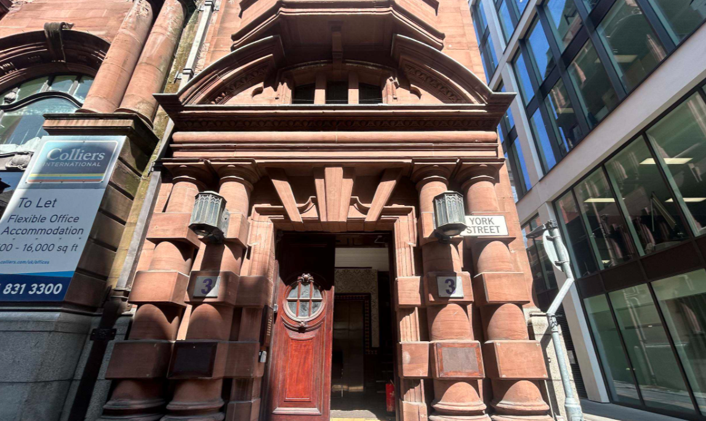

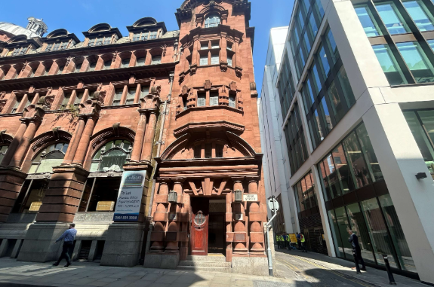

Proposed Plans:
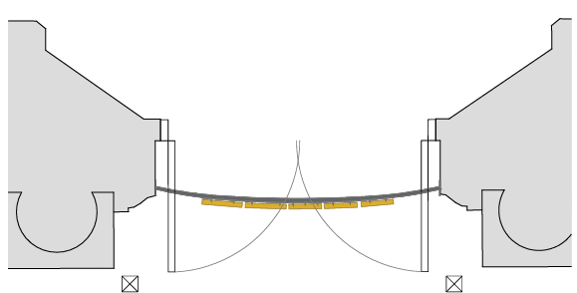

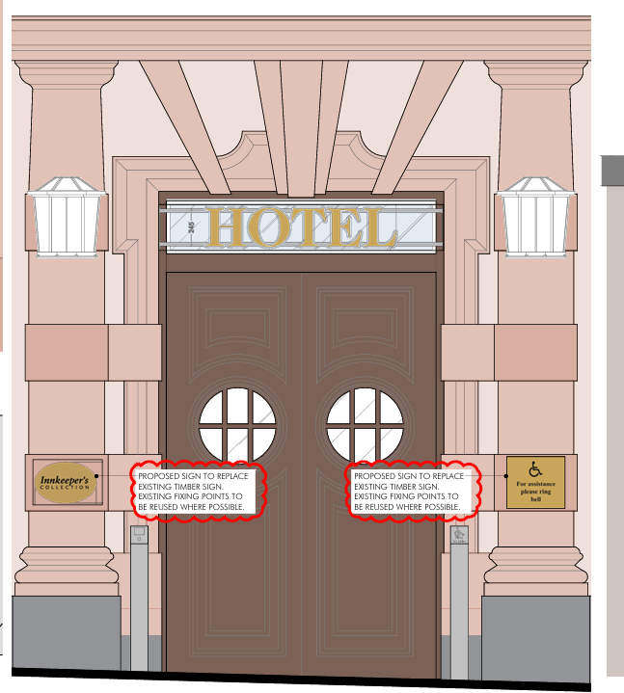

Relevant policies
The Town and County Planning (Control of Advertisements) Regulations 2007
The Local Planning Authority shall exercise its powers under these Regulations in the interests of amenity and public safety, taking into account-

- The provisions of the development plan, so far they are material; and
- Any other relevant factors

2.

- Factors relevant to amenity include the general characteristics of the locality, including the presence of any feature of historic, architectural, cultural or similar interest;
- Factors relevant to the public safety include-

- The safety of persons using any highway, railway, waterway, etc..
- Whether the display of an advertisement in question is likely to obscure or hinder the ready interpretation of, any traffic sign, railway signal or aid
- Whether the display of an advertisement in question is likely to hinder the operation of any device used for the purpose of security or surveillance or for measuring the speed of any vehicle

3. In taking account of factors relevant to amenity, the local planning authority may, if it thinks fit, disregard any advertisement that is being displayed.

4. Unless it appears to the Local Planning Authority to be required in the interests of amenity or public safety, an express consent for the display of advertisements shall not contain any limitation or restriction relating to the subject matter, content or design of what is to be displayed.

The following policies are considered relevant in the consideration of this application:

Places for Everyone- A long term plan of nine Greater Manchester districts for jobs, new homes and sustainable growth, it has been published by the GMCA on behalf of the nine districts (Bolton, Bury, Rochdale, Oldham, Tameside, Stockport, Manchester, Trafford, Salford, Wigan) and took into effect and become part of the statutory development plan on March 21, 2024.

The Manchester Core Strategy- Development Plan Document 2012- 2027 (The Core Strategy) was adopted by the City Council on the 11th of July 2012, it is a key document for the local plan which provides a framework that planning applications are assessed against.

Policy DM1- Development Management
Policy SP1- Spatial Principles

Unitary Development Plan (UDP)- The UDP has been superseded by the Core Strategy Development Plan, but certain policies are still considered relevance:

-Policy 14 – Shopfronts and related signs

The National Planning Policy Framework (August 2026)- The Government’s new national planning policies and how they are to be implemented through local authorities.

Policy DP3- Key principles for well-designed places
Policy S3: Presumption in favour of sustainable development

Other Material Considerations:

The Shopfront and Design Guide (Adopted 2024)

Assessment
The advertisement regulations require that applications for shop signs be considered only in the interests of amenity and public safety. An assessment of the proposals under these criteria is outlined below.

Background
Full planning permission has been approved for a change of use of mezzanine first, second and third floors from offices to hotel (Class C1) with associated internal alterations to front entrance and new lift shaft to rear (134736/FO/2022). This advertisement consent application is based on these alterations to the front entrance.

Visual Amenity
Chapter 12 of the National Planning Policy Framework requires that when assessing design quality Local Planning Authorities will consider what ‘will function well and add to overall quality of the area… are visually attractive’ and ‘are sympathetic to local character and history. Including the surrounding built environment and landscape setting.’

The proposed fascia sign would be composed of individual letters affixed to curved rails that will be placed across the previously approved top light above the original doors. Behind the fascia sign would be an aluminium LED light deflector panel coated white. The letters would be polished brass with opal acrylic letter backs. The runner bars would be finished to the match the substrate. The use of individual letters is acceptable under the requirements of the Shopfront and Design Guide, and the overall scheme is considered to reflect the existing ‘Browns’ signage and therefore would be in character with the surrounding advertisement environment. Through matching the existing signage at Browns, this creates consistent and congruous signage across the building.

The plaque signs would be located either side of the entrance doors on the columns. The plaques would be fixed to an existing timber board and would be brass in colour to match the proposed ‘HOTEL’ sign. The matching materials and placement would ensure that the plaques are consistent in appearance and provide a uniformed appearance to the entrance door.

The materials to be used are considered to be acceptable given that the fascia sign would be made from aluminium runner bars and brass letter faces and the plaque signs would be brass with infilled logo and letters. Policy DM1 and the Shopfront and Design Guide require that proposed advertisements are commensurate in scale to their proposed locations in which the proposed is considered to be.

Public Safety
Signage would be installed so not to exceed illuminance level of 300cd/m2. As part of the assessment of this application, Environmental Health and MCC Highway Services were consulted and no objections received. As such, there are no public safety concerns associated with this proposal, pursuant to Policy DC14 and DM1.

Other Legislative Requirements

Equality Act 2010
Section 149 (Public Sector Equality Duty) of the Equality Act 2010 requires due regard to the need to: Eliminate unlawful discrimination, harassment and victimisation and other conduct prohibited by the Act and; Advance equality of opportunity between persons who share a protected characteristic and persons who do not share it. The Equality Duty does not impose a legal requirement to conduct an Equality Impact Assessment. Compliance with the Equality Duty involves consciously thinking about the aims of the Equality Duty as part of the process of decision-making.

Human Rights Act 1998 considerations
This application needs to be considered against the provisions of the Human Rights Act 1998. Under Article 6, the applicants (and those third parties, including local residents, who have made representations) have a right to a fair hearing and to this end the local planning authority must give full consideration to their comments.

Protocol 1 Article 1, and Article 8 where appropriate, confer(s) a right of respect for a person’s home, other land and business assets. In taking account of all material considerations, including Council policy as set out in the Core Strategy and saved polices of the Unitary Development Plan, the Director of Planning, Building Control & Licensing has concluded that some rights conferred by these articles on the applicant(s)/objector(s)/resident(s) and other occupiers and owners of nearby land that might be affected may be interfered with but that that interference is in accordance with the law and justified by being in the public interest and on the basis of the planning merits of the development proposal. She believes that any restriction on these rights posed by the recommendation given is proportionate to the wider benefits of and that such a decision falls within the margin of discretion afforded to the Council under the Town and Country Planning Acts.

Conclusion
Given the above issues, it is considered that the advertisements are acceptable in terms of its impact upon visual amenity and public safety in accordance with Policies SP1, DM1 of the Core Strategy, Policy DC15 of the UDP, Chapter 12 of the NPPF.

Recommendation: Approve

Conditions attached to this decision
- No advertisement is to be displayed without the permission of the owner of the site or any other person with an interest in the site entitled to grant permission.

No advertisement shall be sited or displayed so as to:
(a) endanger persons using any highway, railway, waterway, dock, harbour or aerodrome (civil or military);
(b) obscure, or hinder the ready interpretation of, any traffic sign, railway signal or aid to navigation by water or air; or
(c) hinder the operation of any device used for the purpose of security or surveillance or for measuring the speed of any vehicle.

Any advertisement displayed, and any site used for the display of advertisements, shall be maintained in a condition that does not impair the visual amenity of the site. Any structure or hoarding erected or used principally for the purpose of displaying advertisements shall be maintained in a condition that does not endanger the public. Where an advertisement is required under these Regulations to be removed, the site shall be left in a condition that does not endanger the public or impair visual amenity.

- The development hereby approved shall be carried out in accordance with the following documents:

Proposed door section, ref- AP104 B
Proposed signage

Received 17 August 2026

Location plan, ref- AP100
Application form

Received 4 June 2026

Reason- to ensure that the development is carried out in accordance with the approved plans, pursuant to saved policy DC1 of the Unitary Development Plan for the City of Manchester and policies SP1 and DM1 of the Manchester Core Strategy.

- Illuminated signage

Lighting from illuminated signage shall selected and installed so to not exceed 300cd/m2 to control glare and overspill onto nearby properties.

Reason - To safeguard the amenities of the occupiers of nearby properties.

