

Planning

Delegated Officer Report

Summary of application details
Application reference: | PLA-2026-000594
Application type: | Listed building consent (Alt/Ext)
Proposal: | Listed Building Consent for the installation of 1no. illuminated individual letter sign and 2no. plaque signs.
Site address: | 1-3, York Street Manchester M2 2AW
Ward(s): | Deansgate
Date application valid: | 01 July 2026
Applicant name: | Mitchells & Butlers Retail Ltd
Agent (if any): | Miss Alicia Lai
Case officer: | Ciara Gettinby
Recommendation: | Approve
Date of recommendation: | 19 August 2026

Description of site, building and/or area
The application relates to 1-3 York Street which currently operates on the ground floor as a restaurant. The proposed signage relates to the new hotel use operating on the above floors. The building itself is a grade II* listed building and located in the City of Manchester (Upper King Street) Conservation Area 1985. Historically, the building operated as a National Westminster Bank and features red sandstone on grey granite plinth with a slate roof. Opposite the site is 41 Spring Gardens (Grade II Listed) and Fromer Reform Club, 81 King Street (Grade II*).

The surrounding area is commercial in nature with this area of the City, known for the retention of historical buildings and its setting. The site is located west of St Peter’s Square and the surrounding shops benefits from its sustainable transport links that attracts footfall.

Description of development
Listed building consent is sought for the installation of 1no. illuminated individual letter sign and 2no plaque signs. A previous planning permission has been approved for a change of use mezzanine first, second and third floors from offices to hotel (Class C1) with associated internal alterations to front entrance and new lift shaft to rear (134736/FO/2022). This Listed Building Consent is based on these alterations to the front entrance.

Consultation, notification and publicity responses

Consultations
Historic England- no comments or objections.

Notifications and publicity
Occupiers of neighbouring buildings were notified of the proposal via the notification letters. No representations have been received.

The application was advertised in the local press as listed building consent and a site notice was displayed adjacent to the site. No representations have been received.

Site Photos:

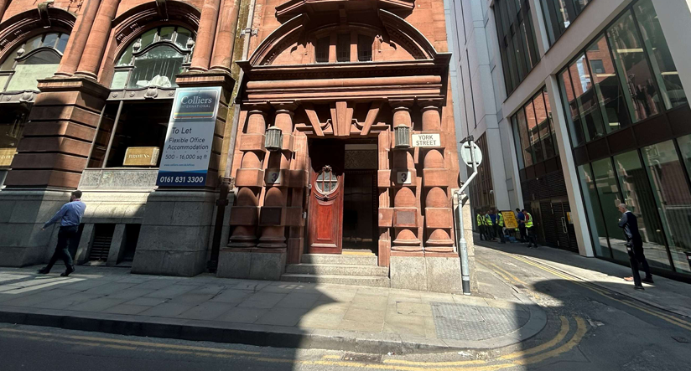

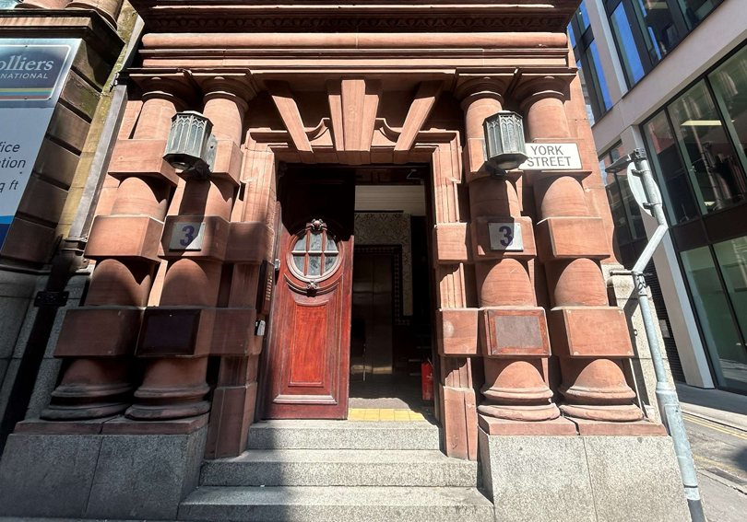

Proposed Plans:
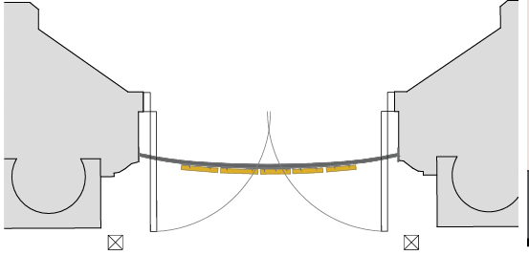

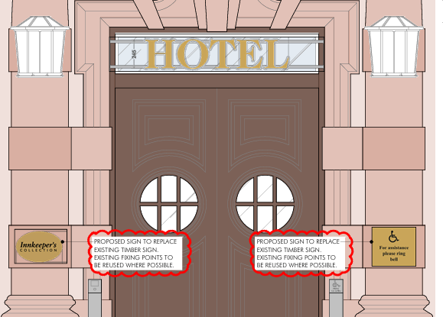

Relevant policies
The following policies are considered relevant in the consideration of this application:

Places for Everyone- A long term plan of nine Greater Manchester districts for jobs, new homes and sustainable growth, it has been published by the GMCA on behalf of the nine districts (Bolton, Bury, Rochdale, Oldham, Tameside, Stockport, Manchester, Trafford, Salford, Wigan) and took into effect and become part of the statutory development plan on March 21, 2024.

-Policy JP-P1: Sustainable Places
-Policy JP-P2: Heritage
-Policy JP-Strat2: City Centre

Unitary Development Plan (UDP)- The UDP has been superseded by the Core Strategy Development Plan, but certain policies are still considered of relevance:

-Policy DC19- Listed Buildings
-Policy DC18- Conservation Areas

The Manchester Core Strategy- Development Plan Document 2012- 2027 (The Core Strategy) was adopted by the City Council on the 11th of July 2012, it is a key document for the local plan which provides a framework that planning applications are assessed against.

Policy DM1- Development Management
Policy SP1- Spatial Principles
Policy EN1- Design Principles and Strategic Character Areas
Policy EN3- Heritage
Policy CC9: Design and Heritage

The National Planning Policy Framework (August 2026)- The Government’s new national planning policies and how they are to be implemented through local authorities.

Policy DP3- Key principles for well-designed places
Policy HE5: Assessing effects on heritage assets
Policy HE6- Proposals affecting designated heritage assets
Policy HE9: Conservation Areas

Other Legislative Requirements Planning (Listed Buildings and Conservation Areas) Act 1990

Section 66 – For development which affects a listed building or its setting, the local planning authority shall have special regard to the desirability of preserving the building or its setting.

Section 72- Special attention shall be paid to the desirability of preserving or enhancing the character of appearance of that area.

Assessment
In determining whether the proposed works are acceptable, the main issue to consider is the impact these proposed works will have on the historic character and fabric of the listed building itself and to establish whether the public benefits, including heritage benefits of the proposal will outweigh any harm to the significance of the heritage asset.

Principle
The application would advertise the service and provide wayfinding to visitors and staff and therefore the location of the signs by the main entrance is considered acceptable. It is not expected that the proposed development would create an unacceptable impact on the visual amenity of the Grade II* Listed Building or nearby heritage assets, these matters are set out below.

Impact on The Listed Building and Public Benefits
As set out in Policy HE5 of the NPPF (August 2026) development proposals affecting heritage assets should be accompanied by their assessment of the significance of assets affected. The level of detail should be proportionate to the asset’s importance. As this application affects a Grade II* Listed Building, great weight is given to the impact of the proposal.

The ‘HOTEL’ fascia sign would utilise matching materials of brass to match the already existing signage to the entrance of ‘Browns’ restaurant (see picture below). The fascia sign would be individually lettered and affixed to a railing in order to provide a congruous appearance to the existing signage of the building and would be located over a newly inserted top light (approved in planning application 1347/FO/2022.) The sign would be fixed using M10 Rawl bolts which would be inserted into the modern addition of the top light and surrounding material.

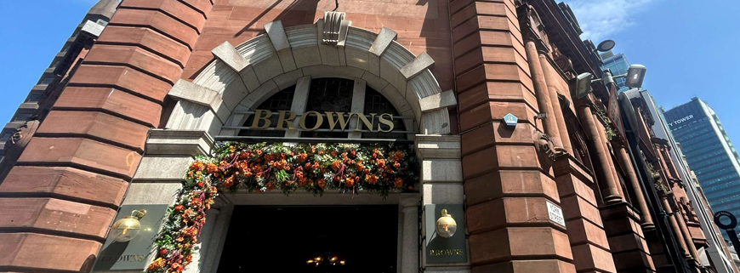

The plaque signs located on either column would be affixed to a timber plate in order to minimise any damage to the Listed Building from the fixings. The screws to be used would be colour-matching gold screws and the plaques would also be matching in height, positioning and colour. The brass of the plaque’s would match that of the fascia sign and would be in-keeping with the standard advertisement design for this listed building.

The proposed signage is considered to be consistent with existing signage and is not considered to harm the Listed Building or its setting. The proposed advertisements are also considered to serve public benefits through enabling the re-use of a vacant or underused listed building, as set out in paragraph 4 of Policy HE6 of the NPPF (2026). Whilst it is necessary to have special regard to the desirability of preserving the building and the setting of any affected Heritage Assets it is considered that the proposal would have no effect on the significance of the heritage asset and would result in important public benefits through securing the long-term reuse of a vacant listed building.

Other Legislative Requirements

Equality Act 2010
Section 149 (Public Sector Equality Duty) of the Equality Act 2010 requires due regard to the need to: Eliminate unlawful discrimination, harassment and victimisation and other conduct prohibited by the Act and; Advance equality of opportunity between persons who share a protected characteristic and persons who do not share it. The Equality Duty does not impose a legal requirement to conduct an Equality Impact Assessment. Compliance with the Equality Duty involves consciously thinking about the aims of the Equality Duty as part of the process of decision-making.

Human Rights Act 1998 considerations
This application needs to be considered against the provisions of the Human Rights Act 1998. Under Article 6, the applicants (and those third parties, including local residents, who have made representations) have a right to a fair hearing and to this end the local planning authority must give full consideration to their comments.

Protocol 1 Article 1, and Article 8 where appropriate, confer(s) a right of respect for a person’s home, other land and business assets. In taking account of all material considerations, including Council policy as set out in the Core Strategy and saved polices of the Unitary Development Plan, the Director of Planning, Building Control & Licensing has concluded that some rights conferred by these articles on the applicant(s)/objector(s)/resident(s) and other occupiers and owners of nearby land that might be affected may be interfered with but that that interference is in accordance with the law and justified by being in the public interest and on the basis of the planning merits of the development proposal. She believes that any restriction on these rights posed by the recommendation given is proportionate to the wider benefits of and that such a decision falls within the margin of discretion afforded to the Council under the Town and Country Planning Acts.

Conclusion
Given the above issues, it is considered that the proposal is acceptable in terms of its principle, visual amenity, impact on the conservation area and on the setting of listed buildings as it broadly complies with the saved Policy DC19 and DC18 of the Unitary Development Plan for the City of Manchester, Policies DM1, SP1, EN1, EN3, CC9 and EC3 of the Manchester Core Strategy and Policy DP3, HE5, HE6 and HE9 of the National Planning Policy Framework and Policies JP-P1, JP-P2 and JP-Strat2 of the Places for Everyone Joint Development plan document.

Article 35 Declaration
Officers have worked with the applicant in a positive and proactive manner based on seeking solutions to problems arising in relation to dealing with the planning application. No significant problems have arisen during the consideration of this application, and the application has been determined in a timely manner, in accordance with the policies with the development plan.

Recommendation: Approve

Conditions attached to this decision

The development must have begun no later than the expiration of three years beginning with the date of permission. Required to be imposed pursuant to Section 91 of the Town and Country Planning Act of 1990.

Reason - Required to be imposed pursuant to Section 91 of the Town and Country Planning Act of 1990.

- The development hereby approved shall be carried out in accordance with the following documents:

Proposed door section, ref- AP104 B
Proposed signage

Received 10 August 2026

Location plan, ref- AP100
Application form

Received 4 June 2026

Reason- to ensure that the development is carried out in accordance with the approved plans, pursuant to saved policy DC1 of the Unitary Development Plan for the City of Manchester and policies SP1 and DM1 of the Manchester Core Strategy.

- No above ground construction works shall take place until details/samples of the materials to be used in the construction of the external surfaces of the development hereby approved have been submitted to and approved in writing by the Local Planning Authority. The development shall then be carried out in accordance with the approved details/samples.

Reason - In order to ensure a satisfactory appearance in the interests of visual amenity in accordance with policies SP1 and DM1 of the Core Strategy and the requirements of the National Planning Policy Framework.

