

Planning

Delegated Officer Report

Summary of application details
Application reference: | PLA-2026-000846
Application type: | Full planning permission
Proposal: | City Council Development: Erection of 2m high fencing and access gates.
Site address: | Land at Ashkirk Street Car Park Manchester M18 8LS
Ward(s): | Gorton & Abbey Hey
Date application valid: | 27 July 2026
Applicant name: | Mr Peter Wood

Agent (if any):
Case officer: | Steven Mccoombe
Recommendation: | Approve
Date of recommendation: | 19 August 2026

Description of site, building and/or area
The application side relates to an area of hardstanding informally used for car parking on land bounded by Ashkirk Street to the north, Cross Lane to the south, the rear of commercial premises to the east and west along Carfax Street and Wellington Street. Vehicular access can be gained from Ashkirk Street.

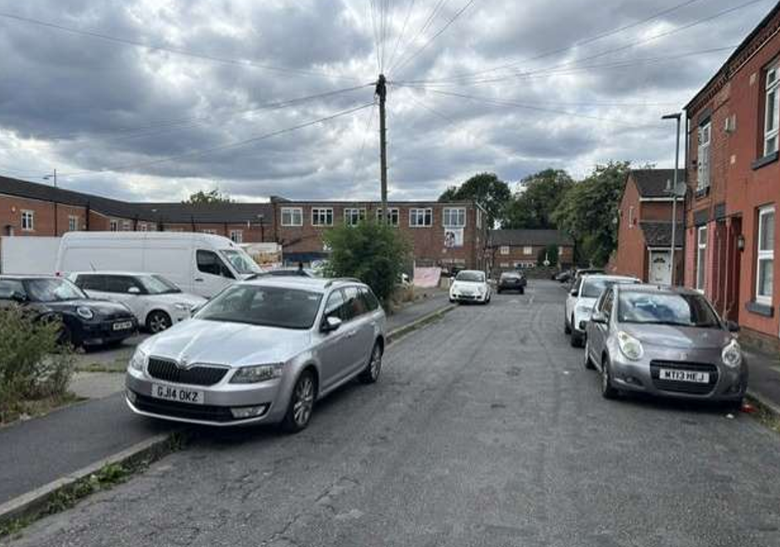
View of Ashkirk Street frontage (left)
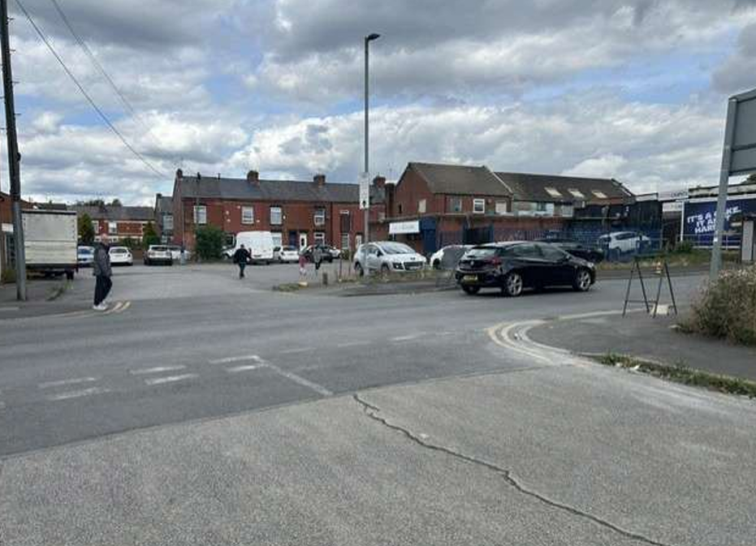
View of application site from the opposite side of Cross Lane

The site is situated within a mixed-use area characterised by a concentration of commercial premises around the junction of Wellington Street and Cross Lane. Ashkirk Street and the surrounding area are predominantly residential in nature, comprising mainly two-storey terraced houses.

Description of development
Planning permission is sought for the erection of a 2-metre-high weld mesh fence around part of the car park incorporating an access gate. The fence is to be powder coated green (RAL 6005).

Ashkirk Street car park, is owned by the Council but is not managed as a car park. Parking use has been established informally over the years.

The proposed fencing has been designed to maintain access to the yard serving an adjoining business, reflecting established access rights and existing patterns of use.

The Council considers it necessary to secure and better manage the site in response to ongoing issues of antisocial behaviour, misuse of the land and persistent fly tipping. There are also public safety concerns following the emergence of a sinkhole in July, which has highlighted potential ground stability risks pending the completion of further surveys and investigations. Securing the site will assist in mitigating these issues whilst enabling the Council to exercise greater control over its use.

The proposal also supports the Council's wider strategic objectives, including its commitment to improving environmental quality, promoting a ‘Green and Clean’ agenda, and investing in the regeneration of District Centres.

Relevant planning history
None

Consultation, notification and publicity responses
Local Residents/Occupiers – No representations received.

Highway Services - No objections regarding the proposed erection of 2m high fencing and access gates. It is understood that the proposals would not have an impact on the approved pedestrian/vehicular access, parking, circulation or the external highway network.

Detail should be sought from the applicant in relation to any proposed construction or fit-out arrangements, where there is an impact on the highway.

Relevant policies
-Policies DM1 and SP1 of the Manchester Core Strategy.
-National Planning Policy Framework (NPPF).

Assessment
Principle

The principle of enclosing the site is considered acceptable in this case as it would assist in limiting anti-social behaviour, fly tipping whilst being of benefit to public safety. Access for the adjoining carpet business would be maintained. On this basis, the proposed development is considered acceptable.

Crime and Security

The proposed fencing would provide enhanced security to the site by creating a durable and difficult to climb perimeter barrier, helping to deter vandalism and unauthorised access. Its open mesh design maintains visibility through the fence, allowing natural surveillance whilst avoiding the creation of an overly dominant or visually intrusive boundary treatment.

Residential and Visual Amenity

The proposed Paladin fencing would provide a robust and secure boundary treatment, enhance site security and deter unauthorised access. Given its design, scale and location and the context of the site within the immediate commercial back drop, the fencing would not result in any material harm to the visual amenity and would have no significant ,adverse impact on the residential amenity of neighbouring occupiers. Any visual impact is considered to be outweighed by the benefits to site security.

Other Legislative Requirements

Equality Act 2010
Section 149 (Public Sector Equality Duty) of the Equality Act 2010 requires due regard to the need to: Eliminate unlawful discrimination, harassment and victimisation and other conduct prohibited by the Act and; Advance equality of opportunity between persons who share a protected characteristic and persons who do not share it. The Equality Duty does not impose a legal requirement to conduct an Equality Impact Assessment. Compliance with the Equality Duty involves consciously thinking about the aims of the Equality Duty as part of the process of decision-making.

Human Rights Act 1998 considerations
This application needs to be considered against the provisions of the Human Rights Act 1998. Under Article 6, the applicants (and those third parties, including local residents, who have made representations) have a right to a fair hearing and to this end the local planning authority must give full consideration to their comments.

Protocol 1 Article 1, and Article 8 where appropriate, confer(s) a right of respect for a person’s home, other land and business assets. In taking account of all material considerations, including Council policy as set out in the Core Strategy and saved polices of the Unitary Development Plan, the Director of Planning, Building Control & Licensing has concluded that some rights conferred by these articles on the applicant(s)/objector(s)/resident(s) and other occupiers and owners of nearby land that might be affected may be interfered with but that that interference is in accordance with the law and justified by being in the public interest and on the basis of the planning merits of the development proposal. She believes that any restriction on these rights posed by the recommendation given is proportionate to the wider benefits of and that such a decision falls within the margin of discretion afforded to the Council under the Town and Country Planning Acts.

Article 35 Declaration
Officers have worked with the applicant / agent in a positive and proactive manner to guide the application through all stages of the planning process and resolve any issues that arose in dealing with the planning application

Recommendation: Approve

Conditions attached to this decision
1) | The development must be begun not later than the expiration of three years beginning with the date of this permission.  Reason - Required to be imposed pursuant to Section 91 of the Town and Country Planning Act 1990
2) | 1) The development hereby approved shall be carried out in accordance with the following drawings and documents:  Site plan and fencing specification details received on 13 and 17 July 2026 respectively.  Reason - To ensure that the development is carried out in accordance with the approved plans, pursuant to policies SP1 and DM1 of the Manchester Core Strategy.
3) | Notwithstanding the submitted details, the boundary treatment hereby approved shall be finished in Moss Green (RAL 6005) and shall be retained as such thereafter.  Reason - in the interests of visual amenity, pursuant to policies DM1 and SP1 of the Manchester Core Strategy.

