

Planning

Delegated Officer Report

Summary of application details
Application reference: | PLA-2026-000786
Application type: | Householder planning permission
Proposal: | Erection of single-storey rear extension with associated external alterations to form additional living accommodation.
Site address: | 11 Whitehaven Gardens Manchester M20 2SY
Ward(s): | Didsbury West
Date application valid: | 01 July 2026
Applicant name: | Mr Vincent Keasberry & Mrs Janice Hoon Keasberry
Agent (if any): | Mr W Lau
Case officer: | Holly Wright
Recommendation: | Approve
Date of recommendation: | 19 August 2026

Description of site, building and/or area
The application relates to a two-storey semi-detached dwellinghouse of redbrick and white render with a red tiled hipped roof. The property features white uPVC framed windows, including a two-storey bay to the front, a front porch extension, a cobble driveway with no front boundary treatment, a two-storey side and rear extension, and a detached outbuilding situated within the rear garden space.

Whitehaven Gardens is a residential cul-de-sac situated within the Didsbury West ward of Manchester, close to the River Mersey, Fletcher Moss Botanical Gardens, and Marie Louise Gardens. The surrounding area is predominantly residential in terms of its character, consisting of terraced and semi-detached dwellinghouses, and benefits from its proximity to public outdoor amenity and green spaces.

The property is not listed, nor is it sited within a conservation area.

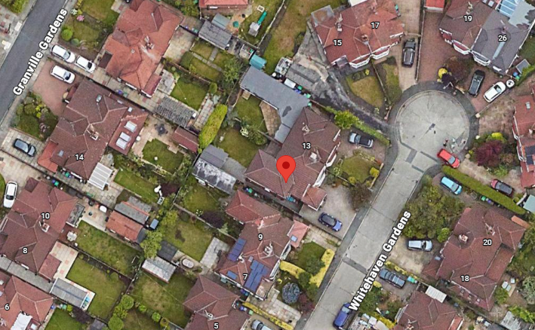

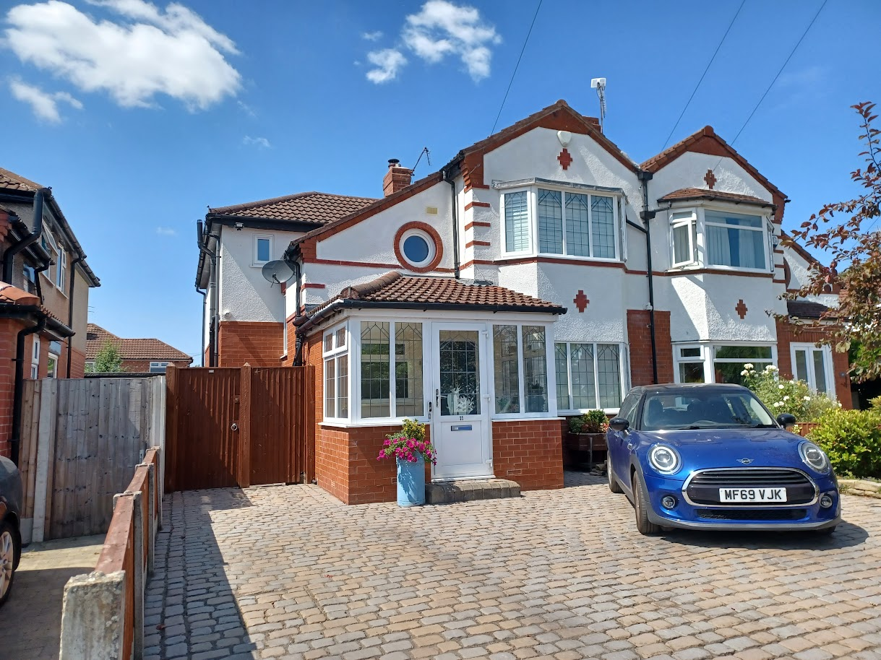

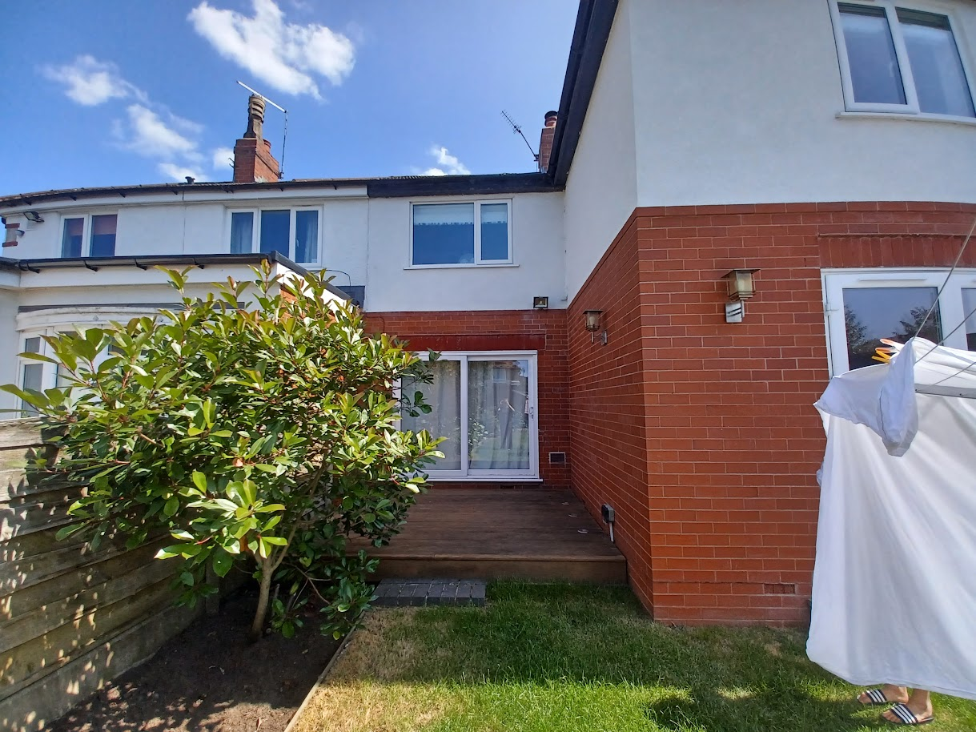

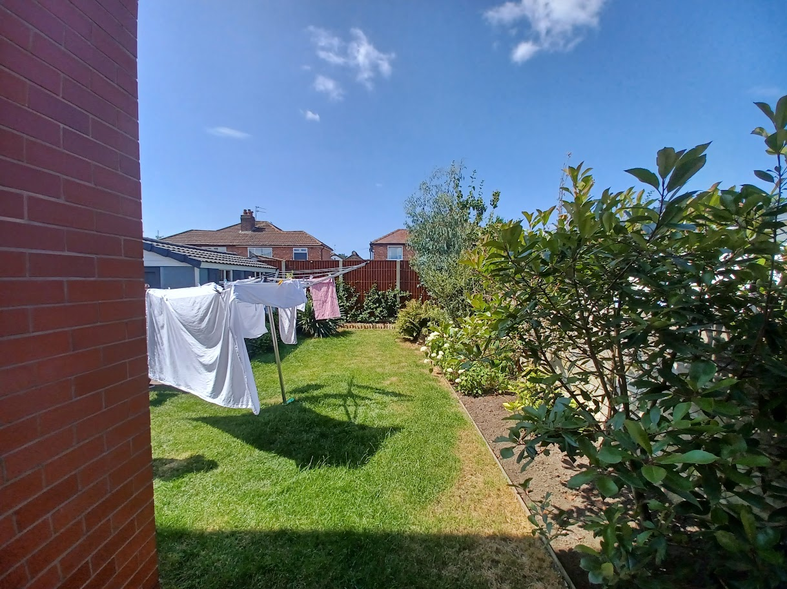

Description of development
The applicant is seeking planning permission for the erection of a single storey rear extension with associated external alterations to form additional living accommodation.

Relevant planning history
Planning Application – 023921 - Construction of a new front porch with w.c. – Approved (1985).

Planning Application - 077823/FH/2005/S2 - Erection of 2 storey side and rear extension to form additional living accommodation – Approved (2006).

Planning Application - 099465/FH/2012/S2 - Erection of single storey front extension to form new porch – Approved (2012).

Planning Application - NOT-2026-000122 - Prior notification of proposed larger home extension projecting 3.3m to the rear with a maximum height of 3.95m and a height at eaves of 3m – Turned Away (2026).

Consultation, notification and publicity responses

Consultations

West Didsbury Residents’ Association – no response received.

Notifications and publicity

No responses received.

Relevant policies
Unitary Development Plan (UDP) – The UDP has been superseded by the Core Strategy Development Plan, but certain policies are still considered of relevance:
- Policy DC1 – Residential Extensions

The Manchester Core Strategy – Development Plan Document 2012-2027 (“the Core Strategy”) was adopted by the City Council on the 11th of July 2012:
- Policy DM1 – Development Management
- Policy SP1 – Spatial Principles

Places for Everyone - is a long-term plan of nine Greater Manchester districts for jobs, new homes, and sustainable growth. It has been published by the GMCA on behalf of the nine districts and took effect and became part of the statutory development plan on March 21, 2024.
- Policy JP-P1 – Sustainable Places

National Planning Policy Framework (NPPF, August 2026)
- Chapter 14 – Achieving Well-Designed Places
- Policy DP3: Key principles for well-designed places

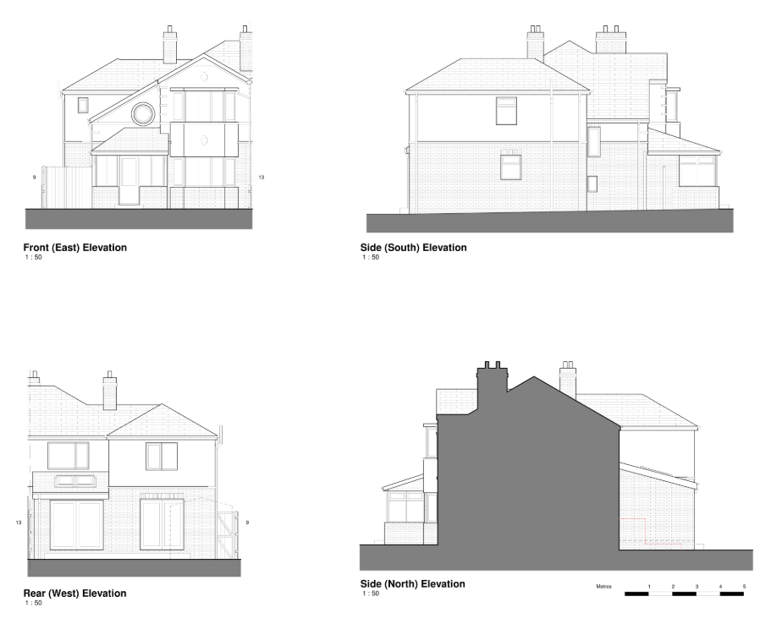
Submitted proposed elevations

Assessment
Principle – the principle of the proposal, to erect a single storey rear extension to provide additional living accommodation, is acceptable. Notwithstanding this, consideration must be given to the proposal’s siting, scale, and massing, appearance, impact upon visual and residential amenity, waste storage, and parking, amongst other matters.

Siting, scale, and massing – the single storey extension would be sited at rear of the property, representing a small-scale infill extension between the existing two-storey extension and the northern shared boundary. The extension would project approximately 3.1m rearwards from the host dwellinghouse with a width of 3.1m, a pitched roof height of 3.7m, and an eaves height of 2.5m. It would be sited adjacent to the boundary shared with No.13 Whitehaven Gardens.

The overall siting, scale, and massing of the proposal is considered acceptable. The 3.1m rearward projection of the rear extension would not exceed the limit stipulated in saved policy DC1 of the Unitary Development Plan for the City of Manchester (of 3.65m) and is therefore considered acceptable as well as being in-keeping with the existing rear extensions evident in the surrounding area. Further to this, the rear extension would feature subservient dimensions to the host dwellinghouse on account of its single storey form, and appropriate length, width, and height. For these reasons, the extension would avoid reading as an excessively large or bulky addition to the dwellinghouse. Sufficient private amenity space would also be retained to the rear of the dwellinghouse.

Appearance and visual amenity – the extension would be constructed of brickwork, roof tiles, and uPVC-framed windows and doors to match the existing dwellinghouse. To the rear, it would feature a window, with two skylights on its rear-facing roof slope. Its side elevation would be blank.

The proposal is relatively standard in terms of its design and scale for developments of this type and would be in-keeping with the existing precedent of residential extensions in this locale, with a number of comparable extensions evident in the surrounding area. Sited to the rear of the property, the proposal would not be highly visible within the street scene or public realm. Moreover, its use of matching materials (i.e., brickwork, roof tiles, and windows) would ensure that the proposal does not form an overly prominent visual feature within the area. For these reasons, the proposal is not anticipated to give rise to significant harm to the character and appearance of the application property or the visual amenity of the surrounding area.

Residential amenity – given that the extension would be single storey only and would feature subservient dimensions to the host dwellinghouse with an approximate height of 3.7m, significant issues associated with overshadowing, loss of light, loss of outlook, and the introduction of an overbearing feature are not anticipated. Additionally, as the extension would not include any side-facing windows in proximity to shared boundaries, no unacceptable impacts in terms of overlooking or loss of privacy are anticipated.

Waste storage – the current waste storage arrangements would be unaffected by the proposal as external access to the rear would be retained.

Parking – the current parking arrangements would be unaffected by the proposal as the existing driveway space would be retained.

Conclusion – given the above issues, it is considered that the proposal is acceptable in terms of its principle, siting, scale and massing, appearance, impact upon visual and residential amenity, waste storage and parking as it broadly complies with saved policy DC1 of the Unitary Development Plan for the City of Manchester, policies DM1, and SP1 of the Manchester Core Strategy, chapter 14 of the National Planning Policy Framework (2026), and policy JP-P1 of the Places for Everyone joint development plan document.

Other Legislative Requirements

Equality Act 2010
Section 149 (Public Sector Equality Duty) of the Equality Act 2010 requires due regard to the need to: Eliminate unlawful discrimination, harassment and victimisation and other conduct prohibited by the Act and; Advance equality of opportunity between persons who share a protected characteristic and persons who do not share it. The Equality Duty does not impose a legal requirement to conduct an Equality Impact Assessment. Compliance with the Equality Duty involves consciously thinking about the aims of the Equality Duty as part of the process of decision-making.

Human Rights Act 1998 considerations
This application needs to be considered against the provisions of the Human Rights Act 1998. Under Article 6, the applicants (and those third parties, including local residents, who have made representations) have a right to a fair hearing and to this end the local planning authority must give full consideration to their comments.

Protocol 1 Article 1, and Article 8 where appropriate, confer(s) a right of respect for a person’s home, other land and business assets. In taking account of all material considerations, including Council policy as set out in the Core Strategy and saved polices of the Unitary Development Plan, the Director of Planning, Building Control & Licensing has concluded that some rights conferred by these articles on the applicant(s)/objector(s)/resident(s) and other occupiers and owners of nearby land that might be affected may be interfered with but that that interference is in accordance with the law and justified by being in the public interest and on the basis of the planning merits of the development proposal. She believes that any restriction on these rights posed by the recommendation given is proportionate to the wider benefits of and that such a decision falls within the margin of discretion afforded to the Council under the Town and Country Planning Acts.

Recommendation: Approve

Article 35 Declaration:

Officers have worked with the applicant in a positive and proactive manner based on seeking solutions to problems arising in relation to dealing with the planning application. No significant problems have arisen during the consideration of this application, and the application has been determined in a timely manner, in accordance with the policies with the Development Plan.

Condition(s) to be attached to decision for approval OR Reasons for recommendation to
Refuse

1) 3-year time limit:

The development must be begun not later than the expiration of three years beginning with the date of permission.

Reason - Required to be imposed pursuant to Section 91 of the Town and Country Act Planning Act 1990.

2) Specified plans:

The development hereby approved shall be carried out in accordance with the following drawings and documents:

‘Proposed Plans’, numbered ‘11WG-120 Rev C’, received by the City Council as Local Planning Authority on 26 June 2026.
‘Proposed Elevations’, numbered ‘11WG-125 Rev C’, received by the City Council as Local Planning Authority on 26 June 2026.

Reason - To ensure that the development is carried out in accordance with the approved plans, pursuant to saved policy DC1 of the Unitary Development Plan for the City of Manchester and policies SP1 and DM1 of the Manchester Core Strategy.

3) Materials:

The materials used in the external surfaces of the development hereby approved shall be similar in appearance to the existing dwellinghouse in terms of type, size, colour and texture.

Reason - In order to ensure a satisfactory appearance in the interests of visual amenity in accordance with policies SP1 and DM1 of the Manchester Core Strategy and the requirements of the National Planning Policy Framework.

4) Restriction on additional openings:

Notwithstanding the provisions of Schedule 2, Part 1 of the Town and Country Planning (General Permitted Development) Order 2015 (as amended) (or any order revoking and re-enacting that Order with or without modification), no additional windows, doors or other openings shall be inserted into the elevations of the development hereby approved, without planning permission being granted by the City Council as Local Planning Authority.

Reason - In the interests of residential amenity, pursuant to policies DM1 and SP1 of the Manchester Core Strategy.

