

Planning

Delegated Officer Report

Summary of application details
Application reference: | PLA-2026-000805
Application type: | Consent to display an advertisement
Proposal: | Advertisement consent for the display of 1no. non- illuminated building sign, 1no. non-illuminated sign attached to entrance gate and 2.no entrance signs to the building.
Site address: | Bowersgate School Floats Road Manchester M23 9PL
Ward(s): | Brooklands
Date application valid: | 25 June 2026
Applicant name: | Mr Rupert Litherland

Agent (if any):
Case officer: | Ciara Gettinby
Recommendation: | Approve
Date of recommendation: | 12 August 2026

Description of site, building and/or area
The applicant site relates to an independent SEN school in the Wythenshawe Ward of Manchester. The property itself is made from grey cladding and aluminium framed windows. The site features a private driveway from Floats Road, a playing field to the rear of the site and associated car parking north of the site. As existing, at the front gates the school has erected a totem sign. The surrounding area is industrial in nature, with large warehouses and their associated parking bounding the site to all aspects.

Description of development
This advertisement consent is for the display of 1no. non- illuminated building sign, 1no. non-illuminated sign attached to entrance gate and 2.no entrance signs to the building.

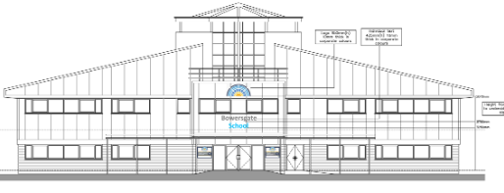
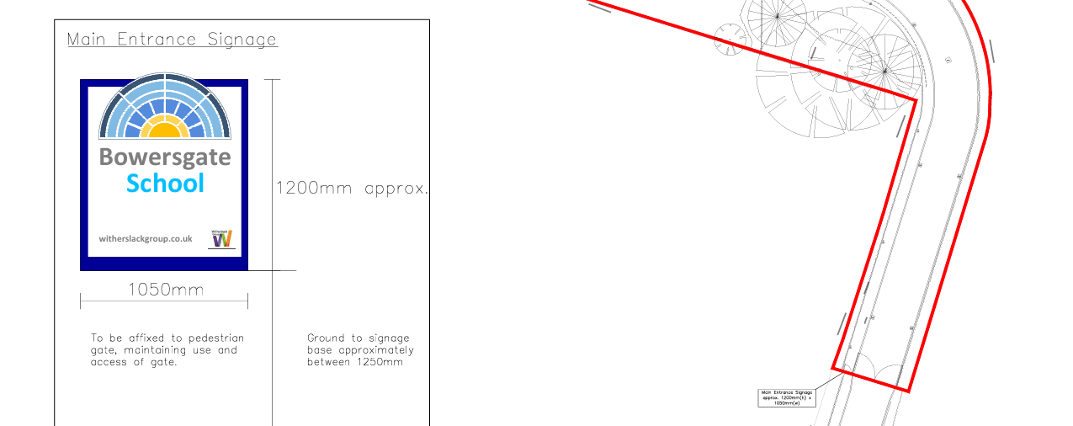

Consultation, notification and publicity responses

Consultations:

MCC Highways- no objections or recommended conditions.
Environmental Health- no objections or comments.

Notifications and publicity
Neighbours were notified of the proposed advertisements by letter. No representations have been received.

Relevant Policies

The following policies are considered relevant in the consideration of this application:

The Town and County Planning (Control of Advertisements) Regulations 2007
The Local Planning Authority shall exercise its powers under these Regulations in the interests of amenity and public safety, taking into account-

- The provisions of the development plan, so far they are material; and
- Any other relevant factors

2.

- Factors relevant to amenity include the general characteristics of the locality, including the presence of any feature of historic, architectural, cultural or similar interest;
- Factors relevant to the public safety include-

- The safety of persons using any highway, railway, waterway, etc..
- Whether the display of an advertisement in question is likely to obscure or hinder the ready interpretation of, any traffic sign, railway signal or aid
- Whether the display of an advertisement in question is likely to hinder the operation of any device used for the purpose of security or surveillance or for measuring the speed of any vehicle

3. In taking account of factors relevant to amenity, the local planning authority may, if it thinks fit, disregard any advertisement that is being displayed.

4. Unless it appears to the Local Planning Authority to be required in the interests of amenity or public safety, an express consent for the display of advertisements shall not contain any limitation or restriction relating to the subject matter, content or design of what is to be displayed.

The following policies are considered relevant in the consideration of this application:

Places for Everyone- A long term plan of nine Greater Manchester districts for jobs, new homes and sustainable growth, it has been published by the GMCA on behalf of the nine districts (Bolton, Bury, Rochdale, Oldham, Tameside, Stockport, Manchester, Trafford, Salford, Wigan) and took into effect and become part of the statutory development plan on March 21, 2024.

The Manchester Core Strategy- Development Plan Document 2012- 2027 (The Core Strategy) was adopted by the City Council on the 11th of July 2012, it is a key document for the local plan which provides a framework that planning applications are assessed against.

Policy DM1- Development Management
Policy SP1- Spatial Principles

Unitary Development Plan (UDP)- The UDP has been superseded by the Core Strategy Development Plan, but certain policies are still considered relevance:

-Policy 14 – Shopfronts and related signs

Other Material Considerations:

The Shopfront and Design Guide (Adopted 2024)

The National Planning Policy Framework (2024)- The Government’s own planning policies for England and how they are expected to be applied.

-Chapter 12- Achieving well-designed and beautiful places

The DRAFT National Planning Policy Framework (December 2025)- The Government’s new national planning policies and how they are to be implemented through local authorities. Whilst this is a draft NPPF for consultation it is considered that the development proposals are in accordance with the general thrust of policy contained within it.

Assessment
The advertisement regulations require that applications for shop signs be considered only in the interests of amenity and public safety. An assessment of the proposals under these criteria is outlined below.

Visual Amenity
Chapter 12 of the National Planning Policy Framework requires that when assessing design quality Local Planning Authorities will consider what ‘will function well and add to overall quality of the area’…’are visually attractive’ and ‘are sympathetic to local character and history, including the surrounding built environment and landscape setting.’

The proposed building sign would be composed of individual letter signs affixed to the centre of the front elevation of the building. This would also include the school’s logo in the corporate colours. The signs are considered to be in proportion to the building in scale and positioning.

The 2no. entrance signs to the building offer wayfinding to visitors, staff and pupils of the site and therefore the location of the signs by the main entrance is considered acceptable. The signs offer a congruous appearance as they are of the same dimensions and positioning to the entrance. Therefore, these signs are considered acceptable from a visual amenity perspective.

The gate sign would be affixed to the pedestrian side gate, non-illuminated and would be the only sign to be visible from the public. It would be small in scale and proportionate to the overall gate. This sign would aid visitors in wayfinding to the school and is considered to have a minimal effect on the visual amenity of the surrounding area.

Public Safety
Signage would not be illuminated and therefore environmental health colleagues are satisfied with the proposal. No objections were also received from MCC Highways as such, there are no public safety concerns associated with this proposal, pursuant to Policy DC14 and DM1

Other Legislative Requirements

Equality Act 2010
Section 149 (Public Sector Equality Duty) of the Equality Act 2010 requires due regard to the need to: Eliminate unlawful discrimination, harassment and victimisation and other conduct prohibited by the Act and; Advance equality of opportunity between persons who share a protected characteristic and persons who do not share it. The Equality Duty does not impose a legal requirement to conduct an Equality Impact Assessment. Compliance with the Equality Duty involves consciously thinking about the aims of the Equality Duty as part of the process of decision-making.

Human Rights Act 1998 considerations
This application needs to be considered against the provisions of the Human Rights Act 1998. Under Article 6, the applicants (and those third parties, including local residents, who have made representations) have a right to a fair hearing and to this end the local planning authority must give full consideration to their comments.

Protocol 1 Article 1, and Article 8 where appropriate, confer(s) a right of respect for a person’s home, other land and business assets. In taking account of all material considerations, including Council policy as set out in the Core Strategy and saved polices of the Unitary Development Plan, the Director of Planning, Building Control & Licensing has concluded that some rights conferred by these articles on the applicant(s)/objector(s)/resident(s) and other occupiers and owners of nearby land that might be affected may be interfered with but that that interference is in accordance with the law and justified by being in the public interest and on the basis of the planning merits of the development proposal. She believes that any restriction on these rights posed by the recommendation given is proportionate to the wider benefits of and that such a decision falls within the margin of discretion afforded to the Council under the Town and Country Planning Acts.

Conclusion
Given the above issues, it is considered that the advertisements are acceptable in terms of its impact upon visual amenity and public safety in accordance with Policies SP1, DM1 of the Core Strategy, Policy DC15 of the UDP, Chapter 12 of the NPPF.

Recommendation: Approve

Conditions attached to this decision:

- No advertisement is to be displayed without the permission of the owner of the site or any other person with an interest in the site entitled to grant permission.

No advertisement shall be sited or displayed so as to:
(a) endanger persons using any highway, railway, waterway, dock, harbour or aerodrome (civil or military);
(b) obscure, or hinder the ready interpretation of, any traffic sign, railway signal or aid to navigation by water or air; or
(c) hinder the operation of any device used for the purpose of security or surveillance or for measuring the speed of any vehicle.

Any advertisement displayed, and any site used for the display of advertisements, shall be maintained in a condition that does not impair the visual amenity of the site. Any structure or hoarding erected or used principally for the purpose of displaying advertisements shall be maintained in a condition that does not endanger the public. Where an advertisement is required under these Regulations to be removed, the site shall be left in a condition that does not endanger the public or impair visual amenity.

- The development hereby approved shall be carried out in accordance with the following documents:

Location plan, ref- AG25/0475 00 A
Site Signage Plan

Received 27 July 2026

Proposed elevations signage

Received 25 June 2026

Reason- to ensure that the development is carried out in accordance with the approved plans, pursuant to saved policy DC1 of the Unitary Development Plan for the City of Manchester and policies SP1 and DM1 of the Manchester Core Strategy.

