CCTV Improvements Piccadilly Gardens
Introduction
Manchester City Council are delivering significant investment in Piccadilly Gardens to make it more colourful vibrant and inviting area. A key priority is making Piccadilly Gardens feel safer, so there will be an increased Greater Manchester Police presence in and around it, along with improved and additional CCTV coverage.
As a part of the CCTV upgrade we are seeking to attach 5 additional cameras to One Piccadilly that will provide 360 degree surveillance of the area significantly improving both the image quality and functionality of the CCTV as well as widening the areas that can be monitored.
Proposals
The following proposed locations have been discussed with the building manager of One Piccadilly Gardens following a site visit and discussions about accessible locations for the CCTV cameras.
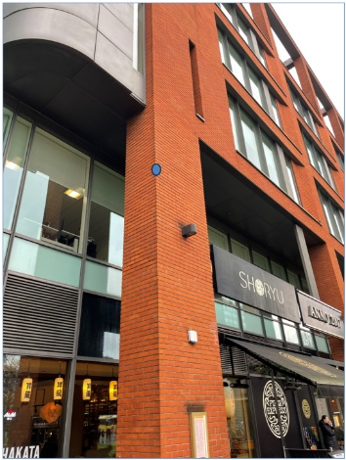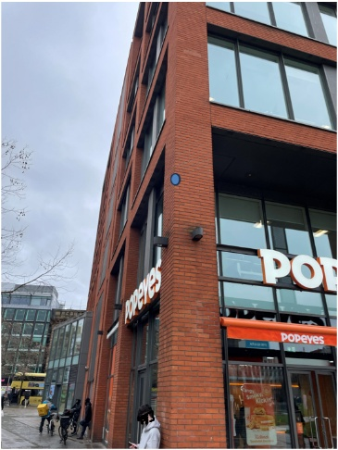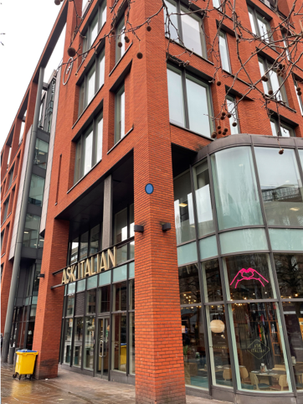
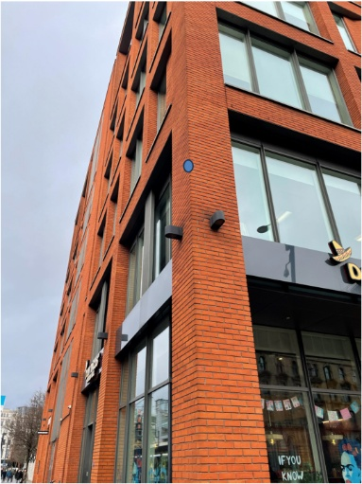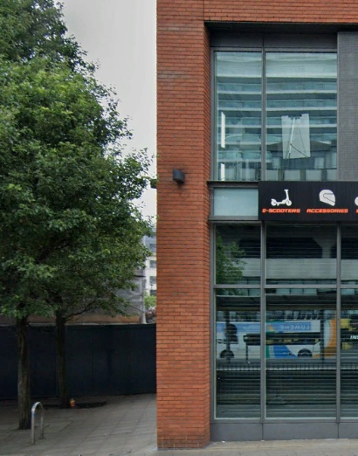
5 cameras would be located at the points identified above. This would require a bracket mount for the cameras, which will also support the radio for the wireless transmission.

