178 Ladybarn Lane – Survey of 8 Windows

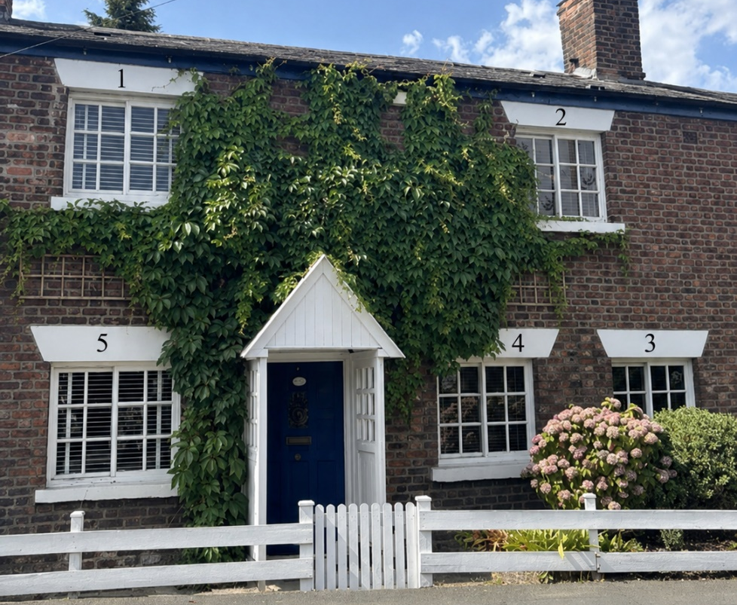
Front Elevation – 5 Yorkshire Sash Windows
The front elevation of 178 Ladybarn Lane has 5 white Yorkshire Sash Windows all of the same height and width.

Windows 3,4 and 5 do not open due to being painted shut and Window 2 does not open as it is being held up by masking tape and is rotten. This is incredibly dangerous should a fire break out.

There are no windows on the side elevation of the house.
Rear Elevation – 3 windows
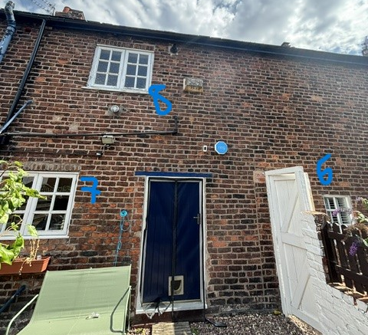
The rear elevation of 178 Ladybarn Lane has 3 Windows.

Windows 6 and 8 have rotting windowsills
Window 7 lets water into the house when it is raining heavily.

Proposed Works
No whole windows are to be replaced – only refurbished and sills/panes to be replaced as necessary.

The Proposed Works to Windows 1,2,3,5,6,7 and 8:
- Replace to rotten sills.
- To remove all failed putty and reinstate with new.
- To remove old parting beads where applicable.
- Remove any rotten timber and replace with new.
- Remove and replace rotten glazing beads with new.
- Sand and paint windows in keeping with Grade II listing.
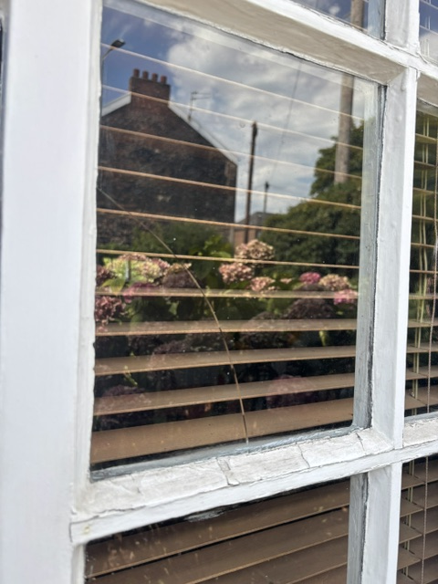
The Proposed Works to Window 4:

On Window 4 of 178 Ladybarn Lane (on the front elevation), one pane of glass has a curved crack from the left-hand side to the bottom side. This started as a small crack and has gotten bigger with the changing of the seasons. We are worried in time it will shatter the glass.

Therefore, the proposed works for Window 4 is to:
- Replace to rotten sills.
- To remove all failed putty and reinstate with new.
- To remove old parting beads where applicable.
- Remove any rotten timber and replace with new.
- Remove and replace rotten glazing beads with new.
- One cracked pane of glass will be replaced with glazing matching the existing glass in thickness, appearance and character.
- Sand and paint windows in keeping with Grade II listing.

Evidence of why this is necessary:
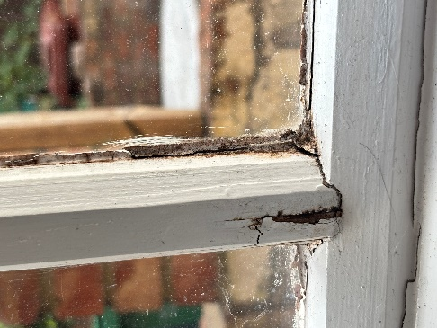
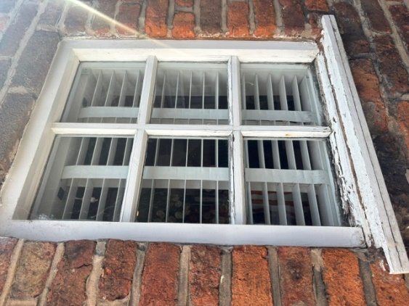
Window 6: Rotten beading and sill. The inside of the window is starting to split.

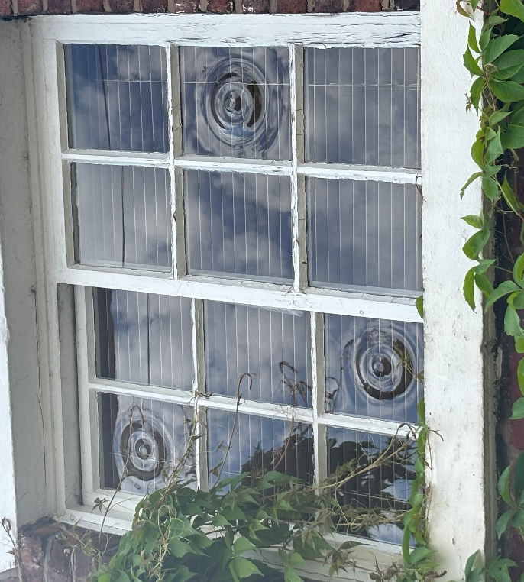
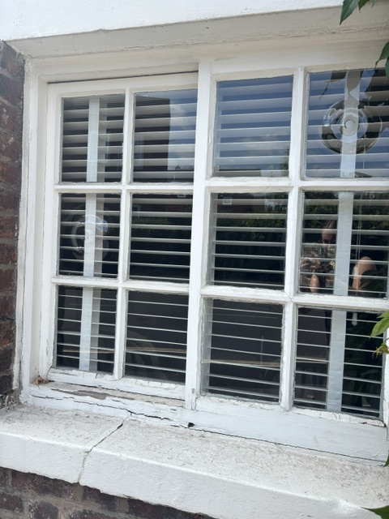
Window 3,4 and 5: Rotten beading and sill (all painted shut)
Window 2: Masking tape can be seen on the bottom left-hand corner holding this window together. Rotting timber can be seen on the right-hand side.

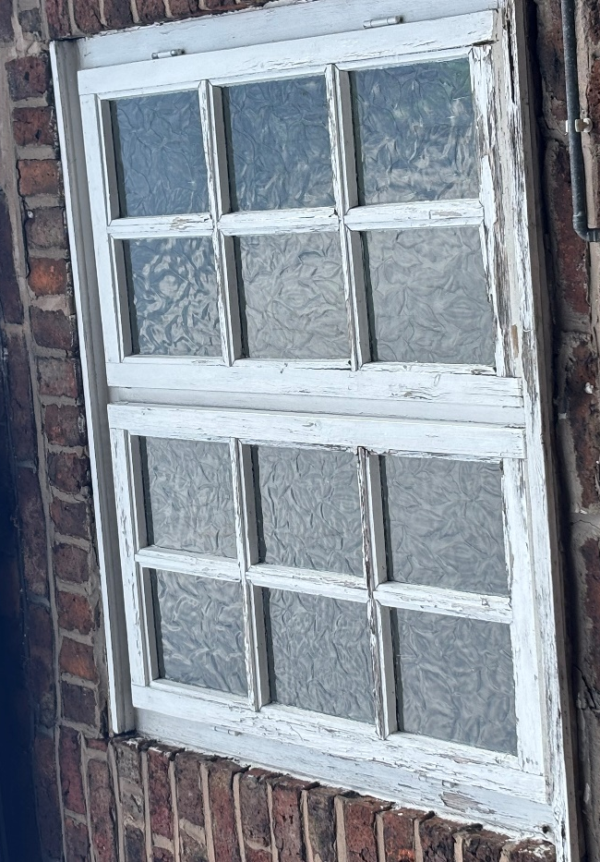
Window 8: Rotten sill, beading and panes of timber
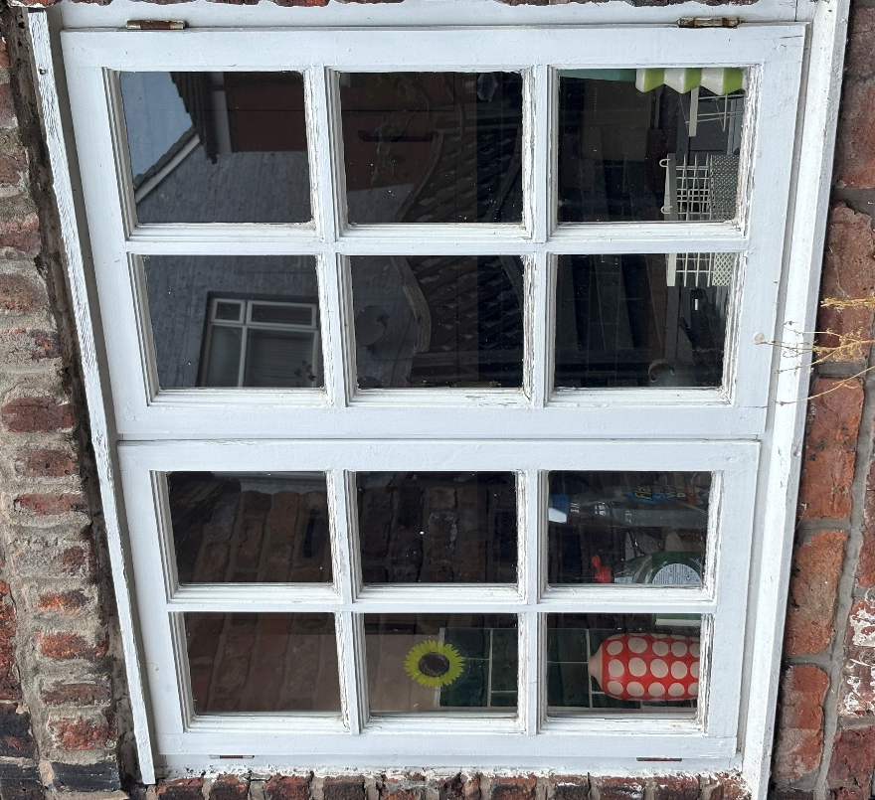
Window 7: Failed putty at the top letting water through when it rains.

Statement:
The intention is to retain and repair as much historic timber fabric as possible. Only decayed timber that cannot reasonably be repaired will be removed and replaced on a like-for-like basis, matching the existing profiles, dimensions and appearance. The proposed works will not alter the design, opening style, dimensions, glazing pattern, materials or appearance of the windows. Following repair, the windows will appear substantially the same as existing. Continued deterioration of the windows is allowing water ingress and decay of historic timber. Without repair, the condition of the windows will worsen and may ultimately necessitate more extensive replacement works in the future. The proposed repairs are therefore a conservation-led approach intended to preserve the original windows.

