

Planning

Delegated Officer Report

Summary of application details
Application reference: | PLA-2026-000412
Application type: | Consent to display an advertisement
Proposal: | Temporary siting of 2no. externally illuminated scaffold mounted advertisements for a period of 9 months.
Site address: | 6 Oldham Road Manchester
Ward(s): | Ancoats & Beswick
Date application valid: | 18 June 2026
Applicant name: | Ms Maddalena Sanvito
Agent (if any): | Mr Ben Kelly
Case officer: | Ciara Gettinby
Recommendation: | Refuse
Date of recommendation: | 10 August 2026

Description of site, building and/or area
The applicant site is located in the Ancoats (1989) Conservation Area. Also in proximity of the site are, Grade II* Listed Express Building, the Grade II listed Crown and Kettle Public House, the Grade II Listed Former Midland Bank and the Grade II Listed Victoria Square. Ancoats Conservation Area is recognised as the place where the Industrial Revolution commenced and is characterised by its industrial mill buildings and later additions that provide a contrast of architectural styles. The Crown and Kettle public house that adjoins the applicant site is a late 19th Century buff brick, Gothic style building with stone traceried windows.

6 Oldham Road is a residential apartment block with commercial use at ground floor level. It is located on Oldham Road, which is a gateway route into the City Centre from North Manchester. Other uses in the immediate area include offices, hotels, residential apartments, houses, creative industries, warehouses, shops, bars, live music venues, restaurants and car parking.

Description of development
Advertisement consent is sought for the temporary siting of 2no. externally illuminated scaffold mounted advertisements for a period of five months. The works would include a printed protective scaffolding shroud with inset illuminated advertising space during re-cladding works at 6 Oldham Road. This application is pursuant to the existing build contract in place for 142760/AOH/2025. The static, external illuminance levels would be 110 cd/m2 and switched off between 23:00 and 07:00 hours.

Relevant planning history
This application site has previous advertisement consent for the temporary siting of 2no. scaffold mounted advertisements for a period of 12 months. Approved in December 2025 (142760/AOH/2025).

Consultation, notification and publicity responses

Consultations:

MCC Highways: No objections subject to a recommended informative.

MCC Environmental health: No objections subject to lighting installed in accordance with the illuminance level 110cd/m2 and used only between 07:00 and 22:00.

Notifications and publicity

Occupiers of neighbouring buildings were notified of the proposal via notification letters. No representations have been received.

Relevant policies
The following policies are considered relevant in the consideration of this application:

Places for Everyone- A long term plan of nine Greater Manchester districts for jobs, new homes and sustainable growth, it has been published by the GMCA on behalf of the nine districts (Bolton, Bury, Rochdale, Oldham, Tameside, Stockport, Manchester, Trafford, Salford, Wigan) and took into effect and become part of the statutory development plan on March 21, 2024.

-Policy JP-P1: Sustainable Places
-Policy JP-P2: Heritage
-Policy JP-Strat2: City Centre

Unitary Development Plan (UDP)- The UDP has been superseded by the Core Strategy Development Plan, but certain policies are still considered of relevance:

-Policy DC14 (Shopfronts and Related Signs)
-Policy DC15 (Advertisements, Hoardings and Posters)
-Policy DC19- Listed Buildings
-Policy DC18- Conservation Areas

The Manchester Core Strategy- Development Plan Document 2012- 2027 (The Core Strategy) was adopted by the City Council on the 11th of July 2012, it is a key document for the local plan which provides a framework that planning applications are assessed against.

Policy DM1- Development Management
Policy SP1- Spatial Principles
Policy EN1- Design Principles and Strategic Character Areas
Policy EN3- Heritage
Policy CC9: Design and Heritage

The National Planning Policy Framework (December 2025)- The Government’s own planning policies for England and how they are expected to be applied.

-Chapter 12- Achieving well-designed and beautiful places
-Chapter 16- Conserving and enhancing the historic environment

Other Legislative Requirements

Planning (Listed Buildings and Conservation Areas) Act 1990

Section 66 – For development which affects a listed building or its setting, the local planning authority shall have special regard to the desirability of preserving the building or its setting.

Section 72- Special attention shall be paid to the desirability of preserving or enhancing the character of appearance of that area.

The DRAFT National Planning Policy Framework (December 2025)- The Government’s new national planning policies and how they are to be implemented through local authorities. Whilst this is a draft NPPF for consultation it is considered that the development proposals are in accordance with the general thrust of policy contained within it.

Achieving sustainable development

Policy S3- Presumption in favour of sustainable development

Achieving well-designed places

Policy DP3- Key principles for well-designed places
Policy DP4- The design process

Site Photos
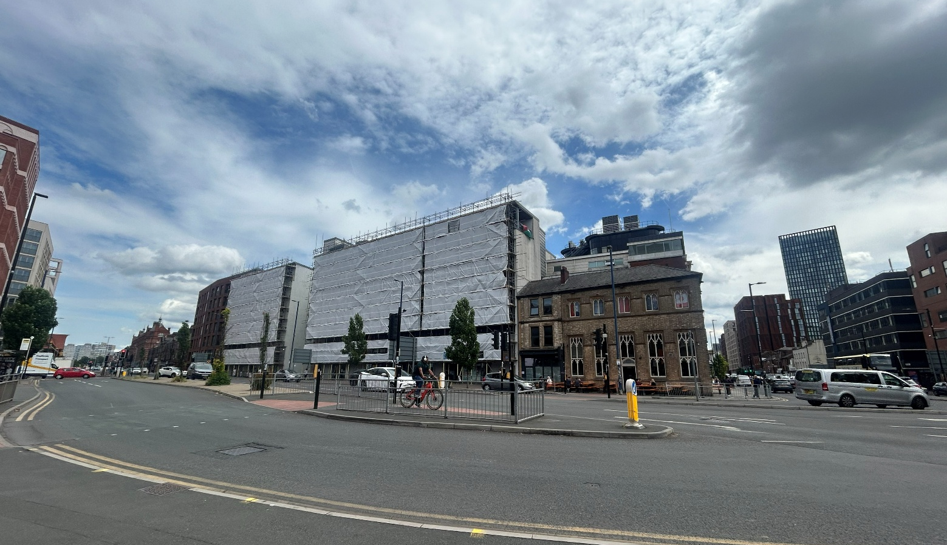

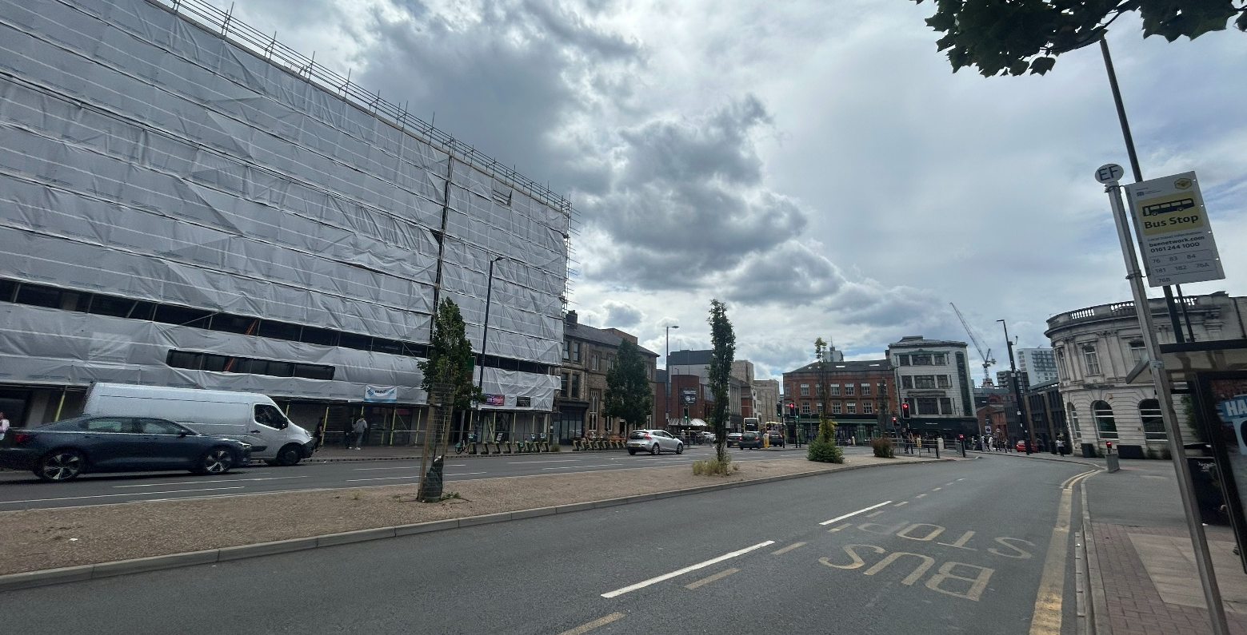

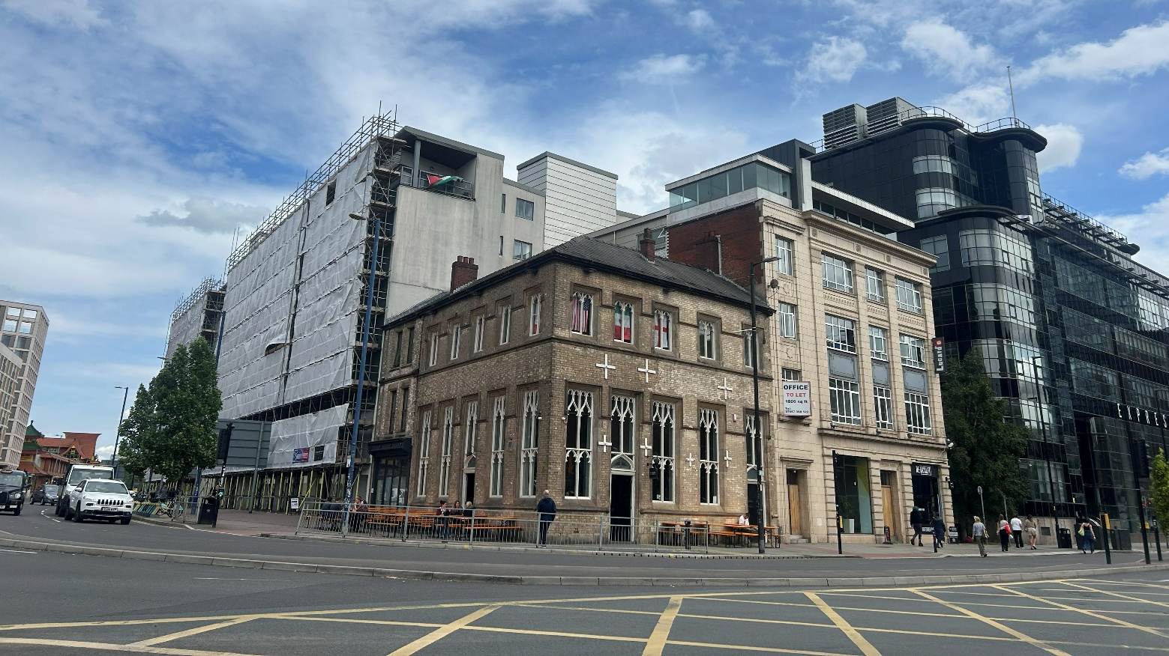
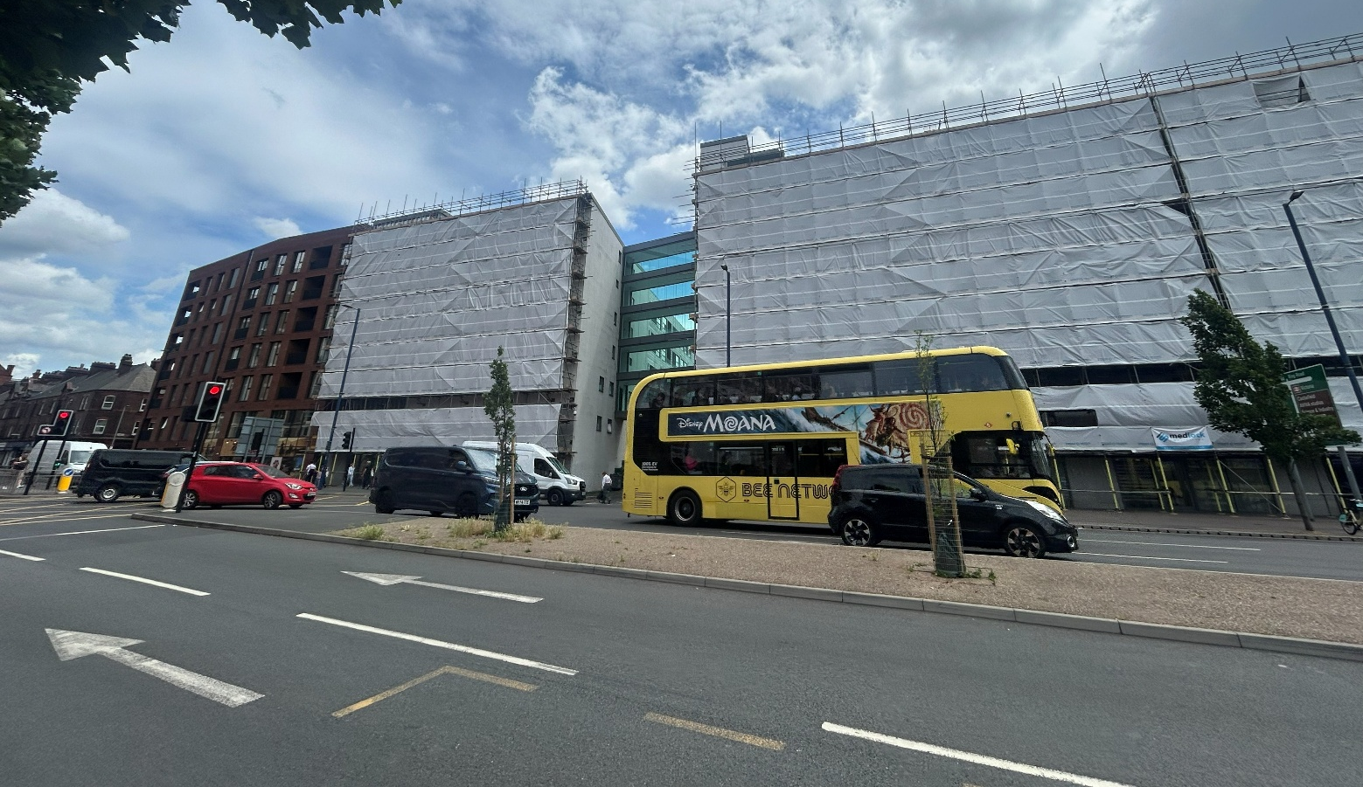

Proposed Plans:
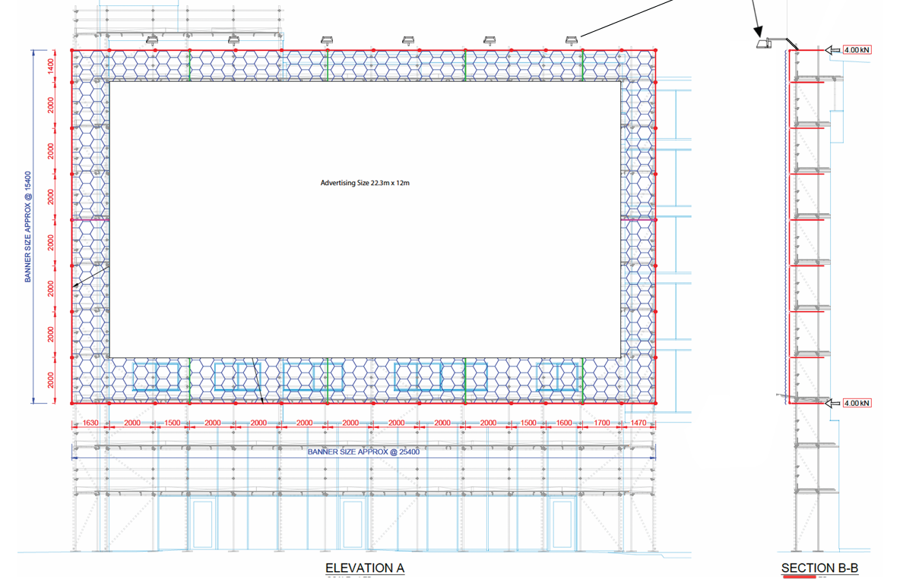

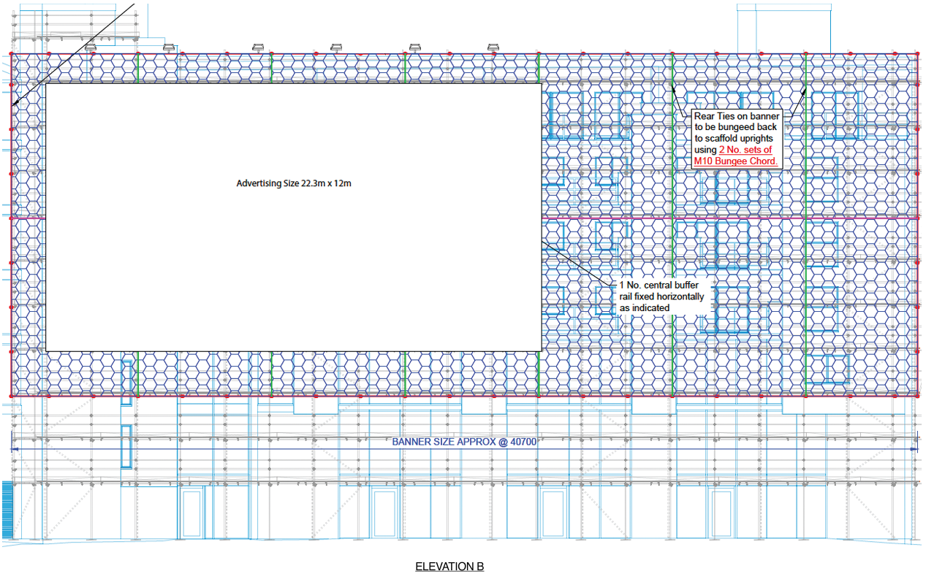

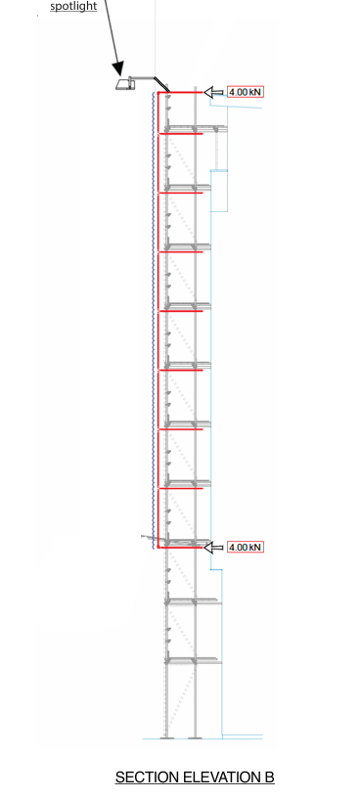

Assessment
Principle
Section 38(6) of the Planning and Compulsory Purchase Act 2004 requires that decisions must be made in accordance with the development plan, unless material considerations indicate otherwise. The National Planning Policy Framework reinforces this requirement in paragraphs 2 and 48, whilst paragraph 12 indicates that the presumption in favour of sustainable development does not alter the statutory status of the development plan as starting point for decision making and that, where a planning application conflicts with an up to-date development plan, permission should not normally be granted.

In the case of this application, the principle of the proposal is considered unacceptable and cannot be supported as it conflicts with the development plan policies and associated guidance listed in the preceding section. It is considered that the externally illuminated advertisements would have an unduly harmful impact upon the visual amenity of the area and character of the Ancoats Conservation Area and surrounding listed buildings.

Background
The previous advertisement consent at this site (142760/AOH/2025) permits the existing non-illuminated advertisements for a temporary period of 12 months, due to expire in December 2026. Therefore, the key issue in the assessment of this application relates to the proposed lighting.

Impact on the Visual Amenity of the City of Manchester (Ancoats) Conservation Area 1989
The setting of the Ancoats Conservation Area and surrounding listed buildings (Grade II* Listed Express Building, the Grade II listed Crown and Kettle Public House, the Grade II Listed Former Midland Bank and the Grade II Listed Victoria Square) creates a strong sense of place, contributing to the street setting in this area of the City. Any external illumination would detract from this setting and special character. This would especially detract from the designated character during the darker evening hours. The illuminance of the advertisement is considered to be visually incongruous to the character of the Conservation Area. As existing, there are no other illuminated advertisements in this area and therefore no relevant precedent.

The proposal would be sited in a visually prominent position to the street scene, located towards the corner of Oldham Street. This road is frequently used by visitors to the City and this location acts as a prominent gateway into the City Centre. The illuminance of the advertisement would detract from this key access route and would be perceived to be out of keeping with the historic character of the Conservation Area and views in the surrounding area.

On this basis, the proposal is considered to conflict with the principles set out under saved Policy DC18 or DC19 of the Unitary Development Plan for the City of Manchester, as it would not preserve or enhance the character of [the] designated Conservation Area or listed buildings; as well as Policy EN3 of the Manchester Core Strategy which highlights that developments should complement and take advantage of the ‘distinct historic and heritage features of its districts’ and Policy JP-P2.

Other Legislative Requirements

Equality Act 2010
Section 149 (Public Sector Equality Duty) of the Equality Act 2010 requires due regard to the need to: Eliminate unlawful discrimination, harassment and victimisation and other conduct prohibited by the Act and; Advance equality of opportunity between persons who share a protected characteristic and persons who do not share it. The Equality Duty does not impose a legal requirement to conduct an Equality Impact Assessment. Compliance with the Equality Duty involves consciously thinking about the aims of the Equality Duty as part of the process of decision-making.

Human Rights Act 1998 considerations
This application needs to be considered against the provisions of the Human Rights Act 1998. Under Article 6, the applicants (and those third parties, including local residents, who have made representations) have a right to a fair hearing and to this end the local planning authority must give full consideration to their comments.

Protocol 1 Article 1, and Article 8 where appropriate, confer(s) a right of respect for a person’s home, other land and business assets. In taking account of all material considerations, including Council policy as set out in the Core Strategy and saved polices of the Unitary Development Plan, the Director of Planning, Building Control & Licensing has concluded that some rights conferred by these articles on the applicant(s)/objector(s)/resident(s) and other occupiers and owners of nearby land that might be affected may be interfered with but that that interference is in accordance with the law and justified by being in the public interest and on the basis of the planning merits of the development proposal. She believes that any restriction on these rights posed by the recommendation given is proportionate to the wider benefits of and that such a decision falls within the margin of discretion afforded to the Council under the Town and Country Planning Acts.

Conclusion
For the reasons specified above, it is considered that the proposal is unacceptable due its unduly harmful impact upon the visual amenity as well as the overall character and appearance of the setting of surrounding listed buildings and The Ancoats Conservation Area. The agent of the application was informed of the above issues and notified of the LPA’s intent to refuse the proposal. The proposal therefore cannot be supported by the City Council as it acts against principles set out in the aforementioned policies.

Recommendation: REFUSE

Reasons for refusal

The proposed illuminated advertisement by virtue of its siting and appearance would result in harm to the significance and visual amenity of the Ancoats Conservation Area and Grade II* Listed Express Building, the Grade II listed Crown and Kettle Public House, the Grade II Listed Former Midland Bank and the Grade II Listed Victoria Square. The illuminated advertisement would detract from the setting of the heritage assets and conservation area.

The proposed would therefore be contrary to Places for Everyone Policies JP-Strat2, JP-P1 and JP-P2, and Core Strategy Policies SP1, EN1, EN3, and DM1, saved UDP policies DC18 and DC19; Sections 66 and 72 of the Listed Buildings and Conservation Areas Act 1990; as well as guidance contained in Sections 12 and 16 of the National Planning Policy Framework and Section 2.41 of The Guide to Development in Manchester Supplementary Planning Document and Planning Guidance.

