

Planning

Delegated Officer Report

Summary of application details
Application reference: | PLA-2026-000779
Application type: | Householder planning permission
Proposal: | Construction of a gazebo in the garden of the property.
Site address: | 6 Oakfield Road Manchester M20 6XA
Ward(s): | Didsbury West
Date application valid: | 09 July 2026
Applicant name: | Mr Peter Folkman
Agent (if any): | Mrs Joanne Walker
Case officer: | Joshua Lee
Recommendation: | Approve
Date of recommendation: | 12 August 2026

Description of site, building and/or area
The proposal related to a large detached dwellinghouse on Oakfield Road. The property features an existing single storey conservatory addition and detached garage/outbuilding. The property features hardstanding to the front for off street vehicle parking and surrounding gardens.
The proposal is in a mostly residential part of the Didsbury East ward of Manchester. The site is within the Blackburn Park conservation area.

Description of development
Construction of a gazebo in the garden of the property.
The proposed gazebo is 3200mm(W)x3200m(D)x3038mm(H), constructed of timber with a shingle roof and located in the northwest corner of the garden over 2m away from the neighbouring boundaries.
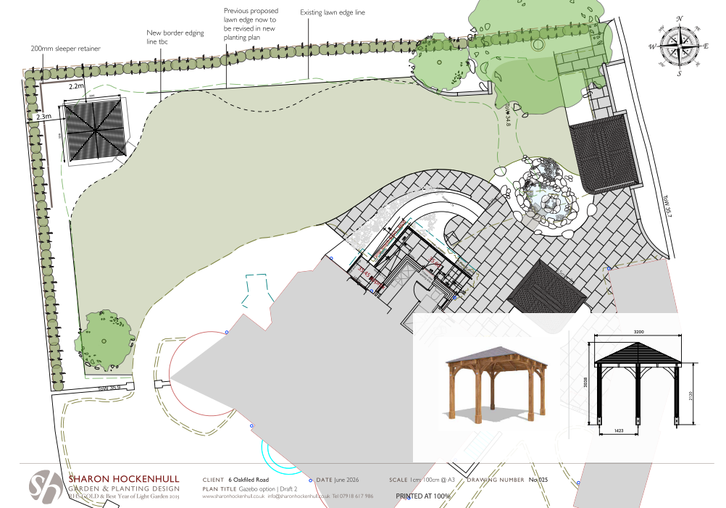
Figure 1. Proposed site plan and gazebo detail

Relevant planning history
Ref | Description | Decision | Decision Date
145269/FH/2026 | Erection of a 2.0m high fence with 300mm trellis above | Approved | 17 Apr 2026
145270/LP/2026 | Construction of a 2.5m high pergola | Lawful Development Certificate (Proposed) Granted | 16 Apr 2026
141726/FH/2024 | Erection of access ramp to rear | Approved | 5 Feb 2025
054590/FH/SOUTH1/98 | Erection of 2.3m high wall and single-storey extension to existing garage | Approved | 3 Aug 1998

Consultation, notification and publicity responses

Notifications and publicity

Neighbour letters, site notice and press advertisement
No responses received.

Blackburn Park Conservation Society
No response received.

Relevant policies
In accordance with Section 38(6) of the Planning and Compulsory Purchase Act 2004, decisions on planning applications must be made in line with the statutory development plan, unless material considerations indicate otherwise.

For Manchester, the development plan comprises:

- The Core Strategy (2012–2027)
- Saved policies of the Unitary Development Plan (UDP)
- The Places for Everyone Joint Development Plan Document (2022–2039)

These documents are considered up to date and carry substantial weight in decision-making. Supplementary Planning Documents (SPDs) and other local guidance may also be relevant.

National planning policy, including the National Planning Policy Framework (NPPF), is a material consideration and provides overarching guidance.

The Government has published a consultation draft of the NPPF, intended to improve housebuilding rates through a clearer, more predictable and faster policy basis for decision and plan making. While this draft is not yet adopted, it is a material consideration.

Where applicable, the Council must give special regard to preserving the character of conservation areas and the setting of listed buildings, in line with statutory duties under the Planning (Listed Buildings and Conservation Areas) Act 1990.

The policies referenced in this report are those considered most relevant to the nature, scale and location of the proposed development as follows:

- The Manchester Core Strategy Development Plan Document 2012-2027
  - Development Management and Planning Obligations
    - DM 1 - Development Management
  - Objective 1 - Spatial Principles
    - SP 1 - Spatial Principles (Partially replaced by PfE Policy JP-S 1)
  - Objective 6 Environment
    - EN 1 - Design Principles and Strategic Character Areas
    - EN 3 – Heritage (Deletions replaced with PfE Policy JP-P2)
    - EN 9 – Green Infrastructure
    - EN 19 – Waste
- Guide to development in Manchester - supplementary planning document and planning guidance, April 2007
- Extant Unitary Development Plan (UDP) –
  - Citywide Development Control Policies
    - DC1 - Residential extensions
    - DC18 - Conservation Areas
    - DC26 - Development and Noise
- Places for Everyone Plan Joint Development Plan Document 2022-2039-
  - Strategy
    - JP-Strat9: Southern Areas
  - Sustainable and Resilient Places
    - JP-S1: Sustainable Development
  - Places for People
    - JP-P1 Sustainable Places
- National Planning Policy Framework (NPPF) December 2024–
  - Section 2 - Achieving sustainable development
  - Section 4 – Decision-making
  - Section 11 – Making effective use of land
  - Section 12 – Achieving well-designed places
  - Section 16 - Conserving and enhancing the historic environment
- National Planning Policy Framework Draft for Consultation December 2025 - National decision-making policies
  - Chapter 3 – Decision-making policies
    - DM1: Preparing development proposals
    - DM2: Information requirements
    - DM3: Determining development proposals
    - DM6: Use of planning conditions and obligations
    - DM7: Relationship with other regulatory regimes
  - Chapter 4 - Achieving sustainable development
    - S3: Presumption in favour of sustainable development
    - S4: Principle of development within settlements
  - Chapter 12 - Making effective use of land
    - L4: Residential extensions
  - Chapter 14 - Achieving well-designed places
    - DP3: Key principles for well-designed places
    - DP4: The Design process
  - Chapter 20 - Conserving and enhancing the historic environment
    - HE9: Conservation areas

Assessment

Principle of development
The proposal seeks planning permission for the erection of a gazebo within the curtilage of an existing dwellinghouse. The structure would be used for purposes incidental to the enjoyment of the dwellinghouse and is therefore an acceptable form of domestic development in principle.
The proposal requires planning permission because it would be located to the side of the dwellinghouse within the a Conservation Area, where permitted development rights for certain outbuildings are restricted. Were it not for this restriction, a structure of this nature may otherwise fall to be considered under permitted development provisions. Accordingly, there is no objection to the principle of the development, and the acceptability of the proposal rests on its detailed impact on visual amenity, residential amenity and the character and appearance of the conservation area.

Appropriate siting, layout, scale, form, massing, materials, and detail
The proposed gazebo would be located within the side garden of the dwellinghouse and would be positioned away from neighbouring boundaries. The structure would have a relatively modest footprint and, whilst its maximum height would exceed 3 metres, it would remain clearly subordinate to the host dwelling and would not compete with it in terms of scale or prominence. The proposed timber frame and tiled roof are appropriate domestic materials that relate well to the character of the property and surrounding residential area.
The gazebo would be read as an incidental garden structure rather than as an extension to the dwellinghouse. Due to its scale, design and position within the curtilage, it would not appear visually intrusive or incongruous within the street scene. The proposal therefore accords with the design objectives of Core Strategy Policies EN1 and DM1 and saved UDP Policy DC1.
Impact on the surrounding areas in terms of the design, scale and appearance of the proposed development. Development should have regard to the character of the surrounding area.
The proposed gazebo would be a modest, subordinate structure within the curtilage of the dwellinghouse. Its scale, siting and design are appropriate to the spacious residential plot and it would not appear dominant or incongruous within the street scene or wider area. The use of timber and a shingle roof would complement the character of the host dwelling and surrounding development. As such, the proposal would preserve the character and appearance of the area and the Blackburn Park Conservation Area.

Effects on amenity

Privacy
The gazebo is an open-sided garden structure and does not contain elevated platforms, balconies or other features that would facilitate overlooking. Having regard to its position within the site and the existing relationship with neighbouring properties, no unacceptable loss of privacy would arise

Light
Given the modest footprint of the structure, its separation from neighbouring boundaries and its siting within a spacious residential plot, the gazebo would not result in any material loss of daylight or sunlight to neighbouring occupiers

Noise

The gazebo would provide a covered outdoor sitting area incidental to the residential use of the property. Whilst it may facilitate outdoor recreational activities, the level of activity associated with such domestic use would not be materially different from that which could occur within the existing garden. The proposal is therefore not expected to result in unacceptable noise impacts.

Accessibility: buildings and neighbourhoods fully accessible to disabled people, access to new development by sustainable transport modes.
The proposal relates to a domestic garden structure and would not alter existing access arrangements to the dwellinghouse. No accessibility concerns are raised.

Adequacy of internal accommodation and external amenity space.
The proposal would occupy only a small proportion of the substantial garden area serving the property. A generous amount of private amenity space would remain available for occupiers following development

Refuse storage and collection.
The proposal would not alter existing refuse storage or collection arrangements at the property. Existing facilities would remain available and adequate

Vehicular access and car parking
The proposal would not affect existing vehicular access, parking provision or highway safety. Adequate off-street parking would remain available at the property.

Effects relating to biodiversity, landscape, archaeological or built heritage

Built heritage
The site lies within the Blackburn Park Conservation Area. The significance of the conservation area derives largely from its spacious plots, mature landscaping and high-quality residential architecture.
The proposed gazebo would be positioned within the side garden and would be viewed in the context of the existing dwelling and surrounding garden enclosure. Owing to its modest scale, subordinate appearance and use of traditional materials, the structure would not appear harmful to the character or appearance of the conservation area. It would preserve the significance of the Blackburn Park Conservation Area and therefore accords with Core Strategy Policy EN3, saved UDP Policy DC18 and Section 16 of the NPPF.

Green Infrastructure including open space, both public and private
The proposal would retain the vast majority of the site's existing garden area and would not adversely affect green infrastructure or open space provision.

Flood risk and drainage.
The proposal is of limited scale and would have a negligible impact on surface water drainage. No flood risk or drainage concerns arise.

Other Legislative Requirements

Equality Act 2010
Section 149 (Public Sector Equality Duty) of the Equality Act 2010 requires due regard to the need to: Eliminate unlawful discrimination, harassment and victimisation and other conduct prohibited by the Act and; Advance equality of opportunity between persons who share a protected characteristic and persons who do not share it. The Equality Duty does not impose a legal requirement to conduct an Equality Impact Assessment. Compliance with the Equality Duty involves consciously thinking about the aims of the Equality Duty as part of the process of decision-making.

Human Rights Act 1998 considerations
This application needs to be considered against the provisions of the Human Rights Act 1998. Under Article 6, the applicants (and those third parties, including local residents, who have made representations) have a right to a fair hearing and to this end the local planning authority must give full consideration to their comments.
Protocol 1 Article 1, and Article 8 where appropriate, confer(s) a right of respect for a person’s home, other land and business assets. In taking account of all material considerations, including Council policy as set out in the Core Strategy and saved polices of the Unitary Development Plan, the Director of Planning, Building Control & Licensing has concluded that some rights conferred by these articles on the applicant(s)/objector(s)/resident(s) and other occupiers and owners of nearby land that might be affected may be interfered with but that that interference is in accordance with the law and justified by being in the public interest and on the basis of the planning merits of the development proposal. She believes that any restriction on these rights posed by the recommendation given is proportionate to the wider benefits of and that such a decision falls within the margin of discretion afforded to the Council under the Town and Country Planning Acts.

Conclusion
The proposed gazebo represents an acceptable form of domestic development within the curtilage of the dwellinghouse. Although planning permission is required because the structure would be located to the side of the dwelling within the Blackburn Park Conservation Area, the principle of such a garden structure is acceptable. The gazebo would be subordinate to the host dwelling and would not result in unacceptable impacts on residential amenity, the character of the area or the significance of the Blackburn Park Conservation Area. The proposal accords with the relevant policies of the Development Plan and with the National Planning Policy Framework.

Recommendation: Approve

Article 35 Declaration
Officers have worked with the applicant in a positive and proactive manner based on seeking solutions to problems arising in relation to dealing with the planning application. The proposal is considered to be acceptable and therefore determined within a timely manner.

Conditions to be attached to decision for approval

3-year time limit
The development must be begun not later than three years beginning with the date of this permission.
Reason - Required to be imposed by Section 91 of the Town and Country Planning Act 1990 (as amended).

Specified plans
The development hereby approved shall be carried out in accordance with the following drawings and documents:
  - LocationPlan.pdf - Location Plan (received 23 June 2026)
  - 416-WSA-ZZ-ZZ-DR-A-1253-S0-P01 – Gazebo Existing and Proposed Plan (received 9 July 2026)
  - 025_Gazbo_version2.pdf – Site Plan (received 23 June 2026)
  - Leviathan Chunky Gazebo W3.2m x D3.2m Walled Corner – Product Specification (received 23 June 2026)
Reason - To ensure that the development is carried out in accordance with the approved plans, pursuant to policies DM 1, SP 1 and EN 1 of the Core Strategy and JP-P1 & of Places for Everyone.

Materials as approved on plan
The materials used in the external surfaces of the development hereby approved shall be those as specified on approved plan/drawing ref.
  - Leviathan Chunky Gazebo W3.2m x D3.2m Walled Corner – Product Specification (received 23 June 2026)

Reason - In order to ensure a satisfactory appearance in the interests of visual amenity in accordance with policies SP1 and DM1 of the Core Strategy and the requirements of the National Planning Policy Framework.

