

Planning

Delegated Officer Report

Summary of application details
Application reference: | OTH-2026-001060
Application type: | Non-Material Amendment
Proposal: | Non-material amendment to Planning Permission referenced 135454/JO/2022 (Phase 2) to allow the realignment of the retaining wall along the maintenance path, the installation of an access staircase to facilitate maintenance operations, the addition of a small grasscrete area between Units 4 and 5 and the relocation of the Unit 4 waste store.
Site address: | Former Mather & Platt Foundry, Grimshaw Lane, Manchester M40 2BA
Ward(s): | Miles Platting & Newton Heath
Date application valid: | 17 July 2026
Applicant name: | Mr Ian Murray
Agent (if any): | Mr Roland Lee
Case officer: | Steven Mccoombe
Recommendation: | Approve
Date of recommendation: | 30 July 2026

Description of site, building and/or area

The application site comprises a large area of previously developed vacant land accessed from Grimshaw Lane, Newton Heath, and bounded by Ten Acres Lane to the north.

The site forms part of the wider development area associated with the parent planning permission. Historically, it operated as a long-established employment site, accommodating a range of industrial uses. Most notably, the former Mather and Platt foundry and engineering works occupied the site until its closure in 2017.

The site is bounded by Grimshaw Lane, the Rochdale Canal and its towpath, and Ten Acres Lane.

To the rear of the site, along Ten Acres Lane, is a small residential development and a sports complex. Further to the south-east, the wider residential area of Newton Heath is characterised predominantly by semi-detached housing.

The surrounding area is largely industrial in nature, interspersed with vacant former industrial land. Beyond this, to the east, lies the established residential area of Newton Heath. To the south of the site is a large bakery and distribution facility, which received planning permission in 2009 and was completed in 2010. To the south-east, beyond Briscoe Lane, are a number of established industrial premises of varying scales and construction types, all accessed from Briscoe Lane.

Grimshaw Lane, to the north-west of the site, serves a mixed industrial area, with the Princes soft drinks manufacturing and distribution complex being the principal occupier. Grimshaw Lane extends north-westwards to connect with the A62 Oldham Road, a key arterial route providing access to the M60 motorway to the north-east.

Description of development

Non-material amendment to planning permission referenced 135454/JO/2022, a S.73 minor material amendment application which allow for the development to be implemented int 2 phases and to provide future access to the adjoining Stone House site, following permission being granted for the erection of 12 No. industrial units (Class E(g), B2 and B8) with ancillary offices (42782 sqm), together with service areas, car parking, landscaping and boundary treatment following demolition of existing building (Ref: 129444/FO/202).

In this case, the non-material amendment relates to minor revisions to the retaining wall between Units 4 and 5 and to the grasscrete area.

The proposed changes include the realignment of the retaining wall along the maintenance path, which corrects a previous drafting error, the introduction of a personal access staircase to the maintenance path to improve operational access, the addition of a small grasscrete section to extend the access route between Units 4 and 5, and the relocation of the waste store serving Unit 4 to the opposite side of the yard to accommodate the new access stairs.

The amendments have arisen through the continued development of the site's level design and are required to ensure suitable access to the building façade in accordance with the requirements of the Building Safety Act.

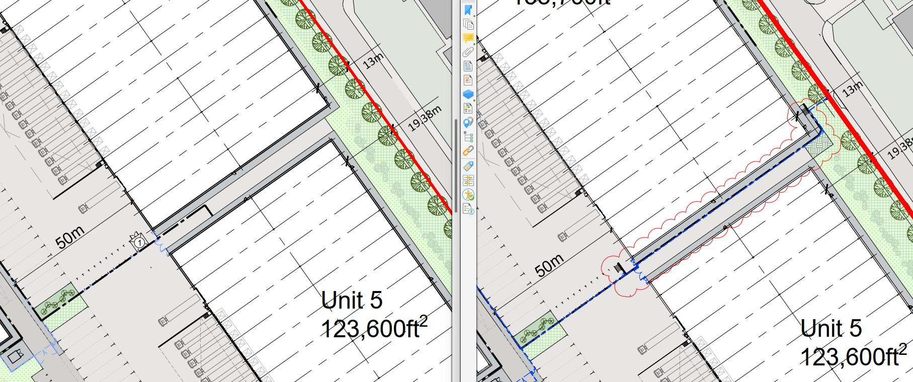
Approved Layout Proposed Layout

Relevant planning history
138587/NMC/2023

Non-material amendment to planning permission referenced 135454/JO/2022 to allow minor amendments to site levels, re-location of the substation and alterations to roof overhang details. Approved 28 November 2023.

135454/JO/2022

Variation of conditions 2 (specified plans), 6 (drainage), 10 (boundary treatment), 16a (acoustic), 18 (opening hours), 24 (car parking provision), 25 (cycle storage), 33 (landscaping and 34 (sub-division) attached to planning permission referenced 129444/FO/2021 to allow the development in 2 phases and provide future access to the adjoining Stone House site by allowing minor changes to the location of the site access road ramp and gates together with adjusting the location of the access gates and fencing to the service yard of Unit 1. Approved 15 February 2023.

129444/FO/2021

Erection of 12 No. industrial units with Use Class E(g), B2 and B8 uses with ancillary offices (42782 sqm) together with service areas, car parking, landscaping and boundary treatment following demolition of existing building. Approved 24 September 2021.

099637/FO/2012/N1

Retrospective consent for extraction plant in association with existing foundry. Approved 13 August 2012.

Consultation, notification and publicity responses

None required.

Relevant policies

The following policy and guidance is considered relevant to the consideration of this application:

-Policies SO1, SO2, SO6, EC1, EC3, SP1, T1, T2, EC6, EN4, EN5, EN6, EN9, EN14, EN15, EN16, EN17, EN18, EN19 and DM1 of the Manchester Core Strategy;

-Saved policies DC26, DC20 and E3.3 of the UDP;
-Places for Everyone Joint Development Plan.

-The Guide to Development in Manchester (SPD);

-Manchester Green and Blue Infrastructure Strategy 2015;

-National Planning Policy Framework (2021) and Consultation Draft (December 2025)

Assessment

The principle of development has already been established through the extant planning permission and therefore the scope of this application is limited to the proposed amendments relating to the retaining wall, landscaping arrangements, relocation of the waste store, and the introduction of an access staircase.

Having regard to the nature and scale of these amendments within the context of the wider approved scheme, it is considered that they would not result in any material alteration to the overall design concept, site layout, or appearance of the development. Further, the proposed changes would not give rise to any adverse impacts on neighbouring amenity, highway safety and operation, or environmental considerations. The amendments largely reflect the continued refinement of the approved scheme, including measures necessary to facilitate safe and appropriate access to the building façade in accordance with Building Safety Act requirements.

As the proposed revisions do not alter the conclusions of the technical assessments that informed the original planning permission and there have been no changes to the relevant planning policy framework that would affect the assessment of the development, the amendments are considered to be non-material in nature and acceptable in planning terms.

Other Legislative Requirements

Equality Act 2010
Section 149 (Public Sector Equality Duty) of the Equality Act 2010 requires due regard to the need to: Eliminate unlawful discrimination, harassment and victimisation and other conduct prohibited by the Act and; Advance equality of opportunity between persons who share a protected characteristic and persons who do not share it. The Equality Duty does not impose a legal requirement to conduct an Equality Impact Assessment. Compliance with the Equality Duty involves consciously thinking about the aims of the Equality Duty as part of the process of decision-making.

Human Rights Act 1998 considerations
This application needs to be considered against the provisions of the Human Rights Act 1998. Under Article 6, the applicants (and those third parties, including local residents, who have made representations) have a right to a fair hearing and to this end the local planning authority must give full consideration to their comments.

Protocol 1 Article 1, and Article 8 where appropriate, confer(s) a right of respect for a person’s home, other land and business assets. In taking account of all material considerations, including Council policy as set out in the Core Strategy and saved polices of the Unitary Development Plan, the Director of Planning, Building Control & Licensing has concluded that some rights conferred by these articles on the applicant(s)/objector(s)/resident(s) and other occupiers and owners of nearby land that might be affected may be interfered with but that that interference is in accordance with the law and justified by being in the public interest and on the basis of the planning merits of the development proposal. She believes that any restriction on these rights posed by the recommendation given is proportionate to the wider benefits of and that such a decision falls within the margin of discretion afforded to the Council under the Town and Country Planning Acts.

Recommendation: Approve

Reasons for approval
1) | The proposed amendments relate to the realignment of the retaining wall along the maintenance path, the installation of an access staircase to facilitate maintenance operations, the addition of a small grasscrete area between Units 4 and 5 and the relocation of the Unit 4 waste store to the opposite side of the service yard.
2) | Following an assessment of the details submitted, the proposed amendments are considered to be of a non-material nature and acceptable to the City Council as the Local Planning Authority. The City Council is satisfied that the proposed changes will not result in any significant or material alteration to the host planning permission.

Conditions attached to this decision
2) | The development hereby approved shall be carried out in accordance with the following drawings and documents:  Drawings referenced PL1251-C, PL1255-C, PL1014-C, PL1054-C, PL1074-D, PL1084-D and PL1124-E, received by the City Council as Local Planning Authority on 22 November 2023.  Drawings referenced PL1001A, PL1218A, 205229/AT/N01/D and 205229/AT/N02/D, received by the City Council as Local Planning Authority on 12 December 2022.  Drawing 20-93-05H, stamped as received by the City Council, as Local Planning Authority on 25 August 2021.  Drawings referenced PL1081C, PL1083A, PL1085B, PL1101C, PL1103A, PL1104B, PL1105B, PL1111C, PL1113A, PL1114A, PL1115B, PL1122C -A1, PL1123A and PL1125C D received by the City Council, as Local Planning Authority 13 August 2021.  Drawings referenced PL1202, PL1203, PL1011B, PL1012A, PL1013, PL1051B, PL1052A, PL1071C, PL1073, PL1075A, PL1201, PL1205, PL1207 and PL1053 received by the City Council, as Local Planning Authority 7 February 2021.  Drawings referenced PL1250 and PL1254A relating to the proposed phasing, received by the City Council on 14 November 2022 and 11 January 2023;  Drawings referenced 205229-AT-N01 RevD and 205229-AT-N02 RevD, received by the City Council on 11 January 2023.  Drawings referenced PL1003-R Proposed Site Plan, PL1004-I Site Block Plan, PL1005-I Proposed Fence Line Drawing, PL1007-A Waste Management and Collection Plan, PL1206-B Proposed Site Sections CC, DD & EE, received by the City Council as Local Planning Authority on 17 July 2026.  - Soft Landscape proposals by BEA Landscape drawing ref 20-93-05C  - Soft Landscape proposals Phase 1 by BEA Landscape drawing ref 20-93-07  - Soft Landscape proposals Phase 2 by BEA Landscape drawing ref 20-93-10  - Tree Survey Report By BEA Landscape RevA ref 2093/EH/TR001A dated 06/02/21  - Tree survey plan by BEA Landscape ref 20-93-01C  - Tree Constraints Plan 20-93-02B  - Tree retention plan by BEA Landscape ref 20-93-03C  - Tree retention plan Phase 1 by BEA Landscape ref 20-93-08  - Tree retention plan Phase 2 by BEA Landscape ref 20-93-11  - Tree protection plan by BEA Landscape ref 20-93-04A  - Tree protection plan Phase 1 by BEA Landscape ref 20-93-09  - Tree protection plan Phase 2 by BEA Landscape ref 20-93-12  Reason - To ensure that the development is carried out in accordance with the approved plans, pursuant to policies SP1 and DM1 of the Manchester Core Strategy.

