Application details: | Application number: OTH-2026-000557  Description: Application to discharge condition no. 8 (surface water drainage) attached to planning permission 142311/FO/2025.  Location: Land at the Former Burnage Cricket Club Mauldeth Road Manchester

LLFA Comments 24/07/2026
BMC Comments 29/07/2026
The following Information has been considered:
Planning Portal uploads: | 02/06/2026
Further submission emails: | -
Previous CDN attempts to discharge the Condition: | CDN/26/0293

Any LLFA Comments to LPA

Condition number | 8
Decision Notice | 142311/FO/2025

Decision Notice Clause | Contained in submission | Approvable standard | Further information required: | BMC COMMENTS
Progression through the drainage hierarchy must be evidence based and supported by site investigation including assessments of ground conditions and infiltration testing in accordance with BRE365. Proposals of attenuation should achieve half drain time within 24 hours. | - | - | Previously approved in Application number CDN/26/0293. | N/A
Where surface water is connected to the public sewer, agreement in principle from United Utilities is required that there is adequate spare capacity in the existing system taking future development requirements into account. An email of acceptance of proposed flows and/or new connection will suffice. | Y | N | Although UU Ref. 0666360 – WW PDE – Burnage Cricket Club, Manchester, in an email to the applicant dated 21 November 2024, indicated a provisional agreement for a discharge rate of 5.0 l/s to the 600 x 900 mm combined sewer in Mauldeth Road, no subsequent correspondence or formal confirmation has been provided following completion of the feasibility assessment.  The LLFA considers that a formal letter of approval/connection agreement from United Utilities confirming acceptance of the proposed discharge rate and point of connection would be sufficient to satisfy this requirement. | We have full technical approval from UU for the S104 with a new manhole to be installed on the existing public sewer. I have included the email exchange between myself and UU to confirm this.  (Please refer to outlook items referenced ‘S104 HOUSING DEVELOPMENT_ FORMER BURNAGE CRICKET CLUB – UU Ref 09056491’ and ‘RE_ RE_ S104 HOUSING DEVELOPMENT_ FORMER BURNAGE CRICKET CLUB – UU Ref 09056491’)
Maximised integration of green SuDS components (utilising infiltration or attenuation) if practicable. | Y | Y | A minimum green SuDS (4 lots of) “Rain Gardens” have been incorporated in the design and will be adopted by the MCC. | N/A
Development must be limited to greenfield runoff on Greenfield sites up to a 1 in 100 year event, including climate change allowance | - | - | Previously approved in Application number CDN/26/0293. | N/A
A finalised drainage layout showing all components, outfalls, levels and connectivity. | Y | N | The applicant must present a consistent package to discharge this condition (Including all layouts and calculations). The layout and calculations must be jointly updated to account for any edits required. When preparing a resubmission, the applicant must ensure that the drainage layout and hydraulic calculations correspond, and that they can be cross-referenced for checks. This includes layout annotations and schedule printouts. | Please find all drawings and calculations resubmitted in the attached pack.  The following drawings have been included:  The following Calculations/Microdrainage files/emails have been included:  - J8929 Hydraulic Calculations (.pdf)  - J8929 Microdrainage - adopted network (up to 1in30) (.MDX)  - J8929 Microdrainage - full network (1in100+45CC) (.MDX)  - S104 HOUSING DEVELOPMENT_ FORMER BURNAGE CRICKET CLUB – UU Ref 09056491 (.msg)  - RE_ RE_ S104 HOUSING DEVELOPMENT_ FORMER BURNAGE CRICKET CLUB – UU Ref 09056491 (.msg)  - SHE-0100-5000-1400-5000_Design_Drawing (.pdf)  - SHE-0100-5000-1400-5000_Hydraulic_Characteristics (.pdf)
  S104-D01 | S104 adopted layout | A1 | E
  S104-D02 | S104 longsections | A1 | D
  S104-D03 | S104 longsections ctnd | A1 | B
  S104-D04 | impermeable contributing areas plan | A1 | -
  S104-D05 | S104 land registry plan | A3 | E
  S104-D06 | flood routing plan | A1 | -
  S104-D07 | S104 manhole schedules | A1 | B
  S104-D08 | bespoke manhole details (1/5) | A1 | B
  S104-D09 | bespoke manhole details (2/5) | A1 | -
  S104-D10 | bespoke manhole details (3/5) | A1 | -
  S104-D11 | bespoke manhole details (4/5) | A1 | -
  S104-D12 | bespoke manhole details (5/5) | A1 | A
  S104-D13 | SUDS feaures easement plan | A1 | B
  S104-D14 | Easement Sections | A1 | -
  D01 | Plot Drainage 1 | A1 | D
  D02 | Plot Drainage 2 | A1 | D
  D03 | Plot Drainage 3 | A1 | D
  D04 | Plot Drainage 4 | A1 | D
  D05 | Plot Drainage 5 | A1 | D
  D06 | Private drainage details | A1 | B
  D07 | adopted drainage details | A1 | -
  S38-HW01 | S38 highway adoption plan | A1 | C
  S38-HW04 | S38 surfacing plan | A1 | C
  S38-HW05 | S38 surfacing details | A1 | B
  S38-HW06 | S38 kerb layout | A1 | C
  EX02 | Private Surfacing Plan | A1 | A
  EX03 | Private Details | A1 | -
An existing and proposed impermeable areas drawing to accompany all discharge rate calculations | - | - | Previously approved in Application number CDN/26/0293. | N/A
Hydraulic calculations of the proposed drainage system, including all design parameters. Calculations must Include Critical Storm Events for the 1 in 2, 1 in 30 and 1 in 100 + 45% Climate Change. Results must demonstrate no surcharge for the 1 in 2, no flooding in the 1 in 30 and no flooding of buildings for the 1 in 100 + 45% Climate Change. | N | N | Hydraulic calculations should be provided using industry standard software for surface water drainage (such as Infodrainage/Microdrainage). | Hydraulic calculations (carried out in Microdrainage) have already been submitted and are entitled ‘J8929 Hydraulic Calculations’. I have included these again within the attached pack alongside both Microdrainage files: J8929 Microdrainage - adopted network (up to 1in30) (.MDX)  J8929 Microdrainage - full network (1in100+45CC) (.MDX)
A blockage risk assessment must be undertaken as part of the drainage strategy to support proposed flows less than 5 l/s | N/A | N/A |  | N/A
A plan indicating surface water overland flow routes for extreme events to ensure flows are diverted away from existing and proposed buildings (including basements). | Y | N | The exceedance surface water flow has been routed to the public highway rather than being managed within the proposed rain gardens, which is considered unacceptable. | The comments for this are unclear? Our drawing (J8929 S104-D06) shows the overland flows being directed towards the rain gardens where rain gardens have been provided.
Construction details of flow control and SuDS elements | Y | N | A generic drawing for Manhole Type 5 has been provided; however, no information has been submitted to demonstrate the available head of water required to achieve the proposed discharge rate of 5.0 l/s. The LLFA therefore requests supporting calculations and hydraulic information to verify the performance of the proposed flow control arrangement.  In addition, detailed drawings for all other proposed manholes, including any backdrop manholes, have not been provided. The LLFA requires detailed design drawings for each manhole type, including dimensions, levels, pipe connections, and construction details.  Given that the scheme involves the installation of large-diameter drainage pipes, comprehensive construction and design details are required to demonstrate compliance with Construction (Design and Management) Regulations (CDM) requirements and to ensure the safe construction, operation, and maintenance of the drainage infrastructure.  Furthermore, the LLFA requests the manufacturer's performance data and hydraulic design information for the proposed Hydro-Brake flow control device, including the design head, flow characteristics, and confirmation that the device is capable of restricting discharge to the proposed rate under the specified design conditions. | The 1:20 details drawings for the hydrobrake manhole (SW11) have been provided on drawing J8929 S104-D12 Rev A and hydraulic calculations have been provided (as mentioned above). Performance data and hydraulic design information for the proposed Hydrobrake flow control device have also been provided (entitled ‘SHE-0100-5000-1400-5000_Design_Drawing’ and ‘SHE-0100-5000-1400-5000_Hydraulic_Characteristics’). Please find resubmitted in the attached pack.  I have also included the full set of 1:20 manhole details and schedules for every adopted manhole. (please refer to J8929 S104-D07 - J8929 S104-D12).
A plan indicating easements. SuDS features (including attenuation tanks) should be appropriately positioned, including a 2.5m easement from the existing highway and a 5m easement from any dwellings, guaranteeing accessibility for future maintenance and contingency for asset failure. This practice is in accordance with SuDS Manual (C753). | Y | N | The following observations have been made during the review of Easement Plan J8929/S104-D13:  - No dimensions have been provided to verify the extent of the drainage easement, including the location and clearance requirements associated with the proposed manholes.  - Tree pits are proposed along the drainage pipe route; however, no dimensions or offsets have been provided to demonstrate the relationship between the tree pits and the drainage infrastructure.  - To enable a full technical assessment, the Lead Local Flood Authority (LLFA) requests cross-sectional drawings showing the drainage layout in relation to the proposed building foundations. The sections should clearly indicate pipe invert levels, foundation depths, and horizontal and vertical clearances between the drainage assets and structures.  - As the tree pits are proposed adjacent to a large-diameter surface water pipe, the applicant should provide:  - A dimensioned plan showing the offset between the tree pit and pipe.  - Cross-sections indicating pipe crown and invert levels relative to the tree pit excavation depth.  - Details of root barriers and tree pit construction.  - Confirmation that future access to the pipe and manholes for maintenance will not be compromised. | We have removed the tree pits from the design due to minimal space please refer to the updated easement plan (J8929 S104-D13 – they were replaced with the rain gardens adjacent to the main access road.  As all adoptable assets fall within the highway no easements are required however I have included the 500mm clearance on all adoptable manholes and 1000mm clearance on all adoptable pipes for clarity. (please refer to UU Easements Guidance screenshot below)  I have added dimensions to J8929 S104-D13 rev B and included a new ‘easement sections’ drawing (J8929 S104-D14) to assist with points 1, 2, 3 and 4.  Please refer to J8929 S38 HW05 for the typical rain garden detail.  Future access for maintenance should be fine – there is plenty of room around both the manholes/pipes and there would be nothing unusual required for deep excavation.

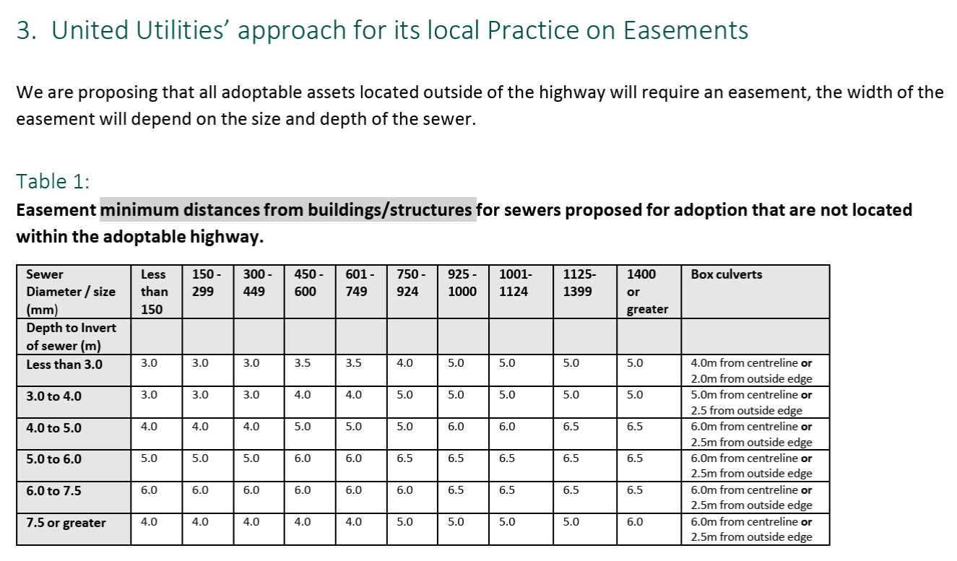
% Complete submission: | 86%
% At approvable standard: | 14%
Refusal trigger points:
Submission 1 = less than 20% complete.
Submission 2 = not 100% approvable standard.

LLFA Recommendation: | Further information required

